Chapter 2: Assessment of the Pacific cod stock   
in the Gulf of Alaska

Steven Barbeaux, Bridget Ferriss, Ben Laurel, Mike Litzow, Susanne McDermott

Julie Nielsen, Wayne Palsson, Kalei Shotwell, Ingrid Spies, and Muyin Wang

November 2021

# Executive Summary

## Summary of Changes in Assessment Inputs

Relative to last year’s assessment, the following changes have been made in the current assessment:

### Changes in the input data

1. Federal and state catch data for 2020 were updated and preliminary federal and state catch data for 2021 were included;
2. Commercial federal and state fishery size composition data for 2020 were updated, and preliminary commercial federal and state fishery size composition data for 2021 were included;
3. AFSC bottom trawl survey Pacific cod abundance and length composition data for 2021 were included;
4. AFSC longline survey Pacific cod abundance index and length composition data for the GOA for 2021 were included;
5. All length composition samples with less than 30 fish for a particular area, year, quarter, and gear type were excluded from the dataset. This made up 2% of the data representing < 1% of the overall catch.
6. Age-0 beach seine survey index was included in one alternative model.

### Changes in the methodology

Model 19.1 is last year’s accepted model (Model 19.1) with the addition of the new data described above. There are two new models described this year, Model 21.1, which is Model 19.1 but with a changed mortality block to 2015-2017 from 2014-2016 in Model 19.1 fit with the same prior for the base natural mortality (Table 2.1), and Model 21.2 which has temperature dependent growth, heatwave dependent recruitment, and heatwave dependent natural mortality instead of the 2014-2016 block used in Model 19.1. In addition 21.2 includes an age-0 beach seine survey index (Litzow *et al.* In review).

All three models presented in this document are single sex age-based models with length-based selectivity. The models have data from three fisheries (longline, pot, and combined trawl fisheries) with a single season and two survey indices (post-1990 GOA bottom trawl survey and the AFSC Longline survey indices). Length composition data are available for all three fisheries and both indices. In both models growth is parameterized using the standard three parameter von Bertalanffy growth curve. In Model 21.2 the von Bertalanffy growth curve has additional link parameters on L2 and K which scale growth to the CFSR temperature at depth for 0-20 cm fish, and a link parameter on L1 which scales this parameter to an index of growth for larval Pacific cod based on the relationship of larval growth with temperatures published by Laurel et al. (2016). In Model 19.1 and 21.1 recruitment is parameterized as a standard Beverton-Holt with Sigma R is fixed at 0.44 and steepness is fixed at 1.0 for all three models. For model 21.2 there is a parameter on R0 which scales it based on the spawning heatwave index. All scaling parameters are fit with non-informative priors. All selectivity estimates are fit using six parameter double-normal selectivity curves. For Model 21.2 the age-0 beach seine survey index is fit with an additional parameter which estimates variance of the index internally.

### Summary of results

All three models performed well, and all three models produce similar results. Model 21.1 provided an overall better fit than Model 19.1; however, the fit made a tradeoff in providing an improved fit to the longline survey, length composition, and recruitment while degrading the fit to the bottom trawl survey. Because of the addition of the beach seine survey index data Model 21.2 could not be directly compared to the other two models using overall likelihoods. Model 21.2 provided a better fit to all of the conditional age at length data. However the seine data index was in conflict with the longline and trawl surveys resulting in a worse fit for these two. While all three models performed well in the retrospective analyses, Model 19.1 performed marginally better in the spawning stock biomass retrospective analysis and Model 21.2 performed marginally better in the recruitment retrospective analysis. A leave-one-out analysis was performed where all data for a single year were removed back to 11 years and changes in the variance of parameters and derived quantities evaluated. In this analysis all three models performed similarly with rather low bias. However Model 21.2 showed the least bias in the unfished spawning biomass, 2022 spawning stock biomass, and 2022 ABC. In particular, the removal of the 2021 data from Models 19.1 and 21.1 resulted in a substantial change in unfished spawning biomass, 2022 spawning stock biomass, and 2022 ABC, while the change in results from Model 21.2 were substantially lower. The largest differences among models were in the projections. Model 19.1 and 21.1 assume average 1977-2019 recruitment, growth, and natural mortality after 2020. For Model 21.2 the authors present two different assumptions; Projection A assumes environmental conditions after 2021 will match the 1977-2021 average, Projection B assumes that the environmental conditions after 2021 will match the 2012-2021 average. Projection B was provided because conditions for 2012-2021 in the GOA have been decidedly warmer than previous decades in the time series and projections by the IPCC suggests the warming trend will continue and worsen in the coming decades.

The data as interpreted through Model 21.2 indicates that the stock remains at low levels with poor recruitment since 2014. Although the 2017 and 2018 beach seine survey indicated higher densities of age-0 cod in those years, these fish failed to materialize at higher abundance in the 2019 - 2021 surveys or fisheries. Given selectivity in the fisheries and surveys, the high density of age-0 cod in the 2020 beach seine survey would not yet be collaborated by other data. Despite recent low recruitment, the stock was projected to either increase slowly (Projection A) or remain relatively stable (Projection B) due to low fishing levels in 2020 and 2021. Both projections have the stock at B24.5% in 2022, however they differ in 2023 with Projections A at B23.8% and Projection B at B21.6%. For setting ABC and OFL in 2022 and 2023 the authors present results for both Projection A and Projection B and seek guidance from the Plan Team and SSC on which future conditions should be considered for setting management advice.

Key results for both projections are tabulated below:

|  |  |  |  |  |
| --- | --- | --- | --- | --- |
| **M21.2 Projection A**  **(Mean 1977-2021 conditions projected)**  **Quantity** | As estimated or *specified last* year for: | | As estimated or *specified this* year for: | |
| 2021 | 2022 | 2022 | 2023 |
| *M* (natural mortality rate) | 0.47 | 0.47 | 0.48* | 0.48* |
| Tier | 3b | 3b | 3b | 3b |
| Projected total (age 0+) biomass (t) | 265,661 | 312,783 | 159,837 | 185,745 |
| Female spawning biomass (t) |  |  |  |  |
| Projected | 39,977 | 50,813 | 39,873 | 38,594 |
|  |  |  |  |  |
| *B100%* | 180,111 | 180,111 | 162,426 | 162,426 |
| *B40%* | 72,045 | 72,045 | 64,970 | 64,970 |
| *B35%* | 63,039 | 63,039 | 56,849 | 56,849 |
| *FOFL* | 0.41 | 0.54 | 0.54 | 0.52 |
| *maxFABC* | 0.33 | 0.43 | 0.44 | 0.42 |
| *FABC* | 0.33 | 0.43 | 0.44 | 0.42 |
| OFL (t) | 28,977 | 46,587 | 29,131 | 27,715 |
| maxABC (t) | 23,627 | 38,141 | 24,043 | 22,882 |
| ABC (t) | 23,627 | 38,141 | 24,043 | 22,882 |
| **Status** |  | |  | |
| 2019 | 2020 | 2020 | 2021 |
| Overfishing | No | n/a | No | n/a |
| Overfished | n/a | No | n/a | No |
| Approaching overfished | n/a | No | n/a | No |

*\*Base natural mortality M varies between 0.48 and 1.07*

*\*\* Assumed 2021 catch at the ABC, 23,627 t . For 2023 projections the 2022 catch was assumed to be at the projected ABC.*

|  |  |  |  |  |
| --- | --- | --- | --- | --- |
| **M21.2 Projection B**  **(Mean 2010-2021 conditions projected)**  **Quantity** | As estimated or *specified last* year for: | | As estimated or *specified this* year for: | |
| 2021 | 2022 | 2022 | 2023 |
| *M* (natural mortality rate) | 0.47 | 0.47 | 0.48* | 0.48* |
| Tier | 3b | 3b | 3b | 3b |
| Projected total (age 0+) biomass (t) | 265,661 | 312,783 | 160,755 | 169,832 |
| Female spawning biomass (t) |  |  |  |  |
| Projected | 39,977 | 50,813 | 39,873 | 35,050 |
|  |  |  |  |  |
| *B100%* | 180,111 | 180,111 | 162,426 | 162,426 |
| *B40%* | 72,045 | 72,045 | 64,970 | 64,970 |
| *B35%* | 63,039 | 63,039 | 56,849 | 56,849 |
| *FOFL* | 0.41 | 0.54 | 0.54 | 0.47 |
| *maxFABC* | 0.33 | 0.43 | 0.44 | 0.38 |
| *FABC* | 0.33 | 0.43 | 0.44 | 0.38 |
| OFL (t) | 28,977 | 46,587 | 28,000 | 22,072 |
| maxABC (t) | 23,627 | 38,141 | 23,099 | 18,170 |
| ABC (t) | 23,627 | 38,141 | 23,099 | 18,170 |
| **Status** |  | |  | |
| 2019 | 2020 | 2020 | 2021 |
| Overfishing | No | n/a | No | n/a |
| Overfished | n/a | No | n/a | Yes |
| Approaching overfished | n/a | No | n/a | Yes |

*\*Base natural mortality M varies between 0.48 and 1.07*

*\*\* Assumed 2021 catch at the ABC, 23,627t . For 2023 projections the 2022 catch was assumed to be at the projected ABC.*

## Area apportionment

In 2012 the ABC for GOA Pacific cod was apportioned among regulatory areas using a Kalman filter approach based on summer trawl survey biomass estimates. In the 2013 assessment, the random effects model (which is similar to the Kalman filter approach, and was recommended in the Survey Average working group report which was presented to the Plan Team in September 2013) was used; this method was used for the ABC apportionment for 2014. The SSC concurred with this method in December 2013. Using this method with the trawl survey biomass estimates through 2021, the area-apportioned ABCs would be:

Projection A:

|  |  |  |  |  |
| --- | --- | --- | --- | --- |
|  | Western | Central | Eastern | Total |
| Random effects area apportionment | 30.3% | 60.2% | 9.5% | 100% |
| 2022 ABC | 7,285 | 14,474 | 2,284 | 24,043 |
| 2023 ABC | 6,933 | 13,775 | 2,174 | 22,882 |

Projection B:

|  |  |  |  |  |
| --- | --- | --- | --- | --- |
|  | Western | Central | Eastern | Total |
| Random effects area apportionment | 30.3% | 60.2% | 9.5% | 100% |
| 2022 ABC | 6,999 | 13,905 | 2,194 | 23,099 |
| 2023 ABC | 5,505 | 10,938 | 1,726 | 18,170 |

## Responses to SSC and Plan Team Comments Specific to this Assessment

**Plan Team Comments – September 2021**

The Team recommended that the rationale for increases in the bottom trawl catchability parameter, particularly when re-weighting, should be noted; specifically, compare values with earlier experimental results.

*Under the newest version of Stock Synthesis the Dirichlet multinomial option has been updated and now appears to function. There was a bug in the programing prior to August that was identified and has since been fixed.This configuration suggested no reweighting of the composition data and therefore these models were not brought forward for this assessment. Models presented for consideration have survey catchabilities within historic norms (1.0 to 1.15)*

**Science and Statistical Committee comments – October 2021**

The SSC supports the authors’ recommendation to bring forward Model 19.1 for the November assessment, and encourages the authors to explore a tuned version of this model that does not fit to the age-0 beach seine index. The SSC further supports the authors presenting several additional research models at their discretion:

* Model 21.1e that includes the age-0 beach seine index and environmentally-linked growth, mortality, and recruitment.
* Model 21.1g a tuned version of 21.1e.
* Model 21.5c which includes environmentally-linked growth and recruitment, the updated natural mortality time block, and is tuned.
* A possible model variant described in the GOA GPT presentation as 21.6 which includes the age-0 beach seine index and is tuned.

*The authors presented three models for consideration which don’t include any additional tuning. The Dirichlet multinomial option was explored and results indicated that the model would not require changes in data weighting. Given continued issues with convergence when the Dirichlet multinomial was used the authors chose to return to the base weighting used in prior year’s assessments and described below. Model 21.1 includes an updated time block for natural mortality as described in model 21.5c and Model 21.2 includes all of the environmental links demonstrated in the September exploratory models along with the age-0 beach seine index.*

With respect to the age-0 beach seine index, the SSC encourages the authors to consider whether the model-based estimates of uncertainty are accurately reflecting the true uncertainty in juvenile Pacific cod abundance, given the spatial extent of sampling relative to the distribution of juvenile Pacific cod in the GOA.

*To address this issue the authors chose to fit an additional parameter which internally estimates the scale of the variance of the beach seine index in Model 21.2. This parameter in effect inflated the variance by 138% on average substantially reducing the indices weight within the model.*

# Introduction

Pacific cod (*Gadus macrocephalus*) is a transoceanic species, occurring at depths from shoreline to 500 m. The southern limit of the species’ distribution is about 34° N latitude, with a northern limit of about 63° N latitude. Pacific cod is distributed widely over Gulf of Alaska (GOA), as well as the eastern Bering Sea (EBS) and the Aleutian Islands (AI) area. The Aleut word for Pacific cod, *atxidax*, literally translates to “the fish that stops” (Betts *et al.* 2011). Recoveries from archeological middens on Sanak Island in the Western GOA show a long history (at least 6,000 years) of exploitation. Over this period, the archeological record reveals fluctuations in Pacific cod size distribution which Betts et al. (2011) tie to changes in abundance due to climate variability (Fig. 2.1). Over this long period colder climate conditions appear to have consistently led to higher abundance with more small/young cod in the population and warmer conditions to lower abundance with fewer small/young cod in the population. Recent comparisons of Pacific cod length distributions extrapolated from bones retrieved from middens and those from the modern domestic fishery show a cline in size from larger fish in the west to smaller fish in the southeastern GOA that has been consistent for over 6,000 years (West *et al.* 2020) (Fig 2.2).

Tagging studies (e.g., Shimada and Kimura 1994) have demonstrated significant migration both within and between the EBS, AI, and GOA outside of spawning season (Fig. 2.3). There appears to be substantial migration between the southern Bering Sea and the western GOA based on tagging data, however little movement has been observed from the Central GOA to the Western GOA. In March 2021, a cooperative tagging study between the Alaska Fisheries Science Center (AFSC) and the Aleutian East Borough (AEB) was initiated to examine the seasonal movements of Pacific cod captured in the western GOA during the spawning season (P.I.s McDermott, Palsson, and Barbeaux, AFSC, and Levy, AEB). The goal of this study is to better understand the relationship of these fish to Pacific cod in the wider GOA and eastern Bering Sea (EBS) during the summer when the AFSC bottom trawl surveys are conducted. Twenty-five satellite-tagged and 957 conventionally-tagged Pacific cod were released in 8 subareas of the Western GOA near the Shumagin and Sanak Islands (Fig. 2.4). Satellite tags were programmed to pop-up and transmit data after 90, 180, or 365 days. Early pop-ups were likely due to predation instead of tagging mortality. Locations of tags recovered in March, April, and May were largely in the vicinity of release area but fish with tags recovered June through September had moved west toward the Aleutian Islands region and north into the EBS, Northern Bering Sea (NBS), Russia, and the Chukchi Sea. More than half of the tag recoveries (10 of 17) between the beginning of June and the end of September had moved northward out of the GOA, indicating substantial seasonal connectivity between the GOA and other management regions. Work is in progress to reconstruct movement paths of fish tagged with satellite tags which will provide valuable information on migration timing and pathways. Additional satellite and conventional tag releases are planned for March 2022.

Two genetics studies using Restriction-site Associated DNA sequencing have indicated significant genetic differentiation among spawning stocks of Pacific cod in the GOA and the EBS (Drinan et al. 2018; Spies et al. 2019). High assignment success (>80%) was demonstrated among five spawning populations of Pacific cod throughout their range off Alaska using 6,425 single-nucleotide polymorphism (SNP) loci (Drinan et al. 2018). Further work using 3,599 SNP loci and spawning samples throughout the range of Pacific cod off Alaska, as well as a summer sample from the Northern Bering Sea in August 2017 showed significant differentiation among all spawning groups (Spies et al. 2019). The three spawning groups examined in the GOA, Hecate Strait, Kodiak Island, and Prince William Sound, were all genetically distinct and could be assigned to their population of origin with 80-90% accuracy (Fig. 2.5; Drinan et al. 2018). There was strong evidence for selective differentiation of some loci, including one that aligned to the zona pellucida glycoprotein 3 (ZP3) in the Atlantic cod genome (Drinan et al. 2018). This locus had the level of differentiation of any locus examined (FST=0.071). ZP3 a reproductive protein that is known to undergo rapid selection, and it has been shown to neofunctionalize as an antifreeze protein in Antarctic icefishes (Spies et al. 2021). At the putative ZP3 locus in Pacific cod, a distinct set of haplotypes have been observed in spawning cod from Kodiak Island westward vs. Prince William Sound and samples to the east. Results were consistent with directional selection in the Bering Sea (Bering Sea, Aleutian Islands, Shumagin Islands, and Kodiak Island), and large regional differences among ZP3 haplotype frequencies between the Bering Sea group and other spawning locations in the Gulf of Alaska and further south, including Prince William Sound and Hecate Strait (Fig. 2.6). Results were also indicative of selection currently acting on northern collections, as may indicate local adaptation driven by differences in ZP3.

Although there appears to be some genetic differentiation within the GOA management area and some cross migration between the Western GOA and Bering Sea that may vary seasonally, the Pacific cod stock in the GOA region is currently managed as a single stock. Further work is needed to understand the genetic stock structure of cod in the GOA and its relationship with the Bering Sea stock of cod during spawning and feeding periods.

A detailed account of Pacific cod life history, environmental drivers, economic and social indicators can be found in the GOA Pacific cod ecosystem and social processes (ESP) Appendix 2.1.

# Fishery

## General description

During the two decades prior to passage of the Magnuson Fishery Conservation and Management Act (MFCMA) in 1976, the fishery for Pacific cod in the GOA was small, averaging around 3,000 t per year. Most of the catch during this period was taken by the foreign fleet, whose catches of Pacific cod were usually incidental to directed fisheries for other species. By 1976, catches had increased to 6,800 t. Catches of Pacific cod since 1991 are shown in Table 2.2; catches prior to that are listed in Thompson et al. (2011). Presently, the Pacific cod stock is exploited by a multiple-gear fishery, including trawl, longline, pot, and jig components. Trawl gear took the largest share of the catch in every year but one from 1991-2002, although pot gear has taken the largest single-gear share of the catch in each year since 2003. Figure 2.7 shows landings by gear since 1977. Table 2.2 shows the catch by jurisdiction and gear type.

The history of acceptable biological catch (ABC) and total allowable catch (TAC) levels is summarized and compared with the time series of aggregate commercial catches in Table 2.3. Changes in ABC over time are typically attributable to three factors: 1) changes in resource abundance, 2) changes in management strategy, and 3) changes in the stock assessment model. Assessments conducted prior to 1988 were based on survey biomass alone. From 1988-1993, the assessment was based on stock reduction analysis (Kimura *et al.* 1984). From 1994-2004, the assessment was conducted using the Stock Synthesis 1 modeling software (Methot 1986, 1990) with length-based data. The assessment was migrated to Stock Synthesis 2 (SS2) in 2005 (Methot 2005), at which time age-based data began to enter the assessment. Several changes have been made to the model within the SS2 framework (renamed “Stock Synthesis,” or SS3, in 2008) each year since then.

For the first year of management under the Magnuson-Stevens Fishery Conservation and Management Act (MSFCMA, 1977), the catch limit for GOA Pacific cod was established at slightly less than the 1976 total reported landings. During the period 1978-1981, catch limits varied between 34,800 and 70,000 t, settling at 60,000 t in 1982. Prior to 1981 these limits were assigned for “fishing years” rather than calendar years. In 1981 the catch limit was raised temporarily to 70,000 t and the fishing year was extended until December 31 to allow for a smooth transition to management based on calendar years, after which the catch limit returned to 60,000 t until 1986, when ABC began to be set on an annual basis. From 1986 (the first year in which an ABC was set) through 1996, TAC averaged about 83% of ABC and catch averaged about 81% of TAC. In 8 of those 11 years, TAC equaled ABC exactly. In 2 of those 11 years (1992 and 1996), catch exceeded TAC.

To understand the relationships between ABC, TAC, and catch for the period since 1997, it is important to understand that a substantial fishery for Pacific cod has been conducted during these years inside State of Alaska waters (Table 2.2), mostly in the Western and Central Regulatory Areas. To accommodate the State-managed fishery, the Federal TAC was set well below ABC (15-25% lower) in each of those years. Thus, although total (Federal plus State) catch has exceeded the Federal TAC in 16 of the 23 years since 1997, this is basically an artifact of the bi-jurisdictional nature of the fishery and is not evidence of overfishing as this would require exceeding OFL. At no time since the separate State waters fishery began in 1997 has total catch exceeded ABC, and total catch has never exceeded OFL.

Historically, the majority of the GOA catch has come from the Central regulatory area. To some extent the distribution of effort within the GOA is driven by regulation, as catch limits within this region have been apportioned by area throughout the history of management under the MFCMA. Changes in area-specific allocation between years have usually been traceable to changes in biomass distributions estimated by Alaska Fisheries Science Center (AFSC) trawl surveys or management responses to local concerns. Currently the area-specific ABC allocation is derived from the random effects model (which is similar to the Kalman filter approach). The complete history of allocation (in percentage terms) by regulatory area within the GOA is shown in Table 2.4. Table 2.2 and Table 2.3 include discarded Pacific cod, estimated retained and discarded amounts are shown in Table 2.5.

In addition to area allocations, GOA Pacific cod is also allocated on the basis of processor component (inshore/offshore) and season. The inshore component is allocated 90% of the TAC and the remainder is allocated to the offshore component. Within the Central and Western Regulatory Areas, 60% of each component’s portion of the TAC is allocated to the A season (January 1 through June 10) and the remainder is allocated to the B season (June 11 through December 31, although the B season directed fishery does not open until September 1).

NMFS has also published the following rule to implement Amendment 83 to the GOA Groundfish FMP:

“Amendment 83 allocates the Pacific cod TAC in the Western and Central regulatory areas of the GOA among various gear and operational sectors, and eliminates inshore and offshore allocations in these two regulatory areas. These allocations apply to both annual and seasonal limits of Pacific cod for the applicable sectors. These apportionments are discussed in detail in a subsequent section of this rule. Amendment 83 is intended to reduce competition among sectors and to support stability in the Pacific cod fishery. The final rule implementing Amendment 83 limits access to the Federal Pacific cod TAC fisheries prosecuted in State of Alaska (State) waters adjacent to the Western and Central regulatory areas in the GOA, otherwise known as parallel fisheries. Amendment 83 does not change the existing annual Pacific cod TAC allocation between the inshore and offshore processing components in the Eastern regulatory area of the GOA.

“In the Central GOA, NMFS must allocate the Pacific cod TAC between vessels using jig gear, catcher vessels (CVs) less than 50 feet (15.24 meters) length overall using hook-and-line gear, CVs equal to or greater than 50 feet (15.24 meters) length overall using hook-and-line gear, catcher/processors (C/Ps) using hook-and-line gear, CVs using trawl gear, C/Ps using trawl gear, and vessels using pot gear. In the Western GOA, NMFS must allocate the Pacific cod TAC between vessels using jig gear, CVs using hook-and-line gear, C/Ps using hook-and-line gear, CVs using trawl gear, and vessels using pot gear. Table 3 lists the proposed amounts of these seasonal allowances. For the Pacific cod sector splits and associated management measures to become effective in the GOA at the beginning of the 2012 fishing year, NMFS published a final rule (76 FR 74670, December 1, 2011) and will revise the final 2012 harvest specifications (76 FR 11111, March 1, 2011).”

“NMFS proposes to calculate of the 2012 and 2013 Pacific cod TAC allocations in the following manner. First, the jig sector would receive 1.5 percent of the annual Pacific cod TAC in the Western GOA and 1.0 percent of the annual Pacific cod TAC in the Central GOA, as required by proposed § 679.20(c)(7). The jig sector annual allocation would further be apportioned between the A (60 percent) and B (40 percent) seasons as required by § 679.20(a)(12)(i). Should the jig sector harvest 90 percent or more of its allocation in a given area during the fishing year, then this allocation would increase by one percent in the subsequent fishing year, up to six percent of the annual TAC. NMFS proposes to allocate the remainder of the annual Pacific cod TAC based on gear type, operation type, and vessel length overall in the Western and Central GOA seasonally as required by proposed § 679.20(a)(12)(A) and (B).”

The longline and trawl fisheries are also associated with a Pacific halibut mortality limit which sometimes constrains the magnitude and timing of harvests taken by these two gear types.

## Recent fishery performance

Data for managing the Gulf of Alaska groundfish fisheries are collected in multiple ways. The primary source of catch composition data in the federally managed fisheries for Pacific cod are collected by on-board observers (Faunce *et al.* 2017). The Alaska Department of Fish and Game (ADFG) sample individual deliveries for state managed fisheries (Nichols *et al.* 2015). Overall catch delivered is reported through a (historically) paper and electronic catch reporting system. Total catch is estimated through a blend of catch reporting, observer, and electronic monitoring data (Cahalan *et al.* 2014).

The distribution of directed cod fishing is distinct to gear type, Figure 2.8 shows the distribution of catch from 1990-2015 for the three major gear types. Figure 2.9 and Figure 2.10 show the distribution of observed catch for 2020 and 2021 through October 13, 2021 for the three major gear types. In the 1970’s and early to mid-1980’s the majority of Pacific cod catch in the Gulf of Alaska was taken by foreign vessels using longline. With the development of the domestic Gulf of Alaska trawl fleet in the late 1980’s trawl vessels took an increasing share of Pacific cod and Pacific cod catch increased sharply to around 70,000 t throughout the 1990’s. Although there had always been Pacific cod catch in crab pots, pots were first used to catch a measurable amount of Pacific cod in 1987. This sector initially comprised only a small portion of the catch, however by 1991 pots caught 14% of the total catch. Throughout the 1990s the share of the Pacific cod caught by pots steadily increased to more than a third of the catch by 2002 (Table 2.2 and Fig. 2.5). The portion of catch caught by the pot sector steeply increased in 2003 with incoming Steller sea lion regulations and halibut bycatch limiting trawl and for 2003 through 2021 the pot sector caught on average 58% of the total catch of Pacific cod in the Gulf of Alaska annually.

In 2015 combined state and federal catch was 79,489 t (23%) below the ABC while in 2016 combined catch was 64,087 t (35% below the ABC) and in 2017 catch was 48,734 t (45% below the ABC) (Table 2.3). The ABC was substantially reduced for 2018 to 18,000 t from 88,342 t in 2017, an 81% reduction. This was a 65% reduction from the realized 2017 catch. In 2018 the total catch was 15,247 t. For 2019 the ABC was set below the maximum ABC at 17,000 t and combined fishery caught 15,411 t which was 91% of the ABC.

In 2020 the spawning stock biomass was projected to have dropped below 20% of the unfished spawning biomass (B20%) and the federal Pacific cod fishery in the GOA was closed by regulation to directed Pacific cod fishing. B20% is a minimum spawning stock size threshold instituted to help ensure adequate forage for the endangered western stock of Steller sea lions. The Alaska State directed Pacific cod fishery remained open and Pacific cod bycatch in other federally managed groundfish fisheries was allowed. The Pacific cod ABC for 2020 was set to 14,621 t, but the combined TAC and Alaska State groundfish harvest level (GHL) was reduced to account for additional uncertainty. The Alaska State managed fisheries are allocated 26.7% of the GOA Pacific cod ABC. The federal Pacific cod TAC was reduced by 40% from the maximum of 10,719 t as a further level of precaution to 6,431 t. ADF&G also reduced their maximum prescribed harvest limit of 3,902 t by 35% to 2,537 t. This resulted in a total combined federal TAC and Alaska State GHL of 8,968 t or 61% of the maximum ABC. In 2020 a total combined catch of 6,233 t was harvested (Table 2.2), the state having taken 2,318 t (91% of the GHL) and federal fisheries haven taken 3,916 t (61% of the federal TAC). The catch in the federal fisheries were split primarily between the arrowtooth flounder (1,237 t), walleye pollock (1,040 t), and shallow water flatfish fisheries (938 t).

In 2021 the stock was projected to be above B20% and the federal fishery was once again allowed to open. The federal TAC was set at 17,321 t and state GHL set at 5,864 t (Table 2.3). As of October 4, 2021 a total of 16,502 t (69% of the ABC) have been harvested (Table 2.2). State fisheries have harvested 5,573 t (95% of the GHL) and federal fisheries 10,930 t (63% of the TAC). In 2021 43% of the Pacific cod catch was by pot gear (Table 2.2), 32% by trawl, 1and 8% by longline, while jig and other gear harvested less than 7%.

The largest component of incidental catch of other targeted groundfish species in the GOA Pacific cod fisheries by weight are skate species in combination followed by walleye pollock, shark species, rock sole, arrowtooth flounder, and octopus (Table 2.6). Rockfish and sculpin species also make up a major component of the bycatch in these fisheries. Incidental catch of non-target species in the GOA Pacific cod fishery are listed in Table 2.7.

### Longline

For 1990-2015 the longline fishery had been dispersed across the Central and Western GOA, however more longline catch taken to the west of Kodiak, with some longline fishing occurring in Barnabus trough and a small concentration of sets along the Seward Peninsula (Fig. 2.8). The 2017 longline fishery was predominantly conducted on the border of are 620 and 610 in deeper waters south of the Shumagin Islands and South of Unimak Island to the western edge of the 610 GOA management area shelf. In 2018 and 2019 with the drastic cut in TAC the fishery showed very little effort, the majority of catch being south of the Shumagin Islands straddling the 610 and 620 management area edges. In 2020 there was no directed Pacific cod longline fishery in federal waters (Fig. 2.9). In 2021 observers and electronic monitoring show a large portion of the longline catch coming from near the Shumagin Islands in the Western GOA, and the southern edge of Kodiak Island and the southern edge of the Seward Peninsula in the Central GOA (Fig. 2.10). In years with a fishery, the longline fishery tends to catch larger fish on average than the other fisheries (Fig. 2.11). The mean size of Pacific cod caught in the longline fishery is 64 cm (annual mean varies from 58cm to 70cm). There was a drop in the mean length of fish in the longline fishery between 1990 and 2010, however this trend has been more variable over the last 10 years (Fig. 2.12). In 2018 and 2019 fewer boats participated in the fishery and catch was substantially slower and lower than previous years, this trend continued in 2020 when the federal fishery was closed (Fig. 2.20). In 2021 there was an increase in vessels participating in the Pacific cod longline fishery in the Central GOA from 3 in 2020 to 37 in 2021 exceeding the 33 that participated in 2019. There was only a single longline vessel fishing Pacific cod in the Western GOA, up from 2020, but fewer than the 3 that participated in 2019 (Fig. 2.20). In both the Central and Western GOA catch in 2021 was earlier than in 2018 or 2019, but like those years the A-season was completed by week 10 (Fig. 2.18 and Fig. 2.19). Although CPUE figures were produced for the longline fisheries in the GOA (Fig. 2.21), the consistency of the data are in question in the last three years, first because of the electronic monitoring reducing the available data and second because of changes in observer coverage due to COVID-19. It should be noted that CPUE is not available from the EM monitored vessels as number of hooks retrieved and soak time are not recorded.

### Pot

The pot fishery is a relatively recent development (Table 2.2) and predominately pursued using smaller catcher vessels. In the Alaska State managed fishery an average of 84% of the state catch comes from pot fishing vessels. In 2016, 60% of the overall GOA Pacific cod catch was removed using pots. Pot fishing occurs close to the major ports of Kodiak, Sand Point and on either side of the Seward Peninsula (Fig. 2.8). In 2017, the observer coverage rate of pot fishing vessels was greatly reduced from 14% to ~4% this impacted our ability to adequately identify the spatial distribution of the pot fishery. From the data collected there appears to have been less fishing to the southwest of Kodiak in 2017, however this may be due to low observer coverage. In 2018 - 2020, there were few observed hauls throughout the GOA due to the lower TAC, low fishing levels, and 2020 directed federal fishery closure (Fig. 2.9 and Fig. 2.10). The pot fishery in the Central GOA moved to deeper water in 2017 through 2019 than previous years. Like the longline fishery CPUE figures were produced for the pot fisheries in the GOA and similarly the consistency of the data are in question in the last three years for the same reasons. It should be noted that there were no data available for CPUE calculations in 2020 nor any CPUE data available for the Western GOA in 2021.

The pot fishery generally catches fish greater than 40 cm (Fig. 2.13), but like the longline fishery there was a declining trend in Pacific cod mean length in the fishery from 1998 through 2016 with the smallest fish at less than 60cm on average caught during the 2016 fishery (Fig. 2.14). The 2017 through 2019 fishery data show a sharp increase in mean length, potentially due to a combination of the fishery moving to deeper water and lower recruitment since 2014.

In 2017, the pot fishery in the Central GOA was slower than previous years and did not take the full TAC for the A season. In 2018 and 2019, the Pot fisheries in both regions were slower than the previous three years. In the Western GOA in 2018 and 2019, approximately half the catch was caught in a single week in March (Fig.18). In 2020 pot fishing was greatly reduced with 15 vessels in the Central GOA and 19 in the Western GOA compared to 27 and 33 the year previously (Fig. 2.20). In 2021 the number of participating vessels increased again to pre-closure levels with 24 vessels in the Central GOA and 37 in the Western GOA. In 2020 and 2021 there was no observer coverage of the pot fishery in the Western GOA despite substantial participation (37 vessels) and catch of 3,073 t (19% of the total GOA cod catch). There was however biological data collected from the Western GOA region by the ADF&G port samplers which were incorporated into the stock assessment.

### Trawl

The Gulf of Alaska Pacific cod trawl fishery rapidly developed starting in 1987, surpassing the catch from the foreign longline fishery pursued in the 1970’s to mid-1980s in 1987. The trawl fishery dominated the catch into the early-2000s, but was then replaced by increases in pot fishing in the mid-2000’s. This transition to pot fishing was partially due to Steller sea lion regulations, halibut bycatch caps, and development of an Alaska state managed fishery. The distribution of catch from the trawl fishery for 1990-2015 shows it has been widely distributed across the Central and Western GOA (Fig. 2.8) with the highest concentration of catch coming from southeast of Kodiak Island in the Central GOA and around the Shumigan Islands in the Western GOA. In 2016 trawl fishing in the Western GOA shifted away from the Shumigan Islands further to the west around Sanak Island and near the Alaska Peninsula, this shift continued through 2017. Trawl fishing in 2018 for the A-season had a similar pattern as 2017 with large catches from around Sanak Island, but some increased effort on Portlock Bank to the southeast of Kodiak. There was substantially less catch and observed effort in 2018 and 2019 (Fig. 2.7) than previous years. Although the 2020 directed federal Pacific cod fishery was closed there was observations of Pacific cod catch in other fisheries (Fig. 2.9), these observations primarily surrounded Kodiak from the pollock and shallow water flatfish fisheries. In 2021with the reopening of the directed Federal Pacific cod fishery there were observed catches in the Western GOA (Fig. 2.10). Trawl catch in the Western GOA was 1,780 t as of October 24, exceeding the 2018 and 2019 catches for the region (1,464 t and 1,589 t). Trawl catch of Pacific cod in the Central GOA so far in 2021 (3,767 t) have exceeded the catch over the previous 3 years. Due to bycatch in other fisheries trawl catch of Pacific cod in 2020 remained above 3,000 t despite the closure of the federal directed fishery.

The trawl fishery catches smaller fish than the other two gear types with fish as small as 10 cm appearing in the observed length composition samples (Fig. 2.15). The average size of Pacific cod caught by trawl in the 1980’s was on average smaller than those caught later (Fig. 2.16). The trawl fishery shows an increase in average size in the 1990s with the maturation of the domestic fishery. The decline in the mean length from the mid-1990s until 2015 mimics that observed in the longline and pot fisheries with some prominent outliers (2005-2006). The years 2005 and 2006 shows little observed fishing in the B-season when smaller fish are more often encountered with this gear type. The mean size shows a sharp increase in 2016 through 2020. The change to deeper depth and a larger proportion of the catch coming from the Western GOA might partially explain this recent increase as well as lower recruitment in recent years leading to a larger overall population on average as older fish make up higher percentage of the population age structure.

The 2018-2019, directed A-season trawl fishery in the Central GOA started much later than previous years, catch rates were lower and the fishery did not take the full TAC (Fig. 2.17). In 2018, 2019, and 2021 despite there being vessels 14 to 18 vessels participating in the Western GOA trawl fishery, there was no observed effort. There were no vessels participating in the directed Pacific cod fishery in the Central GOA for 2018-2020 and only 2 vessels in 2021 (Fig. 2.20).

### Other gear types, non-directed, and non-commercial catch

There is a small jig fishery for Pacific cod in the GOA, this is a primarily state managed fishery and there is no observer data documenting distribution. This fishery has taken on average 2,400 t per year. In 2017 through 2020 the jig fishery remained low with catch at less than 500 t for all regions (Table 2.2 and Fig. 2.19). In 2017 there were 35 Jig vessels participating in the GOA Pacific cod fishery, 27 in 2018, 61 vessels in 2019, 41 vessels in 2020, then a sharp increase in 2021 to 65 vessels (Fig. 2.20). Catch in 2021 also increased to 1,125 t, with 808 t of that from the Central GOA.

Pacific cod is also caught as bycatch in other commercial fisheries. Although historically the shallow water flatfish fishery caught the most Pacific cod, since 2014, Pacific cod bycatch in the Arrowtooth flounder target fishery has surpassed it (Table 2.8). The weight of Pacific cod catch summed for all other target fisheries was 2,803 in 2017, 2,770 in 2018, 3,400 t in 2019, 3,903 t in 2020, and in 2021 as of October 4 a total of 4,071 t. This following an all-time high of 10,780 t in 2015 with 1/3 of this from the Arrowtooth flounder target fishery.

Non-commercial catch of Pacific cod in the Gulf of Alaska is considered to be relatively small at less than 400 t; data are available through 2019 (Table 2.9). The largest component of this catch comes from the recreational fishery, generally taking approximately one-third to one-half of the accounted for non-commercial catch and the IPHC Annual Longline survey also taking between one-third and one half of the accounted for non-commercial catch.

### Other fishery related indices for stock health

There is a long history of evaluating the health of a stock by its condition which examines changes in the weight to length relationship (Nash *et al.* 2006). Condition is measured in this document as the deviance from a log linear regression on weight by length for all Pacific cod fishery A season (January-March) data for 1998-2021. There is some variability in the length to weight relationships between Pacific cod captured in the Central and Western GOA fisheries and among gear types. However, there is a consistent trend in both areas for Pacific cod captured using longline and pot gear in there being lower condition during 2015-2016 (Fig. 2.22 - 2.25). In 2018 and 2019, where data are available the condition of fish in both the Central and Western GOA are mixed with differences in condition by gear and season. The Central GOA longline fishery shows improving condition in January through March (Fig. 2.22) in 2018 through 2021. The Central GOA pot fishery shows improvement in 2018 and 2021 as well (Fig 2.23), but there were no data available for 2019 and 2020. In the Western GOA, longline fishery cod condition in 2019 returned to average (Fig. 2.24). The Western GOA pot fishery shows improved cod condition in 2017 and 2018 following the heatwave (Fig. 2.25), but then again in 2019, cod condition once again drops to below average. There were no data for 2019-2021 to evaluate condition in the Western GOA pot fishery.

Incidental catch of Pacific cod in other targeted groundfish fisheries is provided in Table 2.8 and noncommercial catch of Pacific cod are listed in Table 2.9.

Indices of fishery catch per unit effort (CPUE) can be informative to the health of a stock, however CPUE in directed fisheries can be hyper-stable with CPUE remaining high even at low abundance (Walters 2003). This phenomenon is believed to have contributed to the decline of the Northern Atlantic cod (*Gadus morhua*) on the eastern coast of Canada (Rose and Kulka 1999). Instead we show the occurrence of Pacific cod in other directed fisheries. We examine two disparate fisheries to evaluate trends in incidental catch of Pacific cod, the pelagic walleye pollock fishery and the bottom trawl shallow water flatfish fishery. The occurrence of Pacific cod in the pelagic pollock fishery appears to be an index of abundance that is particularly sensitive to 2 year old Pacific cod, which are thought to be more pelagic. The shallow water flatfish fishery tracks a larger portion of the adult population of Pacific cod. For the pollock fishery we track incidence of occurrence as proportion of hauls with cod (Fig. 2.26). There were no haul data available from the pollock fishery in the Western GOA for 2020 and 2021 due to electronic monitoring and COVID-19 restriction on observer deployment. In the shallow water flatfish fishery, catch rates in tons of Pacific cod per ton of all species catch were examined (Fig. 2.27). For the pollock fishery in areas 620 and 630 the 2021 value was the lowest in the series (2008-2021). There were no data available in area 610 in 2021 to conduct this analysis. The catch of Pacific cod in the shallow water flatfish fisheries was the lowest in 2017 with an increasing trend through 2020, however 2021 shows a drop to the 2019 level. It should be noted that none of these indices are controlled for gear, vessel, effort, or fishing practice changes.

## Surveys

### Bottom trawl survey

The AFSC has been conducting standardized bottom trawl surveys for groundfish and crab in the Gulf of Alaska since 1984. From 1984-1997 surveys were conducted every third year, and every two years thereafter. Two or three commercial fishing vessels are contracted to conduct the surveys with fishermen working alongside AFSC scientists. Survey design is stratified random with the strata based on depth and distance along the shelf, with some concentrated strata in troughs and canyons (Raring *et al.* 2016). There are generally between 500 and 825 stations completed during each survey conducted between June and August starting in the western and ending in the southeastern Gulf of Alaska. Some changes in methods have occurred over the years with the addition of electronics to monitor how well the net is tending on-bottom, also to measure differences in net and trawl door dynamics and detect when general problems with the trawl gear occur. Surveys conducted prior to 1996 are considered to have more uncertainty given changes in gear mensuration. Also, the trawl duration was changed in 1996 to be 15 minutes instead of 30. Since 1996, methods have been consistent but in some years the extent of the survey has varied. In 2001 the Southeastern portion of the survey was omitted and in 2011, 2013, 2017, 2019, and 2021 deeper strata had fewer stations sampled than in other years due to budget and/or vessel constraints.

The 2021 survey was conducted with two chartered vessels that accomplished 529 stations following the protocols of Stauffer (2004) and von Szalay and Raring (2018). While the GOA Bottom Trawl Survey optimally employs three chartered vessels and targets 825 stations, the reduced 2021 survey likely captured the trend and magnitude of the cod abundance in the GOA. The 2021 survey covered all strata; regions; and shelf, gully, and upper slope habitats to 700 m. The percent standard error of the biomass estimate was 8.7% and was lower than the historic average of 17.2%. The 2021 survey design was comparable to the 2013, 2017, and 2019 surveys that were also conducted with two vessels and achieved 547, 534, and 541 stations, respectively.

The Pacific cod biomass estimates from the bottom trawl survey are highly variable between survey years (Table 2.10 and Fig. 2.28). For example, the estimates dropped by 48% between the 1996 and 1999 estimates, but subsequent estimates were similar through 2005. The 2009 survey estimate spiked at 2 times the 2006 estimate, but was highly uncertain (CV = 0.185). Subsequent surveys showed a decline through 2017 with a slight uptick in 2019 and drop in 2021. The 2017 estimates for abundance and biomass estimates were the lowest in the time series (a 71% drop in abundance and 58% drop in biomass compared to the 2015 estimate). Although the 2019 survey resulted in a 126% increase in abundance over 2017, the estimate remained historically low at 58% of the time series mean. The 2021 survey abundance estimate (90,914,000) was the second lowest in the time series (41% of the time series mean), next only to the 2017 estimate. The 2021 abundance estimate was 73% lower than the 2013 estimate (337,992,000) and 28% lower than the 2019 estimate (127,118,000). The 2021 biomass estimate was only 4% lower than the 2019 biomass estimate and 62% higher than the 2017 biomass estimate. The 2021 biomass and abundance estimate were within the 95% confidence intervals of the 2019 survey estimates.

The bottom trawl survey encounters fish as small as 5 cm and generally tracks large year-classes as they grow (e.g., the 1996, 2005-2008, and 2012 year-classes; Fig. 2.29). The mean length in the trawl survey generally increased from 1984-2005 excepting the 1997 and 2001 surveys (Fig. 2.30). The decline in mean length in 2007 and 2009 were apparently due to the large incoming 2005-2008 year-classes. The mean length in the survey increased in the 2011-2017 survey then dropped again in 2019, but then increased again in 2021. The average length of fish for 2007-2021 remains below the 1984-2005 overall average.

The spatial distribution of Pacific cod in the survey has been highly variable (Fig. 2.31) with inconsistent peaks in CPUE. In 2017 the survey had the lowest average density of the time series, but also no high density peaks in CPUE were observed in any survey station. There were some higher than average densities for the 2017 survey located along the Alaska Peninsula and south of Unimak island, but for the most part CPUE was universally low throughout the Gulf of Alaska. The 2019 survey showed an increase in cod in the area of the Central GOA east of Kodiak Island on Portlock Bank and South of Marmot Island, but fewer cod in the Eastern and Western GOA. The distribution of cod in the 2021 survey is comparable to the 2019 survey except the peaks in CPUE east of Kodiak were not observed and more cod were encountered to the west of Kodiak Island and in the Western GOA near the Shumagin Islands.

### AFSC sablefish longline survey

Japan and the United States conducted a cooperative longline survey for sablefish in the GOA annually from 1978 to 1994, adding the AI region in 1980 and the eastern BS in 1982 (Sasaki 1985, Sigler and Fujioka 1988). Since 1987, the AFSC has conducted annual longline surveys of the upper continental slope, referred to as domestic longline surveys, designed to continue the time series of the Japan-U.S. cooperative survey (Sigler and Zenger 1989). The domestic longline survey began annual sampling of the GOA in 1987, biennial sampling of the AI in 1996, and biennial sampling of the eastern BS in 1997 (Rutecki *et al.* 1997). The domestic survey also samples major gullies of the GOA in addition to sampling the upper continental slope. The order in which areas are surveyed was changed in 1998 to reduce interactions between survey sampling and short, intense fisheries. Before 1998, the order was AI and/or BS, Western Gulf, Central Gulf, Eastern Gulf. Starting in 1998, the Eastern Gulf area was surveyed before the Central Gulf area. International Pacific halibut longline survey

A Relative Population Number (RPN) index of Pacific cod abundance and length compositions for 1990 through 2021 is available from this survey (Table 2.11 and Fig 2.32). Details about these data and a description of the methods for the AFSC sablefish longline survey can be found in Hanselman *et al.* (2016) and Echave *et al.* (2012). This RPN index follows the trend observed in the bottom trawl survey for 1990 through 2018 with a decline in abundance from 1990 through 2008 and a sharp increase (154%) in 2009 and continued increase through 2011 with the maturation of the large 2005-2008 year-classes. In 2012-2013 there appears a decline in the abundance index concurrent with a drop in overall shelf temperature potentially due to changes in availability of Pacific cod in these years as the population moved to shallower areas (Yang *et al.* 2019). In 2014-2016 the index increases but this may reflect increased availability with warmer conditions. The index showed a sharp drop (53%) in abundance from 2016 to 2017, again (40%) from 2017 to 2018, and yet again (37%) from 2018 to 2019. The 2019 estimate was 83% lower than the 2015 abundance estimate. The 2020 RPN showed a 30% increase from 2019, but the 2020 RPN remains the second lowest estimate of the time series. The increasing trend observed in 2020 continues in 2021 with a 58% increase, however the index remains rather low at 43% of the 1990-2021 average.

Unlike the bottom trawl survey, the longline survey encounters few small fish (Fig. 2.33). The size composition data show consistent and steep unimodal distributions with a stepped decreasing trend in mean size between 1990 and 2015 (Fig. 2.34) and then increasing mean size from 2015-2021. This matches the trend observed in all three fisheries. Changes in mean size appear consistent with changing availability in the survey due to bottom temperatures and changes in the overall population with large year classes. A larger number of smaller fish are encountered during this survey in warm years vs. cold years. There is a sharp decline in mean size in 2009 when the large 2005 year-class would be becoming available to this survey. The even steeper decline in average length in 2015 was encountered in the second warmest year on record for the time series. In 2019 a more severe drop in average length was anticipated due to the increased temperatures on the shelf and an increase in abundance due to increased availability. That we observed neither of these anticipated outcomes portends that either very few small fish were available in the population, or a change in behavior. Given the high abundance of sablefish in recent years, there could potentially be an issue with hook competition. This has not been adequately examined and should be a priority in future examination of these data.

### Laurel and Litzow age-0 index

Beach seine sampling of age-0 cod was conducted at two Kodiak Island bays during 2006-2021 and an expanded survey was conducted during 2018-21 at 13 additional bays on Kodiak Island, the Alaska Peninsula, and the Shumagin Islands (n = 3 - 9 fixed stations per bay, 95 total stations). Sampling occurred during July and August (days of year 184-240), within two hours of a minus tide at the long-term Kodiak sites, and within three hours of a low tide at the expanded survey sites. At all sites, a 36 m long, negatively buoyant beach seine was deployed from a boat and pulled to shore by two people standing a fixed distance apart on shore. Wings on the seine (13 mm mesh) were 1 m deep at the ends and 2.25 m in the middle with a 5 mm delta mesh cod end bag. The seine wings were attached to 25 m ropes for deployment and retrieval from shore. The seine was set parallel to and ~ 25 m, making the effective sampling area ~ 900 m 2 of bottom habitat.

A model-based index of annual catch per unit effort (CPUE) for age-0 cod was used to resolve inter-annual differences in sampling across different bays and different days of the year. Specifically, a Bayesian zero-inflated negative binomial (ZINB) model was used invoking year as a categorical variable, day of year as a continuous variable, and site nested within bay as a group-level (random) effect. The day of year effect was modeled with thin plate regression splines to account for non-linear changes in abundance through the season and the number of basis functions was limited to 3 to avoid over-fitting data. This model was fit using Stan 2.21.0, R 4.0.2 and the *brms* package (Carpenter et al. 2017, Buerkner 2017, R Core Team 2021). The beach seine age-0 CPUE index showed the large 2012 year class and subsequent drop in CPUE for 2013-2016, larger recruitment in 2017 and 2018, a drop again in 2019, and a large 2020 year class, and then low 2021 value (Table 2.12 and Fig. 2.35).

### International Pacific halibut Commission (IPHC) longline survey

This survey differs from the AFSC longline survey in gear configuration and sampling design, but catches substantial numbers of Pacific cod. More information on this survey can be found in Soderlund *et al.* (2009). A major difference between the two longline surveys is that the IPHC survey samples the shelf consistently from ~ 10-500 meters, whereas the AFSC longline survey samples the slope and select gullies from 150-1000 meters. Because the majority of effort occurs on the shelf in shallower depths, the IPHC survey may catch smaller and younger Pacific cod than the AFSC longline survey. On the other hand, the IPHC uses larger hooks (16/0) than the AFSC longline survey (13/0) which may prevent very small Pacific cod from getting hooked. To compare these two surveys, IPHC relative population number’s (RPN) were calculated using the same methods used to estimate the AFSC longline survey RPNs (but using different depth strata). Stratum areas (km2) from the RACE trawl surveys were used for IPHC RPN calculations.

The IPHC survey estimates of Pacific cod tracks well with both the AFSC longline and AFSC bottom trawl surveys (Table 2.13 and Fig. 2.36). There was an apparent drop in abundance from 1997-1999 followed by a stable but low population through to 2006. The population increases sharply starting in 2007, likely with the incoming large 2005 year class and continues to increase through 2009 as the large 2005-2008 year classes matured. The population then remained relatively stable through to 2014. The RPN index shows a steep decline in 2015 and 2017 consistent with the two AFSC surveys. The 2017 RPN was the lowest on record for the 20-year time series. This index showed a slight increase of the population abundance in 2018 (28% from 2017) to values slightly higher than 2016, but remain the fourth lowest estimate on record after 2001, 2016, and 2017. The 2019 survey estimated a slight decrease (3.5%), however the uncertainty in the estimate is high. The length composition data available from 2018 and 2019 (Fig. 2.32) show the IPHC survey encounters fish greater than 40 cm. The length data in 2018 have a mode at approximately 60 cm in the western GOA. The other management areas have modes slightly higher between 65 and 75 cm. 2019 shows a slight increase in these modes for all three areas.

Due to COVID-19 restrictions the 2020 IPHC survey did not survey the western GOA and did not collect length composition data for Pacific cod. The IPHC survey Pacific cod catch data for the other GOA regions has not yet been made available for this analysis.

The 2021 IPHC survey observed a 28% increase from 2019 (Table 2.13), but remained 7.8% below the timeseries average. The RPN weighted length composition data were not available at the time this document was written, however the raw length data were. The raw length composition data collected during the IPHC survey was comparable to the 2018 length distribution with a similar mean and variance, both these years were smaller on average than the 2019 data (Fig. 2.37).

### Alaska Department of Fish and Game bottom trawl survey

The Alaska Department of Fish and Game (ADFG) has conducted bottom trawl surveys of nearshore areas of the Gulf of Alaska since 1987. Although these surveys are designed to monitor population trends of Tanner crab and red king crab, Pacific cod and other fish are also sampled. Standardized survey methods using a 400-mesh eastern trawl were employed from 1987 to the present. The survey is designed to sample at fixed stations from mostly nearshore areas from Kodiak Island to Unimak Pass, and does not cover the entire shelf area. The average number of tows completed during the survey is 360. On average, 89% of these tows contain Pacific cod. Details of the ADFG trawl gear and sampling procedures are in Spalinger (2006).

To develop an index from these data, a simple delta GLM model was applied covering 1988-2021. Data were filtered to exclude missing latitude and longitudes and missing depths. This model is separated into two components: one that tracks presence-absence observations and a second that models factors affecting positive observations. For both components, a fixed-effects model was selected and includes year, geographic area, and depth as factors. Strata were defined according to ADFG district (Kodiak, Chignik, South Peninsula) and depth (< 30 fathoms, 30-70 fathoms, > 70 fathoms). The error assumption of presence-absence observations was assumed to be binomial but alternative error assumptions were evaluated for the positive observations (lognormal versus gamma). The AIC statistic indicated the lognormal distribution was more appropriate than the gamma (ΔAIC= 2092.89). Comparison of delta GLM indices with the area-swept estimates indicated similar trends. Variances were based on a bootstrap procedure, and CVs for the annual index values ranged from 0.06 to 0.14. These values underestimate uncertainty relative to population trends since the area covered by the survey is a small percentage of the GOA shelf area where Pacific cod have been observed.

The ADFG survey index follows the other three indices presented above with a drop in abundance between 1998 and 1999 (-45%) and relatively low abundance throughout the 2000s (Table 2.14 and Fig. 2.37). This survey differs from other indices as the estimates only increased in 2012 (an 89% increase from 2011), and then dropped off steadily afterwards to a record low in 2016. The 2017 survey index was 6% higher than the 2016 survey index. 2018 increased by 31% from 2017. The 2019 survey showed a slight decline (15.8%) from 2018, but 2020 showed a sharp increase of 41% from 2019 and a 64% increase from the 2016 record low, but still below the time series average. 2021 showed a 19.8% decrease from 2020 with a biomass estimate 67% lower than the time series average. Length composition data (Fig. 2.38) from this survey show wide multi-modal length distributions are common with modes of age-0 fish at times available at near 10cm, however the 2019 through 2021 surveys have no fish smaller than 22 cm.

## Environmental indices

### CFSR bottom temperature indices

The Climate Forecast System Reanalysis (CFSR) is the latest version of the National Centers for Environmental Prediction (NCEP) climate reanalysis. The oceanic component of CFSR includes the Geophysical Fluid Dynamics Laboratory Modular Ocean Model version 4 (MOM4) with iterative sea-ice (Saha *et al.* 2010). It uses 40 levels in the vertical with a 10-meter resolution from surface down to about 262 meters. The zonal resolution is 0.5**°** and a meridional resolution of 0.25° between 10°S and 10°N, gradually increasing through the tropics until becoming fixed at 0.5° poleward of 30°S and 30°N.

To make the index, the CFSR reanalysis grid points were co-located with the AFSC bottom trawl survey stations. The co-located CFSR oceanic temperature profiles were then linearly interpolated to obtain the temperatures at the depths centers of gravity for 10 cm and 40 cm Pacific cod as determined from the AFSC bottom trawl survey. All co-located grid points were then averaged to get the time series of CFSR temperatures over the period of 1979-2020 (Fig. 2.40 and Table 2.15).

The mean depth of Pacific cod at 0-20 cm and 40-60 cm was found to be 47.9 m and 103.4 m in the Central GOA and 41.9 m and 64.07 m in the Western GOA. The temperatures of the 0-20 cm and 40-60 cm Pacific cod in the CFSR indices are highly correlated (R2 = 0.89). The shallower index is more variable (CV0-20 cm = 0.12 vs. CV40-60cm= 0.08). There are high peaks in water temperature in 1981, 1987, 1998, 2015, 2016 and 2019 with 2019 being the highest in both the 0-10 cm and 40-60 cm indices. There are low valleys in temperature in 1982, 1989, 1995, 2002, 2009, 2012, and 2013. The coldest temperature in the 0-20 cm index was in 2009 and in the 40-60 cm index in 2012. The trend is insignificant for both indices. In 2020 and 2021 the temperatures at both the 0-20 and 40-60 are below the time series mean with 2021 being within 1% of the 2020 temperatures.

### Sum of annual marine heatwave cumulative intensity index (MHWCI)

The daily sea surface temperatures for 1981 through October 2021 were retrieved from the NOAA High-resolution Blended Analysis Data database (NOAA 2017) and filtered to only include data from the central Gulf of Alaska between 145°W and 160°W longitude for waters less than 300m in depth. The overall daily mean sea surface temperature was then calculated for the entire region. These daily mean sea surface temperatures data were processed through the R package heatwaveR (Schlegel and Smit 2018) to obtain the marine heatwave cumulative intensity (MHCI; Hobday *et al.* 2016) value where we defined a heat wave as 5 days or more with daily mean sea surface temperatures greater than the 90th percentile of the 1 January 1982 through 31 December 2012 time series. The MHCI were then summed for each year to create an annual index (MHCIAN), summed for each year for the months of January through March, November, and December to create an annual winter index (MHCIW), and the months of February and March to create an annual spawning season index (MHCISP).

The marine heatwave analysis using the daily mean Central GOA sea surface temperatures indicated a prolonged period of increased temperatures in the Central GOA from 2 May 2014 to 13 January 2017 with heatwave conditions persisting for 815 of the 917 days in 14 events of greater than 5 days (Fig. 2.36). The longest stretch of uninterrupted heatwave conditions occurred between 14 December 2015 and 13 January 2017 (397 days). By the criteria developed by Hobday et al. (2018) for marine heatwave classification the event in the Central GOA reached a Category III (Severe) on 16 May 2016 with a peak intensity (Imax) of 3.02°C. The heatwave had a summed cumulative intensity (Icum) for 2016 of 635.26°C days, more than 25% of the sum of the Icum for the entire time series (1981-2018). The 14 events of this prolonged heatwave period summed to 1291.91°C days or 52% of the summed Icum for the time series.

There have been four periods of increased winter heatwave activity in the Central GOA (Table 2.15), the first in 1983-1986, second in 1997-2006, the third 2014-2016, and the fourth 2018-2020. Short winter marine heatwaves (Category I to II) occurred every winter between 1983 and 1986, however none of these exceeded 17 days and the total winter Icum for this period was 84.23°C days over a total of 86 days. In the winter of 1997 there were two short (7 and 12 days) winter heatwave events with a total cumulative intensity of 17.19 °C days. In 1998 there was a strong heatwave from 3 March to the 14 June (102 days) with an Imax of 2.36°C and cumulative intensity of 146.01°C days. From 2001 through 2006 there were 6 winter heatwave events, most were minor and less than two weeks in length, however between 6 November 2002 and 4 March 2003 there were two that lasted in sum 141 days with a cumulative intensity of 165.94°C days and an Imax of 2.04°C. The 2014-2016 series of marine heatwave as described above was substantially longer lasting and more intense than anything experience previously in the region reaching a maximum SST anomaly of 3.12°C on 5 May 2016 and having a cumulative intensity of 1369.24 °C days across the three years. The most recent heatwave began 9 September 2018 to 23 December 2019. There are six distinct events making up the 2018-2019 heatwave with a maximum SST anomaly of 3.03 °C and a cumulative intensity of 625.23 °C days. For 2020 the sea surface temperatures dropped below the long-term mean in March but then increased in April (Fig. 2.41). After April the SST remained above the 1982-2012 mean oscillating into and out of heatwave conditions through October 2020 with four heatwave events occurring between 8 June and mid-October for a cumulative intensity of 131.24 °C days. The highest seasonal anomaly for 2020 was on 22 August at 2.68°C. The longest heatwave event in 2020 has lasted 48 days starting 13 September and continuing to 31 October. In 2021 there were three short heatwaves in January through March, two of 4 days and one of five days with a maximum temperature of 1.79 °C above the seasonal mean. For the most part 2021 remained cool or near average for the remainder of the year through October 24.

# Data

This section describes data used in the current assessment (Fig. 2.42). It does not attempt to summarize all available data pertaining to Pacific cod in the GOA. All data used for all models presented are provided in Stock Synthesis data files in Appendix 2.2:

<https://apps-afsc.fisheries.noaa.gov/Plan_Team/2021/GOAPCOD2021Appendix2.2.zip>

Descriptions of the trends in these data were provided above in the pertinent sections.

|  |  |  |  |
| --- | --- | --- | --- |
| Data | Source | Type | Years included |
| Federal and state fishery catch, by gear type | AKFIN | metric tons | 1977 – 2021 |
| Federal fishery catch-at-length, by gear type | AKFIN / FMA | number, by cm bin | 1977 – 2021 |
| State fishery catch-at-length, by gear type | ADF&G | number, by cm bin | 1997 – 2021 |
| GOA NMFS bottom trawl survey biomass and abundance estimates | AFSC | number | 1984 – 2021 |
| AFSC Sablefish Longline survey Pacific cod RPN | AFSC | RPN | 1990 – 2021 |
| GOA NMFS bottom trawl survey length composition | AFSC | number, by cm bin | 1984 – 2021 |
| GOA NMFS bottom trawl survey age composition | AFSC | number, by age | 1990 – 2019 |
| GOA NMFS bottom trawl survey mean length-at-age and conditional age-at-length | AFSC | mean value and number | 1990 – 2019 |
| AFSC Sablefish Longline survey Pacific Cod length composition | AFSC | number, by cm bin | 1990 – 2021 |
| Federal fishery conditional age-at-length | ASC | proportion age at length | 2007 – 2020 |
| Age-0 beach seine index | AFSC | age-0 numbers per haul | 2006-2021 |
| CFSR bottom temperature indices | National Center for Atmospheric Research | temperature anomaly at mean depth for P. cod size bins 10 cm and 40 cm. | 1979-2021 |

# Fishery

## Catch Biomass

Catches for the period 1991-2021 are shown for the three main gear types in Table 2.2, with the catches for 2021 presented through October 4, 2021. For the assessment model the Oct-Dec catch was assumed to reach the full TAC and state GHL. Three gear type categories were modeled; trawl (all trawl types), longline (longline and jig) and pot. The weight of catch of other commercial species caught in the Pacific cod targeted fisheries for 2013 through 2021 are shown in Table 2.6, and incidental catch of non-commercial species for 2017 – 2021 are shown in Table 2.7. Non-commercial catch of Pacific cod in other activities is provided in Table 2.9.

## Catch Size Composition

Fishery size compositions are presently available by gear for at least one gear type in every year from 1977 through the first half of 2021. Size composition data are based on 1-cm bins ranging from 1 to 116 cm. As the maximum percent of fish larger than 110 cm over each year-gear type-season is less than 0.5%, the upper limit of the length bins was set at 116 cm, with the 116-cm bin accounting for all fish 116 cm and larger. The fishery length composition data are in Figures 2.11 – 2.16 and provided in Appendix 2.3 - 2.6 in Excel spreadsheets:

Model 19.1

[https://apps-afsc.fisheries.noaa.gov/Plan_Team/2021/GOAPCOD2021Appendix2.3.xlsx](https://apps-afsc.fisheries.noaa.gov/Plan_Team/2021/GOAPCOD2021Appendix2.3.xlsx )

Model 21.1

<https://apps-afsc.fisheries.noaa.gov/Plan_Team/2021/GOAPCOD2021Appendix2.4.xlsx>

Model 21.2

Projection A

<https://apps-afsc.fisheries.noaa.gov/Plan_Team/2021/GOAPCOD2021Appendix2.5.xlsx>

Projection B

<https://apps-afsc.fisheries.noaa.gov/Plan_Team/2021/GOAPCOD2021Appendix2.6.xlsx>

### Size composition proportioning

For the 2016 assessment models fishery length composition data were estimated based on the extrapolated number of fish in each haul for all hauls in a gear type for each year.

2016 Method: $p_{ygl}=\frac{\sum_{h}{\frac{n_{yghl}}{\sum_{l}{n_{yahl}}}N_{ygh}}}{\sum_{h}{N_{yg}}}$

Where *p* is the proportion of fishat length *l* for gear type *g* in year *y*, *n* is the number of fish measured in haul *h* at length *l* from gear type *g*, and year *y* and *N* is the total extrapolated number of fish in haul h for gear type *g*, and year *y*.

For 2017 through 2021 for post-1991 length composition we estimated the length compositions using the total Catch Accounting System (CAS) derived total catch weight for each gear type, NMFS management area, trimester, and year. Data prior to 1991 were unavailable at this resolution so those size composition estimates are unchanged.

“New” method (post-1991): $p_{ygl}=\sum_{t,a}{\left(\left(\frac{\sum_{h}{\frac{n_{ytaghl}}{\sum_{l}{n_{ytaghl}}}N_{ytagh}}}{\sum_{h}{N_{ytag}}}\right)\left(\frac{W_{ytag}}{\sum_{tag}{W_{ytag}}}\right)\right)}$

Where *p* is the proportion of fishat length *l* for gear type *g* in year *y*, *n* is the number of fish measured in haul *h* at length *l* from gear type *g*, NMFS area *a*, trimester *t*, and year *y* and *N* is the total extrapolated number of fish in haul h for gear type *g*, NMFS area *a*, trimester *t*, and year *y*. The *W* terms come from the CAS database and represent total (extrapolated) weight for gear type *g*, NMFS area *a*, trimester *t,* and year *y*. In 2020 we have added the additional condition that there be more than 30 lengths measured for a gear type, trimester, and area or else the data for that gear type/trimester/area are not included. This has resulted in a loss of approximately 2% of the length data representing less than 1% of the overall catch.

#### Addition of ADFG port sampling for pot, jig, and longline fishery length data

The ADFG has routinely collected length data from Pacific cod landings since 1997. The ADFG port sampling and NMFS at-sea observer methods follow different sampling frames so combining those poses some challenges. We used ADFG data from the fishery for gear type/trimester/areas in which observer data were missing. The resolution of the ADFG data required the assumption that all of the samples collected in a gear type/trimester/area were representative of the overall catch for that gear type/trimester/area.

Method for ADFG data: $p_{ytagl}=\frac{n_{ygl}}{\sum_{l}{n_{yal}}}\left(\frac{W_{ytag}}{\sum_{tag}{W_{ytag}}}\right)$

Where *p* is the proportion of fishat length *l* for gear type *g* in NMFS area *a* in trimester *t* for year *y*, *n* is the number of fish measured at length *l* from gear type *g* in trimester *t* of year *y.* W is the catch accounting total weight for gear type *g*, NMFS area *a*, trimester *t,* and year *y*.

### Age composition

Otoliths for fishery age composition have been collected since 1982. In 2017, the Age and Growth laboratory made a concerted effort to begin aging these data. These data have been processed in two ways, the first was to develop an age and gear specific age-length key which was then used in conjunction with the length composition data described above to create age composition distributions (Fig. 2.43). The age data was also used to develop an annual conditional length-at-age matrix for each fishery (Fig. 2.44 -2.46).

## Surveys

### NMFS Gulf of Alaska Bottom Trawl Survey

#### Abundance Estimates

Bottom trawl survey estimates of total abundance used in the assessment models examined this year are shown in Table 2.10 and Fig. 2.28, together with their respective coefficients of variation.

#### Length Composition

The relative length compositions used in the assessment models examined this year from 1984-2021 are shown in Figure 2.47 and provided in Appendices 2.2-2.4 in Stock Synthesis data files and in Appendices 2.3-2.6 in Excel spreadsheets (see links above).

#### Age Composition

Age compositions (Fig. 2.47) and conditional length at age (Fig. 2.48) from 1990-2019 trawl surveys are available and included in this year’s assessment models. The age compositions and conditional length at age data are provided in Stock Synthesis data files in Appendix 2.2 and in Excel spreadsheets in Appendices 2.3-2.6 (see links above).

Kastelle *et al.* (2017) state that one of the specific reasons for their study was to investigate the apparent mismatch between the mean length at age (from growth-zone based ages) and length-frequency modal sizes in the BSAI Pacific cod stock assessments and to evaluate whether age determination bias could account for the mismatch. Mean lengths at age (either from raw age-length pairs or age-length keys) were reported to be smaller than the modal size at presumed age from length distributions. In general, for the specimens in their study, there was an increased probability of a positive bias in fish at ages 3 and 4 (Kastelle *et al.* 2017); that is, they were over-aged. In effect, this over-ageing created a bias in mean length at age, resulting in smaller estimates of size at a given age. When correcting for ageing bias by reallocating age-length samples in all specimens aged 2–5 in proportion to that seen in the true age distribution, mean size at ages 2–4 did indeed increase (Kastelle *et al.* 2017). For example, there was an increase of 35 mm and 50 mm for Pacific cod aged 3 and 4, respectively. This correction brings the mean size at corrected age closer to modal sizes in the length compositions. While beyond the scope of their study, they postulate that the use of this correction to adjust the mean size at age data currently included in Pacific cod stock assessments should prove beneficial for rectifying discrepancies between mean length-at-age estimates and length-frequency modes.

To investigate aging bias the otoliths used in the seminal paper Stark (2007) were reread using the most recent methods and reading criteria. There appeared to be a substantial change in the results to younger fish at length for all collections used in the study. The length at age data were then plotted by year for each age and a pattern appears where post-2007 fish at ages 2 through 6 were substantially larger than those aged prior to 2007 (Barbeaux et al. 2020). Plotting all of the GOA AFSC bottom trawl survey age at length data for 1996-2017 as pre- and post-2007 shows the bias is most apparent from ages 3 onward with at least one year between length categories. Upon further investigation the apparent change in growth observed post-2007 with fish becoming larger at age may have been due to a change in reading criteria and predominant age readers. As in last year’s management model aging bias for the pre-2007 ages were fit in this year’s model configuration.

### AFSC Longline Survey for the Gulf of Alaska

#### Relative Population Numbers Index and Length Composition

The AFSC longline survey for the Gulf of Alaska survey data on relative Pacific cod abundance together with their respective coefficients of variation used in the assessment models examined this year are shown in Table 2.11 and Fig. 2.32.

#### Length Composition

The length composition data for the AFSC longline survey data are shown in Figure 2.33 and provided in Stock Synthesis data files in Appendices 2.2 and in Excel spreadsheets in Appendices 2.3- 2.6 (see links above).

### Laurel and Litzow age-0 index

Beach seine sampling of age-0 Pacific cod number per haul index values together with their respective coefficients of variation used in the assessment models examined this year are shown in Table 2.12 and Fig. 2.35.

## Environmental indices

### CFSR bottom temperature indices

The CFSR bottom temperature indices for 0-20 cm Pacific cod were used in this assessment (see description above; Table 2.15 and Fig. 2.40).

### Heatwave indices

The annual and spawning heatwave indices were used in this assessment (see description above; Table 2.15 and Fig. 2.41).

# Analytic Approach

## Model Structure

This year we present three models; Model 19.1 is the same as last year’s model with updated data, Model 21.1 is the same except for a change to the natural mortality block from 2014-2016 to 2015-2017, and Model 21.2 which is an ecosystem-linked model with temperature or heatwave index links to recruitment, growth, and natural mortality. To see the history of models used in this assessment refer to A’mar and Palsson (2015). All models for this year were run in Stock Synthesis version 3.30.18 (Methot and Wetzell 2013).

All three models presented were single sex, age-based models with length-based selectivity. The models have data from three fisheries (longline, pot, and combined trawl fisheries) with a single season and two survey indices (post-1990 GOA bottom trawl survey and the AFSC Longline survey indices). Length composition data were available for all three fisheries and both survey indices. Conditional length at age were available for the three fisheries and AFSC bottom trawl survey.

**Time varying selectivity components for all models:**

|  |  |
| --- | --- |
| **Component** | **Temporal Blocks/Devs** |
| Longline Fishery | Annually variable 1978-1989  Blocks – 1996-2004, 2005-2006, 2007-2016, 2017-2019 |
| Trawl Fishery |
| Pot Fishery | Blocks – 1977-2012 and 2013-2019 |
| Bottom trawl survey | Blocks – 1977-1995, 1996-2006, 2007-2019 |

The Stock Synthesis control files for all three models evaluated are provided in a zip file in Appendix 2.2 (see links above).

## Parameters Estimated Outside the Assessment Model

### Variability in Estimated Age

Variability in estimated age in Stock Synthesis is based on the standard deviation of estimated age. Weighted least squares regression has been used in the past several assessments to estimate a linear relationship between standard deviation and age. The regression was recomputed in 2011, yielding an estimated intercept of 0.023 and an estimated slope of 0.072 (i.e, the standard deviation of estimated age was modeled as 0.023 + 0.072 × age), which gives a weighted *R*2 of 0.88. This regression was retained in the present assessment.

### Weight at Length

Parameters governing the weight-at-length were estimated outside the model using AFSC GOA bottom trawl survey data through 2015, giving the following values:

|  |  |
| --- | --- |
|  | Value |
| *α*: | 5.631×10−6 |
| *β*: | 3.1306 |
| Samples: | 7,366 |

### Maturity

The length at 50% maturity was calculated using the *morp_mature* function in the sizeMat R package (Torrejon-Magallanes 2017) using all of the length at maturity data available from the Stark (2007) study for the Gulf of Alaska. This included some maturity data that was not available to Stark (2007) at the time of publication and some maturities from March and April not used in the calculation of L50% published. This resulted in the following values: length at 50% maturity = 57.3 cm and slope of linearized logistic equation = -0.27365 (Fig. 2.46).

### Aging Error

Aging error vector was included in all models. These were developed from age reader agreement testing results for otoliths read from the 2007-2017 bottom trawl surveys. The standard deviation at age 3 was 0.57 and at age 10 was 1.16, the model assumed a linear interpolation between these values and no error at ages 1 and 2.

## Parameters Estimated Inside the Assessment Model

Parameters estimated conditionally (i.e., within individual SS runs, based on the data and the parameters estimated independently) in the model include the growth parameters, annual recruitment deviations, gear-specific fishery selectivity parameters, aging bias adjustment parameters, survey catchability, and survey and fishery selectivity parameters (Table 2.16 and Appendices 2.3 - 2.6 see above).

### Natural Mortality

In the 1993 BSAI Pacific cod assessment (Thompson and Methot 1993), the natural mortality rate *M* was estimated to be 0.37. All subsequent assessments of the BSAI and GOA Pacific cod stocks (except the 1995 GOA assessment) have used this value for *M*, until the 2007 assessments, at which time the BSAI assessment adopted a value of 0.34 and the GOA assessment adopted a value of 0.38. Both of these were accepted by the respective Plan Teams and the SSC. The new values were based on Equation 7 of Jensen (1996) and ages at 50% maturity reported by (Stark 2007; see “Maturity” subsection below). In response to a request from the SSC, the 2008 BSAI assessment included further discussion and justification for these values.

For the 2016 reference model (Model 16.08.25) *M* was estimated using a normal prior with a mean of 0.38 and CV of 0.1. In 2017 Dr. Thompson presented a new natural mortality prior based on a literature search (Table 2.1) for the Bering Sea stock assessment (Thompson 2017). For the Gulf of Alaska stock, we used the same methodology and literature search to devise a new prior for M. This resulted in a lognormal prior on M of -0.81 (μ=0.44) with a standard deviation of 0.41 for the Gulf of Alaska Pacific cod. All models presented were fit with this prior on M.

In 2017 it was hypothesized that due to the drop in all available survey indices between 2013 and 2017 it was suspected that there was an increase in natural mortality during the height of the 2014-2016 marine heatwave. The 2017 reference model, Model 17.09.35 used a block for 2015-2016 where M could be fit separately from all other years. In consideration of the marine heatwave analysis, models in 2018 expanded the natural mortality block to 2014-2016. For this Mstandard is fit separate from M2014-2016 with a lognormal prior of log(μ) = -0.81 and σ of either 0.1 or 0.41. The σ of 0.41 was based on a reevaluation of the data presented by Dr. Thompson described above and in Table 2.1, but limited to not include data from the Gulf of Alaska used in the current model.

Natural mortality in the Model 19.1 were fit for two time blocks, 2014-2016 and all other years, as a single non-varying parameter for all ages for each block. For Models 21.1 natural mortality were fit for two time blocks, 2015-2017 and all other years, as a single non-varying parameter for all ages for each block with uninformative priors. The new time block was determined through iterative fits of the model with different blocks specified with the 2015-2017 block resulting in the best objective function. Natural mortality in Model 21.2 was annually varying with a linear ecosystem-link parameter, $η$, which scaled the non-heatwave year natural mortality, , using the annual central GOA marine heatwave cumulative index (*IAy*) as:

A logistic curve was used to convert the index forcing M to asymptote at higher index values (Table 3). Here the shape of the logistic curve including the asymptote, λ, slope, ς, and inflection point in °C days, ψ, was determined within the model iteratively and the parameters resulting in the lowest negative log-likelihood were selected for projections. The best fit model had λ at 0.65, ς = 0.005 and ψ = 400 resulting in increased natural mortality estimates for years with positive *IAy* values. Note the maximum annual marine heatwave index value in the time series was 631°C-days in 2016, well below future projected values.

### Growth

For Model 19.1 and Model 21.1 length at age, $L_{a}$, were modeled as three parameter von Bertalanffy growth models with length in June, $L_{1}$, maximum asymptotic length, L2, and growth rate, k, as:

$L_{a}={L_{2}-\left(L_{2}-L_{1}\right)e}^{-ak}$,

where a was age.

For the ecosystem-linked Model 21.2 length at age for each year, $L_{ay}$, was modeled as six parameter von Bertalanffy growth modeled with annual water temperature covariates on $L_{1}$, $L_{2}$, and k as:

$$L_{ay}={L_{2y}-\left(L_{2y}-L_{1y}\right)e}^{-ak\left(e^{{φf}_{Jy}}\right)}$$

$$L_{1y}={\overline{L}}_{1}e^{\left(γ\frac{e^{\left(0.2494+0.3216\left(\overline{t}+f_{Jy}\right)-0.0069{\left(\overline{t}+f_{Jy}\right)}^{2}-0.0004{\left(\overline{t}+f_{Jy}\right)}^{3}\right)}}{e^{\left(0.2494+0.3216\left(\overline{t}\right)-0.0069{\left(\overline{t}\right)}^{2}-0.0004{\left(\overline{t}\right)}^{3}\right)}}\right)}$$

$$L_{2y}={\overline{L}}_{2}e^{υf_{Jy}}$$

where was the June bottom temperature anomaly in the Central GOA (described above) in year y, γ was the temperature anomaly link parameters for and an index of the ratio of the annual June temperature, , dependent juvenile growth (Laurel *et al.* 2015) for a given year over the growth in June for the mean temperature for 1982-2012, , υ was the temperature anomaly link parameter for L2, and φ the temperature anomaly link parameter for *k*.

The initial growth parameters L1, k, and L2 initial values and ‘priors’ based on a nonlinear least squares regression of the 2007-2015 AFSC GOA bottom trawl survey length at age data. The *nls* function from the **nlstools** library (Baty *et al.* 2015) in R was used to fit the basic model. Variance of the parameters were determined through bootstrap of the model with 1,000 iterations. Linf was estimated at μ=99.46 CV=0.015, K was μ = 0.1966 CV=0.03, L0 was -0.11 CV=0.25. We recognized that these ‘priors’ are not true priors as they are drawn from the data used in the model, but were necessary in setting structure within the model while allowing some flexibility in the model fitting which we think is a compromise to fixing parameters. Previous modeling effort using uninformative priors on these three parameters has led to model convergence at unreasonable values or non-convergence.

### Recruitment

In Model 19.1 and Model 21.1 recruitment by year, Ry, were modeled as:

$R_{y}=\left(R_{0}e^{ϑ}\right)e^{-0.5b_{y}σ_{R}^{2}+{\tilde{R}}_{y}}$, if y ≥ 1977 → $ϑ$ = 0, where ${\tilde{R}}_{y}=N\left(0; σ_{R}^{2}\right)$,

$R_{0}$ was the unfished equilibrium recruitment, ${\tilde{R}}_{y}$ was the lognormal recruitment deviation for year y, was the standard deviation among recruitment deviations in log space and was fixed at 0.44, and by was a bias adjustment fraction applied during year, y (Methot Jr and Taylor, 2011). To account for an environmental regime change in 1977 (Anderson and Piatt, 1999) the parameter was fit for recruitment allowing for a change in R0 prior to the regime change in 1977. Projections in the base model post-2017 assumed average recruitment for 1977-2017 for Ry.

The ecosystem-linked recruitment (Ry) in Model 21.2 was modeled as Beverton-Holt relationships with parameter ($ω$) which scaled the unfished equilibrium recruitment, $R_{0}$, using the annual spawning Central GOA marine heatwave cumulative index (Iy; described below) as:

, if y ≥ 1977 → = 0, where ,

h was the steepness parameter, SB0 was the unﬁshed equilibrium spawning biomass (corresponding to R0), and SBy was the spawning biomass at the start of the spawning season during year y.

Where h=1, the formula reduces to $R_{y}=e^{ϑ+ln\left(R_{0}e^{ωI_{Sy}^{\frac{1}{3}}}\right)}e^{-0.5b_{y}σ_{R}^{2}+{\tilde{R}}_{y}}$.

### Selectivity

The same functional form (pattern 24 for length-based selectivity) used in Stock Synthesis to define the fishery selectivity schedules in previous year’s assessments was used this year for both the fishery and survey in both models described. This functional form, the double normal, is constructed from two underlying and rescaled normal distributions, with a horizontal line segment joining the two peaks. This form uses the following six parameters (selectivity parameters are referenced by these numbers in several of the tables in this assessment):

1. Beginning of peak region (where the curve first reaches a value of 1.0)
2. Width of peak region (where the curve first departs from a value of 1.0)
3. Ascending “width” (equal to twice the variance of the underlying normal distribution)
4. Descending width
5. Initial selectivity (at minimum length/age)
6. Final selectivity (at maximum length/age)

All but the “beginning of peak region” parameter are transformed: The widths are log-transformed and the other parameters are logit-transformed.

In this year’s models both fishery and survey selectivities were length-based. Uniform prior distributions were used for all selectivity parameters, except for *dev* vectors in models with annually varying selectivities which were constrained by input standard deviations (“sigma”) of 0.2.

For all parameters estimated within individual SS runs, the estimator used was the mode of the logarithm of the joint posterior distribution, which was in turn calculated as the sum of the logarithms of the parameter-specific prior distributions and the logarithm of the likelihood function.

In addition to the above, the full set of year- and gear-specific fishing mortality rates were also estimated conditionally, but not in the same sense as the above parameters. The fishing mortality rates are determined exactly rather than estimated statistically because SS assumes that the input total catch data are true values rather than estimates, so the fishing mortality rates can be computed algebraically given the other parameter values and the input catch data.

For all models presented aging bias was estimated for ages 3+ with two parameters, bias at age 3 and bias at age 10, with a linear interpolation between the two, applied to all age data collected prior to 2007 (aged prior to 2008). Age data from post-2007 were assumed to be aged without bias.

### Catchability

For all models considered catchability for the AFSC bottom trawl survey was fit with a non-informative prior. An ecosystem-linked covariate on AFSC longline survey catchability has been in use since 2017 (Barbeaux et al., 2016) and will continue to be used in all of the models presented. Annual catchability, Qy, was modeled using a multiplicative link as:

$log\left(Q_{y}\right)=log\left(\overline{Q}\right)e^{τf_{Jy}}$,

where $\overline{Q}$ was the mean catchability for the AFSC longline survey for 1977 through 2020,τ was the ecosystem link parameter fit with an uninformative prior, and $f_{Jy}$ was the June CFSR bottom temperature anomaly in the Central GOA in year y. An analysis introducing this methodology was presented in 2017 (Barbeaux *et al.* 2017) and a method validating this methodology was presented at the 2018 September Plan team meeting and provided in Barbeaux *et al.* (2018) Appendix 2.1. Bottom trawl survey data show a centroid of distribution for cod greater than 34 cm shifts to deeper water in years with warmer shelf temperatures (Barbeaux *et al.* 2019). This relationship was verified in Yang *et al.* (2019) with a shift to deeper depths in all size classes examined during warm years and shift to shallower waters in cold years. This shift would make cod more available to the AFSC longline survey which starts at 150 m.

### Beach Seine survey extra variance

Model 21.2 estimated an additive constant parameter which was added to the input standard deviation of the age-0 beach seine index variability. There was concern during the October SSC meeting that because of the limited area covered by the beach seine survey that the estimated variance for this index was too conservative. This allows for the variance and thus the weight of the index to be estimated internally within the model in consideration of all other model data and model structure.

## Likelihood Components

The model includes likelihood components for trawl survey relative abundance, fishery and survey size composition, survey age composition, survey mean size at age, recruitment, parameter deviations, and “softbounds” (equivalent to an extremely weak prior distribution used to keep parameters from hitting bounds), initial (equilibrium) catch, and survey mean size at age.

For both models presented there were no parameters near bounds and the likelihoods appear well defined with the gradient of the objective function at less than 10e-4. Both models were examined by “jittering” starting parameters by a factor of 0.05 over 50 runs to evaluate if models had converged to local minima.

### Use of Size and Age Composition Data in Parameter Estimation

Although there were model explorations using the Dirichlet multinomial configuration, all fits resulted in a recommendation of no change to the input weighting. Therefore for all three models presented this year use the same weighting as previous years. Size and age composition data were assumed to be drawn from a multinomial distribution specific to a particular year and gear within the year. In the parameter estimation process, SS weights of a given size composition observation (i.e., the size frequency distribution observed in a given year and gear) according to the emphasis associated with the respective likelihood component and the sample size specified for the multinomial distribution from which the data were assumed to have been drawn. As was done last year, we set initial sample sizes for the fishery at the number of hauls sampled or 200 whichever is least, for the surveys both size and age composition sample sizes were initially set at 100.

# Results

## Model Evaluation

Three models are presented, Model 19.1, which is the 2020 base model with updates to the data, Model 21.1 which has the same configuration and data as Model 19.1 except the heatwave natural mortality block is changed to 2015-2017 instead of 2014-2016, and Model 21.2 which is a climate-enhanced Model 19.1 with the addition of the age-0 beach seine index, temperature or heatwave index dependent growth, recruitment, and mortality. Model evaluation criteria included log likelihood, model adherence to biological principles and assumptions, the relative sizes of the likelihood components, and how well the model estimates fit to the survey indices, the survey and fishery age composition and conditional age-at-length data, reasonable curves for fishery and survey selectivity, retrospective pattern, and model behavior during leave-one-out analysis.

Model likelihoods and key parameter estimates and index RMSSR are provided in Table 2.17. Likelihoods by fleet and are provided in Table 2.18. Composition mean effective sample sizes are provided in Table 2.18. Retrospective results are presented in Table 2.19. Jitter analysis results are presented in Table 2.20 and leave-one-out in Table 2.21 and Table 2.22, as well as Figures 2.58- 2.60.

All parameter estimates and selected model results for all three models are provided in Excel spreadsheets in Appendices 2.3-2.6.

### Comparing and Contrasting Model Configurations

It should be noted that the results from the GOA Pacific cod stock assessment have been particularly volatile with a wide-array of models presented over the past 18 years (A’mar and Palsson 2015). The models presented this year are well within the bounds of models presented in previous years for the spawning stock biomass time series (Fig. 2.49). The female spawning biomass and age-0 recruitment for last year’s base model and all three models presented this year are provided in Figure 2.50. All models show a similar overall fit, and similar recruitment and biomass trends. The size based selectivity curves (Fig. 2.51 and Fig. 2.52) are nearly indistinguishable between the three models.

#### Model 19.1 and Model 21.1

The only difference between Model 19.1 and Model 21.1 was a change in the natural mortality block to take into account increased mortality during the 2014-2016 heatwave. Model 19.1 has the block at 2014-2016 while Model 21.1 has a block for 2015-2017. Overall Model 21.1 with a negative log likelihood (LL) of 3549.61 shows an overall improvement in performance over Model 19.1 with a -LL of 3567.18. The difference in fit to the indices (Fig. 2.53) among the models reveals a changing balance between the fit to the bottom trawl and longline surveys. Model 19.1 demonstrated a closer fit to the 2015 bottom trawl survey index value than Model 21.1, however Model 21.1 fits the 2015 and 2016 longline survey indices better. The index likelihood components by fleet shown in Table 2.18 show that Model 19.1 has a superior fit to the bottom trawl survey while Model 21.1 has a superior fit to the longline survey. The change in overall fit to the indices only changes by -0.3 likelihood between the two models. The change in fit to the two survey indices is reflected in the root mean squared standardized residuals with Model 19.1 with a lower RMSSR for the bottom trawl survey and Model 21.1 with a lower RMSSR on the longline survey (Table 2.17). Model 21.1 has a lower objective function in all other likelihood components (Table 2.18), except for trawl fishery conditional age at length (increase of 0.36 LL). The largest improvement from Model 19.1 to Model 21.1 was in the length composition fit (-8.84 LL) and then recruitment devs (-5.06 LL). Although the fits to length composition and conditional age at length for these two models are quantifiably different, they are not readily differentiable by eye. Natural mortality (Table 2.27 and Fig. 2.54) in Model 19.1 for the base years was estimated at 0.5 which is slightly higher than that fit in Model 21.1 at 0.49. However natural mortality during the heatwave block years in Model 21.1 was estimated to be higher at 0.94 than in Model 19.1 at 0.87. Catchability in the bottom trawl survey for the two models remain within the range of previous years models with Model 19.1 catchability at 1.11 (mean (ln(total biomass estimate)/ln(index)) = 1.00) and Model 21.1 at 1.15 (mean (ln(total biomass estimate)/ln(index ))= 1.00).

Both models had acceptable retrospective evaluation results from the 10-year peals (Fig. 2.55 and Fig. 2.56). The results however were mixed with Model 19.1 having lower Mohn’s ρ for spawning biomass (Table 2.19) and Model 21.1 having a lower Mohn’s ρ for age-0 recruitment. Mohn’s ρ focuses on the end-year values in the peals. The Woods Hole ρ values, which uses the full time series values, was better behaved in Model 19.1 than Model 21.1 for both spawning biomass and recruitment.

Both models performed reasonably well in a jitter analysis with a CV of 0.05 and 50 runs (Table 2.20). For Model 19.1 a total of 49 of the 50 jitter runs converged with 65% of the converged models resulting in estimates at the lowest MLE from the accepted models. For Model 21.1 a total of 47 of the 50 model runs converged and 79% of the converged models resulted in estimates at the lowest MLE from the accepted model. There were no jitter runs from either model at a lower objective value than the final models presented here.

Leave-one-out analysis (LOO) is new to this assessment. For the LOO analysis data for a single year were pulled from the model sequentially and the model refit each time. We then examined the behavior of the model and the effects of removing the data on key parameter estimates (M, and Q), and derived quantities (F40%, unfished spawning biomass, 2022 spawning biomass, and 2022 ABC). Stability of the model estimates and estimates of variance while removing data provided insights on model performance and sensitivity to noise within the data. For this analysis we focused on bias, i.e. was there a direction of change when data were removed from the complete models, and the variability of the variance estimates as data were removed. Both models performed similarly with relatively low bias across all examined parameters and derived quantities (Table 2.21 and Table 2.22). The highest bias was observed in the 2022 ABC, which remained below 9% for both models. Examination of the variance estimates show the largest difference in the variance of the 2022 spawning biomass and ABC with Model 21.1 having the smallest variance of the variance estimates as data were removed. In both models the removal of the 2021 and 2016 data appear most impactful (Fig. 2.58 and Fig. 2.59). The 2016 dataset did not have a bottom trawl survey, but did include a longline survey. The 2016 longline survey remained high despite a dropping of abundance in the 2015 bottom trawl survey and subsequent drop in the 2017 longline survey. Taking the 2016 data out of the model allows it to more easily fit the lower abundances in the 2015 bottom trawl survey and lower 2017-2021 estimates in both surveys, causing reduced estimates of all of the later biomass estimates as well as reference points. In addition the removal of the 2016 data decreases the variability in all of the biomass estimates in both models. In contrast removing the 2021 data caused a sharp increase in spawning biomass for both of these models for 2022, as well as a sharp increase in the unfished spawning biomass. Without the 2021 data both models were expecting a higher abundance in 2021 than observed in the 2021 indices and thus higher biomass estimates for 2022.

#### Model 21.2

Model 21.2 differs from the other two models presented this year in having temperature dependent growth and heatwave dependent natural mortality and recruitment and the addition of the age-o beach seine index. Direct comparison of the overall likelihoods for this model versus the other two is not viable as we have additional data added to Model 21.2. However we can compare individual components. The changes to Model 21.2 deleteriously impact the fit to the bottom trawl and longline survey indices with an increase in negative log likelihoods compared to Model 19.1 for both indices (Table 2.17 and Table 2.18). The change in fit to the indices was most pronounced in the degradation of fit to the bottom trawl survey with an increase of 9.29 LL from Model 19.1 and 0.45 LL from Model 21.1. The fit to the longline survey in Model 21.2 was an increase of 2.63 LL from Model 19.1 and 11.77 LL from Model 21.1. The Model 21.2 fit to the bottom trawl survey was not visually distinguishable from the Model 21.1 fit (Fig. 2.53).

Model 21.2 with the inclusion of temperature dependent growth provides a superior fit to the conditional age-at-length data over both other models. This was an improvement of 30.65 LL from Model 19.1 and 28.83 from Model 21.1. The length composition data fits are comparable among models with Model 21.2 having a better fit to the index length composition data by 6.11 LL and Model 21.1 having a better fit to the fisheries length composition data by 12.03 LL. With heatwave dependent recruitment and natural mortality, as well as the addition of the age-0 beach seine index Model 21.2 has a lower recruitment deviance, an improvement of 8.66 LL from Model 19.1 and 3.6 LL from Model 21.1 (Table 2.17).

Model 21.2 had acceptable retrospective evaluation results from the 10-year peals (Fig. 2.57). Compared to the other two models presented the results were mixed with Model 19.1 and Model 21.1 having lower Mohn’s ρs for spawning biomass (Table 2.19) and Model 21.2 having a lower Mohn’s ρ for age-0 recruitment than the other two models. The Woods Hole ρ values for the spawning stock biomass was the nearly the same for Model 19.1 and Model 21.2 which had lower bias than Model 21.1, but Model 21.2 outperformed both other models in age-0 recruitment. All retrospective bias for all three models were positive for both spawning stock biomass and age-0 recruitment.

Model 21.2 performed reasonably well in a jitter analysis with a CV of 0.05 and 50 runs but not as well as the other two models (Table 2.20). Given the increased complexity of Model 21.2 this would be expected. For Model 21.2 a total of 38 of the 50 jitter runs converged with 61% of the converged models resulting in estimates at the lowest MLE from the accepted models. There were no jitter runs from Model 21.2 at a lower objective value than the final model.

The leave-one-out analysis results for Model 21.2 although similar to the other two models was an improvement with lower bias in estimates of spawning biomass and ABC and lower variability of the variance for these derived quantities as well (Table 2.21 and Table 2.22). For the other parameters and derived quantities examined the difference was less than a 1% in relative bias among models. Although 2016 remained an influential data point as in the other two models presented, 2021 data were less influential on 2022 ABC, SSB, and unfished SSB (Fig. 2.60). With the removal of the 2021 data the variance of the 2022 ABC, 2022 SSB, and unfished biomass was increased with the removal of the 2021 data however the values remained stable compared to the other two models presented.

Model 21.2 is the only model being put forward this year with ecosystem links. The SSC requested a more thorough examination of these link parameters and the strength of the relationships. To that end we performed three related, but separate examinations. The first was to examine the MLE variance estimates obtained through the square root of the inverse Hessian, for the ecosystem-linked parameters. As they were parameterized a value which was not significantly different from 0.0 would indicate a weak relationship. All of the ecological link parameters for Model 21.2 except ϕ, the link parameter on the von Bertalanffy growth K parameter, were significantly different from 0.00 at an α = 0.05 (Table 2.23). In addition an MCMC was run of Model 21.2 with 1 million draws, 10,000 burn in, and thinning at 2,000. The overall results (Table 2.23 and Fig. 2.61 ) were the same as those obtained from the square root of the inverse hessian approach with only the ϕ link parameter on K not being significantly different from 0 at α=0.05. The MCMC results show that the environmental link relationship to L2 and R0 were weaker than those for M, L1 and QBT, but still measurably different from 0. The final examination was one suggested by the SSC. Here we placed normal priors (μ =0) with various levels of variance to test the strength of the relationships. We limited this examination to the new environmental link parameters, excluding the link on QBT. The results were the same as those obtained from the inverse hessian and MCMC approaches (Table 2.24). The strongest relationship held for the environmental links to M and L1, followed by weaker relationships to L2 and R0, and finally a very weak relationship for the link to K with only a minor change in the objective function (+0.36 LL) from the uninformed prior even with the highly influential prior (CV=0.1).

Note that in running Model 21.2 without the K-link parameter ϕ we found very little difference in model results (Fig. 2.62) and given our limited time to conduct this assessment the ϕ parameter was retained in the final model.

### Selection of Final Model

Model 21.1 was demonstrably better fit to the overall data than Model 19.1. This improvement was balanced on the change in fit between the bottom trawl survey and the longline survey as well as an improvement to the overall fit to the length composition, conditional age-at-length data, and recruitment deviations. The difference in retrospective bias shows that both models were within acceptable limits. The LOO analysis for these two models show they were comparable, with little difference, however both models show a substantial bias in unfished spawning biomass, 2022 spawning biomass and 2022 ABC estimates from the full model when the 2021 data were removed. Of the two models Model 21.1 provides a better fit overall to the data without a substantial change in other performance measures.

The choice between Model 21.1 and Model 21.2 was not as clear. The addition of the beach seine data make the fits to the indices not as straight forward. Model 21.2 has a worse fit to the indices which is expected with the addition of the new data, however the improvement of fit to the conditional age-at-length and recruitment data were substantially greater than the increase in LL due to the degradation of fit to the indices. The retrospective analysis shows that both models are within acceptable limits and therefore not very informative for choosing between models. The LOO analysis shows that Model 21.2 was more stable with the removal of the 2021 data and had less bias overall in the estimates of unfished spawning biomass and ABC.

All three models performed well and provide similar management advice, the authors chose Model 21.2 as this year’s base model because of the strength of the relationships found for the environmental links. In addition Model 21.2 results were less sensitive to the end year data and appears to be less sensitive to removal of individual data points.

### Model 21.2 Diagnostics

#### Survey indices

Model 21.2 fit to the NMFS bottom trawl survey was similar to previous base model fits (Fig. 2.53), missing the 2009 bottom trawl survey estimate. Like previous models given the available length and age composition data, the model was not able to increase abundance enough between 2007 and 2009 to match the large increase in abundance between these two surveys. Model 21.2 differs from last year’s model in delaying the peak abundance to 2016 instead of 2015. This was due to the 2016 longline survey RPN remaining high through 2016. Comparison of total biomass predictions and AFSC bottom trawl survey biomass estimates were closely matched for the 1996-2021 values with total biomass predictions at 1.01 times the survey biomass estimate (Fig. 2.63). The bottom trawl log catchability for survey abundance was well fit (Fig. 2.64) at 0.063 (ln(1.05)) with a standard deviation of 0.08.

Model 21.2 fits the AFSC longline survey index well (Fig. 2.53) with a base log catchability of 0.073 (ln(1.08)) and a standard deviation of 0.059. The inclusion of the 10cm CFSR bottom temperature index allowed the model to increase overall biomass in warm years and decrease it in cold year, better fitting the spikes and valleys observed in the index as well as the overall decreasing trend observed with the warming trend in the temperature index for 1990-2016. However the 2019 survey estimate continues to not be fit well, the index value was much lower than expected, the warmer temperatures should have increased the availability of cod to the survey and the model expected a higher index. Given that the mean size of fish also did not decrease with the warmer temperatures this indicates that either cod did not become more available in 2019 due to warmer temperatures or there were few middle-aged fish and the population was at a lower abundance than modeled.

#### Growth and maturity

Model 21.2 has three environmental link parameters directing growth as a factor of June CFSR temperatures. The results suggest an increase in growth with warmer temperatures (Fig. 2.65 and Fig. 2.66). The largest association appears to be in the link from temperature to L1 and L2 (Fig. 2.67). This results in larger and heavier fish with warmer temperatures and smaller and lighter fish at cooler temperatures (Fig. 2.65 and 2.66). The model shows a cohort effect as cohorts that start in warmer years continuing to be larger on average throughout their life. The strength of this relationship was described in the improved fit to the conditional age at length data described above. Fits to the conditional length-at-age data are within the error bounds for most ages (Fig. 2.68, Fig. 2.69, Fig. 2.70, and Fig. 2.71 and with the temperature dependent growth, interannual variability in age at length appears to be well captured (Fig. 2.72). Mean length and weight at age from Model 21.2 are provided in Table 2.29. Because Model 21.2 treats maturity as a factor of length, increased growth of cohorts hatched in warm years also results in earlier maturity of these cohorts (Fig. 2.73).

Even though the AFSC bottom trawl survey age composition data were not fit in the model and did not contribute to the objective function we were able to examine how consistent the model expectations were to the data (Fig. 2.74). The aging bias adjustment made in the 2019 model and carried forward last year’s and this year’s models appears to have corrected the problem identified in previous assessments with poor fits to the pre-2007 age composition data. The model expectations for age composition are consistent with the data for all years.

#### Length composition

Selectivity curves in Model 21.2 do not differ substantially from previous year’s selectivity. Selectivity was allowed to be dome-shaped for the pot fishery, the longline survey and the bottom trawl survey prior to 1996 (Fig. 2.51, Fig. 2.52, and Fig. 2.75). Overall model predictions of the length compositions closely match the data for all components (Fig. 2.76). For the trawl fishery the model predictions (Fig. 2.77 and Fig. 2.78) although matching the mean length well, tended to underestimate the high peaks of the distributions and overestimate either side of the peaks. The addition of the 2005-2006 block on the fit selectivity parameters allowed the model to fit these two years well. The 2020 mean length was small, and not fit well. These data were dominated by lengths from the state and non-cod target fisheries. Predictions of the longline fishery length composition (Fig. 2.79 and Fig. 2.80) were well fit but similarly underestimated the high peaks of some of the distributions, but matched the mean length very well. In addition, when the distributions tended to be bimodal, the model tended to predict a single mode between the two modes. The increase in mean length for 2019 through 2021 were not well fit in the model and the model underestimated the mean length. Predictions of the pot fishery length composition (Fig. 2.81) were generally well fit, again, like the trawl and longline fisheries the high peaks of the distributions tended to be underestimated. The drop in mean length for 2013-2017 were not fit well and may indicate a change in selectivity not accounted for in this model. In addition the 2020-2021 length composition is not well fit, although the mode was modeled correctly the model predicts much smaller fish than what was observed. This may be due to the fishery data changing substantially with the closure of the federal fishery and inclusion of only ADFG port sampling data for these years. For the fishery length composition, generally there is no need for improvement, residuals were small even for the minimal discrepancies noted above for the peak modes.

Model 21.2 matched the NMFS bottom trawl survey length composition data mean lengths well (Fig. 2.82), however like previous years small fish (sub-27 cm) the dominant length modes identified were not always matched in magnitude. The sub-27 cm modes in 1996, 2007, and 2009 were estimated lower than observed while a predicted mode for sub-27 cm fish in 2011 was not observed in the data. A few peak modes were underestimated, but in general the larger fish were well predicted by the model. The 2021 length composition appears to underestimate the size of cod for this year with the predicted mode and mean approximately 5 cm below the observer mode and mean.

Although the selectivity for Model 21.2 AFSC longline survey length composition data (Fig. 2.83) was not time varying, the predictions matched the data well. The 2008 and 2015 predictions were the only ones that didn’t fit within the 95% confidence bounds of the mean length. For 2015 this was likely due to smaller fish moving to deeper waters in this very warm year. For this survey in the future, fitting the selectivity parameters on the CFSR temperature index, similar to how catchability is parameterized, could be explored.

## Time Series Results

### Definitions

The biomass estimates presented here will be defined in two ways: 1) total biomass was defined as age 0+ biomass, consisting of the biomass of all fish aged 0 years or greater in a given year; and 2) spawning biomass was defined as the biomass of all spawning females in a given year. The recruitment estimates presented here was defined as numbers of age-0 fish in a given year; actual recruitment to fishery and survey depends on selectivity curves as estimated (noting that there are no indices involving age-0 Pacific cod). All results presented are from Model 21.2.

### Biomass

Estimates of total biomass were on average 101% higher than the NMFS bottom trawl survey total biomass estimates. Total biomass estimates show a long decline from their peak of 845,182 t in 1988 (Table 2.30 and Fig. 2.84) to 249,486 t in 2006 and then an increase to another peak in 2014 of 486,477 t then decrease continuously through 2020 to a time series low of 141,337 t. With improved recruitment in 2016 and decrease in natural and fishing mortality in 2018 and 2020 total biomass is expected to have begun increasing again in 2021. Spawning biomass (Table 2.30 and Figure 2.85) shows a similar trend of decline since the late 1980s with a peak in 1989 at 275,204 t to a low in 2008 of 56,418 t. There was then a short increase in spawning biomass coincident with the maturation of the 2005-2008 year classes through 2014 to 102,241 t, after which the decline continued to lowest level of 34,006 t in 2020. The spawning biomass is projected to have increased in 2021 and continue to increase in 2022.

Numbers at age and length are shown in Figure 2.86 and given in Appendix 2.5 and Appendix 2.6 available online at:

Projection A

<https://apps-afsc.fisheries.noaa.gov/Plan_Team/2021/GOAPCOD2021Appendix2.5.xlsx>

Projection B

<https://apps-afsc.fisheries.noaa.gov/Plan_Team/2021/GOAPCOD2021Appendix2.6.xlsx>

### Recruitment and Numbers at Age

Model 21.2 has R0 linked to the spring heatwave index. The increase in heatwave °C days reduced R0 such that recruitment drops with an increase in the index (Fig. 2.87). The recruitment predictions in Model 21.2 (Table 2.31, Fig. 2.88, and Fig. 2.89) show large 1977-1979,1981-1985,1987-1992, 2005-2006, 2008, and 2011-2013 year-classes with more than 0.5 billion (at age-0) fish for each, although uncertainty on the 1977 and 1984 year-class estimates were large (σ1977 = 0.32 and σ1984-1990 > 0.12). Between 1991 and 2010 the average recruitment was estimated at 0.496 billion, 52% lower than the 1977-1989 mean recruitment of 0.758 billion and 15% lower than the 1977-2019 mean recruitment of 0.587 billion.

### Fishing Mortality

Fishing mortality appears to have increased steadily with the decline in abundance from 1990 through a peak in 2008 with continued high fishing mortality through 2017 in all models examined (Table 2.32). 2017 had the highest total exploitation rate of the time series at 0.291. The period between 1990 and 2008 saw both a decline in recruitment paired with increases in catch. The period of increasing fishing mortality was mainly attributed to the rise in the pot fishery, which also shows the largest increase in continuous F (Fig. 2.90). In 2018 through 2020 there was a sharp decrease in fishing mortality coincident with the drastic cuts in ABC and closure of the federal directed fishery in 2020. In 2021 with the reopening of the federal fishery F once again increased, but remained lower than observed in the previous decade prior to 2017. In retrospect the phase plane plots (Fig. 2.91 and 2.92) show that F was estimated to have been above the ABC control rule advised levels for 2008 and 2017 and biomass was below *B35%*in 2008 and again 2017 through 2021, and projected to continue to be below through 2023. The spawning biomass in 2018 through 2020 was below B*20%*. It should be noted that this plot shows what the current model predicts, not what the past assessments had estimated.

### MCMC results

MCMC were conducted with 1,000,000 iterations with 10,000 burn-in and thinned to every 2000th iteration leaving 490 iterations for constructing the posterior distributions. Geweke (1992) and Heidelberger and Welch (1983) MCMC convergence tests, as implemented in the *coda* R library (Plummer *et al.* 2006), concluded adequate convergence in the chain. Posterior distributions of key parameters appear well defined and bracket the MLE estimates and are provided in an Excel file here:

<https://apps-afsc.fisheries.noaa.gov/Plan_Team/2021/GOAPCOD2021Appendix2.7.xlsx>

Results from the MCMC are consistent with the MLE estimates (Fig. 2.93 and Fig. 2.94) Model 21.2 predicts an 8% probability that the stock was below B20% in 2021 and a < 0.1% probability the stock was below B17.5%.  For 2022 Model 21.2 Projection B (see below) predicts a 3% probability of the stock being below B20% and < 0.1% probability of it being below B17.5%. For 2023 in Model 21.2 under projection B (see below) there is a 22% probability of the stock being below B20% and 0.2% probability of it being below B17.5% (Fig 2.95 and Fig. 2.96).

## Harvest Recommendations

### Amendment 56 Reference Points

Amendment 56 to the GOA Groundfish Fishery Management Plan (FMP) defines the “overfishing level” (OFL), the fishing mortality rate used to set OFL (*FOFL*), the maximum permissible ABC, and the fishing mortality rate used to set the maximum permissible ABC. The fishing mortality rate used to set ABC (*FABC*) may be less than this maximum permissible level, but not greater. Because reliable estimates of reference points related to maximum sustainable yield (MSY) are currently not available but reliable estimates of reference points related to spawning per recruit are available, Pacific cod in the GOA have generally been managed under Tier 3 of Amendment 56. Tier 3 uses the following reference points: *B40%*, equal to 40% of the equilibrium spawning biomass that would be obtained in the absence of fishing; *F35%*, equal to the fishing mortality rate that reduces the equilibrium level of spawning per recruit to 35% of the level that would be obtained in the absence of fishing; and *F40%*, equal to the fishing mortality rate that reduces the equilibrium level of spawning per recruit to 40% of the level that would be obtained in the absence of fishing. The following formulae apply under Tier 3:

*3a) Stock status:* *B/B40%* > 1

*FOFL* = *F35%*

*FABC* < *F40%*

*3b) Stock status:* 0.05 < *B/B40%* < 1

*FOFL* = *F35%* × (*B/B40%* - 0.05) × 1/0.95

*FABC* < *F40%* × (*B/B40%* - 0.05) × 1/0.95

*3c) Stock status:* *B/B40%* < 0.05

*FOFL* = 0

*FABC* = 0

Other useful biomass reference points which can be calculated using this assumption are *B100%* and *B35%*, defined analogously to *B40%*. These reference points are estimated as follows, based on this year’s model, Model 21.2:

|  |  |  |  |
| --- | --- | --- | --- |
| Reference point: | *B35%* | *B40%* | *B100%* |
| Spawning biomass: | 56,849 t | 64,970 t | 162,426 t |

For a stock exploited by multiple gear types, estimation of *F35%* and *F40%* requires an assumption regarding the apportionment of fishing mortality among those gear types. For this assessment, the apportionment was based on this year’s model’s estimates of fishing mortality by gear for the five most recent complete years of data (2016-2020). This apportionment of catch given the projected selectivity for each gear results in estimates of *F35%* and *F40%* of 0.91 and 0.73 in aggregate.

### Specification of OFL and Maximum Permissible ABC

The projections for Model 21.2 post 2021 are dependent on assumptions of future climate conditions. For projections and setting harvest specification for 2022 and 2023 we present two different climate scenarios. Projection A assumes temperature and heatwave conditions will be the average of the 1977-2021 conditions (mean CFSR temperature for 0-20cm cod anomaly at 0.127 °C ) and Projection B assumes temperatures and heatwave conditions will be the average of the 2010-2021 conditions (mean CFSR temperature for 0-20cm cod anomaly at 0.278 °C).

For both projections spawning biomass for 2021 is estimated by this year’s model to be 39,873 t at spawning. This is below the *B40%* value of 64,970 t, thereby placing Pacific cod in sub-tier “b” of Tier 3. Given this, the model estimates OFL, maximum permissible ABC, and the associated fishing mortality rates for 2022 and 2023 as follows (2023 values are predicated on the assumption of the full TAC and GHL being taken 2021 and that the 2022 catch will be at maximum ABC for each projection):

Projection A:

|  |  |  |  |
| --- | --- | --- | --- |
| Units | Year | Overfishing  Level (OFL) | Maximum  Permissible ABC |
| Harvest amount | 2022 | 29,131 | 24,043 |
| Harvest amount | 2023 | 27,715 | 22,882 |
| Fishing mortality rate | 2022 | 0.54 | 0.44 |
| Fishing mortality rate | 2023 | 0.52 | 0.42 |

The age 0+ biomass projections for 2022 and 2023 from this year’s model are 159,837 t and 185,745 t, respectively.

Projection B:

|  |  |  |  |
| --- | --- | --- | --- |
| Units | Year | Overfishing  Level (OFL) | Maximum  Permissible ABC |
| Harvest amount | 2022 | 28,000 | 23,066 |
| Harvest amount | 2023 | 22.072 | 18,170 |
| Fishing mortality rate | 2022 | 0.54 | 0.44 |
| Fishing mortality rate | 2023 | 0.57 | 0.38 |

The age 0+ biomass projections for 2022 and 2023 from this year’s model are 160,755 t and 169,832 t, respectively.

### ABC Recommendation

From 2008-2017 the GOA Plan Team and SSC recommended setting the ABC at the maximum permissible level under Tier 3. For 2018 through 2019 an ABC was recommended below the maximum ABC in an attempt to ensure the 2019 and 2020 SSB would remain above B20%. For 2020 although the ABC was set at the maximum the stock was below B20%  and because of the rules in place to protect forage for Steller sea lions the directed federal fishery was be required to remain closed. However for added precaution both the federal TAC and state GHL were reduced. For Biological reference points from GOA Pacific cod SAFE documents for years 2002 – 2021 are provided in Table 2.33.

For 2022 the spawning stock biomass is projected to be above B20% , and despite a drop in spawning biomass in 2023 is projected to remain above B20% in 2023 in both Projection A and Projection B. The authors chose to show both Projection A and Projection B for determining the 2022 and 2023 management values. The standard operating rules for Tier 3 stocks under non-ecosystem linked models would be Projection A. However in light of the warming trend observed over the past decade and projections by the IPCC that this warming trend will continue and worsen in the next decade under all current projections (IPCC, 2021) Projection B would be more a more conservative approach. Under Projection A the maximum ABC for 2022 is 24,043 t and for 2023 is 22,882 t. Under Projection B the maximum ABC for 2022 is 23,066 t and for 2023 is 18,170 t.

### Risk Table and ABC Recommendation

The following template is used to complete the risk table:

|  |  |  |  |  |
| --- | --- | --- | --- | --- |
|  | *Assessment-related considerations* | *Population dynamics considerations* | *Environmental/ecosystem considerations* | *Fishery Performance* |
| Level 1: Normal | Typical to moderately increased uncertainty/minor unresolved issues in assessment. | Stock trends are typical for the stock; recent recruitment is within normal range. | No apparent environmental/ecosystem concerns | No apparent fishery/resource-use performance and/or behavior concerns |
| Level 2: Substantially increased concerns | Substantially increased assessment uncertainty/ unresolved issues. | Stock trends are unusual; abundance increasing or decreasing faster than has been seen recently, or recruitment pattern is atypical. | Some indicators showing adverse signals relevant to the stock but the pattern is not consistent across all indicators. | Some indicators showing adverse signals but the pattern is not consistent across all indicators |
| Level 3: Major Concern | Major problems with the stock assessment; very poor fits to data; high level of uncertainty; strong retrospective bias. | Stock trends are highly unusual; very rapid changes in stock abundance, or highly atypical recruitment patterns. | Multiple indicators showing consistent adverse signals a) across the same trophic level as the stock, and/or b) up or down trophic levels (i.e., predators and prey of the stock) | Multiple indicators showing consistent adverse signals a) across different sectors, and/or b) different gear types |
| Level 4: Extreme concern | Severe problems with the stock assessment; severe retrospective bias. Assessment considered unreliable. | Stock trends are unprecedented; More rapid changes in stock abundance than have ever been seen previously, or a very long stretch of poor recruitment compared to previous patterns. | Extreme anomalies in multiple ecosystem indicators that are highly likely to impact the stock; Potential for cascading effects on other ecosystem components | Extreme anomalies in multiple performance indicators that are highly likely to impact the stock |

“The table is applied by evaluating the severity of four types of considerations that could be used to support a scientific recommendation to reduce the ABC from the maximum permissible. These considerations are stock assessment considerations, population dynamics considerations, environmental/ecosystem considerations, and fishery performance. Examples of the types of concerns that might be relevant include the following:

1. “Assessment considerations—data-inputs: biased ages, skipped surveys, lack of fishery-independent trend data; model fits: poor fits to fits to fishery or survey data, inability to simultaneously fit multiple data inputs; model performance: poor model convergence, multiple minima in the likelihood surface, parameters hitting bounds; estimation uncertainty: poorly-estimated but influential year classes; retrospective bias in biomass estimates.
2. “Population dynamics considerations—decreasing biomass trend, poor recent recruitment, inability of the stock to rebuild, abrupt increase or decrease in stock abundance.
3. “Environmental/ecosystem considerations—adverse trends in environmental/ecosystem indicators, ecosystem model results, decreases in ecosystem productivity, decreases in prey abundance or availability, increases or increases in predator abundance or productivity.
4. “Fishery performance—fishery CPUE is showing a contrasting pattern from the stock biomass trend, unusual spatial pattern of fishing, changes in the percent of TAC taken, changes in the duration of fishery openings.”

**Assessment considerations.**  The GOA Pacific cod assessment does not show a strong retrospective bias, and fits to the size composition data for the fisheries and AFSC longline survey well. The fit to the bottom trawl survey size composition does not capture some of the dynamics of the sub-27 cm fish, often underestimating the small fish from the survey. The GOA Pacific cod assessment is fit to three surveys the AFSC bottom trawl survey, AFSC longline survey, and the age-0 beach seine survey. The two adult surveys tend to agree in trend, the AFSC longline survey at times has a delay due to lower selectivity on younger fish which is captured by model selectivity well. One issue for consideration is that estimates for 1977-1989 recruitment (and hence abundance), particularly the 1977 year-class, are sensitive to assumptions on fishery selectivity. As early recruitment values have a direct result on estimates of the reference values, a review of the models presented in 2016-2021 shows substantial modeling uncertainty. We rated the assessment-related concern as level 1, normal, but still have concerns because of the modeling uncertainty in the early recruitment estimates and model sensitivity relative to other North Pacific assessments where this is not an issue. However other aspects of the assessment seem relatively robust, so we could not justify going to a higher risk level.

**Population dynamics considerations.** Female spawning biomass is currently estimated to remain at a low level but climbing or steady. This following several years of poor recruitment in 2014-2019 and increased natural mortality during the recent marine heatwaves 2014-2016 and 2019. Given the assumptions of 2010-2021 average conditions it is expected that recruitment will be at 87% of the 1977-2019 average. With this near average recruitment, it is expected that the stock status will improve, but will remain below B40%. There appears to be an increase in the 2020 recruitment over the record lows during the heatwave, however information from spring ichthyoplankton and beach seine surveys suggest a very weak 2019 year class at age-0. How these indices relate to overall recruitment into the fishery is currently unknown. Currently for the projection Model 21.2 the 2020 year class is assumed to be below average. Overall, we would rate our concern as level 1 normal. This is a reduction in concern from last year as environmental conditions are now being considered in estimation of recruitment, growth, and natural mortality within the model and Model 21.2 therefore should be adequately conservative.

**Environmental/Ecosystem considerations.** Appendix 2.1 provides a detailed look at environmental/ecosystem considerations specific to this stock within the ecosystem and socioeconomic profile (ESP). Broad-scale information on environmental and ecosystem considerations are provided by the Gulf of Alaska Ecosystem Status Report (GOA ESR; Ferriss et al., 2021). The text below summarizes ecosystem information related to GOA Pacific cod provided from both the ESP and GOA ESR.

We scored this category as level 1 (normal concern) for Pacific cod given moderate thermal conditions for adults and larvae, above average retention with mesoscale eddies, moderate to good adult cod prey base (with potential competition for planktivorous juveniles), and potentially unchanged, low levels of predation. The GOA population is still at low levels since the 2014-2016 marine heatwave and the 2021 age-0 cod appear low in abundance. However, the 2020 year class has been observed in high numbers as age-1s in 2021 surveys, and environmental conditions are cautiously favorable for them to persist into next year (cooler ocean temperatures, moderate to good prey base, average to below average predation and competition pressure).

*Environmental Processes:* It is reasonable to expect that 2021, and predicted 2022, average deeper ocean temperatures would provide good spawning habitat and the average to cooler surface temperatures would contribute to good pelagic conditions for cod during a time when they are growing to a size that promotes over winter survival. However, relatively low abundance of age-0 cod were observed in the EcoFOCI spring survey (Deary, 2021), potentially reflecting poor spring larval feeding conditions. Low abundance of larval cod, in addition to larval pollock and northern rock sole, has been observed in previous years that had warmer ocean temperatures and average to late phytoplankton bloom timing (e.g., 2019, 2016). While 2021 was not characterized as a ‘warm year’, the WGOA spring surface temperatures were above average and WGOA bloom timing was average with relatively low chlorophyll-a abundance (Watson 2021). Ocean temperatures at the surface and at depth on the shelf were around the long-term average in 2021 (not a marine heatwave year, Watson 2021; AFSC Bottom Trawl Survey, Laman 2021; AFSC EcoFOCI survey, Rogers 2021; Seward Line Survey, Danielson 2021), although Western GOA started the year with warmer surface waters (satellite data; Watson 2021) and there was above average warmth (5.2°C) at 200m depth along the outer edge of the shelf during the summer (AFSC Longline Survey; Siwicke 2021). Numerous temperature time series showed signs of cooling from previous surveys (returning to average from recent marine heatwave years 2014-2016, 2019) at the surface and at depth and 2022 surface temperatures are predicted to continue cooling, in alignment with La Niña conditions and a negative Pacific Decadal Oscillation. Mesoscale eddy kinetic energy in the Kodiak region remained above average, down from 2020, implying sustained retention in the area and enhanced cross-shelf transport to suitable nearshore nursery environments. The center of gravity in the northeast direction for the GOA Pacific cod population has decreased from 2019, while the area occupied estimate remains consistent and high, implying a shift in distribution toward the southwest and a fairly large population spread. These trends may also reflect a shift in the spatial clustering of the stock concurrent with the change in biomass.

*Prey:* Planktivorous foraging conditions were moderate and forage fish abundance was moderate to good, but regionally variable across the GOA in 2021. Both juvenile and adult Pacific cod eat euphausiids, polychaetes, forage fish (including walleye pollock), amphipods and crangonid shrimp. The average condition (weight at a given length) of cod was at the long-term average in 2021, a decrease from 2019 that occurred primarily in Eastern GOA (Kodiak was the one region that had positive condition) (Bottom Trawl Survey, O’Leary 2021). When split into juveniles and adults, condition was still above average for adults but below average for juveniles. Most other groundfish continued to have negative condition, a trend persisting since 2015. This difference potentially indicates that Pacific cod were more successful at meeting energetic demands via foraging than the other species. During 2021, euphausiid densities were above average in Icy Strait the Eastern GOA and of lower densities around Kodiak in May (Hopcroft and Coyle 2021, Kimmel 2021, Fergusson. 2021). Forage fish had mixed to positive trends, including a continued increase in herring spawning stock biomass (Southeastern Alaska and potentially other regions in GOA; Hebert 2021), a continued moderate presence of sand lance in moderate in piscivorous seabird diets (Middleton Island), and reduced abundance of capelin (a trend since the 2014-2016 marine heatwave) (AFSC summer Acoustic Trawl Survey & AFSC Bottom Trawl Survey: McGowan 2021, Middleton Island seabird diets: Hatch 2021). In general, piscivorous seabirds had average to above average reproductive success, suggesting foraging success (Drummond 2021). Tanner crab around Kodiak (Eastern GOA crab status is not known) have been increasing (ADF&G trawl survey, Worton 2021) and shrimp have been increasing around Chirikof, Yakutat, and southeastern GOA regions, but declining around Kodiak over the past 5 years (AFSC Bottom Trawl Survey, Palsson 2021).

*Predators and Competitors:* There is no cause to suspect increased predation pressure on Pacific cod. In general predators of Pacific cod (including Pacific cod, halibut, salmon shark, northern fur seals, Steller sea lions, harbor porpoises, various whale species, and tufted puffin) appear to be stable or at relatively low population levels. The most recent data available suggest that Steller sea lion trends have stabilized (EGOA) or continued to be at low levels (Western GOA) in the Gulf of Alaska. Pacific halibut, large Pacific cod (representing cannibalistic predation) are estimated at low biomass. In general, apex fish predators in the GOA are at relatively low abundances (including cod and arrowtooth flounder, although sablefish are increasing in abundance) (Whitehouse 2021). Planktivorous juvenile cod may experience moderate levels of competition from recent strong sablefish year classes (2016 and 2018, although they are moving to the slope as they mature), and high returns of pink salmon (Murphy 2021, Shaul 2021).

**Fishery Performance.** Where data were available catch per unit effort measures in the GOA fisheries showed mixed signals. Condition of fish in the fisheries for 2021 were above average where available. It should be noted that catch levels and fishery participation have been low over the past 4 years in comparison with previous years. Bycatch in other fisheries still remain low compared to prior to the 2014-2016 marine heatwave.

We consider the concern level to be 1 – mixed signals in the fishery showing no consistent trend for adverse conditions on this stock more than normal.

These results are summarized in the table below:

|  |  |  |  |  |
| --- | --- | --- | --- | --- |
| Assessment-related considerations | Population dynamics considerations | Environmental/ecosystem considerations | Fishery Performance | Overall score (highest of the individual scores) |
| Level 1:  Normal | Level 1:  Normal | Level 1:  Normal | Level 1:  Normal | Level 1:  Normal |

The overall score of level 1 suggests that setting the ABC below the maximum permissible is not warranted at this time.

### Area Allocation of Harvests

In 2012, the ABC for GOA Pacific cod was apportioned among regulatory areas using a Kalman filter approach based on trawl survey biomass estimates. In the 2013 assessment, the random effects model (which is similar to the Kalman filter approach, and was recommended in the Survey Average working group report which was presented to the Plan Team in September 2013) was used; this method was used for the ABC apportionment for 2014. The SSC concurred with this method in December 2013. Using this method with the trawl survey biomass estimates through 2021 (Fig. 2.99), the area-apportioned ABCs for the two projections of Model 21.2 would be:

Projection A:

|  |  |  |  |  |
| --- | --- | --- | --- | --- |
|  | Western | Central | Eastern | Total |
| Random effects area apportionment | 30.3% | 60.2% | 9.5% | 100% |
| 2022 ABC | 7,285 | 14,474 | 2,284 | 24,043 |
| 2023 ABC | 6,933 | 13,775 | 2,174 | 22,882 |

Projection B:

|  |  |  |  |  |
| --- | --- | --- | --- | --- |
|  | Western | Central | Eastern | Total |
| Random effects area apportionment | 30.3% | 60.2% | 9.5% | 100% |
| 2022 ABC | 6,999 | 13,905 | 2,194 | 23,099 |
| 2023 ABC | 5,505 | 10,938 | 1,726 | 18,170 |

### Harvest and Recruitment Scenarios and Projection Methodology

A standard set of projections is required for each stock managed under Tiers 1, 2, or 3 of Amendment 56. This set of projections encompasses seven harvest scenarios designed to satisfy the requirements of Amendment 56, the National Environmental Policy Act, and the Magnuson-Stevens Fishery Conservation and Management Act (MSFCMA). Prior to this assessment, the standard harvest scenarios were made using the AFSC’s “Proj” program. Beginning this year, however, the projections have been made within SS. Year-end catch for 2021 was estimated to be 23,627 t, equal to the 2021 ABC. In each subsequent year, the fishing mortality rate is prescribed on the basis of the spawning biomass in that year and the respective harvest scenario.

Selectivity used in the projections was the mean selectivity over 2000-2019 (provided for Projection A in the Appendix 2.5 and for Projection B in Appendix 2.6), growth, mortality, and recruitment was based on the ecosystem link relationships fit in the model and environmental conditions assumed post-2021. There were two projections examined both assumed constant conditions post-2021. Projection A assumed the environmental conditions will be at the 1977-2021 mean of each environmental indicator used in the model. Projection B assumed the environmental conditions will be at the 2010-2021 mean of each environmental indicator used in the model. The Stock Synthesis data and forecast files have been provided for all models and projections in the appendices as zip files (see above).

Five of the seven standard scenarios will be used in an Environmental Assessment prepared in conjunction with the final SAFE. These five scenarios, which are designed to provide a range of harvest alternatives that are likely to bracket the final TAC for 2021, are as follow (“*max* *FABC*” refers to the maximum permissible value of *FABC* under Amendment 56):

*Scenario 1*: In all future years, *F* is set equal to *max* *FABC*. (Rationale: Historically, TAC has been constrained by ABC, so this scenario provides a likely upper limit on future TACs.)

*Scenario 2*: In all future years, *F* is set equal to the author’s recommend level, max ABC.

*Scenario 3*: In all future years, *F* is set equal to the 2017‑2021 average *F*. (Rationale: For some stocks, TAC can be well below ABC, and recent average *F* may provide a better indicator of *FTAC* than *FABC*.)

*Scenario 4*: In all future years, *F* is set equal to the *F75%*. (Rationale: This scenario was developed by the NMFS Regional Office based on public feedback on alternatives.

*Scenario 5*: In all future years, *F* is set equal to zero. (Rationale: In extreme cases, TAC may be set at a level close to zero.)

Two other scenarios are needed to satisfy the MSFCMA’s requirement to determine whether a stock is currently in an overfished condition or is approaching an overfished condition. These two scenarios are as follows (for Tier 3 stocks, the MSY level is defined as *B35%*):

*Scenario 6*: In all future years, *F* is set equal to *FOFL*. (Rationale: This scenario determines whether a stock is overfished. If the stock is expected to be above half of its *BMSY* level in 2021 and above its *BMSY* level in 2031 under this scenario, then the stock is not overfished.)

*Scenario 7:* In 2022 and 2023, F is set equal to max FABC, and in all subsequent years, F is set equal to FOFL. (Rationale: This scenario determines whether a stock is approaching an overfished condition. If the stock is 1) above its MSY level in 2023 or 2) above 1/2 of its MSY level in 2023 and expected to be above its MSY level in 2033 under this scenario, then the stock is not approaching an overfished condition.)

Scenarios 1 through 7 were projected 15 years from 2021 in Model 21.2 for Projection A (Table 2.36) and Projection B (Table 2.37). Note that the scenarios are also presented for Model 19.1 (Table 2.34) and Model 21.1 (Table 2.35) for comparison purposes.

#### Projection A

Scenarios 3, 4, and 5 (no fishing) project the stock to be below *B35%* until 2025, scenarios 1, 2, 6, and 7 have the stock below *B35%* until 2026. Fishing at the maximum permissible rate indicate that the spawning stock (Fig. 2.97) will be below *B35%* in 2022 through 2025 due to poor recruitment and high mortality in 2015-2017 and 2019. Under an assumption of environmental conditions at the 1977-2021 mean, the stock recovers above *B35%* by 2026.

Our projection model run under these conditions indicates that for Scenario 6, the GOA Pacific cod stock although below *B35%* in 2022 at 39,873 t will be above its MSY value in 2031 at 65,191 t and therefore would not be classified as overfished.

Projections 7 with fishing at the OFL after 2022 results in an expected spawning biomass of 65,175 t by 2033.

Under Scenarios 6 (Fig. 2.97) and 7 for Projection A of Model 21.2 the Gulf of Alaska Pacific cod stock would not currently be considered overfished, nor would it be approaching an overfished status.

#### Projection B

Scenarios 4 and 5 (no fishing) project the stock to be below *B35%* until 2026, all other scenarios have the stock below below *B35%* for the duration of the projection. Fishing at the maximum permissible rate indicate that the spawning stock (Fig. 2.98) will be below *B35%* in 2021 through the end of the projection and stabilizes at *B29%* , but for the duration of the projection does not rise above *B29%* due to the reduction in recruitment and increase in natural mortality tied to environmental conditions set at the mean for 2010-2021.

Projection B indicates that for Scenario 6 the GOA Pacific cod stock is currently below *B35%* in 2022 at 39,873 t and will remain below its MSY value through 2031 (44,469 t, or B27% ) and would therefore be classified as overfished.

Projections 7 with fishing at the OFL after 2022 results in an expected spawning biomass of 44,472 t in 2033 and therefor below MST. Projection B therefore finds the stock as approaching an overfished condition.

Under Scenarios 6 (Fig. 2.98) and 7 of Model 21.2 under Projection B the projected spawning biomass for Gulf of Alaska Pacific cod would be considered currently overfished and would be approaching an overfished status.

|  |
| --- |
| The 2020 OFL given Model 21.2 would have produced a sum of apical F of 0.3564 in 2020.  The 2021 OFL given Model 21.2 would have produced a sum of apical F of 0.4744 in 2021. |

# Ecosystem and Economic Considerations

An Ecosystem and Socioeconomic Profile has been provided in Appendix 2.1.

# Data Gaps and Research Priorities

Research is needed around three linked themes:

1) **Better understanding effects of warming temperatures on Pacific cod ecology and population dynamics**, with a focus on indices and parameters to improve the stock assessment (e.g. mortality, growth,maturity),

2) **Expanded early life history work** (spawning, larval, age-0) to focus on spatial-temporal variation in stock reproductive output, survival processes, and how these vary with changes in climate, and

3) **Resolving stock spatial structure, migration patterns, and connectivity** based on tagging and new genetics/genomics approaches. Research was discussed that covered a wide range of methods, including understanding early life history, satellite tagging, modelling, genetics, surveys, and maturity.

## Specific project to support these research themes:

### Growth and survival of young cod

Continuation of age-0 juvenile surveys across the Western GOA and Central GOA will generate better estimates of growth and survival for juvenile cod in the stock assessment model. Expanding the temporal scale of Kodiak surveys would help identify the timing of settlement to nearshore habitat, validate a spatial-temporal spawning model and understand overwintering ecology/survival. Larger projects (3-5 years) would include linking observations of spawning - larvae - juvenile surveys to identify climate-driven reproductive output.

### Tagging to determine cod movement

Pop-up satellite tags in GOA recording temperature and depth (modeled location) combined with bioenergetics models could be used to ascertain movement, growth, and spawn timing. Tagging is also useful for improving age estimation for cod, which is critical for successful stock assessment models. In addition it is apparent from the most recent satellite tagging efforts that at least the Western GOA Pacific cod population is highly connected with the Bering Sea and Chukchi Sea.

### Improved stock assessment modeling

In connection with the pop-up tag study, there is a need to develop a multi-area assessment model for the BSAI and GOA. The further development of the ecosystem-linked GOA models is also needed to evaluate impacts of climate change and appropriate management strategies with a warming planet.

### Survey

Research on seasonal migration of Pacific cod and impacts of annual variability in migration on the standard survey estimates would improve our understanding of how climate variability and survey timing impact survey estimates. One way to accomplish this would be to increase bottom trawl survey effort outside of the standard summer survey. To understand seasonal migration and interannual variability in Pacific cod migration would require several, 5 or more, years of survey effort in the spring, but could include a much smaller spatial area limited to the Central and Eastern GOA in waters < 200 m. Besides increasing funding for surveys there would need to be additional survey staff needed to conduct this work as there is currently a shortage of trained personnel for current survey efforts.

### Genetics

Genetics studies are needed to improve understanding of stock structure, which will improve our ability to realistically model stock size. Genetics studies will also allow us to identify the spawning stock origin of different components of the population, to track movement of cod from winter to summer, and to inform selectivity and stock size relative to summer surveys. All of these insights are critical to inform better understanding of stock structure, which will improve management.

### Maturity

The stock assessment critically needs better estimates of size and age at maturity and how these parameters are affected by temperature.

# Literature Cited

A’mar, T. and W. Pallson 2015. Assessment of the Pacific cod stock in the Gulf of Alaska. *In* Plan Team for Groundfish Fisheries of the Gulf of Alaska (compiler), Stock assessment and fishery evaluation report for the groundfish resources of the Gulf of Alaska, p. 173-296. North Pacific Fishery Management Council, 605 W. 4th Avenue Suite 306, Anchorage, AK 99501

Bakkala, R. G., and V. G. Wespestad. 1985. Pacific cod. In R. G. Bakkala and L. L. Low (editors), Condition of groundfish resources of the eastern Bering Sea and Aleutian Islands region in 1984, p. 37-49. U.S. Dep. Commer., NOAA Tech. Memo. NMFS F/NWC-83.

Barbeaux. S. J., T. A’mar, and W. Palsson. 2016. Assessment of the Pacific cod stock in the Gulf of Alaska. *In* Plan Team for Groundfish Fisheries of the Gulf of Alaska (compiler), Stock assessment and fishery evaluation report for the groundfish resources of the Gulf of Alaska, P. 175-324. North Pacific Fishery Management Council, 605 W. 4th Avenue Suite 306, Anchorage, AK 99501

Barbeaux. S. J., K. Aydin, B. Fissel, K. Holsman, W. Palsson, K. Shotwell, Q. Yang, and S. Zador. 2017. Assessment of the Pacific cod stock in the Gulf of Alaska. *In* Plan Team for Groundfish Fisheries of the Gulf of Alaska (compiler), Stock assessment and fishery evaluation report for the groundfish resources of the Gulf of Alaska. North Pacific Fishery Management Council, 605 W. 4th Avenue Suite 306, Anchorage, AK 99501

Barbeaux. S. J., K. Aydin, B. Fissel, K. Holsman, W. Palsson, K. Shotwell, Q. Yang, and S. Zador. 2018. Assessment of the Pacific cod stock in the Gulf of Alaska. *In* Plan Team for Groundfish Fisheries of the Gulf of Alaska (compiler), Stock assessment and fishery evaluation report for the groundfish resources of the Gulf of Alaska. North Pacific Fishery Management Council, 605 W. 4th Avenue Suite 306, Anchorage, AK 99501

Barbeaux. S. J., K. Aydin, B. Fissel, K. Holsman, W. Palsson, K. Shotwell, and S. Zador. 2020. Assessment of the Pacific cod stock in the Gulf of Alaska. *In* Plan Team for Groundfish Fisheries of the Gulf of Alaska (compiler), Stock assessment and fishery evaluation report for the groundfish resources of the Gulf of Alaska. North Pacific Fishery Management Council, 605 W. 4th Avenue Suite 306, Anchorage, AK 99501

Barbeaux. S. J., B. Ferris, B. W. Palsson, K. Shotwell, I. Spies, M. Wang, and S. Zador. 2020. Assessment of the Pacific cod stock in the Gulf of Alaska. *In* Plan Team for Groundfish Fisheries of the Gulf of Alaska (compiler), Stock assessment and fishery evaluation report for the groundfish resources of the Gulf of Alaska. North Pacific Fishery Management Council, 605 W. 4th Avenue Suite 306, Anchorage, AK 99501

Baty, F., Ritz, C. Charles, S., Brutsche, M., Flandrois, J., Delignette-Muller, M. 2015. A Toolbox for Nonlinear Regression in R: The Package nlstools. Journal of Statistical Software, 66(5), 1-21. URL <http://www.jstatsoft.org/v66/i05/>

Betts, M., H. D. G. Maschner, and D. S. Clark 2011. Zooarchaeology of the ‘Fish That Stops’, in Madonna L. Moss and Aubrey Cannon, eds., *The Archaeology of North Pacific Fisheries*, University of Alaska Press, Fairbanks, Alaska, 188.

Cahalan, J., J. Gasper, and J. Mondragon. 2014. Catch sampling and estimation in the federal groundfish fisheries off Alaska, 2015 edition. U.S. Dep. Commer., NOAA Tech. Memo. NMFS-AFSC-286, 46 p.

Danielson, S., and R. Hopcroft. 2021. Ocean temperature synthesis: Seward line may survey. In Ferriss, B., and Zador, S., 2021. Ecosystem Status Report 2021: Gulf of Alaska, Stock Assessment and Fishery Evaluation Report, North Pacific Fishery Management Council, 1007 West Third, Suite 400, Anchorage, Alaska 99501.

Deary, A., L. Rogers, and K. Axler. 2021. Larval fish abundance in the Gulf of Alaska 1981-2021. In Ferriss, B., and Zador, S., 2021. Ecosystem Status Report 2021: Gulf of Alaska, Stock Assessment and Fishery Evaluation Report, North Pacific Fishery Management Council, 1007 West Third, Suite 400, Anchorage, Alaska 99501.

Drinan, D.P., Gruenthal, K.M., Canino, M.F., Lowry, D., Fisher, M.C. and Hauser, L., 2018. Population assignment and local adaptation along an isolation‐by‐distance gradient in Pacific cod (*Gadus macrocephalus*). Evolutionary applications, 11(8), pp.1448-1464.

Drummond, B. and Renner, H. 2021. Seabird synthesis: Alaska Maritime National Wildlife Refuge data. In Ferriss, B., and Zador, S., 2021. Ecosystem Status Report 2021: Gulf of Alaska, Stock Assessment and Fishery Evaluation Report, North Pacific Fishery Management Council, 1007 West Third, Suite 400, Anchorage, Alaska 99501.

Echave KB, Hanselman DH, Adkison MD, Sigler MF. 2012. Inter-decadal changes in sablefish, *Anoplopoma fimbria*, growth in the northeast Pacific Ocean. Fish. Bull. 210: 361-374

Faunce, C., J. Sullivan, S. Barbeaux, J. Cahalan, J. Gasper, S. Lowe, and R. Webster. 2017. Deployment performance review of the 2016 North Pacific Groundfish and Halibut Observer Program. U.S. Dep. Commer., NOAA Tech. Memo. NMFS-AFSC-358, 75 p.

Fergusson, E. 2021. Long-term trends in zooplankton densities in Icy Strait, Southeast Alaska. In Ferriss, B., and Zador, S., 2021. Ecosystem Status Report 2021: Gulf of Alaska, Stock Assessment and Fishery Evaluation Report, North Pacific Fishery Management Council, 1007 West Third, Suite 400, Anchorage, Alaska 99501.

Ferriss, B. and Zador, S. 2021. Ecosystem Status Report 2021: Gulf of Alaska, Stock Assessment and Fishery Evaluation Report, North Pacific Fishery Management Council, 1007 West Third, Suite 400, Anchorage, Alaska 99501.

Fournier, D. 1983. An analysis of the Hecate Strait Pacific cod fishery using an age-structured model incorporating density-dependent effects. Can. J. Fish. Aquat. Sci. 40:1233-1243.

Geweke, J. 1992. Evaluating the accuracy of sampling-based approaches to calculating posterior moments. In Bayesian Statistics 4 (ed JM Bernado, JO Berger, AP Dawid and AFM Smith). Clarendon Press, Oxford, UK.

Hanselman, D.H., C.R. Lunsford, C.J. Rodgveller, and M.J. Peterson. 2016. Assessment of the sablefish stock in Alaska. In Stock assessment and fishery evaluation report for the groundfish resources of the GOA and BS/AI. North Pacific Fishery Management Council, 605 W 4th Ave, Suite 306 Anchorage, AK 99501. pp. 325-488.

Heidelberger P and Welch PD. Simulation run length control in the presence of an initial transient. Opns Res., 31, 1109-44 (1983)

Hobday, A.J., Alexander, L.V., Perkins, S.E., Smale, D.A., Straub, S.C., Oliver, E.C., Benthuysen, J.A., Burrows, M.T., Donat, M.G., Feng, M. and Holbrook, N.J., 2016. A hierarchical approach to defining marine heatwaves. Progress in Oceanography, 141, pp.227-238.Holsman, KK and K Aydin. 2015. Comparative methods for evaluating climate change impacts on the foraging ecology of Alaskan groundfish. Mar Ecol Prog Ser doi: 521:217-23510.3354/ meps11102

Hobday, A.J., Oliver, E.C., Gupta, A.S., Benthuysen, J.A., Burrows, M.T., Donat, M.G., Holbrook, N.J., Moore, P.J., Thomsen, M.S., Wernberg, T. and Smale, D.A., 2018. Categorizing and naming marine heatwaves. Oceanography, 31(2), pp.162-173.

Kastelle, C.R., Helser, T.E., McKay, J.L., Johnston, C.G., Anderl, D.M., Matta, M.E. and Nichol, D.G., 2017. Age validation of Pacific cod (Gadus macrocephalus) using high-resolution stable oxygen isotope (δ 18O) chronologies in otoliths. Fisheries research, 185, pp.43-53.

Ketchen, K.S. 1964. Preliminary results of studies on a growth and mortality of Pacific cod (*Gadus macrocephalus*) in Hecate Strait, British Columbia. J. Fish. Res. Bd. Canada 21:1051-1067.

Kimura, D.K., Balsiger, J.W. and Ito, D.H., 1984. Generalized stock reduction analysis. Canadian Journal of Fisheries and Aquatic Sciences, 41(9), pp.1325-1333.

Laman, N. 2021. Ocean temperature synthesis: Bottom trawl survey. In Ferriss, B. and Zador, S., 2021. Ecosystem Status Report 2021: Gulf of Alaska, Stock Assessment and Fishery Evaluation Report, North Pacific Fishery Management Council, 1007 West Third, Suite 400, Anchorage, Alaska 99501.

Laurel, B., M. Spencer, P. Iseri, and L. Copeman. 2016a. Temperature-dependent growth and behavior of juvenile Arctic cod (Boreogadus saida) and co-occurring North Pacific gadids. Polar Biology 39:1127-1135.

Laurel, B. J., B. A. Knoth, and C. H. Ryer. 2016b. Growth, mortality, and recruitment signals in age-0 gadids settling in coastal Gulf of Alaska. ICES Journal of Marine Science 73:2227-2237.

Litzow M, Abookire A. 2018. Kodiak and Alaska Peninsula Cruise Report, College of Fisheries and Ocean Sciences, University of Alaska Fairbanks pgs 1-3

Low, L. L. 1974. A study of four major groundfish fisheries of the Bering Sea. Ph.D. Thesis, Univ. Washington, Seattle, WA. 240 p.

Matarese, A. C., D. M. Blood, S. J. Picquelle, and J. L. Benson. 2003. Atlas of abundance and distribution patterns of ichthyoplankton from the Northeast Pacific Ocean and Bering Sea ecosystems: based on research conducted by the Alaska Fisheries Science Center (1972–1996).

Methot, R. D. 1986. Synthetic estimates of historical abundance and mortality for northern anchovy, *Engraulis mordax*. NMFS, Southwest Fish. Cent., Admin. Rep. LJ 86-29, La Jolla, CA.

Methot, R. D. 1990. Synthesis model: An adaptable framework for analysis of diverse stock assessment data. Int. N. Pac. Fish. Comm. Bull. 50:259-277.

Methot, R. D. 2005. User manual for the assessment program Strock Synthesis 2 (SS2), Model Version 1.19. National Marine Fisheries Service, Northwest Fisheries Science Center, 2725 Montlake Blvd. East, Seattle, WA 98112-2097. 47 p.

Methot, R.D. and Taylor, I.G., 2011. Adjusting for bias due to variability of estimated recruitments in fishery assessment models. Canadian Journal of Fisheries and Aquatic Sciences, 68(10), pp.1744-1760.

Methot, R. D., and Wetzell, C. R. 2013. Stock synthesis: A biological and statistical framework for fish stock assessment and fishery management. Fish. Rsch. 142:86-99.

Murphy, J., Strasburger, W., Piston, A., Heinl, S., Moss, J., Fergusson, E. and Gray, A. 2021. Juvenile Salmon surface trawl catch rates in Icy Strait, Southeast Alaska. In Ferriss, B. and Zador, S., 2021. Ecosystem Status Report 2021: Gulf of Alaska, Stock Assessment and Fishery Evaluation Report, North Pacific Fishery Management Council, 1007 West Third, Suite 400, Anchorage, Alaska 99501.

Nash, R.D., Valencia, A.H. and Geffen, A.J., 2006. The origin of Fulton’s condition factor—setting the record straight. Fisheries, 31(5), pp.236-238.

National Oceanographic and Atmospheric Administration (NOAA). 2017. NOAA OI SST V2 High Resolution Dataset. Available: https://www.esrl.noaa.gov/psd/data/gridded/data.noaa.oisst.v2.highres.html

Nichols, N. W., P. Converse, and K. Phillips. 2015. Annual management report for groundfish fisheries in the Kodiak, Chignik, and South Alaska Peninsula Management Areas, 2014. Alaska Department of Fish and Game, Fishery Management Report No. 15-41, Anchorage.

O’Leary, C, N. Laman, and S. Rohan 2021. Gulf of Alaska groundfish condition. In Ferriss, B., and Zador, S., 2021. Ecosystem Status Report 2021: Gulf of Alaska, Stock Assessment and Fishery Evaluation Report, North Pacific Fishery Management Council, 1007 West Third, Suite 400, Anchorage, Alaska 99501.

Plummer, M., Best, N., Cowles, K. and Vines K. 2006. CODA: Convergence Diagnosis and Output Analysis for MCMC, R News, vol 6, 7-11

Raring, N. W., E. A. Laman, P. G. von Szalay, and M. H. Martin. 2016. Data report: 2011 Gulf of Alaska bottom trawl survey. U.S. Dep. Commer., NOAA Tech. Memo. NMFS-AFSC-330, 231 p. doi:10.7289/V5/TM-AFSC-330.

Rogers, L.. 2021. Ocean temperature synthesis: EcoFOCI spring survey. In Ferriss, B. and Zador, S., 2021. Ecosystem Status Report 2021: Gulf of Alaska, Stock Assessment and Fishery Evaluation Report, North Pacific Fishery Management Council, 1007 West Third, Suite 400, Anchorage, Alaska 99501.

Rose, G.A. and Kulka, D.W., 1999. Hyperaggregation of fish and fisheries: how catch-per-unit-effort increased as the northern cod (*Gadus morhua*) declined. Canadian Journal of Fisheries and Aquatic Sciences, 56(S1), pp.118-127.

Rutecki, T. L., and Varosi, E. R. 1997. Distribution, age, and growth of juvenile sablefish, *Anoplopoma fimbria*, in southeast Alaska. U.S. Dep. Commer., NOAA Technical Report NMFS, vol. 130, pp. 45– 54.

Schlegel, R.W. and Smit, A.J., 2018. heatwaveR: A central algorithm for the detection of heatwaves and cold-spells. J. Open Source Software, 3(27), p.821.

Shaul, L.D., Ruggerone, G.T., and Justin T. Priest, J.T. 2021. Maturing Coho Salmon Weight as an Indicator of Offshore Prey Status in the Gulf of Alaska. In Ferriss, B. and Zador, S., 2021. Ecosystem Status Report 2021: Gulf of Alaska, Stock Assessment and Fishery Evaluation Report, North Pacific Fishery Management Council, 1007 West Third, Suite 400, Anchorage, Alaska 99501.

Shi, Y., Gunderson, D., Munro, P. and Urban, J., 2007. Estimating movement rates of Pacific cod (Gadus macrocephalus) in the Bering Sea and the Gulf of Alaska using mark-recapture methods. North Pacific Research Board Final Report, 620.

Shimada, A. M., and D. K. Kimura. 1994. Seasonal movements of Pacific cod (*Gadus macrocephalus*) in the eastern Bering Sea and adjacent waters based on tag-recapture data. U.S. Natl. Mar. Fish. Serv., Fish. Bull. 92:800-816.

Sigler, M.F., and Zenger, H.H. 1989. Assessment of Gulf of Alaska sablefish and other groundfish based on the domestic longline survey, 1987. NOAA Tech. Memo. NMFS F/NWC-169.

Siwicke, K. 2021. Ocean temperature synthesis: Longline survey. In Ferriss, B. and Zador, S., 2021. Ecosystem Status Report 2021: Gulf of Alaska, Stock Assessment and Fishery Evaluation Report, North Pacific Fishery Management Council, 1007 West Third, Suite 400, Anchorage, Alaska 99501.

Soderlund, E., Dykstra, C., Geernaert, T., Anderson-Chao, E., Ranta, A. 2009. 2008 Standardized stock assessment survey. Int. Pac. Halibut Comm. Report of Assessment and Research Activities 2008: 469-496

Spalinger, K., 2006. Bottom trawl survey of crab and groundfish: Kodiak, Chignik, South Peninsula, and eastern Aleutian management districts, 2005. Alaska Department of Fish and Game, Division of Sport Fish, Research and Technical Services.

Spies, I., Drinan, D., Petrou, E., Spurr, R., Tarpey, C., Hartinger, T., Larson, W. and Hauser, L. 2021 In Press. Evidence for selection in spatially distinct patterns of a putative zona pellucida gene in Pacific cod, and implications for management. Ecology and Evolution.

Spies, I., Gruenthal, K.M., Drinan, D.P., Hollowed, A.B., Stevenson, D.E., Tarpey, C.M. and Hauser, L., 2020. Genetic evidence of a northward range expansion in the eastern Bering Sea stock of Pacific cod. Evolutionary applications, 13(2), pp.362-375

Stark, J. W. 2007. Geographic and seasonal variations in maturation and growth of female Pacific cod (*Gadus macrocephalus*) in the Gulf of Alaska and Bering Sea. Fish. Bull. 105:396–407.

Stauffer, G. 2004. NOAA protocols for groundfish bottom trawl surveys of the Nation’s fishery resources. U.S. Dep. Commer., NOAA Tech. Memo. NMFS-F/SPO-65, 205 p.

Thompson, G. G. 2007. Assessment of the Pacific cod stock in the Gulf of Alaska. *In* Plan Team for Groundfish Fisheries of the Gulf of Alaska (compiler), Stock assessment and fishery evaluation report for the groundfish resources of the Gulf of Alaska. North Pacific Fishery Management Council, 605 W. 4th Avenue Suite 306, Anchorage, AK 99501.

Thompson, G.G. 2016. Assessment of the Pacific Cod Stock in the Eastern Bering Sea. In Stock assessment and fishery evaluation report for the groundfish resources of the Gulf of Alaska. Compiled by The Plan Team for the Groundfish Fisheries of the Gulf of Alaska. North Pacific Fishery Management Council, Anchorage, Alaska.

Thompson, G.G. 2017. Assessment of the Pacific Cod Stock in the Eastern Bering Sea. In Stock assessment and fishery evaluation report for the groundfish resources of the Gulf of Alaska. Compiled by The Plan Team for the Groundfish Fisheries of the Gulf of Alaska. North Pacific Fishery Management Council, Anchorage, Alaska.

Thompson, G. G., and M. E. Conners. 2007. Report of the Pacific cod technical workshop held at the Alaska Fisheries Science Center, April 24-25, 2007. Unpubl. manuscr., Alaska Fisheries Science Center, Resource Ecology and Fisheries Management Division, 7600 Sand Point Way NE., Seattle, WA 98115-6349. 56 p.

Thompson, G. G., and M. W. Dorn. 2005. Assessment of the Pacific cod stock in the Gulf of Alaska. *In* Plan Team for Groundfish Fisheries of the Gulf of Alaska (compiler), Stock assessment and fishery evaluation report for the groundfish resources of the Gulf of Alaska, p. 155-244. North Pacific Fishery Management Council, 605 W. 4th Avenue Suite 306, Anchorage, AK 99501.

Thompson, G. G., and R. D. Methot. 1993. Pacific cod. In Plan Team for Groundfish Fisheries of the Bering Sea/Aleutian Islands (editor), Stock assessment and fishery evaluation report for the groundfish resources of the Bering Sea/Aleutian Islands region as projected for 1994, chapter 2. North Pacific Fishery Management Council, 605 W. 4th Avenue Suite 306, Anchorage, AK 99501.

Thompson, G. G., and A. M. Shimada. 1990. Pacific cod. In L. L. Low and R. E. Narita (editors), Condition of groundfish resources of the eastern Bering Sea-Aleutian Islands region as assessed in 1988, p. 44-66. U.S. Dep. Commer., NOAA Tech. Memo. NMFS F/NWC-178.

Thompson, G. G, and H. H. Zenger. 1993. Pacific cod. In Plan Team for Groundfish Fisheries of the Gulf of Alaska (editor), Stock assessment and fishery evaluation report for the groundfish resources of the Gulf of Alaska as projected for 1994, chapter 2. North Pacific Fishery Management Council, 605 W. 4th Avenue Suite 306, Anchorage, AK 99501.

Thompson, G. G, and H. H. Zenger. 1995. Pacific cod. In Plan Team for Groundfish Fisheries of the Gulf of Alaska (editor), Stock assessment and fishery evaluation report for the groundfish resources of the Gulf of Alaska as projected for 1994, chapter 2. North Pacific Fishery Management Council, 605 W. 4th Avenue Suite 306, Anchorage, AK 99501.

Torrejon-Magallanes, J. 2020. sizeMat: Estimate Size at Sexual Maturity. R package version 1.1.2.

von Szalay, P.G., and N.W. Raring. 2018. Data report: 2017 Gulf of Alaska bottom trawl survey. NOAA Tech. Mem NMFS-AFSC-374. 260 p.

Walters, C., 2003. Folly and fantasy in the analysis of spatial catch rate data. Canadian Journal of Fisheries and Aquatic Sciences, 60(12), pp.1433-1436.

Watson, J.T. and M.W. Callahan. 2021. Ocean temperature synthesis: Satellite Data and Marine Heat Waves. In Ferriss, B. and Zador, S., 2021. Ecosystem Status Report 2021: Gulf of Alaska, Stock Assessment and Fishery Evaluation Report, North Pacific Fishery Management Council, 1007 West Third, Suite 400, Anchorage, Alaska 99501.

Watson, J.T., Nielsen, J.M., Callahan, M.W., and Gann, J.C. 2021. Satellite-derived chlorophyll for Gulf of Alaska Ecosystem Regions. In Ferriss, B. and Zador, S., 2021. Ecosystem Status Report 2021: Gulf of Alaska, Stock Assessment and Fishery Evaluation Report, North Pacific Fishery Management Council, 1007 West Third, Suite 400, Anchorage, Alaska 99501.

Wespestad, V., R. Bakkala, and J. June. 1982. Current abundance of Pacific cod (Gadus macrocephalus) in the eastern Bering Sea and expected abundance in 1982-1986. NOAA Tech. Memo. NMFS F/NWC-25, 26 p.

West, C.F., Etnier, M.A., Barbeaux, S., Partlow, M.A. and Orlov, A.M., 2020. Size distribution of Pacific cod (*Gadus macrocephalus*) in the North Pacific Ocean over 6 millennia. Quaternary Research, pp.1-21.

Whitehouse, A. and Aydin, K. 2021. Foraging guild biomass-Gulf of Alaska. In Ferriss, B. and Zador, S., 2021. Ecosystem Status Report 2021: Gulf of Alaska, Stock Assessment and Fishery Evaluation Report, North Pacific Fishery Management Council, 1007 West Third, Suite 400, Anchorage, Alaska 99501.

Worton, C. 2021. ADF&G Gulf of Alaska trawl survey. In Ferriss, B., and Zador, S., 2021. Ecosystem Status Report 2021: Gulf of Alaska, Stock Assessment and Fishery Evaluation Report, North Pacific Fishery Management Council, 1007 West Third, Suite 400, Anchorage, Alaska 99501.

Yang, M-S. 2004. Diet changes of Pacific cod (Gadus macrocephalus) in Pavlof Bay associated with climate changes in the Gulf of Alaska between 1980 and 1995. U.S. Natl. Mar. Fish. Serv., Fish. Bull. 102:400-405.

Yang, Q., Cokelet, E.D., Stabeno, P.J., Li, L., Hollowed, A.B., Palsson, W.A., Bond, N.A. and Barbeaux, S.J., 2019. How “The Blob” affected groundfish distributions in the Gulf of Alaska. Fisheries Oceanography, 28(4), pp.434-453.

# Tables

Table 2.. Studies of Pacific cod natural mortality and statistics on the combined values. Use? Column indicates whether the value was used in developing this year’s assessment model prior on natural mortality.

|  |  |  |  |  |  |  |  |
| --- | --- | --- | --- | --- | --- | --- | --- |
| **Area** | **Author** | **Year** | **Value** | **ln(value)** | **Use?** | **Statistics** | |
| EBS | Low | 1974 | 0.375 | -0.981 | Y | mu: | -0.815 |
| EBS | Wespestad et al. | 1982 | 0.7 | -0.357 | Y | sigma: | 0.423 |
| EBS | Bakkala and Wespestad | 1985 | 0.45 | -0.799 | Y | Arithmetic: | 0.484 |
| EBS | Thompson and Shimada | 1990 | 0.29 | -1.238 | Y | Geometric: | 0.443 |
| EBS | Thompson and Methot | 1993 | 0.37 | -0.994 | Y | Harmonic: | 0.405 |
| EBS | Shimada and Kimura | 1994 | 0.96 | -0.041 | Y | Mode: | 0.370 |
| EBS | Shi et al. | 2007 | 0.45 | -0.799 | Y | L95%: | 0.193 |
| EBS | Thompson et al. | 2007 | 0.34 | -1.079 | Y | U95%: | 1.015 |
| EBS | Thompson | 2016 | 0.36 | -1.022 | Y |  |  |
| GOA | Thompson and Zenger | 1993 | 0.27 | -1.309 | Y |  |  |
| GOA | Thompson and Zenger | 1995 | 0.5 | -0.693 | Y |  |  |
| GOA | Thompson | 2007 | 0.38 | -0.968 | Y |  |  |
| GOA | Barbeaux et al. | 2016 | 0.47 | -0.755 | N |  |  |
| BC | Ketchen | 1964 | 0.595 | -0.519 | Y |  |  |
| BC | Fournier | 1983 | 0.65 | -0.431 | Y |  |  |

Table 2.2. Catch (t) for 1991 through 2021 by jurisdiction and gear type (as of 2021-10-04)

|  |  |  |  |  |  |  |  |  |  |  |
| --- | --- | --- | --- | --- | --- | --- | --- | --- | --- | --- |
|  | **Federal** | | | | | **State** | | | | |
| **Year** | **Trawl** | **Long-line** | **Pot** | **Other** | **Subtotal** | **Long-line** | **Pot** | **Other** | **Subtotal** | **Total** |
| 1991 | 58,093 | 7,656 | 10,464 | 115 | 76,328 | 0 | 0 | 0 | 0 | 76,328 |
| 1992 | 54,593 | 15,675 | 10,154 | 325 | 80,747 | 0 | 0 | 0 | 0 | 80,747 |
| 1993 | 37,806 | 8,963 | 9,708 | 11 | 56,488 | 0 | 0 | 0 | 0 | 56,488 |
| 1994 | 31,447 | 6,778 | 9,161 | 100 | 47,485 | 0 | 0 | 0 | 0 | 47,485 |
| 1995 | 41,875 | 10,978 | 16,055 | 77 | 68,985 | 0 | 0 | 0 | 0 | 68,985 |
| 1996 | 45,991 | 10,196 | 12,040 | 53 | 68,280 | 0 | 0 | 0 | 0 | 68,280 |
| 1997 | 48,406 | 10,978 | 9,065 | 26 | 68,476 | 0 | 7,224 | 1,319 | 8,542 | 77,018 |
| 1998 | 41,570 | 10,012 | 10,510 | 29 | 62,121 | 0 | 9,088 | 1,316 | 10,404 | 72,525 |
| 1999 | 37,167 | 12,363 | 19,015 | 70 | 68,614 | 0 | 12,075 | 1,096 | 13,171 | 81,785 |
| 2000 | 25,443 | 11,660 | 17,351 | 54 | 54,508 | 0 | 10,388 | 1,643 | 12,031 | 66,560 |
| 2001 | 24,383 | 9,910 | 7,171 | 155 | 41,619 | 0 | 7,836 | 2,084 | 9,920 | 51,542 |
| 2002 | 19,810 | 14,666 | 7,694 | 176 | 42,345 | 0 | 10,423 | 1,714 | 12,137 | 54,483 |
| 2003 | 18,884 | 9,525 | 12,765 | 161 | 41,335 | 62 | 7,943 | 3,242 | 11,247 | 52,582 |
| 2004 | 17,513 | 10,326 | 14,966 | 400 | 43,205 | 51 | 10,602 | 2,765 | 13,419 | 56,624 |
| 2005 | 14,549 | 5,732 | 14,749 | 203 | 35,233 | 26 | 9,653 | 2,673 | 12,351 | 47,584 |
| 2006 | 13,132 | 10,244 | 14,540 | 118 | 38,034 | 55 | 9,146 | 662 | 9,863 | 47,897 |
| 2007 | 14,775 | 11,539 | 13,573 | 44 | 39,932 | 270 | 11,378 | 682 | 12,329 | 52,261 |
| 2008 | 20,293 | 12,106 | 11,230 | 63 | 43,691 | 317 | 13,438 | 1,568 | 15,323 | 59,014 |
| 2009 | 13,976 | 13,968 | 11,951 | 206 | 40,101 | 676 | 9,919 | 2,500 | 13,096 | 53,196 |
| 2010 | 21,765 | 16,540 | 20,116 | 429 | 58,850 | 826 | 14,604 | 4,045 | 19,475 | 78,325 |
| 2011 | 16,453 | 16,668 | 29,233 | 722 | 63,076 | 1,035 | 16,675 | 4,627 | 22,337 | 85,412 |
| 2012 | 20,072 | 14,467 | 21,238 | 722 | 56,499 | 866 | 15,940 | 4,613 | 21,419 | 77,918 |
| 2013 | 21,700 | 12,866 | 17,011 | 476 | 52,053 | 1,089 | 14,156 | 1,303 | 16,547 | 68,600 |
| 2014 | 26,798 | 14,749 | 19,957 | 1,046 | 62,550 | 1,007 | 18,445 | 2,838 | 22,290 | 84,841 |
| 2015 | 22,269 | 13,054 | 20,653 | 408 | 56,384 | 578 | 19,719 | 2,808 | 23,104 | 79,489 |
| 2016 | 15,217 | 8,153 | 19,248 | 346 | 42,964 | 806 | 18,609 | 1,708 | 21,123 | 64,087 |
| 2017 | 13,041 | 8,978 | 13,426 | 67 | 35,512 | 149 | 13,011 | 62 | 13,222 | 48,734 |
| 2018 | 3,817 | 2,964 | 4,014 | 121 | 10,916 | 36 | 3,660 | 194 | 3,889 | 14,805 |
| 2019 | 4,537 | 2,737 | 3,732 | 178 | 11,184 | 78 | 3,820 | 329 | 4,227 | 15,411 |
| 2020 | 3,427 | 459 | 30 | 0 | 3,916 | 50 | 1,780 | 488 | 2,318 | 6,233 |
| 2021 | 5,257 | 2,967 | 2,653 | 52 | 10,930 | 276 | 4,229 | 1,068 | 5,573 | 16,502 |

Table 2.3 History of Pacific cod catch (t, includes catch from State waters), Federal TAC (does not include State guideline harvest level), ABC, OFL and Alaska State GHL (1997-Present). ABC was not used in management of GOA groundfish prior to 1986. Catch for 2021 is current through 2021-10-04 and includes catch from Alaska state waters fisheries and inside waters. The values in the column labeled “TAC” correspond to “optimum yield” for the years 1980-1986, “target quota” for the year 1987, and true TAC for the years 1988-present. The ABC value listed for 1987 is the upper bound of the range. Source: NPFMC staff.

|  |  |  |  |  |  |
| --- | --- | --- | --- | --- | --- |
| **Year** | **Catch** | **TAC** | **ABC** | **OFL** | **GHL** |
| 1980 | 35,345 | 60,000 | - | - | - |
| 1981 | 36,131 | 70,000 | - | - | - |
| 1982 | 29,465 | 60,000 | - | - | - |
| 1983 | 36,540 | 60,000 | - | - | - |
| 1984 | 23,898 | 60,000 | - | - | - |
| 1985 | 14,428 | 60,000 |  | - | - |
| 1986 | 25,012 | 75,000 | 136,000 | - | - |
| 1987 | 32,939 | 50,000 | 125,000 | - | - |
| 1988 | 33,802 | 80,000 | 99,000 | - | - |
| 1989 | 43,293 | 71,200 | 71,200 | - | - |
| 1990 | 72,517 | 90,000 | 90,000 | - | - |
| 1991 | 76,328 | 77,900 | 77,900 | - | - |
| 1992 | 80,747 | 63,500 | 63,500 | 87,600 | - |
| 1993 | 56,488 | 56,700 | 56,700 | 78,100 | - |
| 1994 | 47,485 | 50,400 | 50,400 | 71,100 | - |
| 1995 | 68,985 | 69,200 | 69,200 | 126,000 | - |
| 1996 | 68,280 | 65,000 | 65,000 | 88,000 | - |
| 1997 | 68,476 | 69,115 | 81,500 | 180,000 | 12,385 |
| 1998 | 62,121 | 66,060 | 77,900 | 141,000 | 11,840 |
| 1999 | 68,614 | 67,835 | 84,400 | 134,000 | 16,565 |
| 2000 | 54,508 | 59,800 | 76,400 | 102,000 | 17,685 |
| 2001 | 41,619 | 52,110 | 67,800 | 91,200 | 15,690 |
| 2002 | 42,345 | 44,230 | 57,600 | 77,100 | 13,370 |
| 2003 | 52,582 | 40,540 | 52,800 | 70,100 | 12,260 |
| 2004 | 56,624 | 48,033 | 62,810 | 102,000 | 14,777 |
| 2005 | 47,584 | 44,433 | 58,100 | 86,200 | 13,667 |
| 2006 | 47,897 | 52,264 | 68,859 | 95,500 | 16,595 |
| 2007 | 52,261 | 52,264 | 68,859 | 97,600 | 16,595 |
| 2008 | 59,014 | 50,269 | 64,493 | 88,660 | 16,224 |
| 2009 | 53,196 | 41,807 | 55,300 | 66,000 | 13,493 |
| 2010 | 78,325 | 59,563 | 79,100 | 94,100 | 19,537 |
| 2011 | 85,412 | 65,100 | 86,800 | 102,600 | 21,700 |
| 2012 | 77,918 | 65,700 | 87,600 | 104,000 | 21,900 |
| 2013 | 68,600 | 60,600 | 80,800 | 97,200 | 20,200 |
| 2014 | 84,840 | 64,738 | 88,500 | 107,300 | 23,762 |
| 2015 | 79,489 | 75,202 | 102,850 | 140,300 | 27,648 |
| 2016 | 64,087 | 71,925 | 98,600 | 116,700 | 26,675 |
| 2017 | 48,734 | 64,442 | 88,342 | 105,378 | 23,900 |
| 2018 | 15,247 | 13,096 | 18,000 | 23,565 | 4,904 |
| 2019 | 15,411 | 12,368 | 17,000 | 23,669 | 4,632 |
| 2020 | 6,233 | 6,431 | 14,621 | 17,794 | 2,537 |
| *2021 | 16,502 | 17,321 | 23,627 | 28,977 | 5,864 |

*As of 10/04/2021

Table 2.4. History of GOA Pacific cod allocations by regulatory area (in percent) for 1991-2021 and proposed for 2022. See Barbeaux et al. (2018) for 1977-1990.

|  |  |  |  |
| --- | --- | --- | --- |
| **Year(s)** | **Western** | **Central** | **Eastern** |
| 1991 | 33 | 62 | 5 |
| 1992 | 37 | 61 | 2 |
| 1993-1994 | 33 | 62 | 5 |
| 1995-1996 | 29 | 66 | 5 |
| 1997-1999 | 35 | 63 | 2 |
| 2000-2001 | 36 | 57 | 7 |
| 2002 | 39 | 55 | 6 |
| 2003 | 38 | 56 | 6 |
| 2004 | 35.3 | 56.5 | 8.2 |
| 2005 | 35.3 | 56.5 | 8.2 |
| 2006 | 38.54 | 54.35 | 7.11 |
| 2007 | 38.54 | 54.35 | 7.11 |
| 2008 | 38.69 | 56.55 | 4.76 |
| 2009 | 38.69 | 56.55 | 4.76 |
| 2010 | 34.86 | 61.75 | 3.39 |
| 2011 | 35 | 62 | 3 |
| 2012 | 32 | 65 | 3 |
| 2013 | 38 | 60 | 3 |
| 2014 | 37 | 60 | 3 |
| 2015 | 38 | 60 | 3 |
| 2016 | 41 | 50 | 9 |
| 2017 | 41 | 50 | 9 |
| 2018 | 44.9 | 45.1 | 10 |
| 2019 | 44.9 | 45.1 | 10 |
| 2020 | 33.8 | 57.8 | 8.4 |
| 2021 | 33.8 | 57.8 | 8.4 | |
| *2022* | *30.3* | *60.2* | *9.5* | |
|  |  |  |  | |

Table 2.5 Estimated retained-and discarded GOA Pacific cod ( *as of 2021-10-04)

|  |  |  |  |
| --- | --- | --- | --- |
| Year | Discarded | Retained | Grand Total |
| 1991 | 1,429 | 74,899 | 76,328 |
| 1992 | 3,873 | 76,199 | 80,073 |
| 1993 | 5,844 | 49,865 | 55,709 |
| 1994 | 3,109 | 43,540 | 46,649 |
| 1995 | 3,546 | 64,560 | 68,085 |
| 1996 | 7,555 | 60,530 | 68,064 |
| 1997 | 4,783 | 63,057 | 67,840 |
| 1998 | 1,709 | 59,811 | 61,520 |
| 1999 | 1,617 | 66,311 | 67,928 |
| 2000 | 1,362 | 52,904 | 54,266 |
| 2001 | 1,901 | 39,632 | 41,533 |
| 2002 | 3,713 | 38,594 | 42,307 |
| 2003 | 2,414 | 50,047 | 52,461 |
| 2004 | 1,265 | 55,304 | 56,569 |
| 2005 | 1,039 | 46,499 | 47,538 |
| 2006 | 1,835 | 45,986 | 47,822 |
| 2007 | 1,438 | 50,456 | 51,895 |
| 2008 | 3,299 | 55,367 | 58,666 |
| 2009 | 3,877 | 48,756 | 52,633 |
| 2010 | 2,881 | 74,821 | 77,703 |
| 2011 | 2,116 | 82,439 | 84,556 |
| 2012 | 938 | 76,273 | 77,211 |
| 2013 | 4,436 | 62,963 | 67,398 |
| 2014 | 5,248 | 78,572 | 83,820 |
| 2015 | 1,637 | 76,149 | 77,786 |
| 2016 | 831 | 62,133 | 62,963 |
| 2017 | 679 | 47,587 | 48,266 |
| 2018 | 583 | 14,222 | 14,805 |
| 2019 | 1,141 | 14,270 | 15,411 |
| 2020 | 1,492 | 4,741 | 6,233 |
| *2021 | 1,237 | 15,266 | 16,502 |

Table 2.6 – Weight of groundfish bycatch (t), discarded (D) and retained (R), for 2017 – 2021 for GOA Pacific cod as target species (AKFIN; as of 2021-10-04). For 2018 and later the discard of halibut bycatch is no longer reported in the AKFIN tables.

|  |  |  |  |  |  |  |  |  |  |  |  |
| --- | --- | --- | --- | --- | --- | --- | --- | --- | --- | --- | --- |
|  | **2017** | | **2018** | | **2019** | | **2020** | | **2021** | | **Grand Total** |
|  | **D** | **R** | **D** | **R** | **D** | **R** | **D** | **R** | **D** | **R** |  |
| Bering flounder |  |  |  |  |  |  |  |  | 0.00006 |  | 0.00 |
| flounder, Alaska plaice | 0.03 |  | 0.06 |  | 0.06 |  |  |  | 0.00009 |  | 0.15 |
| flounder, arrowtooth | 226.87 | 262.27 | 89.91 | 5.11 | 220.24 | 17.13 | 50.25 | 0.26 | 41.32 | 0.18 | 913.54 |
| flounder, general |  | 1.46 | 0.11 |  |  |  |  |  | 0.00004 | 0.003 | 1.57 |
| flounder, starry | 3.55 | 2.66 | 0.17 |  | 0.06 |  |  |  | 0.0001 |  | 6.44 |
| greenling, atka mackerel | 351.62 | 31.80 | 3.01 | 0.24 | 32.79 | 0.24 |  |  | 2.88 | 0.01 | 422.59 |
| groundfish, general | 5.85 |  | 3.63 |  | 2.96 |  | 3.31 |  | 5.07 |  | 20.82 |
| halibut, Pacific | 11.04 | 24.67 | 1.81 | 11.35 | 1.40 | 4.31 |  | 0.21 | 2.75 | 5.13 | 62.67 |
| Kamchatka flounder | 11.77 | 0.04 | 0.03 | 0.00 | 0.15 | 0.01 | 0.0008 |  | 0.02 |  | 12.02 |
| octopus, North Pacific | 26.58 | 196.91 | 10.25 | 142.35 | 39.70 | 192.28 | 0.03 | 12.01 | 9.42 | 9.78 | 639.31 |
| Pacific sleeper shark | 1.79 |  | 6.27 |  | 10.19 |  | 0.20 |  | 0.36 |  | 18.81 |
| perch, Pacific ocean | 46.27 | 30.56 | 0.07 | 0.01 | 0.16 | 19.37 | 0.01 | 7.76 | 0.16 | 1.48 | 105.85 |
| pollock, walleye | 316.62 | 485.93 | 24.59 | 71.58 | 71.50 | 31.05 | 11.37 | 4.38 | 219.19 | 18.92 | 1255.13 |
| rockfish, bocaccio |  |  |  |  |  |  |  |  |  |  | 0.00 |
| rockfish, canary |  | 0.06 |  | 0.15 | 0.11 | 0.05 | 0.002 | 0.03 |  | 0.12 | 0.52 |
| rockfish, china |  | 0.02 |  | 0.00 |  | 0.01 | 0.002 |  | 0.00022 | 0.002 | 0.03 |
| rockfish, copper |  | 0.01 |  | 0.00 |  | 0.01 |  |  |  | 0.004 | 0.02 |
| rockfish, dusky | 77.72 | 17.34 | 3.45 | 3.94 | 2.34 | 5.44 | 0.00001 | 0.81 | 0.45 | 1.92 | 113.41 |
| rockfish, harlequin | 0.64 |  | 0.02 |  |  |  |  |  | 0.00 |  | 0.66 |
| rockfish, northern | 44.34 | 9.22 | 3.57 | 1.40 | 3.33 | 0.25 |  | 0.00 | 0.03 | 0.20 | 62.34 |
| rockfish, other | 15.88 | 0.04 | 3.84 |  | 0.74 |  | 0.06 |  | 0.44 |  | 21.00 |
| rockfish, quillback | 1.54 | 7.67 | 0.07 | 2.10 | 0.90 | 2.98 | 0.01 | 0.33 | 0.28 | 6.83 | 22.71 |
| rockfish, redbanded | 1.38 | 0.53 | 0.61 | 0.02 | 0.07 | 0.02 | 0.27 | 0.07 | 0.01 | 0.03 | 3.01 |
| rockfish, redstripe | 0.25 | 0.13 |  | 0.00 |  | 0.00 |  |  | 0.003 | 0.01 | 0.39 |
| rockfish, rosethorn |  | 0.01 | 0.01 | 0.00 | 0.04 |  |  |  | 0.00001 | 0.01 | 0.07 |
| rockfish, rougheye | 8.16 | 2.46 | 5.95 | 1.72 | 0.62 | 1.22 | 0.03 | 0.22 | 2.03 | 0.80 | 23.21 |
| rockfish, sharpchin |  |  |  |  |  |  |  |  | 0.00 |  | 0.00 |
| rockfish, shortraker | 5.25 | 2.60 | 7.61 | 0.31 | 1.17 | 0.18 | 0.04 | 0.03 | 4.52 | 0.38 | 22.09 |
| rockfish, silvergray | 0.08 | 0.36 | 0.06 | 0.10 | 0.01 | 0.04 |  | 0.03 | 0.00 | 0.32 | 1.00 |
| rockfish, thornyhead (idiots) | 11.27 | 24.59 | 0.52 | 1.99 | 0.61 | 1.16 | 0.02 |  | 0.01 | 0.60 | 40.77 |
| rockfish, tiger | 0.16 | 0.22 | 0.03 | 0.03 | 0.16 | 0.05 |  |  | 0.004 | 0.20 | 0.85 |
| rockfish, widow |  |  |  |  | 0.15 |  |  |  | 0.001 |  | 0.15 |
| rockfish, yelloweye (red snapper) | 44.57 | 34.44 | 1.55 | 15.88 | 3.34 | 13.45 | 0.10 | 0.23 | 3.90 | 4.83 | 122.29 |
| rockfish, yellowtail |  |  |  | 0.01 |  |  |  |  |  | 0.01 | 0.02 |
| sablefish (blackcod) | 84.53 | 22.55 | 55.95 | 2.88 | 36.44 | 53.04 | 5.32 | 24.37 | 48.54 | 11.33 | 344.95 |
| sculpin, bigmouth | 16.51 |  | 0.36 |  | 1.18 |  |  |  |  |  | 18.05 |
| sculpin, general | 0.52 | 2.76 | 0.05 | 0.32 |  | 0.24 |  | 0.20 |  |  | 4.09 |
| sculpin, great | 324.91 |  | 18.62 |  | 4.28 |  | 0.01 |  |  |  | 347.82 |
| sculpin, other large | 226.33 |  | 42.93 |  | 79.41 |  | 0.34 |  |  |  | 349.01 |
| sculpin, plain | 0.07 |  |  |  | 0.12 |  |  |  |  |  | 0.19 |
| sculpin, warty |  |  |  |  |  |  |  |  |  |  | 0.00 |
| sculpin, yellow irish lord | 407.76 |  | 21.33 |  | 15.90 |  | 0.22 |  |  |  | 445.21 |
| shark, other |  |  |  |  | 0.61 | 0.45 |  |  | 0.005 | 0.01 | 1.08 |
| shark, salmon |  |  | 0.45 |  |  |  |  | 0.28 |  |  | 0.73 |
| shark, spiny dogfish | 242.25 |  | 104.24 | 0.00 | 104.22 | 0.00 | 12.84 |  | 49.32 |  | 512.87 |
| skate, Alaskan |  | 1.14 |  | 0.07 |  | 0.08 |  |  |  | 0.004 | 1.29 |
| skate, Aleutian |  | 18.18 |  | 2.11 |  | 1.13 |  |  |  | 0.33 | 21.75 |
| skate, big | 459.55 | 148.88 | 54.26 | 20.65 | 133.55 | 29.95 | 3.26 | 1.10 | 145.74 | 45.13 | 1042.07 |
| skate, longnose | 321.56 | 91.79 | 30.54 | 39.74 | 50.28 | 35.96 | 4.44 | 3.05 | 59.76 | 36.20 | 673.32 |
| skate, other | 943.29 | 85.13 | 170.91 | 12.66 | 202.34 | 32.58 | 3.47 | 0.09 | 119.07 | 8.49 | 1578.03 |
| skate, Whiteblotched |  | 0.74 |  | 0.01 |  |  |  |  |  |  | 0.75 |
| sole, butter | 1.87 | 9.29 | 2.79 |  | 0.17 | 0.05 |  |  | 0.04 |  | 14.21 |
| sole, dover | 0.41 | 0.50 | 0.02 | 0.01 | 0.02 |  | 0.10 | 0.001 | 0.49 |  | 1.55 |
| sole, English | 2.46 | 0.98 | 0.54 |  | 3.50 | 0.46 | 0.06 |  | 2.08 |  | 10.08 |
| sole, flathead | 51.79 | 93.20 | 22.12 | 0.68 | 92.54 | 8.53 | 0.10 | 0.002 | 12.68 | 2.77 | 284.41 |
| sole, rex | 2.75 | 14.93 | 4.51 | 0.01 | 27.68 | 2.00 | 0.15 |  | 1.50 | 0.02 | 53.55 |
| sole, rock | 263.62 | 547.33 | 19.51 | 0.37 | 36.27 | 37.47 |  | 0.04 | 14.00 | 0.005 | 918.62 |
| sole, sand |  |  |  |  |  |  |  |  | 0.00002 |  | 0.00 |
| sole, yellowfin | 1.57 | 0.02 | 4.56 | 0.00 | 0.90 |  |  |  |  |  | 7.05 |
| squid, majestic | 0.02 | 0.11 |  |  |  |  | 0.001 |  | 0.00005 | 0.38 | 0.51 |
| turbot, Greenland | 6.56 |  | 0.00 |  | 0.47 |  |  |  | 0.003 |  | 7.03 |
| Grand Total | 4571.54 | 2173.52 | 720.91 | 337.81 | 1182.67 | 491.19 | 96.02 | 55.50 | 746.08 | 156.44 | 10531.67 |

Table 2.7 - Incidental catch (t or *birds by number*) of non-target species groups by GOA Pacific cod fisheries, 2017-2021 (as of 2021-10-14). 0.0 indicates less and 0.005 tons, a blank indicates no catch.

|  |  |  |  |  |  |
| --- | --- | --- | --- | --- | --- |
| **Species Group** | **2021** | **2020** | **2019** | **2018** | **2017** |
| Benthic urochordata |  |  | 0.233 | 0.006 | 1.368 |
| *Birds* | *42* |  | *23* | *337* | *379* |
| Bivalves |  |  | 0.234 | 2.737 | 0.922 |
| Brittle star unidentified |  |  |  | 0.000 | 0.041 |
| Corals Bryozoans - Corals Bryozoans Unidentified | 0.098 | 0.172 | 1.548 | 1.461 | 1.890 |
| Eelpouts |  |  | 0.187 |  | 0.110 |
| Eulachon |  |  |  |  | 0.004 |
| Giant Grenadier | 124.671 |  | 0.116 | 0.125 | 13.784 |
| Greenlings | 0.150 |  | 0.769 | 0.769 | 5.460 |
| Grenadier - Rattail Grenadier Unidentified | 0.090 |  | 0.146 | 0.594 | 0.029 |
| Hermit crab unidentified | 0.013 |  | 0.923 | 0.088 | 0.136 |
| Invertebrate unidentified | 0.008 | 0.109 | 0.083 | 0.082 | 0.626 |
| Misc crabs | 0.157 |  | 0.143 | 0.427 | 0.802 |
| Misc crustaceans |  |  | 0.000 |  | 0.008 |
| Misc fish | 29.114 | 7.708 | 15.349 | 31.400 | 177.898 |
| Pacific Sand lance |  |  |  |  | 0.013 |
| Sculpin (ecosystem component in 2021) | 128.18 |  |  |  |  |
| Scypho jellies | 0.367 | 0.019 | 2.649 |  | 0.893 |
| Sea anemone unidentified | 0.296 | 0.002 | 1.313 | 2.633 | 12.569 |
| Sea pens whips | 0.020 |  | 0.456 | 0.335 | 0.798 |
| Sea star | 16.376 | 1.594 | 37.471 | 37.687 | 385.659 |
| Snails | 0.419 | 0.060 | 4.741 | 6.782 | 9.464 |
| Sponge unidentified | 0.038 |  | 5.357 | 2.094 | 2.338 |
| State-managed Rockfish | 1.822 |  | 3.446 | 2.798 | 68.548 |
| Stichaeidae |  |  |  |  | 0.275 |
| urchins dollars cucumbers | 0.014 |  | 0.315 | 0.393 | 4.562 |

Table 2.8 – Pacific cod catch (t) by trip target in Gulf of Alaska groundfish fisheries. *Data for 2021 is as of 10/04/2021.

|  |  |  |  |  |  |
| --- | --- | --- | --- | --- | --- |
| **Trip Target** | **2021** | **2020** | **2019** | **2018** | **2017** |
| Arrowtooth Flounder | 364 | 1,237 | 1,439 | 880 | 1,256 |
| Atka Mackerel |  |  |  | 2 | 5 |
| Flathead Sole |  |  | 18 | 2 | 2 |
| Halibut | 415 | 461 | 284 | 273 | 194 |
| Other Species |  |  |  |  | 2 |
| Pacific Cod | 12,431 | 2,330 | 11,977 | 12,009 | 45,318 |
| Pollock - bottom | 2,477 | 899 | 711 | 782 | 819 |
| Pollock - midwater | 50 | 141 | 100 | 65 | 68 |
| Rex Sole - GOA |  | 14 | 83 | 76 | 6 |
| Rockfish | 523 | 170 | 322 | 401 | 253 |
| Sablefish | 29 | 44 | 39 | 39 | 75 |
| Shallow Water Flatfish - GOA | 214 | 938 | 405 | 251 | 124 |
| Grant Total | 16,502 | 6,233 | 15,377 | 14,779 | 48,121 |
| Non-Pacific cod trip target total | 4,071 | 3,903 | 3,400 | 2,770 | 2,803 |

Table 2.9 – Noncommercial fishery catch (in kg); total source amounts less than 1 kg were omitted (AFSC for GOA bottom trawl survey values; AKFIN for other values, as of 2021-10-29)

|  |  |  |  |  |  |
| --- | --- | --- | --- | --- | --- |
| **Source** | **2020** | **2019** | **2018** | **2017** | **2016** |
| AFSC Annual Longline Survey | 10,200 | 5,530 | 10,242 | 15,597 | 24,203 |
| Bait for Crab Fishery | - | - | - | - | 498 |
| GOA Shelf and Slope Walleye Pollock Acoustic-Trawl Survey | - | - | - | 53 | - |
| Gulf of Alaska Bottom Trawl Survey | - | 7,796 | - | 5,197 | - |
| IPHC Annual Longline Survey | 30,032 | 104,968 | 89,231 | 38,927 | 46,273 |
| IPHC Research | - | - | 34 | - | - |
| Kachemak Bay Large Mesh Trawl Survey | - | - | - | 1,254 | - |
| Kenai/Prince William Sound Walleye Pollock Acoustic-Trawl Survey | - | - | - | 15 | - |
| Kodiak Scallop Dredge | - | - | - | 1 | - |
| Large-Mesh Trawl Survey | 7,921 | 7,317 | 6,361 | 6,597 | 6,076 |
| Prince William Sound Large Mesh Trawl Survey | - | - | - | 164 | - |
| Scallop Dredge Survey | - | - | - | - | - |
| Shumagin Islands Walleye Pollock Acoustic-Trawl Survey | - | - | 23 | 11 | - |
| Small-Mesh Trawl Survey | 664 | 341 | 151 | 161 | 160 |
| Sport Fishery | 70,054 | 78,575 | 42,446 | 56,994 | 122,501 |
| Spot Shrimp Survey | 3 | 4 | 1 | - | 2 |
| Summer Acoustic-Trawl Survey of Walleye Pollock in the Gulf of Alaska | - | 70 | - | - | - |
| Winter Acoustic-Trawl Survey of Walleye Pollock in Shelikof Strait and Vicinity | 5 | - | - | - | - |
| Total | 118,879 | 204,601 | 148,489 | 124,971 | 199,713 |

Table 2.10 – Pacific cod abundance measured in biomass (t) and numbers of fish (1000s), as assessed by the GOA bottom trawl survey. Point estimates are shown along with coefficients of variation.

|  |  |  |  |  |
| --- | --- | --- | --- | --- |
|  |  | | | |
| **Year** | **Biomass(t)** | **CV** | **Abundance** | **CV** |
| 1984 | 550,971 | 0.096 | 320,525 | 0.102 |
| 1987 | 394,987 | 0.085 | 247,020 | 0.121 |
| 1990 | 416,788 | 0.100 | 212,132 | 0.135 |
| 1993 | 409,848 | 0.117 | 231,963 | 0.124 |
| 1996 | 538,154 | 0.131 | 319,068 | 0.140 |
| 1999 | 306,413 | 0.083 | 166,584 | 0.074 |
| 2001 | 257,614 | 0.133 | 158,424 | 0.118 |
| 2003 | 297,402 | 0.098 | 159,749 | 0.085 |
| 2005 | 308,175 | 0.170 | 139,895 | 0.135 |
| 2007 | 232,035 | 0.091 | 192,306 | 0.114 |
| 2009 | 752,651 | 0.195 | 573,469 | 0.185 |
| 2011 | 500,975 | 0.089 | 348,060 | 0.116 |
| 2013 | 506,362 | 0.097 | 337,992 | 0.099 |
| 2015 | 253,694 | 0.069 | 196,334 | 0.079 |
| 2017 | 107,342 | 0.128 | 56,199 | 0.117 |
| 2019 | 181,581 | 0.218 | 127,188 | 0.243 |
| 2021 | 174,414 | 0.088 | 90,914 | 0.087 |

Table 2.11 – ABL Longline Relative Population Numbers (RPNs) and CVs for Pacific cod.

|  |  |  |  |  |  |
| --- | --- | --- | --- | --- | --- |
| **Year** | **RPN** | **CV** | **Year** | **RPN** | **CV** |
| 1990 | 116,398 | 0.139 | 2007 | 34,992 | 0.140 |
| 1991 | 110,036 | 0.141 | 2008 | 26,881 | 0.228 |
| 1992 | 136,311 | 0.087 | 2009 | 68,391 | 0.138 |
| 1993 | 153,894 | 0.114 | 2010 | 86,722 | 0.138 |
| 1994 | 96,532 | 0.094 | 2011 | 93,732 | 0.141 |
| 1995 | 120,700 | 0.100 | 2012 | 63,749 | 0.148 |
| 1996 | 84,530 | 0.141 | 2013 | 48,534 | 0.162 |
| 1997 | 104,610 | 0.169 | 2014 | 69,653 | 0.143 |
| 1998 | 125,846 | 0.115 | 2015 | 88,410 | 0.160 |
| 1999 | 91,407 | 0.113 | 2016 | 83,887 | 0.172 |
| 2000 | 54,310 | 0.145 | 2017 | 39,523 | 0.101 |
| 2001 | 33,841 | 0.181 | 2018 | 23,853 | 0.121 |
| 2002 | 51,900 | 0.170 | 2019 | 14,933 | 0.185 |
| 2003 | 59,952 | 0.150 | 2020 | 19,459 | 0.218 |
| 2004 | 53,108 | 0.118 | 2021 | 30,830 | 0.162 |
| 2005 | 29,864 | 0.214 |  |  |  |
| 2006 | 34,316 | 0.197 |  |  |  |

Table 2.12 – Age-0 Pacific cod beach seine index (number/haul) and CVs.

|  |  |  |
| --- | --- | --- |
| **Year** | **Number/haul** | **CV** |
| 2006 | 113.28 | 0.32 |
| 2007 | 7.42 | 0.39 |
| 2008 | 26.23 | 0.38 |
| 2009 | 26.58 | 0.57 |
| 2010 | 9.19 | 0.52 |
| 2011 | 30.58 | 0.41 |
| 2012 | 170.75 | 0.37 |
| 2013 | 8.14 | 0.43 |
| 2014 | 7.68 | 0.55 |
| 2015 | 1.04 | 0.96 |
| 2016 | 1.66 | 0.48 |
| 2017 | 74.71 | 0.32 |
| 2018 | 103.57 | 0.24 |
| 2019 | 1.84 | 0.58 |
| 2020 | 179.03 | 0.29 |
| 2021 | 20.2 | 0.28 |

Table 2.13 – IPHC Longline Relative Population Numbers (RPNs) and CVs for Pacific cod. A full survey was not conducted in 2020 due to COVID-19.

|  |  |  |  |  |  |  |
| --- | --- | --- | --- | --- | --- | --- |
| **Year** | **RPN** | **CV** |  | **Year** | **RPN** | **CV** |
| 1997 | 16,315 | 0.054 |  | 2010 | 28,066 | 0.038 |
| 1998 | 12,357 | 0.060 |  | 2011 | 31,833 | 0.039 |
| 1999 | 14,591 | 0.055 |  | 2012 | 23,397 | 0.043 |
| 2000 | 12,256 | 0.062 |  | 2013 | 26,382 | 0.043 |
| 2001 | 16,585 | 0.058 |  | 2014 | 27,856 | 0.038 |
| 2002 | 15,379 | 0.058 |  | 2015 | 18,044 | 0.047 |
| 2003 | 16,073 | 0.058 |  | 2016 | 11,888 | 0.055 |
| 2004 | 16,335 | 0.066 |  | 2017 | 10,343 | 0.065 |
| 2005 | 15,757 | 0.049 |  | 2018 | 13,922 | 0.054 |
| 2006 | 18,114 | 0.050 |  | 2019 | 13,409 | 0.048 |
| 2007 | 22,269 | 0.044 |  | 2020 | No survey | |
| 2008 | 30,477 | 0.037 |  | 2021 | 17,194 | 0.075 |
| 2009 | 16,315 | 0.054 |  |  |  |  |

Table 2.14 – ADFG trawl survey deltaGLM biomass index and CVs for Pacific cod.

|  |  |  |  |  |  |  |
| --- | --- | --- | --- | --- | --- | --- |
| Year | Index | CV |  | Year | Index | CV |
| 1988 | 2.747 | 0.093 |  | 2005 | 1.037 | 0.092 |
| 1989 | 3.641 | 0.086 |  | 2006 | 0.892 | 0.088 |
| 1990 | 2.721 | 0.080 |  | 2007 | 1.064 | 0.080 |
| 1991 | 1.851 | 0.138 |  | 2008 | 1.230 | 0.066 |
| 1992 | 2.818 | 0.084 |  | 2009 | 1.238 | 0.070 |
| 1993 | 2.281 | 0.086 |  | 2010 | 1.049 | 0.072 |
| 1994 | 2.048 | 0.082 |  | 2011 | 1.347 | 0.070 |
| 1995 | 2.264 | 0.109 |  | 2012 | 2.550 | 0.090 |
| 1996 | 2.295 | 0.085 |  | 2013 | 1.924 | 0.098 |
| 1997 | 2.473 | 0.079 |  | 2014 | 1.320 | 0.097 |
| 1998 | 2.228 | 0.085 |  | 2015 | 1.191 | 0.096 |
| 1999 | 1.235 | 0.071 |  | 2016 | 0.821 | 0.112 |
| 2000 | 0.960 | 0.077 |  | 2017 | 0.867 | 0.106 |
| 2001 | 0.845 | 0.075 |  | 2018 | 1.132 | 0.097 |
| 2002 | 1.068 | 0.069 |  | 2019 | 0.953 | 0.092 |
| 2003 | 0.857 | 0.079 |  | 2020 | 1.347 | 0.090 |
| 2004 | 1.313 | 0.073 |  | 2021 | 1.079 | 0.091 |

Table 2.15 – CFSR bottom temperature index for 0-10 cm and 40-60 cm Pacific cod in June and marine heatwave cumulative intensity index (MHCI) in °C days for full year, winter (Jan-Mar & Oct-Dec), and spawning (Feb-Mar) for 1979-2021. Note that the MHCI for 2021 are only through October 16.

|  |  |  |  |  |  |  |  |  |  |  |  |
| --- | --- | --- | --- | --- | --- | --- | --- | --- | --- | --- | --- |
| Year | 0-10 cm | 40-60 cm | Ann. MHCI | Winter MHC1 | Spawn MHCI | Year | 0-20 cm | 40-60 cm | Ann. MHCI | Winter MHCI | Spawn MHCI |
| 1979 | 4.91 | 5.08 | 0 | 0 | 0 | 2001 | 4.98 | 5.02 | 46.91 | 23.35 | 11.33 |
| 1980 | 5.03 | 4.92 | 0 | 0 | 0 | 2002 | 4.20 | 4.36 | 51.27 | 51.27 | 0 |
| 1981 | 5.71 | 5.36 | 0 | 0 | 0 | 2003 | 5.30 | 5.39 | 207.85 | 151.48 | 108.12 |
| 1982 | 4.00 | 4.52 | 0 | 0 | 0 | 2004 | 4.60 | 4.98 | 117.64 | 0 | 0 |
| 1983 | 5.11 | 5.25 | 31.88 | 15.20 | 4.73 | 2005 | 4.91 | 5.27 | 284.60 | 3.78 | 0 |
| 1984 | 4.73 | 5.23 | 88.21 | 43.10 | 0.00 | 2006 | 4.63 | 4.97 | 35.14 | 5.81 | 0 |
| 1985 | 4.57 | 5.17 | 24.61 | 24.61 | 19.68 | 2007 | 4.13 | 4.29 | 0 | 0 | 0 |
| 1986 | 4.73 | 5.00 | 16.35 | 16.35 | 0 | 2008 | 4.33 | 4.56 | 0 | 0 | 0 |
| 1987 | 5.30 | 5.31 | 5.58 | 0 | 0 | 2009 | 3.66 | 4.31 | 0 | 0 | 0 |
| 1988 | 4.70 | 4.95 | 0 | 0 | 0 | 2010 | 5.21 | 5.08 | 6.52 | 0 | 0 |
| 1989 | 4.05 | 4.40 | 0 | 0 | 0 | 2011 | 4.55 | 4.66 | 0 | 0 | 0 |
| 1990 | 4.12 | 4.53 | 8.72 | 0 | 0 | 2012 | 4.00 | 4.08 | 0 | 0 | 0 |
| 1991 | 4.38 | 4.62 | 0 | 0 | 0 | 2013 | 4.18 | 4.64 | 0 | 0 | 0 |
| 1992 | 4.89 | 4.89 | 0 | 0 | 0 | 2014 | 4.73 | 4.96 | 283.02 | 105.44 | 0.00 |
| 1993 | 4.52 | 4.70 | 19.10 | 0 | 0 | 2015 | 5.88 | 5.59 | 402.32 | 202.38 | 133.28 |
| 1994 | 4.47 | 4.82 | 0 | 0 | 0 | 2016 | 5.71 | 5.10 | 630.87 | 314.57 | 155.56 |
| 1995 | 4.04 | 4.62 | 0 | 0 | 0 | 2017 | 4.75 | 4.58 | 53.03 | 38.78 | 0 |
| 1996 | 4.50 | 4.77 | 0 | 0 | 0 | 2018 | 5.10 | 5.02 | 128.50 | 99.89 | 0 |
| 1997 | 4.56 | 4.85 | 142.05 | 23.24 | 0 | 2019 | 5.94 | 5.63 | 496.74 | 199.48 | 100.45 |
| 1998 | 5.73 | 5.52 | 150.85 | 87.05 | 80.81 | 2020 | 4.30 | 4.70 | 146.45 | 31.38 | 0 |
| 1999 | 4.43 | 4.86 | 0 | 0 | 0 | 2021 | 4.26 | 4.70 | 15.38 | 15.38 | 10.71 |
| 2000 | 4.51 | 4.79 | 0 | 0 | 0 |  |  |  |  |  |  |

Table 2.16 – Number of parameters by category for model configurations presented.

|  |  |  |  |
| --- | --- | --- | --- |
|  | **M19.1** | **M21.1** | **M21.2** |
| **Recruitment** |  |  |  |
| Early Init Ages | 10 | 10 | 10 |
| Early Rec. Devs (1977) | 1 | 1 | 1 |
| Main Rec. Devs  (1978-2018) | 39 | 39 | 39 |
| Late Rec. Devs  (2019-2021) | 3 | 3 | 3 |
| Future Rec. Devs. (2022-2036) | 15 | 15 | 15 |
| R0 | 1 | 1 | 2 |
| 1976 R reg. | 1 | 1 | 1 |
| Steepness (H) | 0 | 0 | 0 |
| **Natural mortality** | 2 | 2 | 2 |
| **Growth** | 5 | 5 | 8 |
| **Aging Bias** | 2 | 2 | 2 |
| **Catchability** |  |  |  |
| Qtrawl | 1 | 1 | 1 |
| Qlongline | 2 | 2 | 2 |
| QSeine | 0 | 0 | 2 |
| **Initial F** | 0 | 0 | 0 |
| **Selectivity** |  |  |  |
| Trawl Survey | 16 | 16 | 16 |
| Longline survey | 5 | 5 | 5 |
| Trawl Fishery | 58(39 dev) | 58(39 dev) | 58(39 dev) |
| Longline Fishery | 39(24 dev) | 39 (24 dev) | 39 (24 dev) |
| Pot Fishery | 8 | 8 | 8 |
| **Total** | 210 | 210 | 216 |
|  |  |  |  |

Table 2.17 – Likelihood components and derived quantities for models reviewed in 2021.

|  |  |  |  |
| --- | --- | --- | --- |
|  | **Model 19.1** | **Model 21.1** | **Model 21.2** |
| TOTAL_like | 3567.18 | 3549.61 | 3547.06 |
| Survey_like | -15.70 | -16.00 | 10.54 |
| Length_comp_like | 1631.89 | 1623.05 | 1628.95 |
| Age_comp_like | 1939.10 | 1937.28 | 1908.45 |
| Recruitment | -3.46 | -8.52 | -12.12 |
| InitEQ_Regime | 1.60 | 1.94 | 2.71 |
| Forecast_Recruitment | 5.68 | 5.20 | 1.97 |
| Parm_priors_like | 1.44 | 0.07 | 0.01 |
| Recr_Virgin_millions | 516.69 | 480.53 | 585.72 |
| SR_LN(R0) | 13.16 | 13.08 | 13.29 |
| SR_LN(R0)_ENV_mult |  |  | -0.01 |
| NatM (min) | 0.50 | 0.49 | 0.48 |
| NatM (max) | 0.87 | 0.94 | 1.07 |
| L_at_Amin | 6.39 | 6.47 | 1.10 |
| L at Amin ENV mult. |  |  | 1.80 |
| L_at_Amax | 99.46 | 99.46 | 99.46 |
| L at Amax ENV mult. |  |  | 0.05 |
| VonBert K | 0.19 | 0.19 | 0.19 |
| VonBert K ENV mult |  |  | -0.03 |
| Q bottom trawl index | 1.11 | 1.15 | 1.06 |
| SSB unfished 1000’s t | 165.51 | 159.95 | 162.43 |
| SSB unfished CV | 0.075 | 0.076 | 0.075 |
| FMSY (sum apical F) | 0.696 | 0.687 | 0.734 |
| 2022 FABC (sum apical F) | 0.495 | 0.447 | 0.44 |
| SSBratio 2021 | 0.27 | 0.25 | 0.23 |
| SSBratio 2022 | 0.29 | 0.27 | 0.25 |
| Root mean squared standard residual (RMSSR) | | | |
| Bottom trawl survey | 1.47 | 1.82 | 1.85 |
| Longline survey | 1.89 | 1.73 | 1.93 |
| Beach seine survey | NA | NA | 0.99 |
| Std.Dev(Ln(age-0)) 1978-2019 | 0.50 | 0.45 | 0.41 |

Table 2.18 – Likelihood components by fleet for all proposed models.

|  |  |  |  |  |  |  |  |  |
| --- | --- | --- | --- | --- | --- | --- | --- | --- |
| **Label** | **ALL** | **FshTrawl** | **FshLL** | **FshPot** | **Srv** | **LLSrv** | **Seine** | **Model** |
| Age_like | 1939.10 | 409.58 | 448.61 | 378.12 | 702.80 |  |  | 19.1 |
| Age_like | 1937.28 | 409.94 | 448.17 | 377.92 | 701.25 |  |  | 21.1 |
| Age_like | 1908.45 | 401.97 | 441.67 | 374.19 | 690.62 |  |  | 21.2 |
| Catch_like | 2.25E-12 | 6.71E-13 | 7.60E-13 | 8.18E-13 |  |  |  | 19.1 |
| Catch_like | 3.35E-12 | 1.01E-12 | 1.14E-12 | 1.20E-12 |  |  |  | 21.1 |
| Catch_like | 2.25E-12 | 6.74E-13 | 7.65E-13 | 8.08E-13 |  |  |  | 21.2 |
| Length_like | 1631.89 | 492.69 | 319.11 | 375.57 | 205.37 | 239.15 |  | 19.1 |
| Length_like | 1623.05 | 487.66 | 315.63 | 374.19 | 205.47 | 240.09 |  | 21.1 |
| Length_like | 1628.95 | 490.73 | 319.19 | 379.59 | 201.03 | 238.42 |  | 21.2 |
| Surv_like | -15.70 |  |  |  | -10.87 | -4.83 |  | 19.1 |
| Surv_like | -16.00 |  |  |  | -2.03 | -13.97 |  | 21.1 |
| Surv_like | 10.54 |  |  |  | -1.58 | -2.20 | 14.32 | 21.2 |

Table 2.19 – Retrospective analysis results for 10-year peal.

|  |  |  |  |  |  |  |
| --- | --- | --- | --- | --- | --- | --- |
|  | **Spawning stock biomass** | | | **Age-0 Recruitment** | | |
| **Model** | **Mohn’s**  **ρ** | **Woodshole ρ** | **RMSE** | **Mohn’s ρ** | **Woodshole ρ** | **RMSE** |
| 19.1 | -0.0002 | 0.0837 | 0.1159 | 0.1084 | 0.1195 | 0.1737 |
| 21.1 | 0.0440 | 0.1280 | 0.1476 | 0.0564 | 0.1339 | 0.1503 |
| 21.2 | 0.0557 | 0.0841 | 0.1230 | 0.0448 | 0.1034 | 0.1716 |

Table 2.20 – Jitter analysis, all jitters set with a jitter fraction of 0.05.

|  |  |  |  |  |  |
| --- | --- | --- | --- | --- | --- |
| **Model** | **Total #** | **Not Converged** | **At MLE** | **Below MLE** | **% converged at MLE** |
| 19.1 | 50 | 1 | 32 | 0 | 65% |
| 21.1 | 50 | 3 | 37 | 0 | 79% |
| 21.2 | 50 | 12 | 23 | 0 | 61% |

Table 2.21 – Leave-one-out bias analysis results. MLE are the maximum likelihood estimated values. Mean bias is the average difference from the MLE. Note that the SSB is female spawning biomass.

|  |  |  |  |  |  |  |
| --- | --- | --- | --- | --- | --- | --- |
|  | **MLE** | | | **Leave-one-out** | |  |
| **Label** | **Value** | **σ** | **CV** | **Mean bias** | **Mean bias/MLE Value** | **Model** |
| ABC2022 | 32811 | 6335 | 0.193 | 2860.32 | 0.0872 | 19.1 |
| ABC2022 | 26759 | 5513 | 0.206 | 1873.84 | 0.0700 | 21.1 |
| ABC2022 | 23099 | 4345 | 0.188 | 1378.89 | 0.0597 | 21.2 |
| F40% | 0.696 | 0.054 | 0.077 | 0.0054 | 0.0078 | 19.1 |
| F40% | 0.687 | 0.056 | 0.086 | 0.0067 | 0.0098 | 21.1 |
| F40% | 0.734 | 0.051 | 0.082 | 0.0066 | 0.0090 | 21.2 |
| Mbase | 0.499 | 0.019 | 0.038 | 0.0024 | 0.0049 | 19.1 |
| Mbase | 0.499 | 0.022 | 0.044 | 0.0032 | 0.0066 | 21.1 |
| Mbase | 0.369 | 0.020 | 0.054 | 0.0033 | 0.0090 | 21.2 |
| QBottom trawl | 0.101 | 0.081 | NA | -0.0045 | -0.0041 | 19.1 |
| QBottom trawl | 0.091 | 0.088 | NA | -0.0060 | -0.0052 | 21.1 |
| QBottom trawl | 0.063 | 0.080 | NA | -0.0055 | -0.0052 | 21.2 |
| SSBUnfished | 165508 | 12407 | 0.075 | 1755.86 | 0.0106 | 19.1 |
| SSBUnfished | 159948 | 12114 | 0.076 | 1645.18 | 0.0103 | 21.1 |
| SSBUnfished | 162426 | 12205 | 0.075 | 1178.41 | 0.0073 | 21.2 |
| SSB2022 | 48061 | 4476 | 0.093 | 1934.96 | 0.0403 | 19.1 |
| SSB2022 | 42763 | 4175 | 0.098 | 1354.25 | 0.0317 | 21.1 |
| SSB2022 | 39873 | 3651 | 0.092 | 1109.95 | 0.0278 | 21.2 |

Table 2.22 – Leave-one-out deviance analysis. MLE are the maximum likelihood estimated values. Mean SD are the standard deviation of the leave-one-out runs, SD of SD is the standard deviation of the LOO runs standard deviations, and CV is the SD of SD/Mean SD. Note that the SSB is female spawning biomass.

|  |  |  |  |  |  |
| --- | --- | --- | --- | --- | --- |
|  |  | **Leave-one-out** | | |  |
| **Label** | **MLE σ** | **Mean SD** | **SD of SD** | **CV of SD** | **Model** |
| ABC2022 | 6335 | 7335 | 2644 | 0.360 | 19.1 |
| ABC2022 | 5513 | 6298 | 1946 | 0.309 | 21.1 |
| ABC2022 | 4345 | 4961 | 1365 | 0.275 | 21.2 |
| F40% | 0.054 | 0.055 | 0.0014 | 0.026 | 19.1 |
| F40% | 0.056 | 0.057 | 0.0021 | 0.037 | 21.1 |
| F40% | 0.051 | 0.052 | 0.0026 | 0.051 | 21.2 |
| Mbase | 0.019 | 0.019 | 0.0013 | 0.067 | 19.1 |
| Mbase | 0.022 | 0.021 | 0.0008 | 0.039 | 21.1 |
| Mbase | 0.020 | 0.020 | 0.0008 | 0.037 | 21.2 |
| QBottom trawl | 0.081 | 0.082 | 0.0042 | 0.051 | 19.1 |
| QBottom trawl | 0.088 | 0.088 | 0.0025 | 0.028 | 21.1 |
| QBottom trawl | 0.080 | 0.080 | 0.0073 | 0.091 | 21.2 |
| SSBUnfished | 12407 | 12595 | 352 | 0.028 | 19.1 |
| SSBUnfished | 12114 | 12342 | 407 | 0.033 | 21.1 |
| SSBUnfished | 12204 | 12275 | 159 | 0.013 | 21.2 |
| SSB2022 | 4476 | 4969 | 1226 | 0.247 | 19.1 |
| SSB2022 | 4175 | 4623 | 1024 | 0.221 | 21.1 |
| SSB2022 | 3651 | 4053 | 919 | 0.227 | 21.2 |

Table 2.23 – Model 21.2 MCMC and MLE estimates of environmental link parameters. The p column indicates the proportion of the MCMC with a value above (for negative parameters) or below (for positive parameters) 0.

|  |  |  |  |  |  |  |  |  |
| --- | --- | --- | --- | --- | --- | --- | --- | --- |
|  |  | **MCMC link posterior percentile** | | | | **Link MLE** | | |
| **Parameter** | **Link** | **2.50%** | **50%** | **97.50%** | **p** | **Value** | **σ** | **Gradient** |
| M | η | 1.0974 | 1.3865 | 1.7005 | < 0.002 | 1.4098 | 0.14725 | -3.91E-06 |
| L1 | γ | 1.3676 | 1.7659 | 2.1559 | < 0.002 | 1.8003 | 0.20917 | 5.98E-07 |
| L2 | ν | 0.0023 | 0.0434 | 0.0854 | 0.02 | 0.0476 | 0.02208 | 2.68E-06 |
| K | ϕ | -0.0893 | -0.0235 | 0.0423 | 0.25 | -0.0299 | 0.03510 | 1.32E-06 |
| R0 | ω | -0.0141 | -0.0076 | -0.0015 | 0.002 | -0.0072 | 0.00351 | -2.66E-06 |
| QBT | τ | 0.5235 | 1.1259 | 2.2078 | < 0.002 | 1.3188 | 0.56170 | 9.55E-0.8 |

Table 2.24 – Model 21.2 analysis of environmental link parameters using priors. This shows the change in value of the environmental link parameter as the CV of a normal prior with mean of 0 was reduced. %Δ is the percent change in the value from using an uninformative prior. LLΔ is the change in log likelihood from a uniform prior. This test was proposed by the October 2021 SSC.

|  |  |  |  |  |  |  |  |
| --- | --- | --- | --- | --- | --- | --- | --- |
| **Prior μ** | **Prior CV** | **Prior σ** | **Parameter** | **Link** | **Value** | **% Δ** | **LL Δ** |
| 0 | 0.1 | 0.002990 | K | ϕ | -0.00022 | 99.3% | 0.364 |
| 0 | 0.25 | 0.007474 | K | ϕ | -0.00131 | 95.6% | 0.350 |
| 0 | 0.5 | 0.014949 | K | ϕ | -0.00464 | 84.5% | 0.309 |
| 0 | 1 | 0.029898 | K | ϕ | -0.01264 | 57.7% | 0.211 |
| 0 | 0.1 | 0.004763 | L2 | ν | 0.00223 | 95.3% | 2.301 |
| 0 | 0.25 | 0.011909 | L2 | ν | 0.011098 | 76.7% | 1.843 |
| 0 | 0.5 | 0.023817 | L2 | ν | 0.025918 | 45.6% | 1.084 |
| 0 | 1 | 0.047635 | L2 | ν | 0.039279 | 17.5% | 0.412 |
| 0 | 0.1 | 0.180026 | L1 | γ | 0.755919 | 58.0% | 21.564 |
| 0 | 0.25 | 0.450065 | L1 | γ | 1.499503 | 16.7% | 6.434 |
| 0 | 0.5 | 0.900130 | L1 | γ | 1.709467 | 5.0% | 1.899 |
| 0 | 1 | 1.800260 | L1 | γ | 1.776392 | 1.3% | 0.493 |
| 0 | 0.1 | 0.140976 | M | η | 0.656814 | 53.4% | 23.445 |
| 0 | 0.25 | 0.352440 | M | η | 1.197071 | 15.1% | 6.799 |
| 0 | 0.5 | 0.704880 | M | η | 1.350543 | 4.2% | 1.916 |
| 0 | 1 | 1.409760 | M | η | 1.39453 | 1.1% | 0.495 |
| 0 | 0.1 | 0.000716 | R0 | ω | -0.0003 | 95.9% | 2.046 |
| 0 | 0.25 | 0.001791 | R0 | ω | -0.00151 | 78.8% | 1.679 |
| 0 | 0.5 | 0.003581 | R0 | ω | -0.00369 | 48.5% | 1.026 |
| 0 | 1 | 0.007163 | R0 | ω | -0.00578 | 19.3% | 0.404 |

Table 2.25 –Harmonic mean effective N for length and age compositions, and recruitment variability for selected assessed models.

|  |  |  |  |  |  |
| --- | --- | --- | --- | --- | --- |
|  |  | | **M19.1** | **M21.1** | **M21.2** |
| **Size Comp** | | |  |  |  |
| *Har. Mean EffN* Trawl | | | 299.387 | 300.474 | 298.93 |
|  | | Longline | 465.929 | 470.819 | 461.600 |
|  | | Pot | 355.708 | 357.580 | 351.420 |
|  | | AFSC Trawl | 314.485 | 314.845 | 316.110 |
| AFSC Longline | | | 300.479 | 301.330 | 298.837 |
| *Mean input N* Trawl | | | **148.591** | | |
|  | | Longline | **151.976**  **168.625**  **100.000**  **100.000** | | |
|  | | Pot |
|  | | AFSC Trawl |
| AFSC Longline | | |
| **Age Data** | | |  |  |  |
| *Har. Mean EffN* Trawl | | | 1.728 | 1.724 | 1.752 |
| Longline | | | 2.354 | 2.353 | 2.402 |
| Pot | | | 2.278 | 2.275 | 2.335 |
| AFSC Trawl | | | 2.824 | 2.832 | 3.001 |
| *Mean input N* Trawl | | | **0.424**  **1.183**  **0.872**  **1.124** | | |
| Longline | | |
| Pot | | |
| AFSC Trawl | | |

Table 2.26 – Female spawning biomass, ABC, and OFL results for evaluated models.

|  |  |  |  |  |  |
| --- | --- | --- | --- | --- | --- |
|  |  | **M19.1** | **M21.1** | **M21.2A** | **M21.2B** |
| **Results** | |  |  |  |  |
| SSB1978 (t) | | 117,226 | 111,119 | 128,478  162,426 | |
| SSB100% (t) | | 165,508 | 159,948 |
| SSB2021 (t) | | 46,190 | 40,128 | 38,019  0.234 | |
| SSB2021% | | 0.279 | 0.251 |
| SSB2022(t) | | 48,061 | 42,763 | 39,873 | |
| SSB2022% | | 0.290 | 0.267 | 0.245 | |
| SSB2023(t) | | 44,530 | 42,873 | 38,594 | 35,050 |
| SSB2023% | | 0.269 | 0.268 | 0.238 | 0.216 |
| F35% | | 0.866 | 0.854 | 0.913  0.734 | |
| F40% | | 0.696 | 0.687 |
|  | **2022** ABC (t) | 32,811 | 26,759 | 24,043 | 23,099 |
|  | FABC | 0.495 | 0.447 | 0.436 | 0.436 |
|  | OFL (t) | 39,555 | 32,366 | 29,131 | 28,000 |
|  | FOFL | 0.616 | 0.556 | 0.542 | 0.542 |
|  | **2023** ABC (t) | 28,708 | 27,195 | 22,882 | 18,170 |
|  | FABC | 0.456 | 0.448 | 0.421 | 0.379 |
|  | OFL (t) | 34,673 | 32,869 | 27,715 | 22,072 |
|  | FOFL | 0.568 | 0.558 | 0.523 | 0.471 |

Table 2.27 – Natural mortality for all models evaluated. Darker red indicates higher value.

|  |  |  |  |  |  |  |  |
| --- | --- | --- | --- | --- | --- | --- | --- |
| **Year** | **Model 19.1** | **Model 21.1** | **Model 21.2** | **Year** | **Model 19.1** | **Model 21.1** | **Model 21.2** |
| 1977 | 0.4992 | 0.4879 | 0.4783 | 2000 | 0.4992 | 0.4879 | 0.4783 |
| 1978 | 0.4992 | 0.4879 | 0.4783 | 2001 | 0.4992 | 0.4879 | 0.5030 |
| 1979 | 0.4992 | 0.4879 | 0.4783 | 2002 | 0.4992 | 0.4879 | 0.5055 |
| 1980 | 0.4992 | 0.4879 | 0.4783 | 2003 | 0.4992 | 0.4879 | 0.6227 |
| 1981 | 0.4992 | 0.4879 | 0.4783 | 2004 | 0.4992 | 0.4879 | 0.5487 |
| 1982 | 0.4992 | 0.4879 | 0.4783 | 2005 | 0.4992 | 0.4879 | 0.6987 |
| 1983 | 0.4992 | 0.4879 | 0.4946 | 2006 | 0.4992 | 0.4879 | 0.4964 |
| 1984 | 0.4992 | 0.4879 | 0.5284 | 2007 | 0.4992 | 0.4879 | 0.4783 |
| 1985 | 0.4992 | 0.4879 | 0.4908 | 2008 | 0.4992 | 0.4879 | 0.4783 |
| 1986 | 0.4992 | 0.4879 | 0.4865 | 2009 | 0.4992 | 0.4879 | 0.4783 |
| 1987 | 0.4992 | 0.4879 | 0.4811 | 2010 | 0.4992 | 0.4879 | 0.4815 |
| 1988 | 0.4992 | 0.4879 | 0.4783 | 2011 | 0.4992 | 0.4879 | 0.4783 |
| 1989 | 0.4992 | 0.4879 | 0.4783 | 2012 | 0.4992 | 0.4879 | 0.4783 |
| 1990 | 0.4992 | 0.4879 | 0.4826 | 2013 | 0.4992 | 0.4879 | 0.4783 |
| 1991 | 0.4992 | 0.4879 | 0.4783 | 2014 | 0.8748 | 0.4879 | 0.6970 |
| 1992 | 0.4992 | 0.4879 | 0.4783 | 2015 | 0.8748 | 0.9377 | 0.8300 |
| 1993 | 0.4992 | 0.4879 | 0.4879 | 2016 | 0.8748 | 0.9377 | 1.0658 |
| 1994 | 0.4992 | 0.4879 | 0.4783 | 2017 | 0.4992 | 0.9377 | 0.5065 |
| 1995 | 0.4992 | 0.4879 | 0.4783 | 2018 | 0.4992 | 0.4879 | 0.5566 |
| 1996 | 0.4992 | 0.4879 | 0.4783 | 2019 | 0.4992 | 0.4879 | 0.9360 |
| 1997 | 0.4992 | 0.4879 | 0.5670 | 2020 | 0.4992 | 0.4879 | 0.5383 |
| 1998 | 0.4992 | 0.4879 | 0.5739 | 2021 | 0.4992 | 0.4879 | 0.4860 |
| 1999 | 0.4992 | 0.4879 | 0.4783 |  |  |  |  |

Table 2.28 – Estimated beginning year weight and length at age from Model 19.1.

|  |  |  |
| --- | --- | --- |
| **Age** | **Weight (kg)** | **Length (cm)** |
| 0 | 0.0004 | 0.5 |
| 1 | 0.03 | 14.8 |
| 2 | 0.24 | 29.4 |
| 3 | 0.68 | 41.4 |
| 4 | 1.33 | 51.4 |
| 5 | 2.11 | 59.7 |
| 6 | 2.95 | 66.5 |
| 7 | 3.80 | 72.2 |
| 8 | 4.62 | 76.9 |
| 9 | 5.39 | 80.8 |
| 10+ | 7.26 | 88.9 |

Table 2.29 – Estimated beginning year weight and length at age from Model 21.1 and Model 21.2.

|  |  |  |  |  |  |
| --- | --- | --- | --- | --- | --- |
| **Model 21.1** | | | **Model 21.2** | | |
| **Age** | **Weight (kg)** | **Length (cm)** | **Age** | **Weight (kg)** | **Length (cm)** |
| 0 | 0.0004 | 0.5 | 0 | 0.0004 | 0.5 |
| 1 | 0.03 | 14.8 | 1 | 0.04 | 15.0 |
| 2 | 0.24 | 29.4 | 2 | 0.26 | 33.4 |
| 3 | 0.68 | 41.4 | 3 | 0.72 | 42.8 |
| 4 | 1.33 | 51.4 | 4 | 1.38 | 52.0 |
| 5 | 2.10 | 59.6 | 5 | 2.17 | 62.0 |
| 6 | 2.94 | 66.5 | 6 | 3.03 | 69.2 |
| 7 | 3.79 | 72.1 | 7 | 3.90 | 73.4 |
| 8 | 4.61 | 76.8 | 8 | 4.75 | 77.7 |
| 9 | 5.37 | 80.7 | 9 | 5.54 | 81.6 |
| 10+ | 7.25 | 88.8 | 10+ | 6.59 | 86.2 |

Table 2.30 – Estimated female spawning biomass (t) from the last year’s assessment and the author’s recommended Model 21.2.

|  |  |  |  |  |  |  |
| --- | --- | --- | --- | --- | --- | --- |
|  | **Last Year's Model** | | | **Model 21.2** | | |
|  | Sp.Bio | **St.dev** | **Tot. Bio. 0+** | **Sp.Bio** | **St.dev** | **Tot. Bio. 0+** |
| 1977 | 110,410 | 24,581 | 364,209 | 114,766 | 24,011 | 367,899 |
| 1978 | 119,850 | 25,067 | 405,023 | 128,475 | 25,792 | 387,984 |
| 1979 | 117,990 | 23,590 | 471,526 | 126,181 | 24,678 | 448,597 |
| 1980 | 120,265 | 22,926 | 530,446 | 125,789 | 23,272 | 536,489 |
| 1981 | 143,780 | 27,033 | 556,366 | 154,447 | 27,302 | 596,105 |
| 1982 | 166,785 | 30,771 | 579,603 | 199,210 | 34,239 | 666,234 |
| 1983 | 172,375 | 30,733 | 618,424 | 207,011 | 34,384 | 702,843 |
| 1984 | 173,590 | 29,945 | 651,063 | 216,064 | 34,546 | 753,449 |
| 1985 | 188,540 | 30,012 | 690,522 | 228,933 | 33,424 | 760,530 |
| 1986 | 211,100 | 29,897 | 742,523 | 248,705 | 32,098 | 786,725 |
| 1987 | 227,490 | 28,914 | 787,267 | 258,935 | 29,584 | 816,227 |
| 1988 | 233,010 | 26,573 | 794,280 | 265,790 | 27,189 | 845,182 |
| 1989 | 243,170 | 24,688 | 787,561 | 275,204 | 24,667 | 839,938 |
| 1990 | 243,230 | 22,323 | 769,439 | 266,736 | 21,249 | 801,170 |
| 1991 | 223,300 | 19,714 | 736,250 | 239,931 | 18,319 | 750,211 |
| 1992 | 205,080 | 17,718 | 707,463 | 219,830 | 16,472 | 725,674 |
| 1993 | 191,450 | 16,417 | 665,035 | 212,183 | 15,750 | 708,781 |
| 1994 | 194,485 | 15,679 | 628,624 | 216,130 | 15,082 | 679,288 |
| 1995 | 194,410 | 14,283 | 585,143 | 218,287 | 14,167 | 641,051 |
| 1996 | 172,765 | 12,123 | 519,793 | 195,737 | 12,660 | 569,401 |
| 1997 | 146,845 | 10,039 | 465,313 | 170,765 | 11,155 | 523,091 |
| 1998 | 123,625 | 8,519 | 416,933 | 134,686 | 8,715 | 444,086 |
| 1999 | 110,480 | 7,689 | 377,406 | 118,872 | 7,393 | 394,747 |
| 2000 | 97,345 | 7,072 | 338,761 | 106,767 | 7,112 | 360,248 |
| 2001 | 87,890 | 6,394 | 324,757 | 100,344 | 6,925 | 356,364 |
| 2002 | 83,510 | 5,809 | 328,461 | 98,767 | 6,647 | 379,910 |
| 2003 | 82,880 | 5,531 | 323,780 | 97,608 | 6,488 | 389,894 |
| 2004 | 83,425 | 5,551 | 300,952 | 95,757 | 5,866 | 348,192 |
| 2005 | 79,040 | 5,302 | 274,389 | 91,629 | 5,484 | 311,004 |
| 2006 | 70,960 | 4,687 | 266,500 | 70,562 | 3,852 | 249,486 |
| 2007 | 62,375 | 4,190 | 284,405 | 62,041 | 3,472 | 257,368 |
| 2008 | 58,345 | 4,129 | 321,322 | 56,418 | 3,344 | 287,118 |
| 2009 | 63,025 | 4,683 | 365,206 | 60,904 | 3,780 | 326,772 |
| 2010 | 82,160 | 5,914 | 412,065 | 75,943 | 4,722 | 365,593 |
| 2011 | 93,315 | 7,026 | 425,550 | 91,344 | 5,808 | 394,309 |
| 2012 | 99,360 | 8,160 | 431,913 | 98,574 | 6,903 | 398,698 |
| 2013 | 102,620 | 9,141 | 475,139 | 99,812 | 7,792 | 414,466 |
| 2014 | 106,775 | 10,451 | 553,456 | 102,241 | 9,009 | 486,477 |
| 2015 | 78,265 | 6,746 | 408,888 | 85,984 | 7,950 | 455,312 |
| 2016 | 62,895 | 4,957 | 266,608 | 81,032 | 7,008 | 350,920 |
| 2017 | 44,961 | 3,601 | 157,240 | 55,125 | 4,085 | 191,168 |
| 2018 | 35,940 | 3,578 | 131,650 | 48,374 | 4,193 | 172,440 |
| 2019 | 34,794 | 3,513 | 149,969 | 46,938 | 3,931 | 184,803 |
| 2020 | 34,631 | 3,762 | 186,666 | 34,006 | 2,823 | 141,337 |
| 2021 | 44,559 | 5,019 | 247,415 | 38,019 | 2,982 | 150,093 |
| 2022 |  |  |  | 39,873 | 3,651 | 160,755 |

Table 2.31 – Age-0 recruitment and standard deviation of age-0 recruits by year for last year’s model and Model 21.2. Highlighted are the 1977 and 2012 year classes.

|  |  |  |  |  |
| --- | --- | --- | --- | --- |
|  | **M19.1 - 2020** | | **M21.2** | |
| **Year** | **Age-0 x 109** | **Stdev** | **Age-0 x 109** | **Stdev** |
| 1977 | 1.208 | 0.335 | 1.263 | 0.321 |
| 1978 | 0.378 | 0.132 | 0.604 | 0.189 |
| 1979 | 0.370 | 0.118 | 0.507 | 0.150 |
| 1980 | 0.624 | 0.180 | 0.496 | 0.146 |
| 1981 | 0.690 | 0.185 | 0.981 | 0.214 |
| 1982 | 0.756 | 0.205 | 0.982 | 0.237 |
| 1983 | 0.539 | 0.167 | 0.570 | 0.169 |
| 1984 | 0.709 | 0.196 | 0.699 | 0.182 |
| 1985 | 0.887 | 0.211 | 1.125 | 0.215 |
| 1986 | 0.499 | 0.135 | 0.444 | 0.118 |
| 1987 | 0.588 | 0.133 | 0.663 | 0.123 |
| 1988 | 0.598 | 0.132 | 0.734 | 0.131 |
| 1989 | 0.632 | 0.137 | 0.786 | 0.142 |
| 1990 | 0.749 | 0.152 | 0.850 | 0.150 |
| 1991 | 0.445 | 0.100 | 0.496 | 0.102 |
| 1992 | 0.385 | 0.083 | 0.500 | 0.091 |
| 1993 | 0.310 | 0.068 | 0.375 | 0.074 |
| 1994 | 0.348 | 0.072 | 0.449 | 0.080 |
| 1995 | 0.438 | 0.082 | 0.615 | 0.098 |
| 1996 | 0.309 | 0.061 | 0.390 | 0.072 |
| 1997 | 0.294 | 0.057 | 0.397 | 0.073 |
| 1998 | 0.272 | 0.052 | 0.316 | 0.054 |
| 1999 | 0.367 | 0.066 | 0.577 | 0.087 |
| 2000 | 0.439 | 0.076 | 0.574 | 0.090 |
| 2001 | 0.251 | 0.048 | 0.496 | 0.079 |
| 2002 | 0.193 | 0.037 | 0.304 | 0.055 |
| 2003 | 0.244 | 0.043 | 0.367 | 0.057 |
| 2004 | 0.308 | 0.053 | 0.427 | 0.062 |
| 2005 | 0.420 | 0.070 | 0.550 | 0.077 |
| 2006 | 0.687 | 0.112 | 0.725 | 0.095 |
| 2007 | 0.443 | 0.079 | 0.490 | 0.071 |
| 2008 | 0.652 | 0.112 | 0.689 | 0.096 |
| 2009 | 0.392 | 0.076 | 0.391 | 0.068 |
| 2010 | 0.507 | 0.097 | 0.447 | 0.071 |
| 2011 | 0.655 | 0.132 | 0.696 | 0.116 |
| 2012 | 1.215 | 0.261 | 1.332 | 0.239 |
| 2013 | 0.638 | 0.159 | 0.924 | 0.198 |
| 2014 | 0.211 | 0.060 | 0.367 | 0.093 |
| 2015 | 0.260 | 0.064 | 0.224 | 0.061 |
| 2016 | 0.168 | 0.042 | 0.512 | 0.102 |
| 2017 | 0.246 | 0.058 | 0.322 | 0.062 |
| 2018 | 0.390 | 0.108 | 0.361 | 0.074 |
| 2019 | 0.399 | 0.160 | 0.207 | 0.059 |
| 2020 | 0.464 | 0.223 | 0.315 | 0.080 |
| 2021 |  |  | 0.473 | 0.215 |
| Mean 1977-2019 | 0.493 |  | 0.587 |  |
| Stdev(Ln(x)) |  | 0.471 |  | 0.422 |

Table 2.32 – Estimated fishing mortality in Apical F and Total exploitation for Model 21.2.

|  |  |  |  |  |  |  |  |
| --- | --- | --- | --- | --- | --- | --- | --- |
|  | **Sum Apical F** | | **Total Exploitation** |  | **Sum Apical F** | | **Total Exploitation** |
| **Year** | F | σ | **Year** | F | σ |
| 1977 | 0.009 | 0.002 | 0.007 | 2001 | 0.273 | 0.021 | 0.142 |
| 1978 | 0.042 | 0.009 | 0.036 | 2002 | 0.286 | 0.021 | 0.134 |
| 1979 | 0.055 | 0.012 | 0.047 | 2003 | 0.381 | 0.026 | 0.156 |
| 1980 | 0.127 | 0.027 | 0.076 | 2004 | 0.422 | 0.027 | 0.179 |
| 1981 | 0.079 | 0.014 | 0.068 | 2005 | 0.577 | 0.096 | 0.177 |
| 1982 | 0.059 | 0.010 | 0.051 | 2006 | 0.674 | 0.103 | 0.230 |
| 1983 | 0.076 | 0.013 | 0.065 | 2007 | 0.623 | 0.045 | 0.262 |
| 1984 | 0.049 | 0.008 | 0.036 | 2008 | 0.759 | 0.061 | 0.276 |
| 1985 | 0.043 | 0.009 | 0.021 | 2009 | 0.608 | 0.049 | 0.194 |
| 1986 | 0.064 | 0.011 | 0.036 | 2010 | 0.707 | 0.057 | 0.260 |
| 1987 | 0.056 | 0.010 | 0.047 | 2011 | 0.661 | 0.052 | 0.244 |
| 1988 | 0.056 | 0.006 | 0.043 | 2012 | 0.562 | 0.048 | 0.232 |
| 1989 | 0.070 | 0.009 | 0.058 | 2013 | 0.473 | 0.045 | 0.205 |
| 1990 | 0.179 | 0.016 | 0.101 | 2014 | 0.641 | 0.064 | 0.233 |
| 1991 | 0.210 | 0.018 | 0.113 | 2015 | 0.720 | 0.071 | 0.206 |
| 1992 | 0.238 | 0.020 | 0.125 | 2016 | 0.686 | 0.059 | 0.199 |
| 1993 | 0.172 | 0.014 | 0.087 | 2017 | 0.671 | 0.082 | 0.291 |
| 1994 | 0.142 | 0.011 | 0.076 | 2018 | 0.209 | 0.024 | 0.116 |
| 1995 | 0.213 | 0.015 | 0.115 | 2019 | 0.251 | 0.026 | 0.107 |
| 1996 | 0.233 | 0.017 | 0.131 | 2020 | 0.120 | 0.011 | 0.060 |
| 1997 | 0.279 | 0.020 | 0.147 | 2021 | 0.422 | 0.043 | 0.185 |
| 1998 | 0.314 | 0.022 | 0.154 |  |  |  |  |
| 1999 | 0.407 | 0.029 | 0.196 |  |  |  |  |
| 2000 | 0.352 | 0.026 | 0.174 |  |  |  |  |

Table 2.33 – Biological reference points from GOA Pacific cod SAFE documents for years 2002 – 2021, and recommended for 2022 from Model 21.2 Projection B.

|  |  |  |  |  |  |  |
| --- | --- | --- | --- | --- | --- | --- |
| **Year** |  | **SB100%** | **SB40%** | **F40%** | **SBy+1** | **ABCy+1** |
| 2002 |  | 212,000 | 85,000 | 0.41 | 82,000 | 57,600 |
| 2003 |  | 226,000 | 90,300 | 0.35 | 88,300 | 52,800 |
| 2004 |  | 222,000 | 88,900 | 0.34 | 103,000 | 62,810 |
| 2005 |  | 211,000 | 84,400 | 0.31 | 91,700 | 58,100 |
| 2006 |  | 329,000 | 132,000 | 0.56 | 165,000 | 68,859 |
| 2007 |  | 259,000 | 103,000 | 0.46 | 136,000 | 68,859 |
| 2008 |  | 302,000 | 121,000 | 0.49 | 108,000 | 66,493 |
| 2009 |  | 255,500 | 102,200 | 0.52 | 88,000 | 55,300 |
| 2010 |  | 291,500 | 116,600 | 0.49 | 117,600 | 79,100 |
| 2011 |  | 256,300 | 102,500 | 0.42 | 124,100 | 86,800 |
| 2012 |  | 261,000 | 104,000 | 0.44 | 121,000 | 87,600 |
| 2013 |  | 234,800 | 93,900 | 0.49 | 111,000 | 80,800 |
| 2014 |  | 227,800 | 91,100 | 0.54 | 120,100 | 88,500 |
| 2015 |  | 316,500 | 126,600 | 0.50 | 155,400 | 102,850 |
| 2016 |  | 325,200 | 130,000 | 0.41 | 116,600 | 98,600 |
| 2017 |  | 196,776 | 78,711 | 0.53 | 105,378 | 88,342 |
| 2018 |  | 168,583 | 67,433 | 0.80 | 35,973 | 18,972 |
| 2019 |  | 172,240 | 68,896 | 0.76 | 34,515 | 19,665 |
| 2020 |  | 187,780 | 75,112 | 0.67 | 32,957 | 14,621 |
| 2021 |  | 180,111 | 72,045 | 0.62 | 39,977 | 23,627 |
| *2022* |  | *162,426* | *64,970* | *0.73* | *28,000* | *23,099* |

Table 2.34 – Results for the projection scenarios from Model 19.1. Catch in tons, fishing mortality (F), and Female spawning stock biomass (SSB) in tons for the 7 standard projection scenarios.

|  |  |  |  |  |  |  |  |
| --- | --- | --- | --- | --- | --- | --- | --- |
| Catch | Scenario 1 | Scenario 2 | Scenario 3 | Scenario 4 | Scenario 5 | Scenario 6 | Scenario 7 |
| 2021 | 23,627 | 23,627 | 23,627 | 23,627 | 23,627 | 23,627 | 23,627 |
| 2022 | 32,811 | 32,811 | 22,067 | 8,083 | 0 | 39,555 | 32,811 |
| 2023 | 28,708 | 28,708 | 22,623 | 10,156 | 0 | 31,283 | 28,708 |
| 2024 | 30,798 | 30,798 | 25,381 | 12,702 | 0 | 33,156 | 37,294 |
| 2025 | 50,300 | 50,300 | 40,435 | 17,912 | 0 | 55,398 | 56,719 |
| 2026 | 70,067 | 70,067 | 52,085 | 22,978 | 0 | 80,110 | 80,064 |
| 2027 | 76,440 | 76,440 | 59,331 | 27,348 | 0 | 84,912 | 84,829 |
| 2028 | 78,921 | 78,921 | 63,161 | 30,321 | 0 | 86,185 | 86,143 |
| 2029 | 79,757 | 79,757 | 64,927 | 32,091 | 0 | 86,434 | 86,418 |
| 2030 | 80,068 | 80,068 | 65,771 | 33,180 | 0 | 86,499 | 86,493 |
| 2031 | 80,211 | 80,211 | 66,217 | 33,893 | 0 | 86,533 | 86,531 |
| 2032 | 80,257 | 80,257 | 66,404 | 34,276 | 0 | 86,540 | 86,539 |
| 2033 | 80,272 | 80,272 | 66,483 | 34,481 | 0 | 86,541 | 86,541 |
| 2034 | 80,277 | 80,277 | 66,516 | 34,591 | 0 | 86,541 | 86,541 |
| F |  |  |  |  |  |  |  |
| 2021 | 0.34 | 0.34 | 0.34 | 0.34 | 0.34 | 0.34 | 0.34 |
| 2022 | 0.50 | 0.50 | 0.32 | 0.11 | 0.00 | 0.62 | 0.50 |
| 2023 | 0.46 | 0.46 | 0.32 | 0.12 | 0.00 | 0.53 | 0.46 |
| 2024 | 0.46 | 0.46 | 0.34 | 0.14 | 0.00 | 0.54 | 0.58 |
| 2025 | 0.61 | 0.61 | 0.43 | 0.15 | 0.00 | 0.71 | 0.73 |
| 2026 | 0.70 | 0.70 | 0.45 | 0.15 | 0.00 | 0.87 | 0.87 |
| 2027 | 0.70 | 0.70 | 0.45 | 0.15 | 0.00 | 0.87 | 0.87 |
| 2028 | 0.70 | 0.70 | 0.45 | 0.15 | 0.00 | 0.87 | 0.87 |
| 2029 | 0.70 | 0.70 | 0.45 | 0.15 | 0.00 | 0.87 | 0.87 |
| 2030 | 0.70 | 0.70 | 0.45 | 0.15 | 0.00 | 0.87 | 0.87 |
| 2031 | 0.70 | 0.70 | 0.45 | 0.15 | 0.00 | 0.87 | 0.87 |
| 2032 | 0.70 | 0.70 | 0.45 | 0.15 | 0.00 | 0.87 | 0.87 |
| 2033 | 0.70 | 0.70 | 0.45 | 0.15 | 0.00 | 0.87 | 0.87 |
| 2034 | 0.70 | 0.70 | 0.45 | 0.15 | 0.00 | 0.87 | 0.87 |
| SSB |  |  |  |  |  |  |  |
| 2021 | 46,190 | 46,190 | 46,190 | 46,190 | 46,190 | 46,190 | 46,190 |
| 2022 | 48,061 | 48,061 | 48,061 | 48,061 | 48,061 | 48,061 | 48,061 |
| 2023 | 44,530 | 44,530 | 48,429 | 53,594 | 56,623 | 42,117 | 44,530 |
| 2024 | 45,293 | 45,293 | 50,615 | 59,378 | 65,652 | 42,449 | 45,293 |
| 2025 | 58,145 | 58,145 | 64,077 | 75,373 | 84,942 | 55,197 | 55,977 |
| 2026 | 72,672 | 72,672 | 80,519 | 97,126 | 111,113 | 68,760 | 68,773 |
| 2027 | 79,894 | 79,894 | 92,298 | 115,876 | 135,329 | 73,429 | 73,366 |
| 2028 | 82,927 | 82,927 | 98,898 | 129,259 | 154,767 | 74,815 | 74,778 |
| 2029 | 84,015 | 84,015 | 102,102 | 137,596 | 168,408 | 75,126 | 75,110 |
| 2030 | 84,446 | 84,446 | 103,723 | 143,032 | 178,533 | 75,216 | 75,210 |
| 2031 | 84,655 | 84,655 | 104,631 | 146,807 | 186,409 | 75,265 | 75,263 |
| 2032 | 84,721 | 84,721 | 105,010 | 148,828 | 191,190 | 75,274 | 75,273 |
| 2033 | 84,742 | 84,742 | 105,170 | 149,913 | 194,092 | 75,276 | 75,275 |
| 2034 | 84,750 | 84,750 | 105,237 | 150,494 | 195,854 | 75,276 | 75,276 |

Table 2.35 – Results for the projection scenarios from Model 21.1. Catch in tons, fishing mortality (F), and Female spawning stock biomass (SSB) in tons for the 7 standard projection scenarios.

|  |  |  |  |  |  |  |  |
| --- | --- | --- | --- | --- | --- | --- | --- |
| Catch | Scenario 1 | Scenario 2 | Scenario 3 | Scenario 4 | Scenario 5 | Scenario 6 | Scenario 7 |
| 2021 | 23,627 | 23,627 | 23,627 | 23,627 | 23,627 | 23,627 | 23,627 |
| 2022 | 26,759 | 26,759 | 18,412 | 6,519 | 0 | 32,366 | 26,759 |
| 2023 | 27,195 | 27,195 | 21,371 | 9,134 | 0 | 30,064 | 27,195 |
| 2024 | 31,082 | 31,082 | 25,675 | 12,321 | 0 | 33,675 | 37,609 |
| 2025 | 50,391 | 50,391 | 41,175 | 17,404 | 0 | 55,416 | 56,685 |
| 2026 | 67,753 | 67,753 | 51,564 | 22,371 | 0 | 77,355 | 77,319 |
| 2027 | 74,258 | 74,258 | 58,796 | 26,676 | 0 | 82,448 | 82,373 |
| 2028 | 76,938 | 76,938 | 62,675 | 29,648 | 0 | 83,986 | 83,947 |
| 2029 | 77,890 | 77,890 | 64,483 | 31,438 | 0 | 84,359 | 84,344 |
| 2030 | 78,257 | 78,257 | 65,354 | 32,556 | 0 | 84,471 | 84,465 |
| 2031 | 78,425 | 78,425 | 65,813 | 33,292 | 0 | 84,522 | 84,520 |
| 2032 | 78,480 | 78,480 | 66,007 | 33,692 | 0 | 84,535 | 84,534 |
| 2033 | 78,499 | 78,499 | 66,089 | 33,909 | 0 | 84,538 | 84,538 |
| 2034 | 78,506 | 78,506 | 66,125 | 34,027 | 0 | 84,539 | 84,539 |
| F |  |  |  |  |  |  |  |
| 2021 | 0.41 | 0.41 | 0.41 | 0.41 | 0.41 | 0.41 | 0.41 |
| 2022 | 0.45 | 0.45 | 0.30 | 0.10 | 0.00 | 0.56 | 0.45 |
| 2023 | 0.45 | 0.45 | 0.32 | 0.12 | 0.00 | 0.53 | 0.45 |
| 2024 | 0.47 | 0.47 | 0.35 | 0.14 | 0.00 | 0.55 | 0.59 |
| 2025 | 0.62 | 0.62 | 0.45 | 0.15 | 0.00 | 0.73 | 0.74 |
| 2026 | 0.69 | 0.69 | 0.45 | 0.15 | 0.00 | 0.85 | 0.85 |
| 2027 | 0.69 | 0.69 | 0.45 | 0.15 | 0.00 | 0.85 | 0.85 |
| 2028 | 0.69 | 0.69 | 0.45 | 0.15 | 0.00 | 0.85 | 0.85 |
| 2029 | 0.69 | 0.69 | 0.45 | 0.15 | 0.00 | 0.85 | 0.85 |
| 2030 | 0.69 | 0.69 | 0.45 | 0.15 | 0.00 | 0.85 | 0.85 |
| 2031 | 0.69 | 0.69 | 0.45 | 0.15 | 0.00 | 0.85 | 0.85 |
| 2032 | 0.69 | 0.69 | 0.45 | 0.15 | 0.00 | 0.85 | 0.85 |
| 2033 | 0.69 | 0.69 | 0.45 | 0.15 | 0.00 | 0.85 | 0.85 |
| 2034 | 0.69 | 0.69 | 0.45 | 0.15 | 0.00 | 0.85 | 0.85 |
| SSB |  |  |  |  |  |  |  |
| 2021 | 40,128 | 40,128 | 40,128 | 40,128 | 40,128 | 40,128 | 40,128 |
| 2022 | 42,763 | 42,763 | 42,763 | 42,763 | 42,763 | 42,763 | 42,763 |
| 2023 | 42,872 | 42,872 | 45,902 | 50,286 | 52,721 | 40,862 | 42,872 |
| 2024 | 45,207 | 45,207 | 49,795 | 57,929 | 63,384 | 42,543 | 45,207 |
| 2025 | 57,946 | 57,946 | 63,397 | 74,596 | 83,492 | 55,006 | 55,747 |
| 2026 | 71,849 | 71,849 | 79,211 | 96,402 | 109,852 | 67,911 | 67,927 |
| 2027 | 79,312 | 79,312 | 90,841 | 115,192 | 134,211 | 72,900 | 72,842 |
| 2028 | 82,600 | 82,600 | 97,423 | 128,739 | 153,917 | 74,553 | 74,518 |
| 2029 | 83,837 | 83,837 | 100,641 | 137,251 | 167,836 | 74,992 | 74,976 |
| 2030 | 84,342 | 84,342 | 102,281 | 142,876 | 178,273 | 75,134 | 75,127 |
| 2031 | 84,587 | 84,587 | 103,196 | 146,793 | 186,396 | 75,202 | 75,200 |
| 2032 | 84,666 | 84,666 | 103,581 | 148,919 | 191,383 | 75,218 | 75,217 |
| 2033 | 84,694 | 84,694 | 103,745 | 150,073 | 194,444 | 75,222 | 75,222 |
| 2034 | 84,703 | 84,703 | 103,815 | 150,700 | 196,324 | 75,223 | 75,223 |

Table 2.36 – Results for the projection scenarios from Model 21.2A. Catch in tons, fishing mortality (F), and Female spawning stock biomass (SSB) in tons for the 7 standard projection scenarios.

|  |  |  |  |  |  |  |  |
| --- | --- | --- | --- | --- | --- | --- | --- |
| Catch | Scenario 1 | Scenario 2 | Scenario 3 | Scenario 4 | Scenario 5 | Scenario 6 | Scenario 7 |
| 2021 | 23,627 | 23,627 | 23,627 | 23,627 | 23,627 | 23,627 | 23,627 |
| 2022 | 24,043 | 24,043 | 13,375 | 5,811 | 0 | 29,131 | 24,043 |
| 2023 | 22,882 | 22,882 | 15,261 | 7,535 | 0 | 25,403 | 22,882 |
| 2024 | 25,806 | 25,806 | 18,396 | 9,804 | 0 | 28,191 | 31,320 |
| 2025 | 43,314 | 43,314 | 30,310 | 16,146 | 0 | 48,150 | 49,215 |
| 2026 | 64,305 | 64,305 | 41,282 | 20,492 | 0 | 70,371 | 70,372 |
| 2027 | 68,833 | 68,833 | 46,850 | 24,162 | 0 | 77,675 | 77,609 |
| 2028 | 70,512 | 70,512 | 49,955 | 26,611 | 0 | 77,729 | 77,696 |
| 2029 | 71,046 | 71,046 | 51,480 | 28,073 | 0 | 77,474 | 77,462 |
| 2030 | 71,217 | 71,217 | 52,199 | 28,909 | 0 | 77,338 | 77,335 |
| 2031 | 71,275 | 71,275 | 52,535 | 29,380 | 0 | 77,290 | 77,288 |
| 2032 | 71,295 | 71,295 | 52,690 | 29,640 | 0 | 77,274 | 77,274 |
| 2033 | 71,302 | 71,302 | 52,760 | 29,782 | 0 | 77,269 | 77,269 |
| 2034 | 71,305 | 71,305 | 52,792 | 29,859 | 0 | 77,268 | 77,268 |
| F |  |  |  |  |  |  |  |
| 2021 | 0.42 | 0.42 | 0.42 | 0.42 | 0.42 | 0.42 | 0.42 |
| 2022 | 0.44 | 0.44 | 0.23 | 0.10 | 0.00 | 0.54 | 0.44 |
| 2023 | 0.42 | 0.42 | 0.25 | 0.11 | 0.00 | 0.50 | 0.42 |
| 2024 | 0.44 | 0.44 | 0.27 | 0.13 | 0.00 | 0.52 | 0.55 |
| 2025 | 0.59 | 0.59 | 0.35 | 0.16 | 0.00 | 0.69 | 0.70 |
| 2026 | 0.73 | 0.73 | 0.39 | 0.16 | 0.00 | 0.86 | 0.86 |
| 2027 | 0.73 | 0.73 | 0.39 | 0.16 | 0.00 | 0.91 | 0.91 |
| 2028 | 0.73 | 0.73 | 0.39 | 0.16 | 0.00 | 0.91 | 0.91 |
| 2029 | 0.73 | 0.73 | 0.39 | 0.16 | 0.00 | 0.91 | 0.91 |
| 2030 | 0.73 | 0.73 | 0.39 | 0.16 | 0.00 | 0.91 | 0.91 |
| 2031 | 0.73 | 0.73 | 0.39 | 0.16 | 0.00 | 0.91 | 0.91 |
| 2032 | 0.73 | 0.73 | 0.39 | 0.16 | 0.00 | 0.91 | 0.91 |
| 2033 | 0.73 | 0.73 | 0.39 | 0.16 | 0.00 | 0.91 | 0.91 |
| 2034 | 0.73 | 0.73 | 0.39 | 0.16 | 0.00 | 0.91 | 0.91 |
| SSB |  |  |  |  |  |  |  |
| 2021 | 38,019 | 38,019 | 38,019 | 38,019 | 38,019 | 38,019 | 38,019 |
| 2022 | 39,873 | 39,873 | 39,873 | 39,873 | 39,873 | 39,873 | 39,873 |
| 2023 | 38,594 | 38,594 | 42,322 | 45,006 | 47,090 | 36,842 | 38,594 |
| 2024 | 40,343 | 40,343 | 45,963 | 50,865 | 55,271 | 38,097 | 40,343 |
| 2025 | 52,585 | 52,585 | 59,222 | 65,859 | 72,657 | 50,164 | 50,811 |
| 2026 | 64,928 | 64,928 | 74,101 | 83,856 | 94,603 | 61,604 | 61,627 |
| 2027 | 69,902 | 69,902 | 84,576 | 99,225 | 114,704 | 65,390 | 65,339 |
| 2028 | 71,904 | 71,904 | 90,708 | 109,904 | 130,342 | 65,560 | 65,531 |
| 2029 | 72,592 | 72,592 | 93,891 | 116,618 | 141,531 | 65,362 | 65,350 |
| 2030 | 72,824 | 72,824 | 95,459 | 120,625 | 149,154 | 65,239 | 65,235 |
| 2031 | 72,905 | 72,905 | 96,214 | 122,952 | 154,201 | 65,191 | 65,190 |
| 2032 | 72,933 | 72,933 | 96,570 | 124,267 | 157,449 | 65,175 | 65,175 |
| 2033 | 72,942 | 72,942 | 96,733 | 124,995 | 159,496 | 65,170 | 65,170 |
| 2034 | 72,946 | 72,946 | 96,808 | 125,391 | 160,766 | 65,168 | 65,168 |

Table 2.37 – Results for the projection scenarios from Model 21.2B. Catch in tons, fishing mortality (F), and Female spawning stock biomass (SSB) in tons for the 7 standard projection scenarios.

|  |  |  |  |  |  |  |  |
| --- | --- | --- | --- | --- | --- | --- | --- |
| Catch | Scenario 1 | Scenario 2 | Scenario 3 | Scenario 4 | Scenario 5 | Scenario 6 | Scenario 7 |
| 2021 | 23,627 | 23,627 | 23,627 | 23,627 | 23,627 | 23,627 | 23,627 |
| 2022 | 23,099 | 23,099 | 12,837 | 5,574 | 0 | 28,000 | 23,099 |
| 2023 | 18,170 | 18,170 | 12,067 | 5,935 | 0 | 20,205 | 18,170 |
| 2024 | 17,720 | 17,720 | 12,385 | 6,481 | 0 | 19,502 | 21,596 |
| 2025 | 25,540 | 25,540 | 17,375 | 9,097 | 0 | 28,662 | 29,397 |
| 2026 | 32,194 | 32,194 | 22,435 | 12,057 | 0 | 35,753 | 35,847 |
| 2027 | 33,658 | 33,658 | 24,564 | 13,831 | 0 | 36,710 | 36,673 |
| 2028 | 33,455 | 33,455 | 25,048 | 14,624 | 0 | 36,246 | 36,225 |
| 2029 | 33,256 | 33,256 | 25,087 | 14,940 | 0 | 36,020 | 36,015 |
| 2030 | 33,193 | 33,193 | 25,059 | 15,055 | 0 | 35,976 | 35,976 |
| 2031 | 33,183 | 33,183 | 25,040 | 15,085 | 0 | 35,978 | 35,978 |
| 2032 | 33,184 | 33,184 | 25,031 | 15,089 | 0 | 35,981 | 35,981 |
| 2033 | 33,185 | 33,185 | 25,027 | 15,091 | 0 | 35,982 | 35,982 |
| 2034 | 33,185 | 33,185 | 25,026 | 15,091 | 0 | 35,982 | 35,982 |
| F |  |  |  |  |  |  |  |
| 2021 | 0.42 | 0.42 | 0.42 | 0.42 | 0.42 | 0.42 | 0.42 |
| 2022 | 0.44 | 0.44 | 0.23 | 0.10 | 0.00 | 0.54 | 0.44 |
| 2023 | 0.38 | 0.38 | 0.22 | 0.10 | 0.00 | 0.45 | 0.38 |
| 2024 | 0.37 | 0.37 | 0.22 | 0.10 | 0.00 | 0.43 | 0.46 |
| 2025 | 0.45 | 0.45 | 0.27 | 0.12 | 0.00 | 0.53 | 0.54 |
| 2026 | 0.51 | 0.51 | 0.31 | 0.14 | 0.00 | 0.61 | 0.61 |
| 2027 | 0.53 | 0.53 | 0.32 | 0.15 | 0.00 | 0.62 | 0.62 |
| 2028 | 0.53 | 0.53 | 0.33 | 0.16 | 0.00 | 0.61 | 0.61 |
| 2029 | 0.52 | 0.52 | 0.33 | 0.16 | 0.00 | 0.61 | 0.61 |
| 2030 | 0.52 | 0.52 | 0.33 | 0.16 | 0.00 | 0.61 | 0.61 |
| 2031 | 0.52 | 0.52 | 0.33 | 0.16 | 0.00 | 0.61 | 0.61 |
| 2032 | 0.52 | 0.52 | 0.33 | 0.16 | 0.00 | 0.61 | 0.61 |
| 2033 | 0.52 | 0.52 | 0.33 | 0.16 | 0.00 | 0.61 | 0.61 |
| 2034 | 0.52 | 0.52 | 0.33 | 0.16 | 0.00 | 0.61 | 0.61 |
| SSB |  |  |  |  |  |  |  |
| 2021 | 38,019 | 38,019 | 38,019 | 38,019 | 38,019 | 38,019 | 38,019 |
| 2022 | 39,873 | 39,873 | 39,873 | 39,873 | 39,873 | 39,873 | 39,873 |
| 2023 | 35,050 | 35,050 | 38,437 | 40,876 | 42,770 | 33,458 | 35,050 |
| 2024 | 34,117 | 34,117 | 38,571 | 42,406 | 45,820 | 32,318 | 34,117 |
| 2025 | 41,139 | 41,139 | 45,830 | 50,367 | 54,870 | 39,386 | 39,947 |
| 2026 | 46,380 | 46,380 | 52,118 | 57,876 | 63,960 | 44,240 | 44,318 |
| 2027 | 47,516 | 47,516 | 54,611 | 61,989 | 70,229 | 44,911 | 44,892 |
| 2028 | 47,405 | 47,405 | 55,228 | 63,846 | 74,183 | 44,639 | 44,627 |
| 2029 | 47,269 | 47,269 | 55,310 | 64,615 | 76,586 | 44,497 | 44,494 |
| 2030 | 47,224 | 47,224 | 55,293 | 64,909 | 78,005 | 44,469 | 44,468 |
| 2031 | 47,216 | 47,216 | 55,275 | 65,015 | 78,832 | 44,469 | 44,469 |
| 2032 | 47,216 | 47,216 | 55,265 | 65,050 | 79,299 | 44,471 | 44,471 |
| 2033 | 47,217 | 47,217 | 55,261 | 65,061 | 79,559 | 44,472 | 44,472 |
| 2034 | 47,217 | 47,217 | 55,259 | 65,064 | 79,702 | 44,472 | 44,472 |

# Figures



Figure 2.1 Gulf of Alaska mean lengths with climate reconstruction. The shaded boxes represent periods of significant changes in air temperature, sea surface temperature, storminess, and ocean circulation that drive ocean productivity. The lightly shaded boxes represent periods of cooler and stormier environments, which are generally more productive, while the darkly shaded boxes represent warmer and generally less productive environments. Dates are presented as calibrated means; (From Betts *et al.* 2011; Figure 11.4).

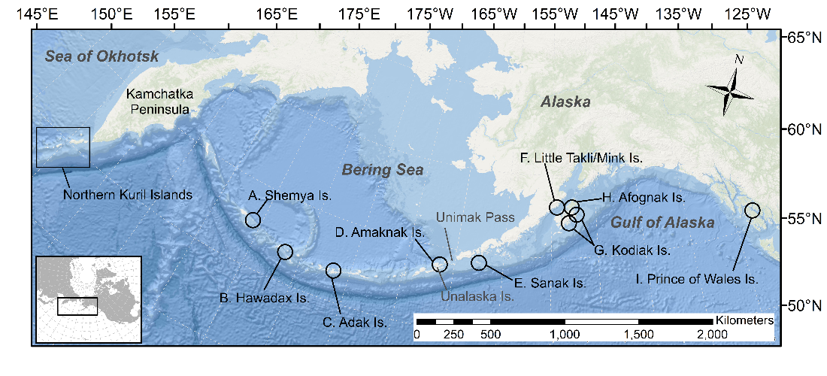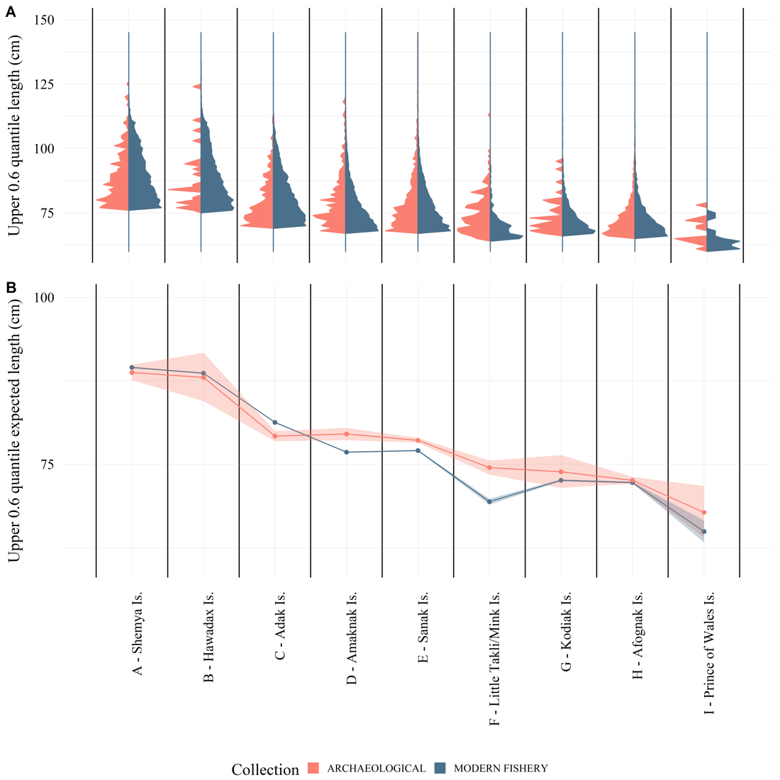

Figure 2.2 (A) The 0.6 quantile of the length distribution of Pacific cod from the Alaska archaeological collections (red) and modern longline and jig commercial fishery data (blue) within 50 km of the archaeological sites; and (B) log-linked gamma generalized linear regression results of Alaska modern fishery and archaeological collections by site showing expected lengths and 95% confidence intervals (From West *et al.* 2020; Figure 1 and Figure 5).

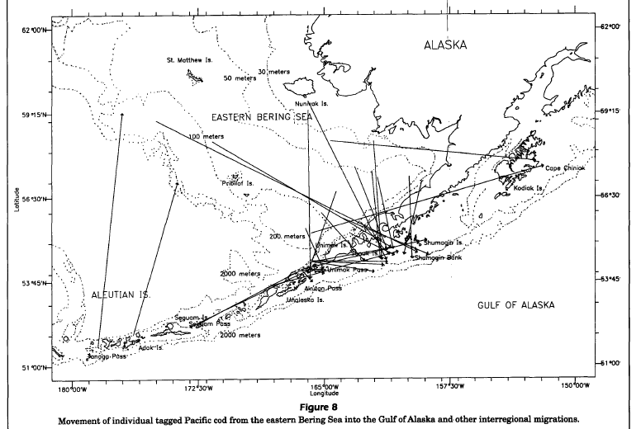

Figure 2.3 Tag recoveries from Shimada and Kimura 1994 (Figure 8), showing movement of individual tagged Pacific cod from eastern Bering Sea into the Gulf of Alaska and other interregional migrations.

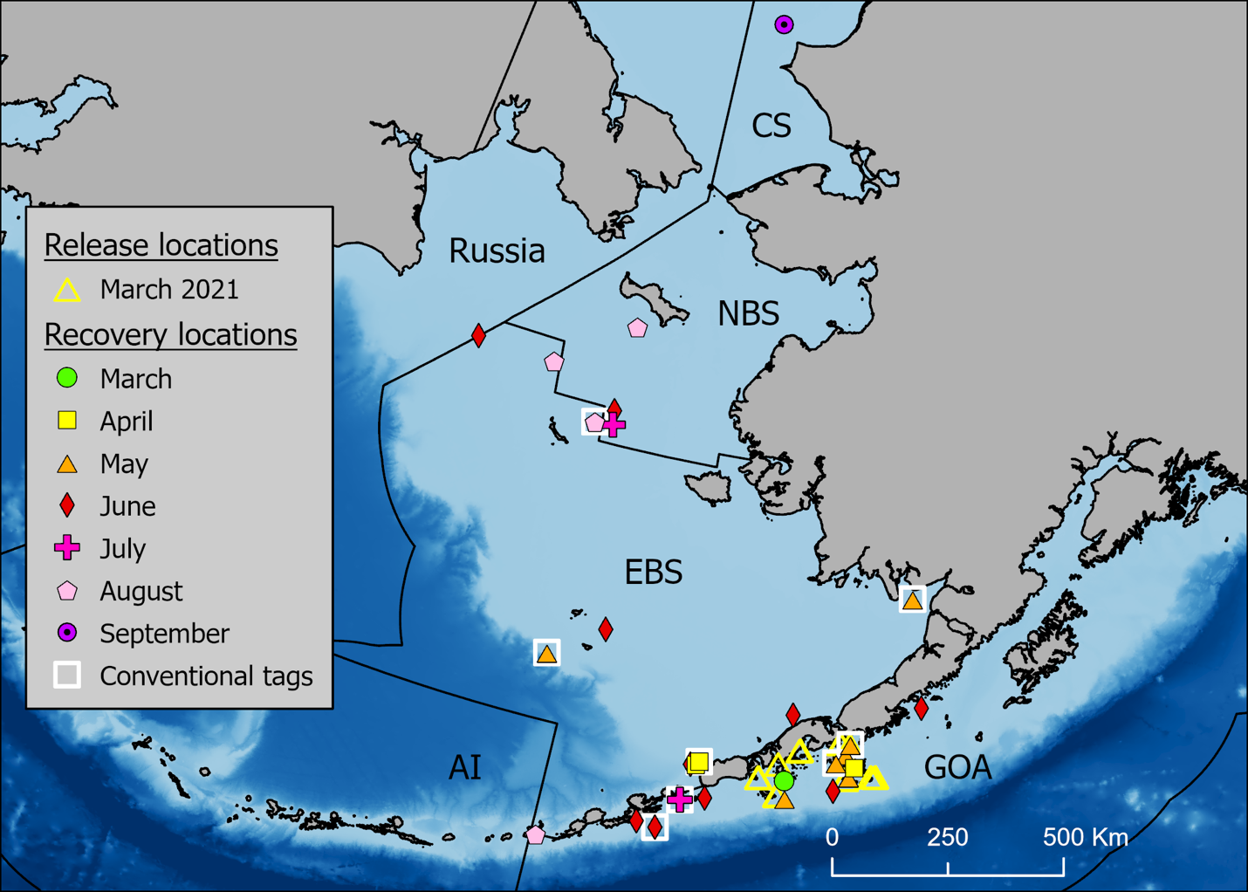

Figure 2.4 Release and monthly satellite and conventional tag recovery locations through September 2021 by region (NBS = Northern Bering Sea, EBS = Eastern Bering Sea, AI = Aleutian Islands, and GOA = Gulf of Alaska, CS = Chukchi Sea). Conventional tag recaptures are indicated by a white square around the symbol.

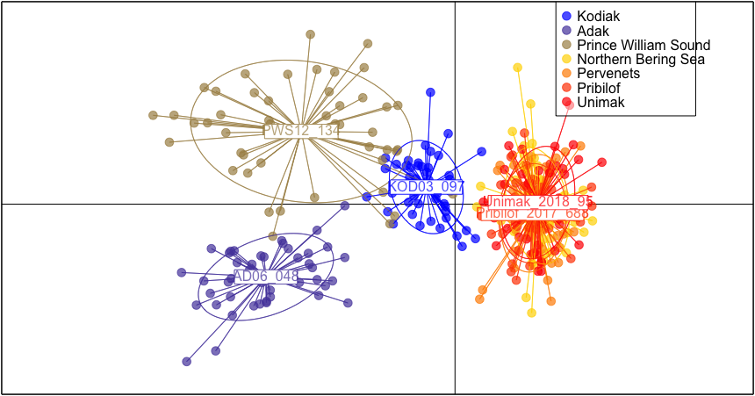

Figure 2.5 Discriminant analysis of principal components (DAPC) scatterplot with the following populations represented: Adak (2006), Prince William Sound, PWS (2012), Kodiak (2003), Unimak (2018), Pervenets (2016), Pribilof (2017), and Norton Sound, NBS (2017). All populations represent spawning groups except the Norton Sound sample, which was sampled in August, 2017. Note: The Norton Sound sample in panel b. is behind the Unimak and Pribilof labels, and barely visible (Spies et al. 2020).

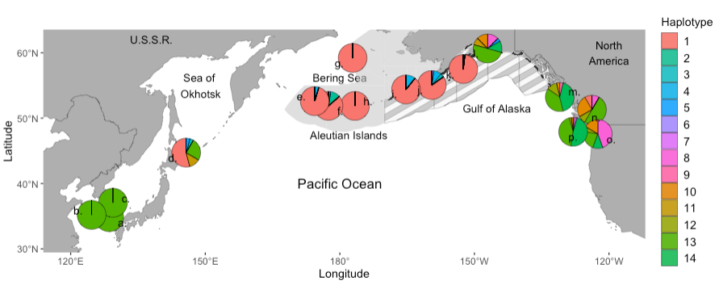

Figure 2.6 Map with pie charts showing relative haplotype frequencies between all collections, and Numbers on map represent the name of the collection, west to east: a. Geoje, Korea, b. Yellow Sea, Korea, c. Jukbyeon, Korea, d. Sea of Okhotsk, Japan, e. Near Islands, f. Kiska Island, g. Pervenets Canyon, h. Adak Island, i. Unimak Island, j. Shumagin Islands, k. Kodiak Island, l. Prince William Sound, m. Hecate Strait, n. Strait of Georgia, o. Puget Sound, p. Washington Coast. The spatial area comprising the Gulf of Alaska Fishery Management Plan is shown with grey stripes and the area comprising the Bering Sea and Aleutian Islands Fishery Management Plan is light grey (Spies et al. 2021).

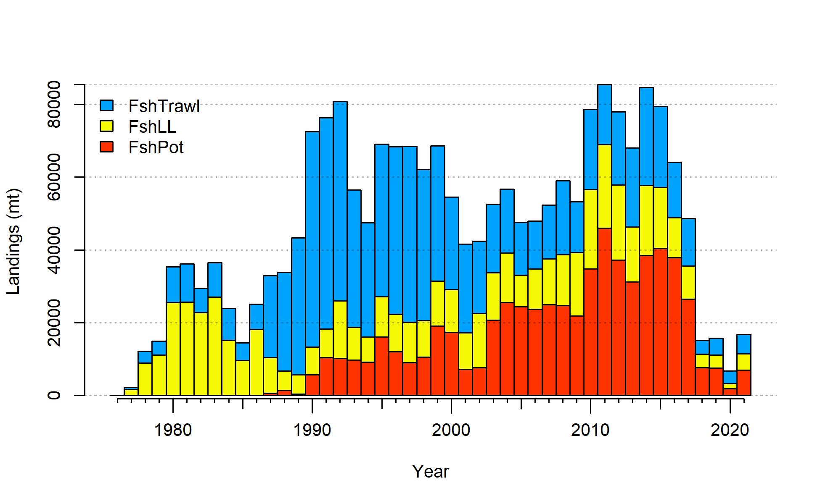

Figure 2.7 Gulf of Alaska Pacific cod catch from 1977-2021. Note that 2021 catch was through October 1.



Figure 2.8 Commercial catch of Pacific cod in the Gulf of Alaska by 20km2 grid for 1990-2015.

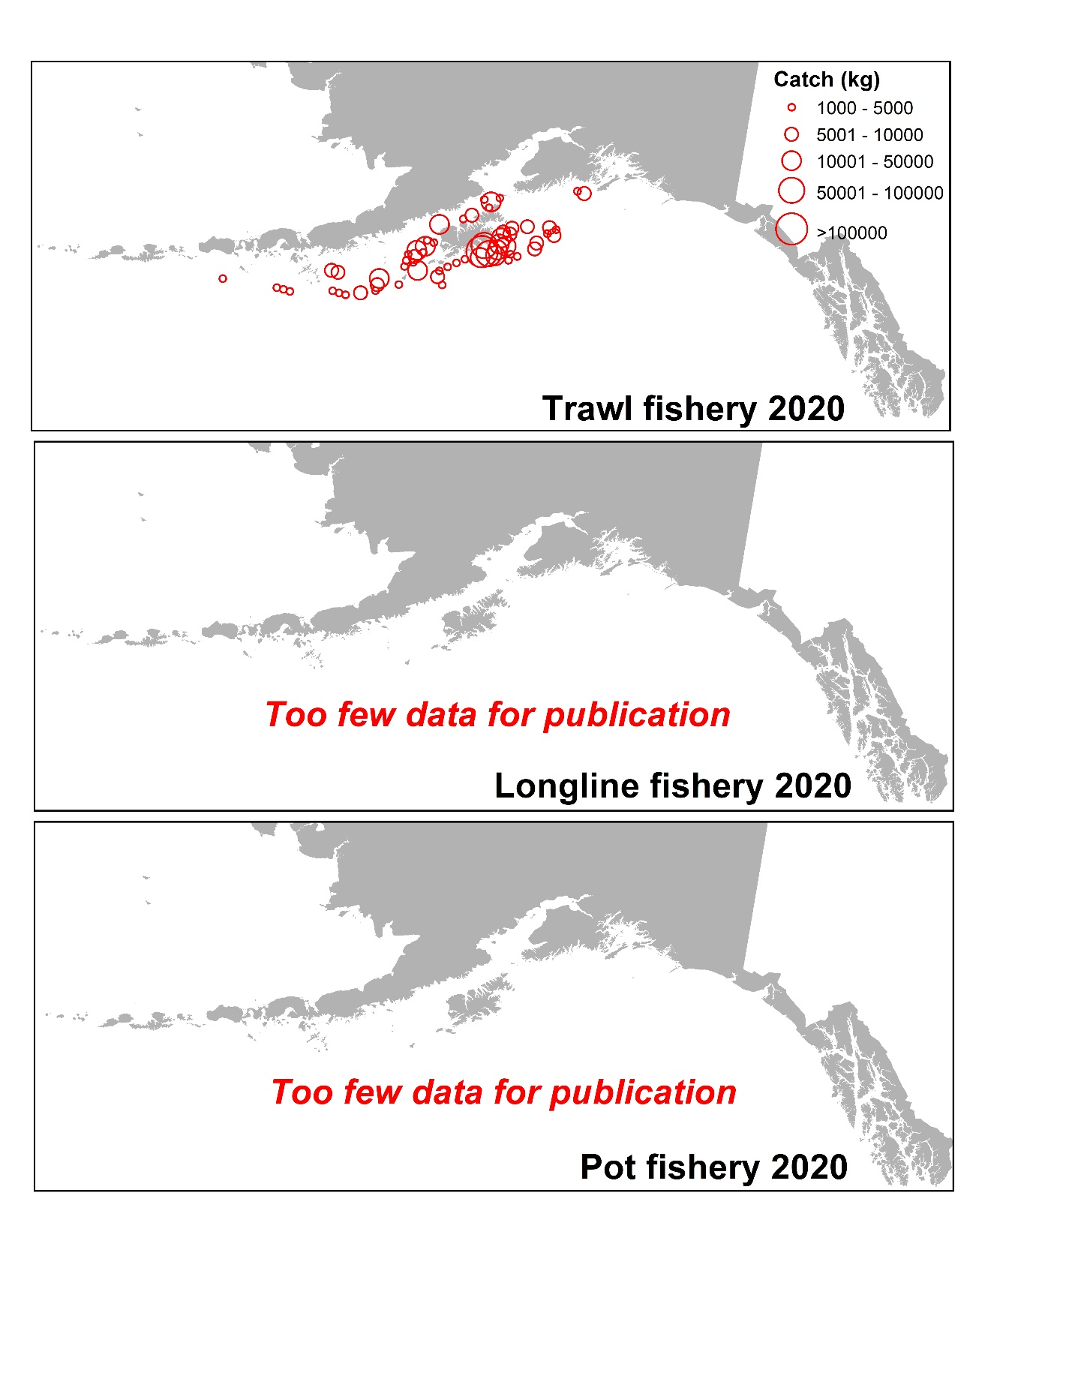

Figure 2.9 Commercial catch of Pacific cod in the Gulf of Alaska by 20km2 grid for 2020 for catch greater than 1000 kg. Observed catch in red circles and EM catch for longline and pot in blue squares. These data include bycatch Pacific cod.

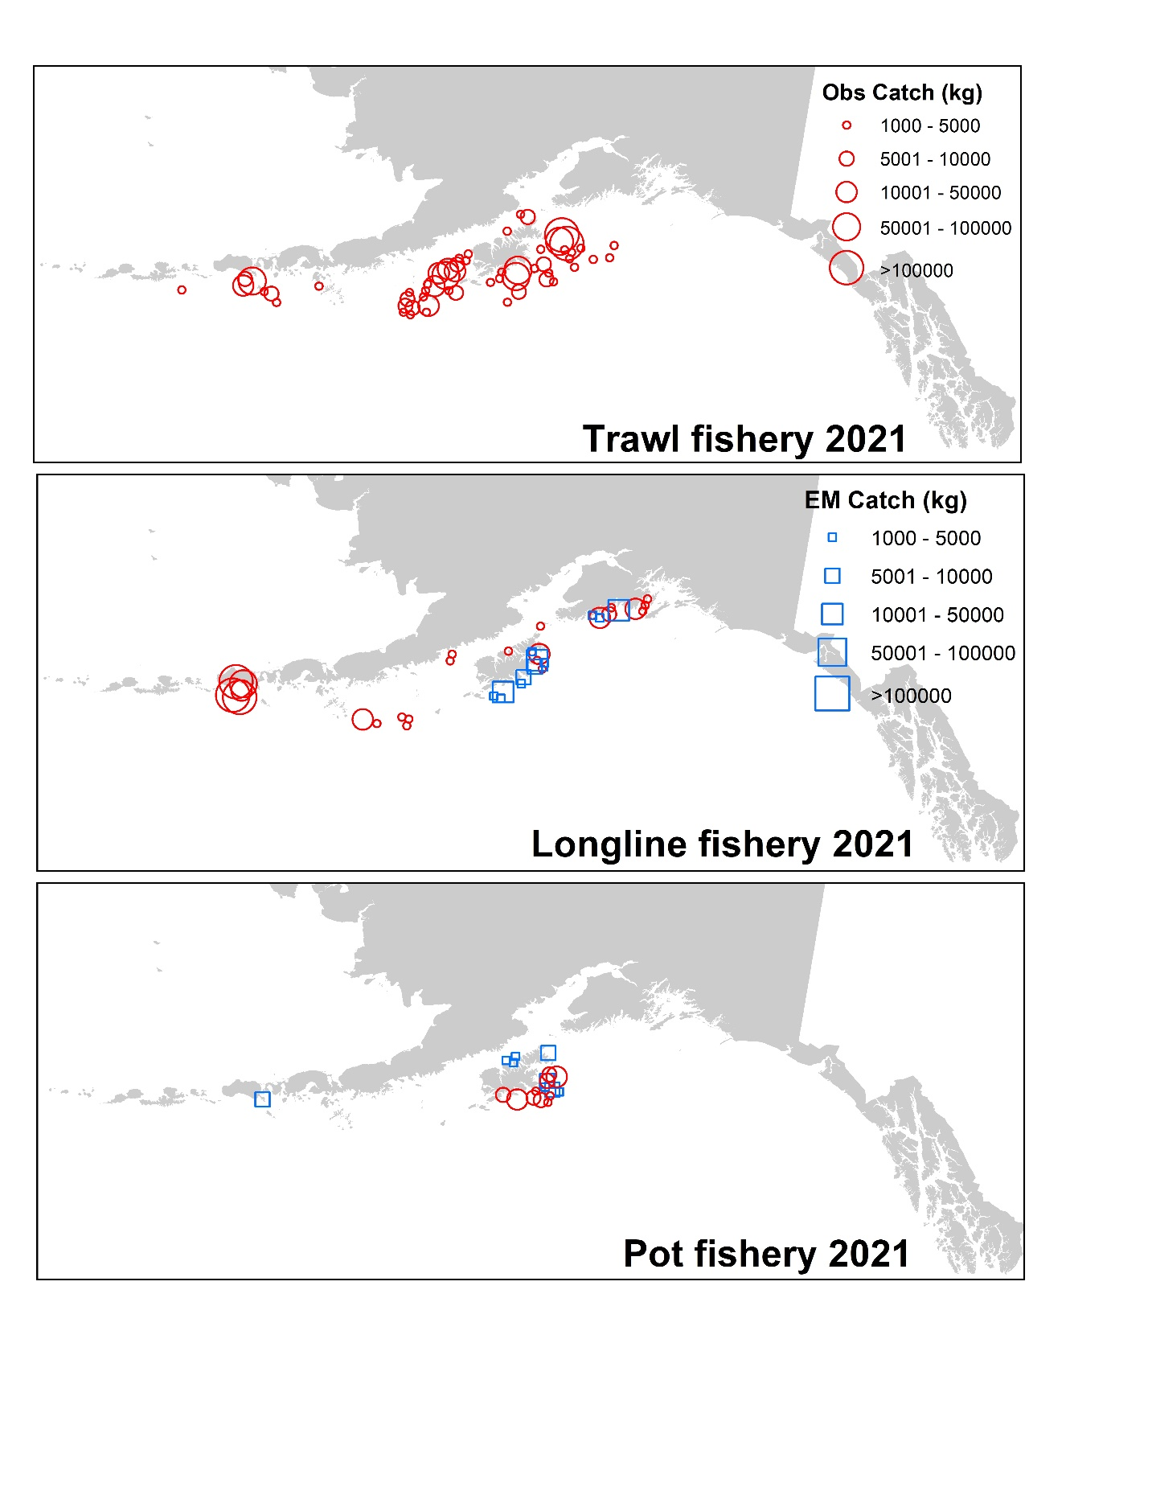

Figure 2.10 Observed commercial catch of Pacific cod in the Gulf of Alaska by 20km2 grid for 2021 as of October 23, 2021 for catch greater than 1000 kg. These data include bycatch Pacific cod, but do not include trawl EM data as locations are not yet available.

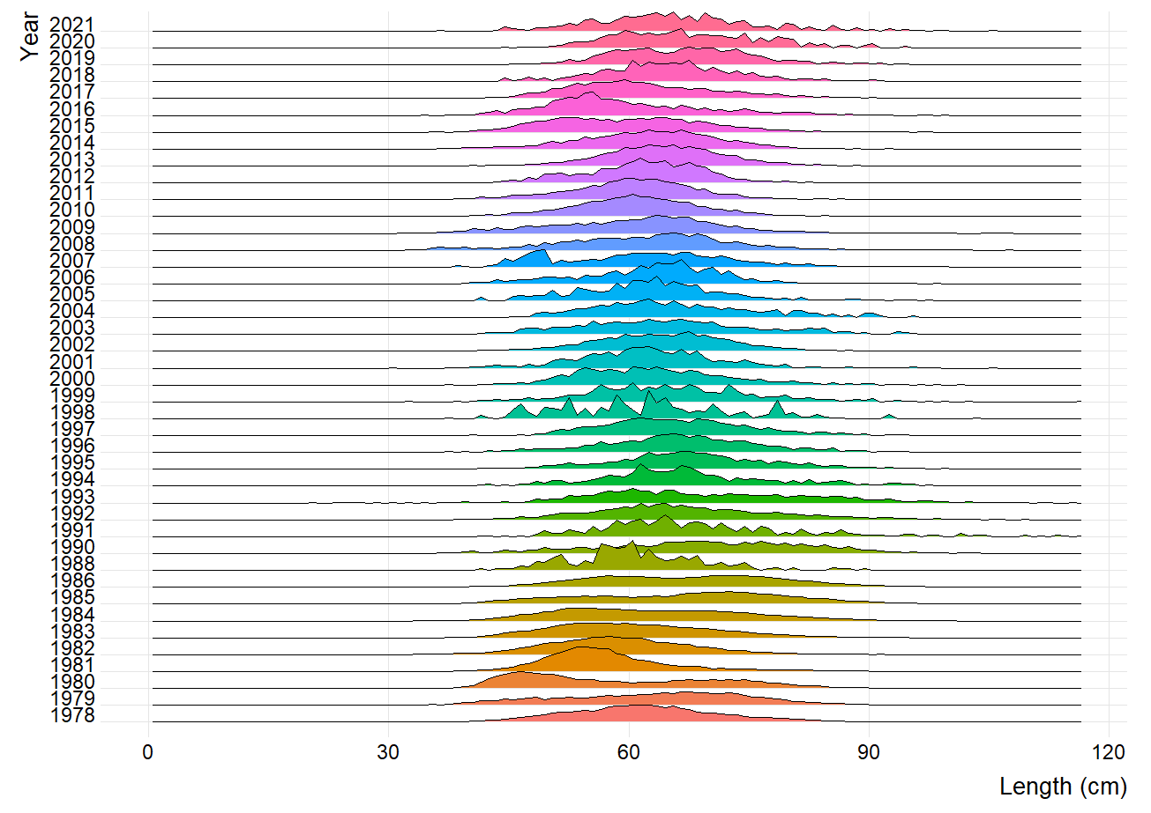

Figure 2.11 Pacific cod length composition by annual proportion from the Gulf of Alaska longline fishery.

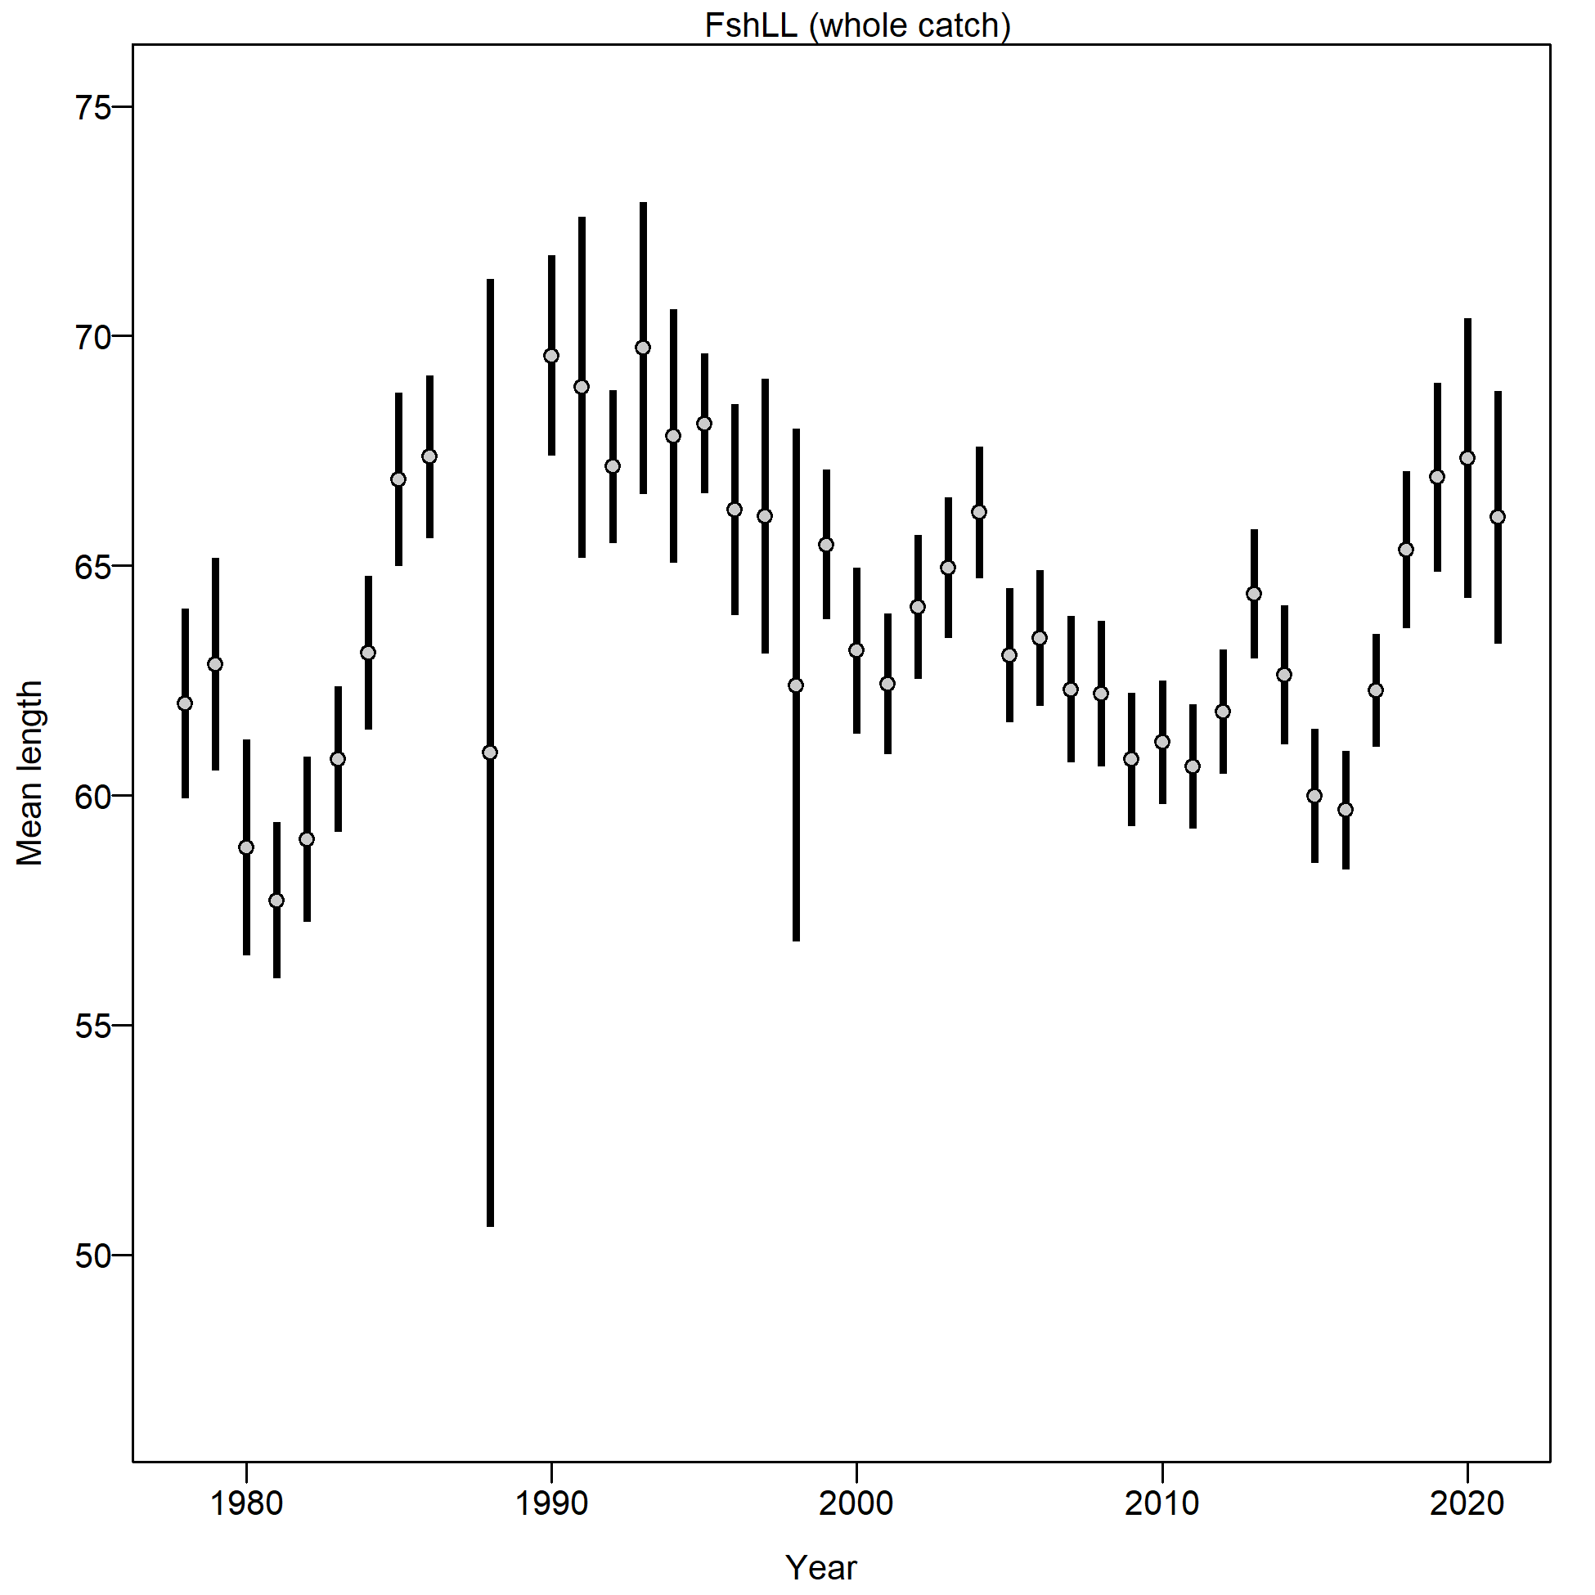

Figure 2.12 Mean length (cm) of Pacific cod from the Gulf of Alaska longline fishery.

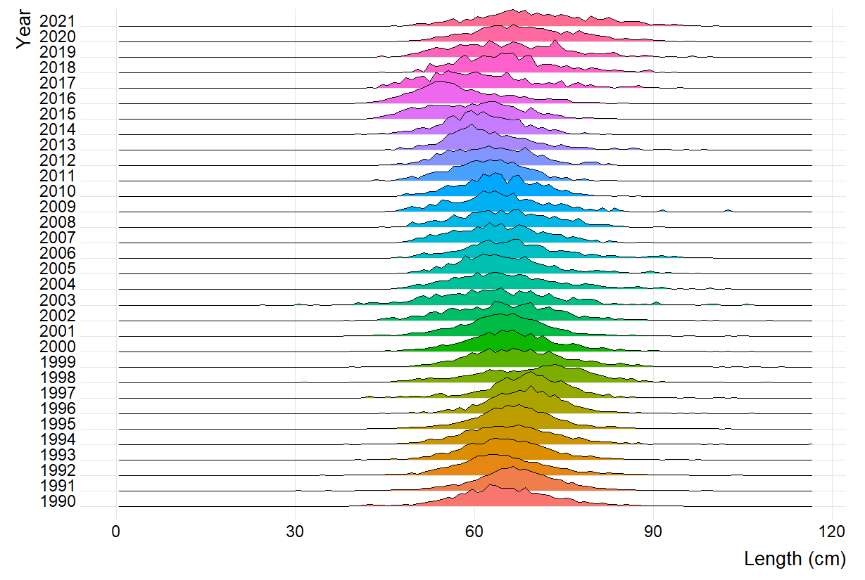

Figure 2.13 Pacific cod length composition by annual proportion from the Gulf of Alaska pot fishery.

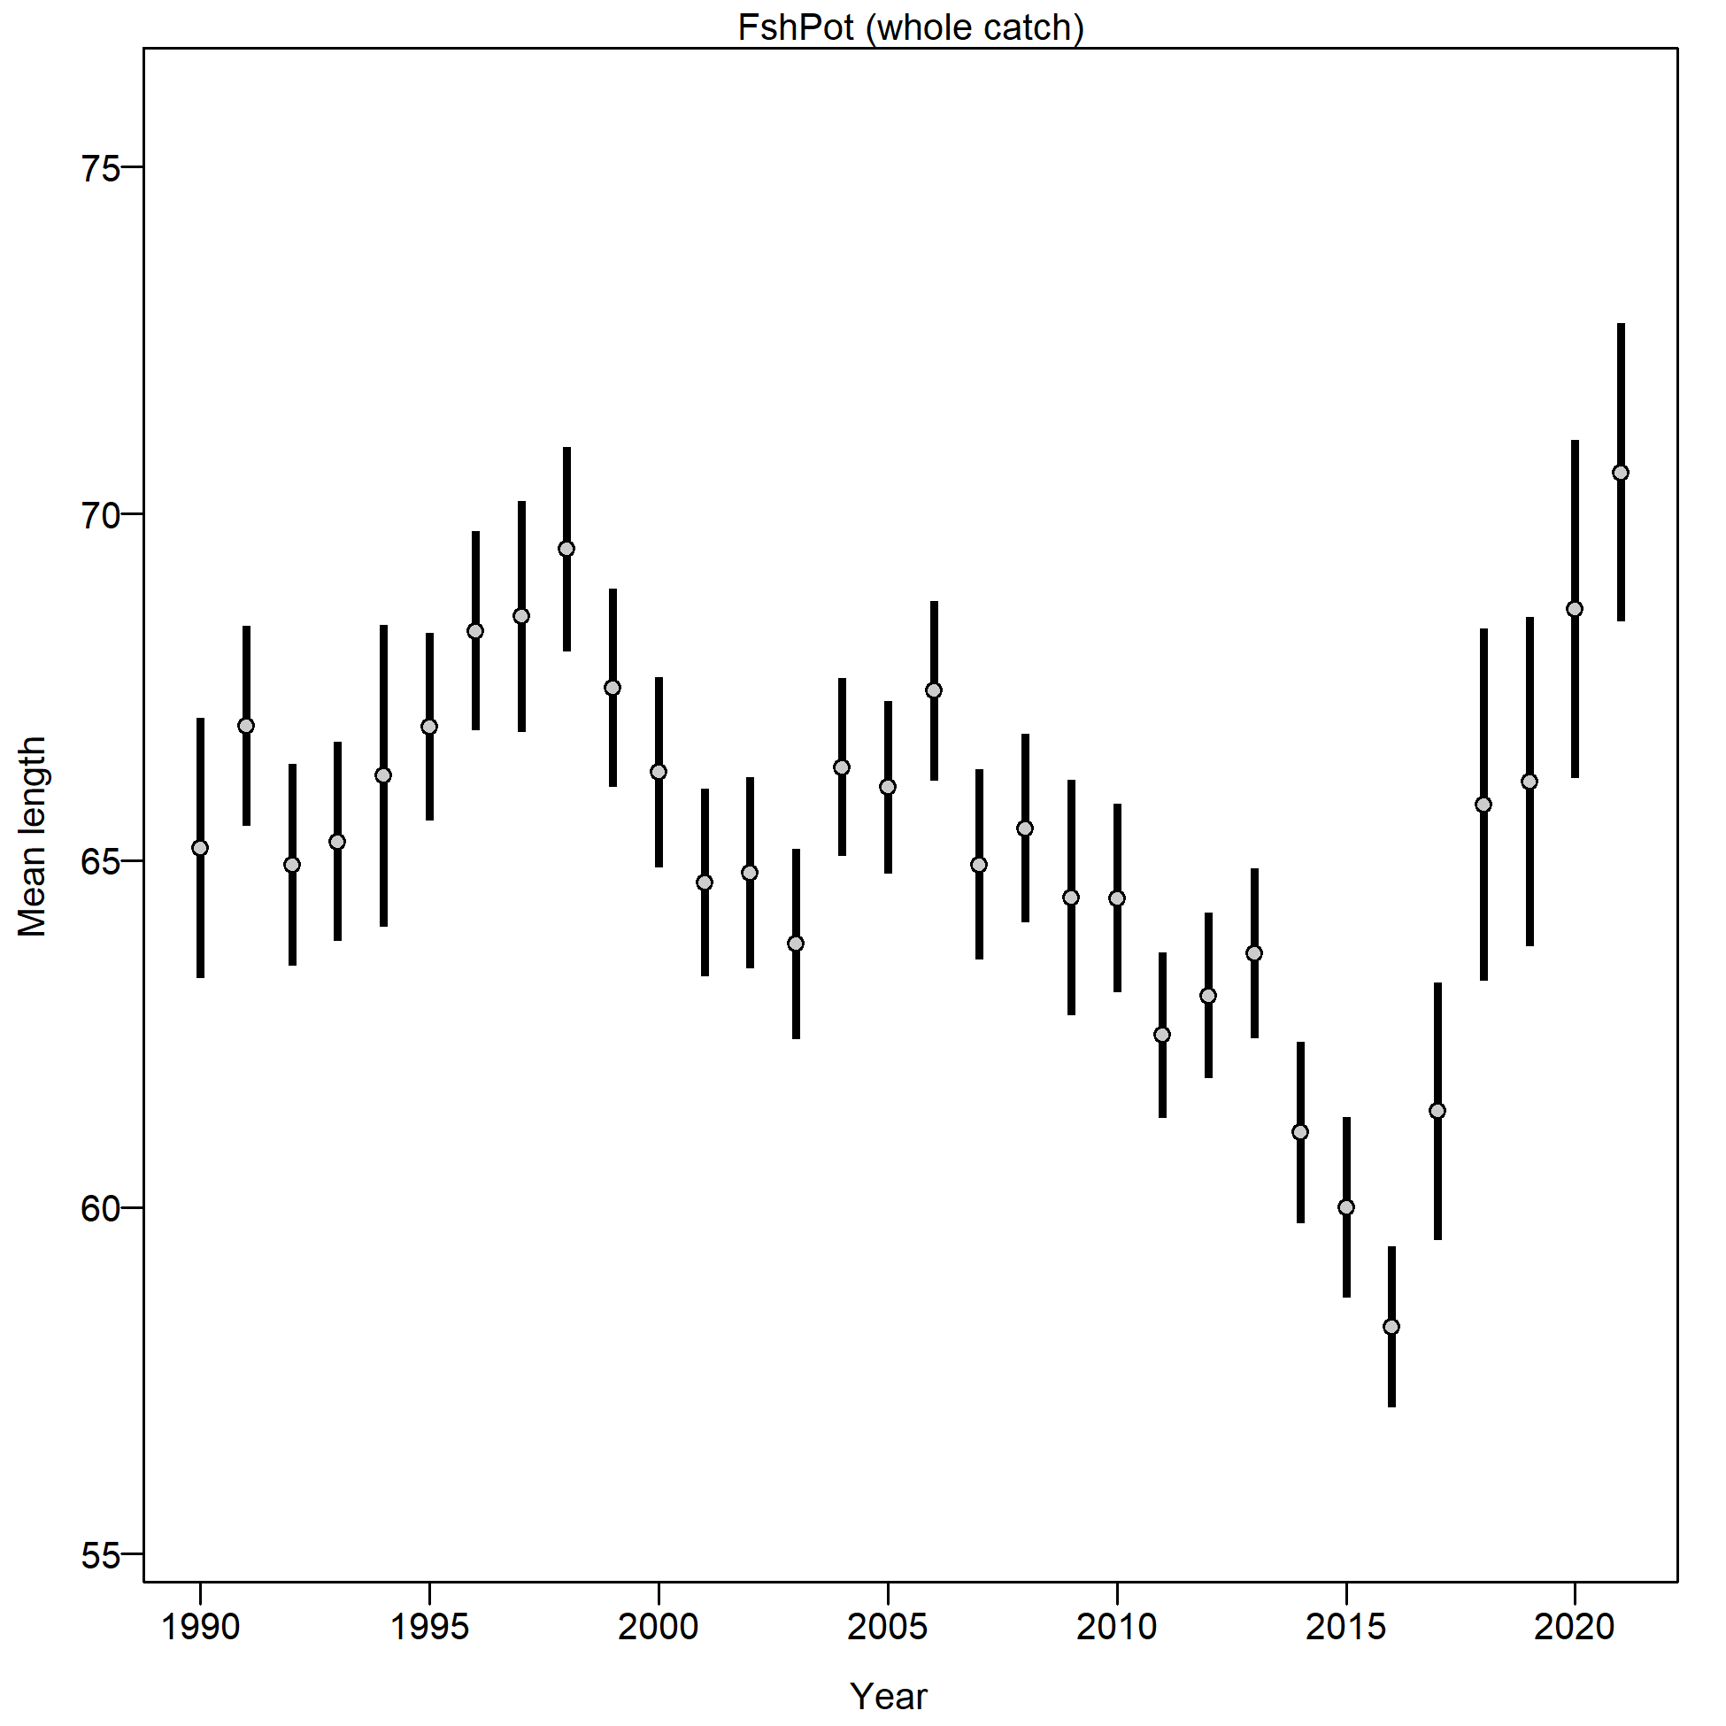

Figure 2.14 Mean length (cm) of Pacific cod from the Gulf of Alaska pot fishery.

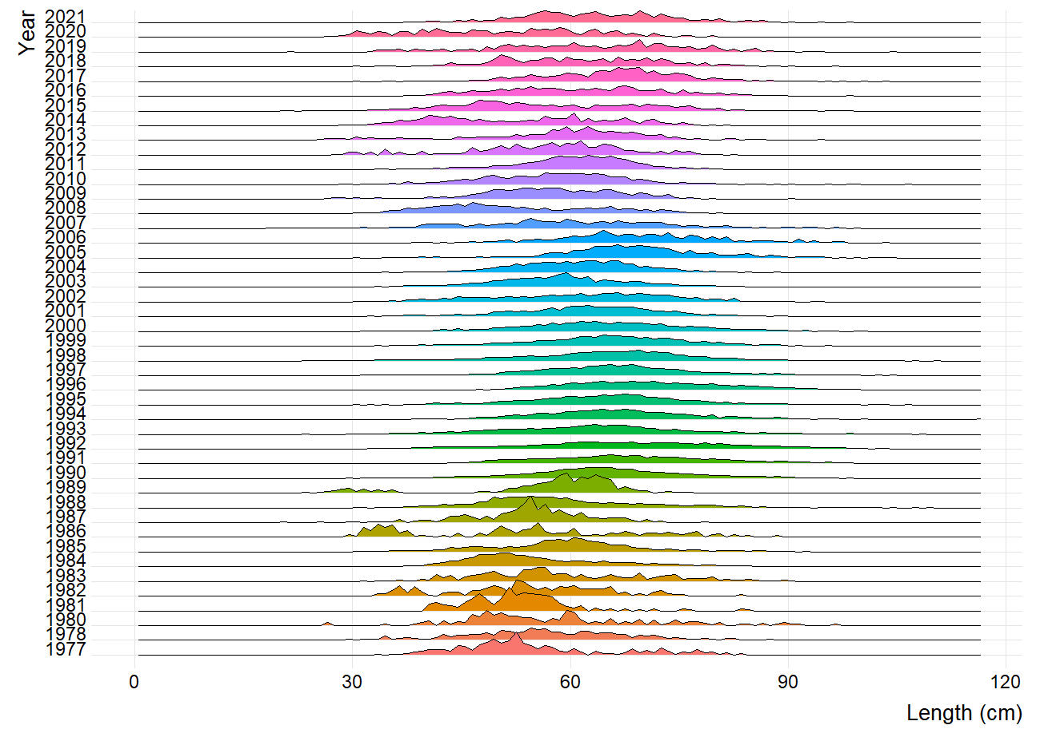

Figure 2.15 Pacific cod length composition by annual proportion from the Gulf of Alaska trawl fishery.

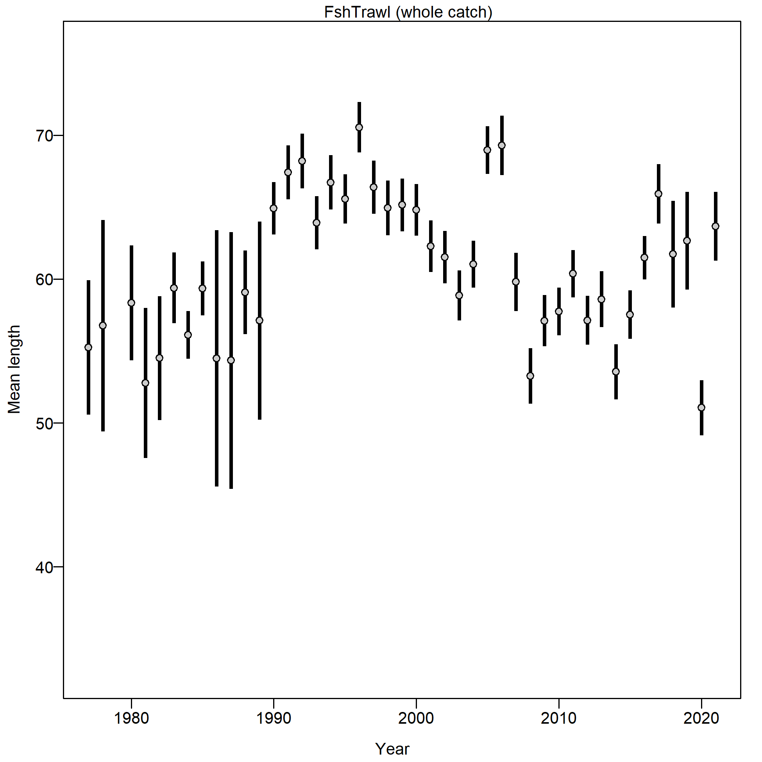

Figure 2.16 Mean length (cm) of Pacific cod from the Gulf of Alaska trawl fishery.

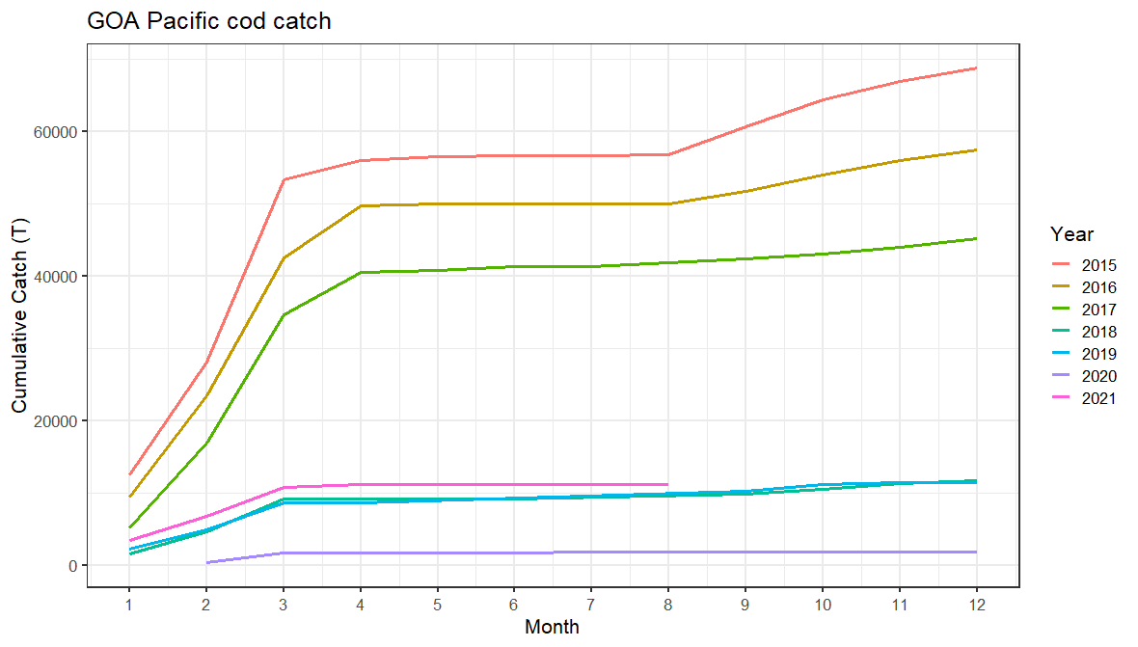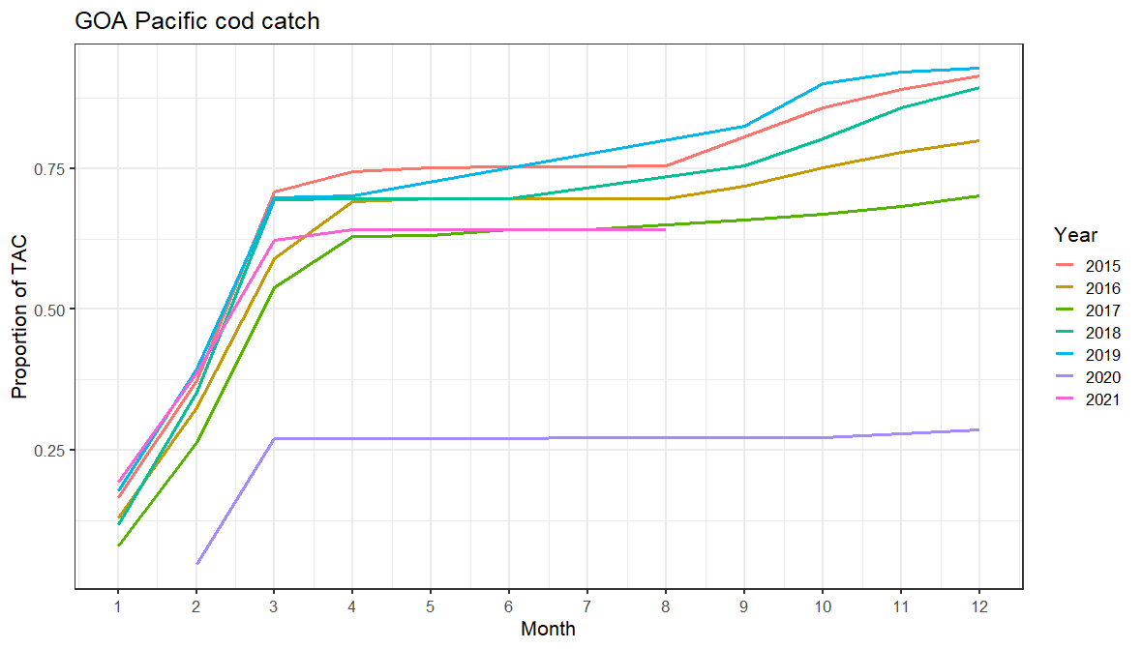

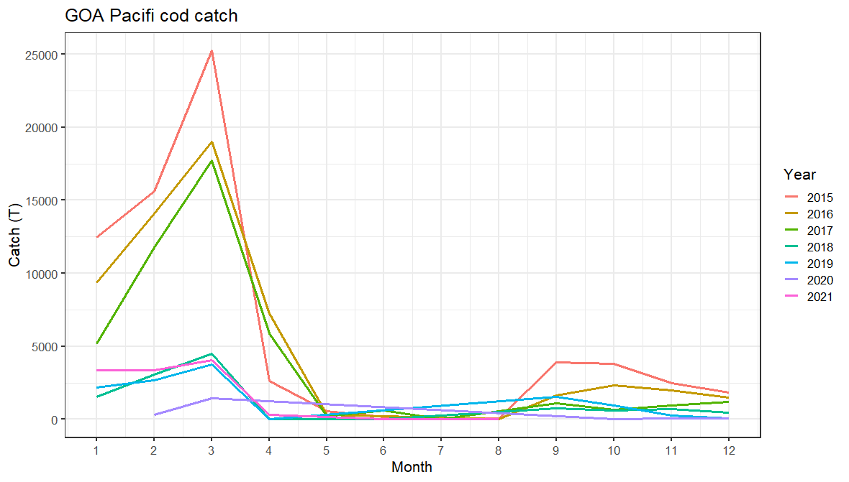

Figure 2.17 Cumulative catch (top left), cumulative proportion of catch (top right), and monthly catch (bottom) by month of the year for 2015-2021.

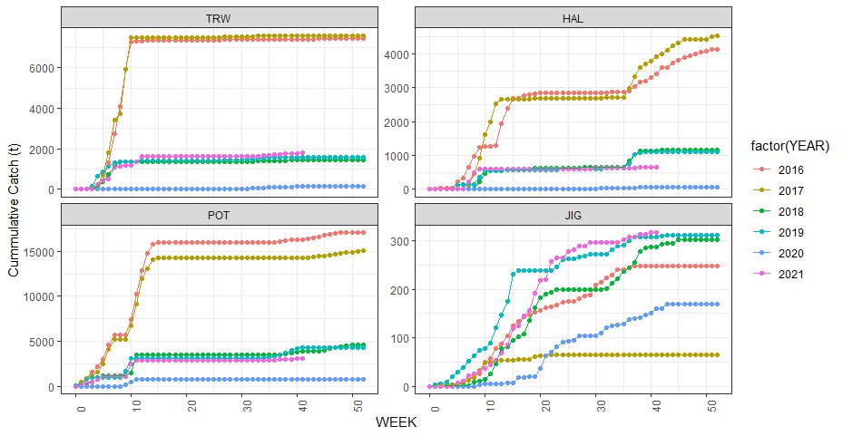

Figure 2.18 Cumulative catch week of the year for 2016-2021 by fleet for the Western Gulf of Alaska.

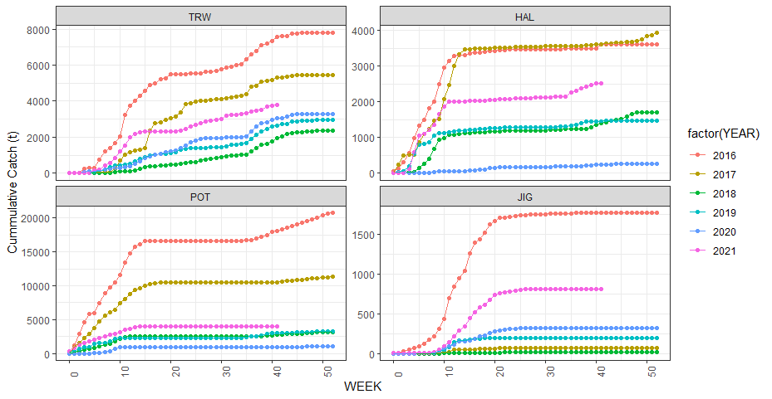

Figure 2.19 Cumulative catch week of the year for 2016-2021 by fleet for the Central Gulf of Alaska.

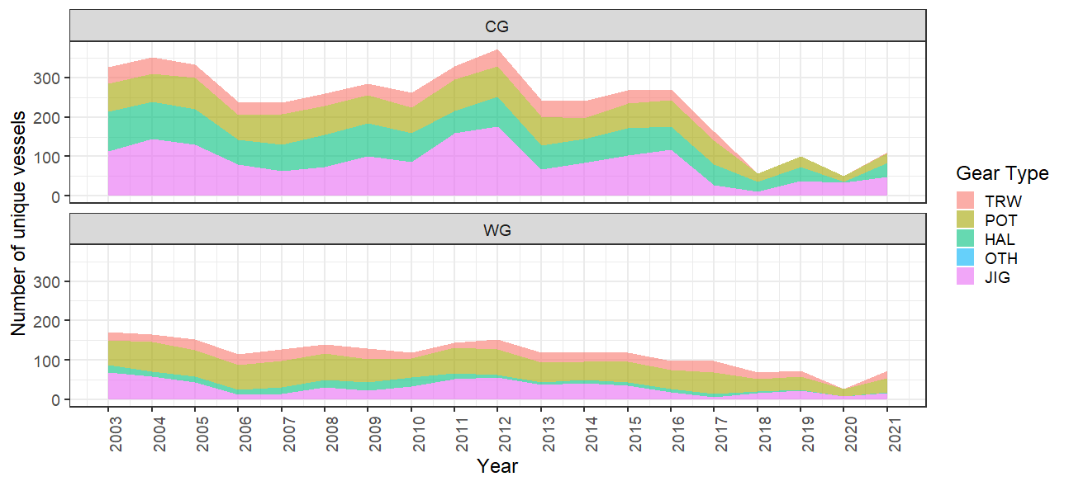

Figure 2.20 Vessel participation in the directed cod fishery by year.

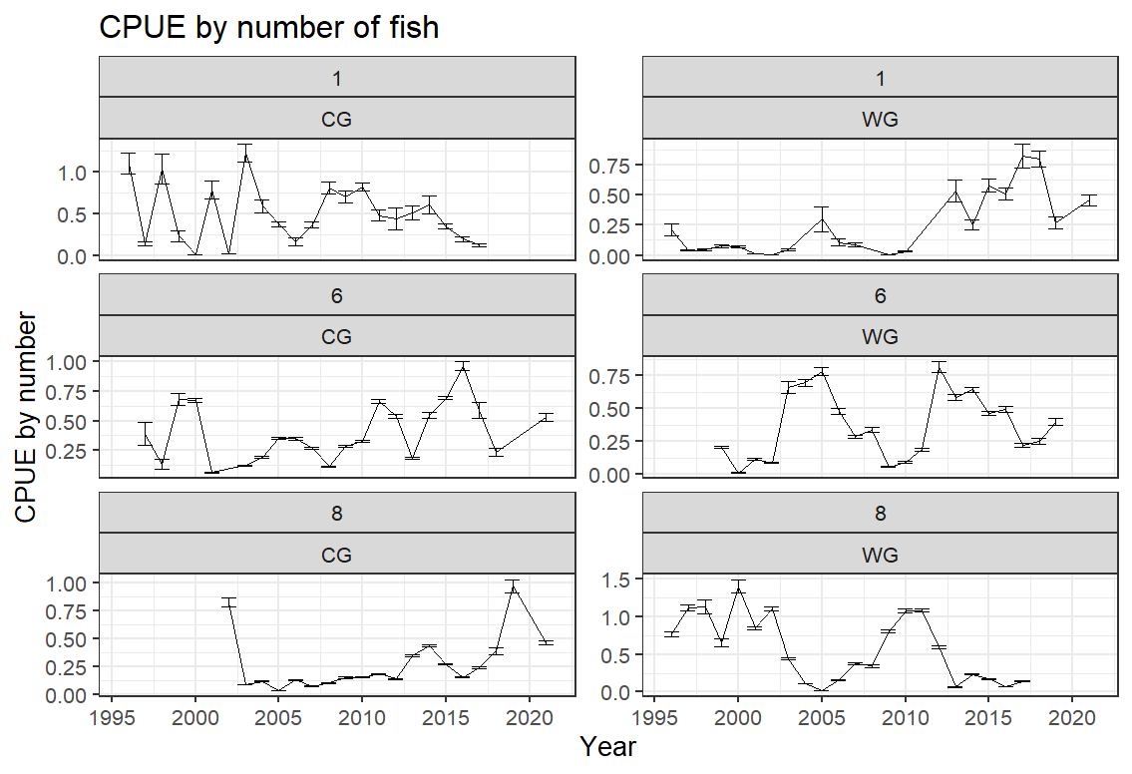 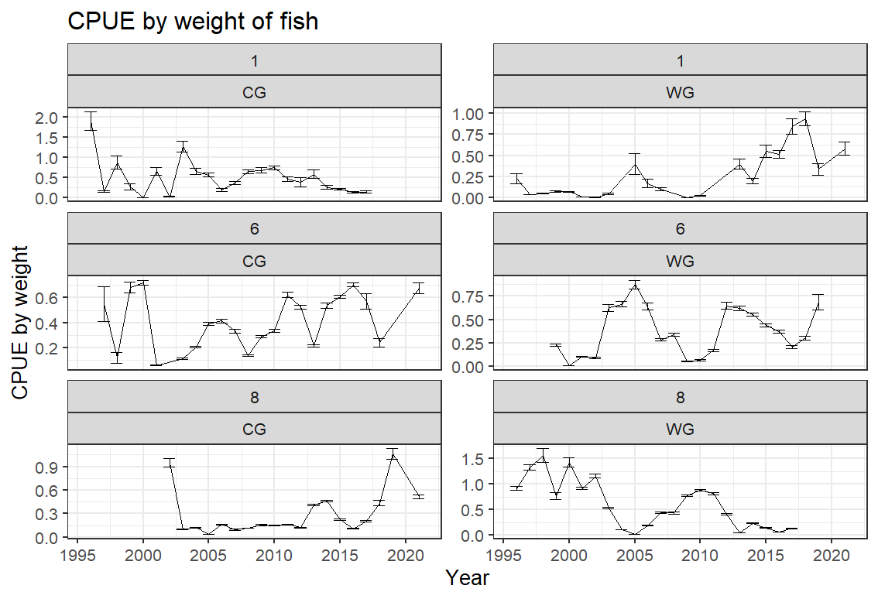

Pot

Longline

Longline

Longline

Longline

Pot

Pot

Pot

Bottom trawl

Bottom trawl

Bottom trawl

Bottom trawl

Figure 2.21 Boxplot of CPUE by number (left) and weight (right) from the 1996-2021 Pacific cod CPUE for the Central (CG) and Western (WG) regulatory areas by gear type. Note that the data in these figures are not controlled for vessel or gear differences within a gear type across time, but shows the raw CPUE data distribution for a year. These represent all observed catches and is limited to the directed cod fishery.

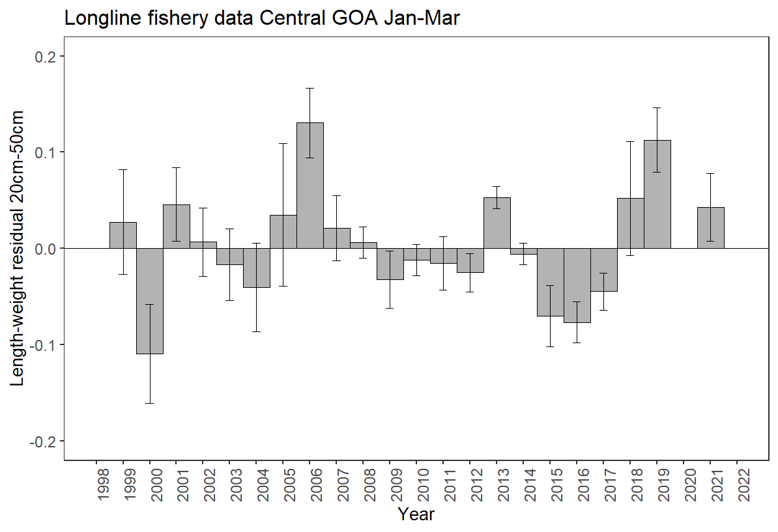

Figure 2.22 Condition of Pacific cod by year in the Central GOA for the longline fishery January-March. Years with zero residuals without error bars are without data.

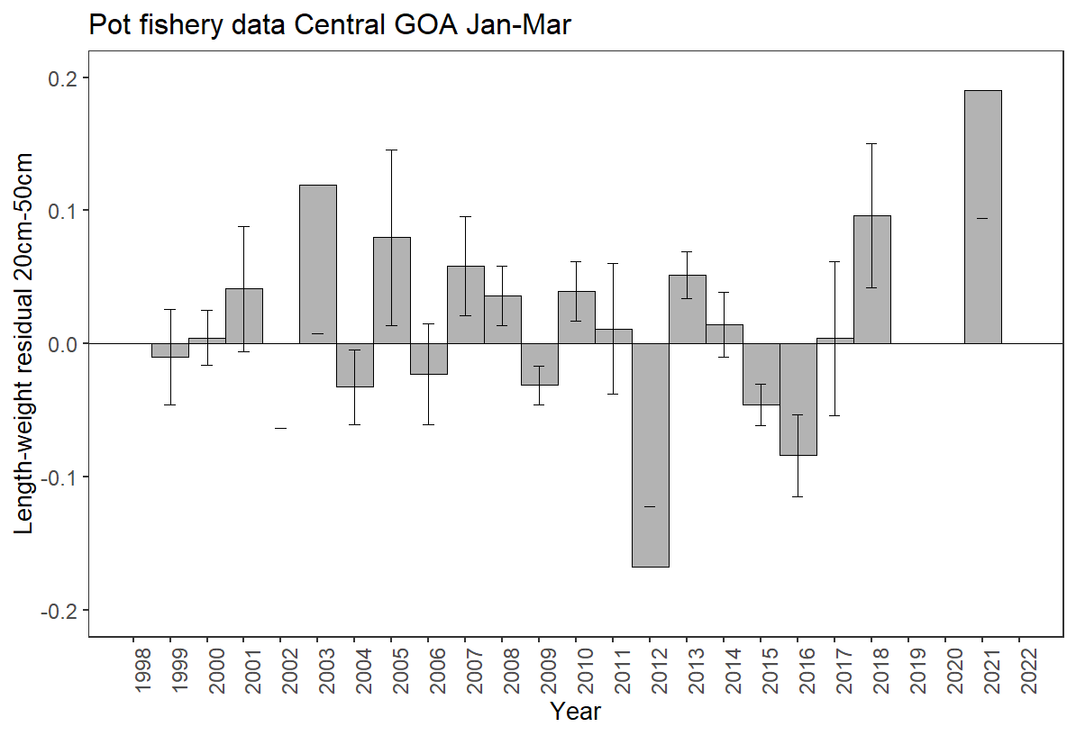

Figure 2.23 Condition of Pacific cod by year in the Central GOA for the pot fishery January-March. Years with zero residuals without error bars are years without data.

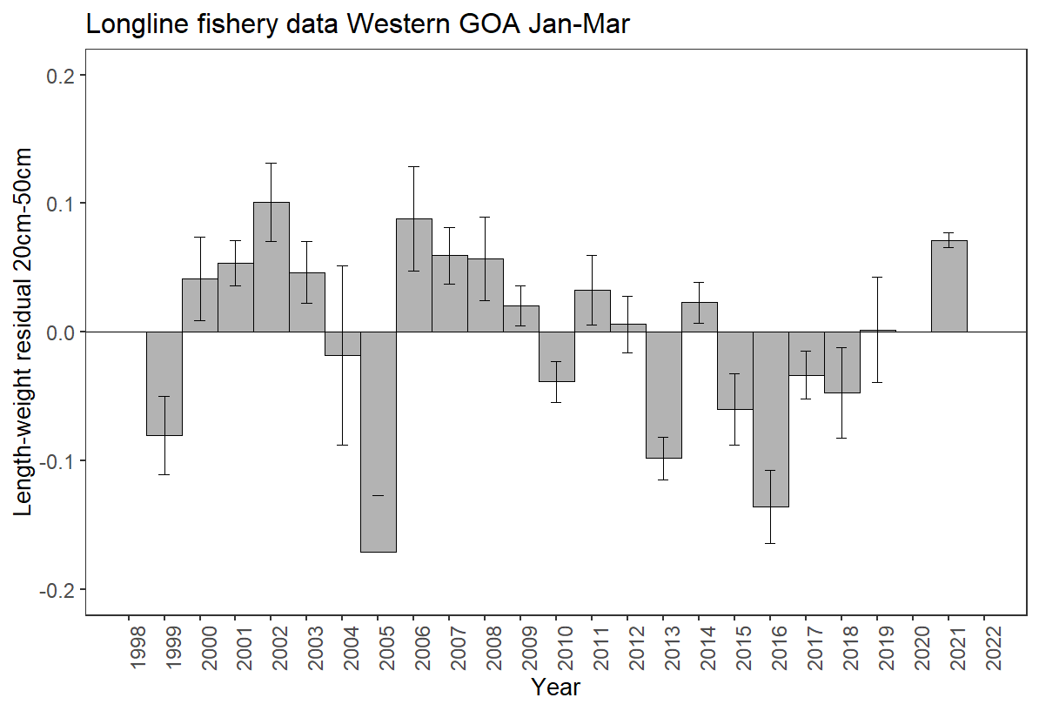

Figure 2.24 Condition of Pacific cod by year in the Western GOA for the longline fishery January-March. Years with zero residuals without error bars are years without data.

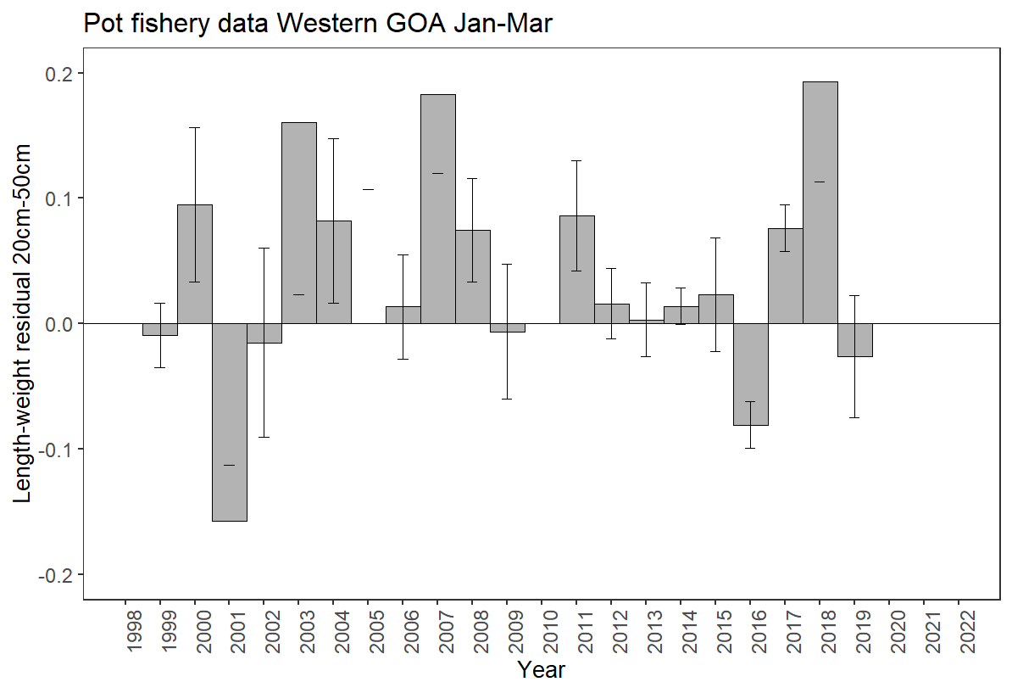

Figure 2.25 Condition of Pacific cod by year in the Western GOA for pot January-March. Years with zero residuals without error bars are years without data.

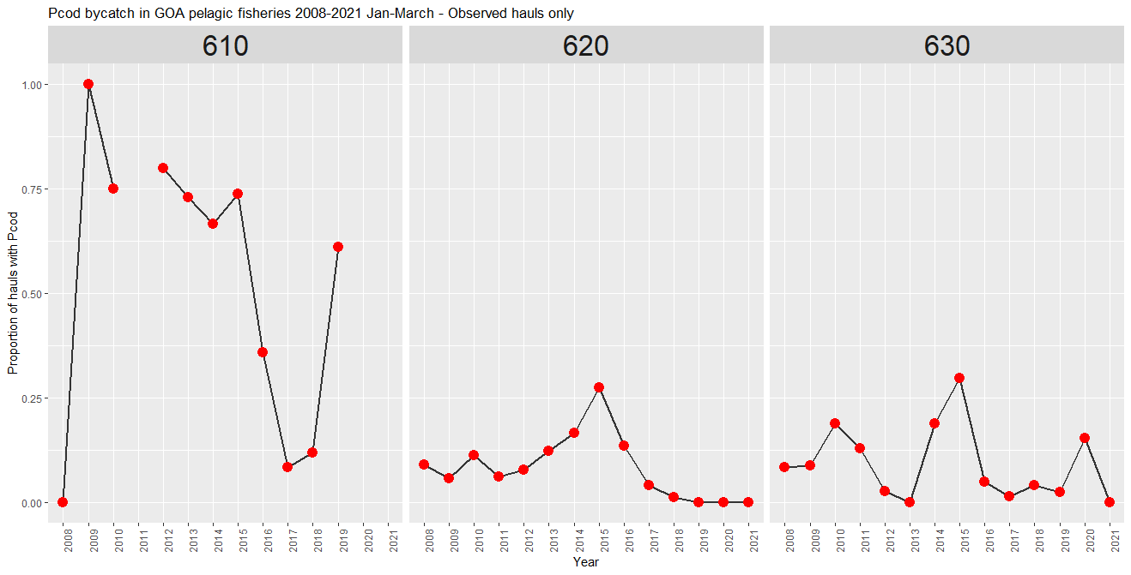

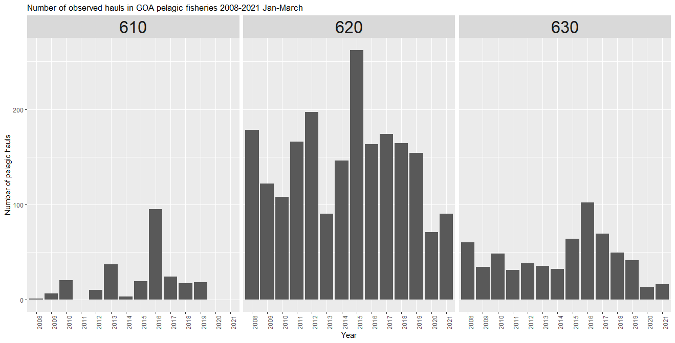

Figure 2.26 Proportion of pelagic trawls in the A Season (January-April) walleye pollock fishery with Pacific cod present by region (top) and number of hauls (bottom).

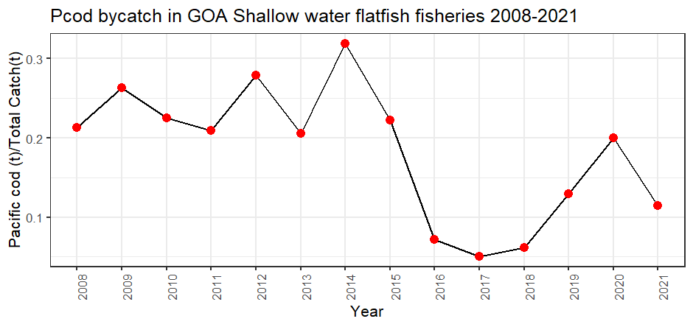

Figure 2.27 Pacific cod bycatch in the Gulf of Alaska shallow water flatfish fishery as tons of Pacific cod per tons of total catch in the fishery by year.

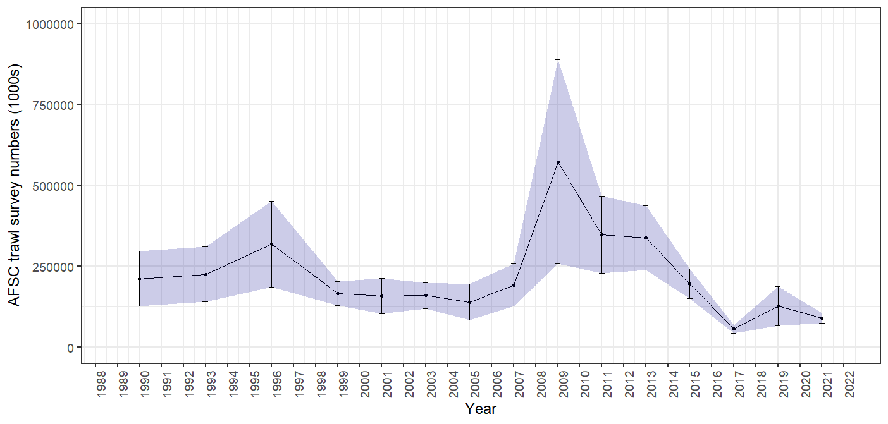

Figure 2.28 GOA bottom trawl survey abundance (numbers) estimate. Bars and shading indicate the 95th percentile confidence intervals.

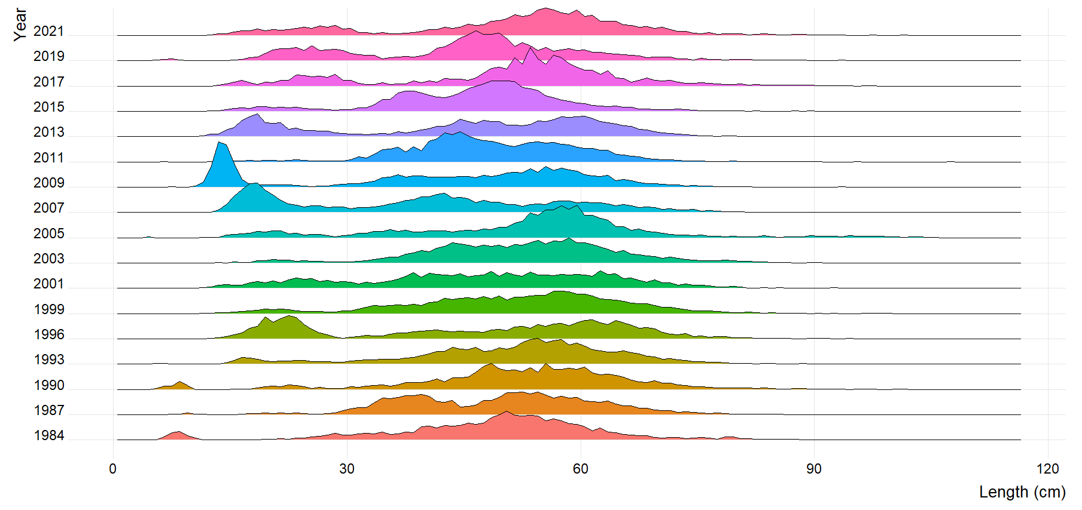

Figure 2.29 GOA bottom trawl survey Pacific cod population numbers at length estimates (max = 0.07).



Figure 2.30 Mean length (cm) of Pacific cod in the GOA bottom trawl survey.



Figure 2.31 Distribution of AFSC bottom trawl survey CPUE of Pacific cod for 2017-2019.

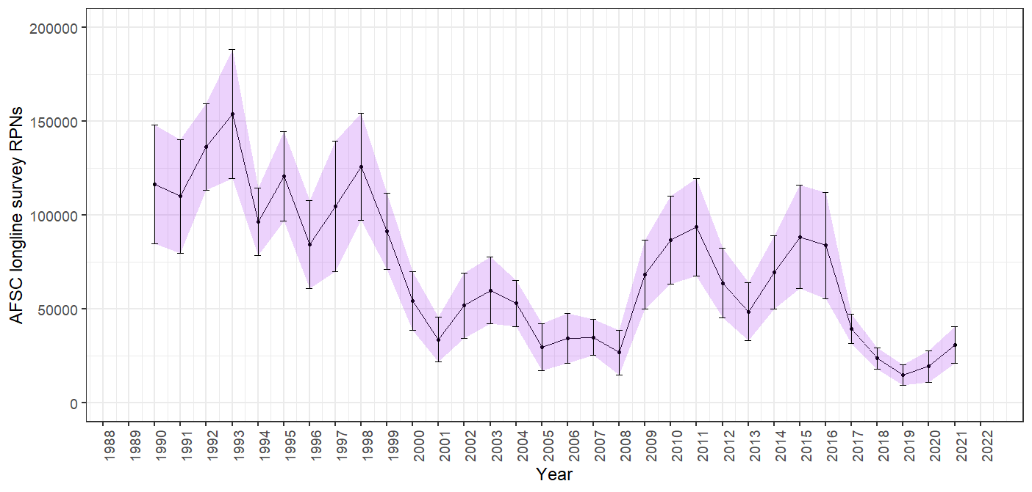

Figure 2.32 AFSC longline survey Pacific cod relative population numbers (RPN) time series. Bars and shading indicate the 95th percentile confidence intervals.

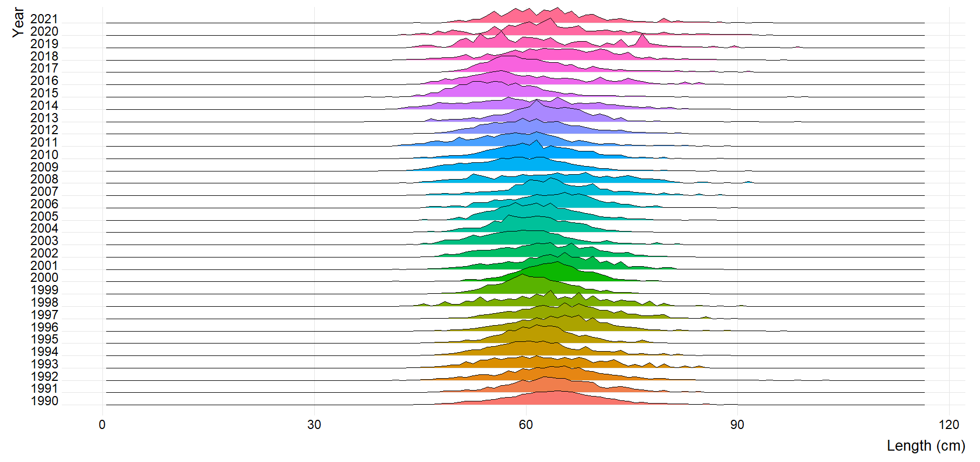

Figure 2.33 AFSC longline survey Pacific cod size composition (max=0.09).

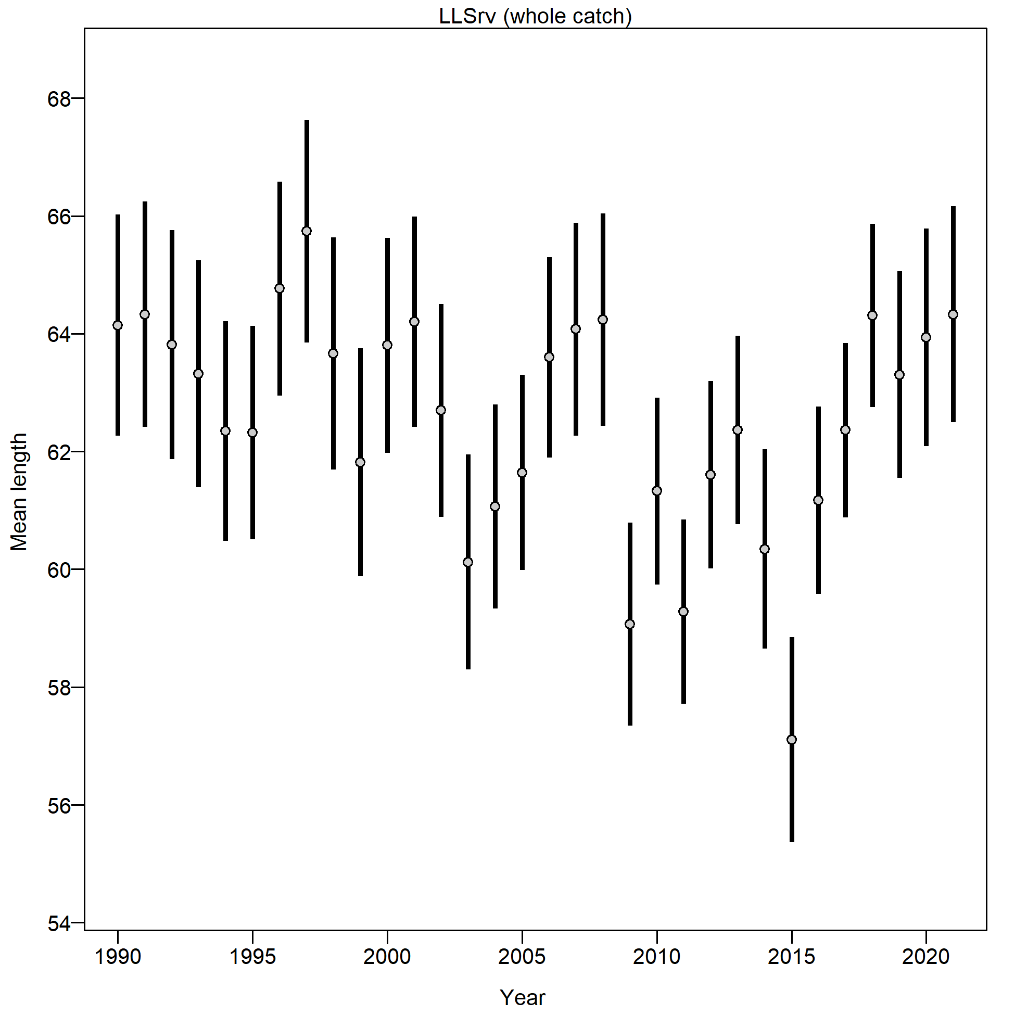

Figure 2.34 Mean length (cm) of Pacific cod from the AFSC longline survey.

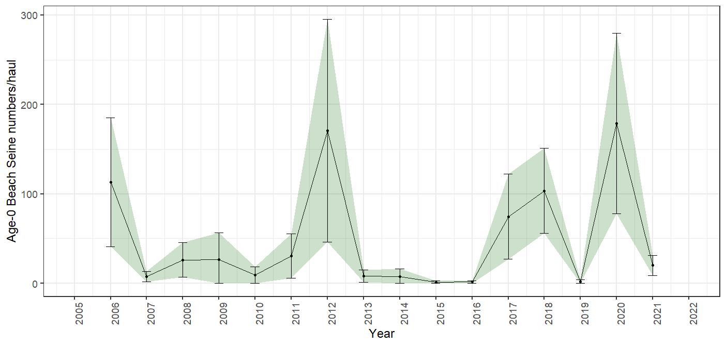

Figure 2.35 Age-0 beach seine survey numbers per haul, bars and shading indicate the 95th percentile confidence intervals.

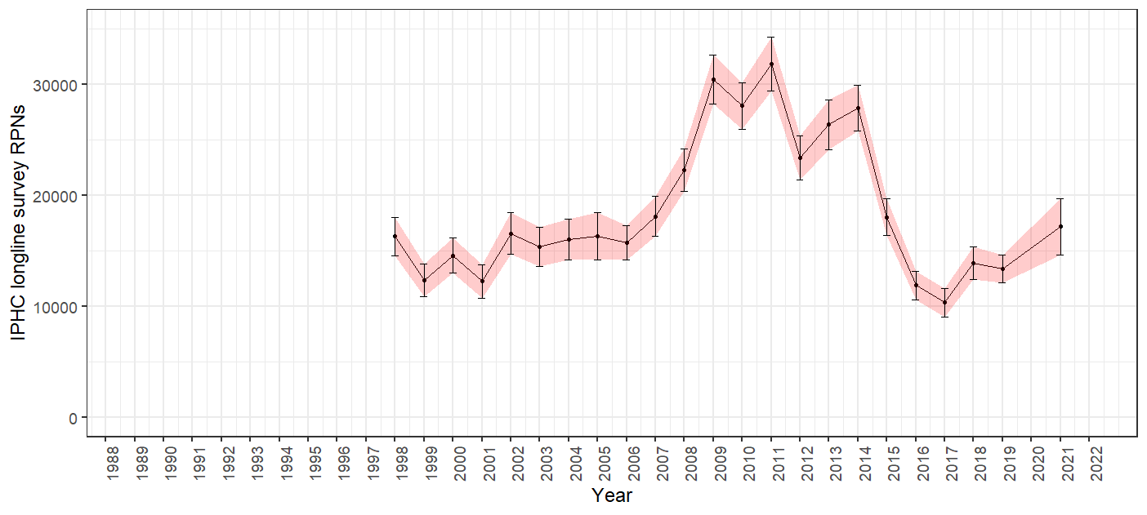

Figure 2.36 IPHC halibut longline survey Pacific cod RPN time series. Bars and shading indicate the 95th percentile confidence intervals.

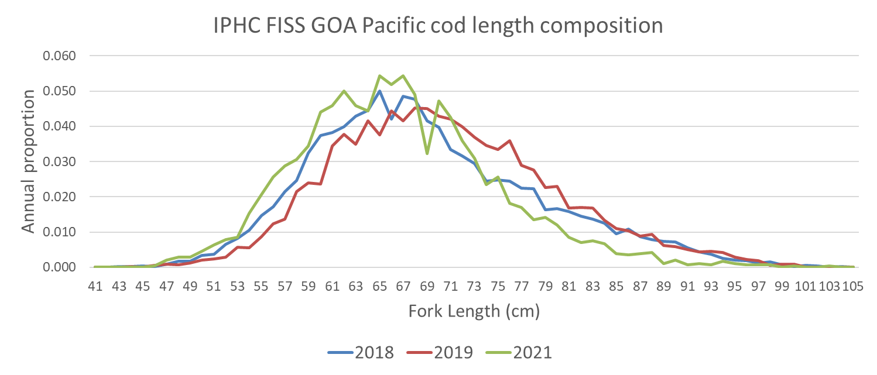

Figure 2.37 IPHC Fishery-independent setline survey (FISS) Pacific cod length composition collection for 2018, 2019, and 2021. These are raw frequency collections and have not been proportioned by FISS RPN.

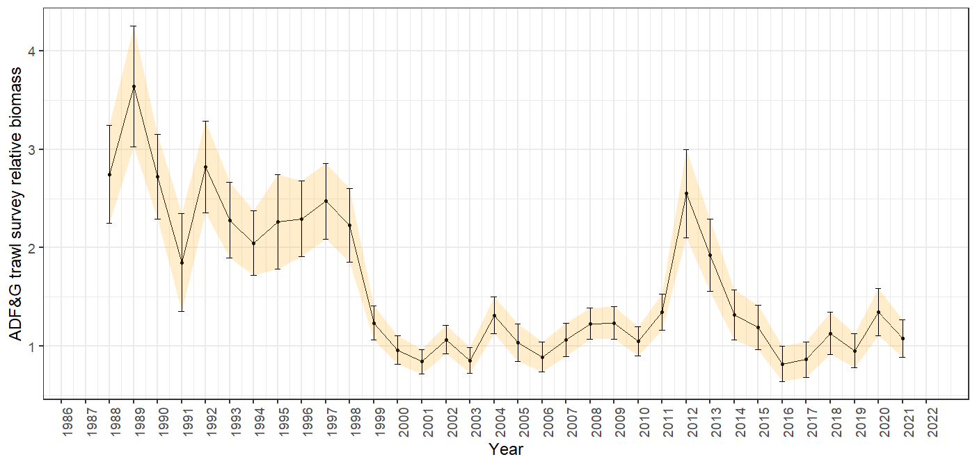

Figure 2.38 ADFG bottom trawl survey delta-glm Pacific cod density index time series. Bars and shading indicate the 95th percentile confidence intervals.

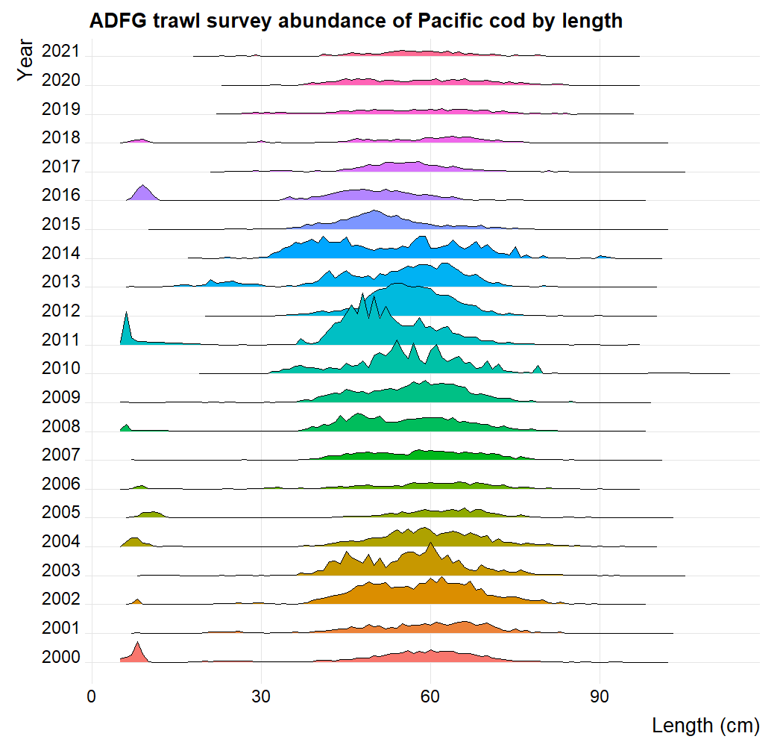

Figure 2.39 ADFG large-mesh trawl survey Pacific cod population numbers at length estimates.

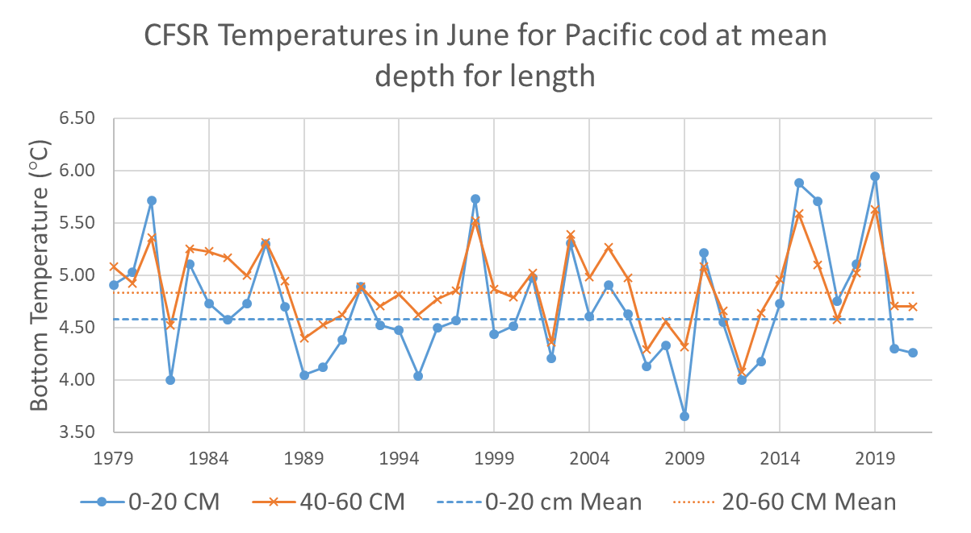

Figure 2.40 Climate Forcast System Reanalysis (CFSR) Central Gulf of Alaska bottom temperatures at the AFSC bottom trawl survey mean depths for 0-20 cm and 40-60 cm Pacific cod in June.

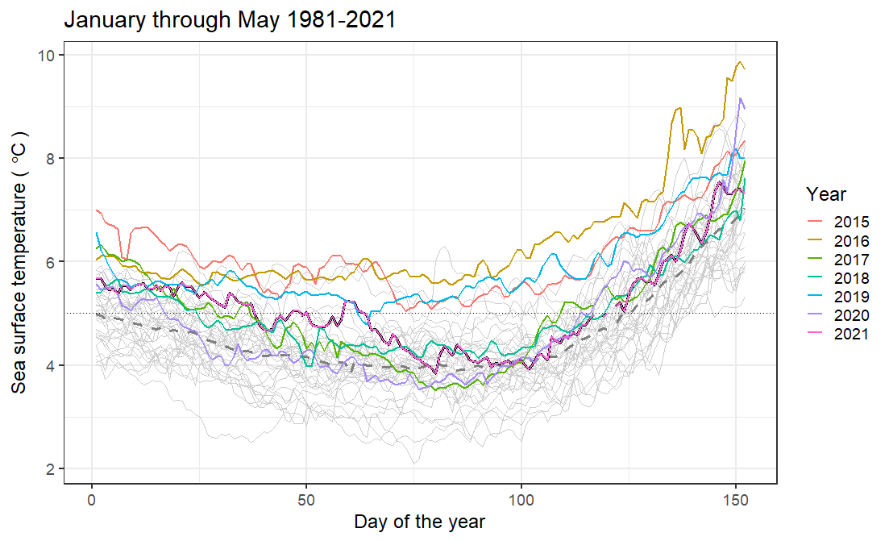 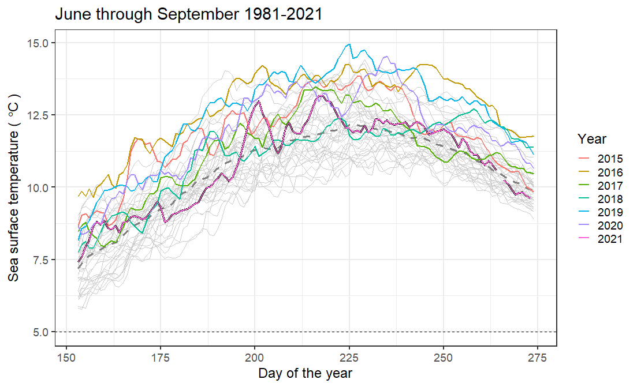

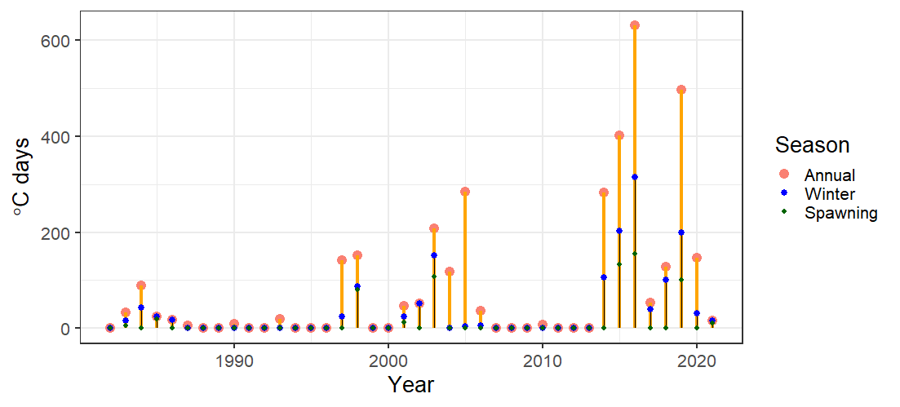

Figure 2.41 Sea surface temperatures (top left) February to March, (top right) June through September, and (bottom) index of the sum of the annual marine heatwave cumulative intensity (℃ days) for 1981-2021 (larger yellow points) and index of the sum of the annual winter marine heatwave cumulative intensity for 1981-2021 (smaller blue points) from the daily mean sea surface temperatures NOAA high resolution blended analysis data for the Central Gulf of Alaska. The 2021 index value is the sum through 30 September 2021.

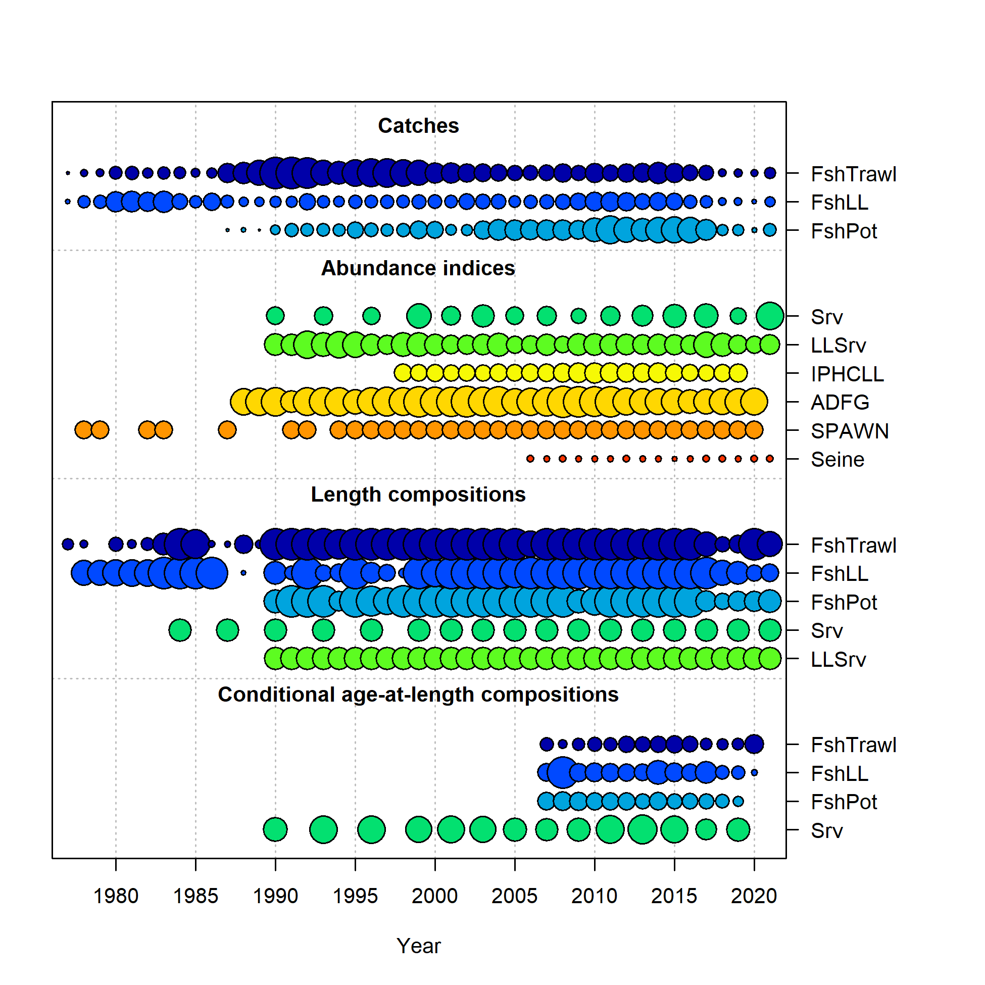

Figure 2.42 Data in the 2021 models, circle area is relative to initial precision within data type. Note that the ADFG, IPHC, and SPAWN are included in the data, but are not fit in any of the models presented this year. In addition the Seine (Age-0 index) data were not included in Models 19.1 or 21.1. Data presence by year for each fleet, where circle area is relative within a data type. Circles are proportional to total catch for catches; to precision for indices and to total sample size for compositions and length-at-age observations. Note that since the circles are scaled relative to maximum within each type, the scaling within separate plots should not be compared.

**Trawl Longline Pot**

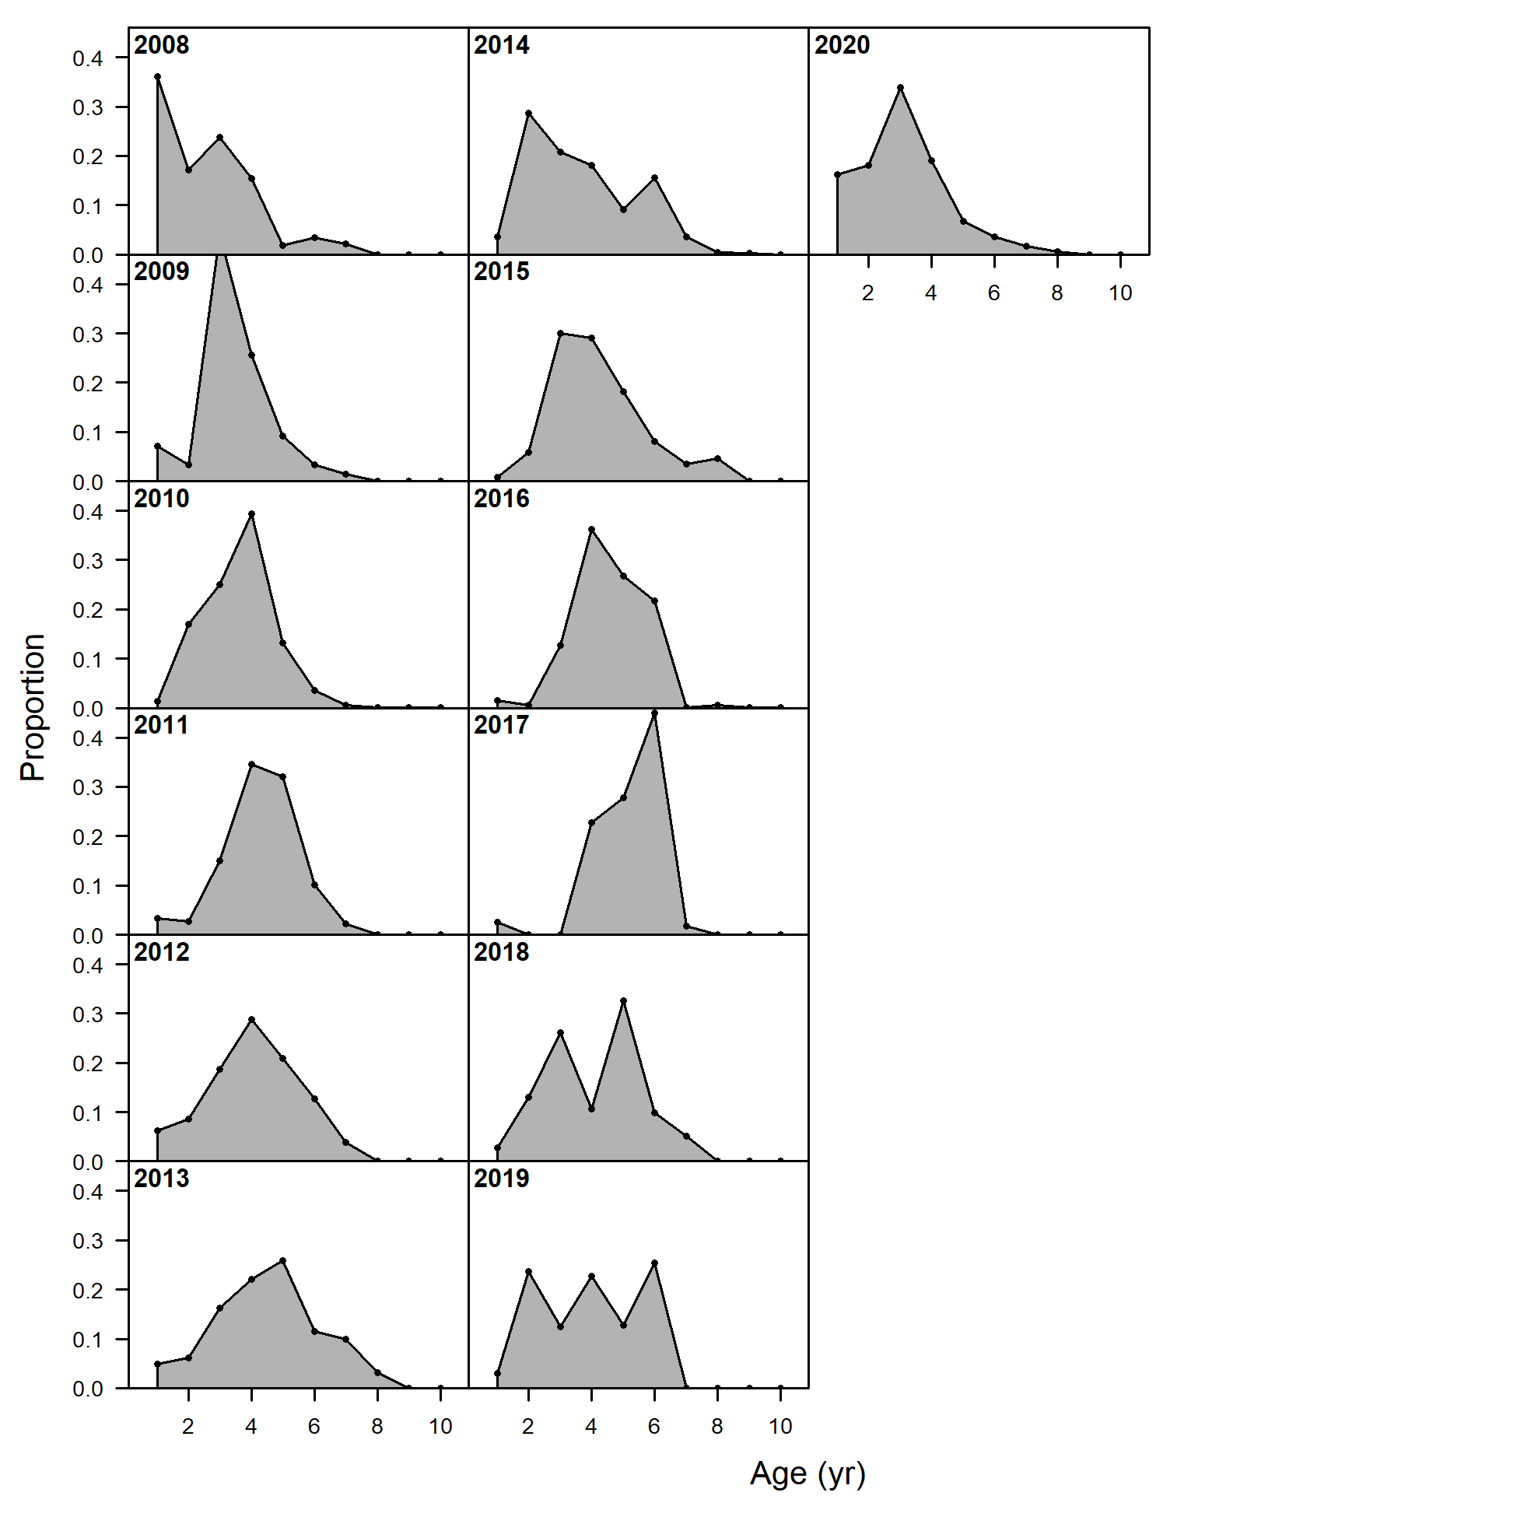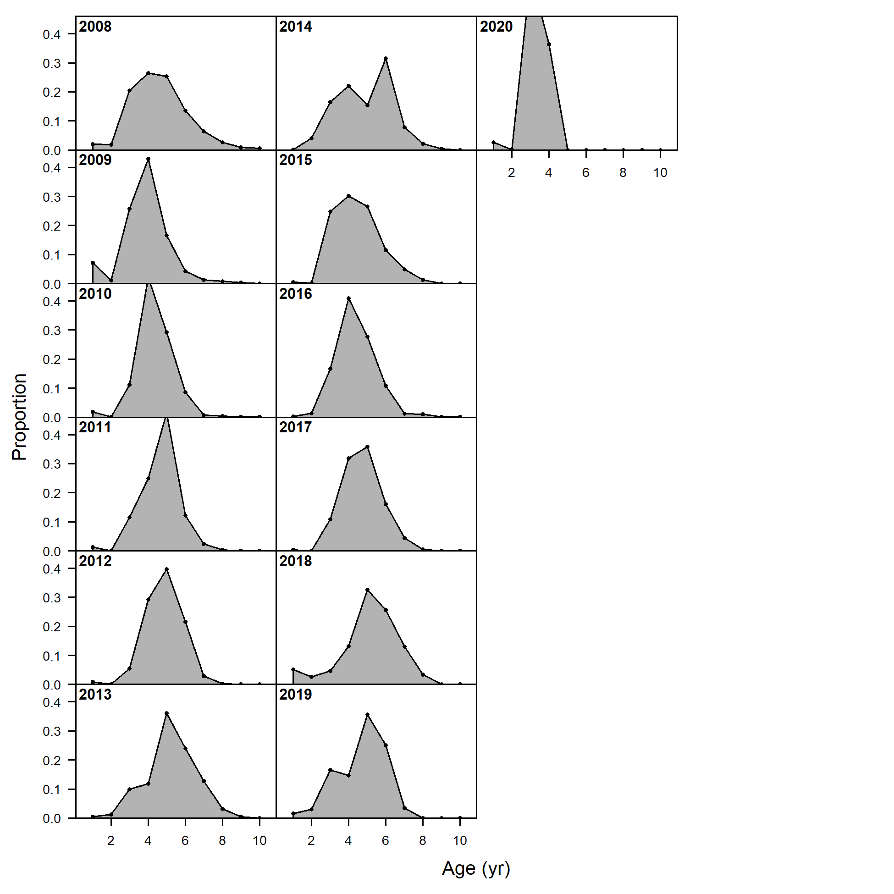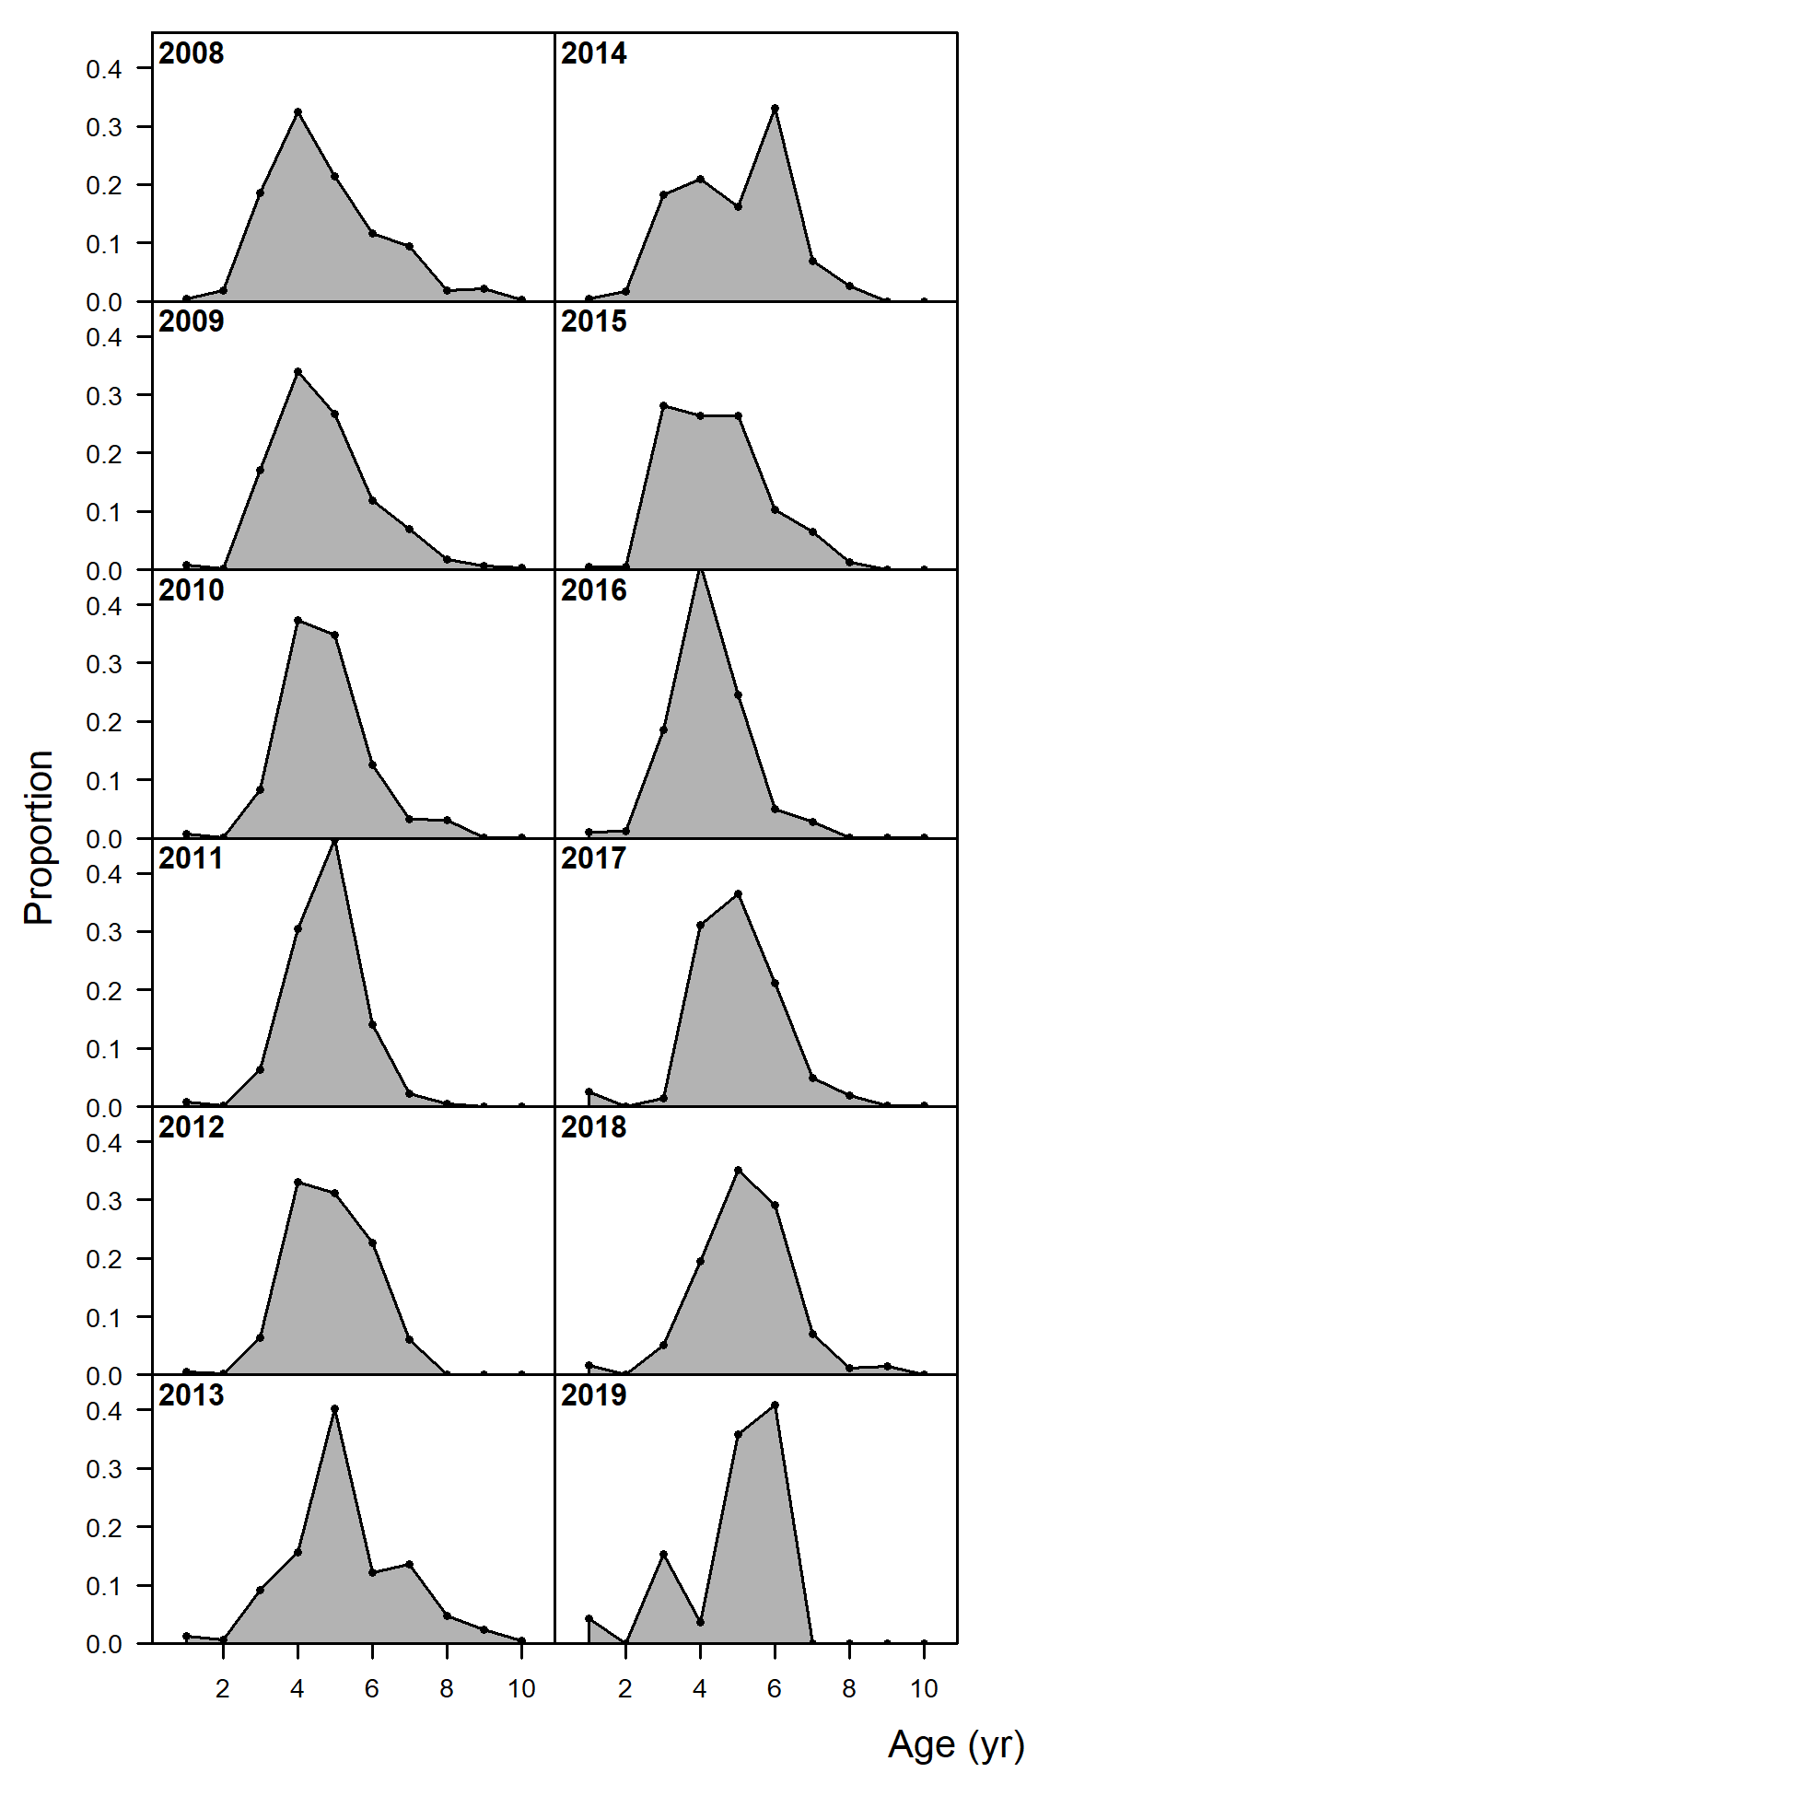

**Age**

Figure 2.43 Pacific cod age composition data from the Gulf of Alaska fisheries by gear type.

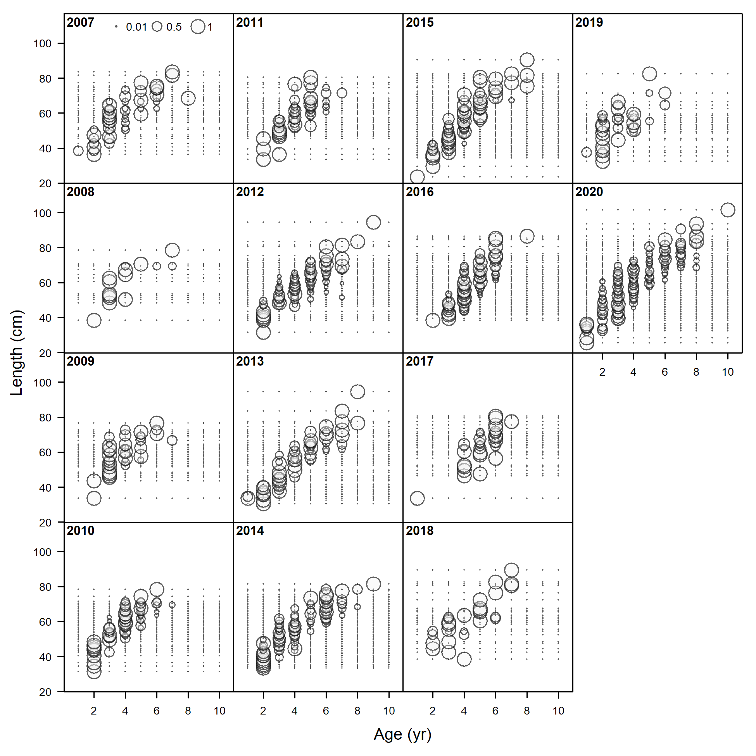

Figure 2.44 Pacific cod conditional length at age from the Gulf of Alaska trawl fishery.

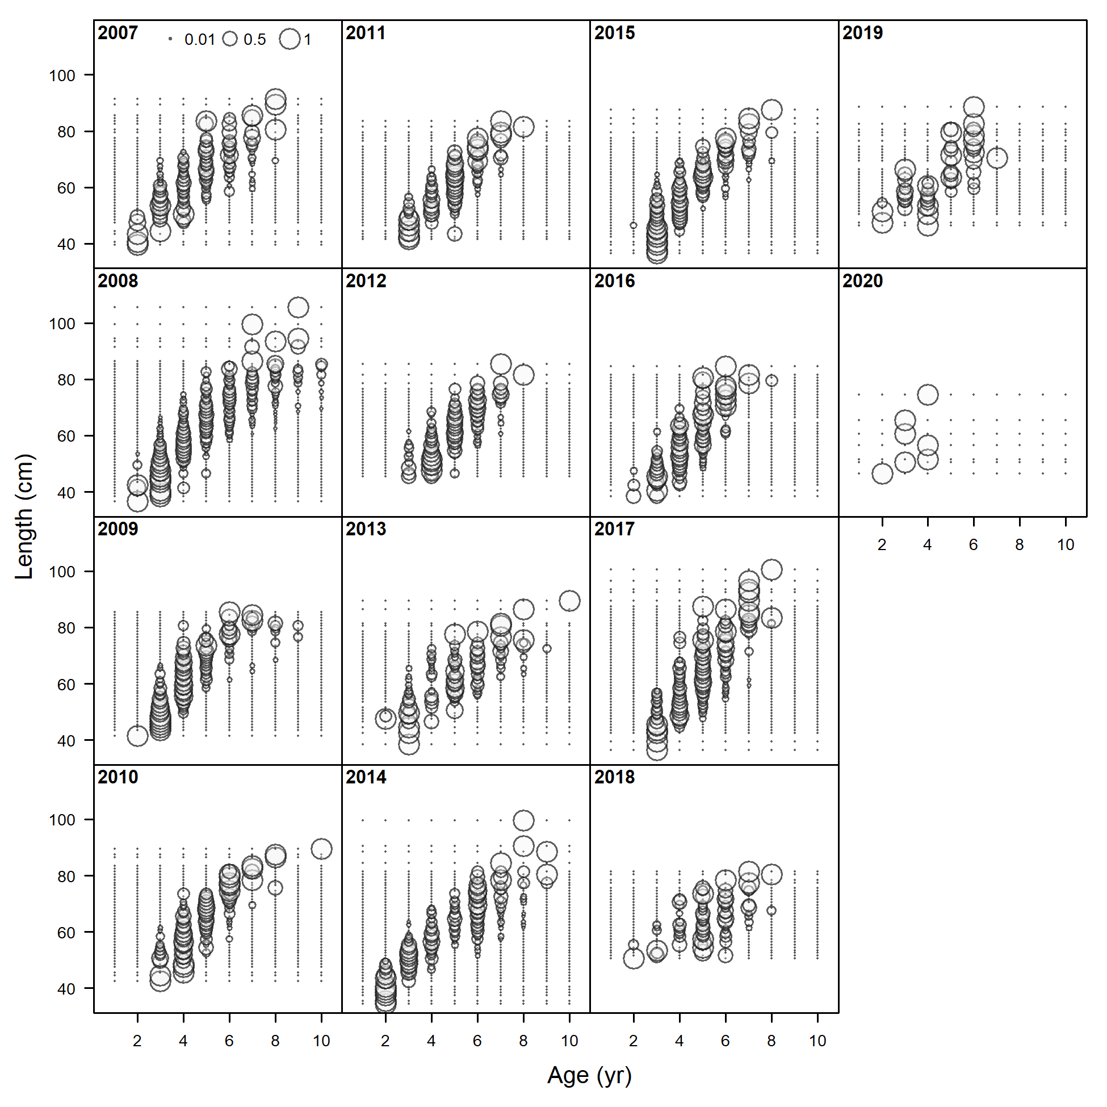

Figure 2.45 Pacific cod conditional length at age from the Gulf of Alaska bottom longline fishery.

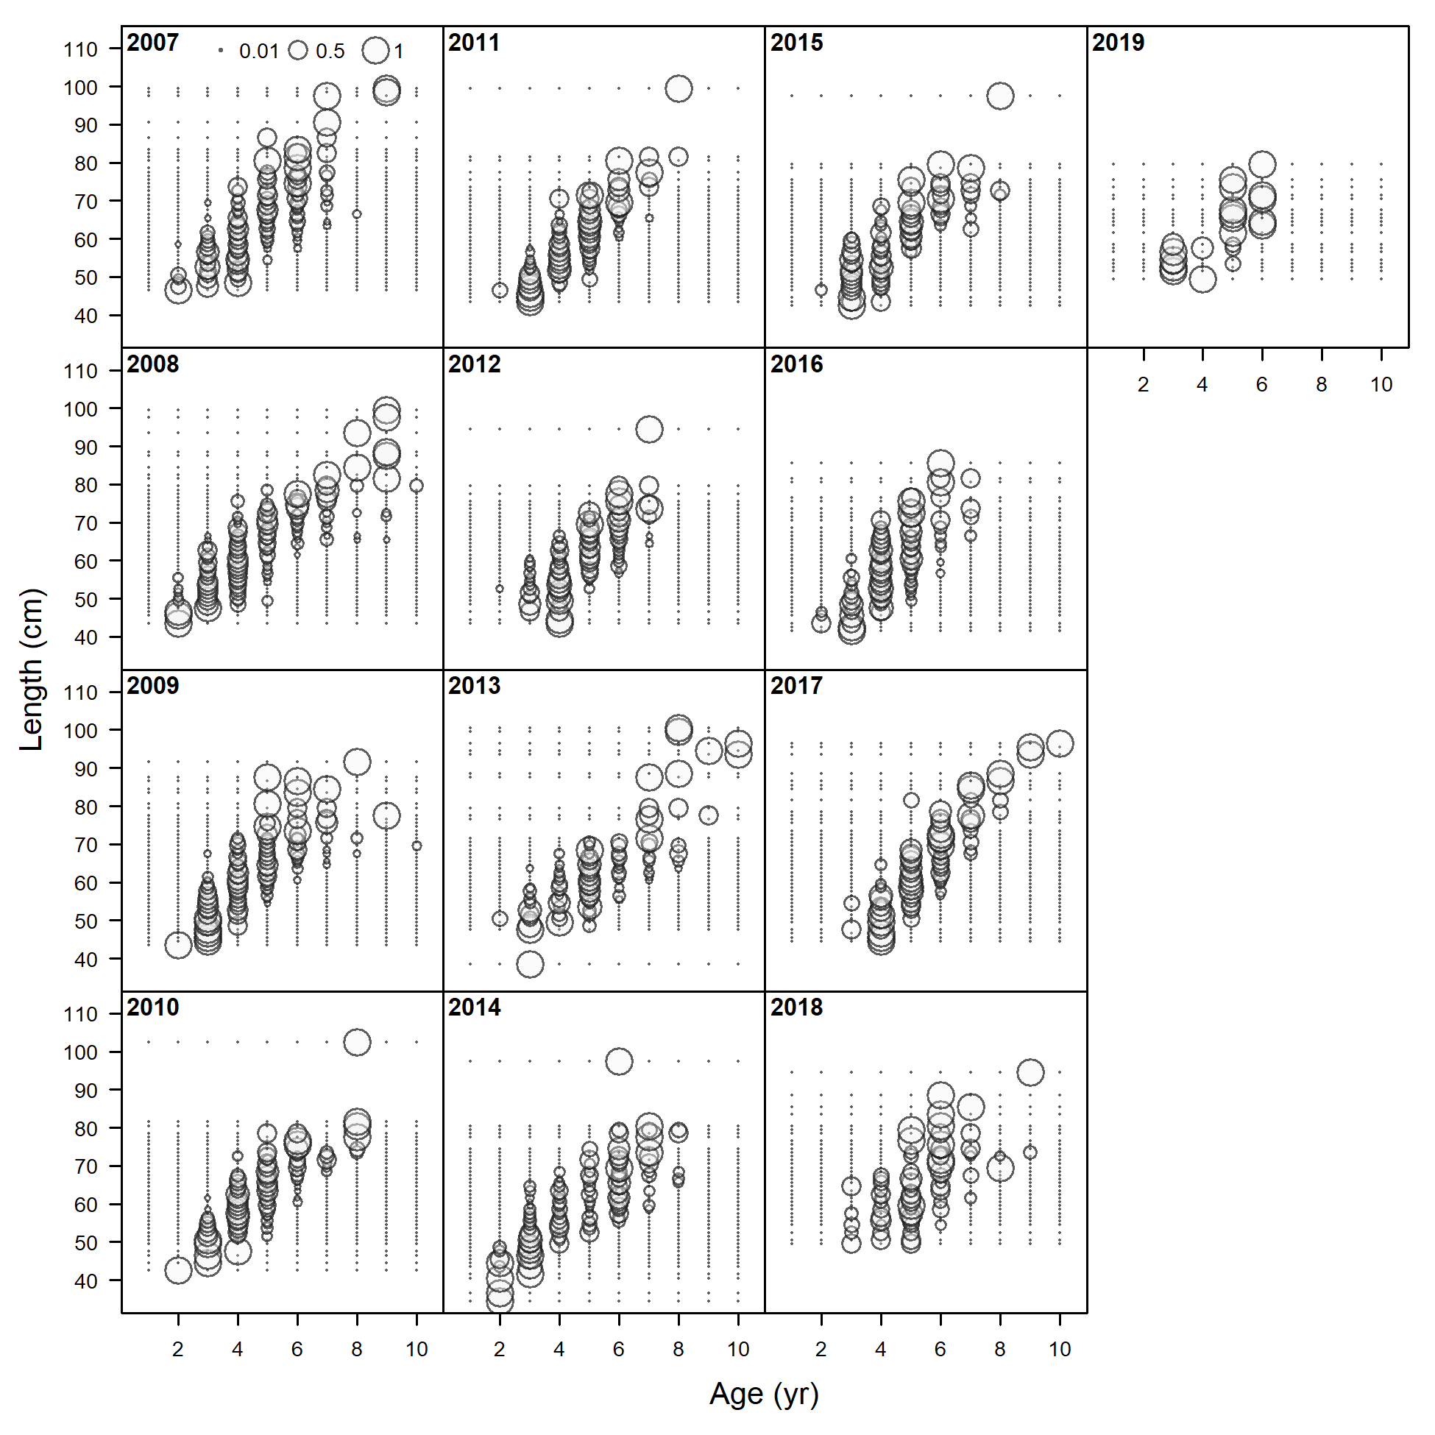

Figure 2.46 Pacific cod conditional length at age from the Gulf of Alaska pot fishery.

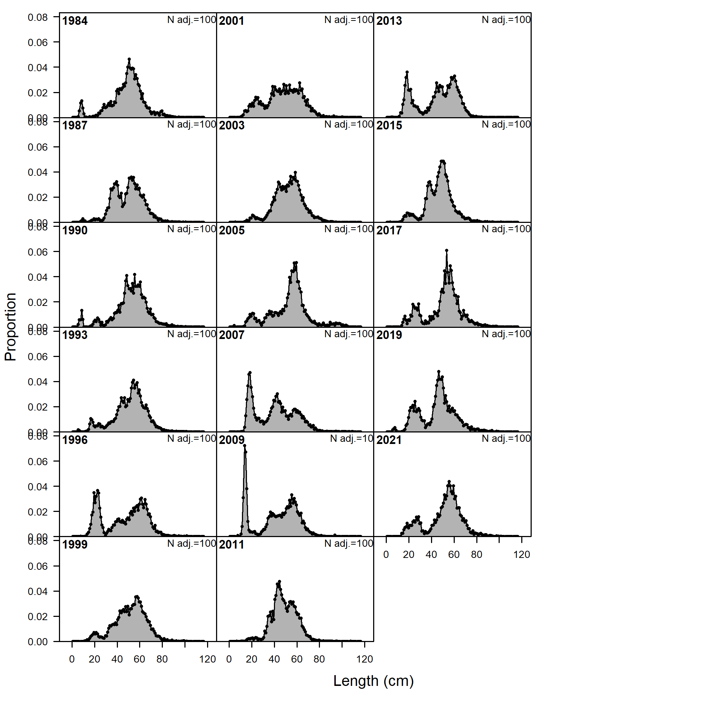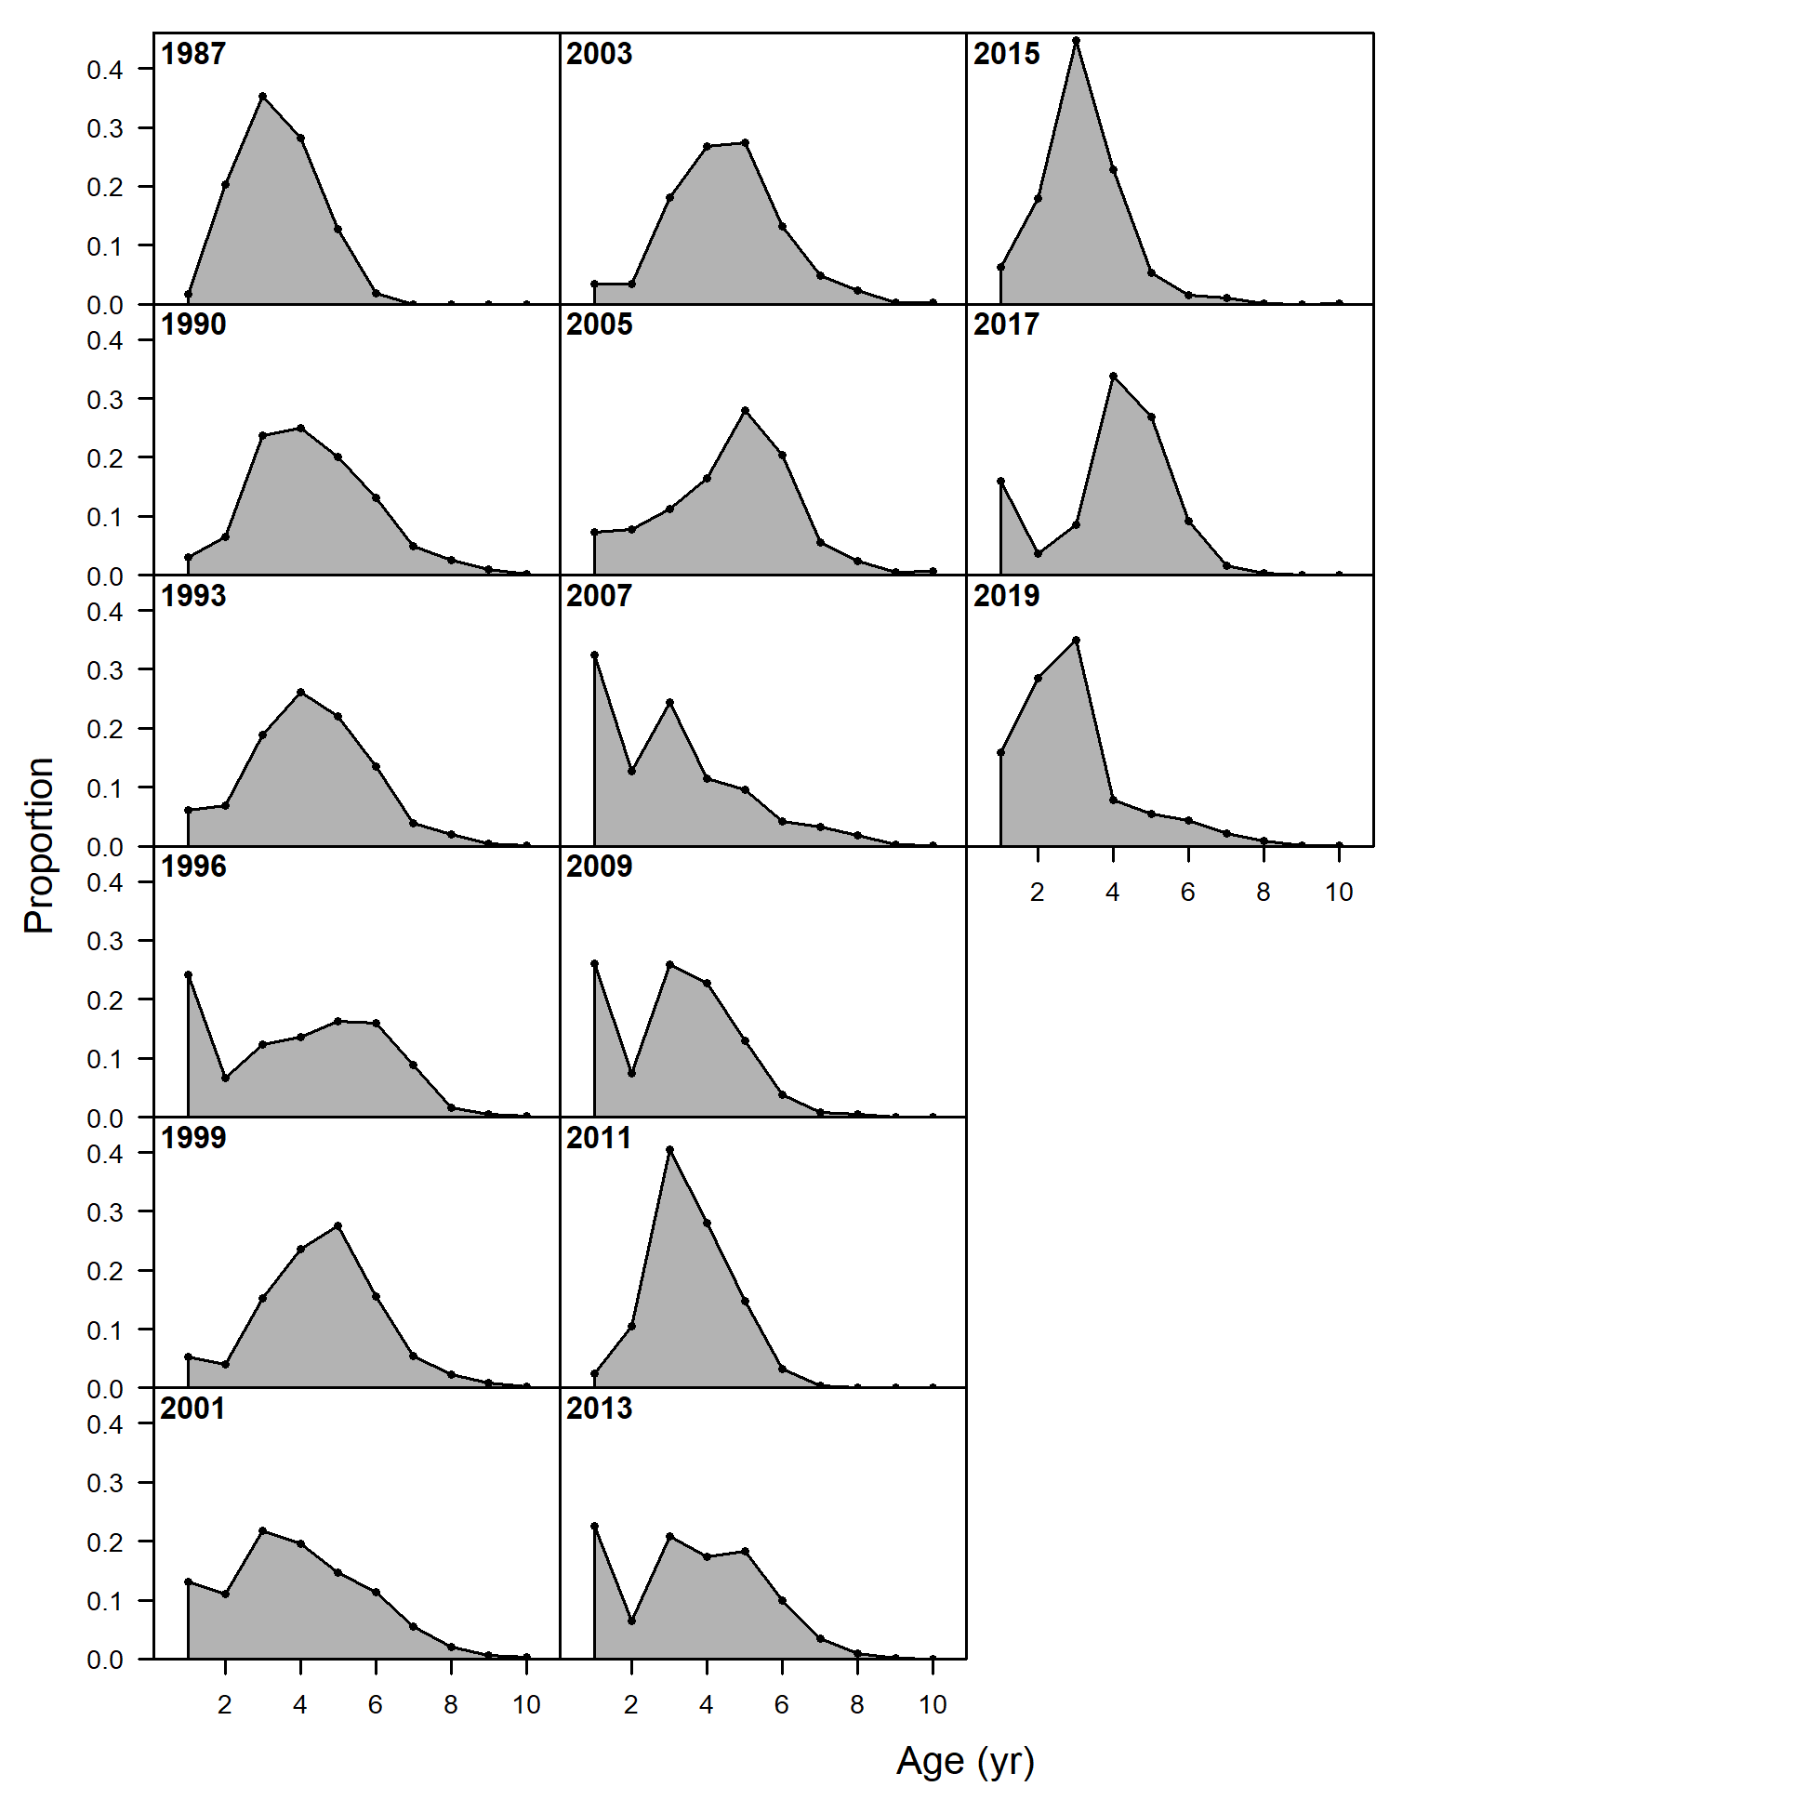

Figure 2.47 Available Pacific cod length (left) and age (right) composition data from the Gulf of Alaska bottom trawl survey 1984-2021.

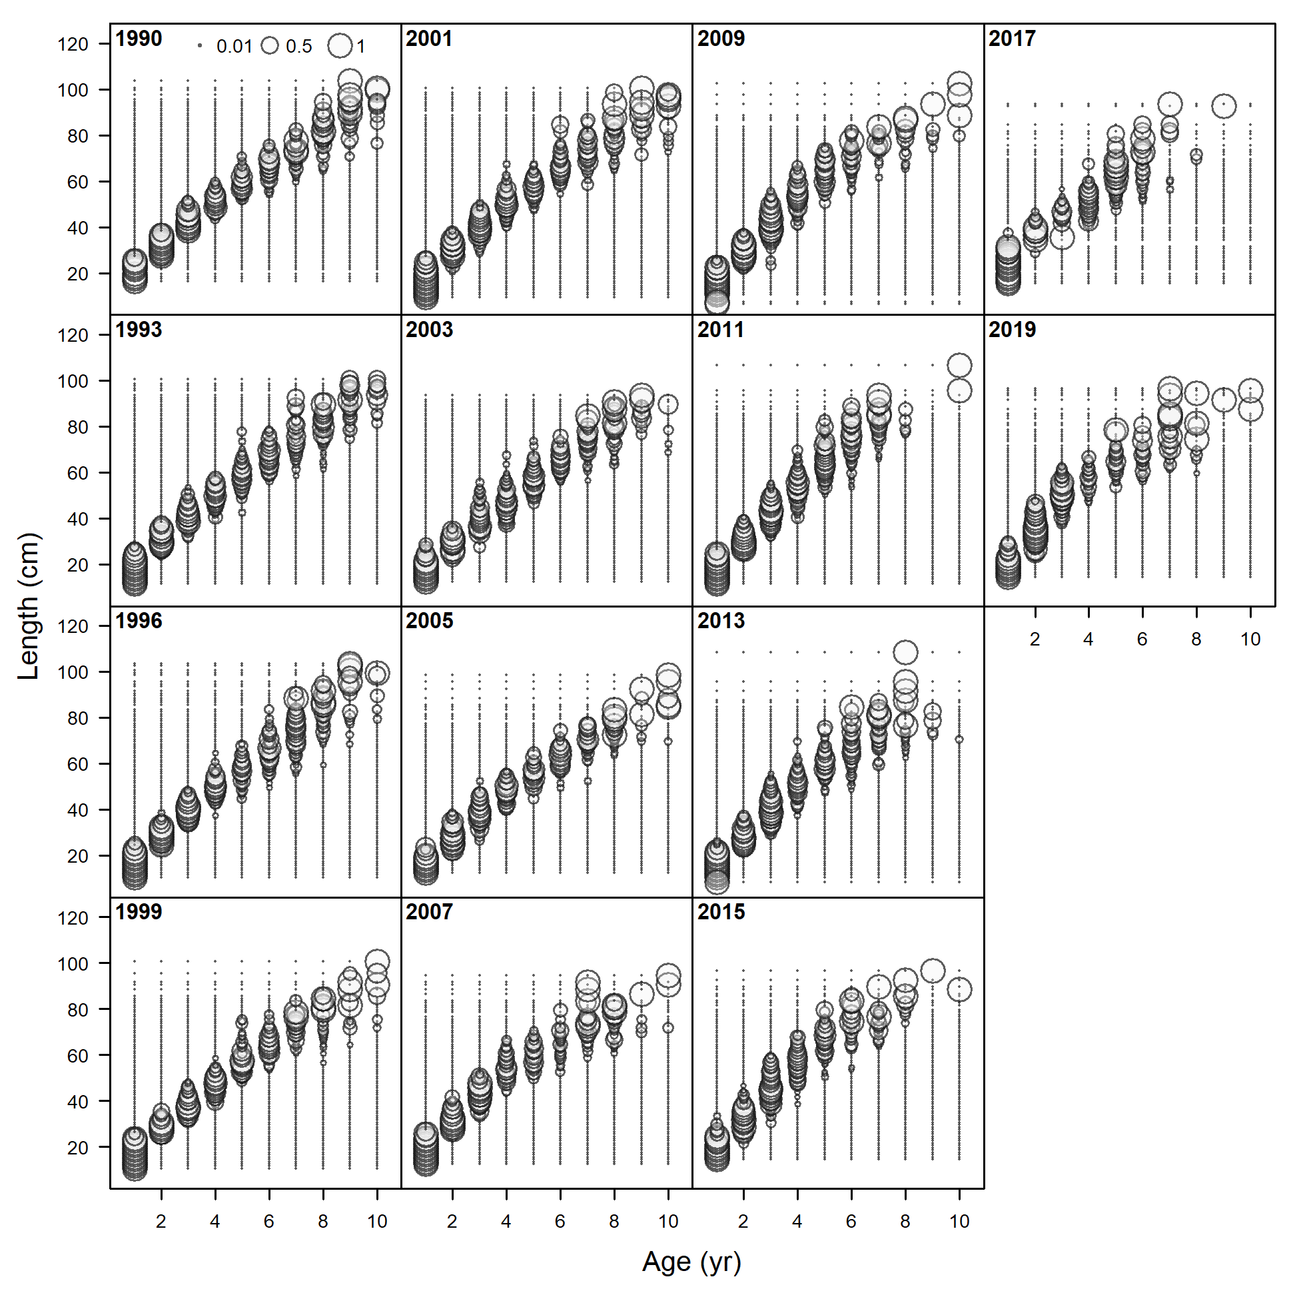

Figure 2.48 Pacific cod conditional length at age from the Gulf of Alaska bottom trawl survey 1990-2019.

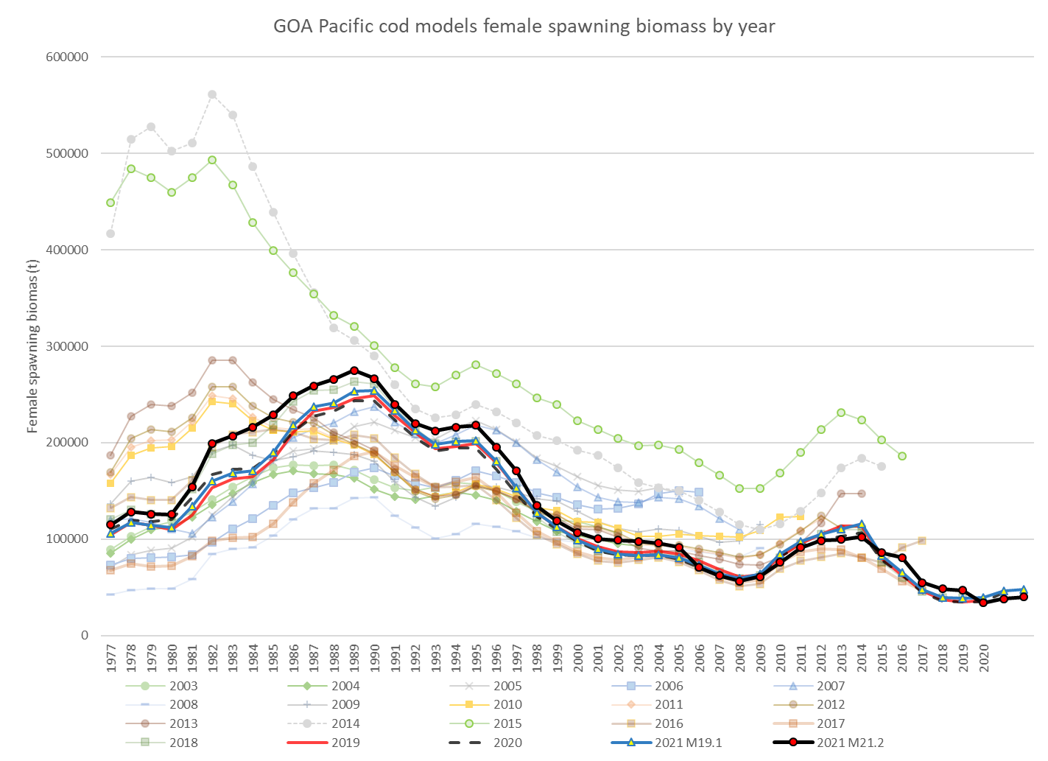

Figure 2.49 1977-2021 Gulf of Alaska Pacific cod female spawning biomass from the 2003 through 2021 stock assessments with estimates from both the author’s preferred (Model 21.2) and last year’s base model (Model 19.1) model results and (inset) images from the NMFS small net surveys off Kodiak Alaska showing change in species composition over time from: <https://www.thenakedscientists.com/articles/science-features/ecosystem-shifts-and-sharks-alaska>

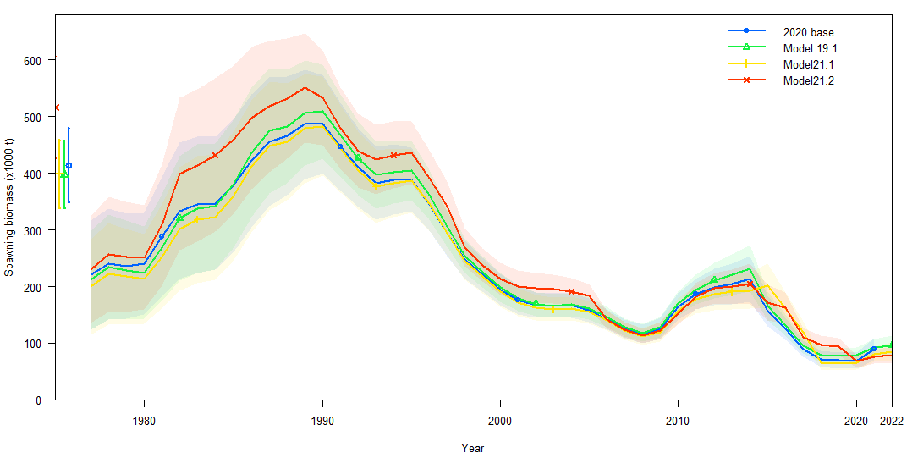

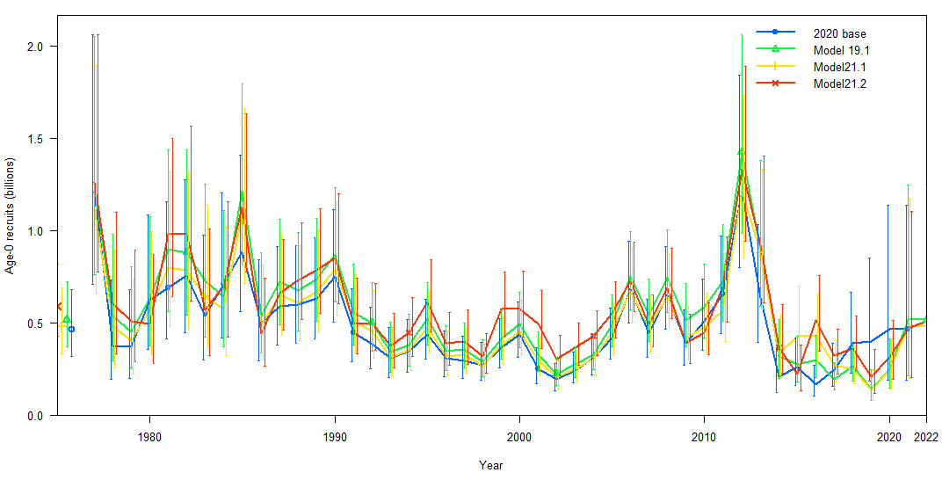

Figure 2.50 Estimates of female spawning biomass (t; top) and age-0 recruits (billions; bottom) for 2020 base model and 2021 proposed models.

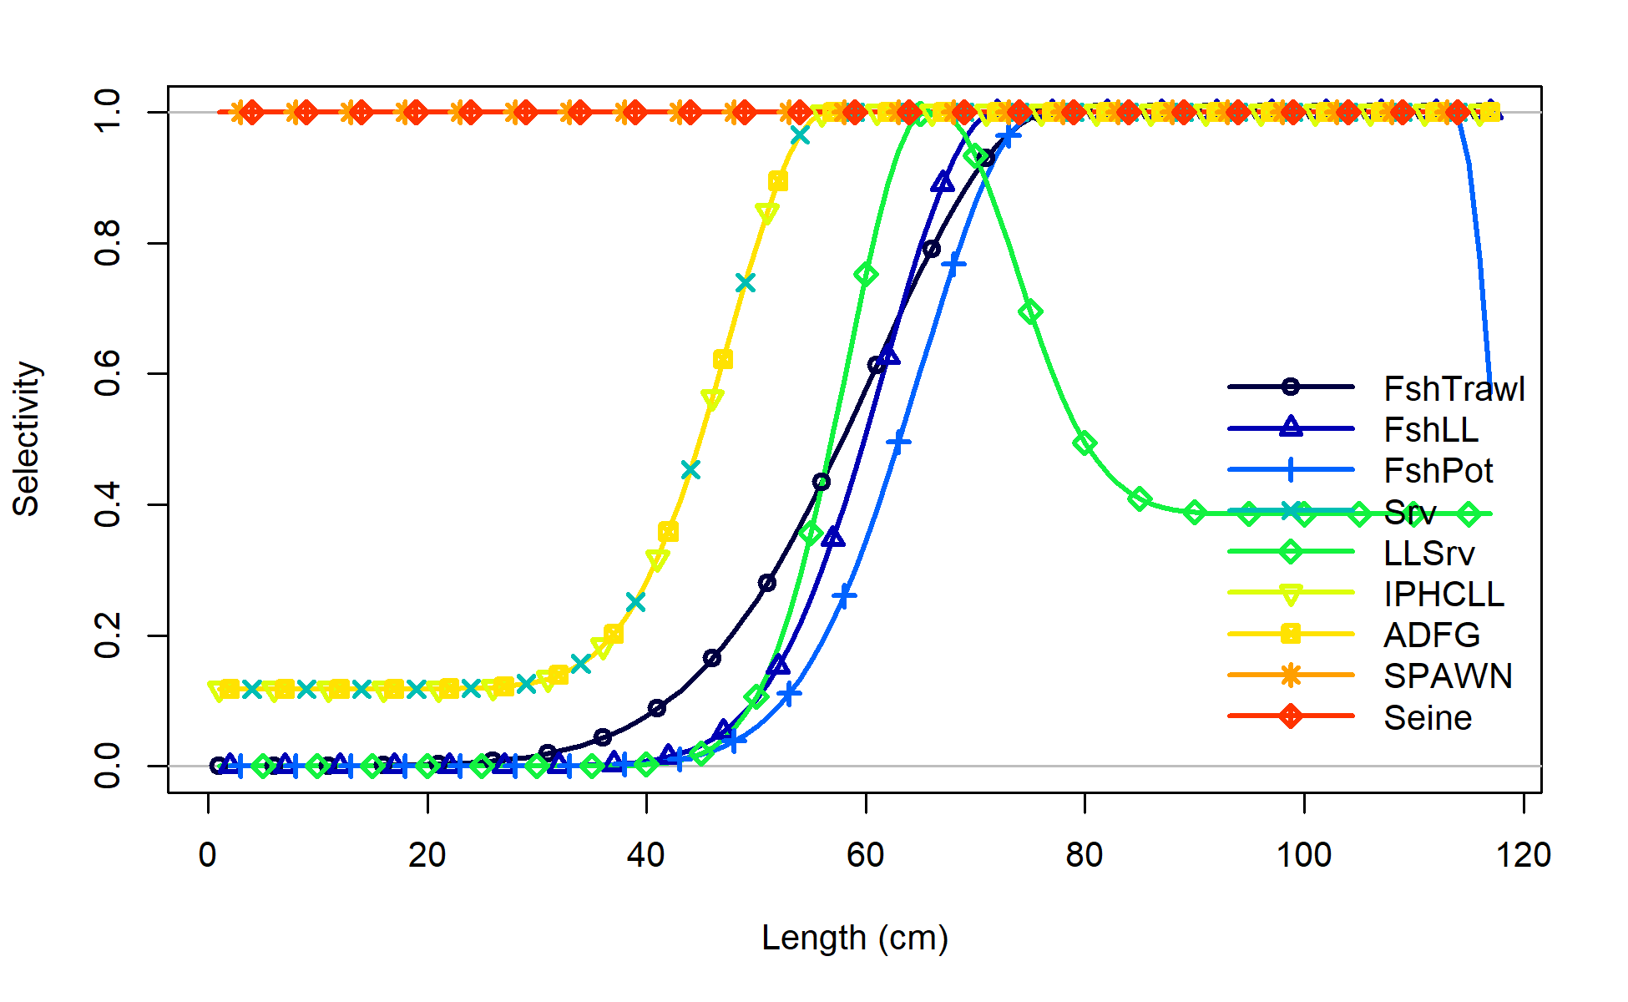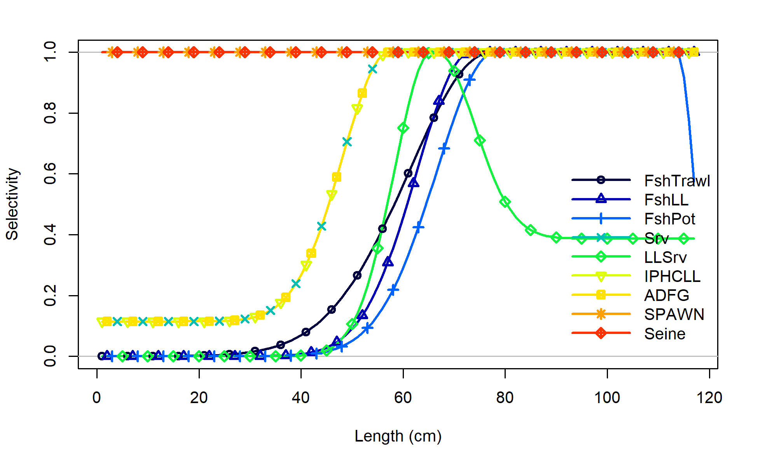

Model21.1

Model19.1

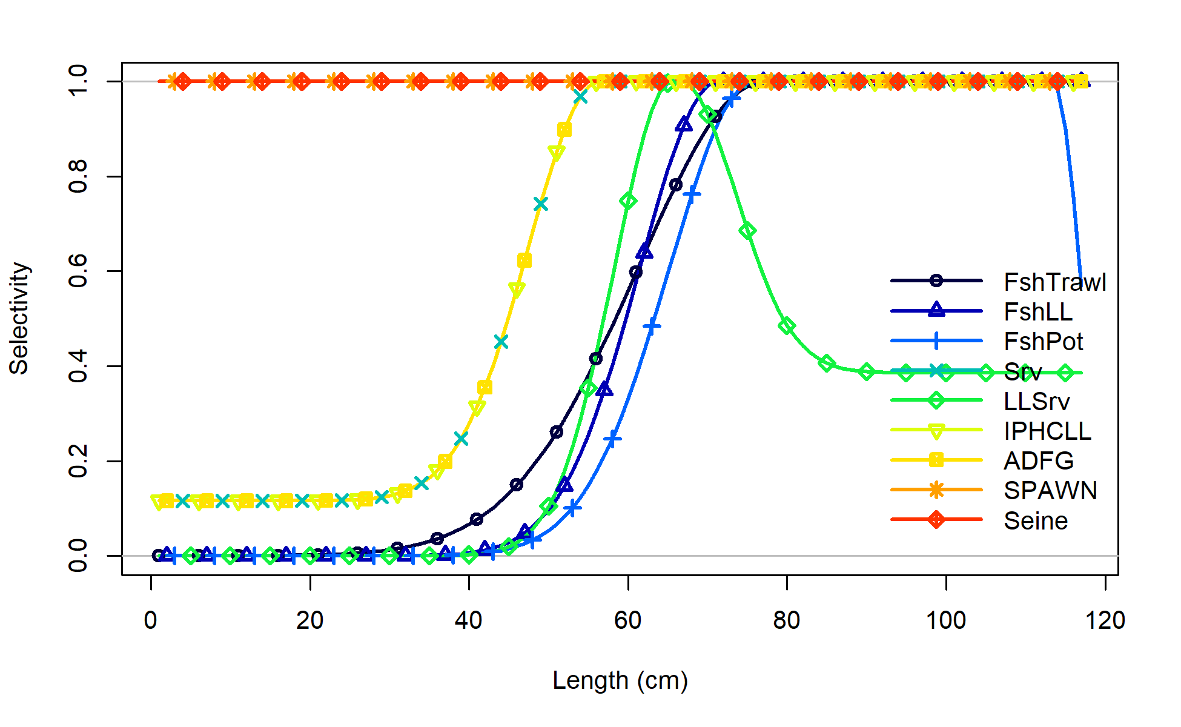

Model21.2

Figure 2.51 Model19.1, Model 21.1, and Model 21.2 selectivity for all size composition components for 2021.

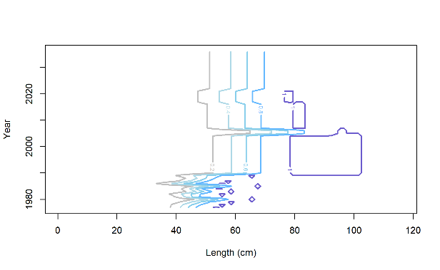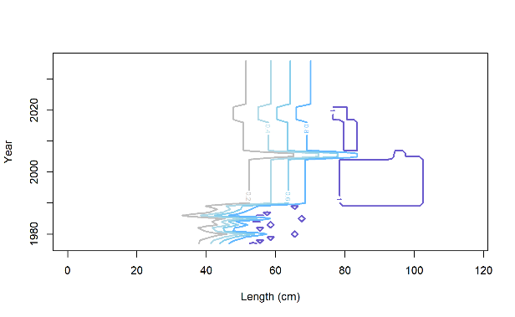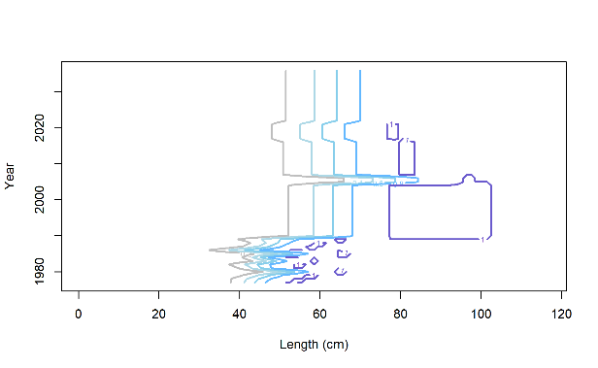

M 21.2

Trawl

M 21.1

Trawl

M 19.1

Trawl

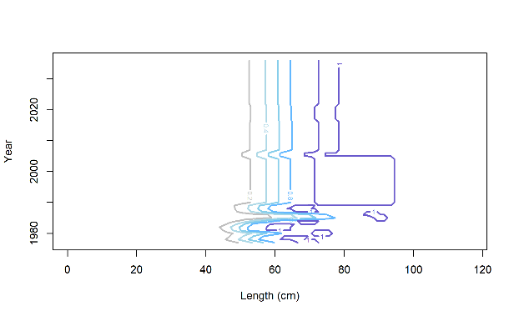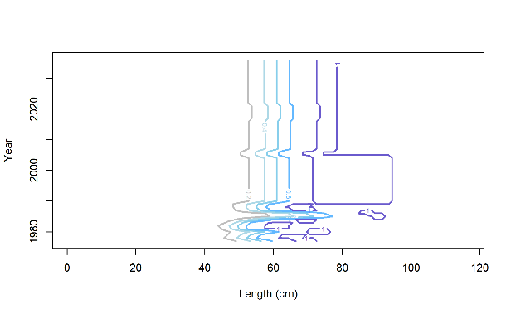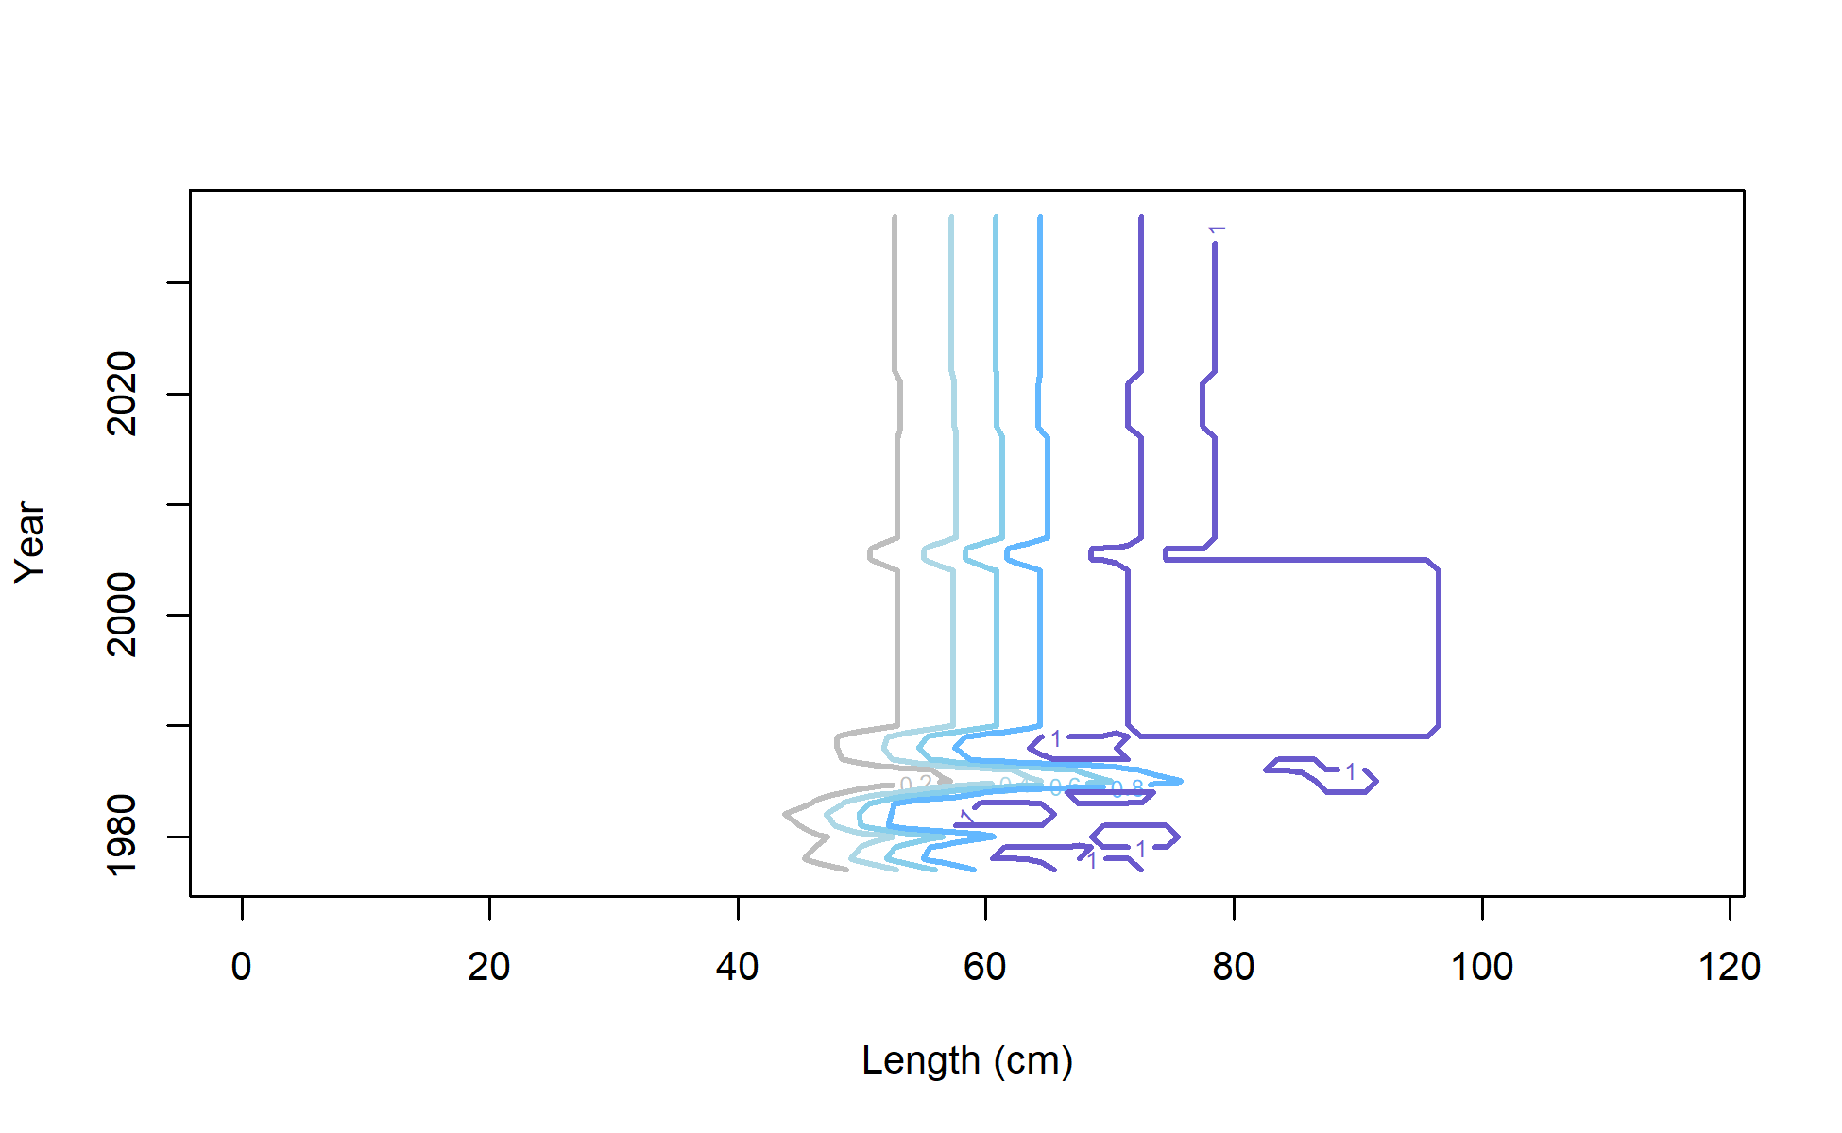

M 21.1

Longline

M 21.2

Longline

M 19.1

Longline

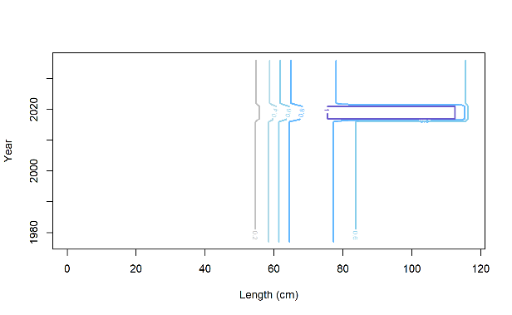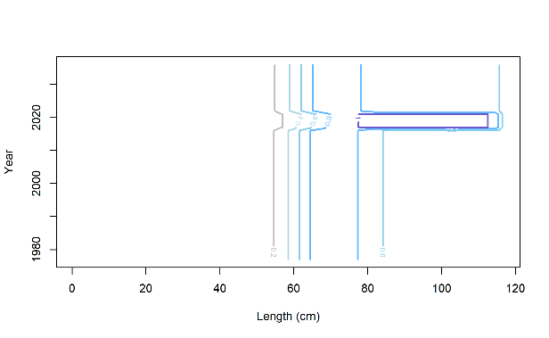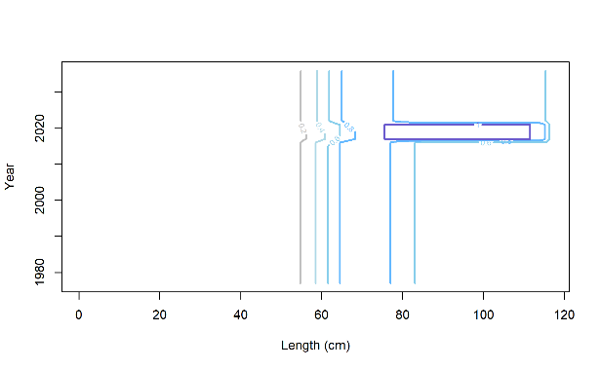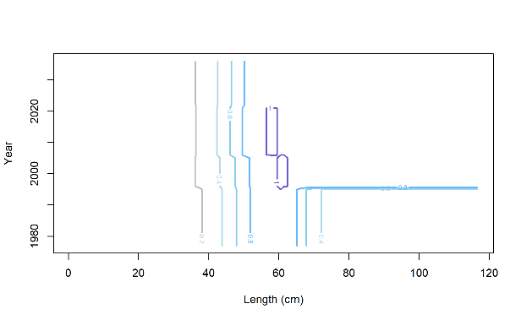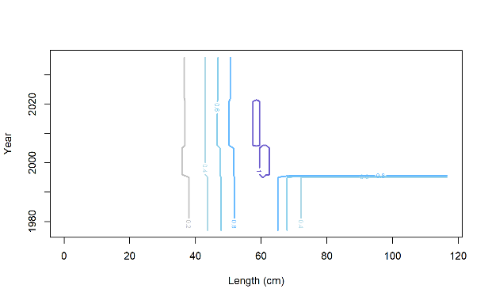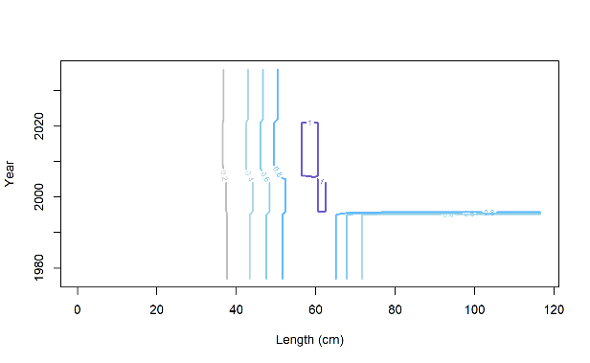

M 19.1

BT Survey

M 21.2

BT Survey

M 21.1

BT Survey

M 21.2

Pot

M 21.1

Pot

M 19.1

Pot

Figure 2.52 Estimates of fishery and AFSC bottom trawl survey selectivities for evaluated models. Red dashed line is the size at 50% mature.

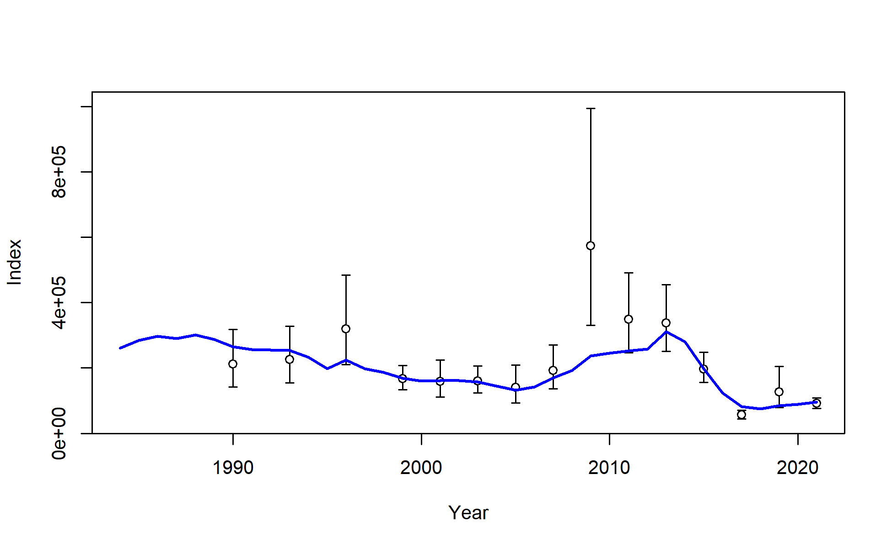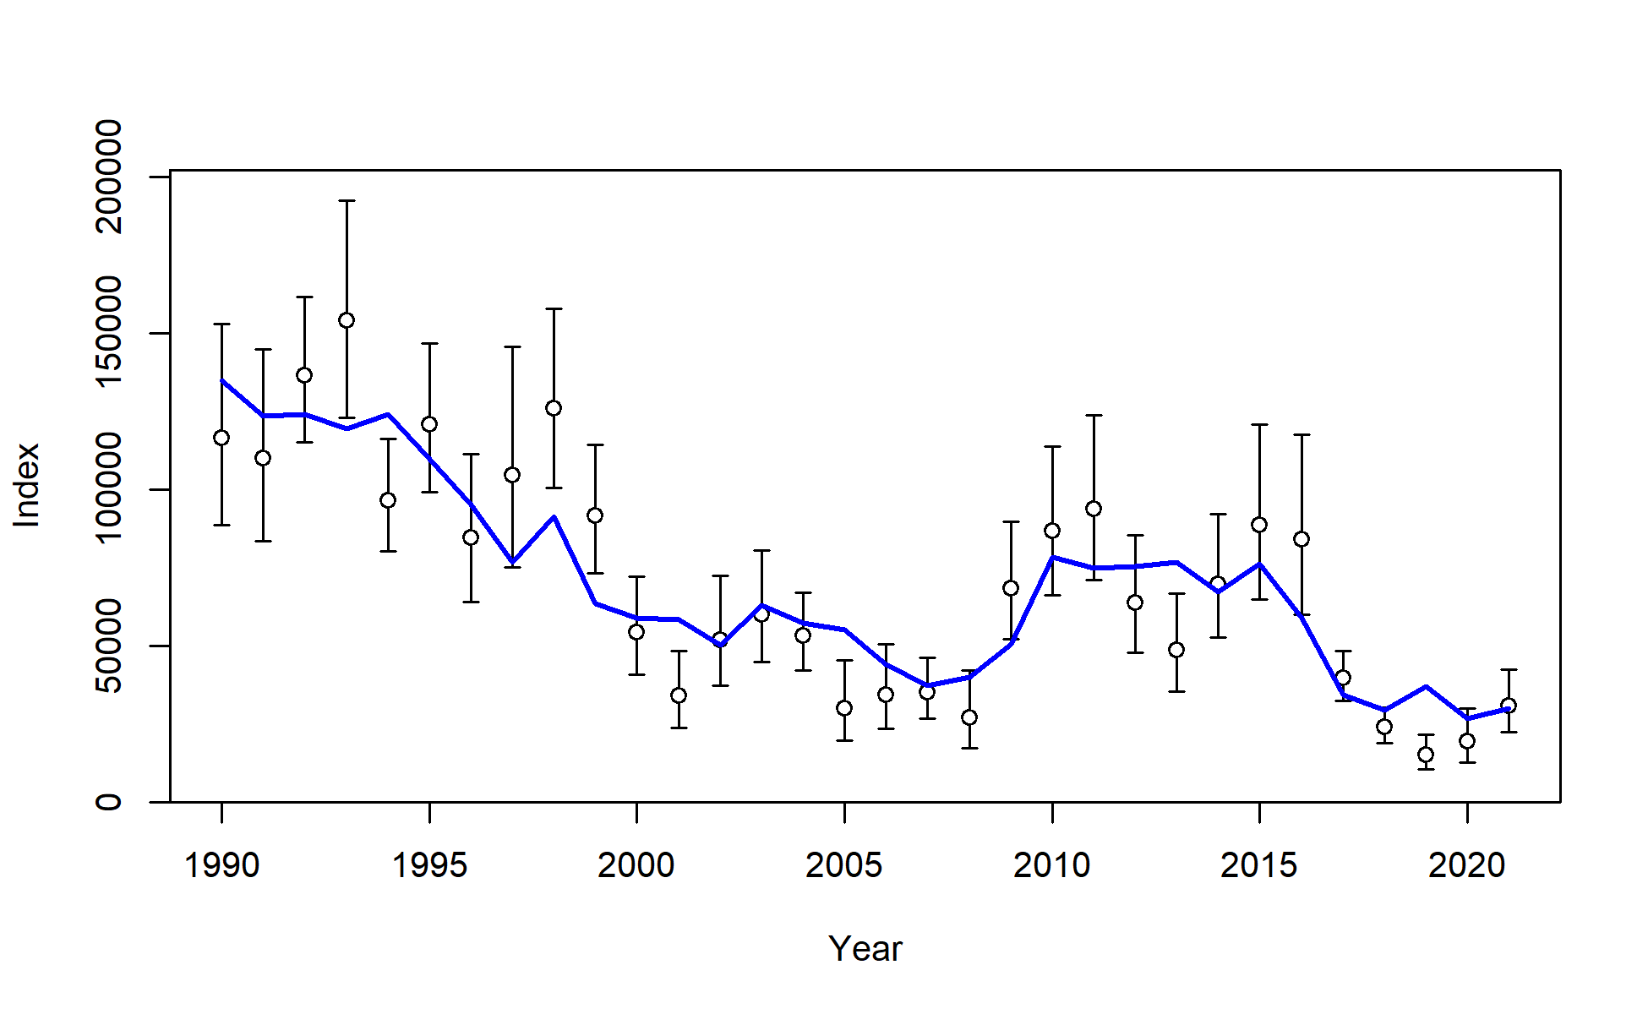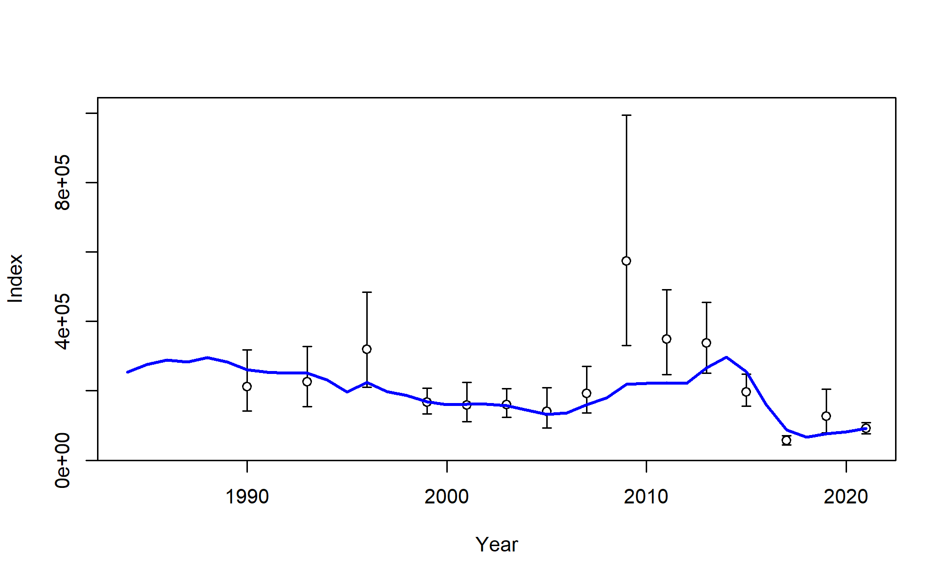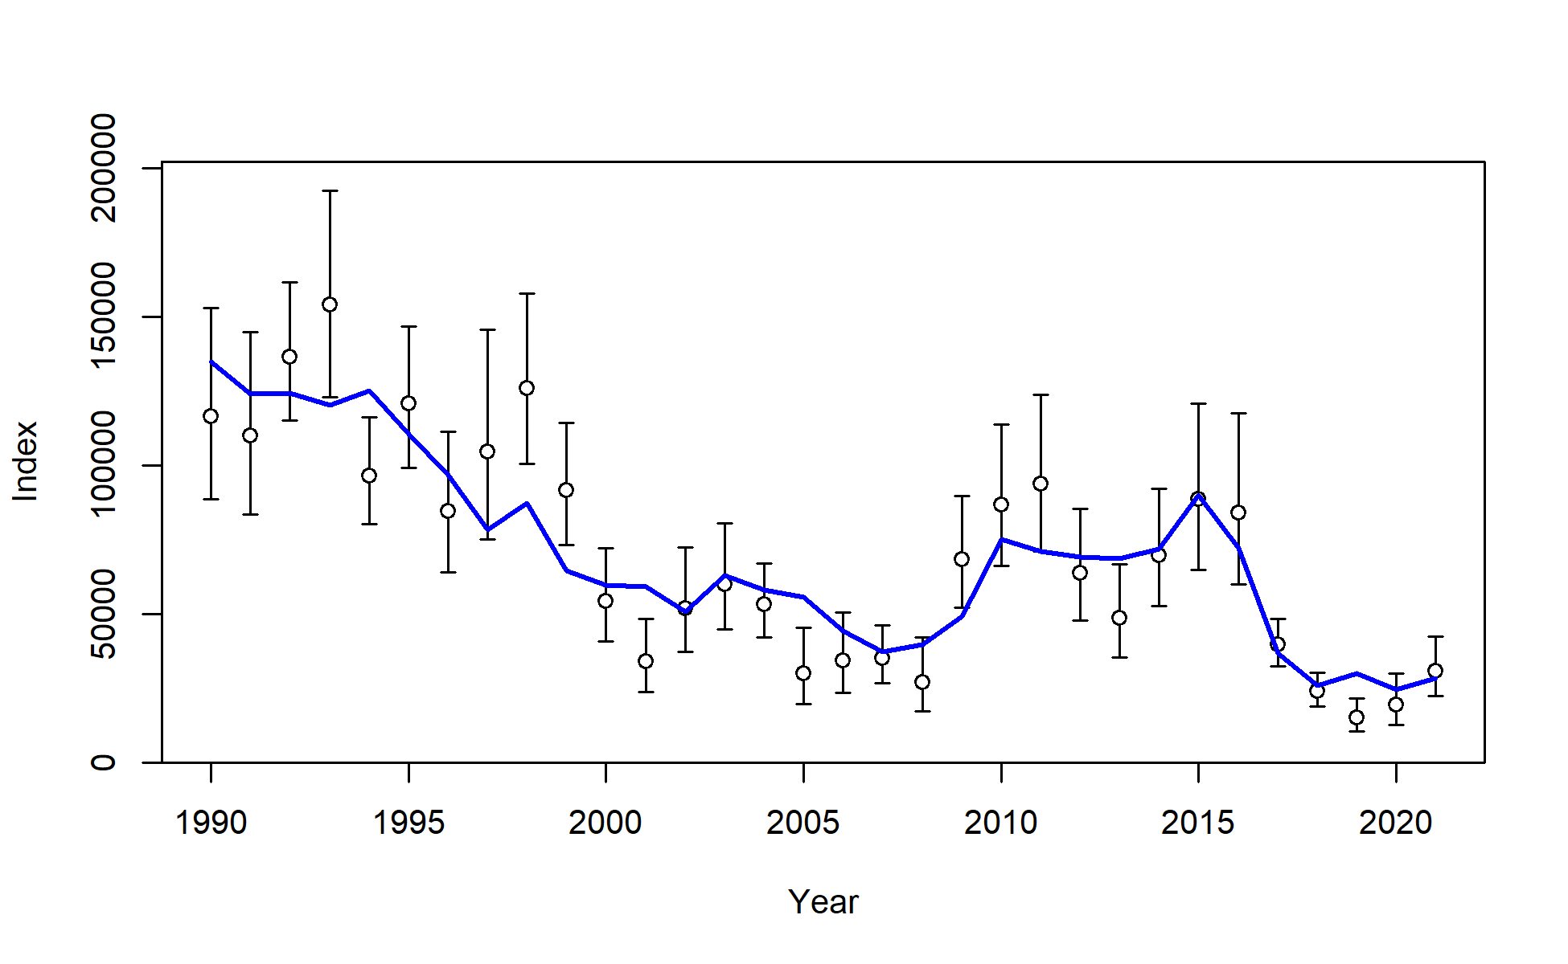

Model 19.1 AFSC longline survey

Model 21.1 AFSC longline survey

Model 21.1 AFSC trawl survey

Model 19.1 AFSC trawl survey

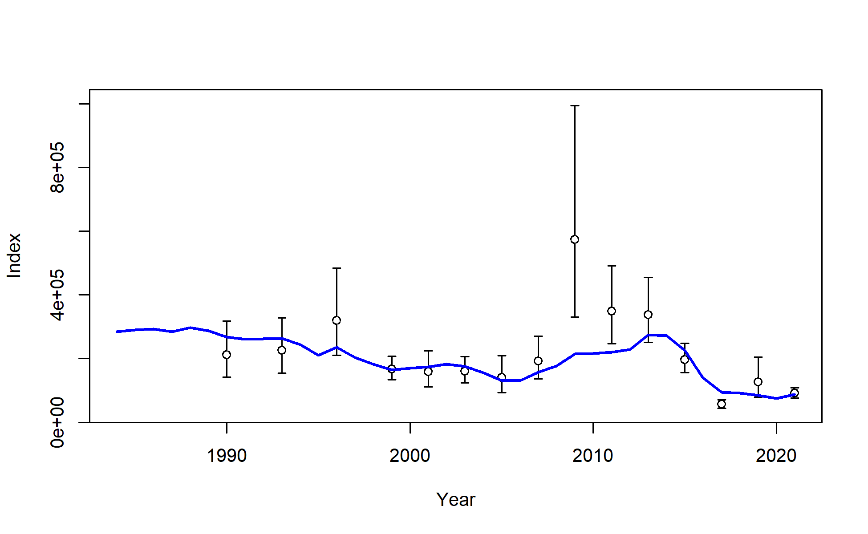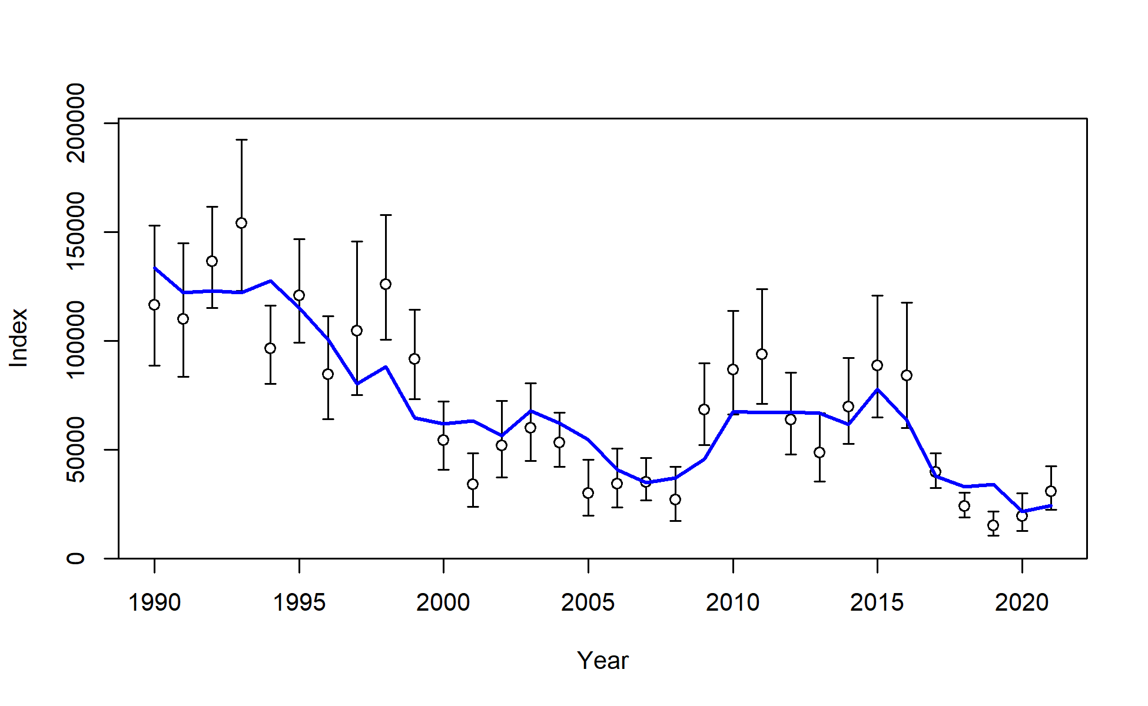

Model 21.2 AFSC longline survey

Model 21.2 AFSC trawl survey

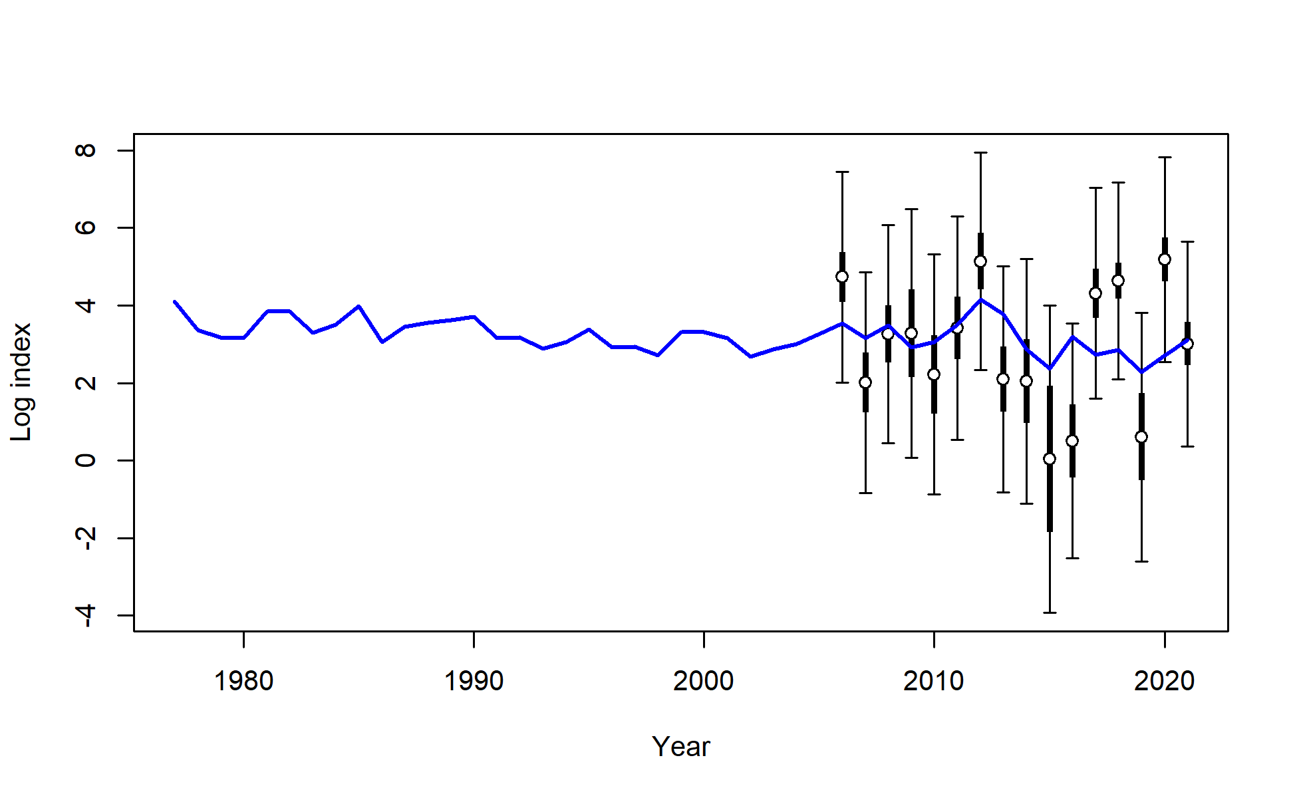

Model 21.2 beach seine

Figure 2.53 Model fits to AFSC bottom trawl (left), AFSC longline (right) survey, and age-0 beach seine (bottom middle) survey indices.

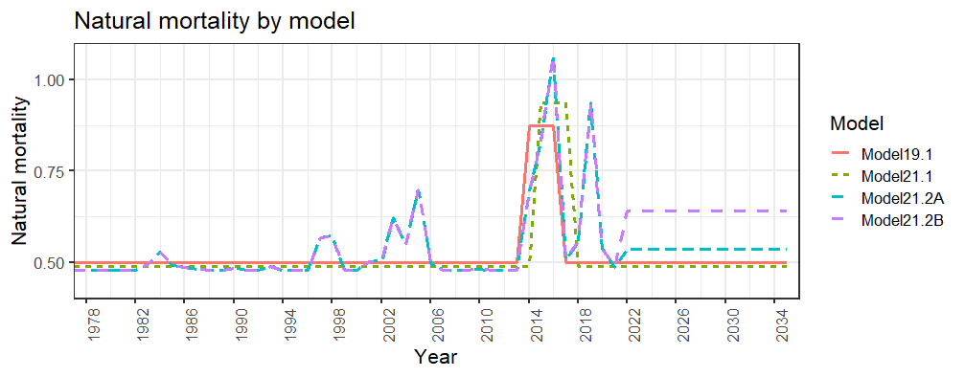

Figure 2.54 Natural mortality over time for the assessed models with projections for 2022-2036.

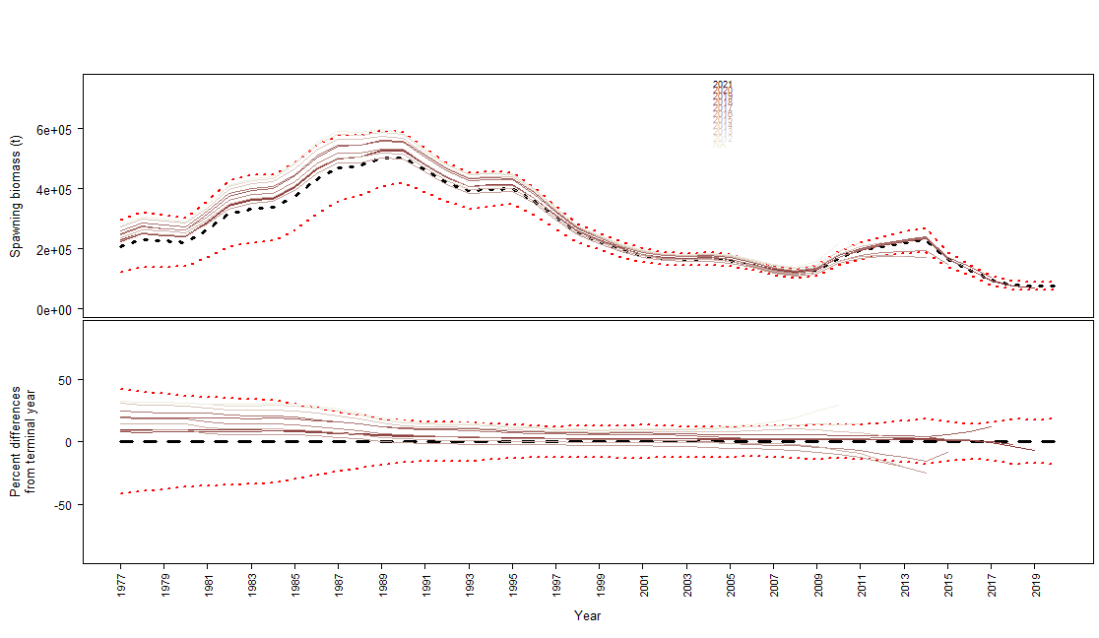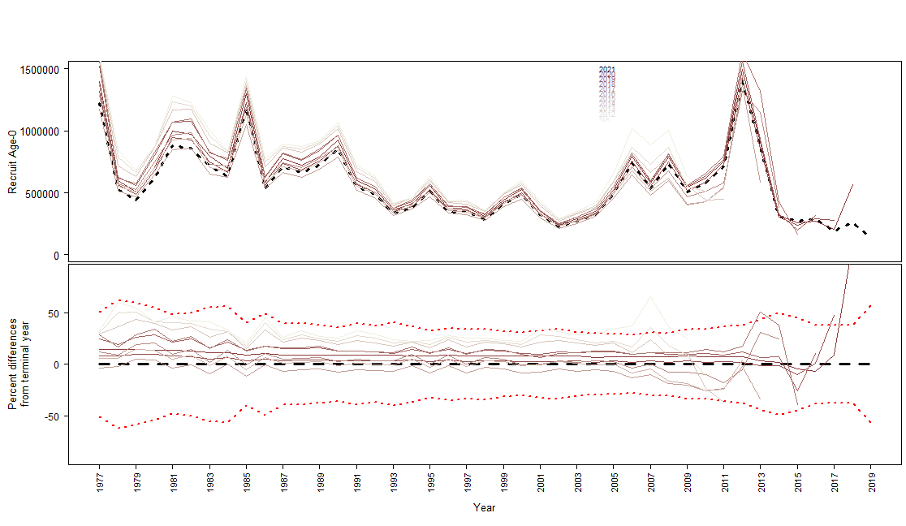

Figure 2.55 Retrospective analysis for Model 19.1 for female spawning biomass (top) and age-0 recruitment (bottom).

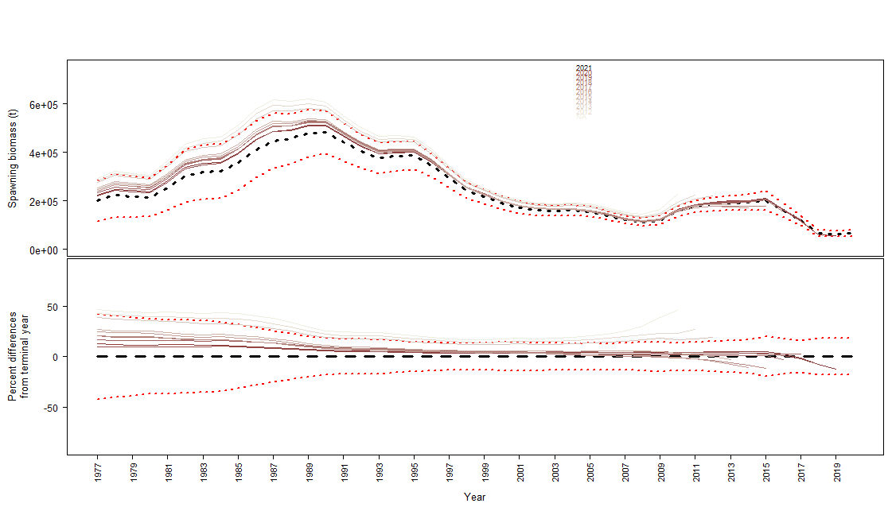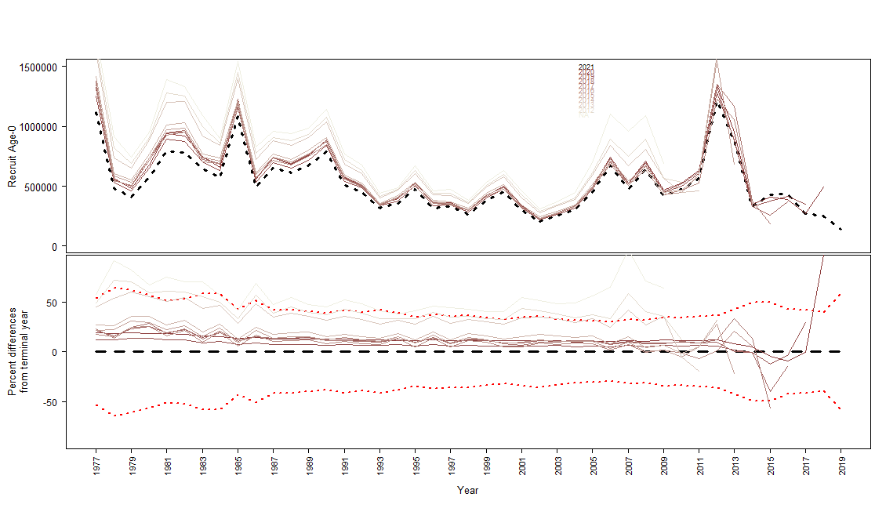

Figure 2.56 Retrospective analysis for Model 21.1 for female spawning biomass (top) and age-0 recruitment (bottom)..

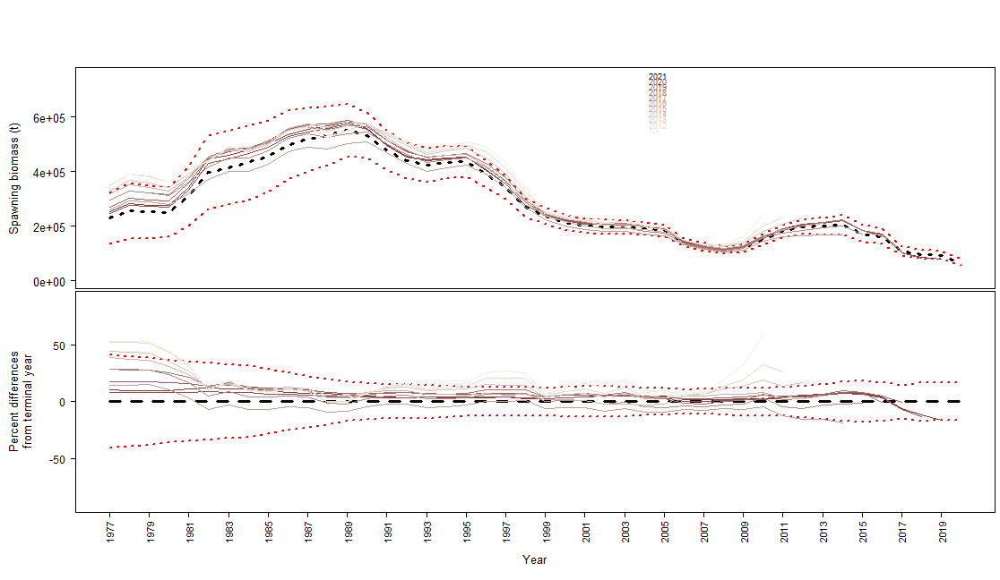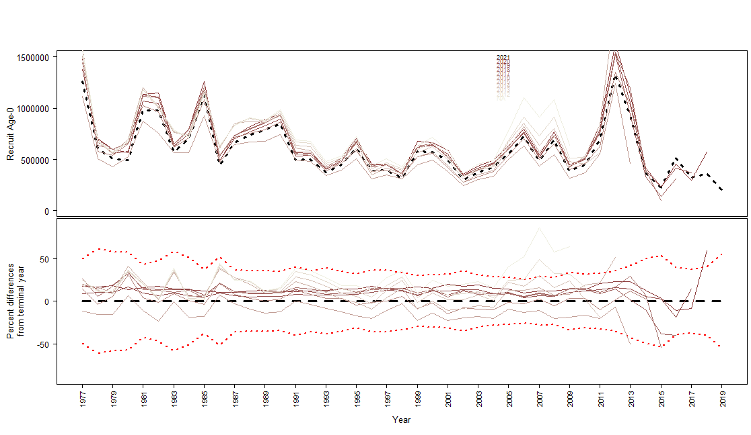

Figure 2.57 Retrospective analysis for Model 21.2 for female spawning biomass (top) and age-0 recruitment (bottom)..

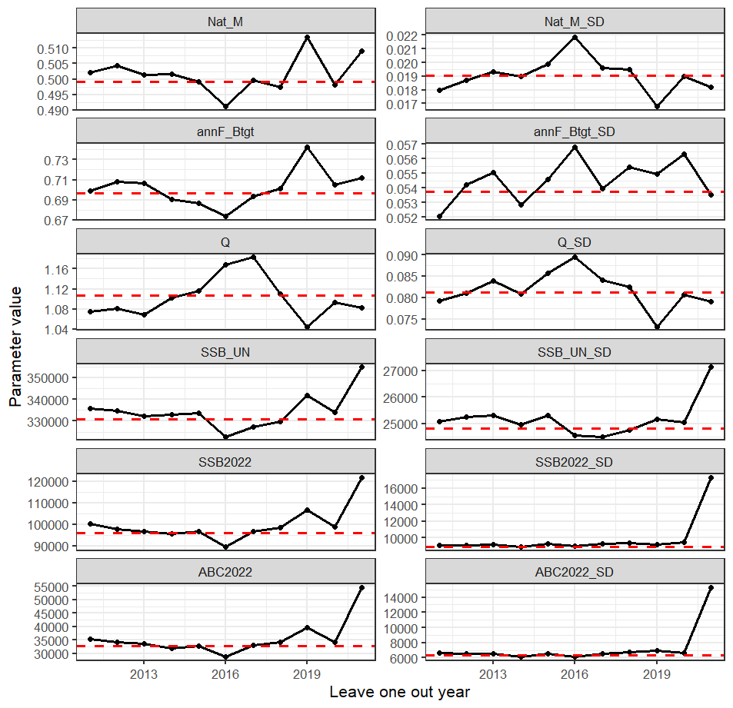

Figure 2.58 Model 19.1 leave-one-out analysis showing parameters and derived quantities as one year of data were removed from the model fit. Nat_M is the base natural mortality, annF_Btgt is the F40%, SSB_UN is the unfished spawning biomass, SSB2022 is the total spawning biomass for 2022 and ABC2022 is the estimated ABC for 2022. The SDs are the standard deviations of the estimates.

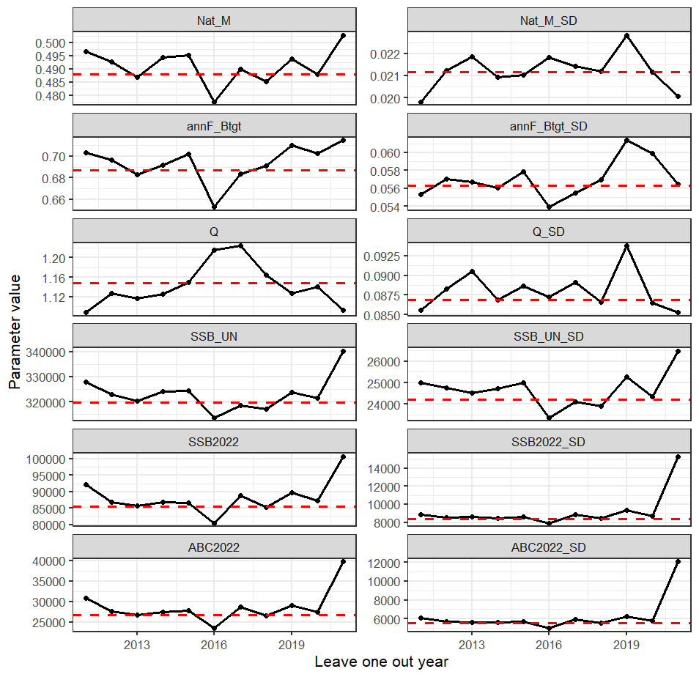

Figure 2.59 Model 21.1 leave-one-out analysis showing parameters and derived quantities as one year of data were removed from the model fit. Nat_M is the base natural mortality, annF_Btgt is the F40%, SSB_UN is the unfished spawning biomass, SSB2022 is the total spawning biomass for 2022 and ABC2022 is the estimated ABC for 2022. The SDs are the standard deviations of the estimates.

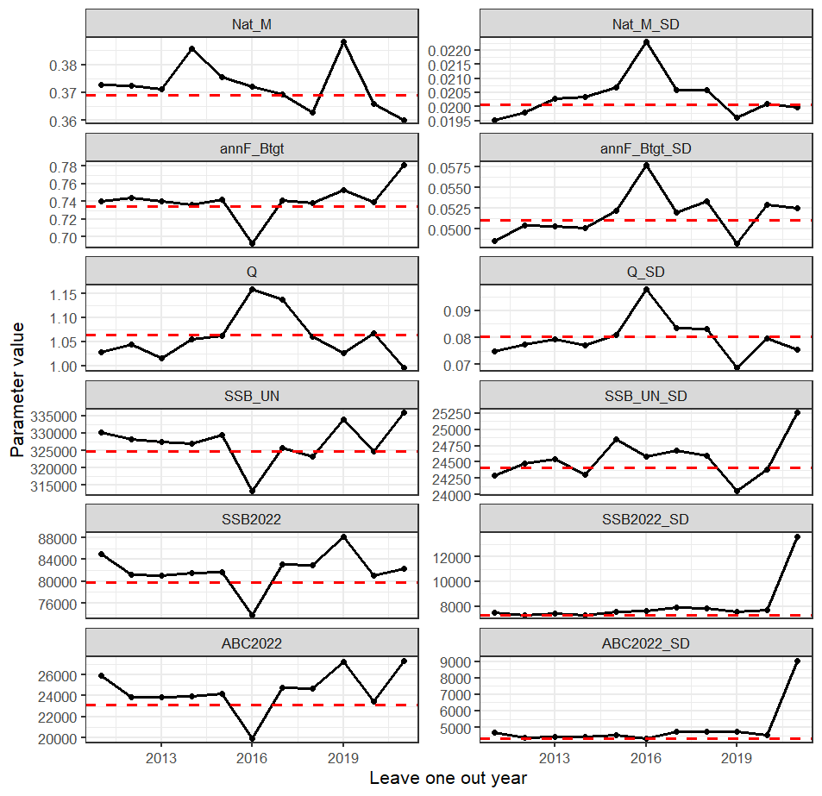

Figure 2.60 Model 21.2 leave-one-out analysis showing parameters and derived quantities as one year of data were removed from the model fit. Nat_M is the base natural mortality, annF_Btgt is the F40%, SSB_UN is the unfished spawning biomass, SSB2022 is the total spawning biomass for 2022 and ABC2022 is the estimated ABC for 2022. The SDs are the standard deviations of the estimates.

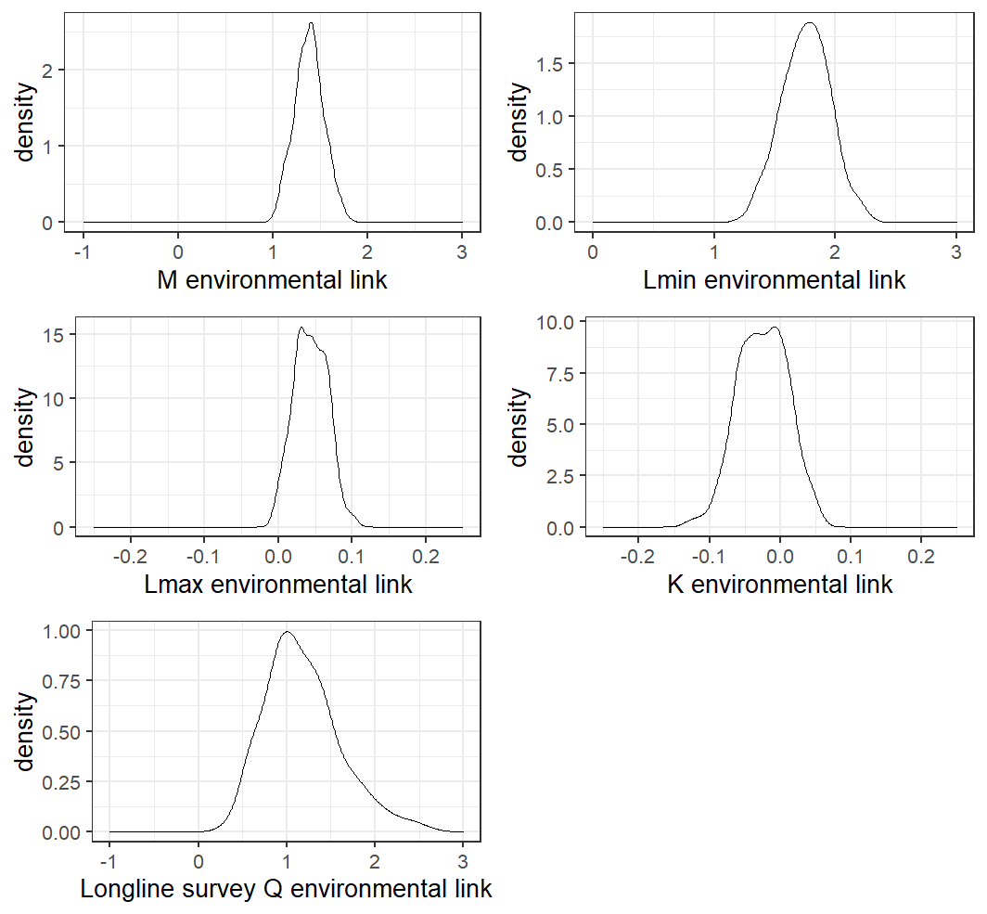

Figure 2.61 MCMC posterior distributions for the environmental link scaling parameters from Model 21.2 with uninformative priors.

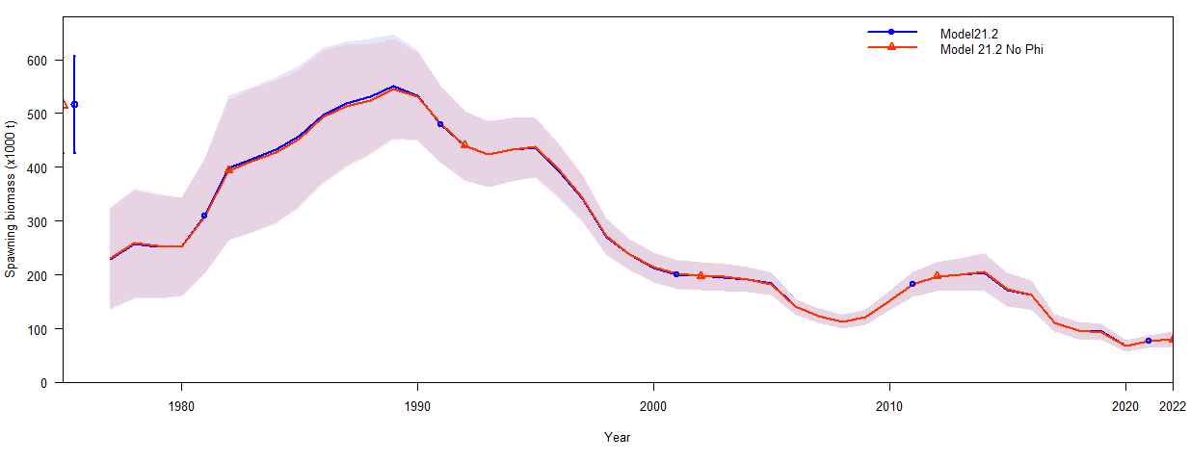

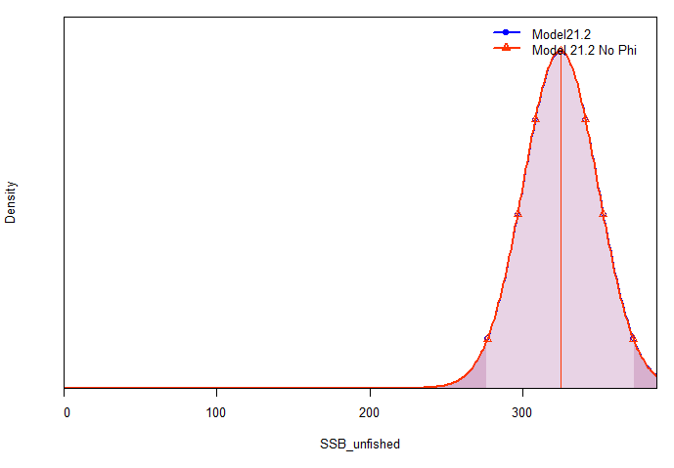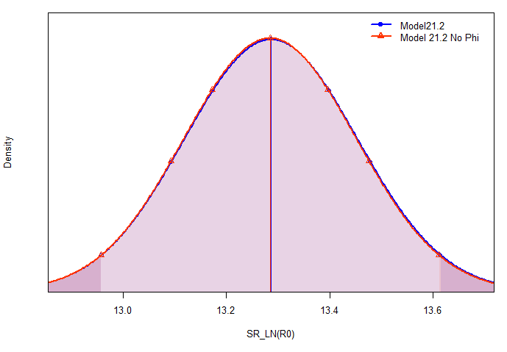

Figure 2.62 Model results from Model 21.2 with and without the ϕ link to K including total spawning biomass (top), unfished spawning biomass (bottom left), and the log of R0 (bottom right).

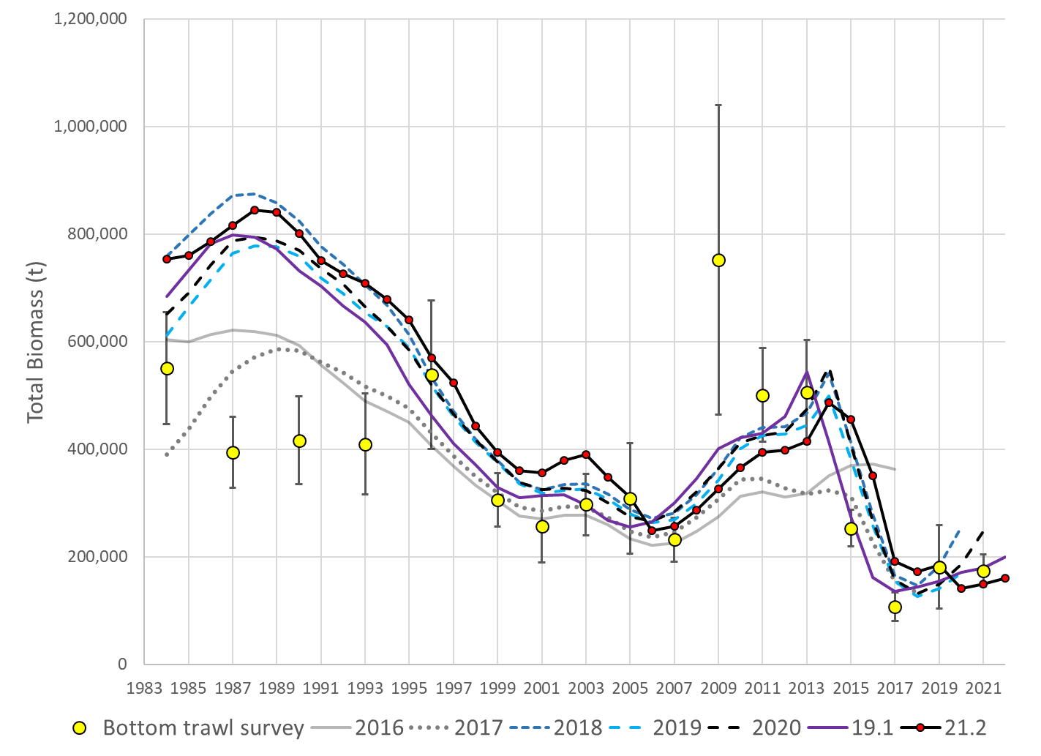

Figure 2.63 Total biomass estimates from reviewed models and NMFS bottom trawl survey biomass estimates with 95% confidence bounds.

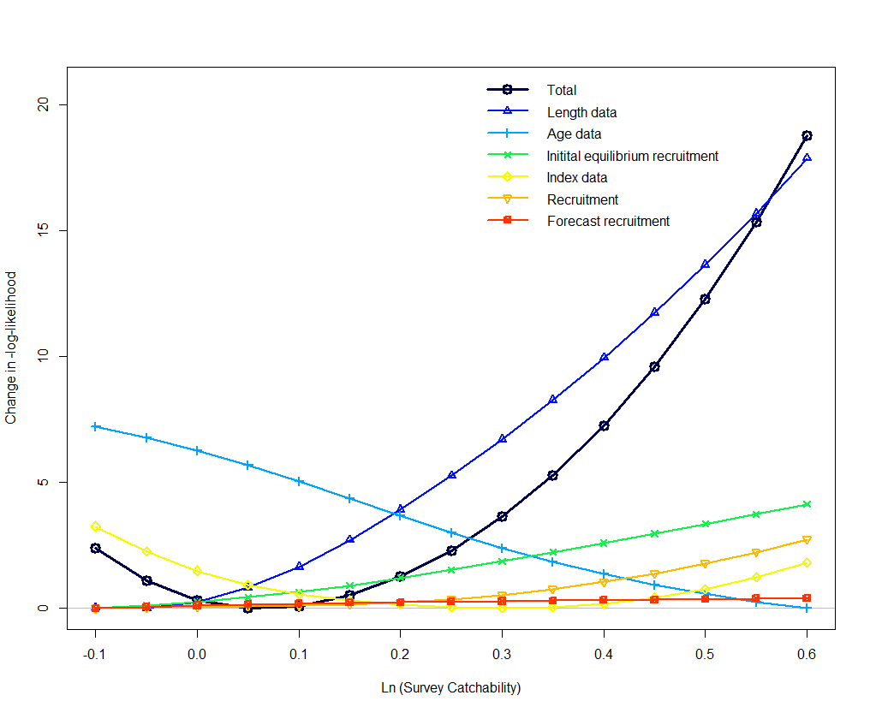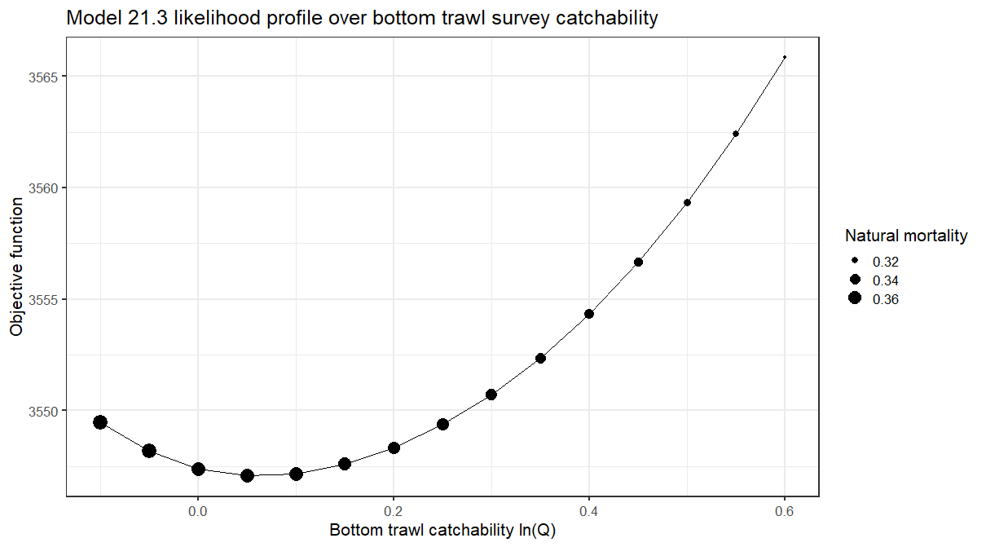

Figure 2.64 Model 21.2 likelihood profile on bottom trawl survey catchability.

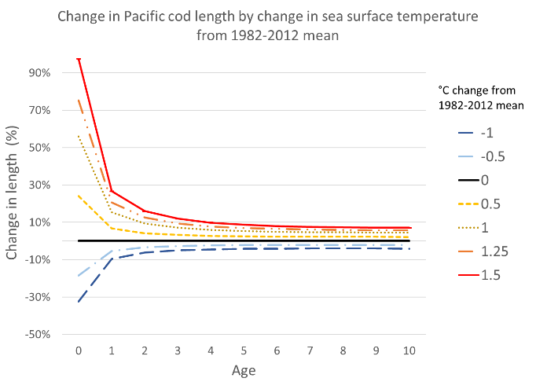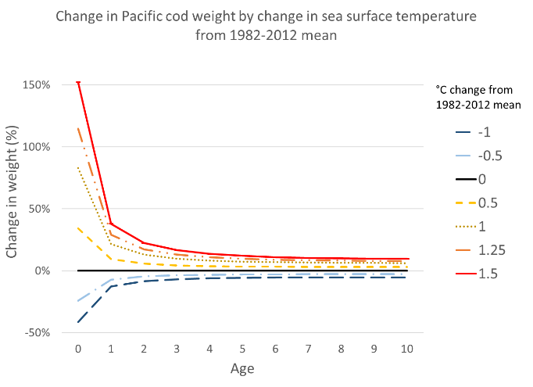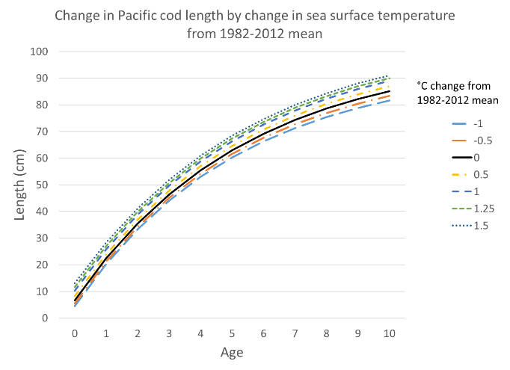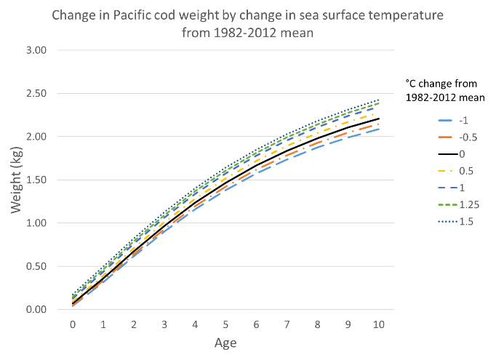

Figure 2.65 Model 21.2 change in length by age (left) and change in weight by age (right) by temperature anomaly from the 1982-2012 mean.

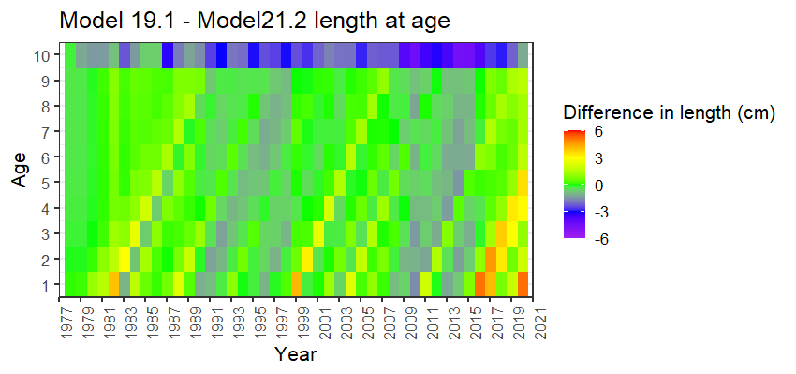

Figure 2.66 Difference in length at age from Model 19.1 with static growth to Model 21.2 with temperature dependent growth.

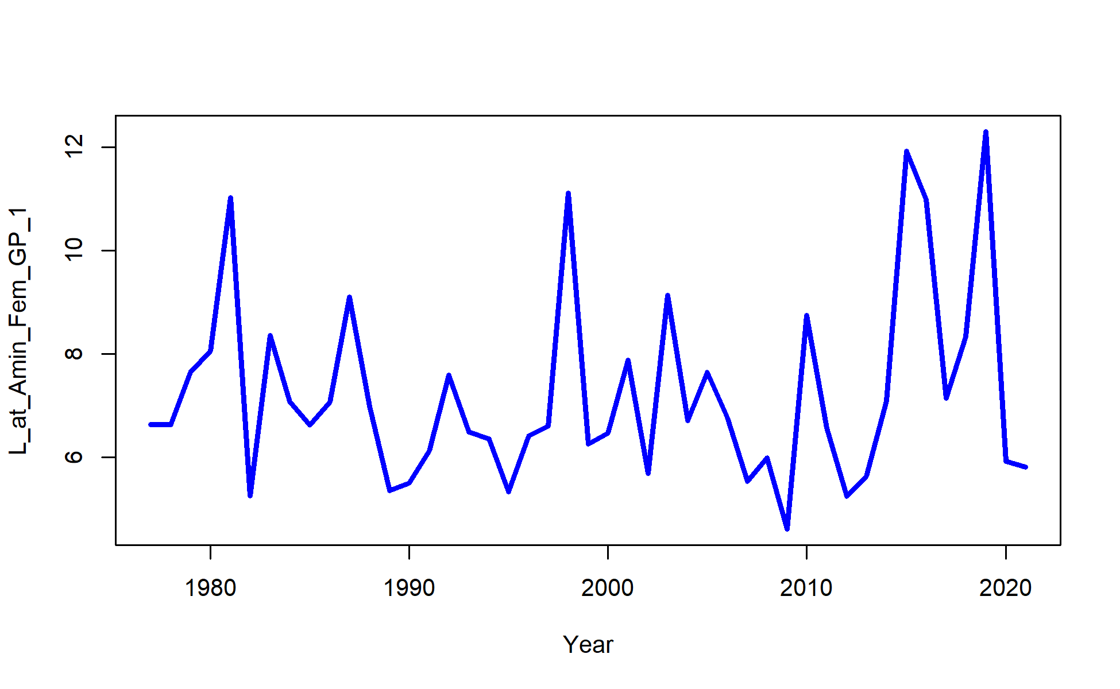

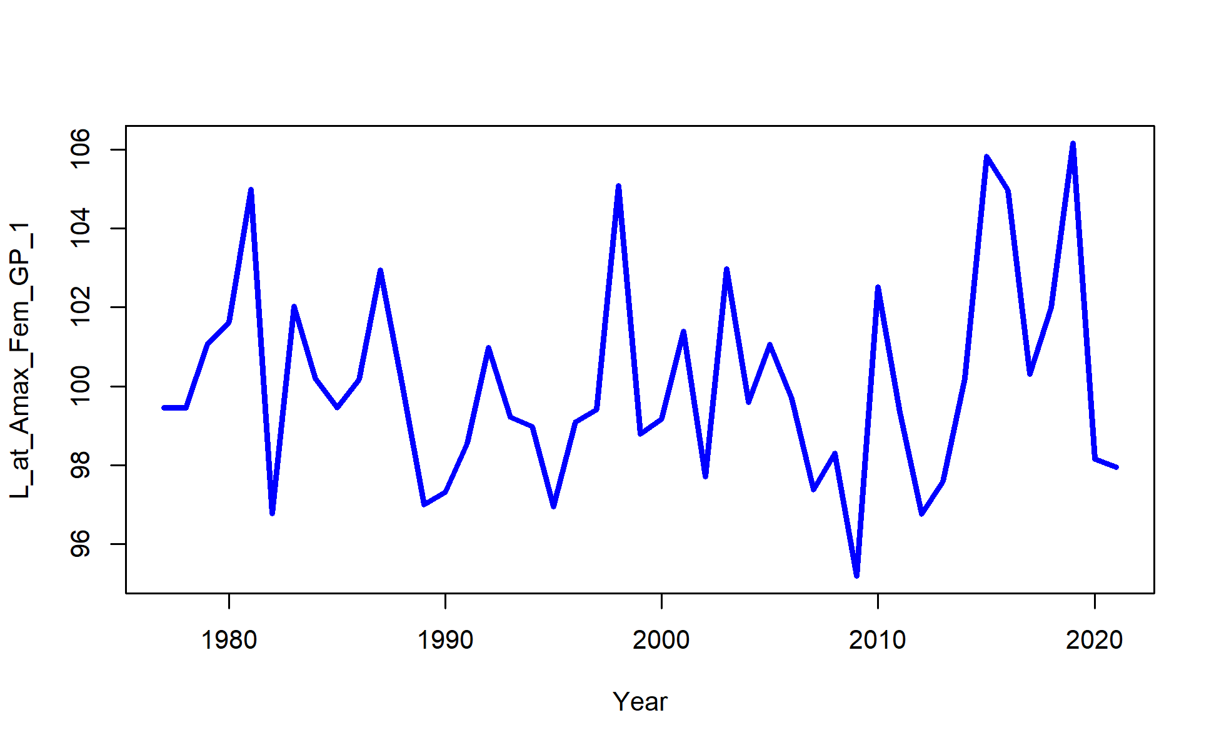

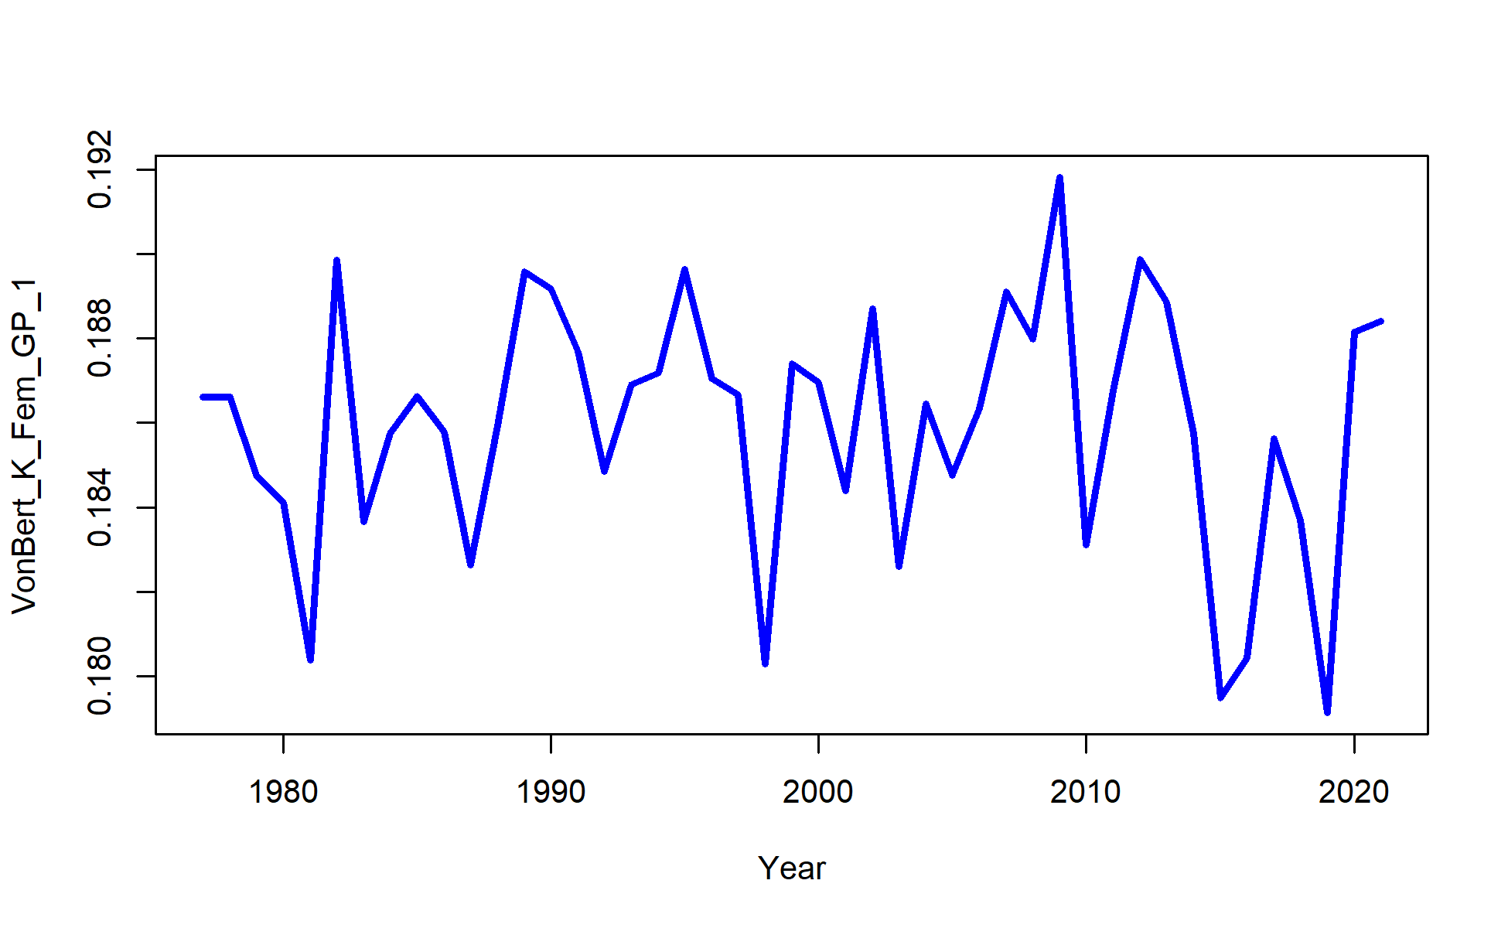

Figure 2.67 Model 21.2 Time-varying growth parameters, L1 (top), L2 (middle), and K (bottom).

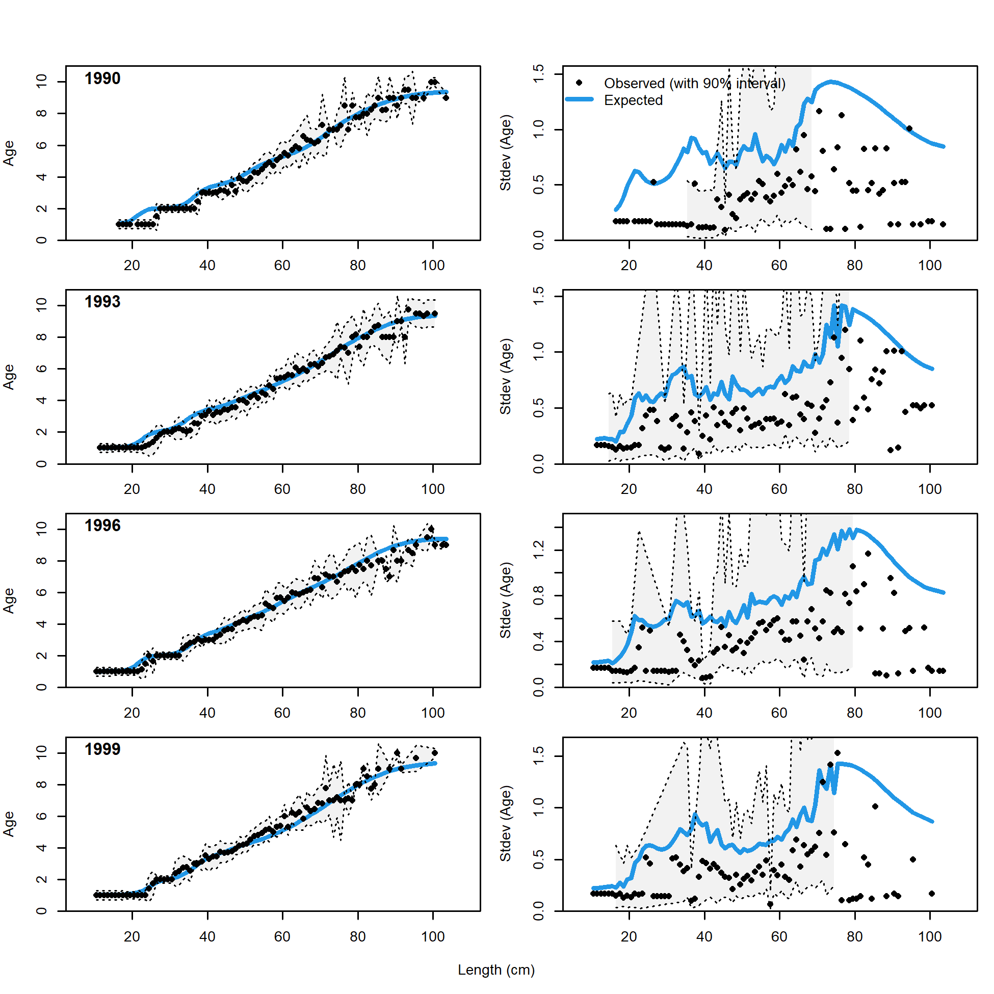 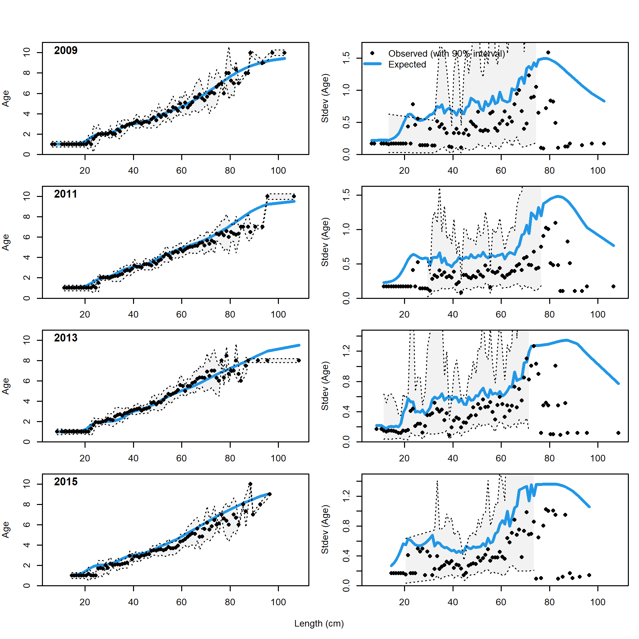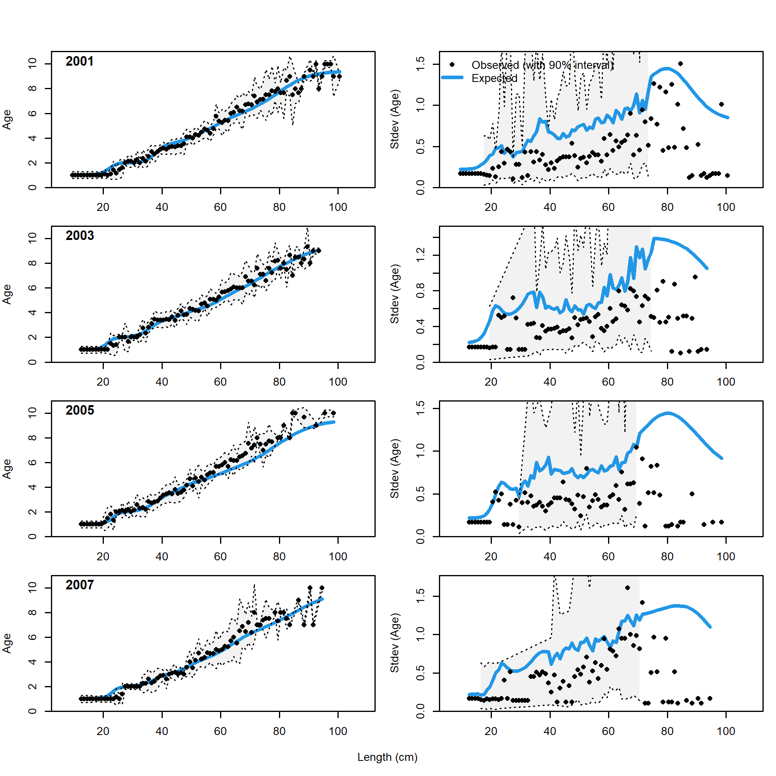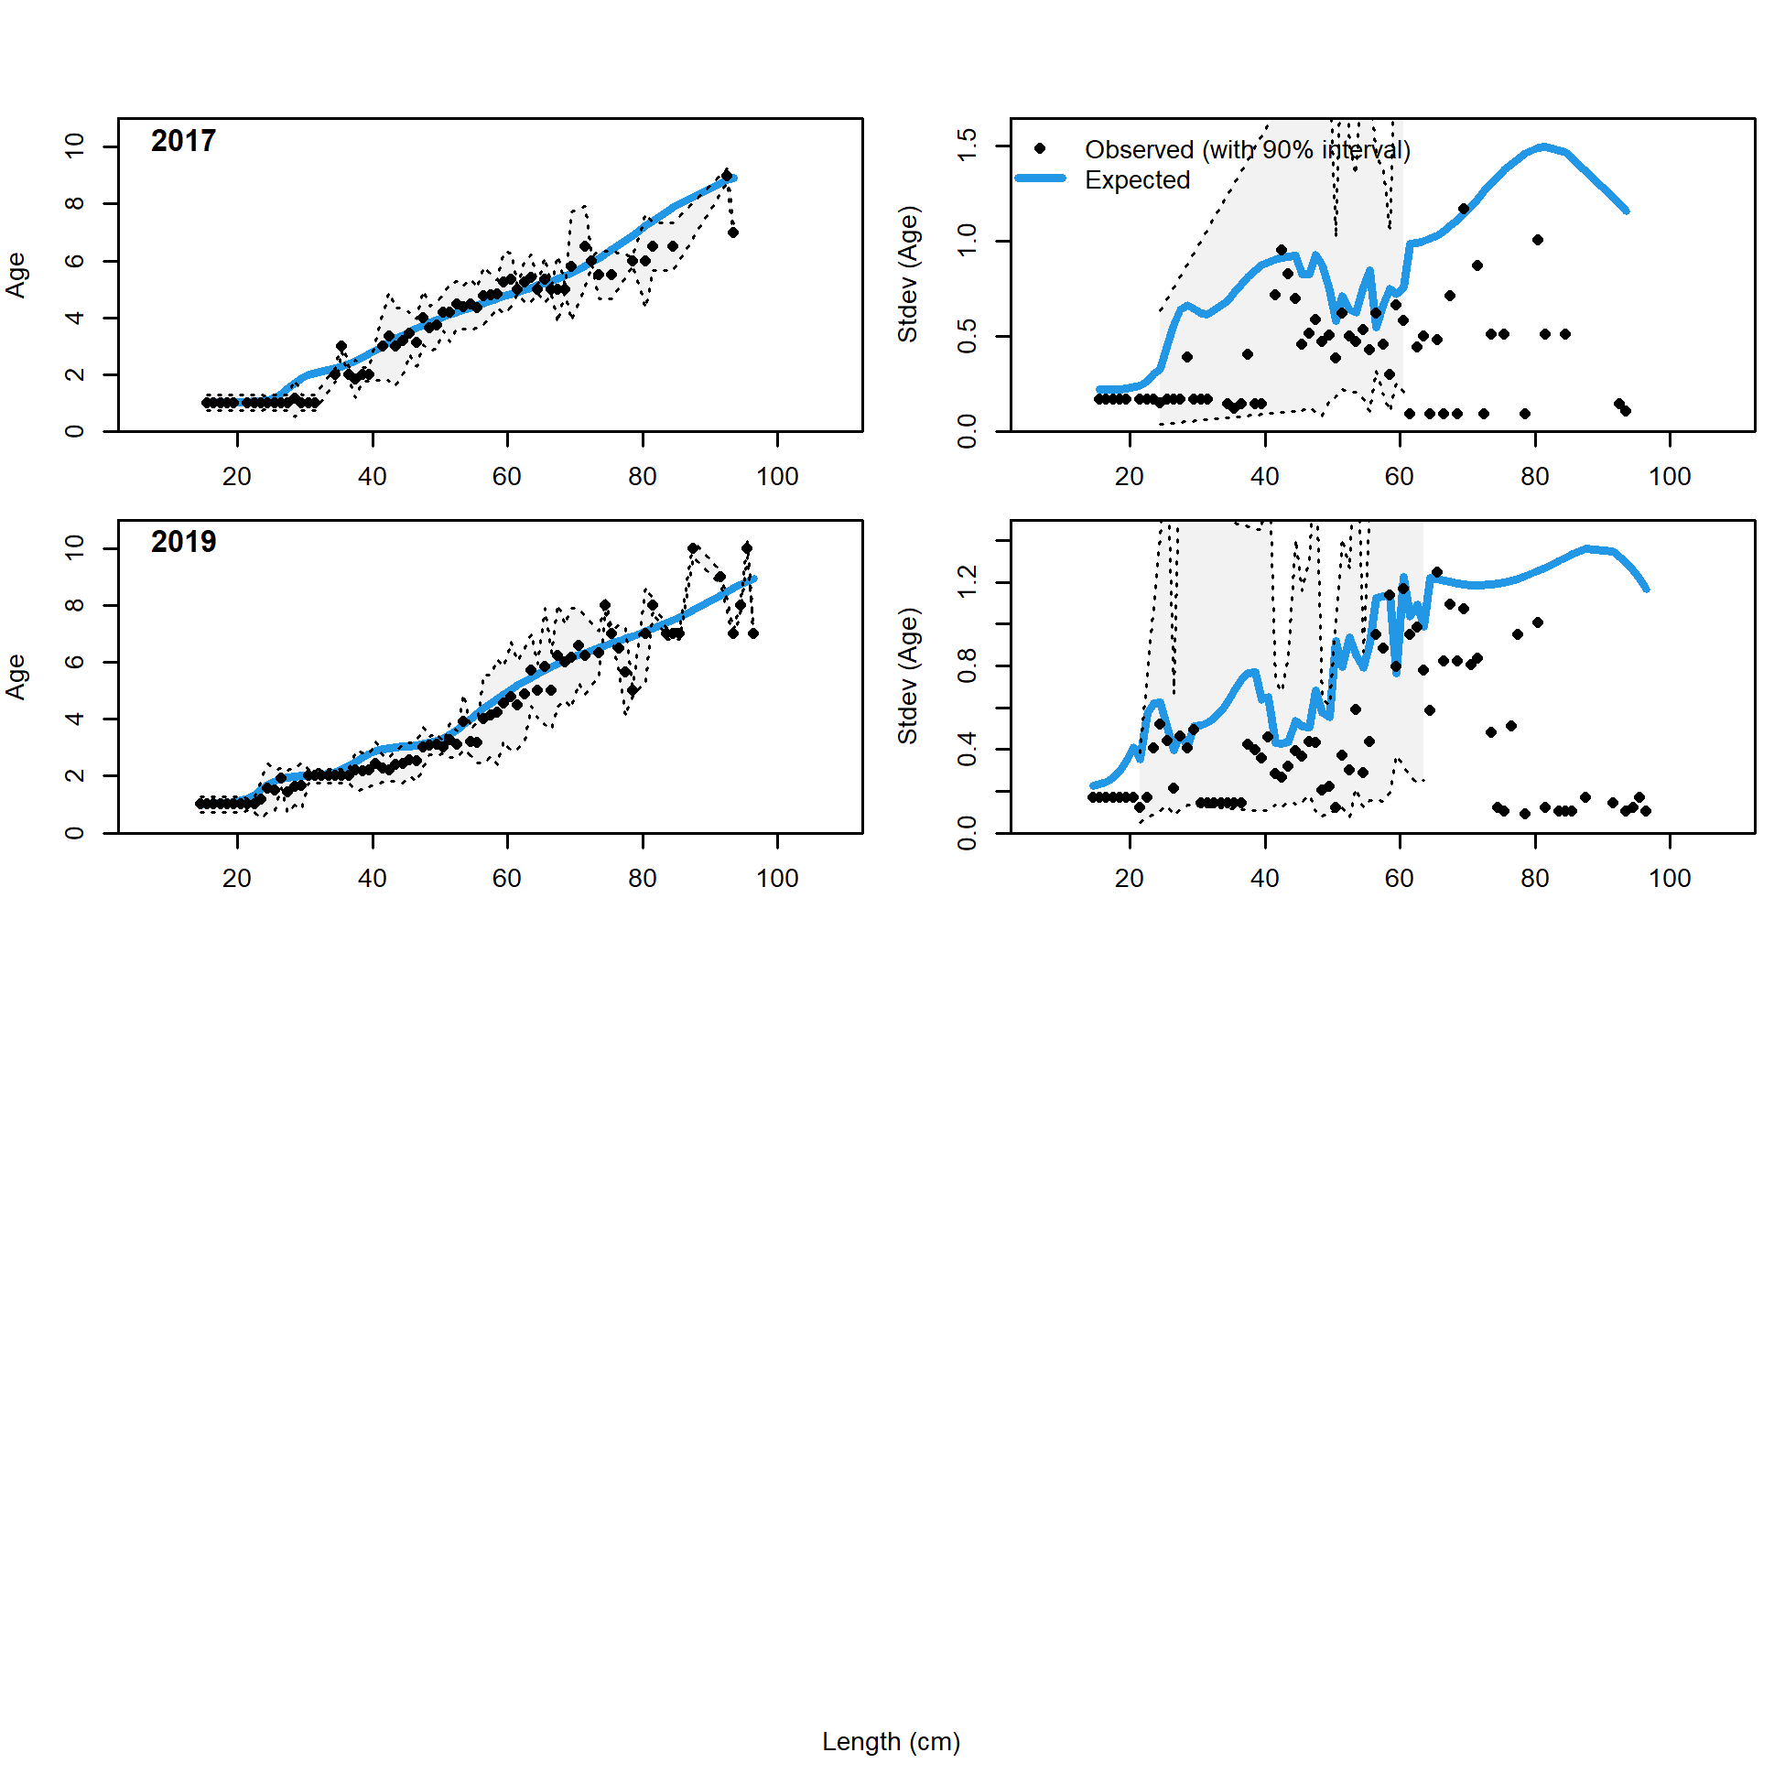

Figure 2.68 NMFS bottom trawl survey conditional age at length data and standard deviation with Model 21.2 fit (blue line).

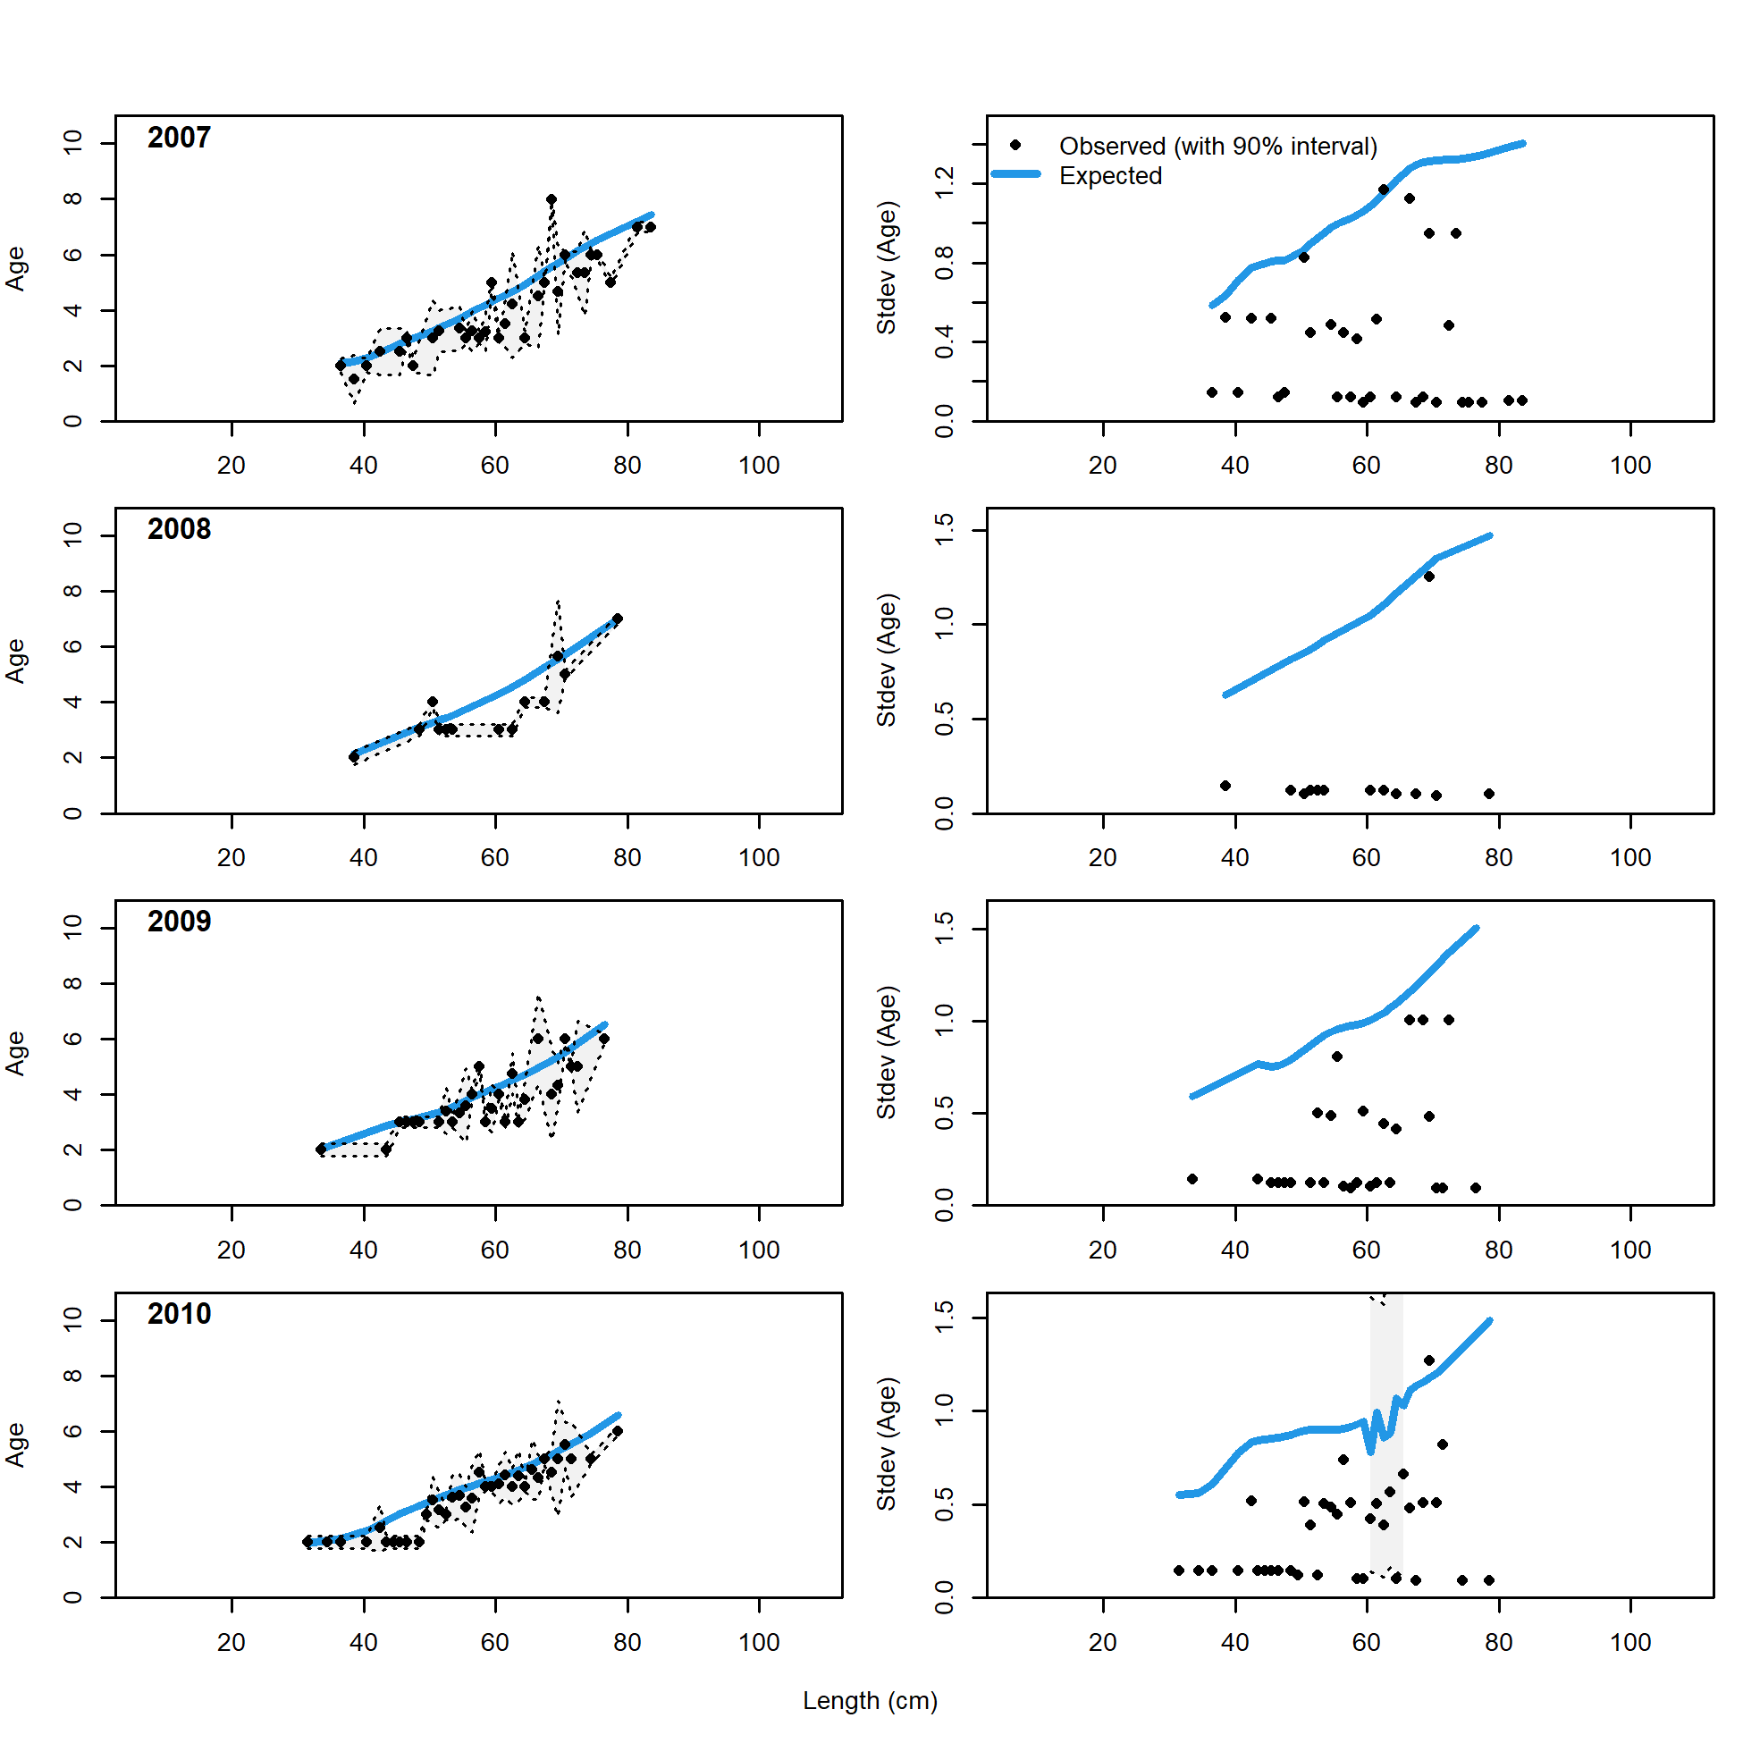 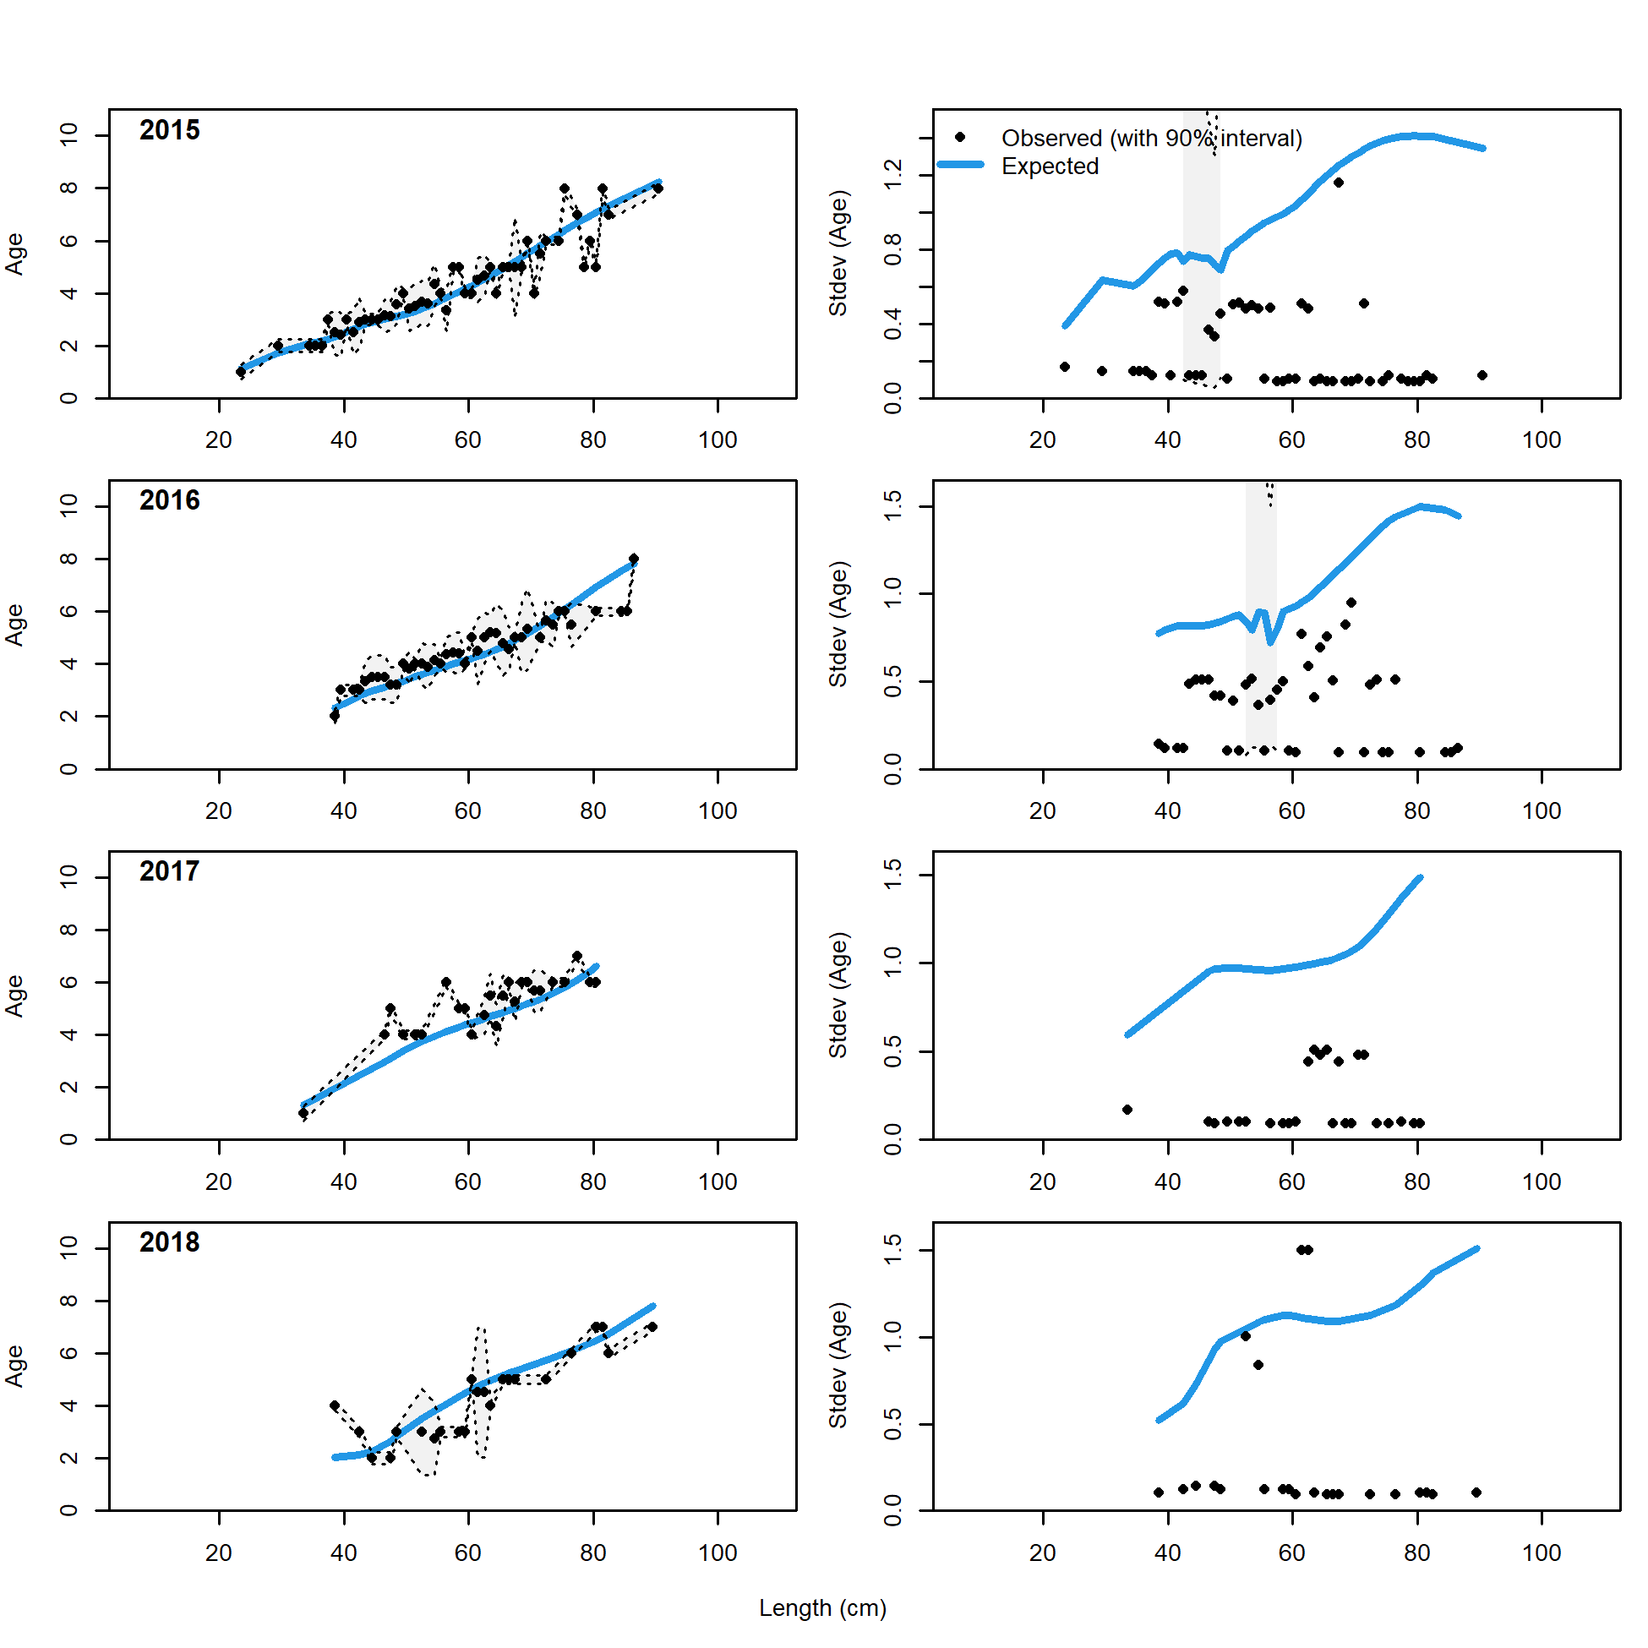

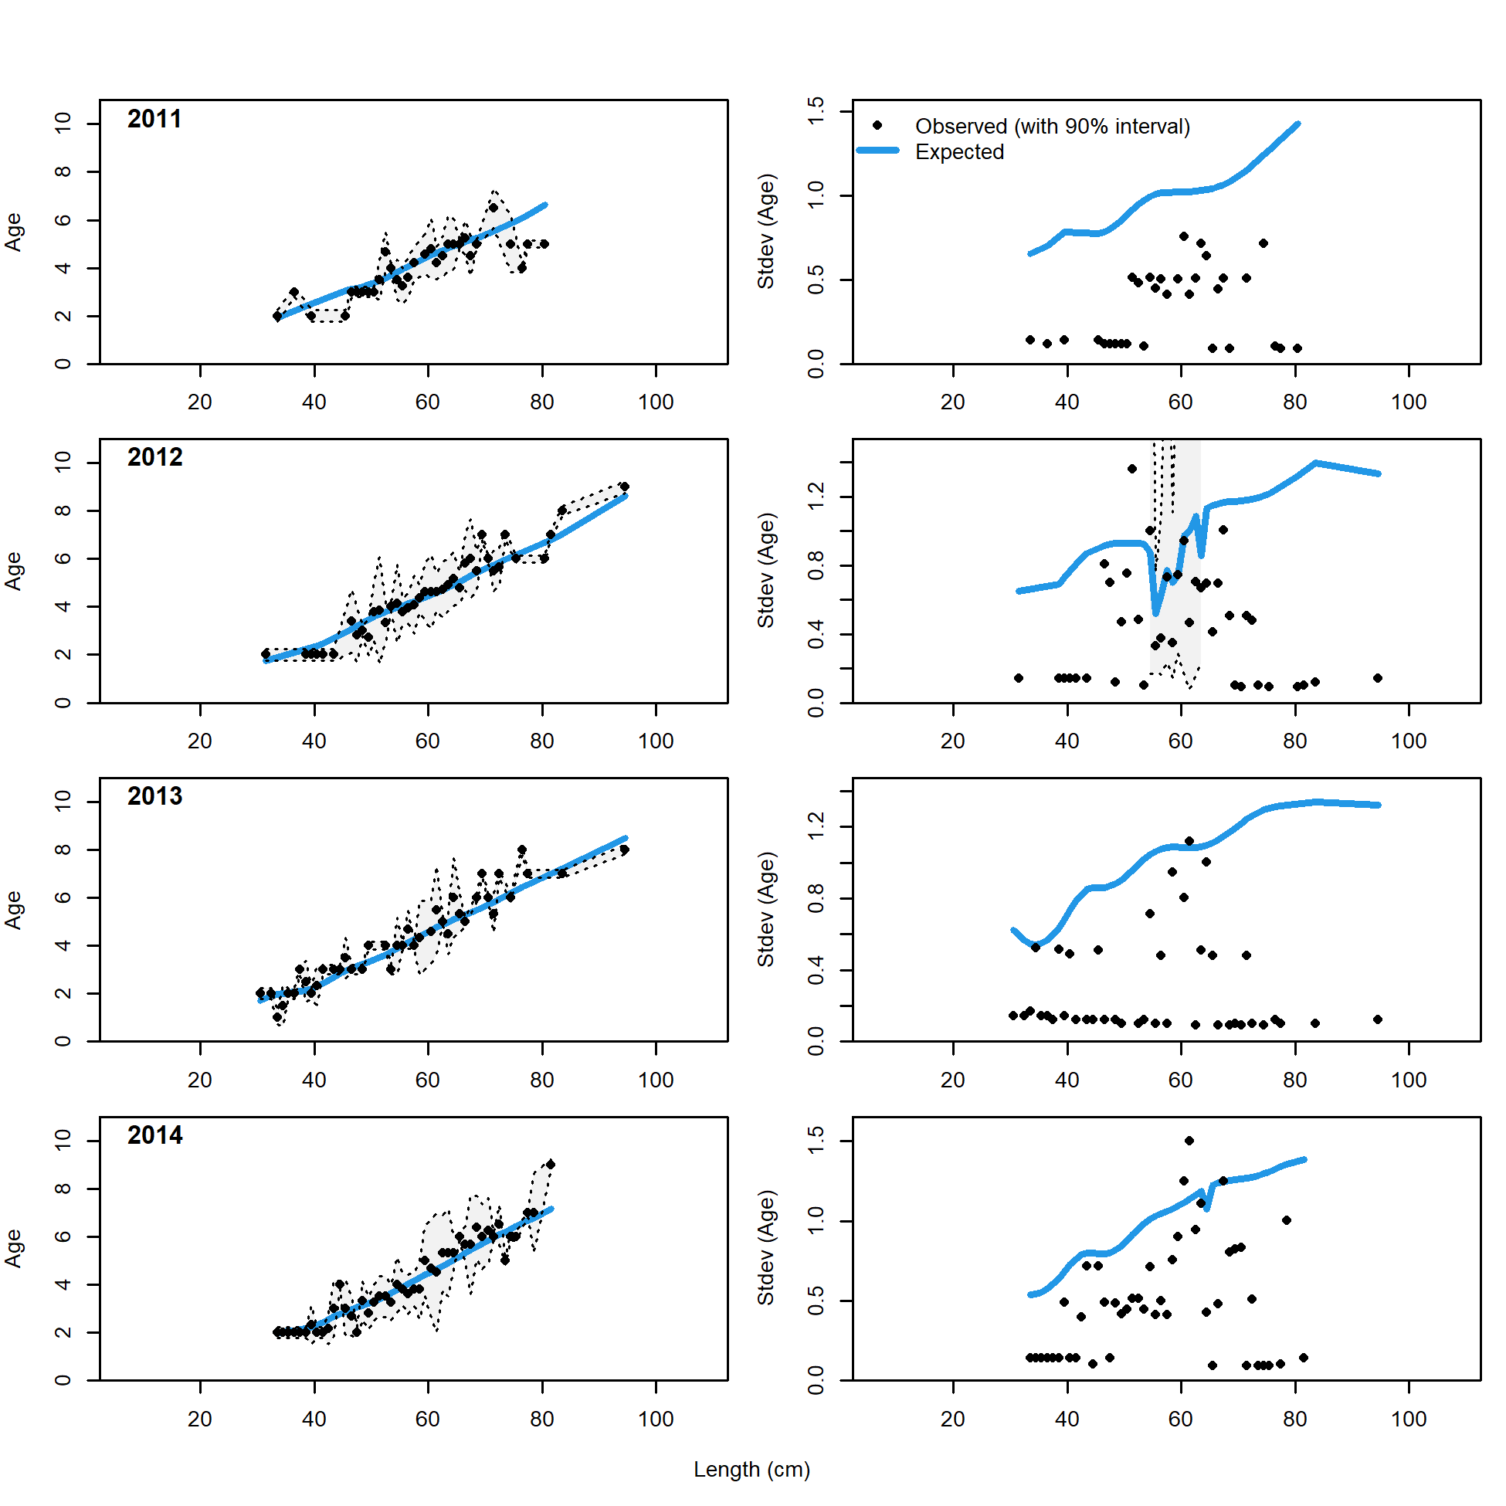 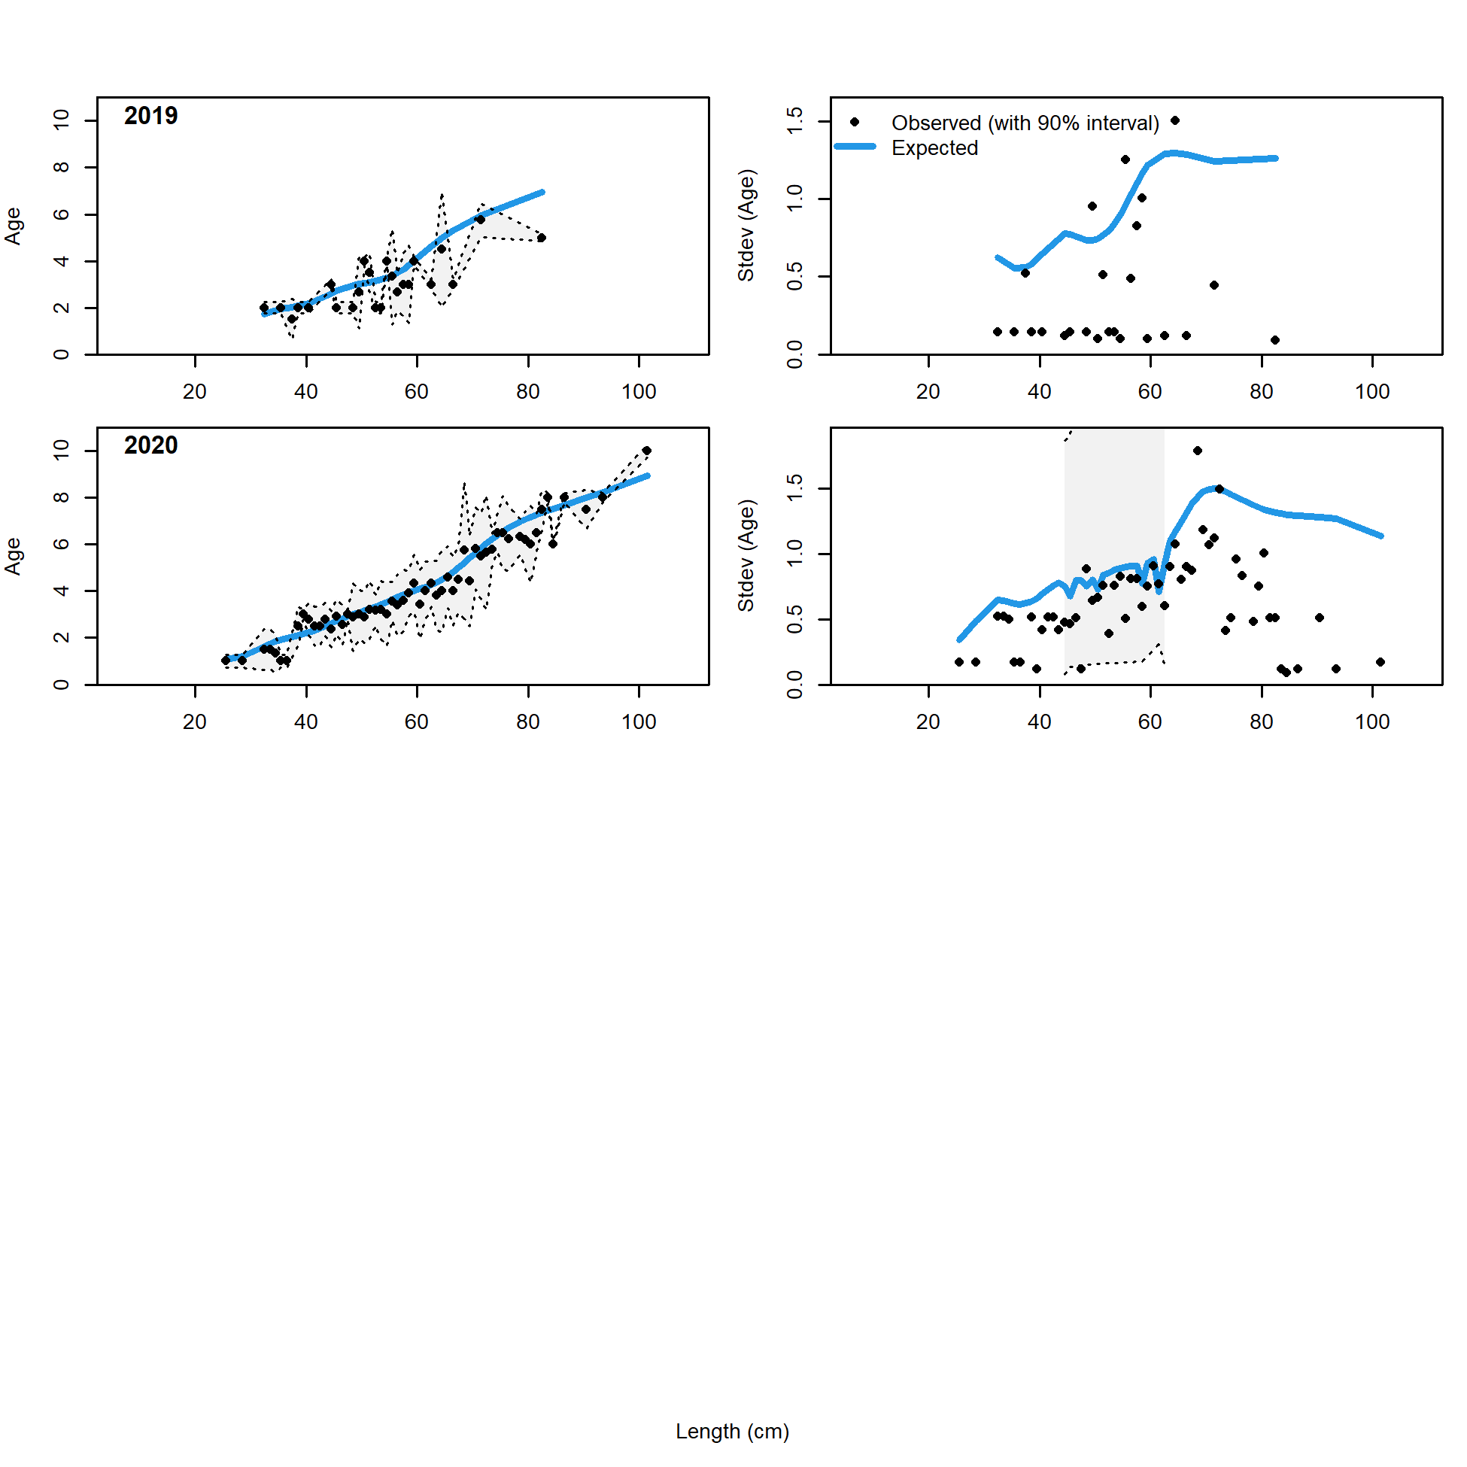

Figure 2.69 Trawl fishery conditional age at length data and standard deviation with Model 21.2 fit (blue line)..

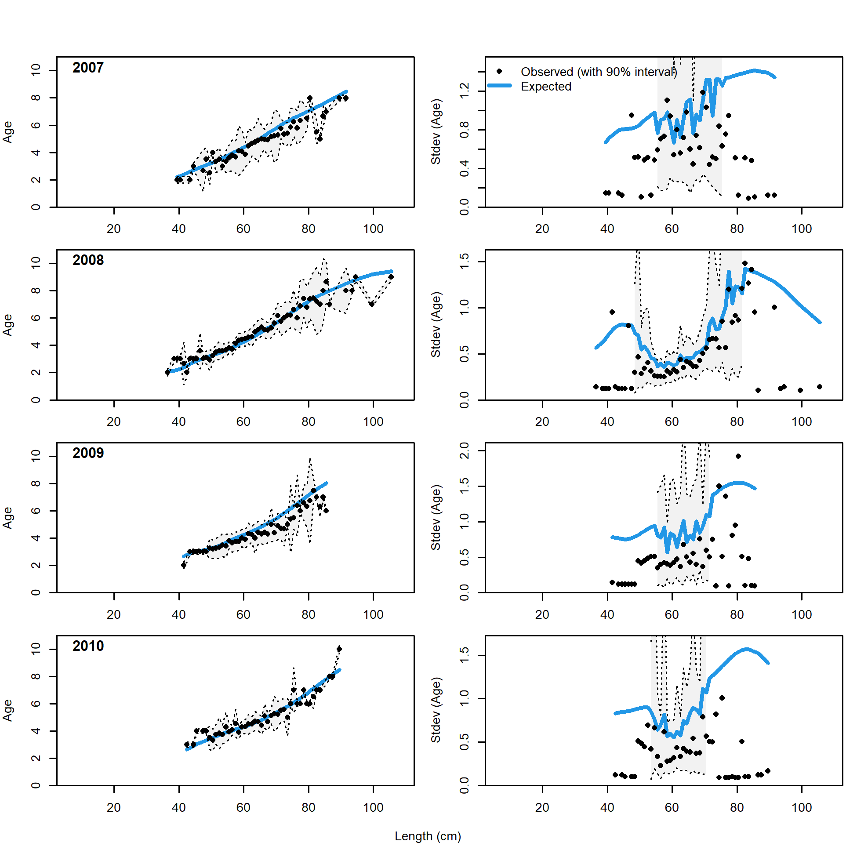 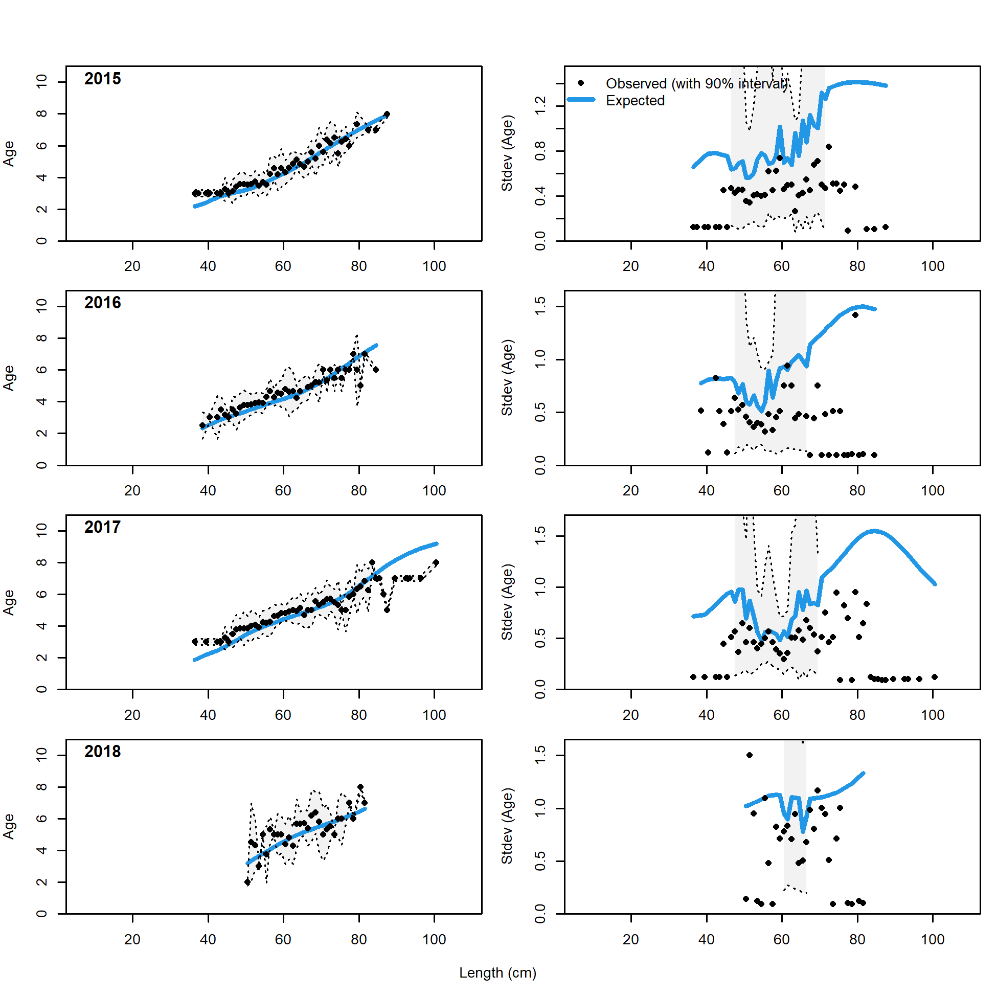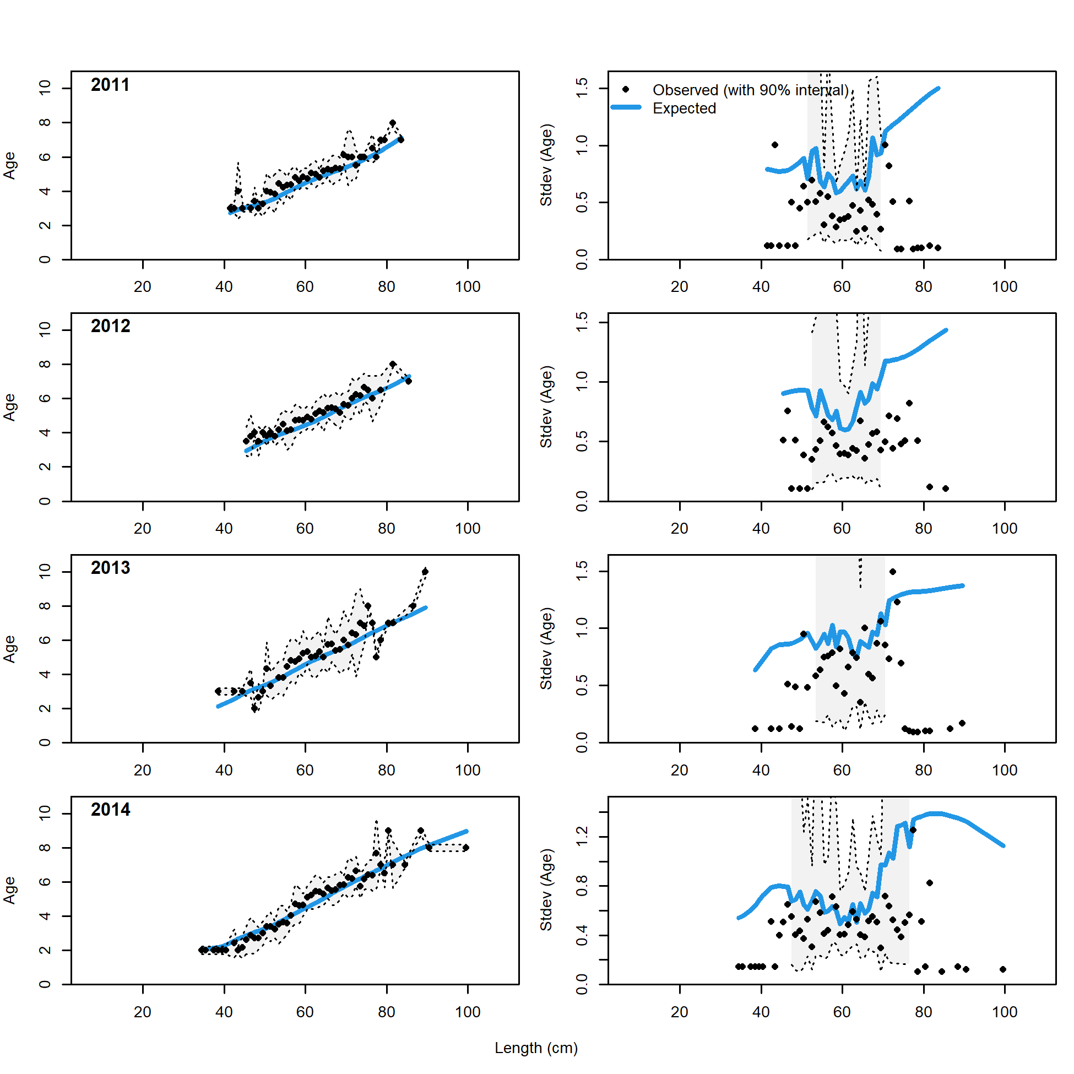 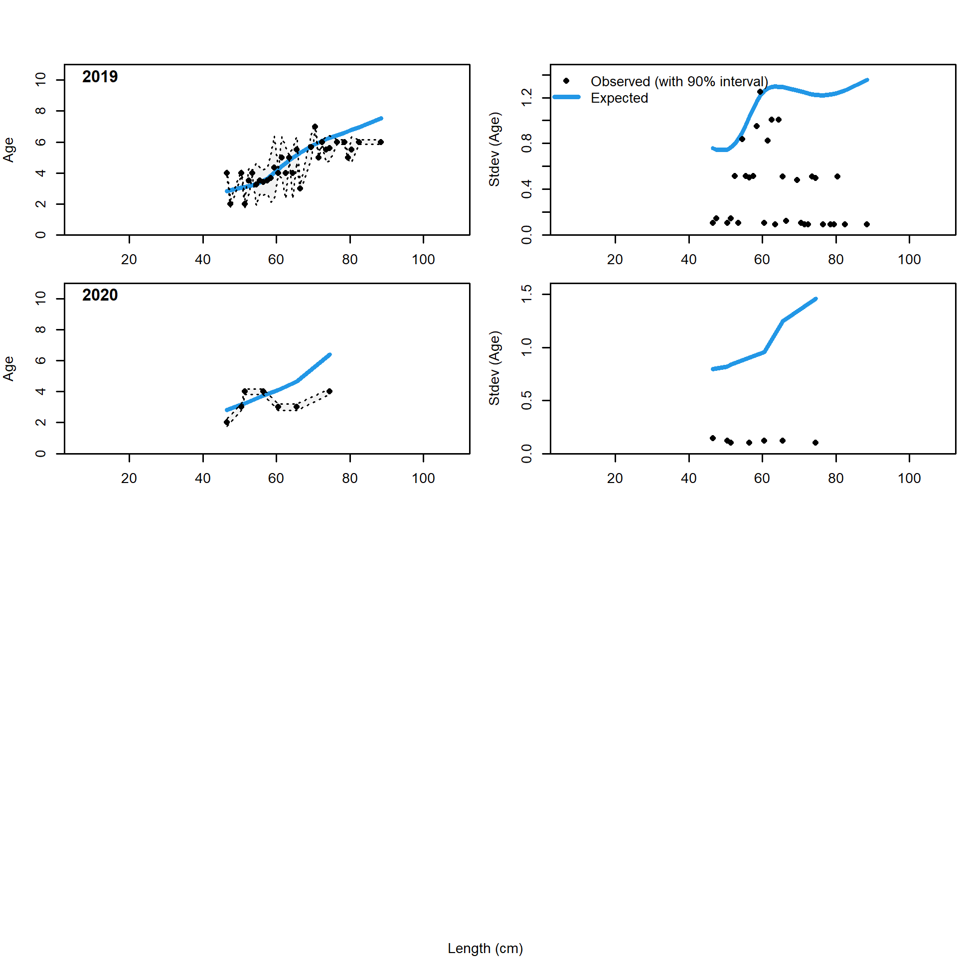

Figure 2.70 Longline fishery conditional age at length data and standard deviation with Model 21.2 fit (blue line)..

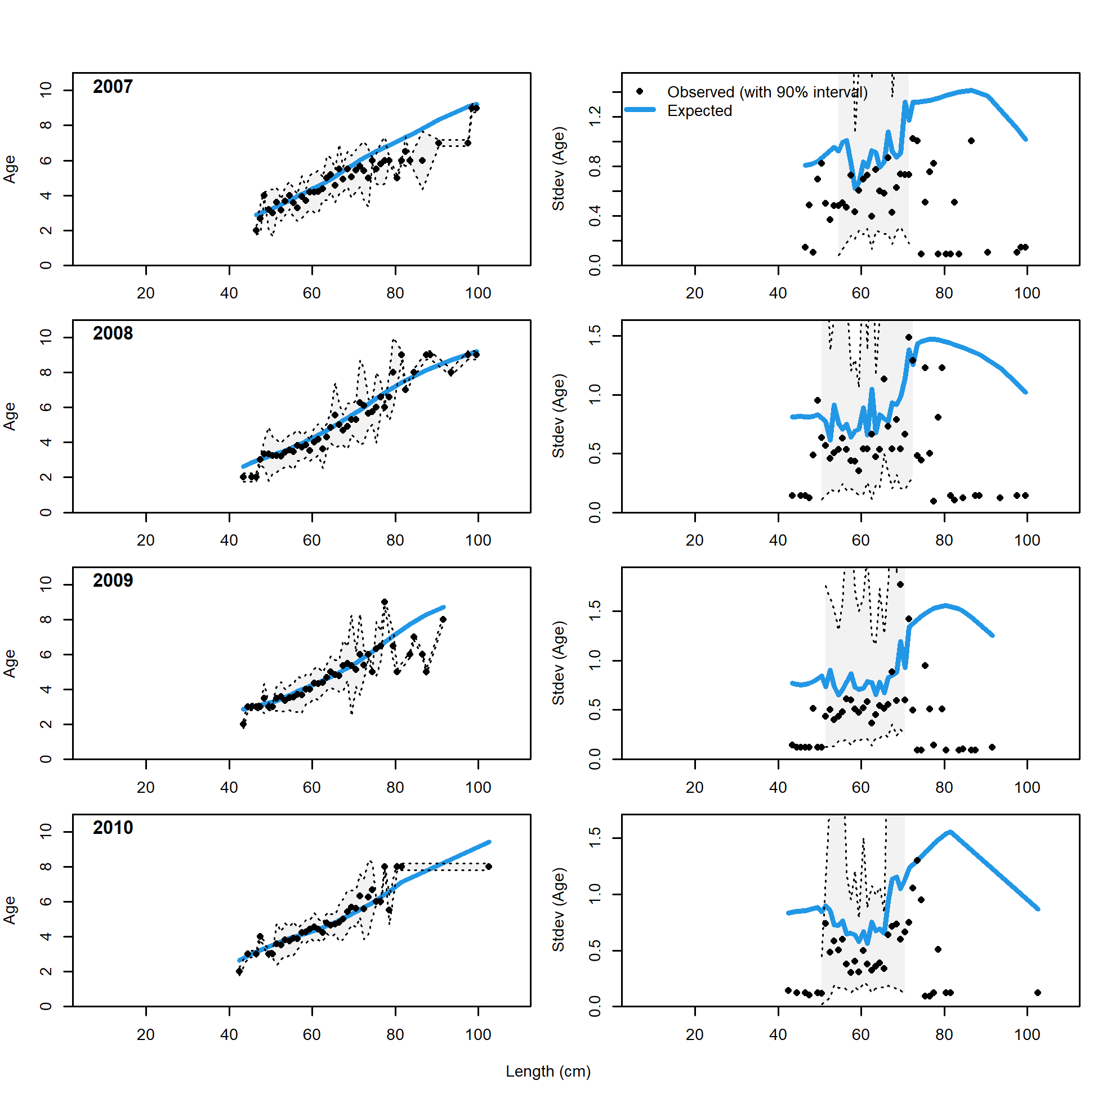 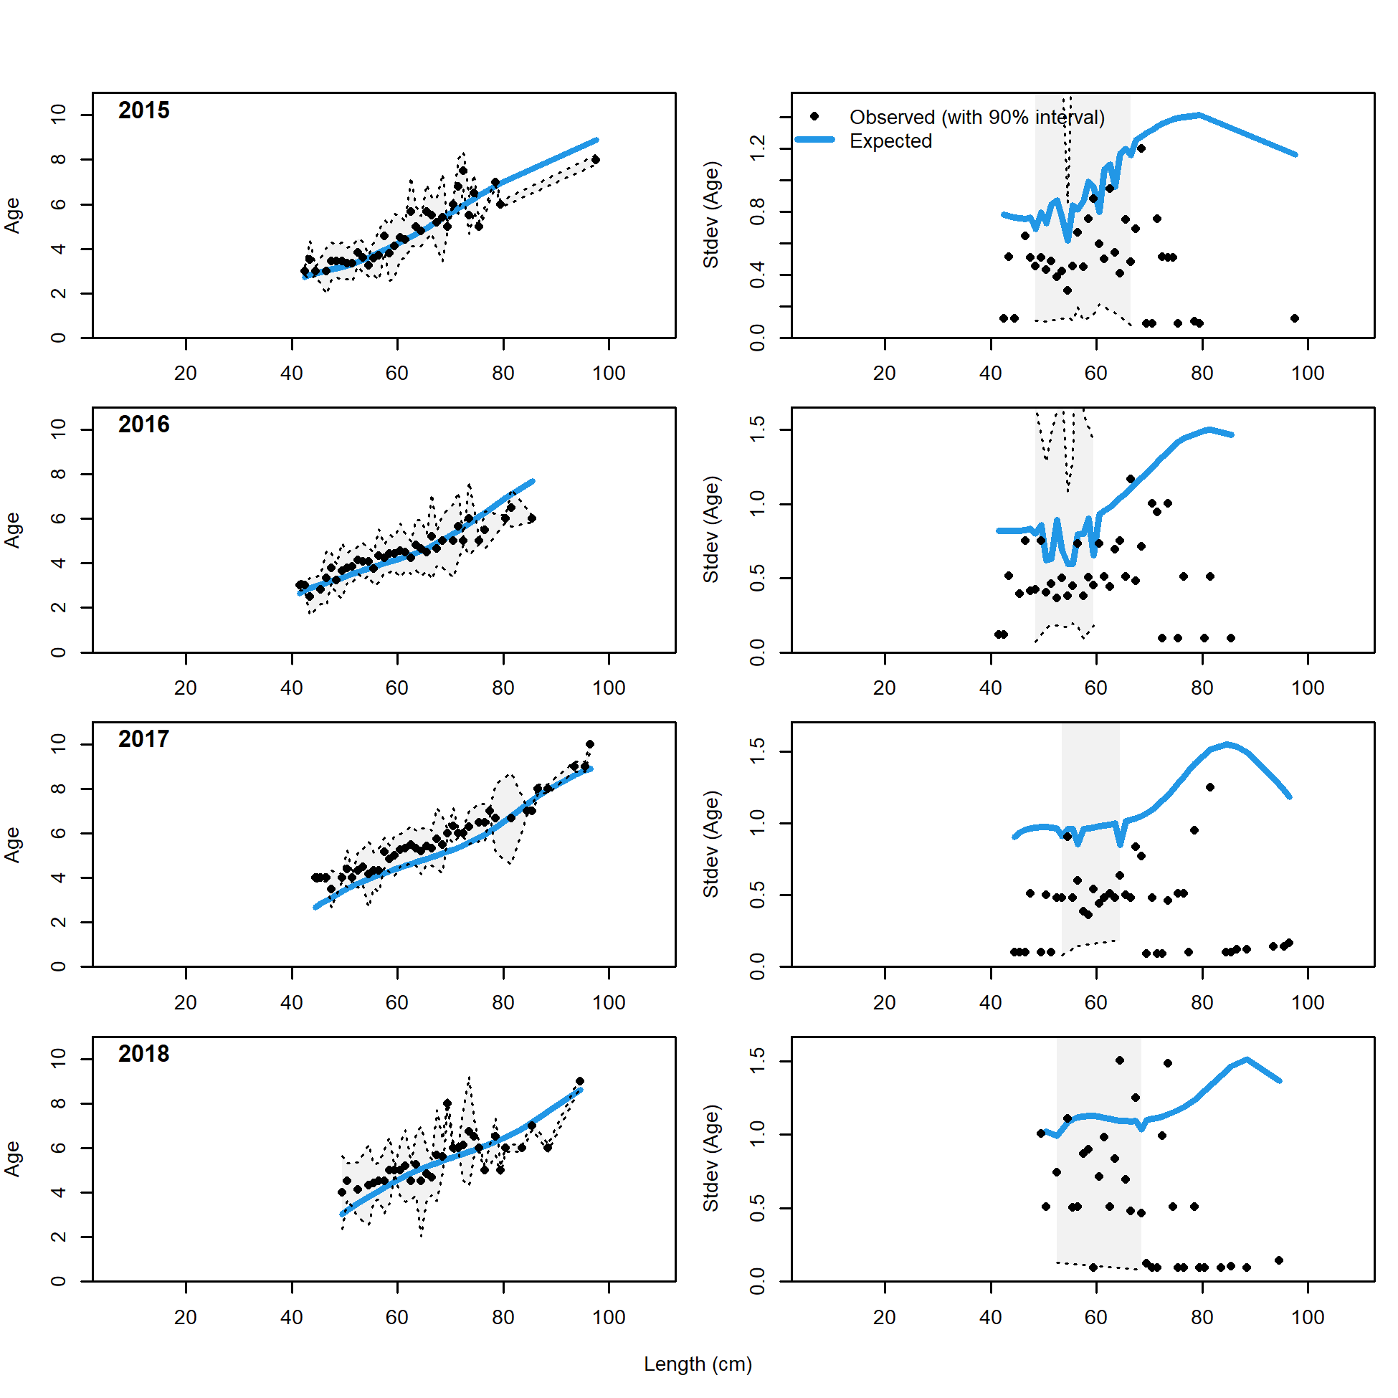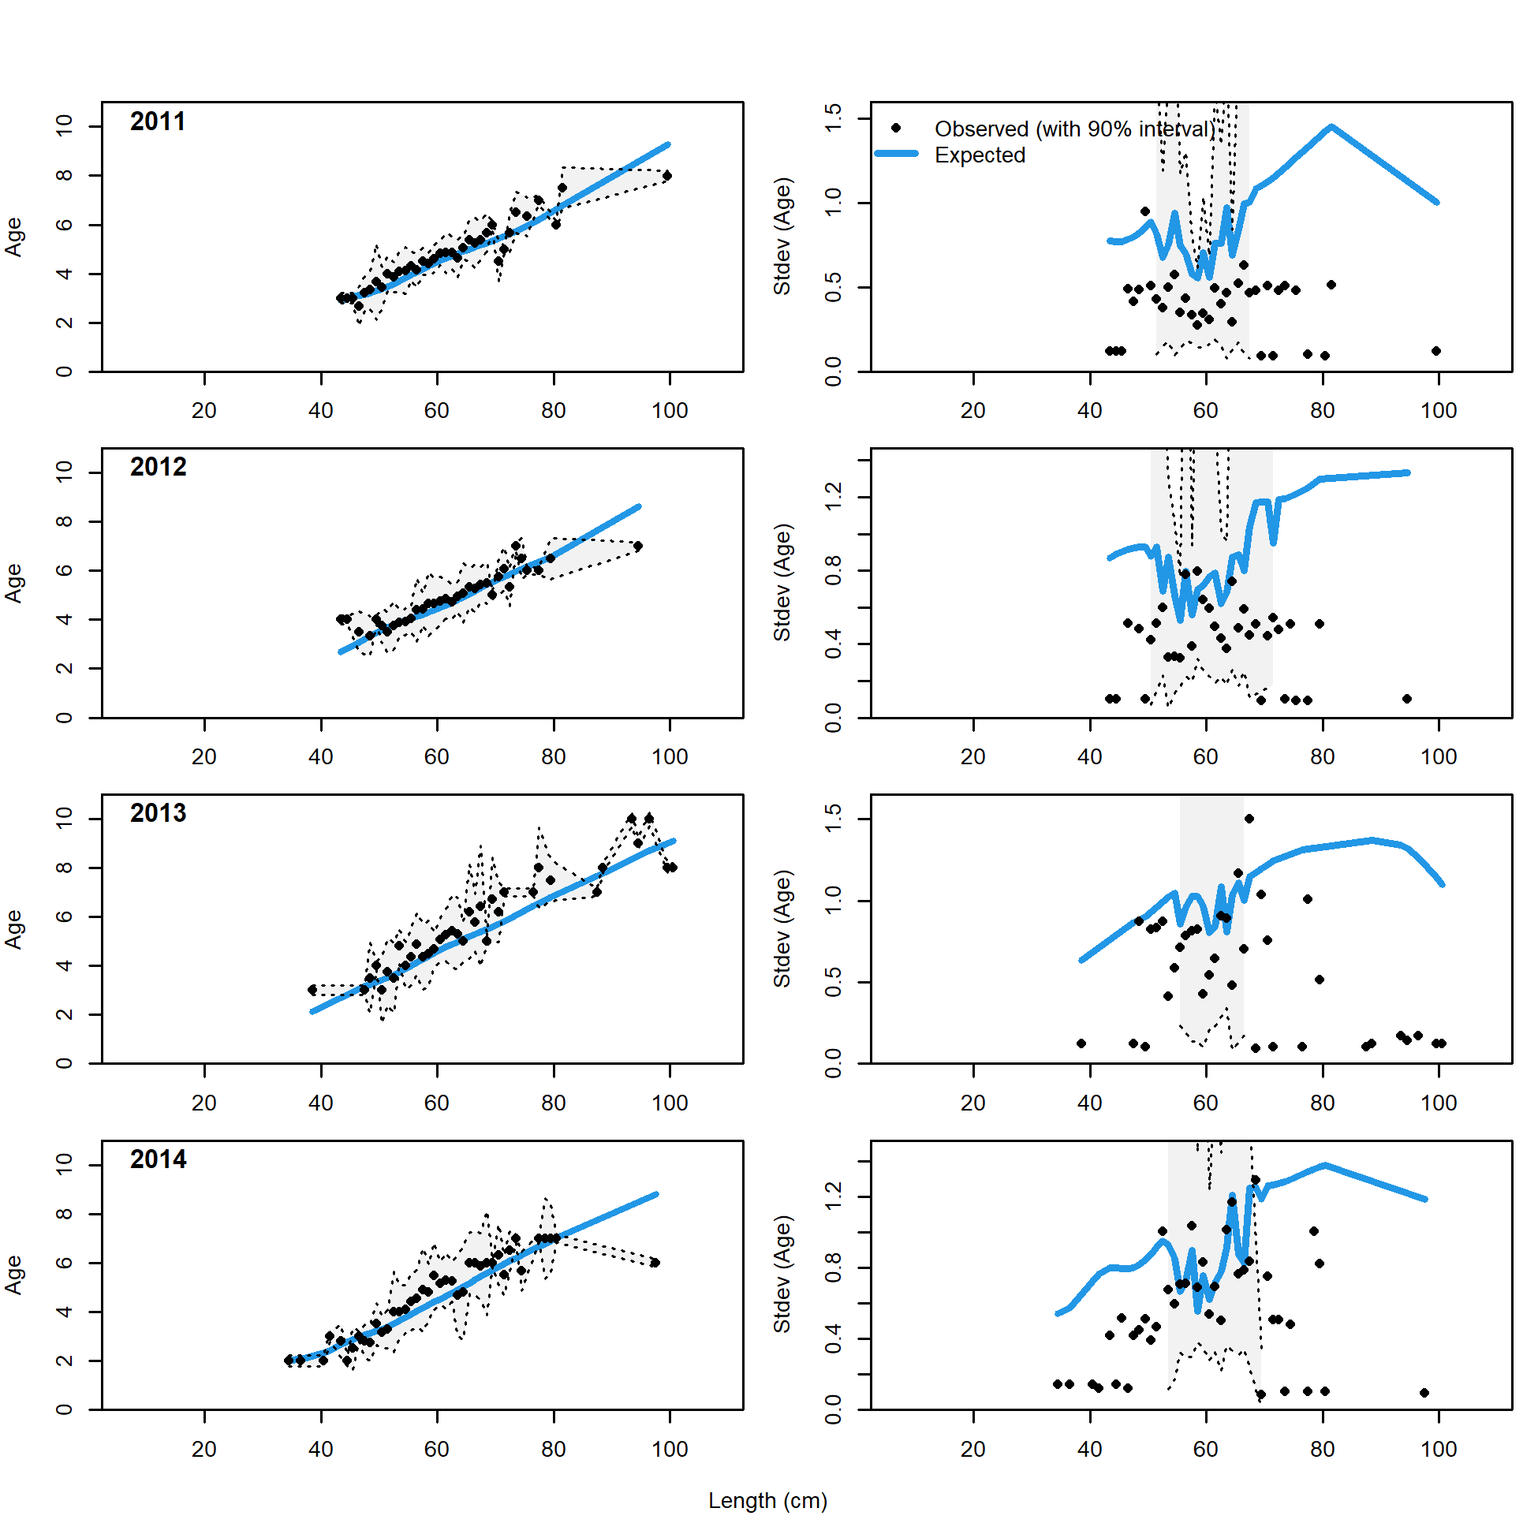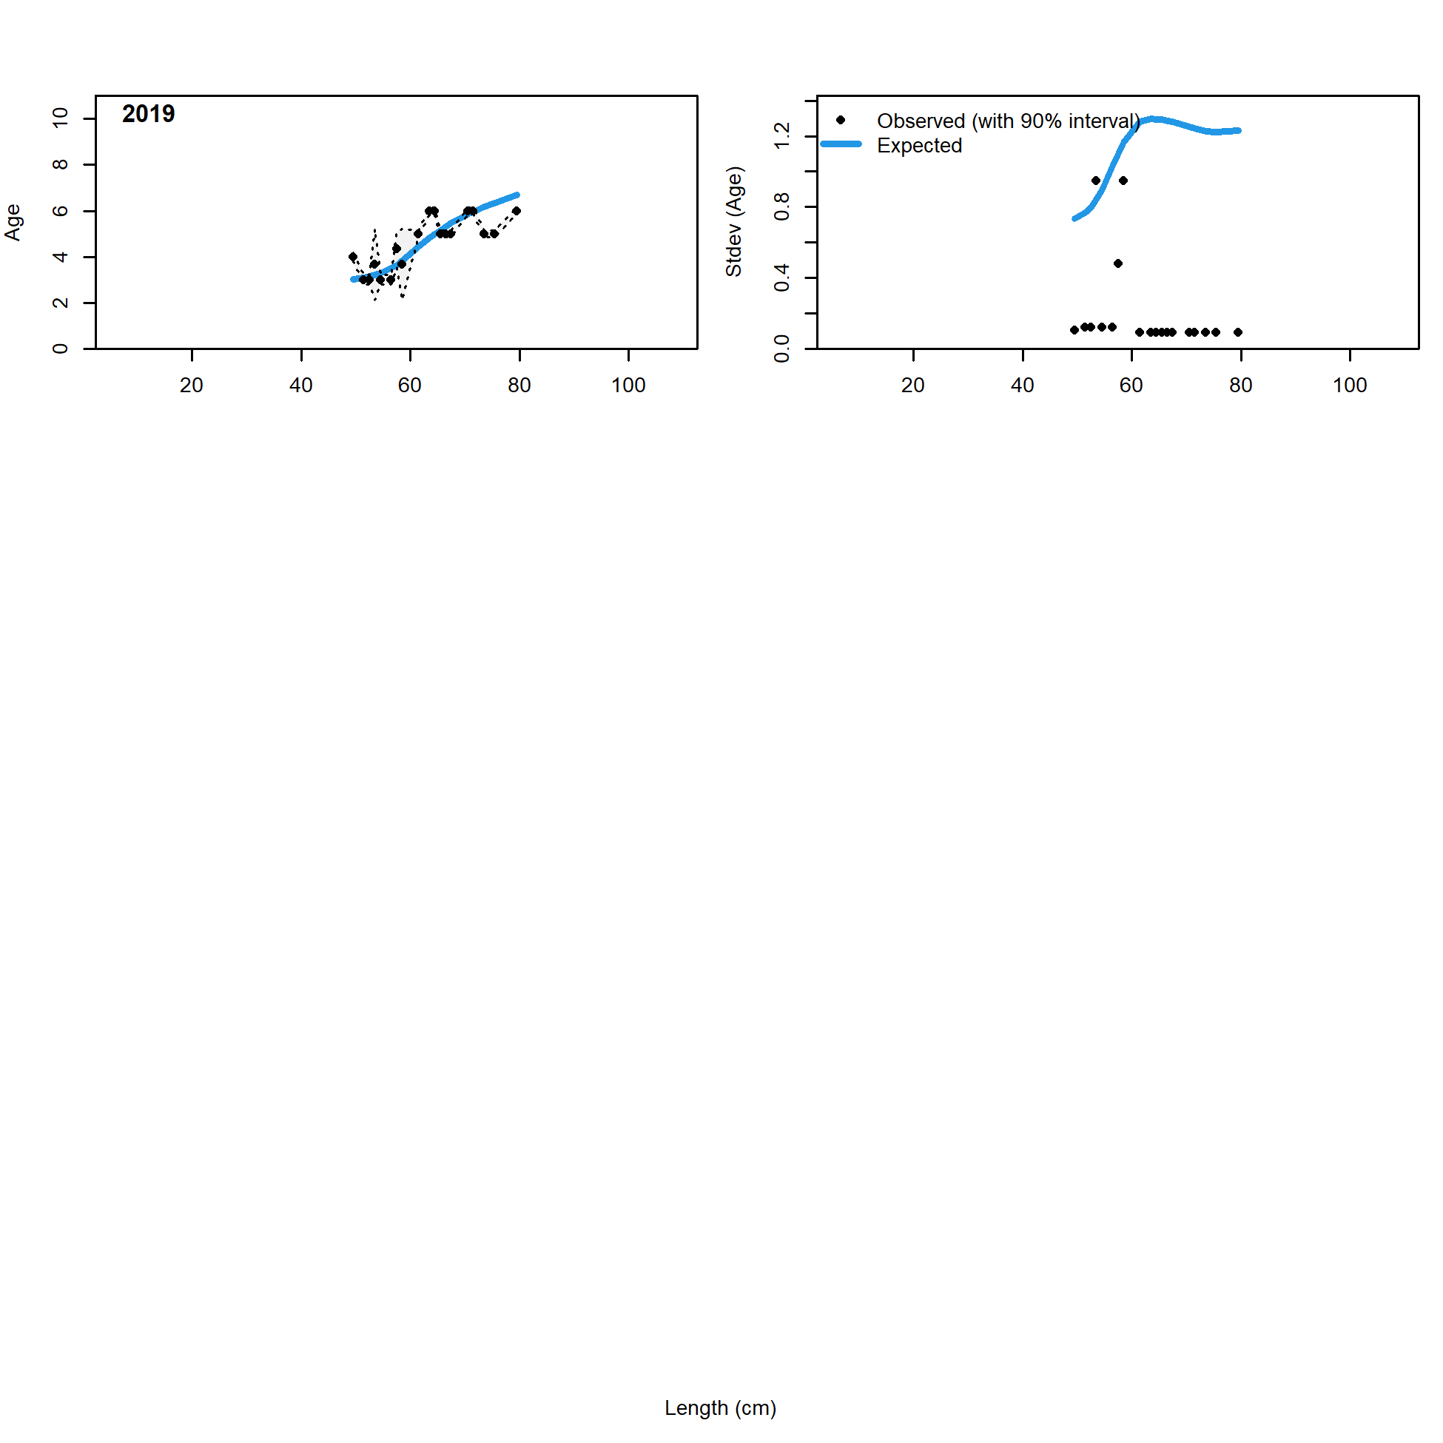

Figure 2.71 Pot fishery conditional age at length data and standard deviation with Model 21.2 fit (blue line).

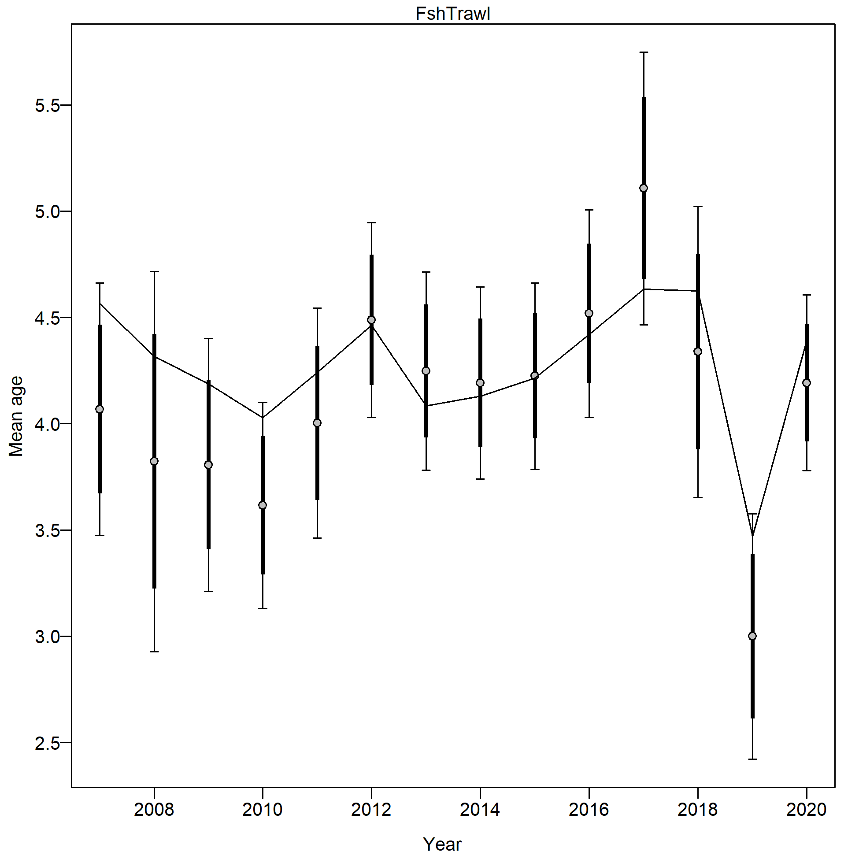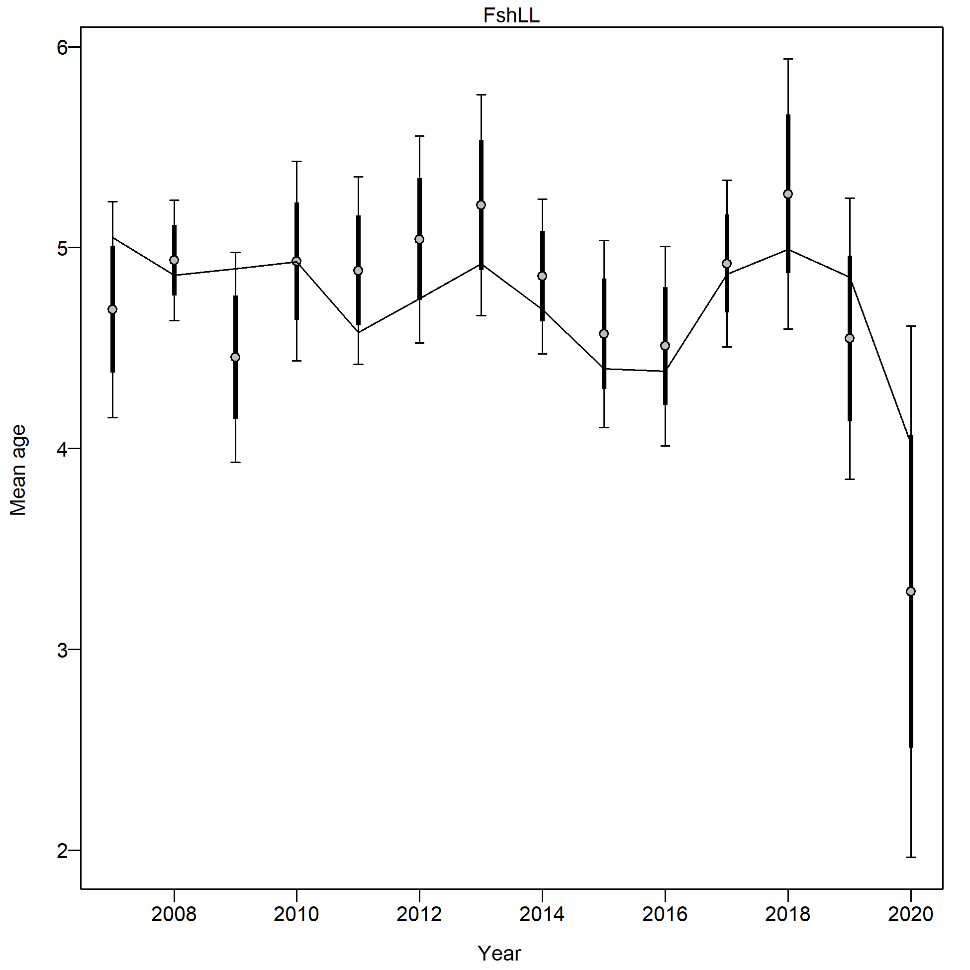

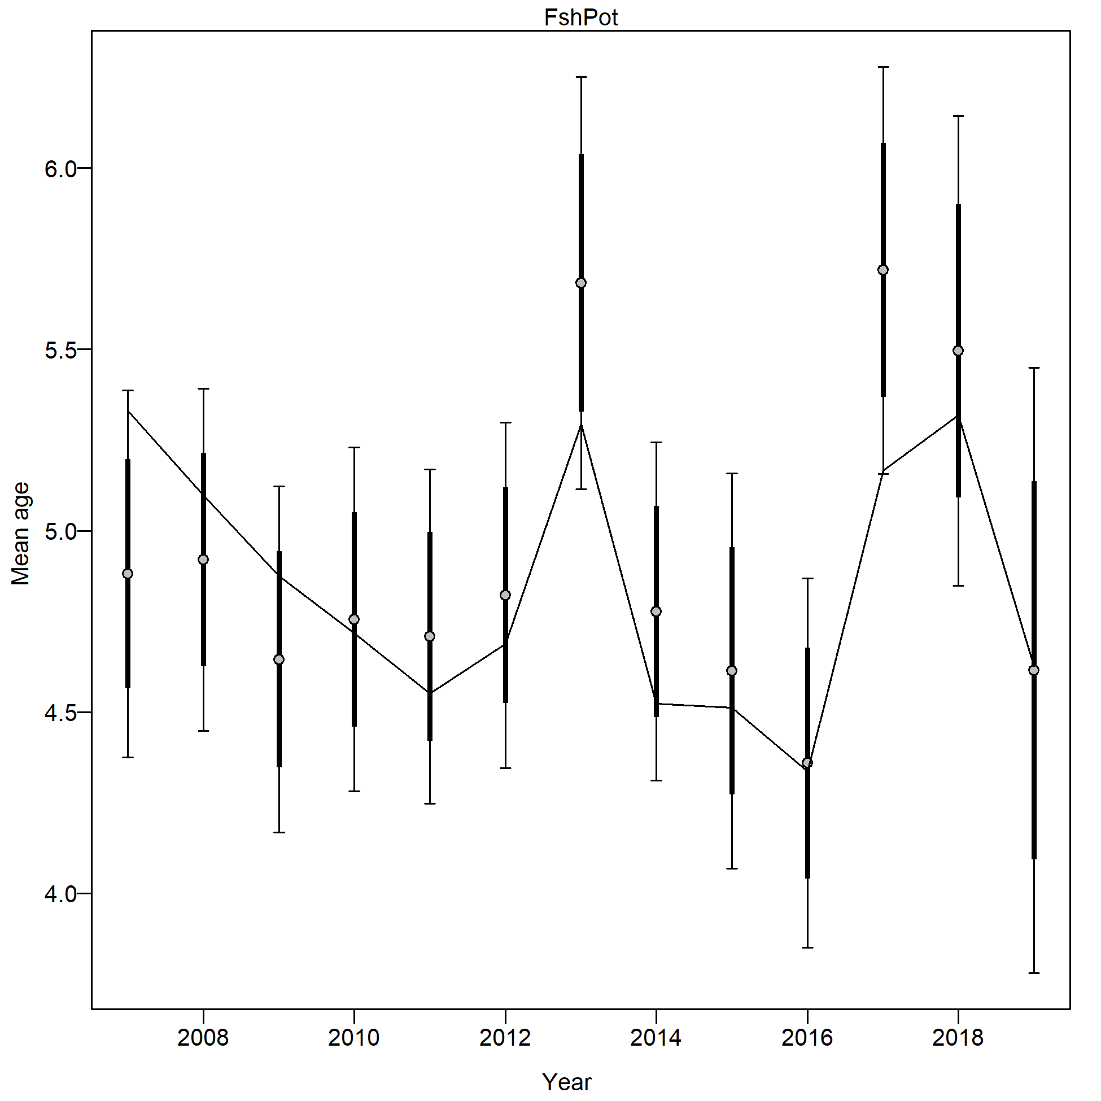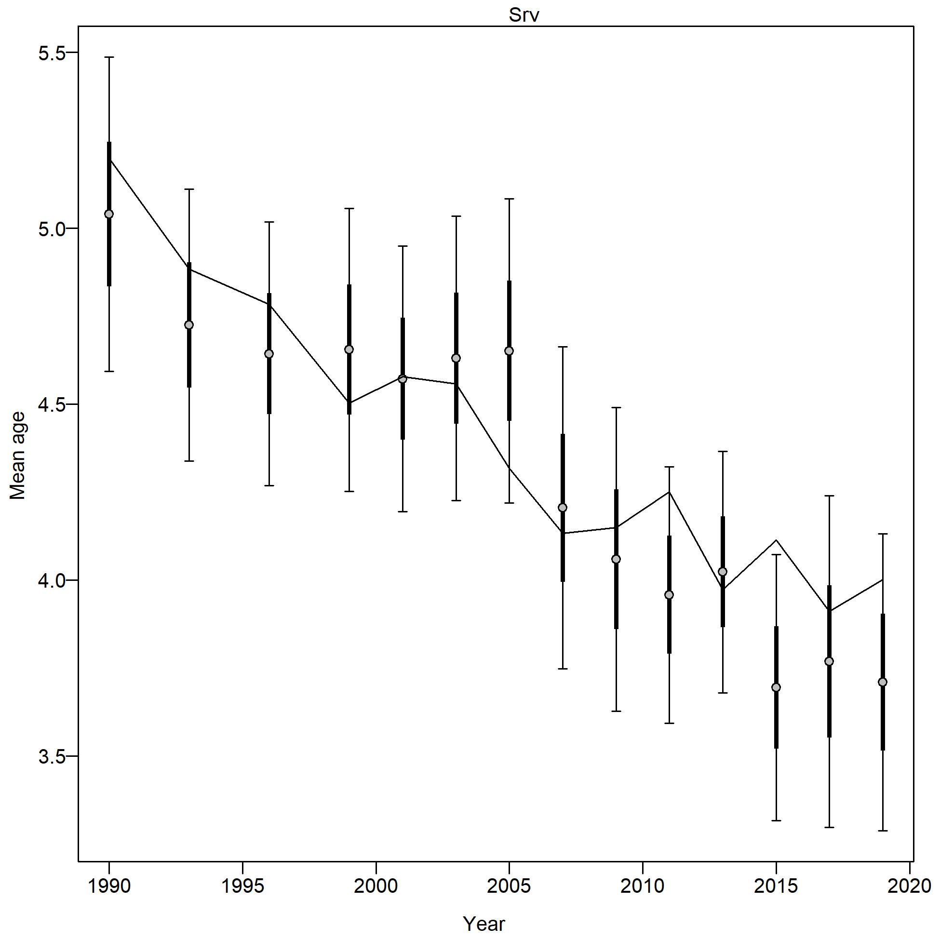

Figure 2.72 Mean age from conditional data (aggregated across length bins) with 95% confidence intervals based on current samples sizes for the trawl fishery (FshTrawl), longline fishery ( FshLL), pot fishery (FshPot) and bottom trawl survey (Srv) with Model 21.2 predictions (line).

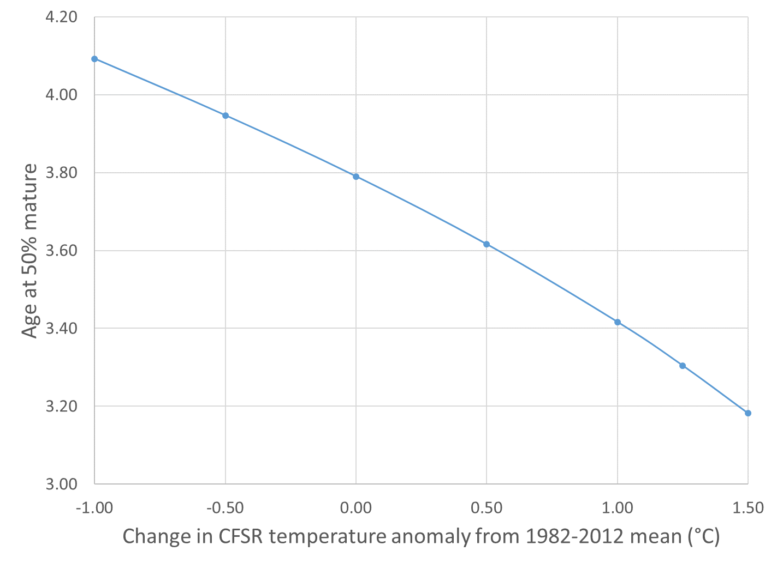

Figure 2.73 Relationship of maturity to temperature anomaly from the 1982-2012 mean for Model 21.2.

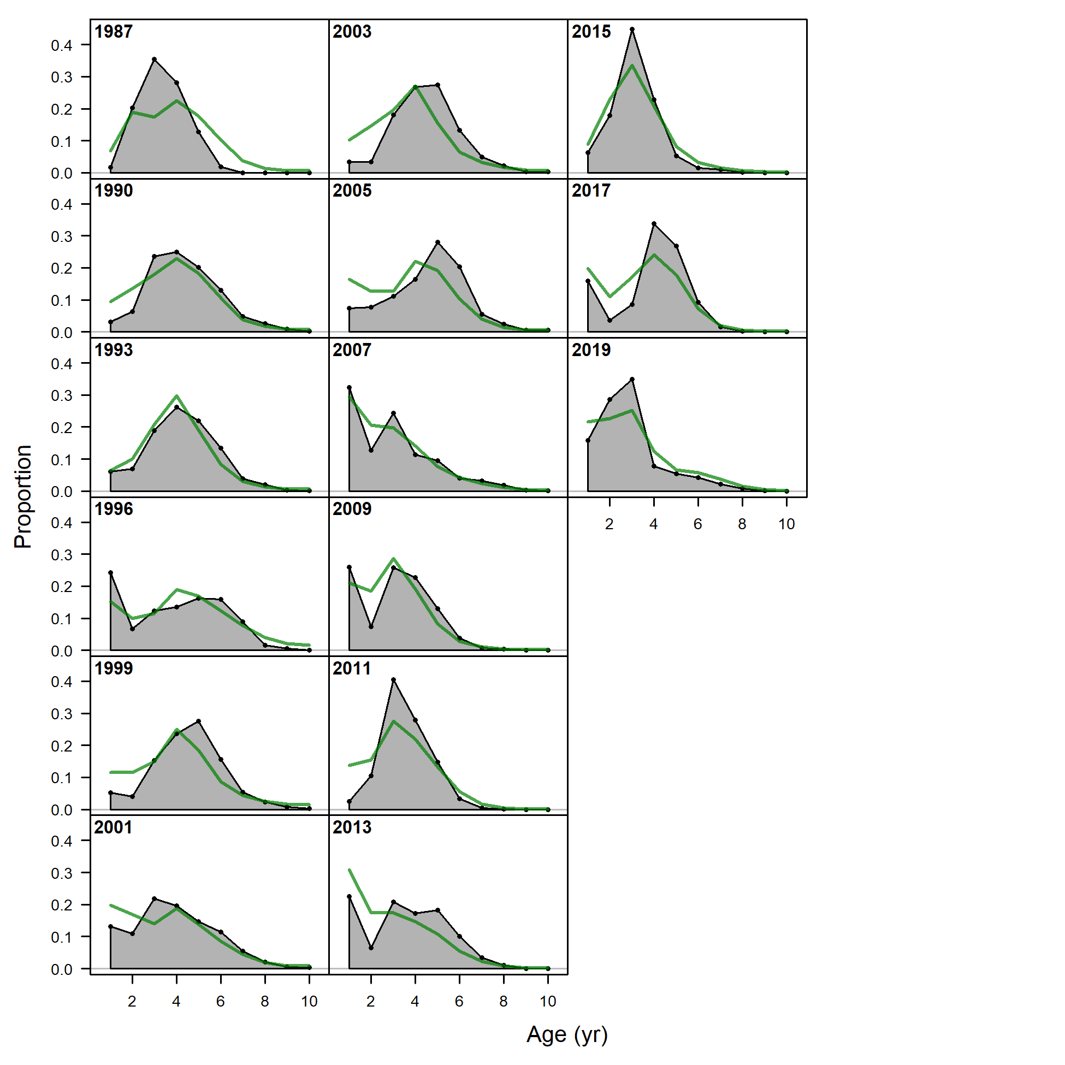

Figure 2.74 NMFS bottom trawl survey age composition and Model 21.2 fit (green line). Note the age data fits are not included in the objective function.

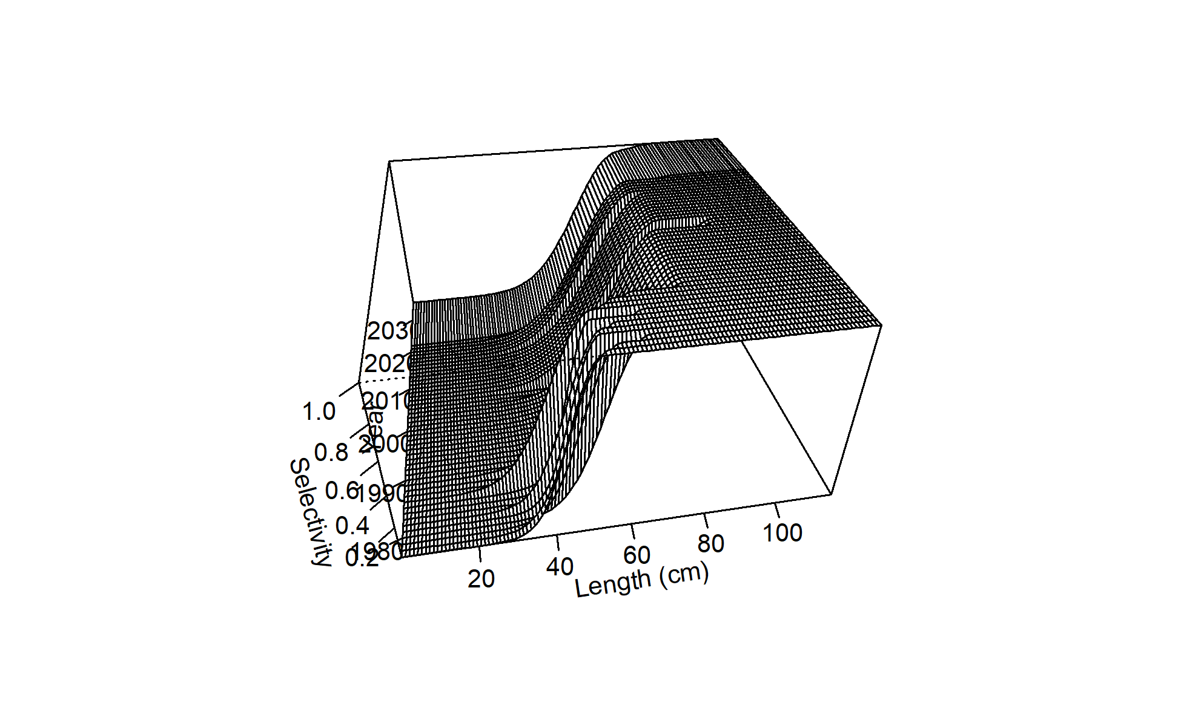 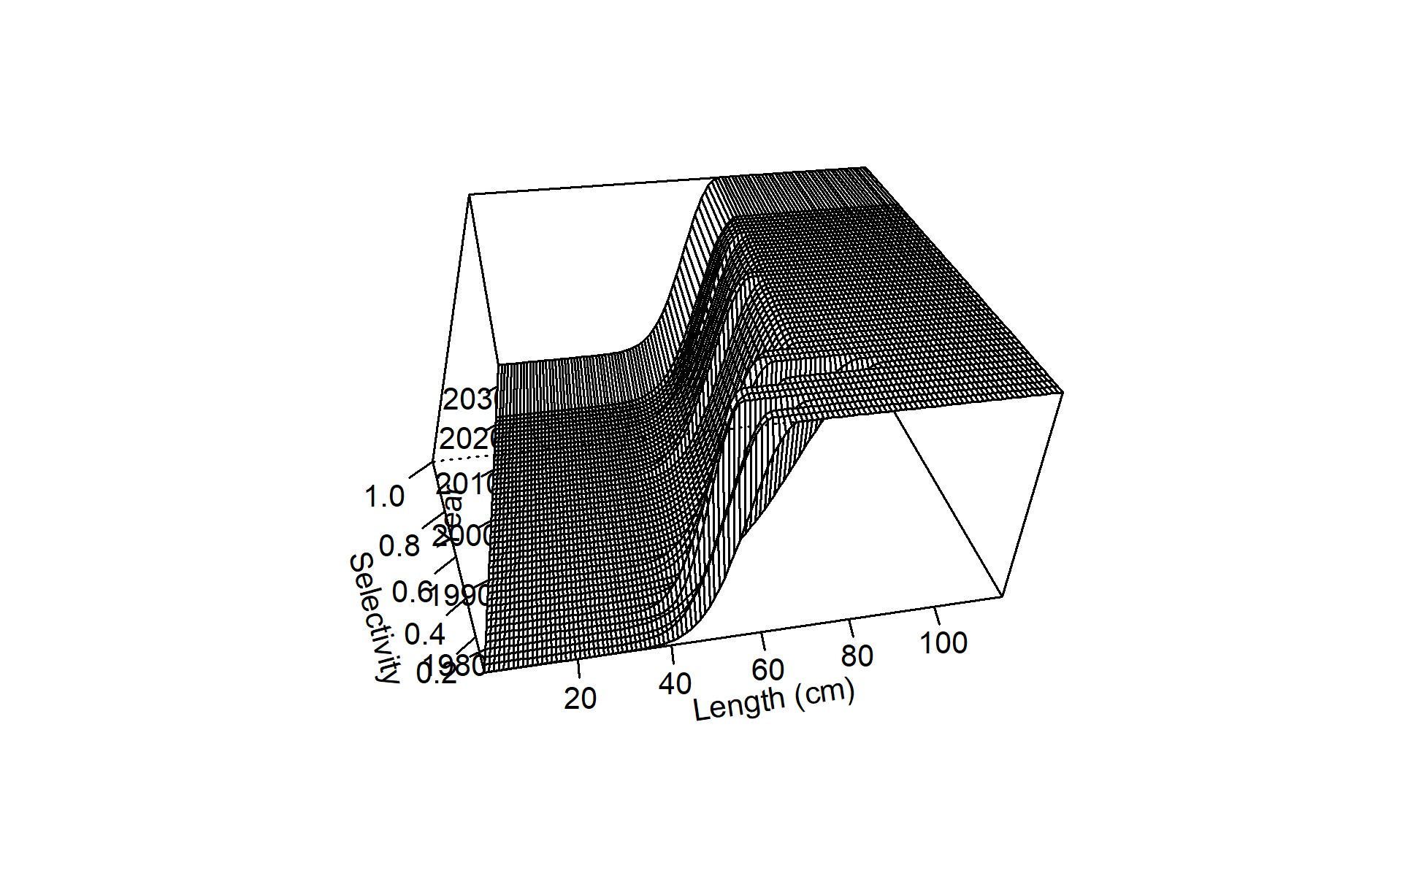 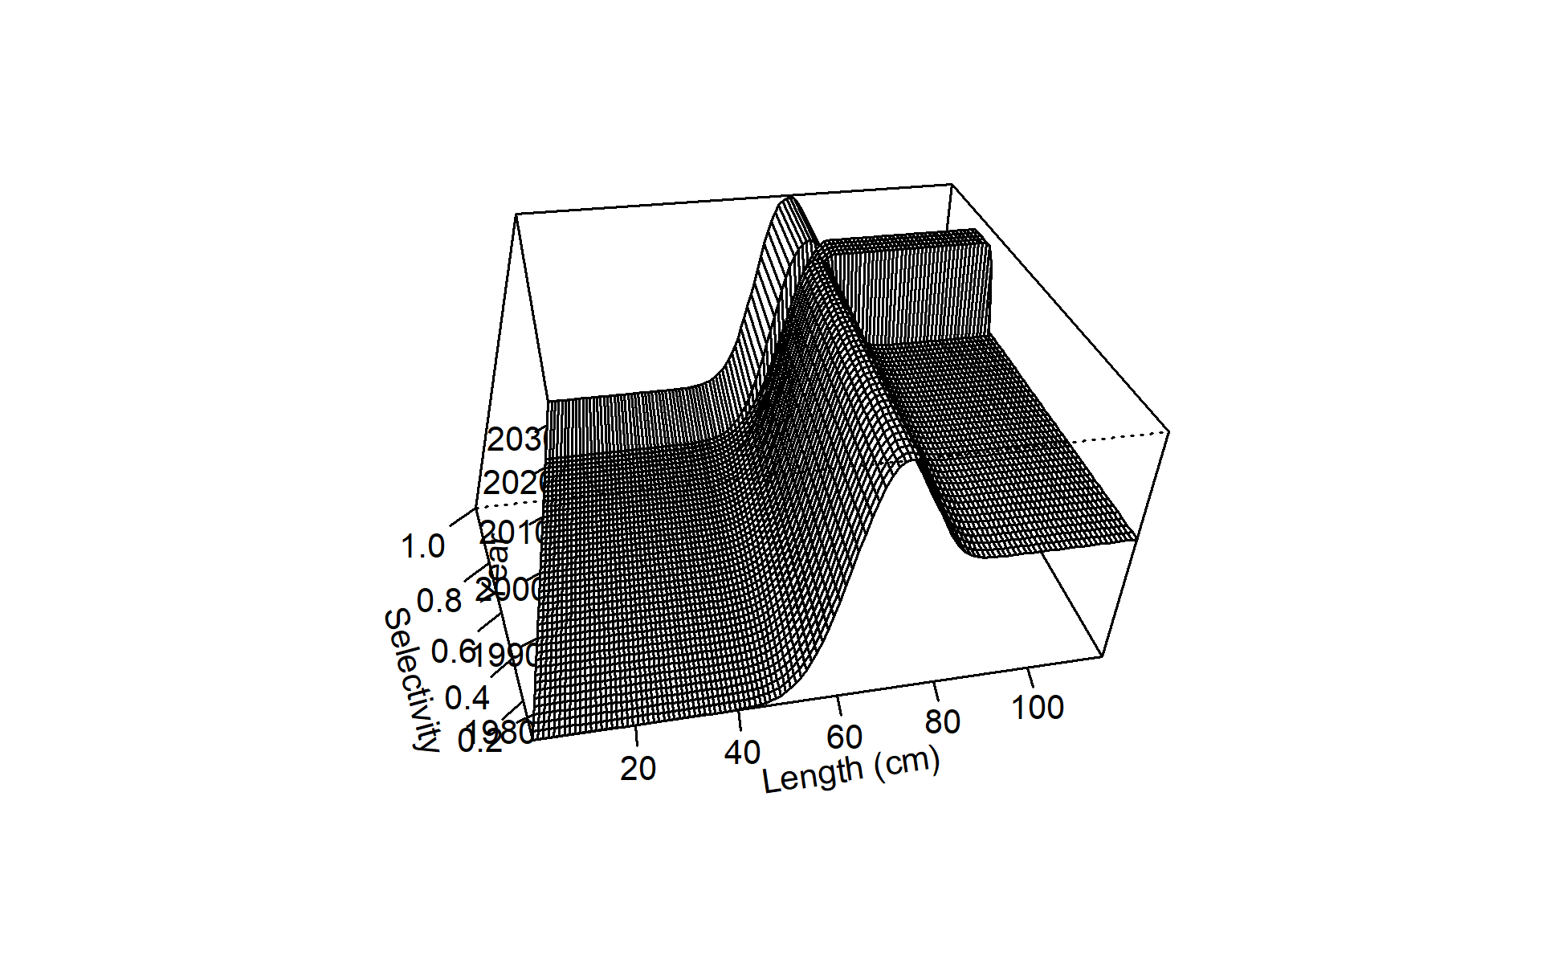 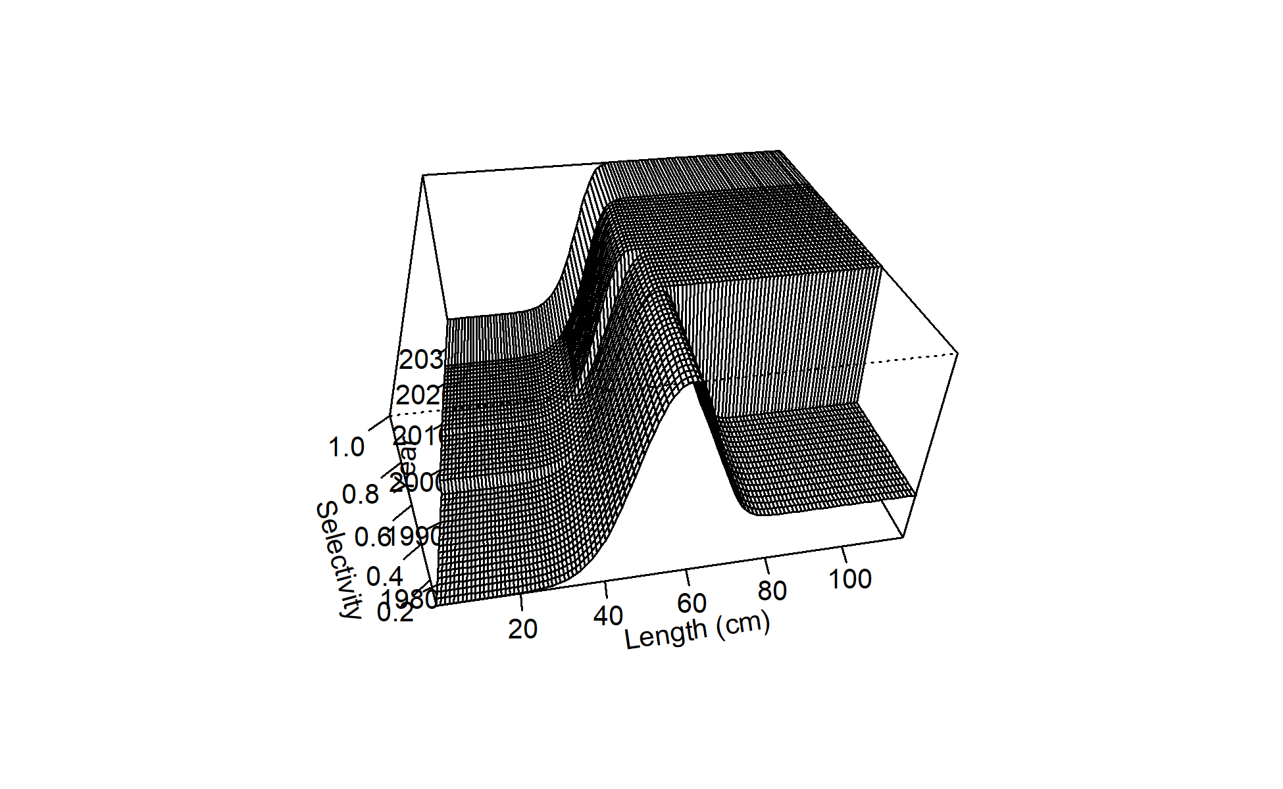 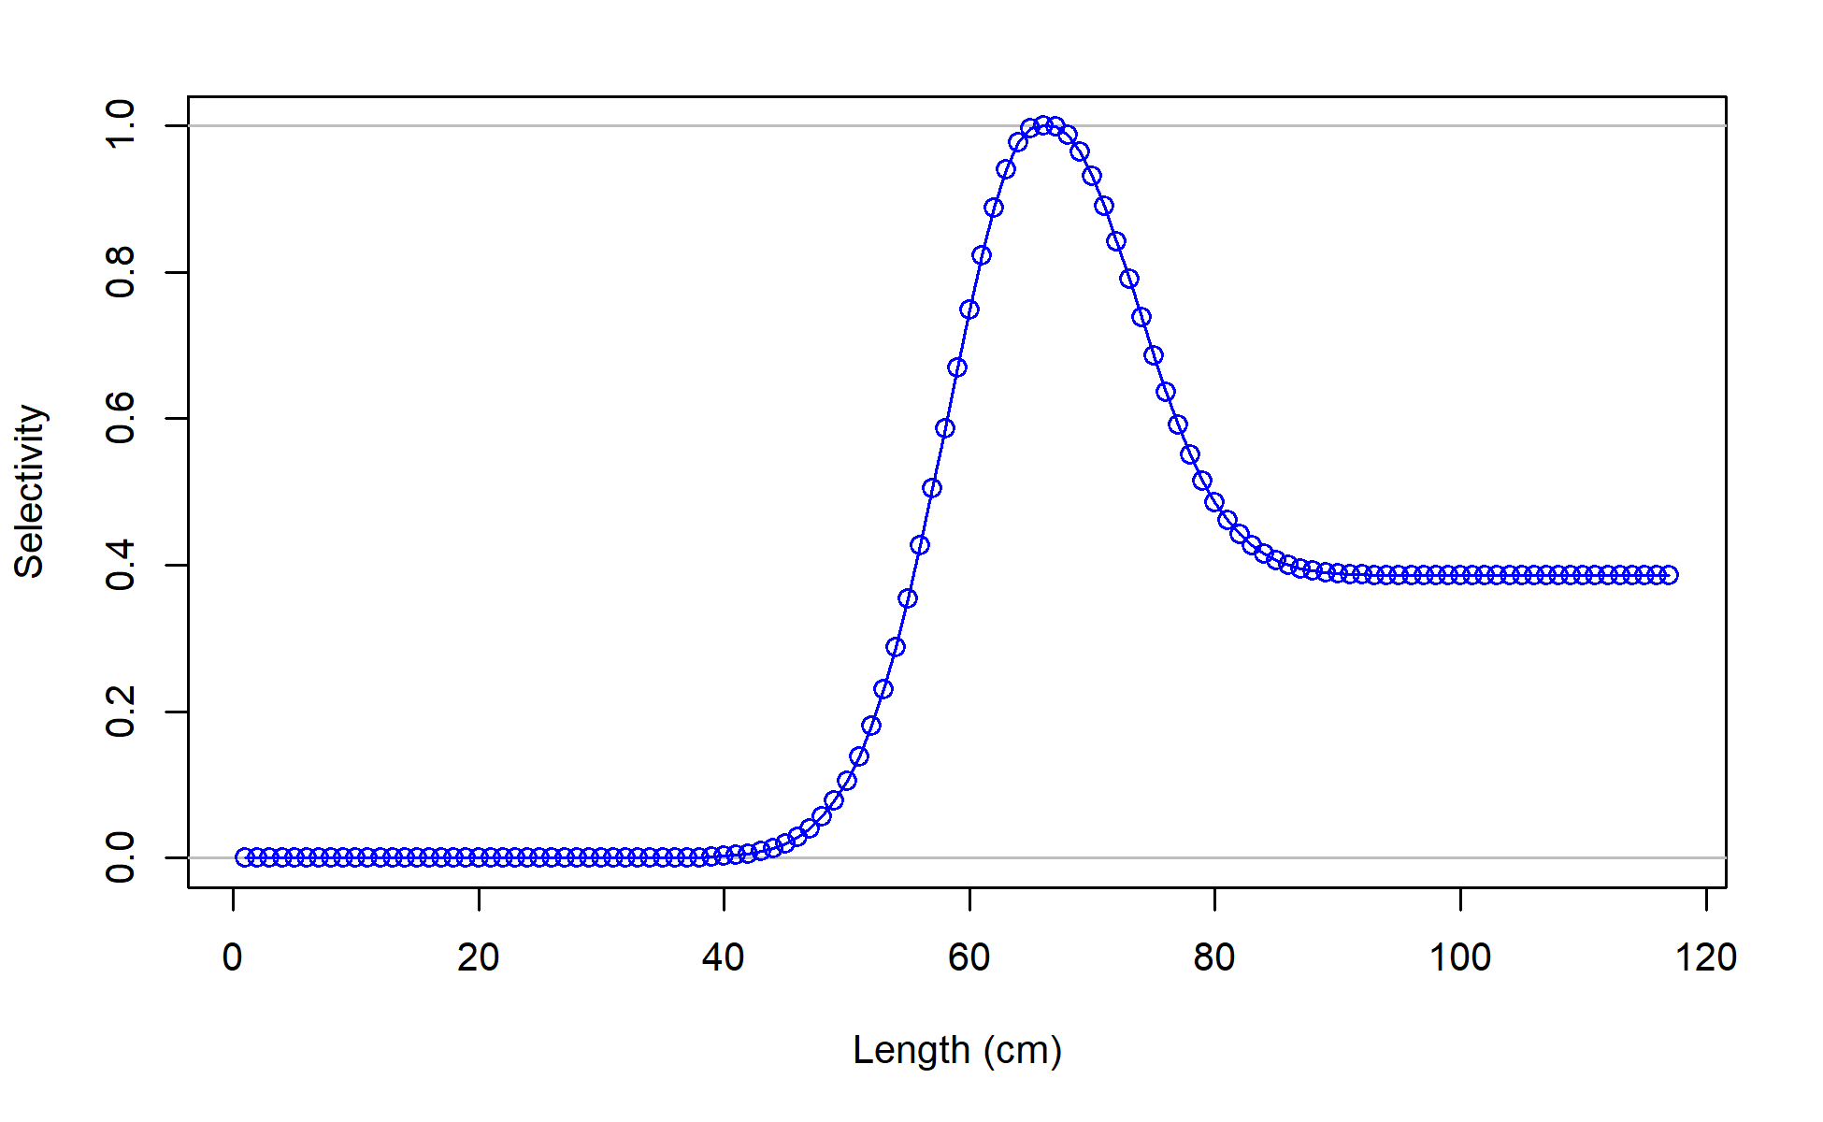

Figure 2.75 Selectivity curves for Model 21.2 Trawl fishery (top left), longline fishery (top right), pot fishery (middle left), NMFS bottom trawl survey (mid right), and AFSC Longline survey (bottom) length composition data.

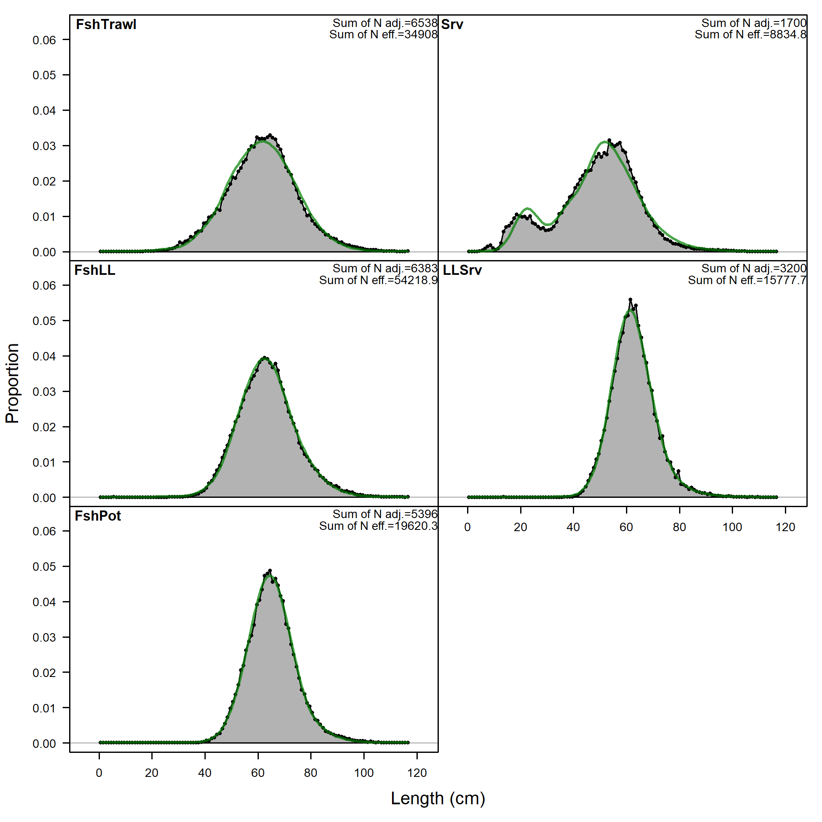

Figure 2.76 Overall Model 21.2 fits to Trawl fishery (FshTrawl), longline fishery (FshLL), pot fishery (FshPot), NMFS bottom trawl survey (Srv), and AFSC Longline survey (LLSrv) length composition data.

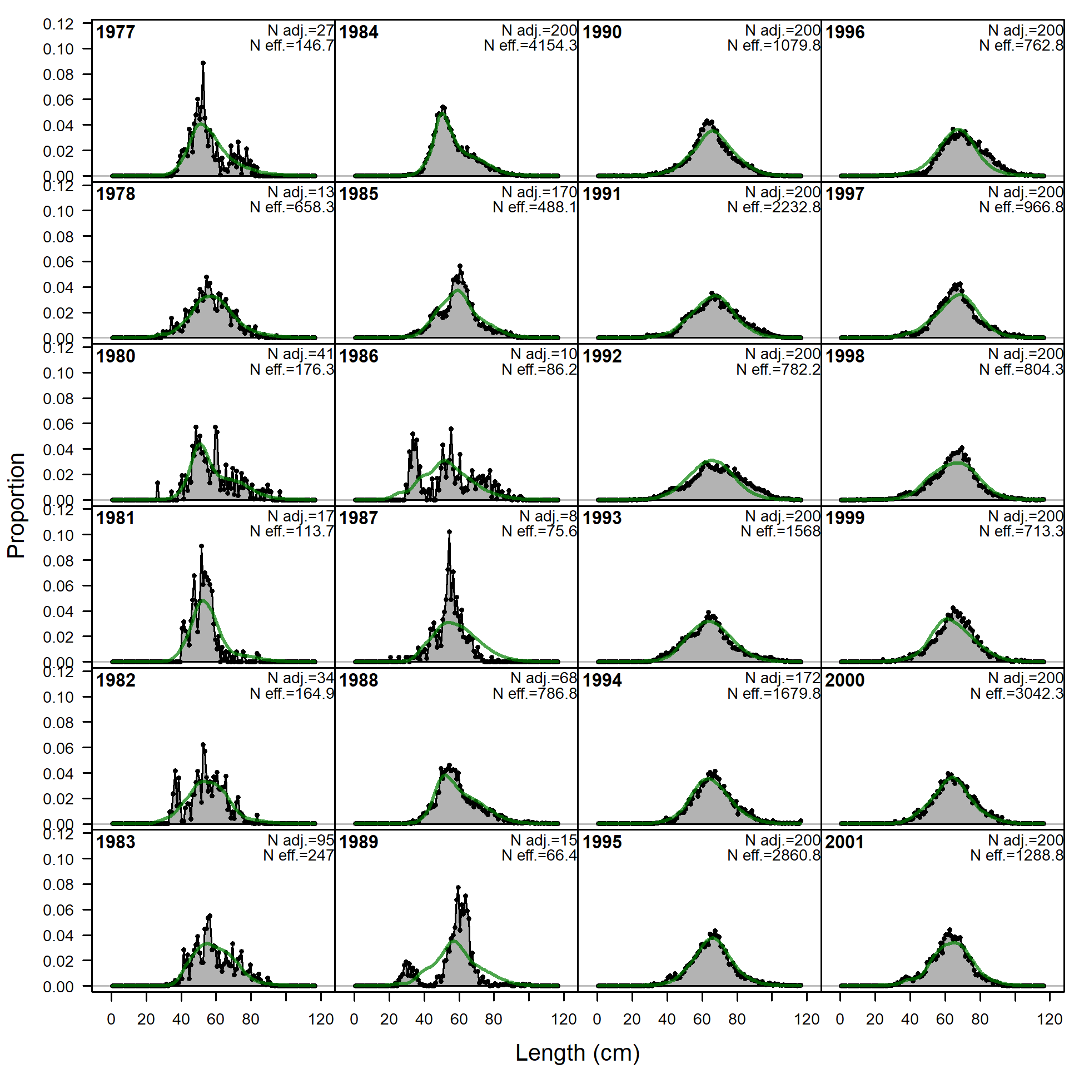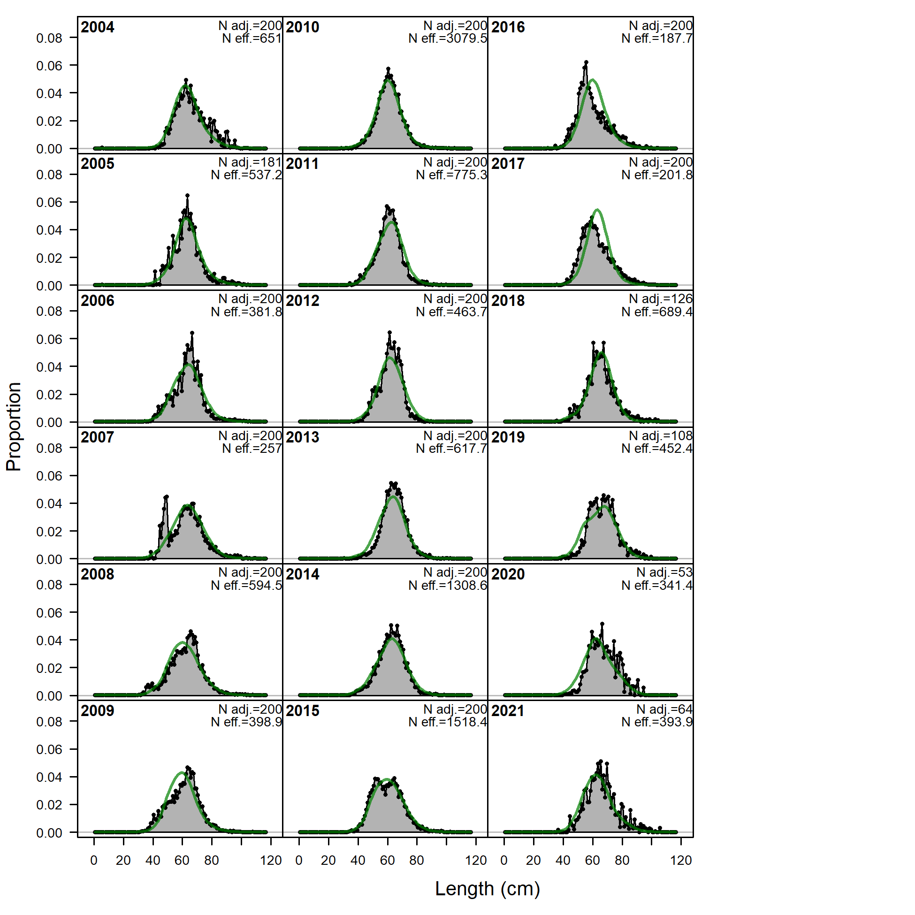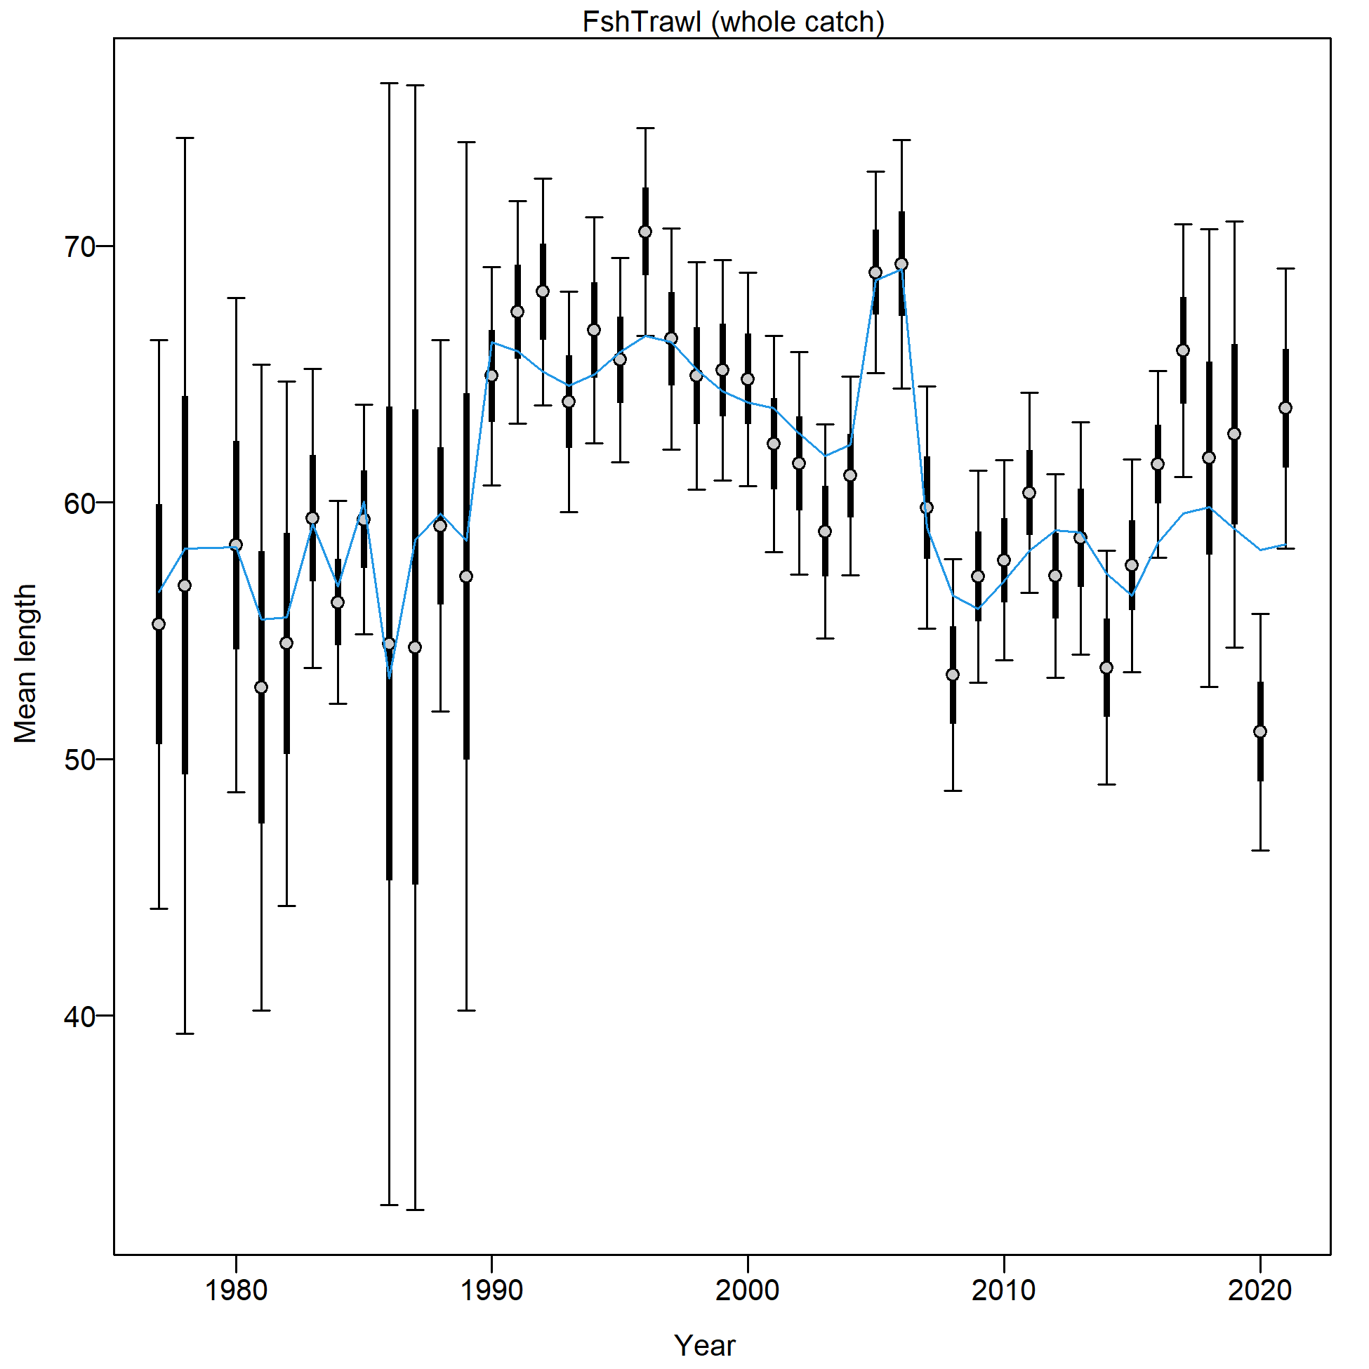

Figure 2.77 Trawl fishery length composition and Model 21.2 fit (top) and mean length (cm; bottom).

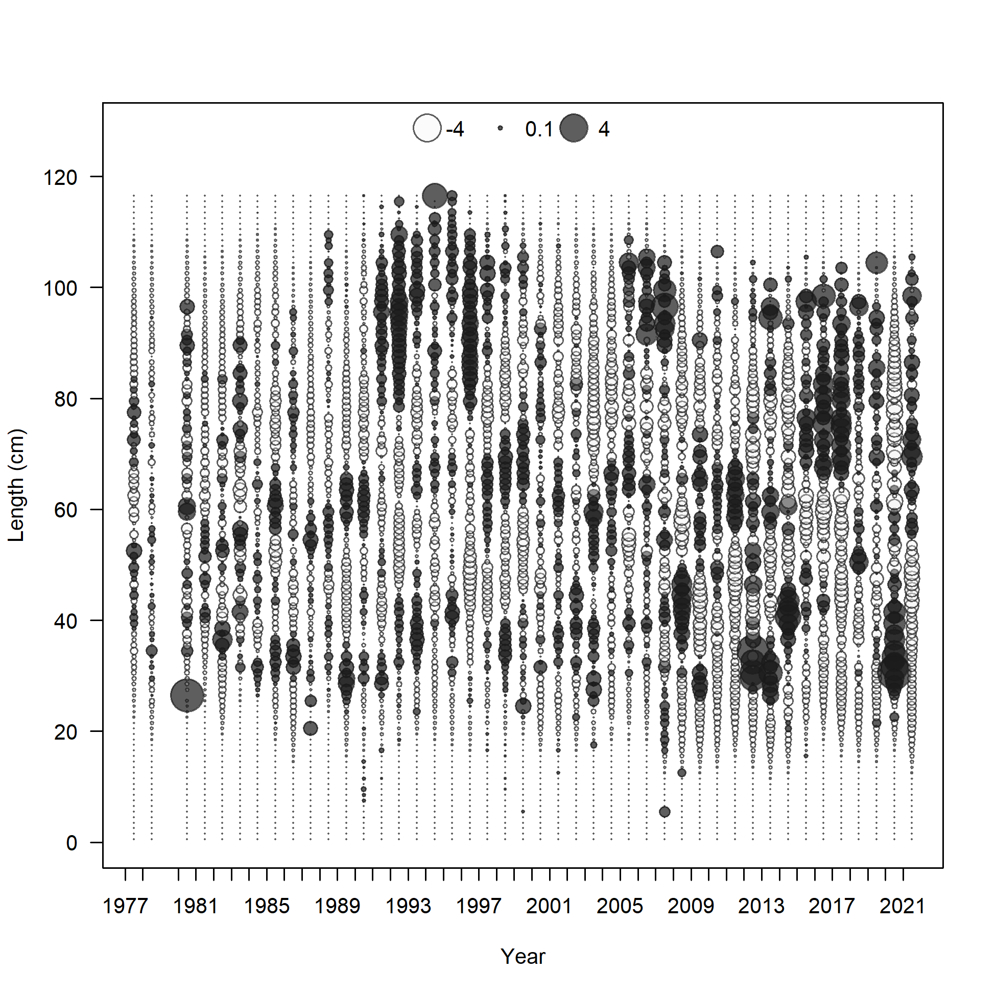

Figure 2.78 Trawl fishery length composition Pearson residuals (max = 5.69) for Model 21.2.

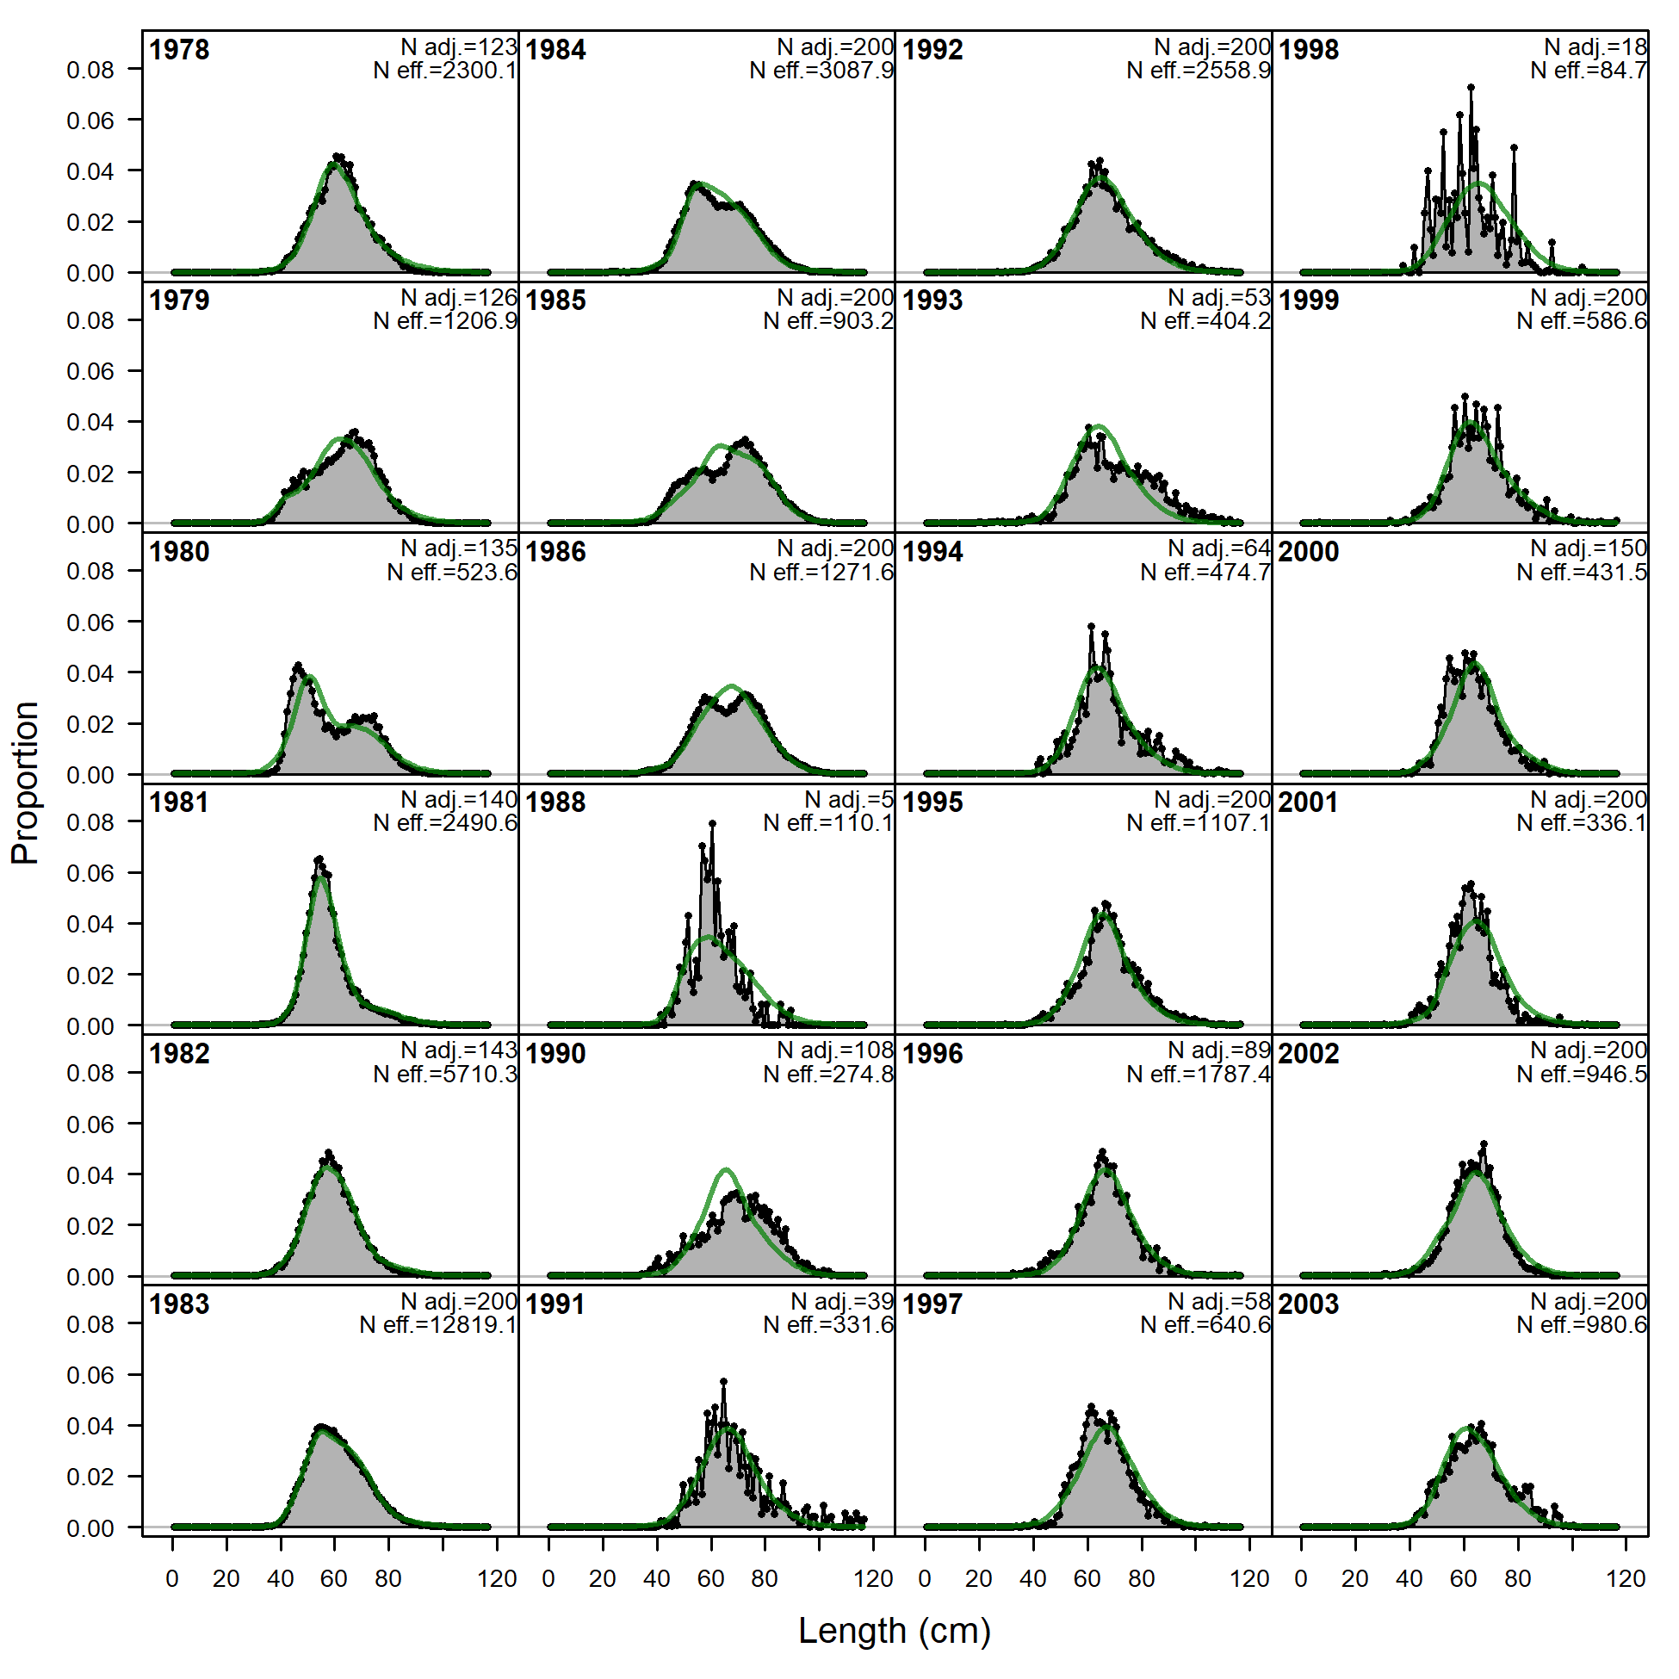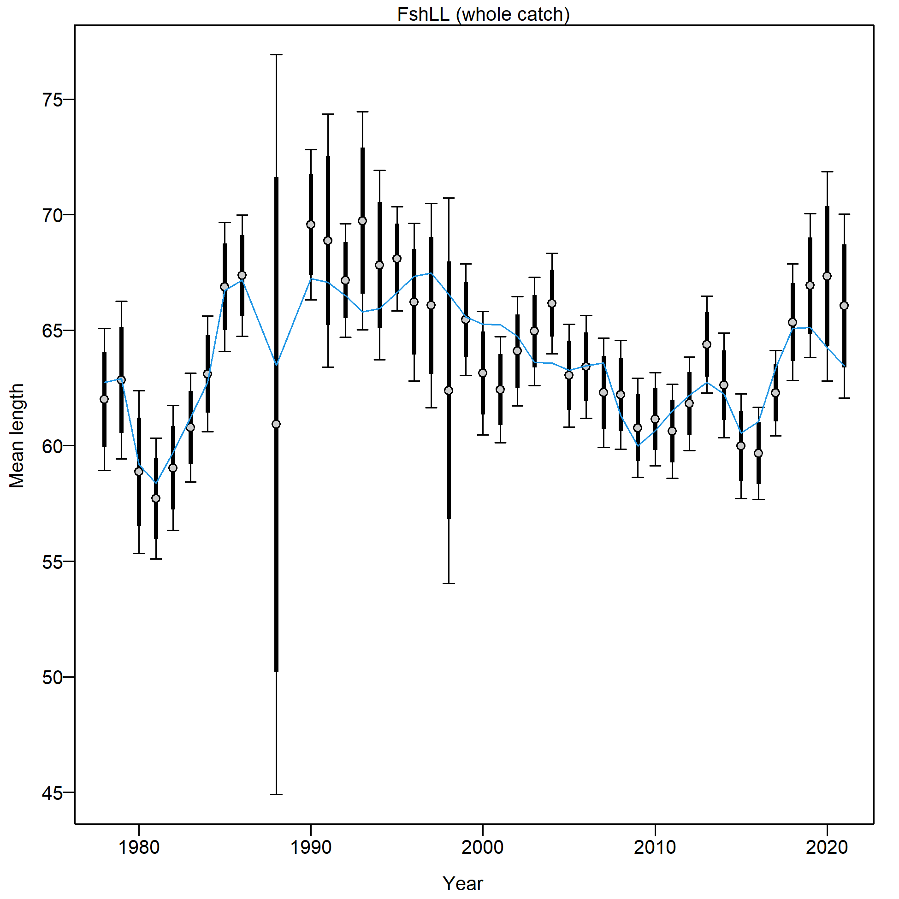

Figure 2.79 Longline fishery length composition and Model 21.2 fit (top) and mean length (cm; bottom).

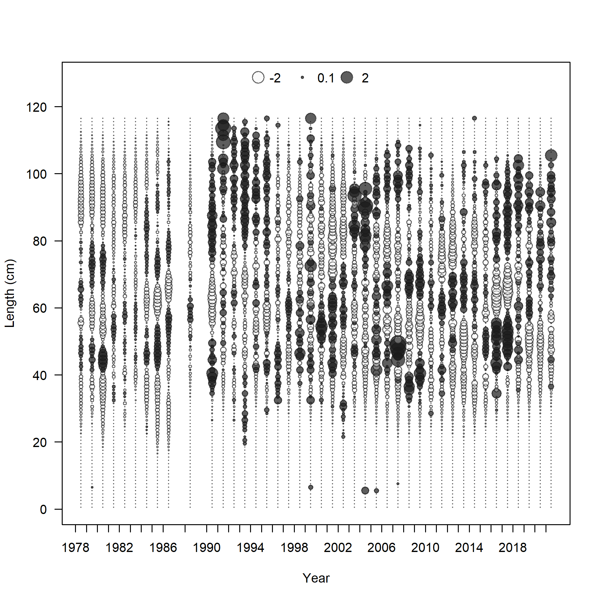

Figure 2.80 Longline fishery length composition and Model 21.2 fit Pearson residuals (max=3.76).

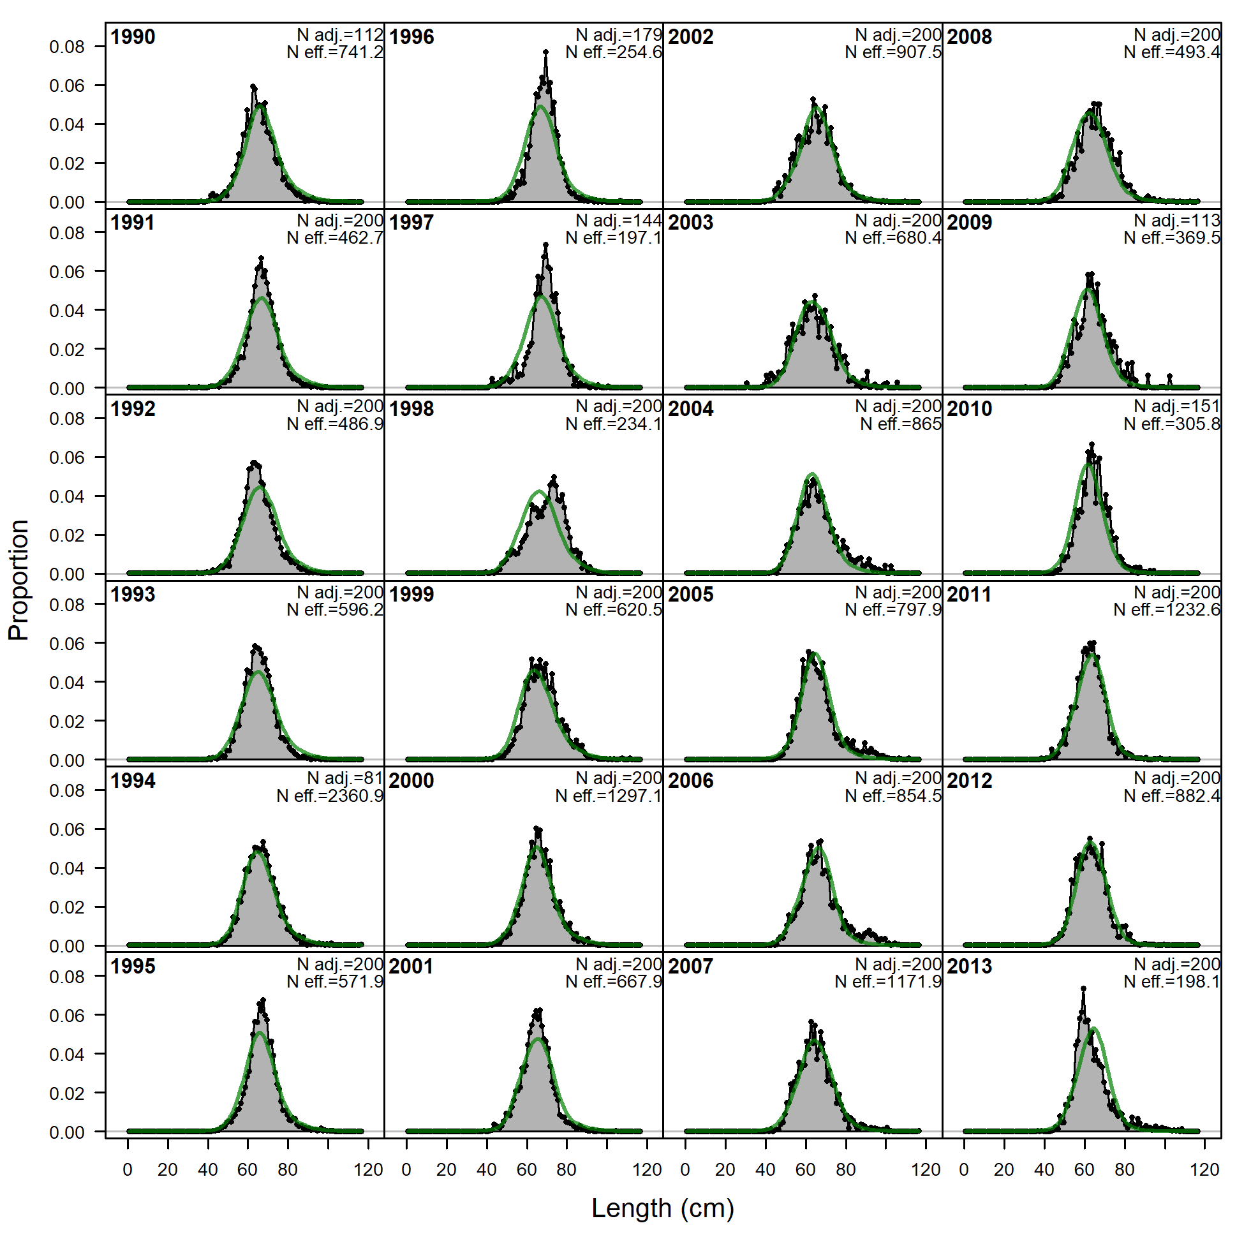 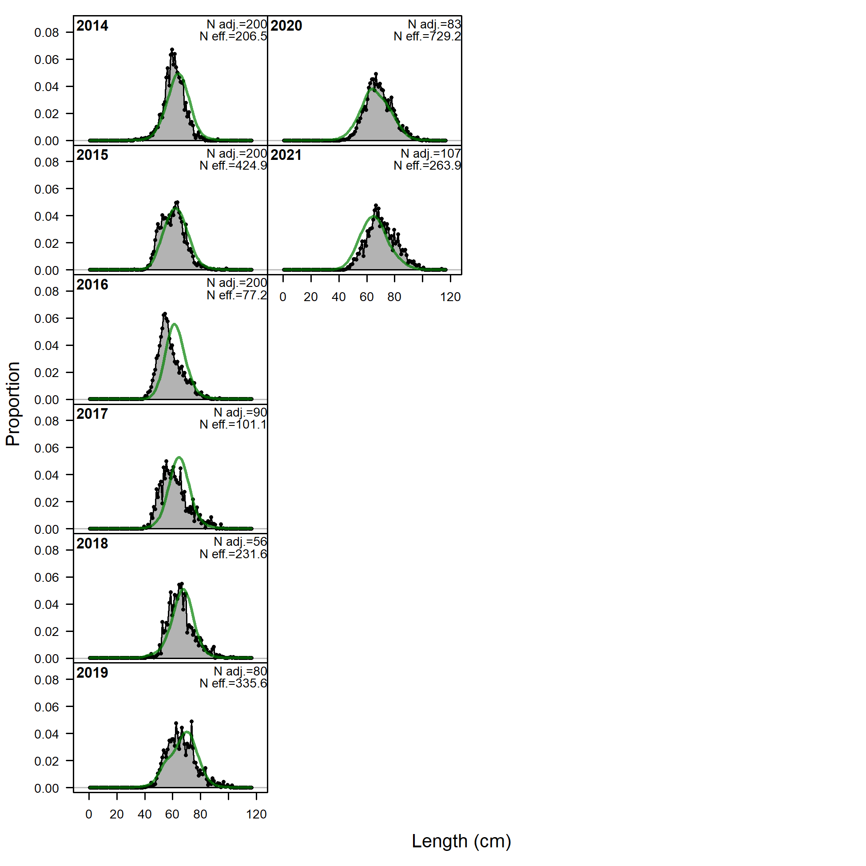 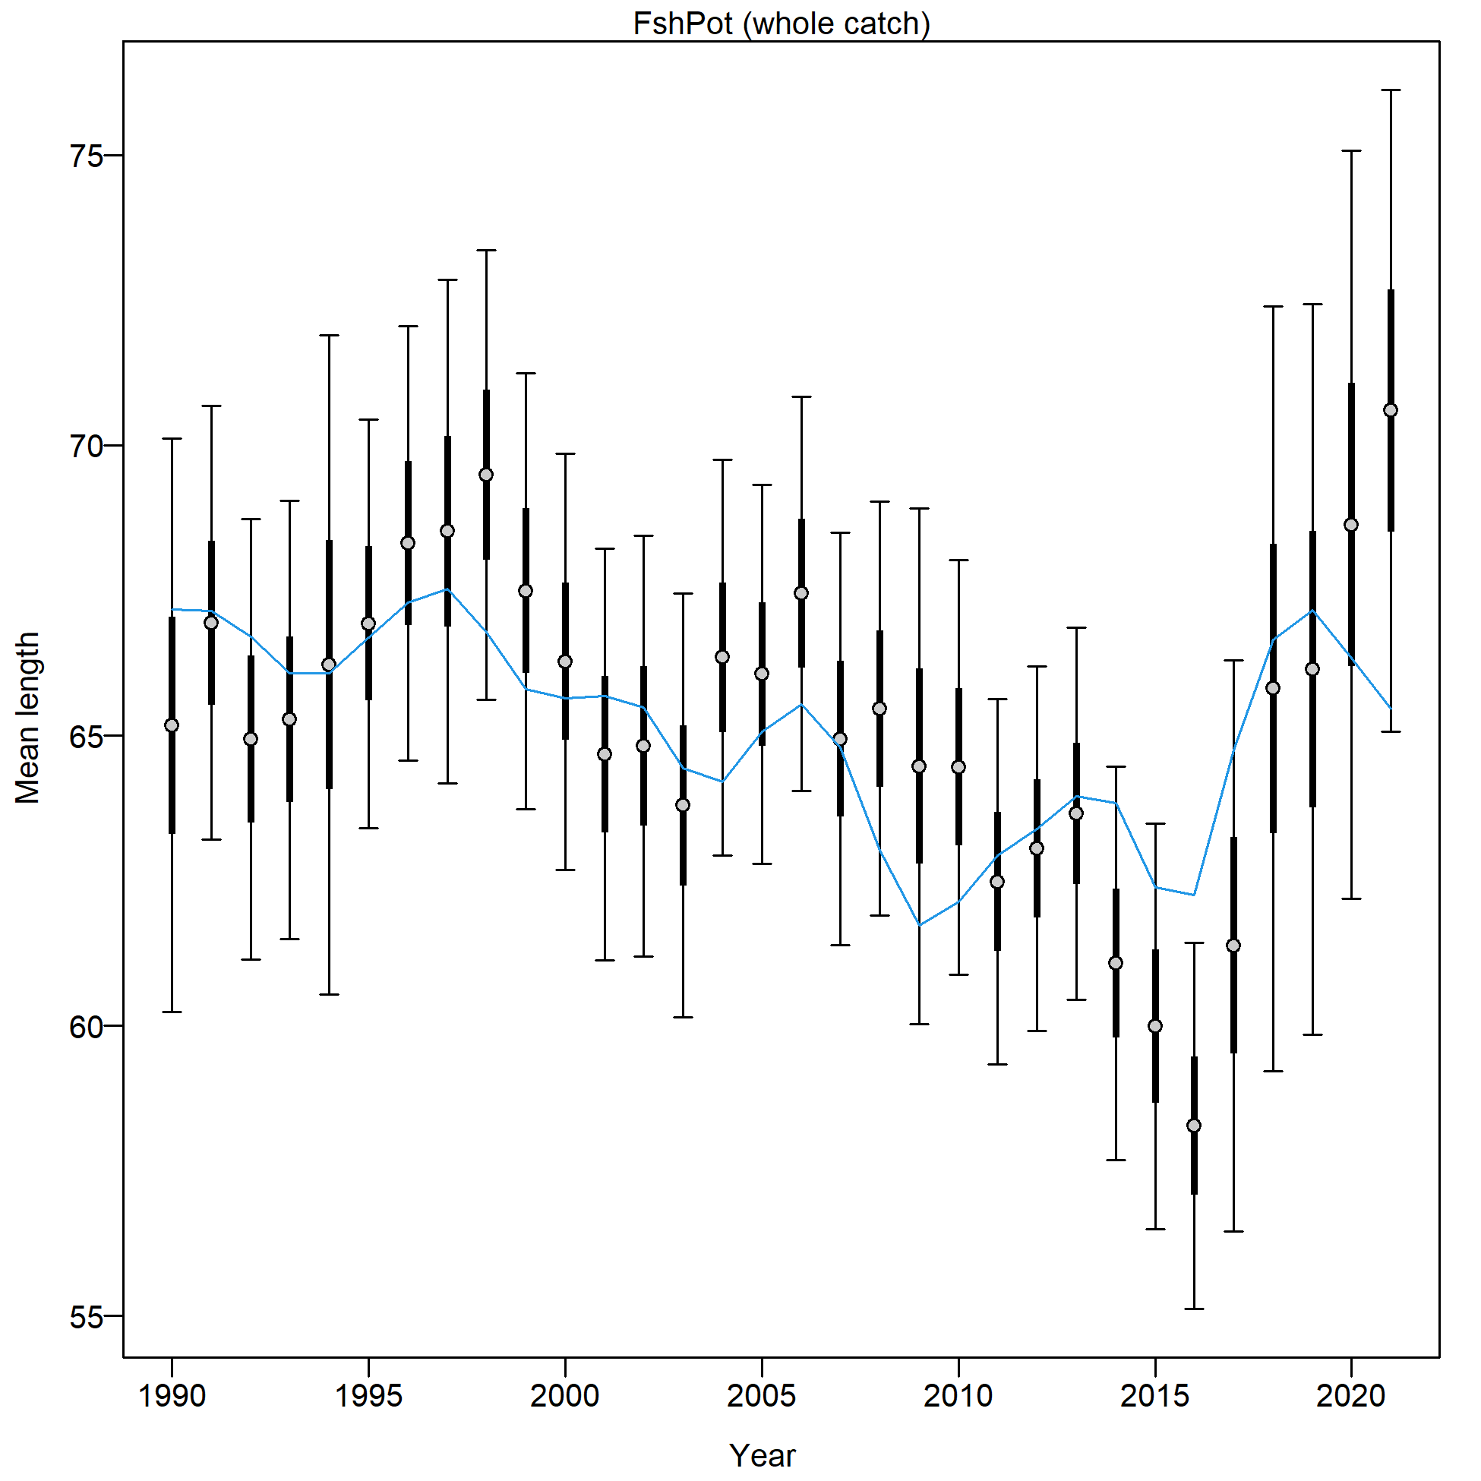 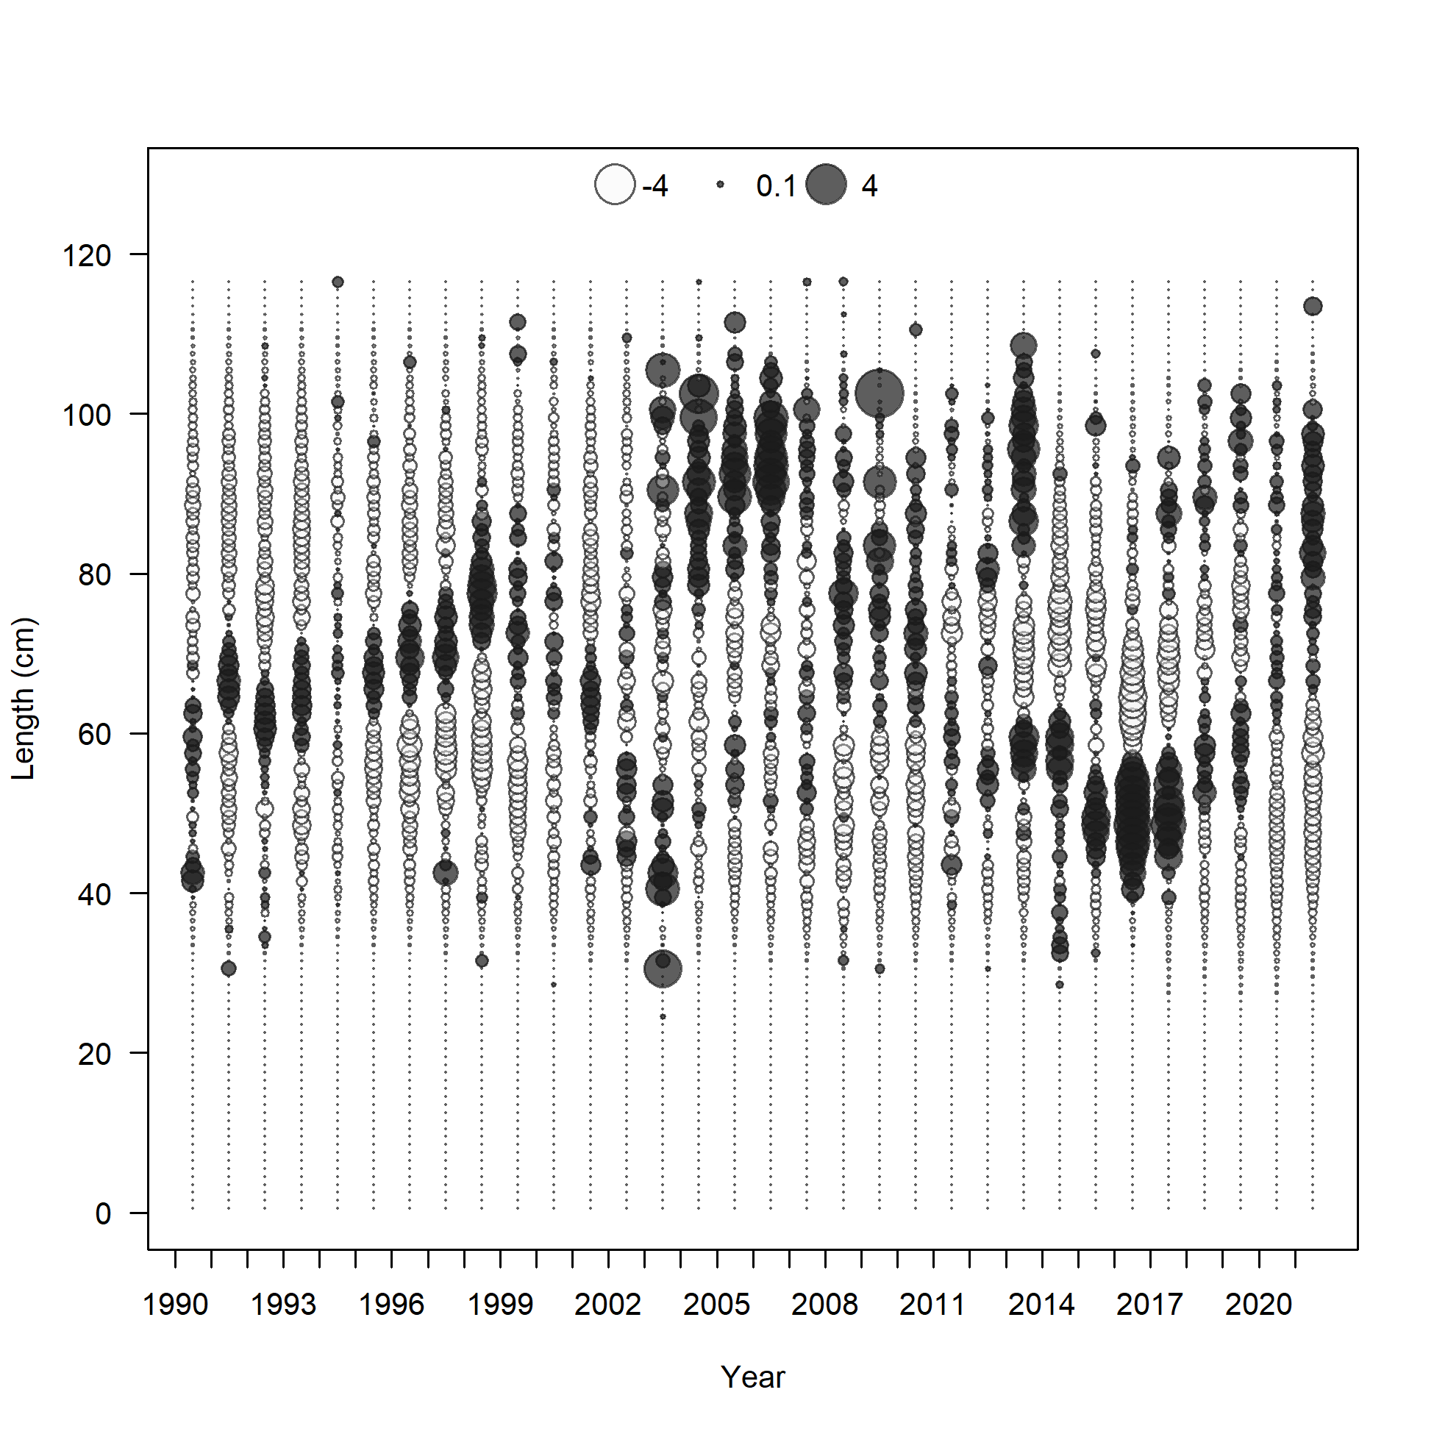

Figure 2.81 Pot fishery length composition and Model 21.2 fit (top), mean length (bottom left), and Pearson residuals (max=5.72; bottom right).

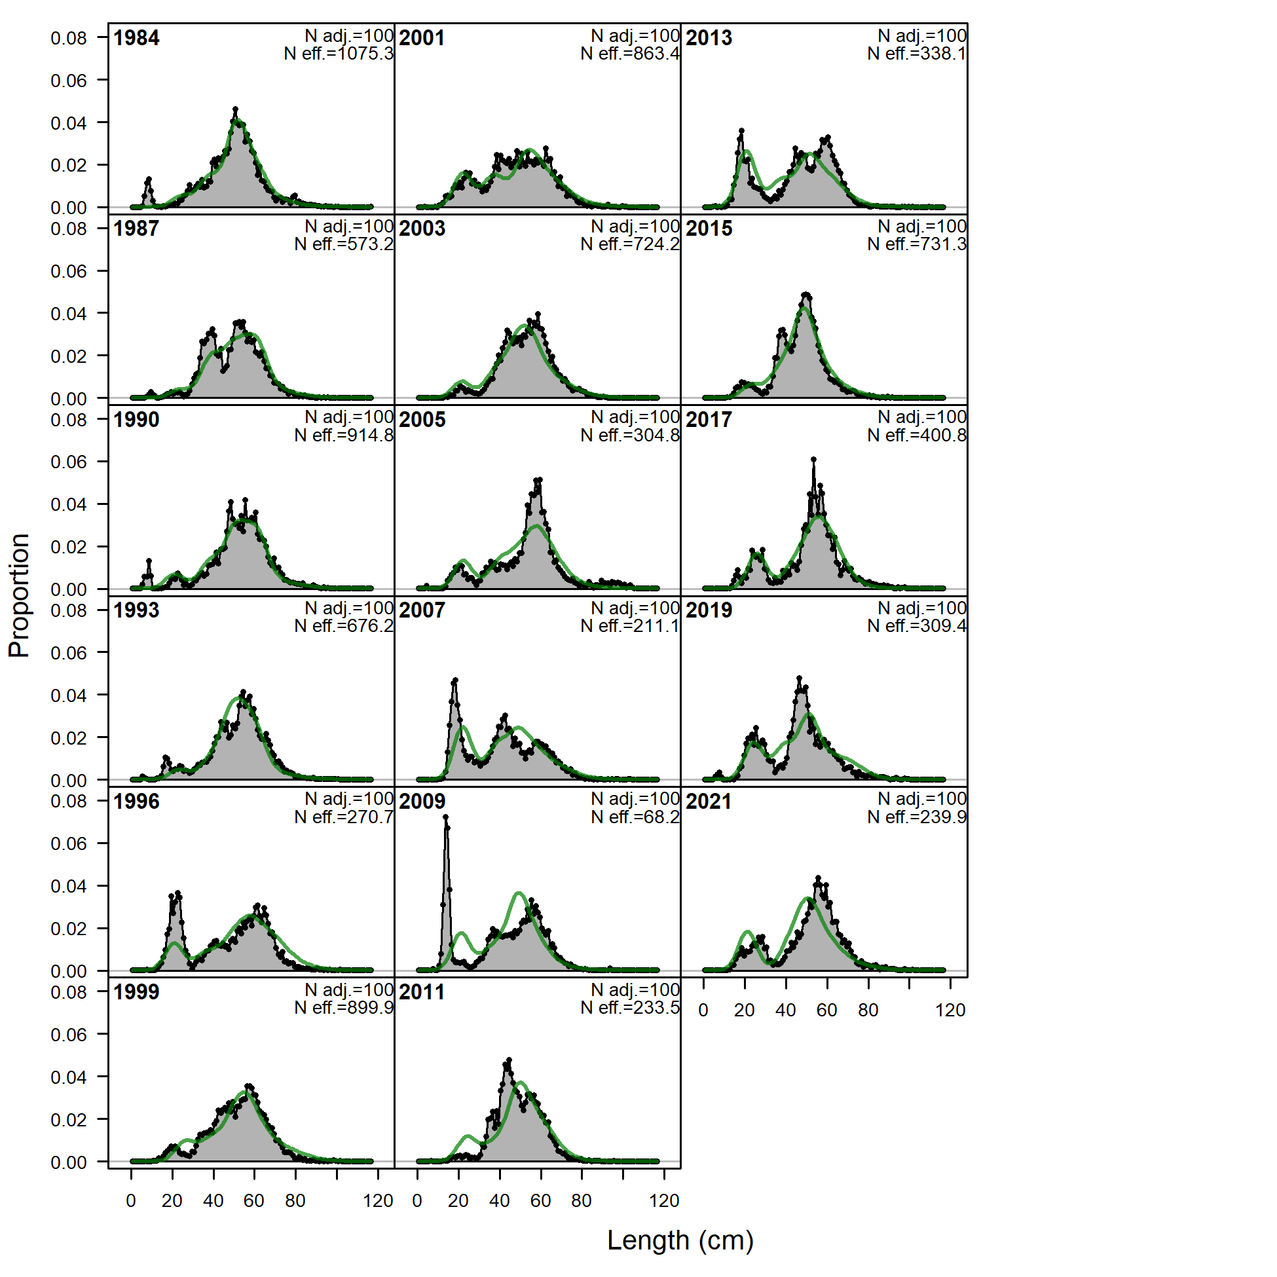

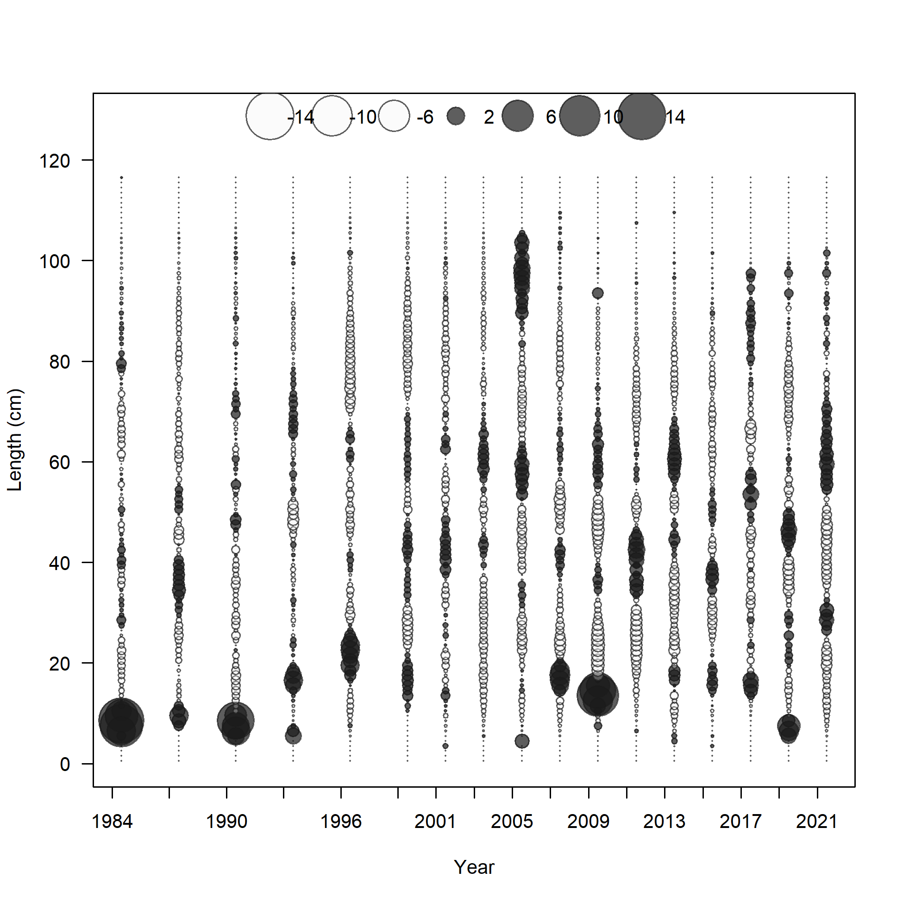 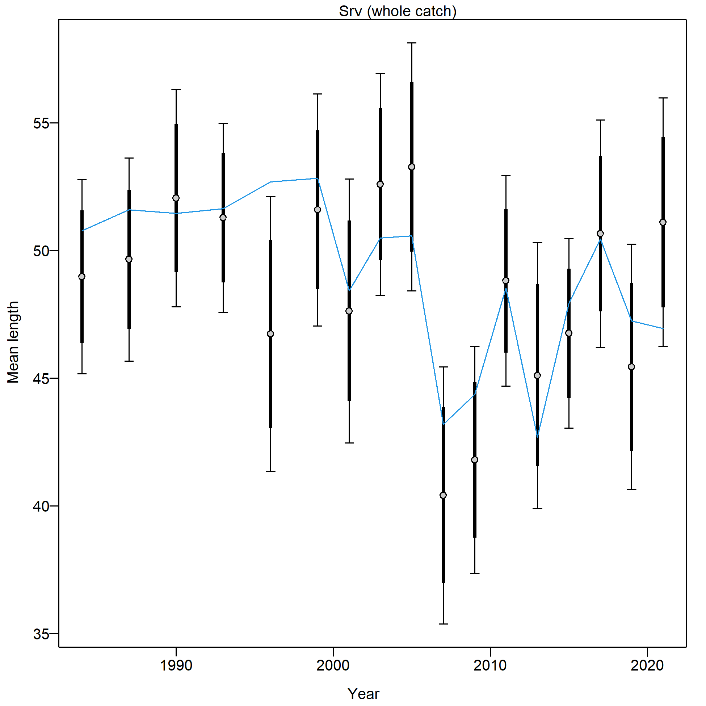

Figure 2.82 NMFS bottom trawl survey length composition and Model 21.2 fit (top), Pearson residuals (left bottom; max = 12.44), and mean length (cm; right bottom).

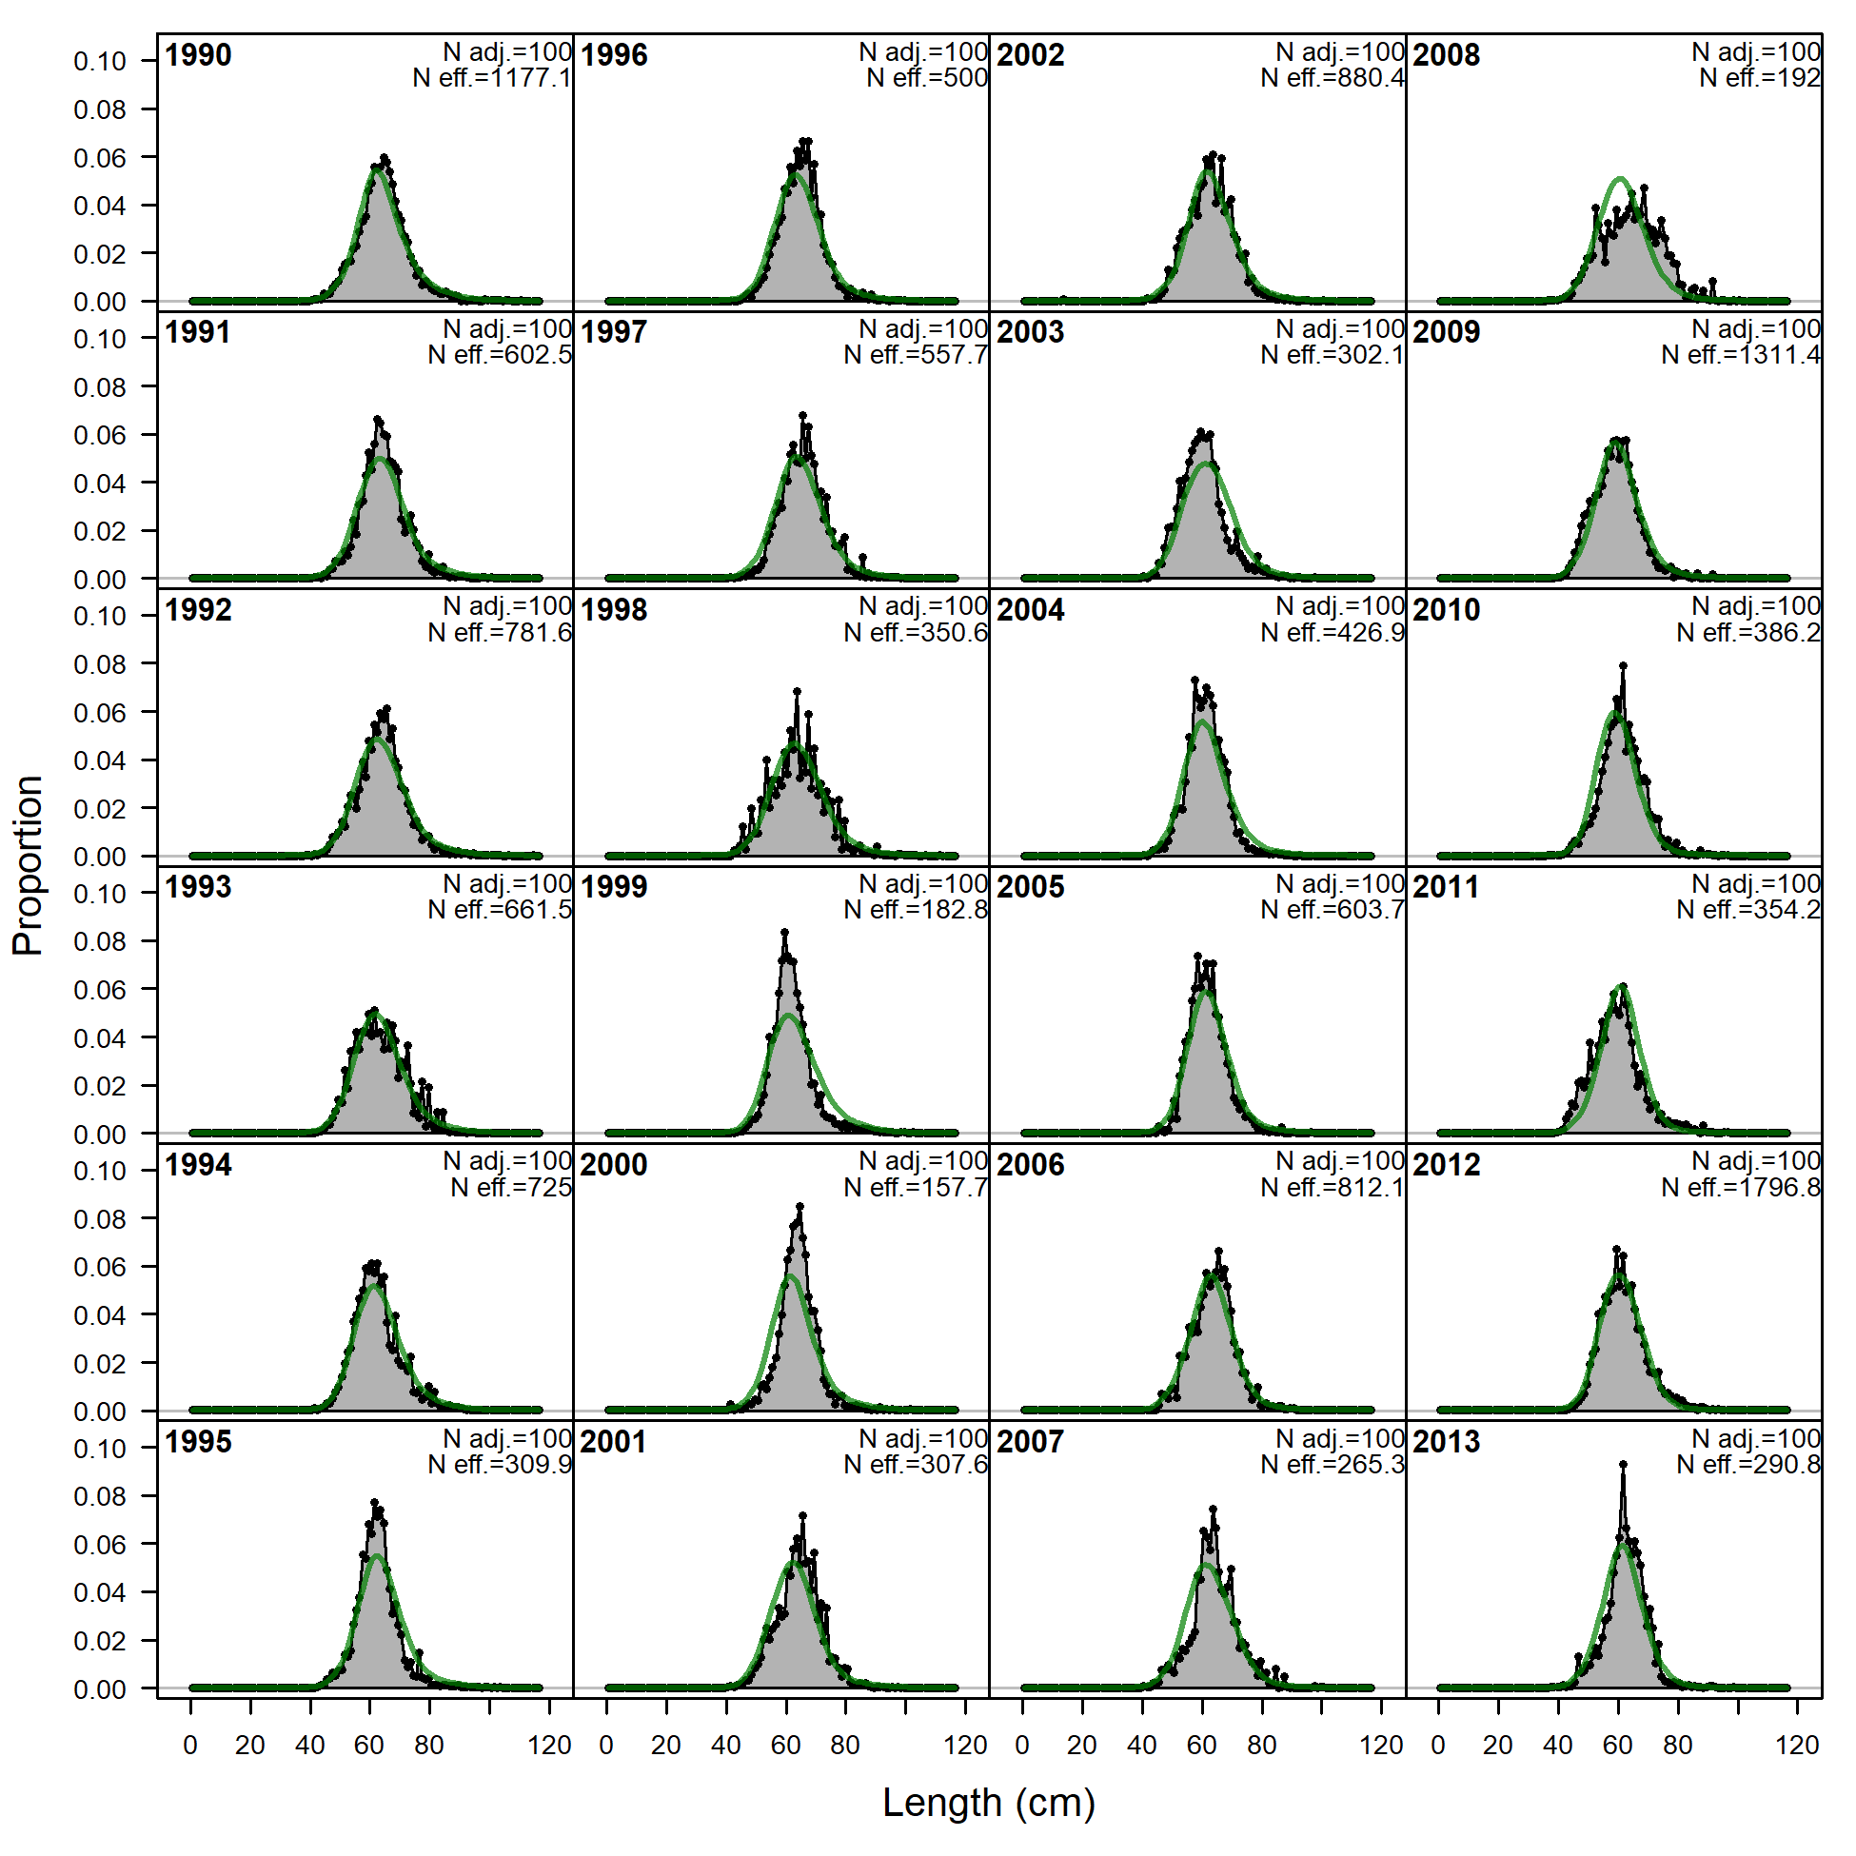 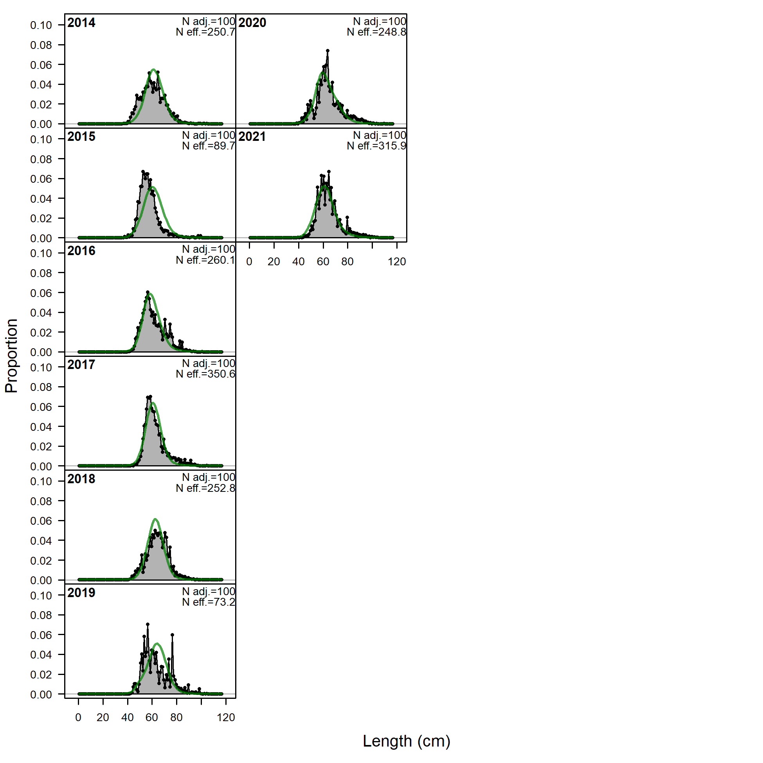

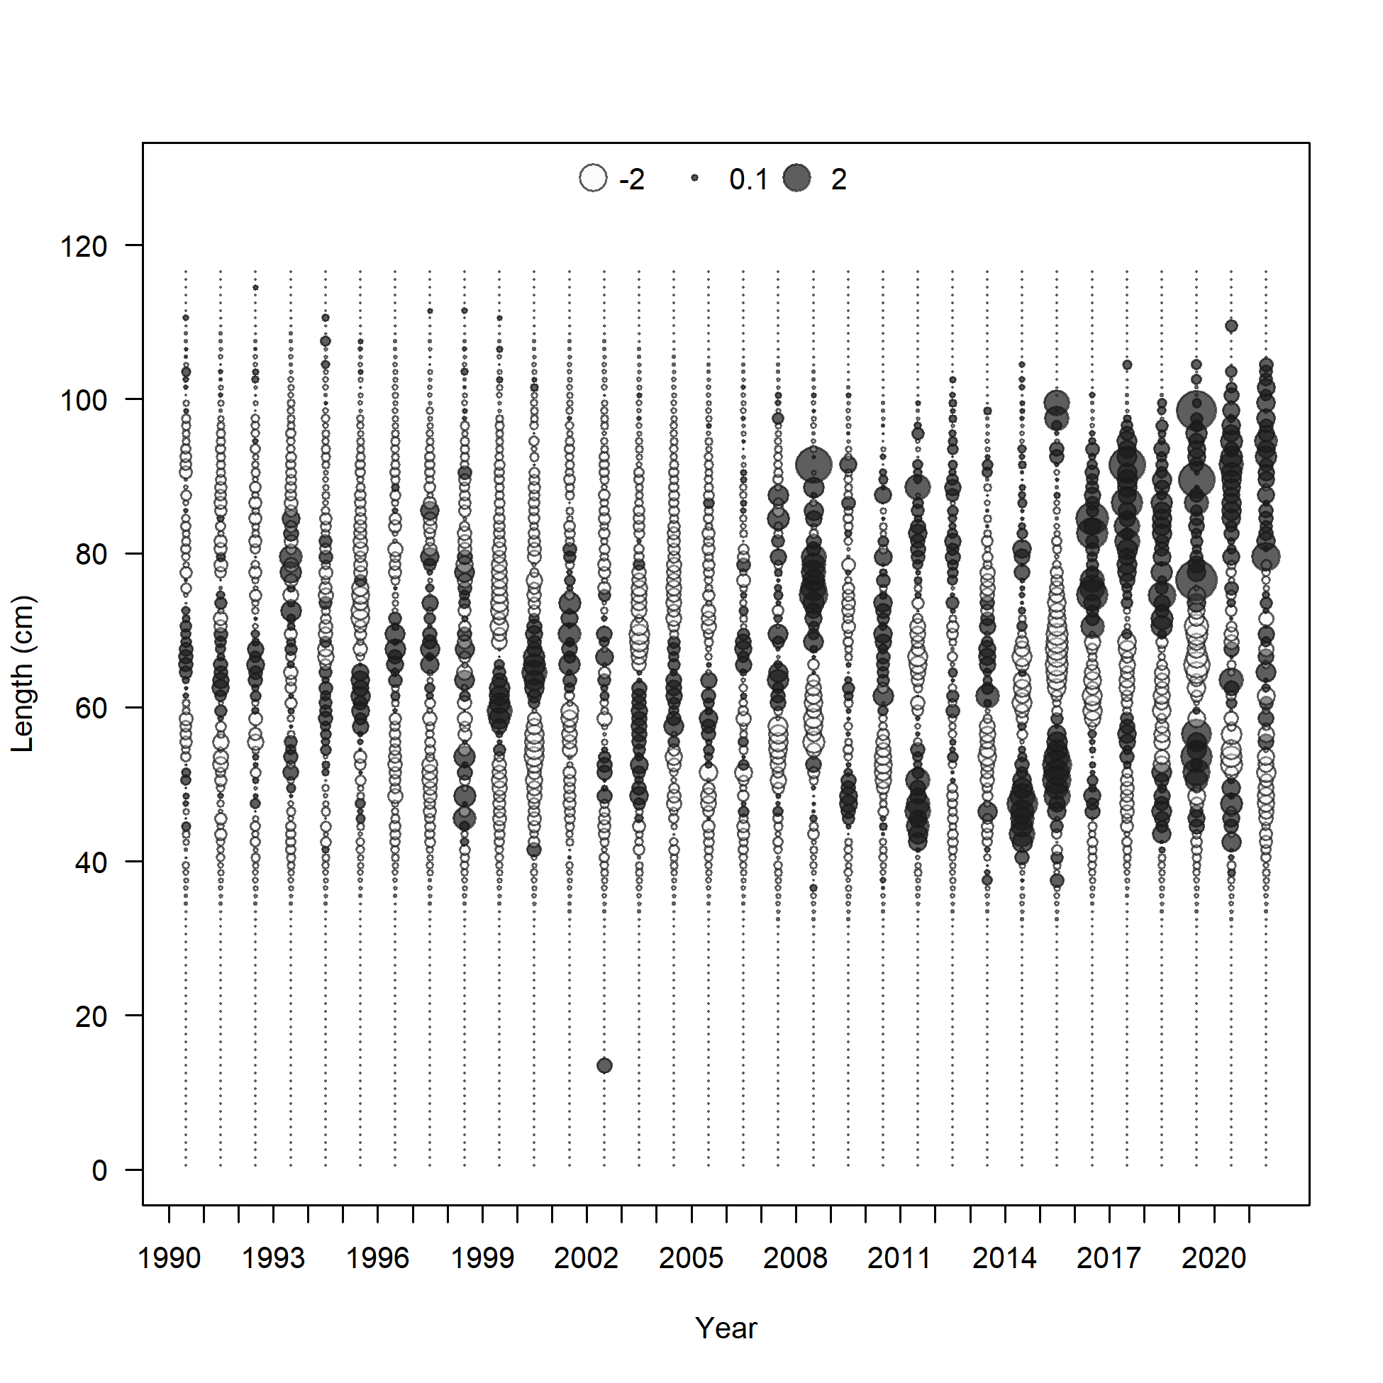 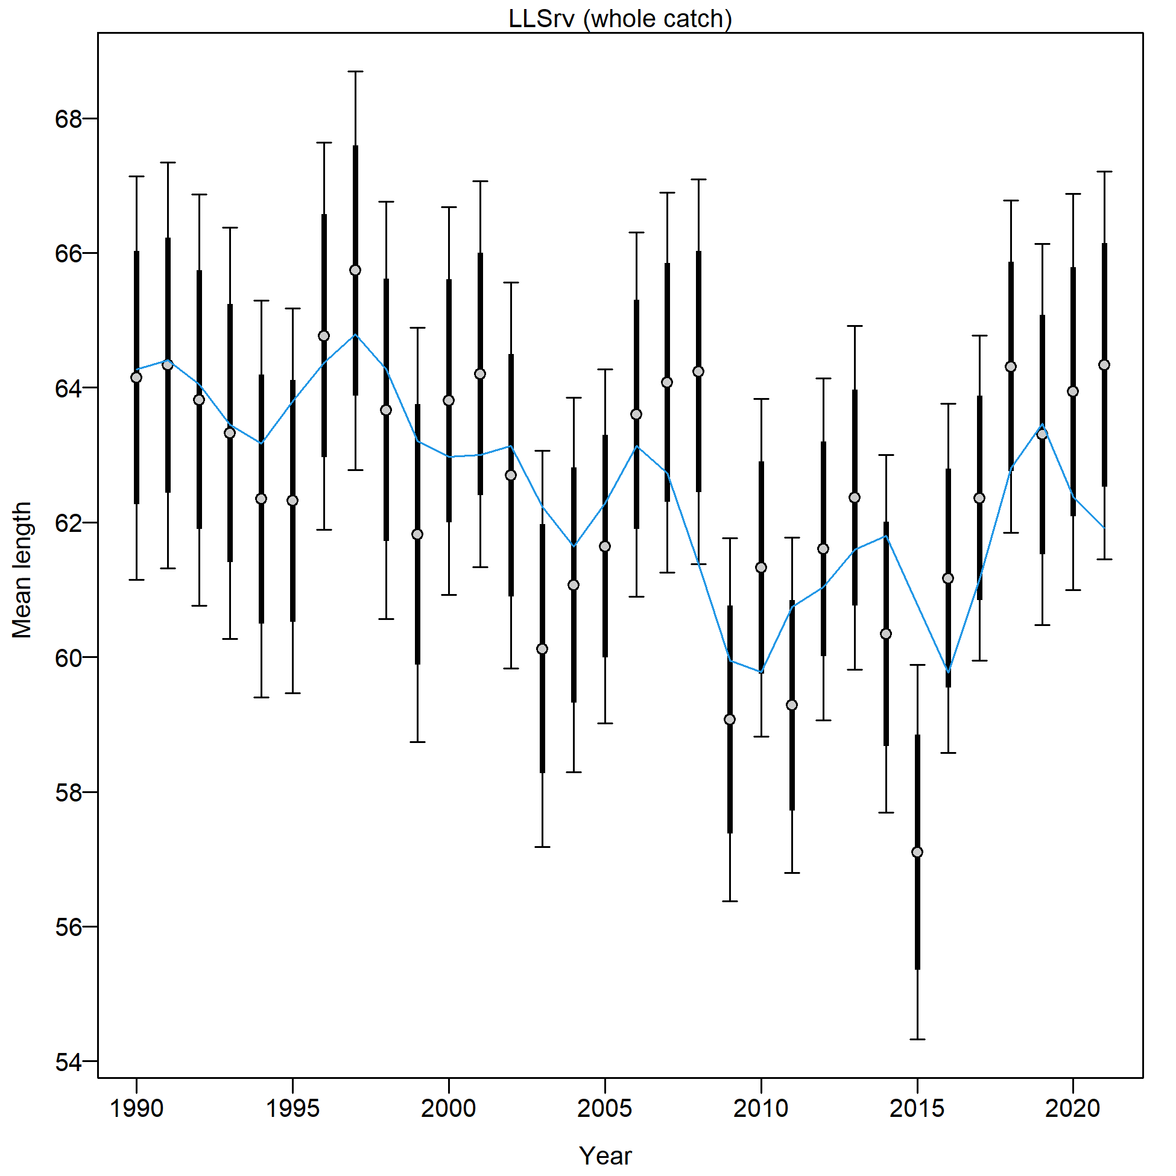

Figure 2.83 AFSC Longline survey length composition and Model 21.2 fit (top), Pearson residuals (left bottom; max=5.19), and mean length (cm; right bottom).

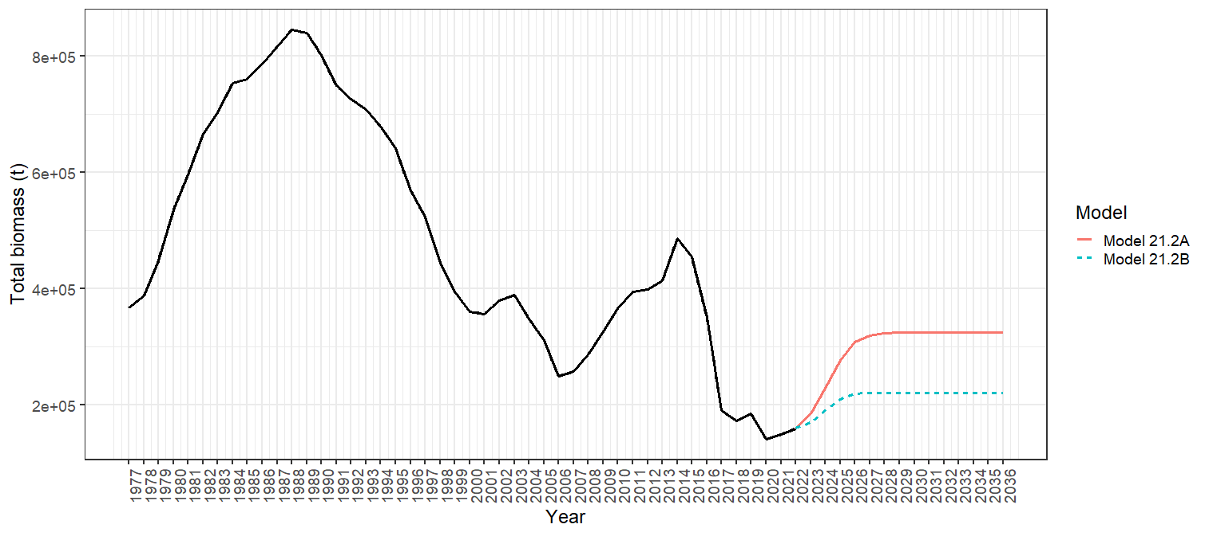

Figure 2.84 Total biomass 1977-2021 for Model 21.2 with Projection A (red solid line) and Projection B (blue dashed line) shown for 2022-2036.

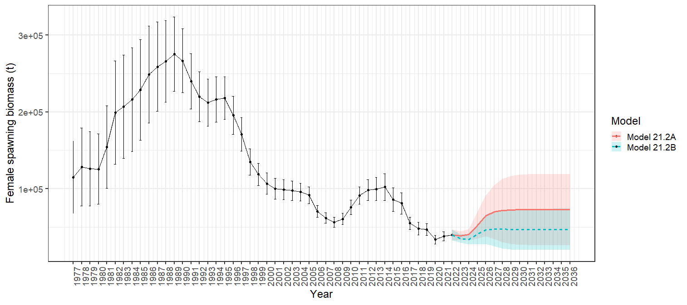

Figure 2.85 Model 21.2 female spawning biomass with 95% asymtotic error intervals with Projection A (red solid line) and Projection B (blue dashed line) shown for 2022-2036.

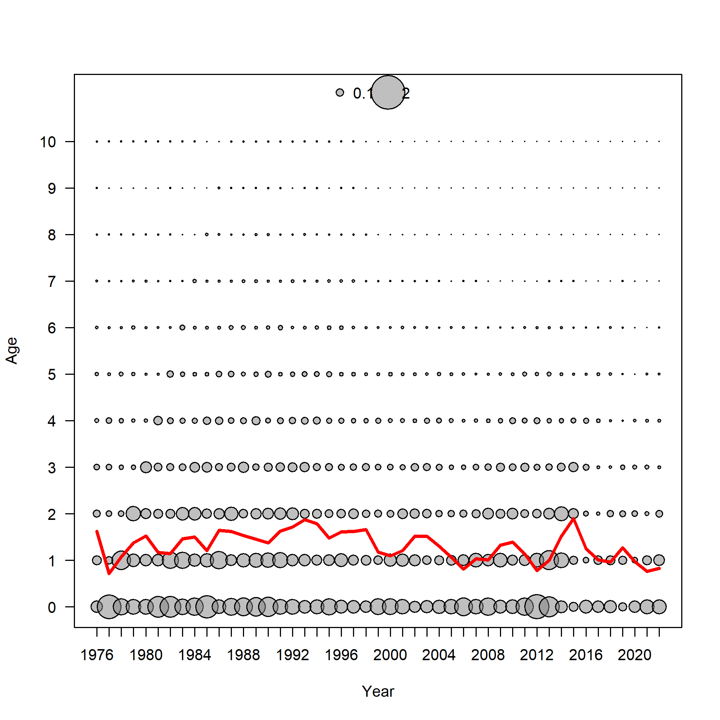 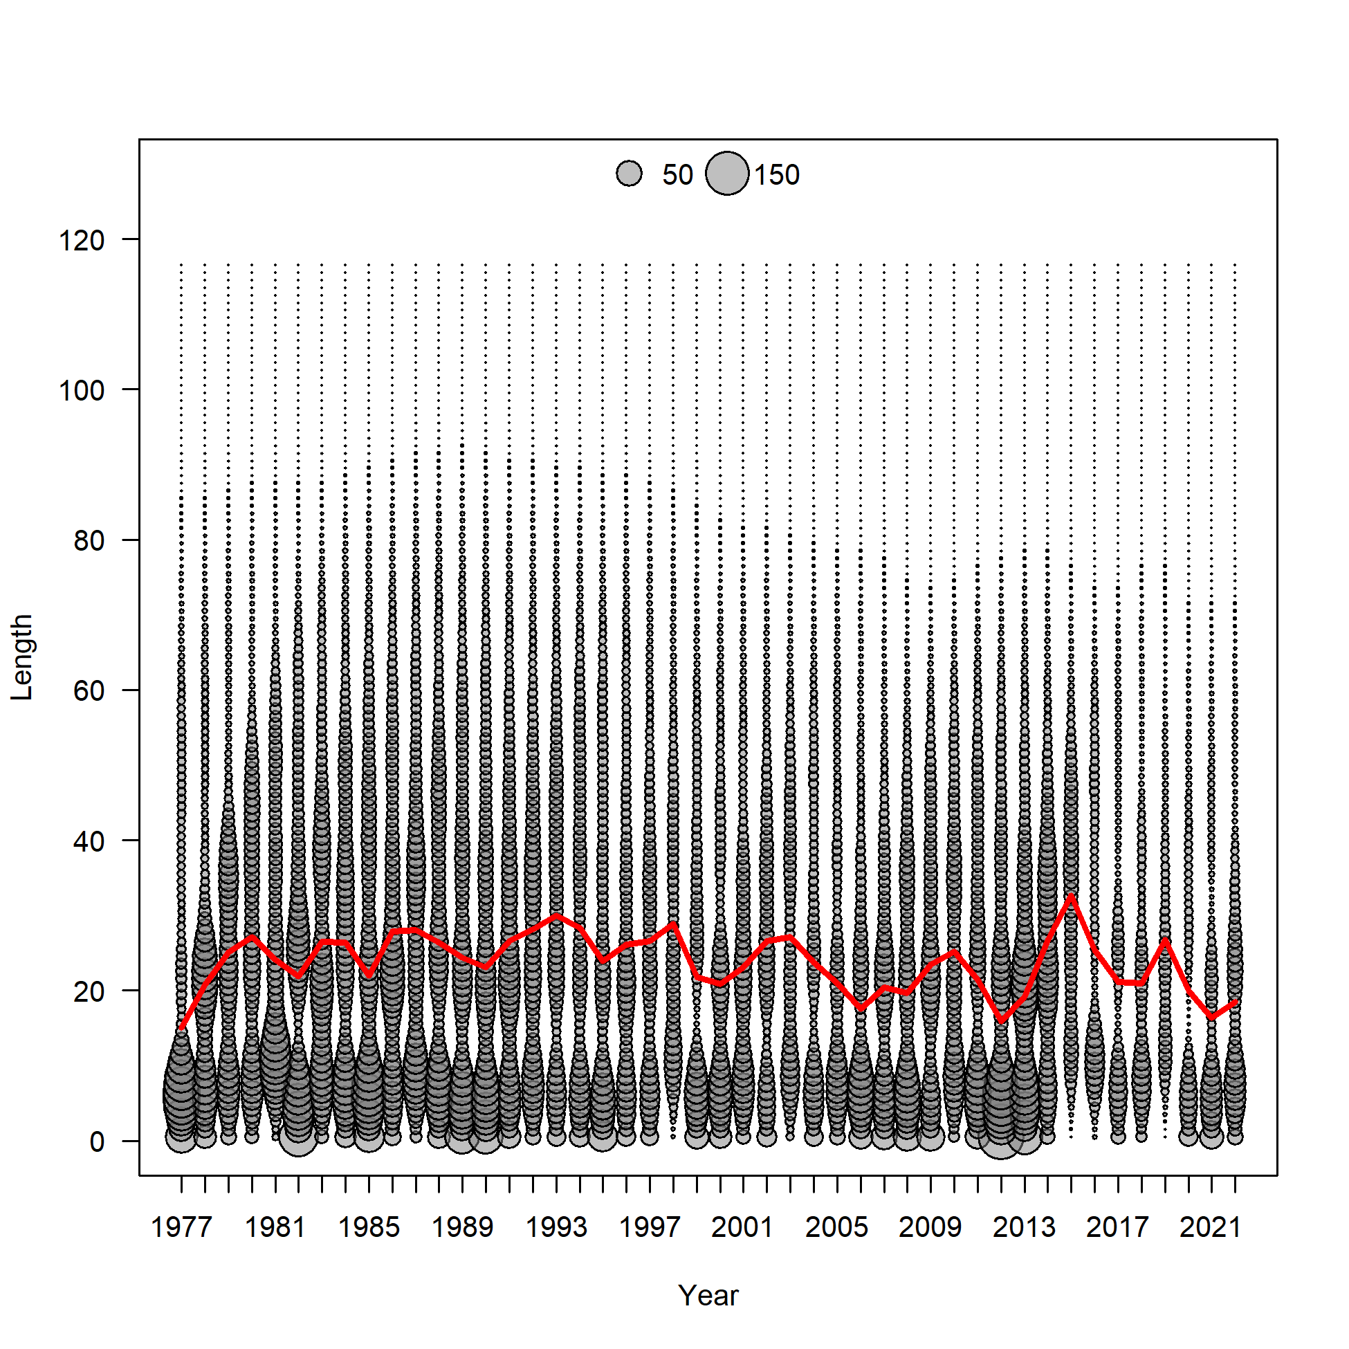

Figure 2.86 Model 21.2 predictions of middle of the year number at age (top) with mean age (red line) and number at length (bottom)with mean length (red line).

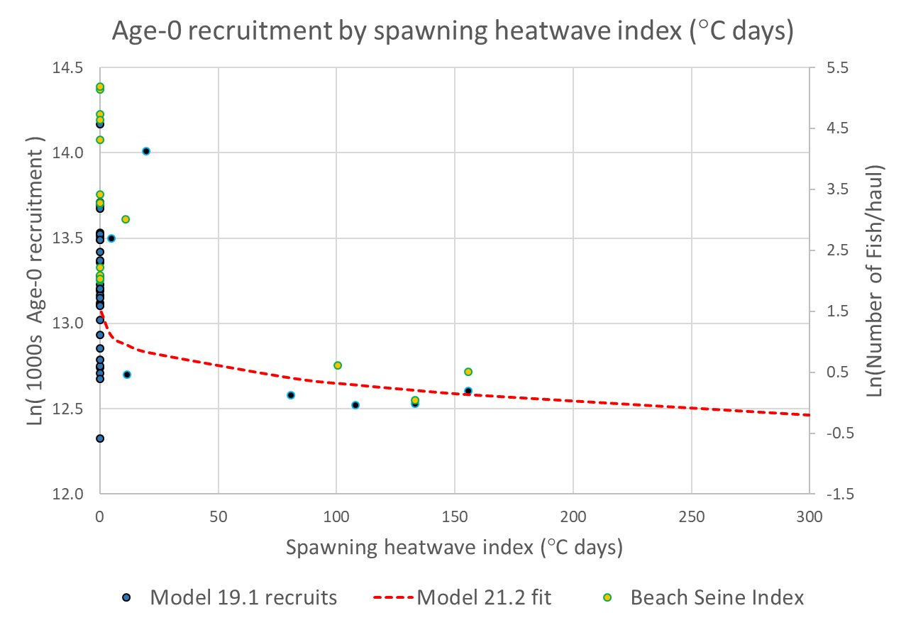

Figure 2.87 Log recruits (1000’1) by spawning heatwave index from the Model 19.1 (blue dots) with spawning heatwave linked recruitment model fit (red line) from Model 21.2. Shown on the secondary y-axis and in yellow are the log of the age-0 beach seine index values (number of fish/haul).

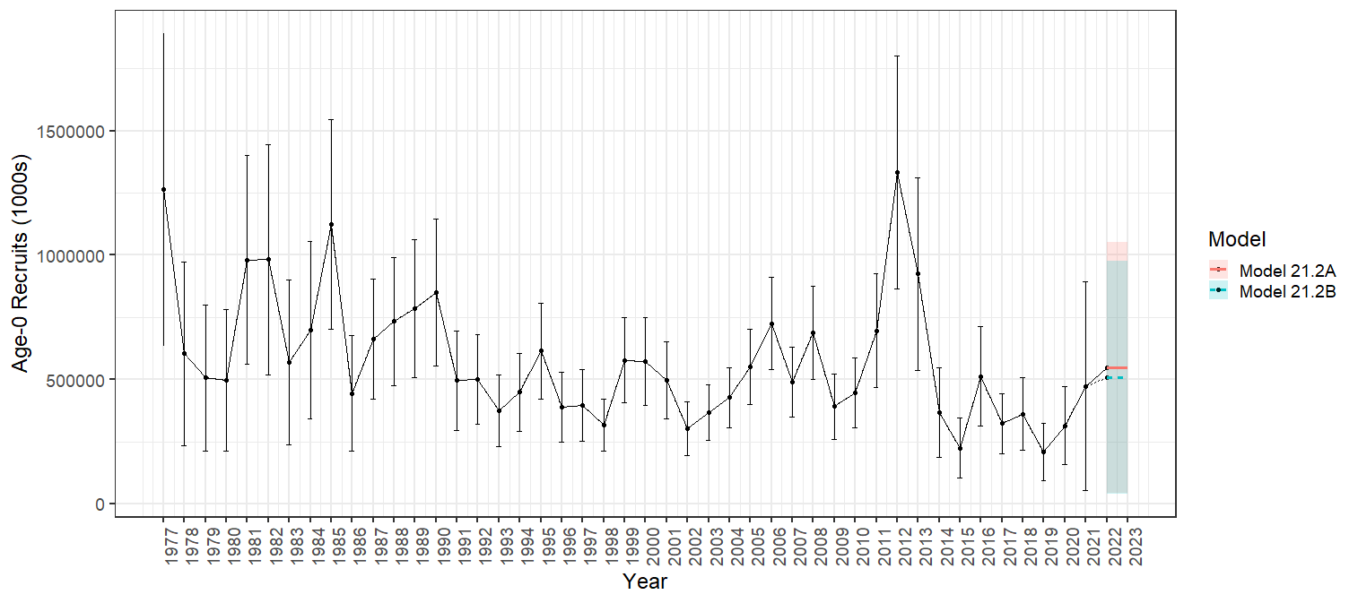

Figure 2.88 Model 21.2 age-0 recruitment (1000’s) with 95% asymtotic error intervals with Projection A (solid red line) and Projection B (dashed blue line).

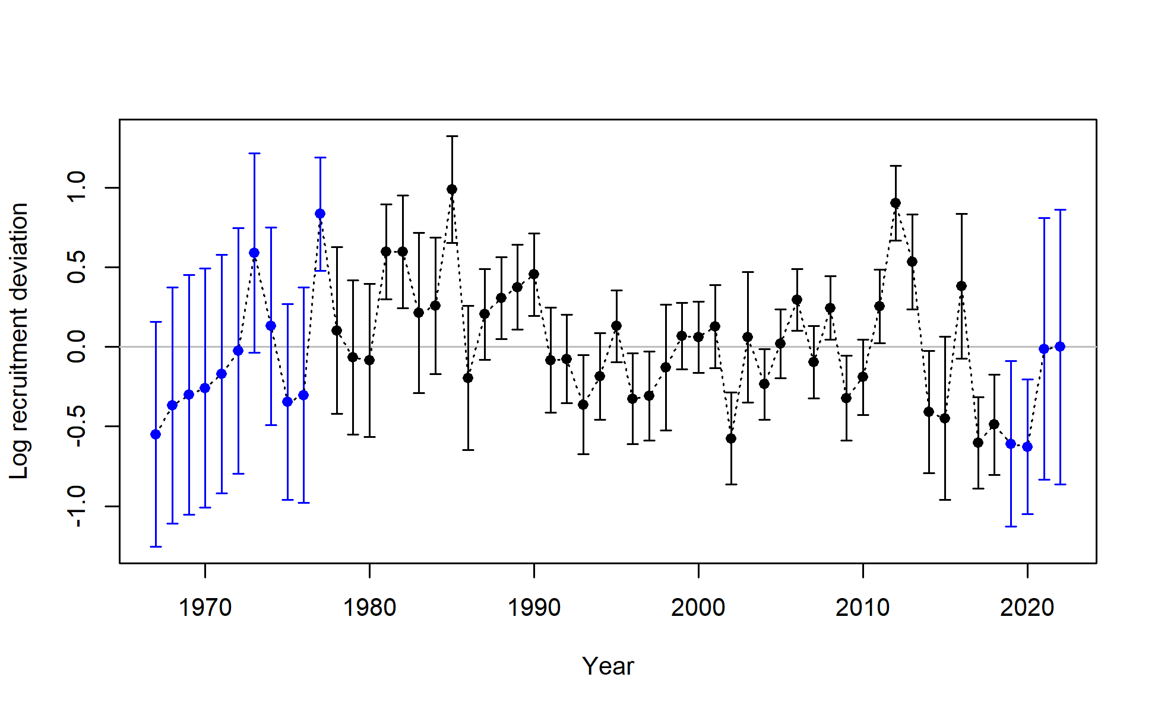

Figure 2.89 Model 21.2 log recruitment deviations with 95% asymtotic error intervals.

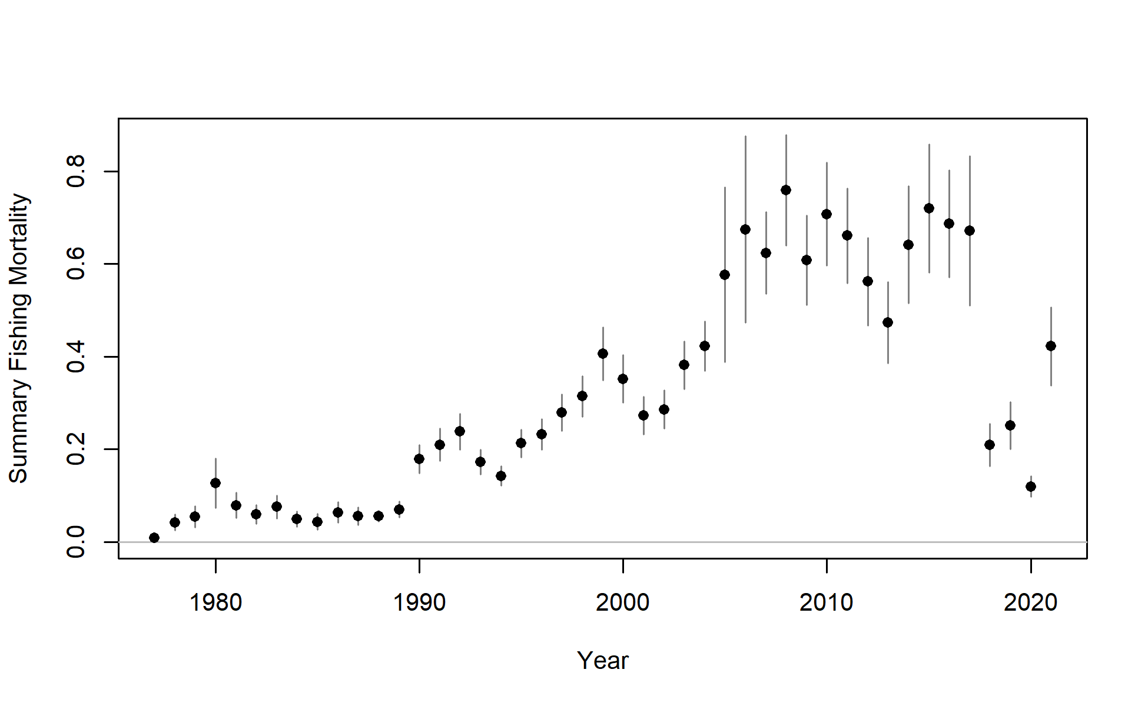 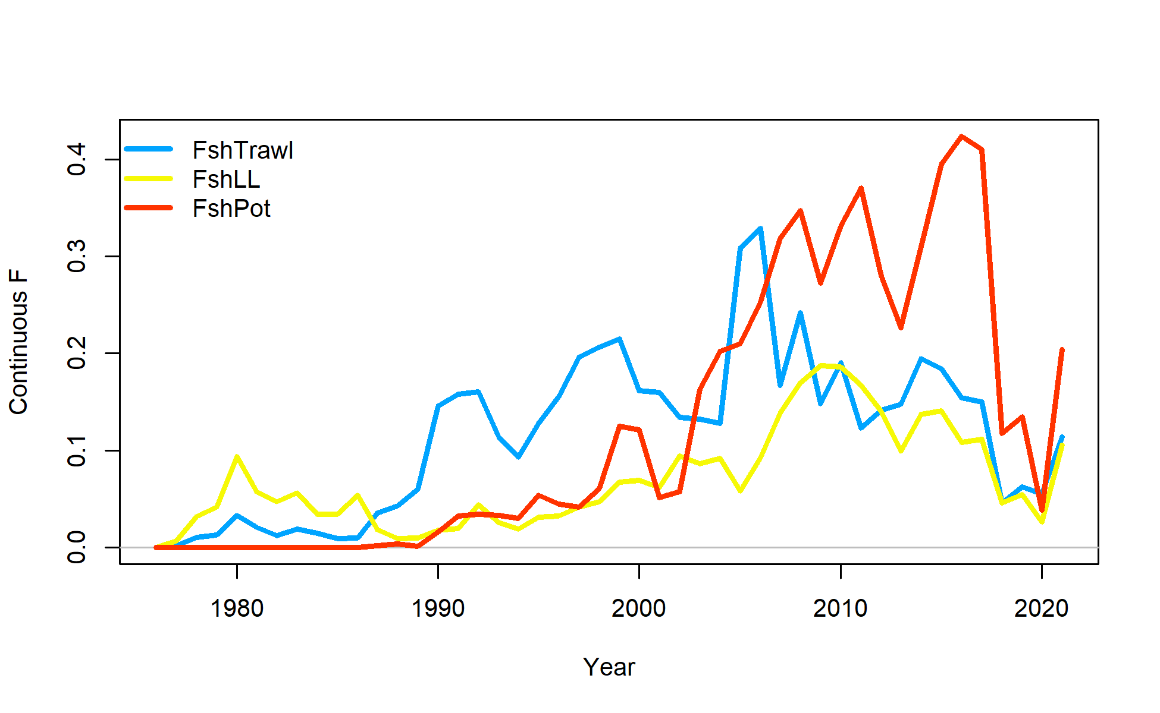

Figure 2.90 Model 21.2 sum of apical fishing mortality (top) and continuos fishing mortality by trawl (FshTrawl), longline (FshLL) and pot (FshPot) fisheries (bottom).

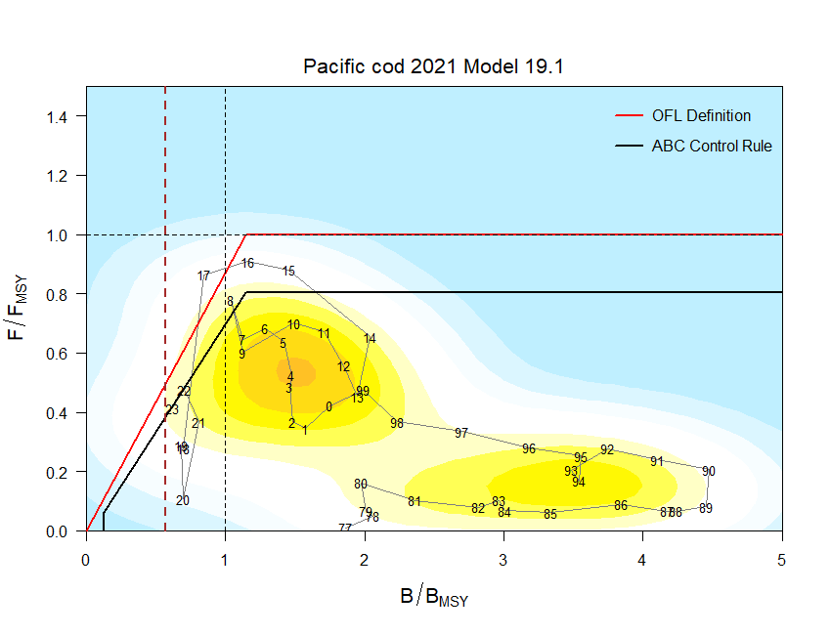 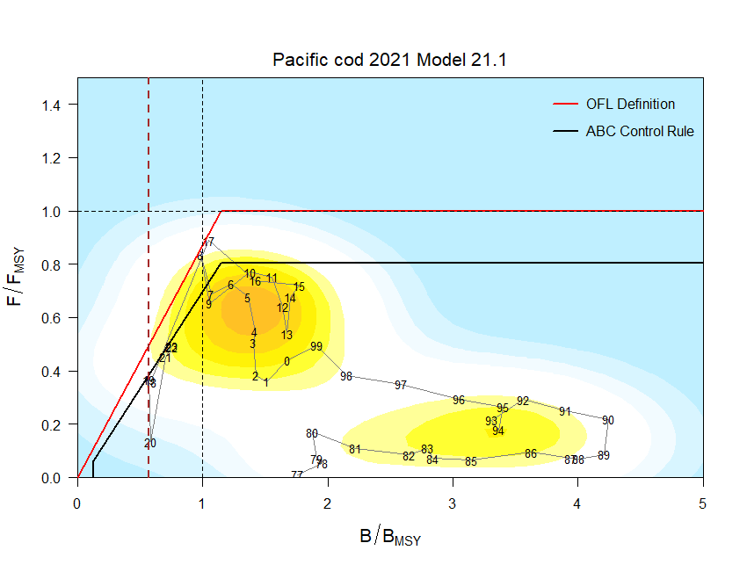

Figure 2.91 For (left) Model 19.1 and (right) Model 21.1 ratio of historical F/*Fmsy* versus female spawning biomass relative to *Bmsy* for GOA pacific cod, 1977-2023. Note that the proxies for *Fmsy* and *Bmsy* are *F35%* and *B35%*, respectively. The Fs presented are the sum of the full Fs across fleets. Dashed line is at B*20%*, Steller sea lion closure rule for GOA Pacific cod.

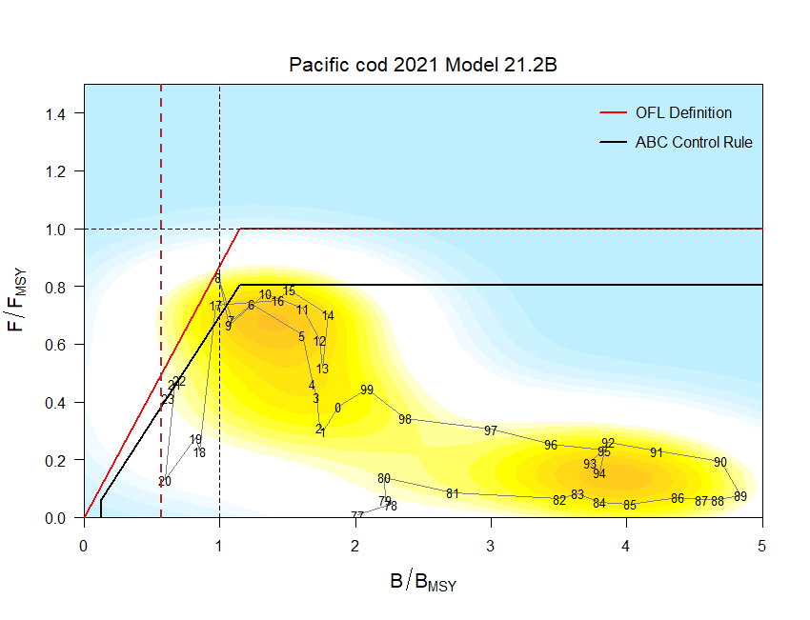

Figure 2.92 For Model 21.2 ratio of historical F/*Fmsy* versus female spawning biomass relative to *Bmsy* for GOA pacific cod, 1977-2023. Note that the proxies for *Fmsy* and *Bmsy* are *F35%* and *B35%*, respectively. The Fs presented are the sum of the full Fs across fleets. Dashed line is at B*20%*, Steller sea lion closure rule for GOA Pacific cod.

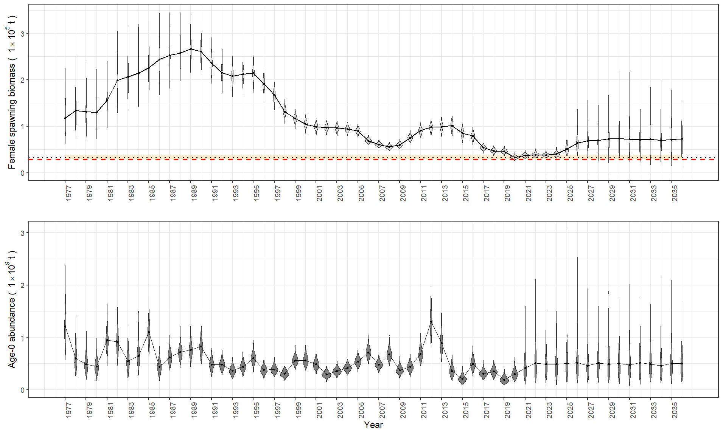

Figure 2.93 Model 21.2 with Projection A MCMC posterior distribitions of beginning of the year female spawning biomass (top) and age-0 abundance (bottom) for 1977-2036. Dotted line is the projected SSB*20%* with 95% confidence interval in orange and the red dashed line is SSB17.5%.

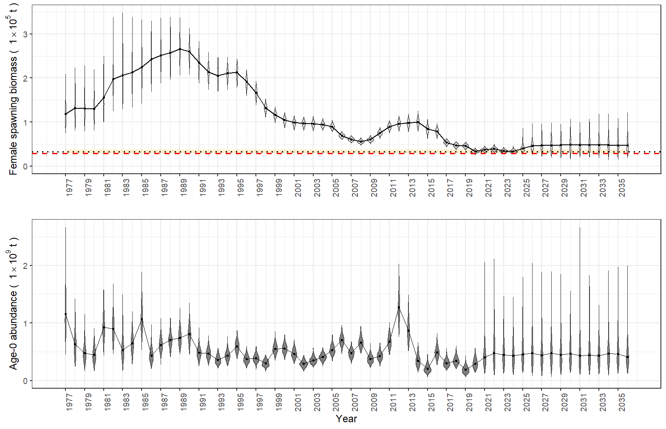

Figure 2.94 Model 21.2 with Projection B MCMC posterior distribitions of beginning of the year female spawning biomass (top) and age-0 abundance (bottom) for 1977-2036. Dotted line is the projected SSB*20%* with 95% confidence interval in orange and the red dashed line is SSB17.5%.

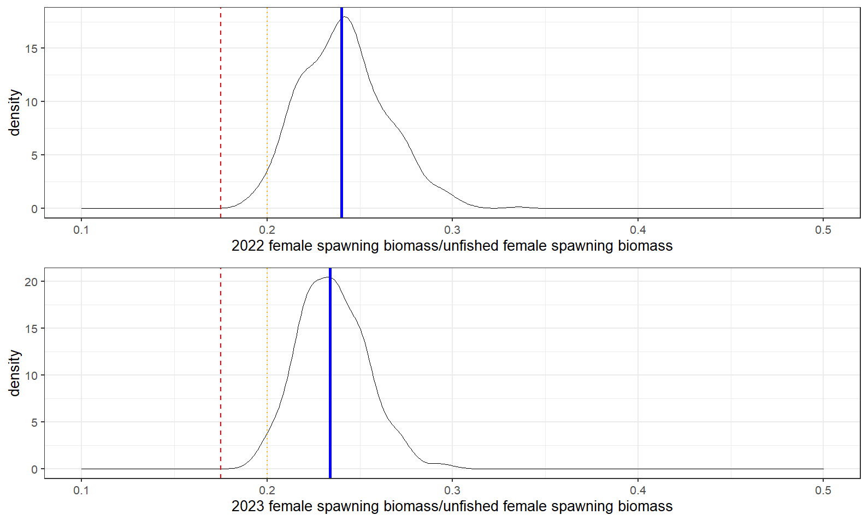

Figure 2.95 Model 21.2 MCMC Projection A posterior distribitions of the 2022 (top) and 2023 (bottom) spawning stock biomass ratio with estimates for SSB20% (orange dotted line) and SSB17.5% (Red dashed line) from the projection model, and posterior median (blue solid line) for beginning year 2022 and 2023.

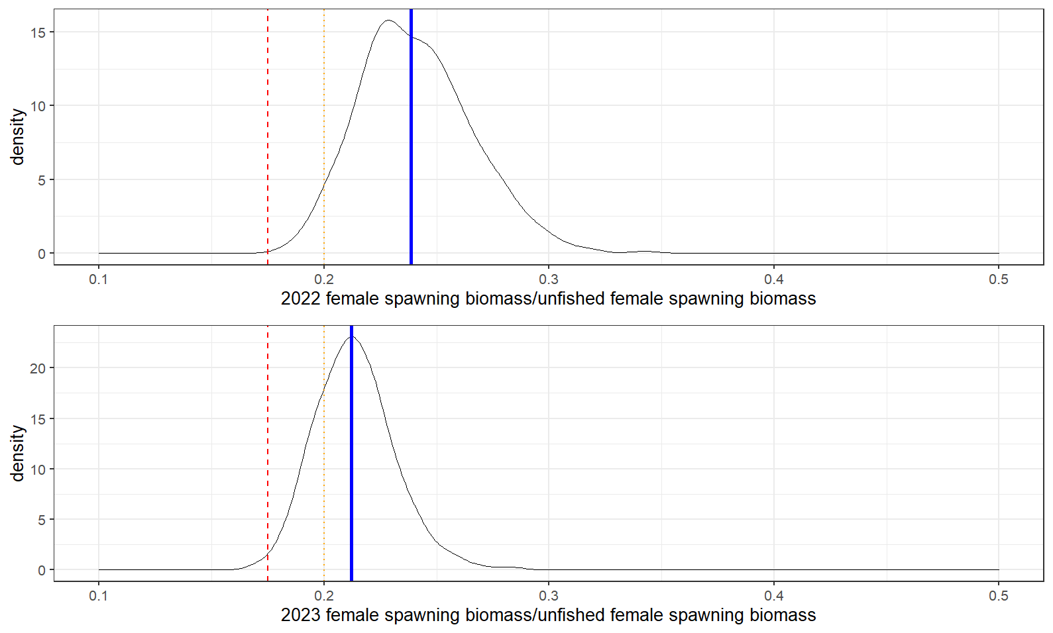

Figure 2.96 Model 21.2 MCMC Projection B posterior distribitions of the 2022 (top) and 2023 (bottom) spawning stock biomass ratio with estimates for SSB20% (orange dotted line) and SSB17.5% (Red dashed line) from the projection model, and posterior median (blue solid line) for beginning year 2022 and 2023.

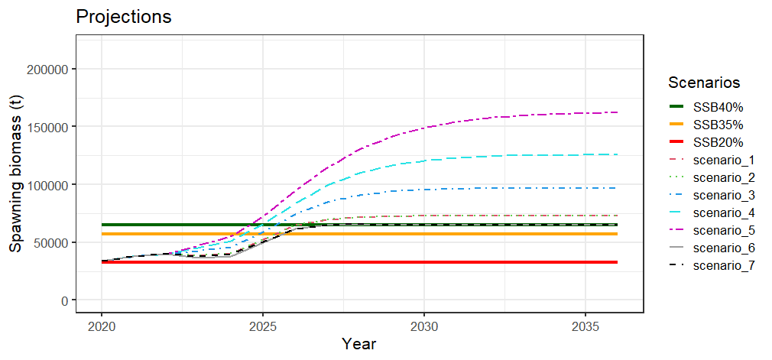 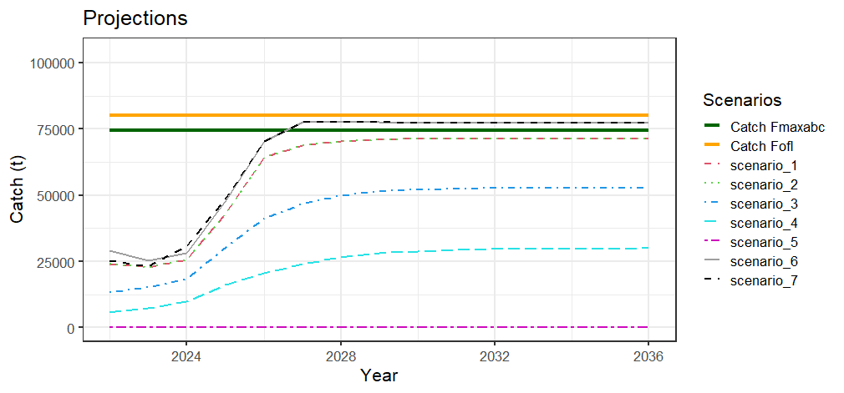

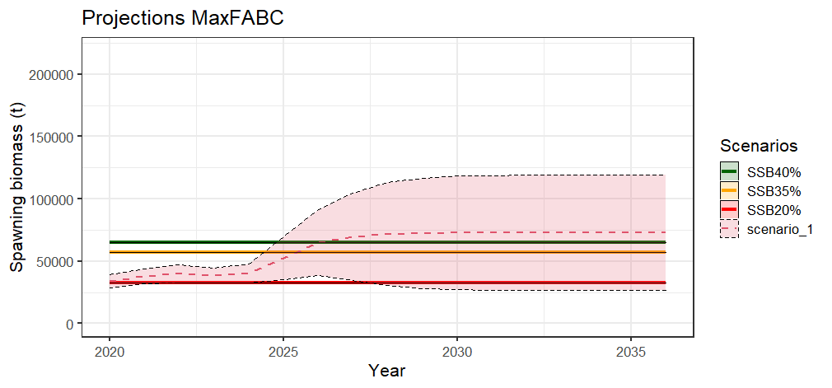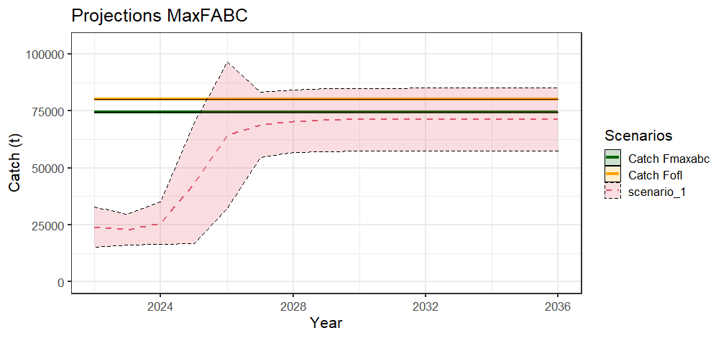

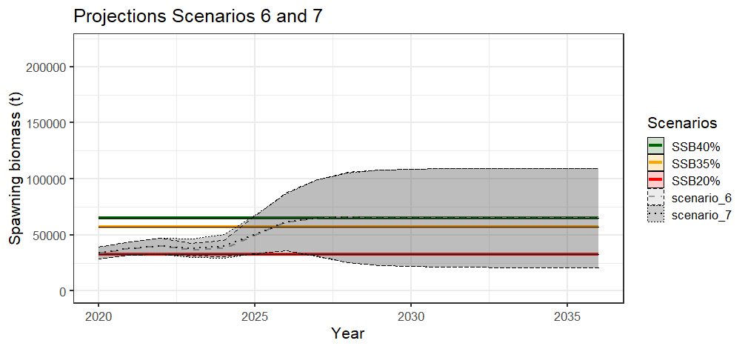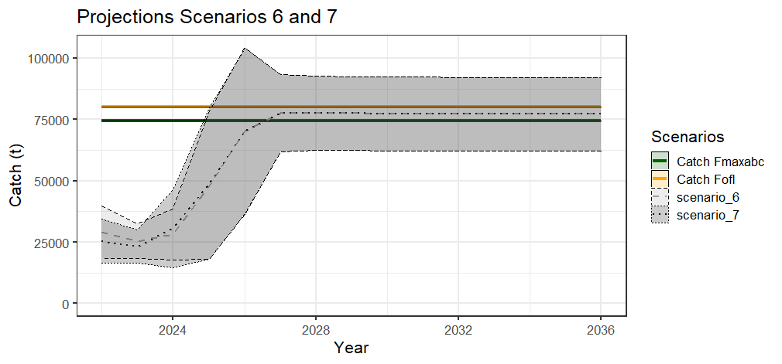

Figure 2.97 Model 21.2A projections of female spawning biomass (top left ) and catch (top right) for the seven management scenarios, for scenario 1 a max ABC (middle), and scenarios 6 and 7 for status determination (bottom ).

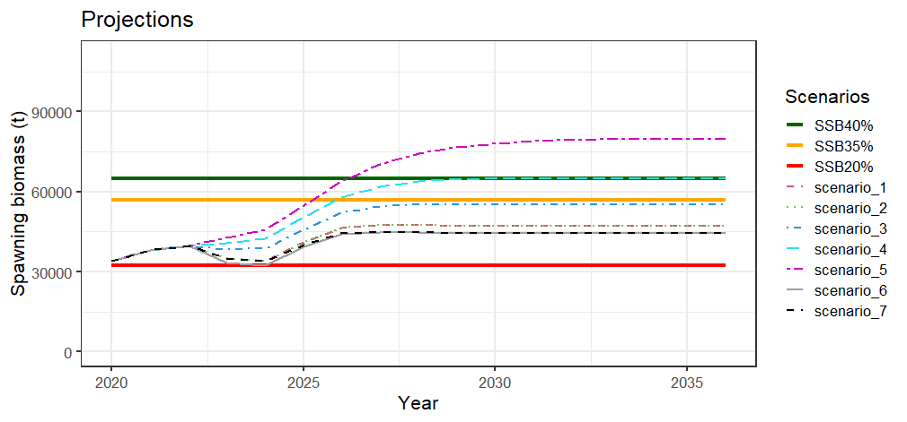 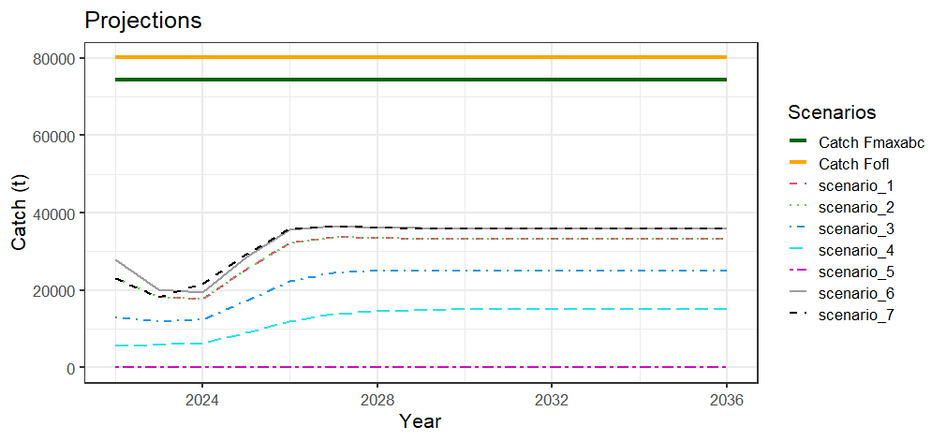

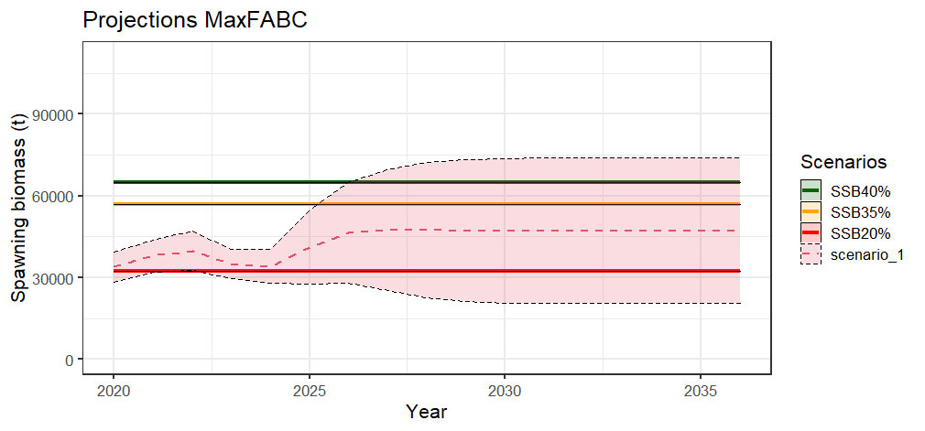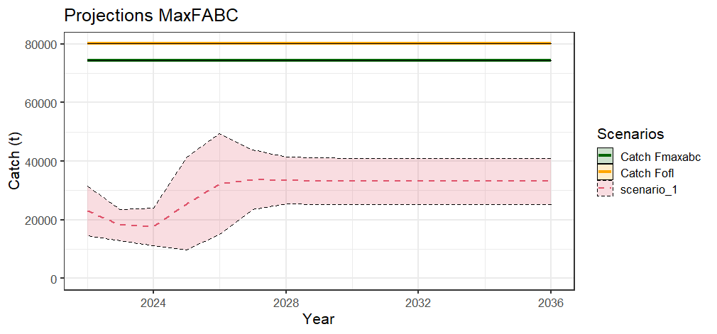

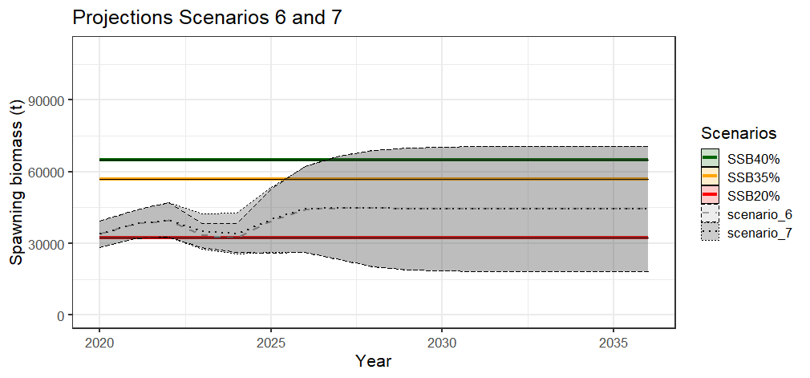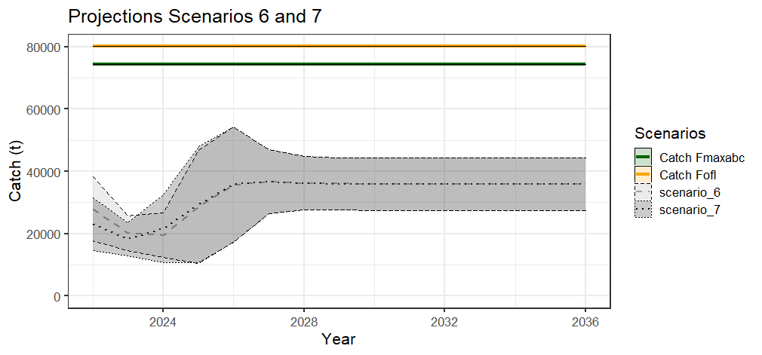

Figure 2.98 Model 21.2B projections of female spawning biomass (top left ) and catch (top right) for the seven management scenarios, for scenario 1 a max ABC (middle), and scenarios 6 and 7 for status determination (bottom ).

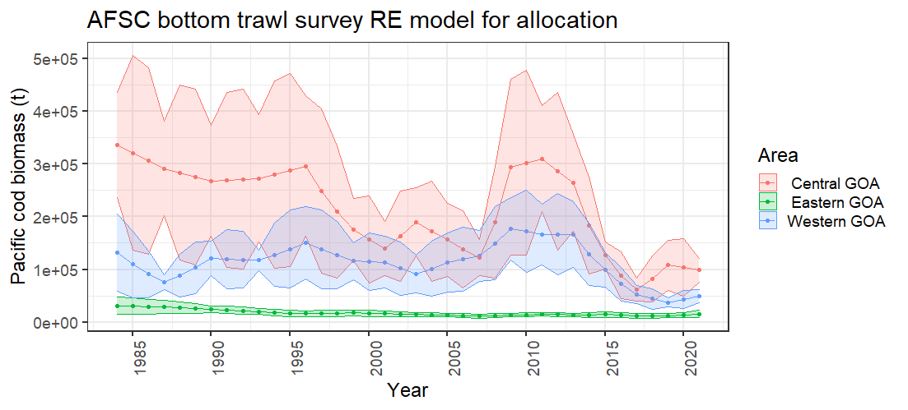

Figure 2.99 Random effects model results for the AFSC bottom trawl survey area used for area allocation.

# Appendix 2.1. Ecosystem and Socioeconomic Profile of the Pacific cod stock in the Gulf of Alaska

S. Kalei Shotwell, Steven Barbeaux, Bridget Ferriss, Ben Fissel, Ben Laurel, Beth Matta, Lauren Rogers

November 2021

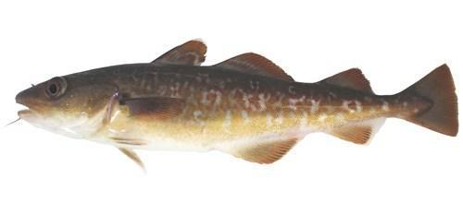

*With Contributions from:*

Kerim Aydin, Curry Cunningham, Kirstin Holsman, Carol Ladd, Sandi Neidetcher, Patrick Ressler, Heather Renner, Sean Rohan, Elizabeth Siddon, Ingrid Spies, Katie Sweeney, Grant Thompson, Muyin Wang, Jordan Watson, Sarah Wise, Stephani Zador

# Executive Summary

National initiatives and AFSC research priorities support conducting an ecosystem and socioeconomic profile (ESP) for Gulf of Alaska (GOA) Pacific cod. Annual guidelines for the AFSC support research that improves our understanding of environmental and climate forcing of ecosystem processes with a focus on variables that can provide direct input into or improve stock assessment and management. The GOA Pacific cod ESP follows the new standardized framework for evaluating ecosystem and socioeconomic considerations for GOA Pacific cod and may be considered a proving ground for potential use in the main stock assessment.

We use information from a variety of data streams available for the GOA Pacific cod stock and present results of applying the ESP process through a metric and subsequent indicator assessment. Analysis of the ecosystem and socioeconomic processes for GOA Pacific cod by life history stage along with information from the literature identified a suite of indicators for testing and continued monitoring within the ESP. Results of the metric and indicator assessment are summarized below as ecosystem and socioeconomic considerations that can be used for evaluating concerns in the main stock assessment.

## Ecosystem Considerations

* Hatch timing and success is highly temperature dependent with optimal hatch occurring in waters between 4-6oC and has implications for spawning habitat suitability and subsequent recruitment
* Warm temperatures can increase susceptibility of starvation for larval Pacific cod when mismatched to prey or reduce growth during shifts in the lipid/fatty acid composition of prey
* Cross-shelf transport may assist larvae and early juveniles to nearshore nurseries for settlement and eddies and gap winds may disrupt along-shore currents to increase growth and survival
* Copepods and euphausiids low since 2009 and returned to average in 2019, and condition of juvenile Pacific cod were poor for 2015 and 2017 surveys
* Annual eddy kinetic energy has shifted from high periods of eddy activity from 2003 to 2015 to a lower energy system in 2016 to 2019 and a strong, persistent eddy around Kodiak in 2020
* The overall spatial distribution of the stock has spread out substantially from 2009 to 2019 with a shift to the farthest northeast in 2019 from the farthest southwest in 2017
* Predators of Pacific cod have steadily decreased over the time series but have recently stabilized suggesting the primary pressure on the 2012 year-classes may be the lack of preferred prey
* Overall, ecosystem indicators have been decreasing since 2012 with a slight recovery to near normal conditions in 2017, when the heat in the system was reduced but return to low values in 2018 and 2019, similar to the GOA pollock
* Highest ranked predictor for recruitment regression model was spawning habitat suitability and eddy kinetic energy on the GOA shelf (inclusion probability > 0.5)

## Socioeconomic Considerations

* Kodiak and a combined group of small communities were selected as highly engaged communities when evaluating commercial processing and harvesting engagement
* Ex-vessel value has been decreasing since about 2011 with price per pound very low from 2013 to 2017 with a recent increase and revenue per unit effort has been increasing since 2016
* Processing and harvesting regional quotient (RQ) in Kodiak has been steadily decreasing since 2015 with small communities declining in both measures since 2014, a year earlier

## Responses to SSC and Plan Team Comments on ESPs in General

*“Regarding ESPs in general, the SSC recommends development of a method to aggregate indices into a score that could be estimated over time and compared to stock history. One potential pathway forward may be to normalize and use an unweighted sum of all the indicators where all time series overlap, or just assign +1 or -1 to each indicator so that a neutral environment would be zero.”* (SSC, February 2020)

*“The Teams discussed concerns of over-emphasizing the 1:1 weighting on the first stage. In the absence of information to indicate an appropriate weighting strategy, it is recommended to not rely too heavily on the uninformed 1:1 weighting to select appropriate indicators. The Teams also requested that the ESP team/authors consider appropriately caveating the indicators to ensure they are interpreted species-specific and not over generalized. The Teams support continuing with the current 3-stage indicator analyses for now, and re-evaluate as the ESP process develops, recognizing that the actual value of the integrated index is yet to be clearly demonstrated although it is one high-level summary statistic that may be valuable to examine.”* (Joint Groundfish Plan Team, September 2020)

*“The JPT were in support of the current templates and the current 3-stage indicator analysis, but noted concerns of over-emphasizing weighting in the first stage and recommended that indicators should be appropriately caveated to not over-generalize indicators across species. The JPT also fully supported the development of the ESP dashboard on AFKIN that includes metadata for each data source, but suggested a staged approach to the integration of data that have not been thoroughly vetted and published.*

*The SSC endorses the recommendations, comments, and suggestions from the JPT, all of which are consistent with previous SSC recommendations and guidance.”* (SSC, October 2020)

We provide a simple score following the SSC recommendation and compare the 1:1 weighting of indicators in the “Beginning Stage: Traffic Light Test” with the results of the “Intermediate Stage, Importance Test” section. In the intermediate stage we use a Bayesian Adaptive Sampling (BAS) method that produces inclusion probabilities for a subset of indicators with the most potential for informing a stock assessment parameter of interest (e.g., recruitment of GOA Pacific cod). This second stage may provide insight on how to weigh the indicators in the beginning stage for a more informed score.

We have also initiated a new document called the request for indicators or RFI to initiate the ESP process once an ESP is recommended for a stock. The RFI begins with a summary of the dominant ecosystem and socioeconomic processes influencing the stock and then provides the requested list of potential indicators representing those dominant pressures. Instructions for how to contribute an indicator in response to the stock request are included along with details on the indicator review process and associated guideline criteria, the role and responsibilities of ESP teams and contributors, and use and acknowledgement of the indicator if selected for the ESP. The standardized structure of the RFIs and the included guideline criteria will help with vetting indicators and assist with the review of indicators by the ESP teams. We plan to create RFIs for those stocks that already have an ESP completed using the “Data Gaps and Research Priorities” section and intend to complete these in January to begin the 2022 ESP cycle.

*“In general, however, the SSC recommends the continued inclusion of community engagement and dependency indices at varying scales in ESPs, ESRs, and SAFEs. For ESPs specifically, changes in patterns of community engagement and dependency at the stock level have the potential to inform not only stock assessments and analyses that support fishery management, but they may also function as early indicators of larger ecosystem changes.”* (SSC, December 2020)

Community indicators are currently available in the Annual Community and Participation Overview (ACEPO) report (Wise et al., 2021), that presents social and economic information for communities that are substantially engaged in the commercial groundfish and crab fisheries in Alaska. Moving forward, we plan to include socioeconomic indicators in the ESP that reflect the condition or health of the stock and will be evaluating how to reference the products available in the ACEPO report with what might inform on stock health. We plan to address this in the next full or partial ESP for GOA Pacific cod.

## Responses to SSC and Plan Team Comments Specific to this ESP

*“Given the results of the stock assessments and the vital historic economic, social, and community importance of Pacific cod, the SSC recommends that within the recognized constraints of available time and resources, Ecosystem and Socioeconomic Profiles (ESPs) of EBS Pacific cod (as well as AI and GOA Pacific cod) be prioritized as new ESPs are developed.”* (SSC, December 2019, pg. 24)

In 2020, we developed a first draft of the ESP for GOA Pacific cod, but some delays in production occurred due to the limitations under COVID-19. In this final ESP report we have updated the life history tables and references and allowed for more internal review of the whole document from the Pacific cod ESP team.

*“The Team noted that consideration of expanding the spawning habitat suitability index using ROMS and potentially including wind information should be discussed at the ESP workshop in the spring. While discussion was focused on indices related to recruitment, it was noted that exploration of indices towards informing other assessment model parameters such as natural mortality would also be good to explore.*

*The climate enhanced model, Model 20.1, was presented and showed similar results to model 19.1 in spawning biomass trends. The Team encourages the author to continue to research this model. It was noted that research models like this could benefit from discussion at the ESP workshop.”* (GOA GPT, November 2020)

Several climate enhanced models for crab and groundfish stocks were presented at the March 2021 ESP Advice workshop. Specifically, Steve Barbeaux provided an overview of his current ecosystem linked models. Model 19.1 includes a temperature index linked to catchability of the longline survey and a natural mortality time block linked to the heatwave years for 2014-2016. Model 20.1 is the same as Model 20.1 with the addition of a June temperature anomaly linked to growth and a spawning heatwave index (heatwave calculated during Pacific cod spawning season) linked to recruitment. Model 21.1 builds off Model 20.1 but replaces the natural mortality time block with time-varying natural mortality that is linked to the spawning heatwave index.

This presentation was very helpful for the discussion during the ESP workshop regarding the utility of these ecosystem linked models and providing advice for management decisions. The presentation also included climate projections from CMIP5 for Models 20.1 and 21.1. which was used to compare the differences in projected spawning biomass between the two models. The output of these climate projections may be helpful for understanding the future productivity of the stock in response to a shifting climate and very relevant for management strategy evaluations.

There are several age structured ecosystem-linked models in development for the 2021 GOA Pacific cod stock assessment that explore the use of ecosystem indices to inform catchability, natural mortality, growth, and recruitment. Although the spawning habitat suitability index was examined for 2021 as an age-0 index, the age-0 beach seine index provided by Ben Laurel and Mike Litzow was found to perform better for this purpose and will be presented as an alternative in the 2021 assessment. The age-specific mortality estimates from the GOA CEATTLE model are being tested as priors for age-specific mortality within the model, however fitting age-specific annually varying mortality within the model has proven to be challenging given the lack of data on younger fish (age 0-3) and will require further development.

*“The first ESP for GOA Pacific Cod was completed during this assessment cycle, and the SSC commends the authors, Dr. Shotwell, and other ESP collaborators and contributors in its development. The SSC supports continued exploration of additional habitat, biological, or environmental indicators that may be appropriate for describing trends in recruitment. With respect to socioeconomic considerations within the ESP, the SSC recommends trying to separate fishery engagement from fishery dependency, given that a focus only on engagement may provide a biased perspective toward the most successful fishery participants. As such, the SSC supports exploration of dependency indices for inclusion in the next ESP for this stock. The SSC further suggests that ESP authors consider avenues for allowing coastal community members to provide review of, and feedback on, subsequent ESPs. The SSC finds aggregating small communities to address confidentiality concerns to be effective in capturing regional socioeconomic trends.”* (SSC, December 2020)

We thank the SSC for their support of exploring indicators to describe trends in recruitment for the GOA Pacific cod stock and plan to continue this exploration through the request for indicators (RFI) document in future years. We plan to evaluate the information provided in the Economic SAFE and ACEPO report to determine what socioeconomic indicators could be provided in the ESP that are not redundant with those reports and related directly to stock health. This may result in a transition of indicators currently reported in this ESP to a different series of socioeconomic indicators in future ESPs and may include a shift in focus from engagement to dependency. Additional considerations should be given for the timing of the economic and community reports that are delayed by 1-2 years depending on the data source from the annual stock assessment cycle.

# Introduction

Ecosystem-based science is becoming a component of effective marine conservation and resource management; however, the gap remains between conducting ecosystem research and integrating it with the stock assessment. A consistent approach has been lacking for deciding when and how to incorporate ecosystem and socioeconomic information into a stock assessment and how to test the reliability of this information for identifying future change. This new standardized framework termed the ecosystem and socioeconomic profile (ESP) has recently been developed to serve as a proving ground for testing ecosystem and socioeconomic linkages within the stock assessment process (Shotwell *et al.,* *In Review*). The ESP uses data collected from a variety of national initiatives, literature, process studies, and laboratory analyses in a four-step process to generate a set of standardized products that culminate in a focused, succinct, and meaningful communication of potential drivers on a given stock. The ESP process and products are supported in several strategic documents (Sigler *et al.,* 2017; Dorn *et al.,* 2018; Lynch *et al.,* 2018) and recommended by the North Pacific Fishery Management Council’s (NPFMC) groundfish and crab Plan Teams and the Scientific and Statistical Committee (SSC).

This ESP for Gulf of Alaska (GOA) Pacific cod (*Gadus macrocephalus*) follows the template for ESPs (Shotwell *et al.,* *In Review*) and replaces the previous ecosystem considerations section in the main GOA Pacific cod stock assessment and fishery evaluation (SAFE) report. Information from the original ecosystem considerations section may be found in Barbeaux et al. (2019).

The ESP process consists of the following four steps:

1. Evaluate national initiative and stock assessment classification scores (Lynch *et al.,* 2018) along with regional research priorities to assess the priority and goals for conducting an ESP.
2. Perform a metric assessment to identify potential vulnerabilities and bottlenecks throughout the life history of the stock and provide mechanisms to refine indicator selection.
3. Select a suite of indicators that represent the critical processes identified in the metric assessment and monitor the indicators using statistical tests appropriate for the data availability of the stock.
4. Generate the standardized ESP report following the guideline template and report ecosystem and socioeconomic considerations, data gaps, caveats, and future research priorities.

## Justification

National initiatives and AFSC research priorities support conducting an ESP for the GOA Pacific cod stock. The high commercial importance of the stock and the early life history habitat requirements created a high score for both stock assessment and habitat assessment prioritization (Hollowed *et al.,* 2016; McConnaughey *et al.,* 2017). The vulnerability scores were in the low to moderate of all groundfish scores based on productivity, susceptibility (Ormseth and Spencer, 2011), and sensitivity to future climate exposure (Spencer *et al.,* 2019). The new data classification scores for GOA Pacific cod suggest a data-rich stock with high quality data for catch, size/age composition, abundance, life history categories, and ecosystem linkages (Lynch *et al.,* 2018). These initiative scores and data classification levels suggest a high priority for conducting an ESP for GOA Pacific cod particularly given the high level of life history information and current application of ecosystem linkages in the stock assessment model for natural mortality and catchability. Additionally, AFSC research priorities support studies that improve our understanding of environmental and climate forcing of ecosystem processes with focus on variables that provide direct input into stock assessment and management. Specifically, research that improves our understanding of Pacific cod dynamics in the Gulf of Alaska and the Bering Sea..

## Data

Initial information on GOA Pacific cod was gathered through a variety of national initiatives that were conducted by AFSC personnel in 2015 and 2016. These include (but were not limited to) stock assessment prioritization, habitat assessment prioritization, climate vulnerability analysis, and stock assessment classification. Data from an earlier productivity susceptibility analysis conducted for all groundfish stocks in Alaska were also included (Ormseth and Spencer, 2011). Data derived from this effort served as the initial starting point for developing the ESP metrics for stocks in the Bering Sea and Aleutian Islands (BSAI) and Gulf of Alaska (GOA) groundfish fishery management plans (FMP). Please see Shotwell *et al.,* *In Review*, for more details.

Supplementary data were also collected from the literature and a variety of process studies, surveys, laboratory analyses, accounting systems, and regional reports (Table 2.1.1). Information for the first year of life was derived from ecosystem surveys and laboratory analyses run by multiple programs and divisions at the AFSC (e.g., Ecosystems and Fisheries Oceanography Coordinated Investigations (EcoFOCI), Recruitment Processes Alliance (RPA), Resource Assessment and Conservation Engineering (RACE) Division, Resource Ecology and Fisheries Management (REFM) Division, Auke Bay Laboratory (ABL) Division, Marine Mammal Laboratory (MML) Division). Data for juveniles (less than 42 cm) through adults were consistently available from the AFSC bottom trawl surveys, and the North Pacific Observer Program administered by the Fisheries Monitoring and Analysis (FMA) division.

Data from Ecosystem Status Report (ESR) contributions were provided through personal communication with the contact author of the contribution (e.g., Ressler *et al.,* 2019). Essential fish habitat (EFH) model output and maps were provided by personal communication with the editors of the EFH update (e.g., Rooney *et al.,* 2018). Remote sensing data were collected through coordination with CoastWatch personnel at the Southwest Fisheries Science Center and initial development of an AFSC-specific ERDDAP (Simons, 2019). High resolution regional ocean modeling system (ROMS) and nutrient-phytoplankton-zooplankton (NPZ) data were provided through personal communication with authors of various publications (e.g., Kearney *et al.,* 2020) that develop these models.

The majority of GOA Pacific cod economic value data were compiled and provided by the Alaska Fisheries Information Network (AKFIN). GOA Pacific cod ex-vessel pricing data were derived from the NMFS Alaska Region Blend and Catch Accounting System, the NMFS Alaska Region At-sea Production Reports, and the ADFG Commercial Operators Annual Reports (COAR). GOA Pacific cod first-wholesale data were from NMFS Alaska Region At-sea and Shoreside Production Reports and ADFG Commercial Operators Annual Reports (COAR). Global catch statistics were found online at FAO Fisheries & Aquaculture Department of Statistics (<http://www.fao.org/fishery/statistics/en>), NOAA Fisheries, Fisheries Statistics Division, Foreign Trade Division of the U.S. Census Bureau (<http://www.st.nmfs.noaa.gov/commercial-fisheries/foreign-trade/index>), and the U.S. Department of Agriculture (<http://www.ers.usda.gov/data-products/agricultural-exchange-rate-data-set.aspx>). Information regarding the community involvement and percent value was derived from reports of the Community Development Quota (CDQ) Program.

# Metrics Assessment

We first provide the analysis of the national initiative data used to generate the baseline metrics for this second step of the ESP process and then provide more specific analyses on relevant ecosystem and/or socioeconomic processes. Metrics are quantitative stock-specific measures that identify vulnerability or resilience of the stock with respect to biological or socioeconomic processes. Over a century of process studies on cod stocks around the world, including research conducted by the FOCI program, revealed that evaluating ecosystem linkages by life history stage can highlight potential bottlenecks and improve mechanistic understanding of ecosystem or socioeconomic pressures on the stock (Pepin, 1991; Bailey *et al.,* 1996; Megrey *et al.,* 1996; Bailey, 2000; Bailey, 2005; Ciannelli *et al.,* 2005; Sundby and Nakken, 2008; Reum *et al.,* 2020).

## National Metrics

The national initiative data were summarized into a metric panel (Figure 2.1.1) that acts as a first pass ecosystem and socioeconomic synthesis. Metrics range from estimated values to qualitative scores of population dynamics, life history, or economic data for a given stock (see Shotwell *et al.,* *In Review* for more details). To simplify interpretation, the metrics are rescaled by using a percentile rank for GOA Pacific cod relative to all other stocks in the groundfish FMP. Additionally, some metrics are inverted so that all metrics can be compared on a low to high scale between all stocks in the FMP. These adjustments allow for initial identification of vulnerable (percentile rank value is high) and resilient (percentile rank value is low) traits for GOA Pacific cod. Data quality estimates from the lead stock assessment author are also provided (0 or green shaded means no data to support answer, 4 or purple shaded means complete data), and if there are no data available for a particular metric then an “NA” will appear in the panel. GOA Pacific cod did not have any data gaps for the metric panel and the data quality was rated as good to complete for nearly all metrics. The metric panel gives context for how GOA Pacific cod relate to other groundfish stocks in the FMP and highlights the potential vulnerabilities for the GOA Pacific cod stock.

The 80th and 90th percentile rank areas are provided to highlight metrics indicating a high level of vulnerability for GOA Pacific cod (Figure 2.1.1). Ecosystem value, depth range, and spawning duration fell within the 80th percentile rank when compared to other stocks in the groundfish FMP. For socioeconomic metrics, constituent demand and commercial demand fell within the 90th percentile rank. Additionally, GOA Pacific cod ecosystem value, commercial importance, and mean trophic level exceeded a threshold of highly vulnerable established in the national initiatives (e.g., Methot, 2015; Patrick et al., 2010). GOA Pacific cod were relatively resilient for habitat dependence, breeding strategy, geographic concentration, population growth rate, age 50% mature, age at 1st maturity, prey specificity, dispersal ELH, maximum age, temperature sensitivity, recruitment variability, reproductive strategy, mean age, habitat specificity, adult mobility, fecundity, and latitude range.

## Ecosystem Processes

Pacific cod release all their eggs near the bottom in a single event during the late winter/ early spring period in the Gulf of Alaska (Stark, 2007). Unlike most cod species, Pacific cod eggs are negatively buoyant and are semi-adhesive to the ocean bottom substrate during development (Alderdice and Forrester 1971, Ormseth and Norcross, 2009). Hatch timing/success is highly temperature-dependent (Laurel *et al.*, 2008), with optimal hatch occurring in waters ranging between 4-6°C (Bian *et al.,* 2016; Laurel and Rogers 2020) over a broad range of salinities (Alderdice and Forrester 1971). Eggs hatch into 4 mm larvae in ~2 weeks at 5°C (Laurel *et al.,* 2008) and become surface oriented and available to pelagic ichthyoplankton nets during the spring (Doyle and Mier 2016). During this period, Pacific cod larvae are feeding principally on eggs, nauplii and early copepodite stages of copepod prey <300 um (Strasburger *et al.,* 2014). Warm surface waters can accelerate larval growth when prey are abundant (Hurst *et al.* 2010), but field observations indicate a negative correlation between temperature and abundance of Pacific cod larvae in the Central and Western Gulf of Alaska (Doyle *et al.,* 2009, Doyle and Mier 2016). Laboratory studies suggest warm temperatures can also indirectly impact Pacific cod larvae by way of two mechanisms: 1) increased susceptibility to starvation when the timing and biomass of prey is ‘mis-matched’ under warm spring conditions (Laurel *et al.,* 2011), and 2) reduced growth by way of changes in the lipid/fatty acid composition of the zooplankton assemblage (Copeman and Laurel 2010).

The spatial-temporal distribution of Pacific cod larvae shifts with ontogeny and is dependent on a number of behavioral and oceanographic processes. In early April, Pacific cod larvae are most abundant around Kodiak Island before concentrations shift downstream to the SW in the Shumagin Islands in May and June (Doyle and Mier 2016). Newly hatched larvae are surface oriented and make extended diel vertical migrations with increased size and development (Hurst *et al.* 2009). Larvae reach a developmental milestone (‘flexion’) between 10-15 mm and gradually become more competent swimmers with increasing size (Voesenek *et al.,* 2018). Very late stage larvae (‘pelagic juveniles’) eventually settle to the bottom in early summer around 30-40 mm and use nearshore nurseries through the summer and early fall in the Gulf of Alaska (Laurel *et al.,* 2017). Cross-shelf transport may be an important process for assisting larvae and early juveniles to the nearshore nurseries for settlement. Sustained along shore currents may sweep eggs and larvae from the system before they can settle to the bottom as juveniles (Hinckley *et al.,* 2019). Mesoscale oceanographic features such as eddies or gap winds may assist in entraining eggs and larvae in the system to allow time for growth to a large enough size to settle in preferred nearshore habitat (Sinclair and Crawford, 2005). Eddies have also been shown to influence distribution of nutrients, phytoplankton, and ichthyoplankton in the GOA and areas near Kodiak are known to have high persistent mesoscale energy (Ladd, 2020). Additionally frequent gap wind events can affect the regional oceanography resulting in disruption of the Alaska Coastal Current and decreased flow down Shelikof Strait. Correlative studies reveal that recruitment of Pacific cod in Hecate Strait, BC, Canada was negatively related to sea level pressure which is influenced by the Haida Eddy (Sinclair and Crawford, 2005) and GOA Pacific cod was positively related to gap wind events in the Kodiak region (Ladd *et al.,* 2016).

Shallow, coastal nursery areas provide age-0 juvenile Pacific cod ideal conditions for rapid growth and refuge from predators (Laurel *et al.,* 2007). A benthic habitat suitability analysis for the most recent EFH update for Alaska groundfish (Figure 2.1.3) indicates depth as the top contributing habitat predictor for the early and late juvenile life stages (79% and 72%, respectively) (Pirtle *et al.,* 2019). A fairly narrow and shallow depth range for the early juveniles suggesting the importance of these nearshore habitats for GOA Pacific cod. Tidal current also contributes to the spatial distribution in the early juvenile stage suggesting some influence of transport mechanisms in this stage as well. A preference for mixed mud, sand, and pebble sediments with some structural complexity was also noted (Pirtle *et al.,* 2019). Settled juvenile cod associate with bottom habitats and feed on small calanoid copepods, mysids, and gammarid amphipods during this period (Abookire *et al.,* 2007). At the end of August, age-0 cod become less associated with structural habitats and transition into deeper water in the fall (Laurel *et al.,* 2009). Overwintering dynamics are currently unknown for Pacific cod, although laboratory-held age-0 juveniles are capable of growth and survival at very low temperature (0°C) for extended periods (Laurel *et al.*, 2016a).

Pelagic age-0 juvenile surveys of Pacific cod have been conducted in some years (Moss *et al.,* 2016), but they are prone to significant measurement error if they are conducted across the settlement period (Mukhina *et al.*, 2003). Therefore, first year assessments of Pacific cod in the Gulf of Alaska are better suited during the early larval or later post-settled juvenile period. There are two surveys that routinely survey early life stages of Pacific cod in the Gulf of Alaska during these phases: 1) the RACE EcoFOCI ichthyoplankton survey in the western GOA (1979 – present; https://access.afsc.noaa.gov/ichthyo/index.php), and 2) the RACE Fisheries Behavioral Ecology (FBE) nearshore seine survey in Kodiak (2006 – present). The EcoFOCI ichthyoplankton survey is focused in the vicinity of Kodiak Island, Shelikof Strait and Shelikof Sea Valley and captures Pacific cod larvae primarily in May when they are 5-8 mm in size (Matarese *et al.,* 2003). The Kodiak seine survey occurs in two embayments and is focused on post-settled age-0 juveniles later in the year (mid-July to late August) when fish are 40-100 mm in length (Laurel *et al.,* 2016b). In 2018, Cooperative Research between the AFSC and academic partners spatially extended the Kodiak seine survey to include 14 different bays on Kodiak Island, the Alaska Peninsula, and the Shumagin Islands (Fig 1; Litzow and Abookire, 2018). This spatially extended survey is currently in its 3rd year and has thus far validated that the highly variable annual CPUEs observed in the small-scale surveys in Kodiak are largely mirrored across the Central and Western GOA.

The summer thermal conditions in the Central/Western GOA have historically been well-suited for high growth and survival potential for juvenile Pacific cod (Laurel *et al.*, 2017), but may have been suboptimal during the 2014-16 marine heatwave (Barbeaux *et al.,* 2020). However, the absence of age-0 fish arriving to nurseries in years with warm springs strongly suggests pre-settlement processes (egg/larval) are determining annual cohort strength in the GOA. Reductions in spawning habitat from subsurface warming appears to be an important mechanism limiting reproductive output in the GOA (Laurel and Rogers 2020), but it is likely one of several mechanisms driving recruitment dynamics. Post-settlement processes (e.g., overwintering processes) may also be important. For example, age-0 CPUEs returned to relatively high numbers in 2017 and 2018 after the heatwave, but few age-1 fish from these cohorts were observed the following year in these surveys. It is unclear whether older juvenile stages have shifted to deeper water (beyond the survey) or if age-0 fish failed to successfully overwinter.

The direct impacts of temperature on life history processes in Pacific cod are stage- and size-dependent but these relationships generally are ‘dome shaped’ like other cod species (e.g., Hurst et al. 2010; Laurel et al. 2016a). In the earliest stages (eggs, yolk-sac larvae), individuals have less flexibility to behaviorally adapt and have finite energetic reserves (non-feeding). In later juvenile stages, individuals can move to more favorable thermal or food habitats that better suit their metabolic demands. Changes in seasonal temperatures also influence how energy is allocated. A recent laboratory study indicated age-0 juvenile Pacific cod shift more energy to lipid storage than to growth as temperatures drop, possibly as a strategy to offset limited food access during the winter (Copeman *et al.,* 2017).

The AFSC continues investigating environmental regulation of 1st year of life processes in Pacific cod to better understand the interrelationship between processes occurring during pre-settlement (spawning/larvae), settlement (summer growth) and post-settlement (1st overwintering) phases. Transport processes and connectivity between larval and juvenile nursery areas will continue to be an important area of research as the Regional Oceanographic Model (ROMS) for the GOA is updated.

Pacific cod are opportunistic predators, eating a variety of zooplankton, crab, and fish species (Aydin *et al.,* 2007). Decreased prey availability and quality can lead to growth-dependent mortality (Gallego and Heath, 1997; Beaugrand *et al.,* 2004). In the absence of abundance estimates of prey resources, the reproductive success of piscivorous (e.g., Common Murre, *Uria aalge*) and planktivorous seabirds (e.g., planktivorous auklets, *Aethia* spp.) in the GOA can be used to inform prey quality and quantity (e.g., Piatt, 2002). Fish condition (length-weight residuals of Pacific cod) is another proxy for prey availability (Brodeur *et al.,* 2004).

Walleye pollock and halibut account for the greatest sources of predation mortality for Pacific cod in the GOA, followed by sperm whales (*Physeter microcephalus*), Steller sea lions (*Eumetopias jubatus*), and dogfish (*Squaliformes*) (Aydin *et al.,* 2007).

## Socioeconomic Processes

Pacific cod has been a critical species in the catch portfolio of the Gulf of Alaska (GOA) fisheries (Fissel *et al.,* 2019). From 2009-2016 Pacific cod typically accounted for just under 30% of the GOA’s FMP groundfish harvest and over 20% of the total Pacific cod catch in Alaska. By 2019 these shares fell to approximately 7%. Catch of Pacific cod in the GOA was down 70% from 2017 with a total catch of 15.7 thousand t and retained catch 14.5 thousand t (Table 2.1.3a). Ex-vessel prices increased 9% to $0.49 per pound in 2019. Ex-vessel revenues in 2018 were up 9% to $15.7 million with the increase in prices (Table 2.1.3a). The Pacific cod total allowable catch (TAC) is allocated to multiple sectors. In the GOA, sectors are defined by gear type (hook and line, pot, trawl and jig) and processing capacity (catcher vessel (CV) and catcher processor (CP)). Within the sectoral allocations the fisheries effectively operate as open access with limited entry. The majority of GOA Pacific cod is caught by CVs which make deliveries to shore-based processors and accounts for 90% of the total GOA Pacific cod catch (Table 2.1.3a). Approximately 25% is caught by the trawl, 55% is caught by pot gear, and 20% caught by hook and line, though the number of hook and line vessels is far greater. The number of catcher processors has dropped from 11 in 2016 to 3 in 2019 and the number of catcher vessels has dropped from 360 in 2016 to 176 in 2019. Poor fishing conditions may have contributed to the significant reduction in jig fleet participation since 2017. Prior to 2016, approximately 60% of the retained catch volume and value was in the Central Gulf fisheries, 40% in the Western Gulf, and 1-2% occurring in other regions of the GOA. Since 2016 the distribution has shifted to about 50% with proportionally more cod being caught in the Western Gulf. Harvests from catcher vessels that deliver to shoreside processors account for approximately 90% of the retained catch (Table 2.1.3a). Catch from the fixed gear vessels (which includes hook-and-line and pot gear) typically receive a slightly higher price from processors because they incur less damage when caught. This price differential was $0.04 per pound in 2019.

The products made from GOA Pacific cod had a first-wholesale value of $35 million in 2019, which was up 10% from 2018 and below the 2010-2014 average of $112 million (Table 2.1.3b). The two primary product forms produced from cod in the GOA are fillets and head and gut (H&G), which comprised approximately 60% and 25% of the value in 2019, though the relative share can fluctuate year over year depending on relative prices and processing decisions. The average price of GOA Pacific cod products in 2019 decreased 17% to $2.14 per pound as fillet prices decreased 5% to $4.13 per pound and H&G prices decreased 37% to $1.28 per pound (Table 2.1.3b). Since 2016 reductions in global supply have put upward pressure on prices resulting in significant year over year price increases in 2017 and 2018. In 2019 prices leveled off, decreasing slightly, as markets have adjusted. These price decreases were also reflected in Pacific cod export prices which fell 3%.

U.S. exports of cod are roughly proportional to U.S. cod production. More than 90% of the exports are H&G, much of which goes to China for secondary processing and re-export (Table 2.1.3c). China’s rise as a re-processor is fairly recent. Between 2001 and 2011 exports to China increased nearly 10 fold and continued to increase up to 2016. Since 2017 China’s share of exports has declined slightly going from 55% in 2016 to 41% in 2019. The cod industry has largely avoided U.S. tariffs that would have a significant negative impact on them in the U.S.-China trade war. However, Chinese tariffs on U.S. products could be inhibiting growth in that market and putting downward pressure on Pacific cod export prices. Japan and Europe (mostly Germany and the Netherlands) are also important export destinations. Japan and Europe accounted for 12% and 22% of the export volume respectively. Approximately 35% of Alaska’s cod production is estimated to remain in the U.S. Because U.S. cod production is approximately 15% of global production and the GOA is approximately 6% of U.S. production, the GOA Pacific cod is a relatively small component of the broader cod market. Strong demand and tight supply in 2017-2018 from the U.S. and globally contributed to increasing prices. The Barents Sea quota was reduced by 13% in 2018 and the global cod supply will remain constrained. Groundfish forum estimates for 2019 indicate global catches of Atlantic and Pacific cod will be reduced by approximately 100 thousand t. A portion of the Russian catch of Pacific cod became MSC certified in Oct. 2019 which could put further downward pressure on prices going forward.

In order to examine participation trends for those communities substantially engaged in the commercial GOA Pacific cod fishery commercial processing and harvesting data were analyzed. This community engagement analysis has been conducted for several groundfish stocks in Alaska as part of the Annual Community Engagement and Participation Overview (ACEPO). This is a new summary document that focuses on providing an overview of harvesting and processing sectors of identified highly engaged communities for groundfish and crab fisheries in Alaska. The analysis presented here is similar to that conducted for the ACEPO report but on the stock level rather than the community level. The analysis separates variables into two categories of fisheries involvement: commercial processing and commercial harvesting. Processing engagement is represented by the amount of landings and associated revenues from landings in the community, the number of vessels delivering in the community, and the number of processors in the community. Harvesting engagement is represented by: the landings, revenues associated with vessels owned by community residents, the number of vessel landings owned by residents in the community, and the number of distinct resident vessel owners whose vessels made landings in any community. By separating commercial processing from commercial harvesting, the engagement indices highlight the importance of fisheries in communities that may not have a large amount of landings or processing in their community, but have a large number of fishers and/or vessel owners that participate in commercial fisheries who are based in the community. To examine the relative harvesting and processing engagement of each community, a separate principal components factor analysis (PCFA) was conducted each year for each category to determine a community’s engagement relative to all other Alaska communities. Top communities were then selected for each sector based on the value and volume of GOA Pacific cod landed (for processing engagement) and value and volume harvested for harvesting engagement. To examine sustained participation in the commercial GOA Pacific cod fishery, engagement indices were calculated from 2000-2019. Within the processing sector four ports emerged as highly engaged: Akutan, King Cove, Kodiak, and Sand Point. Kodiak remained highly engaged for all years analyzed, and At Sea processing also registered as highly engaged. In the last five years, Kodiak accounted for an average of 47% of GOA Pacific cod landings revenue, with Sand Point, King Cove, and Akutan combined landed 53%.

In 2019, the total volume of GOA Pacific cod processed in all communities was 27.8 million pounds, bringing in $12.7 million in associated value. One indication of community engagement in processing activities for the GOA Pacific cod fishery is calculating the portion of the total volume landed, as well as the percentage of the total revenue landed by vessels owned by residents of the specific community. Over the past two decades, the volume landed in these four communities showed a substantial dip in 2009 before peaking in 2011 and beginning to fall downward until 2017 (when volume decreased by 24%, and by an additional 78% in 2019. Kodiak). Akutan shows a continued downward slope; however King Cove and Sand Point have slight upticks in 2018. The landed value in the processing sector has decreased, falling from 21.4% of revenue attributed to GOA Pacific cod in 2000 to 3.21% in 2019 (Figure 2.1.4a). Over the last two decades, at sea processors have accounted for 10-20% of the GOA Pacific cod volume landed; however the amount has consistently diminished over time, and was not recorded for the past two years.

Within the GOA Pacific cod harvesting sector, four communities emerged as highly engaged: Kodiak and Sand Point again, Homer, and Seattle MSA (metropolitan statistical area). Kodiak has historically had the highest harvest engagement, bringing in an average of 50% of all the GOA Pacific cod harvested since 2015. The number of vessels owned by community residents declined substantially from 2015 to 2019 in all four highly engaged communities: in Kodiak, the number of vessels has decreased by 73% (90 vessels); Seattle MSA by 44% (12 vessels); Homer and Sand Point combined has declined (12 vessels) (Figure 2.1.4b).

In order to explore community participation in harvesting activities for GOA Pacific cod, the associated harvest value by vessels owned by residents from 2000 to 2019 was examined. Overall, there has been a decrease in the volume of GOA Pacific cod harvested since 2000 with the largest declines since 2015. Between 2015-2019, Kodiak is down 91% in harvested volume (86% since 2000); Seattle MSA down 82% since 2000 (66% compared to 2015); Homer and Sand Point are down since 2000. The value of Pacific cod harvested has also declined for all communities 2015-2019 Seattle were down 56% (82% since 2000); Kodiak is down 84% (79% since 2000); Homer is down and Sand Point is down 42% (72% since 2000). The number of vessels participating in the GOA Pacific cod fishery decreased across highly engaged communities by 70% (268 vessels) since 2000. These decreases depict an overall decline in sustained participation (Figure 2.1.4b).

# Indicators Assessment

We first provide information on how we selected the indicators for the third step of the ESP process and then provide results on the indicators analysis. In this indicator assessment a time-series suite is first created that represents the critical processes identified by the metric assessment. These indicators must be useful for stock assessment in that they are regularly updated, reliable, consistent, and long-term. The indicator suite is then monitored in a series of stages that are statistical tests that gradually increase in complexity depending on the data availability of the stock (Shotwell *et al.,* *In Review*).

## Indicator Suite

GOA Pacific cod are vulnerable to changes in ocean temperature, relative to other groundfish, due to their short life spans and rapid growth rates. Temperature can influence recruitment due to a narrow temperature tolerance for egg development and larval survival (Alderdice and Forrester, 1971; Laurel *et al.,* 2008; Hurst *et al.,* 2009; Laurel *et al.,* 2011; Laurel and Rogers, 2020). The seasonality and duration of extended warm ocean conditions (e.g., marine heatwaves) can influence productivity and prey availability (Barbeaux *et al.,* 2020). High larval abundance of Pacific cod is associated with years of cooler winters and stronger alongshore winds in the spring (Doyle *et al.,* 2009). Adult Pacific cod can respond to warming shelf temperatures by moving to thermally optimal locations, including deeper depths (Li *et al.,* 2019; Yang *et al.,* 2019), presumably responding to metabolic demands (Paul *et al.,* 1988; Claireaux *et al.,* 1995; Holsman and Aydin, 2015) and prey availability (Nichol *et al.,* 2013).

The current GOA Pacific cod stock assessment includes a June temperature index (temperature at ~40m which is the average depth of 20-40 m fish) to increase AFSC longline survey catchability values (below 150m depth) in warmer years, as shown in Yang et al. (2019). The risk table considers sea surface temperature (including marine heatwaves), indicators of prey quantity and quality (e.g., estimates of euphausiid abundance, seabird reproductive success, seabird diet composition, and Pacific cod condition), and predation mortality (e.g., population estimates of walleye pollock and Steller sea lions).

We generated a suite of ecosystem and socioeconomic indicators using the mechanisms and tested relationships listed above from previous studies and the relevant ecosystem processes identified in the metric assessment (Table 2.1.2b, Figure 2.1.2). The following list of indicators for GOA Pacific cod is organized by categories, three for ecosystem indicators (physical, lower trophic, and upper trophic) and three for socioeconomic indicators (fishery performance, economic, and community) and provides information on whether the indicator was updated or new this year with references where possible. Time series of the ecosystem and socioeconomic indicators are provided in Figure 2.1.5a and Figure 2.1.5b, respectively

### Ecosystem Indicators:

1. Physical Indicators (Figure 2.1.5a.a-f)
   * Spawning marine heatwave cumulative index over the central GOA, 1982 to present (contact: S. Barbeaux). The daily sea surface temperatures for 1 September 1981 through 13 October 2020 were retrieved from the NOAA High-resolution Blended Analysis Data database (National Oceanographic and Atmospheric Administration 2017) and filtered to only include data from the central GOA between 145°W and 160°W longitude for waters less than 300 m in depth. The overall daily mean sea surface temperature was then calculated for the entire region by averaging all points. The daily mean sea surface temperature data were processed through the R package heatwaveR (Schlegel and Smit 2018) to obtain the marine heatwave cumulative intensity (MHCI) value (Hobday *et al*., 2016) where we defined a heatwave as 5 days or more with daily mean sea surface temperatures greater than the 90th percentile of the 1 January 1982 through 31 December 2012 time series. MHCI were then summed for each year for the months of January through March, November, and December to create a winter marine heatwave cumulative index (WMHCI), and summed for February and March for the spawning marine heatwave cumulative index (SMHCI).
   * Spawning habitat suitability index, 1994 to present (contact: L. Rogers and B. Laurel,). A temperature-dependent hatch success rate (derived from laboratory experiments) is applied to GAK-1 temperature-at-depth data and averaged over January to April for depths 100 to 250 m (Laurel and Rogers, 2020). While GAK-1 is located in the central GOA, it broadly represents interannual variation in thermal conditions across the central and western GOA shelf.
   * Summer bottom temperature over the GOA shelf from the CFSR dataset across the depth ranges where 20 to 40 cm Pacific cod have been sampled on the AFSC bottom trawl survey (contact: S. Barbeaux, see SAFE for more details regarding the index creation). Data available from 1979 to present.
   * Annual eddy kinetic energy (EKE) calculated from sea surface height in the Kodiak area as a measure of mesoscale energy in the ocean system (Ladd, 2020). Suite of satellite altimeters provides sea surface height. The Ssalto/Duacs altimeter products were produced and distributed by the Copernicus Marine and Environment Monitoring Service (CMEMS) (http://www.marine.copernicus.eu). Data available from 1994 to 2019 (contact: C. Ladd)
   * Peak timing of the spring bloom was calculated for the western and central GOA (WCGOA) region and derived from chlorophyll a concentration data obtained from MODIS satellite sensor at a 4x4 km resolution and aggregated 8-day composites (Watson *et al.*, 2020). The data are served through the ERDDAP maintained by NOAA CoastWatch West Coast Regional Node and Southwest Fisheries Science Center's Environment Research Division. Data available from 2003 to present (contact: J. Watson).
2. Lower Trophic Indicators (Figure 2.1.5a.g-i)
   * Summer large copepods for young-of-the-year (YOY) GOA Pacific cod from the EcoFOCI summer surveys (Kimmel *et al.,*  2019), 2000 to 2019, various years (contact: L. Rogers).
   * Summer euphausiid abundance is represented as the acoustic backscatter per unit area (sA at 120 kHz, m2 nmi-2) classified as euphausiids and integrated over the water column and then across the surveyed area to produce an annual estimate of acoustic abundance (sA * area, proportional to the total abundance of euphausiids). The index is for the Kodiak core survey area (Ressler *et al.,* 2019), available for variable years historically and biennially since 2013 (contact: P. Ressler).
   * Spring Pacific cod larvae catch-per-unit-of-effort (CPUE) from the EcoFOCI spring surveys (Dougherty *et al.,*  2019), 1981 to 2019, various years (contact: L. Rogers).
   * Summer Pacific cod CPUE of YOY from the AFSC Kodiak beach seine survey, 2006 to 2020 (contact: B. Laurel).
   * Common murre reproductive success at Chowiet Island, 1979 to present, various years (contact: H. Renner).
3. Upper Trophic Indicators (Figure 2.1.5a.g-i)
   * Summer condition for juvenile (< 42 cm) and adult (≥ 42 cm) Pacific cod. Body condition was estimated using a length-weight relationship (Laman and Rohan, 2020) from data collected randomly for otoliths in the GOA bottom trawl survey, 1984 to present, various years (contact: S. Rohan).
   * We calculate the effective area occupied and center of gravity for abundance (numbers) in the bottom trawl survey for the Gulf of Alaska. Spatio-temporal delta-generalized linear mixed model using recommended settings for an “index standardization” model (Thorson 2019), implemented using the package VAST (Thorson and Barnett 2017) in the R statistical environment. This configuration includes spatial and spatio-temporal variation in two linear predictors of a Poisson-link delta model (Thorson 2018), using a gamma distribution for residual variation in positive catch rates. We specified a model with 750 “knots” while using the “fine_scale=TRUE” feature to conduct bilinear interpolation from the location of knots to the location of extrapolation-grid cells. For the extrapolation grid, we used the Gulf of Alaska grid that covers the spatial domain from which the bottom trawl survey randomizes sampling stations. We restricted this extrapolation grid to include only those cells that were shallower than 700 m and west of 140˚W. Knots were distributed proportional to the spatial distribution of extrapolation-grid cells within this spatial domain. We calculated center of gravity as the biomass-weighted average of the location of extrapolation-grid cells (Thorson *et al.* 2016a), with a northeast rotation when projecting geographic coordinates to UTM coordinates. This rotation was performed to improve the interpretation of shifts in center of gravity, such that the axes along which this metric was summarized are approximately parallel and perpendicular to the continental shelf within the core distribution of Pacific cod. We also calculated the effective area occupied as the area required to contain the population at its average biomass (Thorson *et al.* 2016b). We used epsilon bias-correction to correct for retransformation bias (Thorson and Kristensen, 2016) (contact: Z. Oyafuso).
   * Arrowtooth flounder total biomass (metric tons) from the most recent stock assessment model (Shotwell *et al.,* 2020), available 1976 to present (contact: K. Shotwell).
   * Steller sea lion non-pup estimates for the GOA portion of the western Distinct Population Segment (known as the west, central and east GOA) (Sweeney and Gelatt, 2020), 1978 to present (contact: K. Sweeney).

### Socioeconomic Indicators:

1. Economic Indicators (Figure 2.1.5b.a-d)
   * Annual estimated real ex-vessel value measured in millions of dollars and inflation adjusted to 2019 USD (contact: B. Fissel).
   * Average real ex-vessel price per pound of GOA Pacific cod measured in millions of dollars and inflation adjusted to 2019 USD (contact: B. Fissel).
   * Annual estimated real revenue per unit effort measured in weeks fished and inflation adjusted to 2019 USD (contact: B. Fissel).
2. Community Indicators (Figure 2.1.5b.e-h)
   * The suite of community indicators are expressed as regional quotient (RQ) which is a measure of the importance of the community relative to all Alaska fisheries as calculated in pounds landed or revenue generated from specific fisheries. The RQ is calculated as the landings or revenue attributable to a community divided by the total landings or revenue from all communities and community groupings. Indicators of the annual RQ (expressed as percentage) for processing and harvesting revenue are evaluated for the highly engaged communities of Kodiak and a combined summary of three smaller highly engaged communities (Sand Point, King Cove, and Akutan). These three smaller communities were combined for confidentiality concerns. Data were available from 2000-2019 for processing engagement and 2008 to 2019 for harvesting engagement (contact: S. Wise).

## Indicator Monitoring Analysis

We provide the list and time-series of indicators (Figure 2.1.5) and then monitor the indicators using three stages of statistical tests that gradually increase in complexity depending on the stability of the indicator for monitoring the ecosystem or socioeconomic process and the data availability for the stock (Shotwell *et al.,* *In Review*). At this time, we report the initial results of the beginning and intermediate stage statistical tests of the indicator monitoring analysis for GOA Pacific cod and a review of current ecosystem linked modeling developments for the advanced stage.

### Beginning Stage, Traffic Light Test:

The beginning stage of the indicator analysis is a simple traffic-light style assessment of the time series values (log-transformed where applicable) relative to one standard deviation from the long-term mean of the time series. Following recommendations from the SSC in February 2020, we include a scoring calculation to this test. The indicator values are evaluated if they are greater than (+), less than (-), or within (•) one standard deviation of the long-term mean for the time series. A value is then provided for the traffic-light based on whether the indicator creates conditions that are good (1), neutral (0), or poor (-1) for GOA Pacific cod (Caddy *et al.,* 2015). This is based on the conceptual model and associated processes tables (Figure 2.1.2, Table 2.1.2b. We then assign a qualitative score based on the value compared to the long term mean and the traffic light code. If a high value of an indicator generates good conditions for GOA Pacific cod and is also greater than one standard deviation from the mean, then that value receives a +1 score. If a high value generates poor conditions for GOA Pacific cod and is greater than one standard deviation from the mean, then that value receives a -1 score. All values less than or equal to one standard deviation from the long-term mean are average and receive a 0 score. The scores are summed by the three organizational categories within the ecosystem (physical, lower trophic, and upper trophic) or socioeconomic (fishery performance, economic, and community) indicators and divided by the total number of indicators available in that category for a given year. We also calculate the overall ecosystem and socioeconomic score and provide these aggregated scores for the past twenty years as the majority of indicators were available throughout this time period. The scores over time allow for comparison of the indicator performance and the history of stock productivity. Future iterations of this score could recognize that these qualitative indicators represent sequential events through the live history and therefore stopping rules should be considered where a mortality event in the early life history could govern a year class (see the “switch model proposed for GOA pollock in 1996 (Megrey *et al.,* 1996)).

We evaluate the list of ecosystem indicators to understand the pressures on the GOA Pacific cod stock regarding recruitment and stock productivity. We start with the physical indicators and proceed through the increasing trophic levels as the indicators are listed above. There has been increased ocean temperatures in the GOA ecosystem resulting in a series of major marine heatwaves being declared for 2014-2016 and again in 2019 (Suryan *et al.*, 2021; Figure 2.1.5a.a). The severity, extent, and duration of the ocean warming have had a large impact on the productivity of the GOA Pacific cod stock (Barbeaux *et al.*, 2020, Laurel and Rogers, 2020). The suitability of Pacific cod spawning habitat has fluctuated throughout the time series but showed a steep continuous decline from a time series high in 2012 to a time series low in 2016 basically responding to the increased heat in the system from the marine heatwave. The suitability rebounded to near average conditions in 2017 and 2018, concurrent with increases in GOA pollock recruitment (Dorn *et al.,* 2020) and dropped again during the 2019 marine heatwave and is back up to near average conditions in 2020 (Figure 2.1.5a.b). This suitability index mirrors the summer bottom temperatures on the shelf which suggests that the heat remains in the system well through the summer months (Figure 2.1.5a.c). This seems to have some impact on the timing of the spring bloom which appears to be somewhat delayed during years with a marine heatwave (Figure 2.1.5a.e). We also see a shift in the annual eddy kinetic energy from high periods of eddy activity from 2003 to 2015 to a lower energy system in 2016 to 2019 (Figure 2.1.5a.d). Preliminary estimates of near real-time 2020 eddy activity in this region suggest EKE was high in spring 2020 due to a strong persistent eddy in the region near Kodiak but had moved westward out of the region by summer (Ladd, 2020).

For the lower trophic level indicators, the summer copepods decreased rather linearly from a high near the start of the time series in 2001 to a low in 2009 and only recovered to average in 2019. Similarly, euphausiid abundance has dropped from a high in 2011 to a low in 2017 and only moderate recovery in 2019 (Figure 2.1.5a.f-g). The CPUE of larvae in the spring EcoFOCI survey has been variable for the time series with peaks in 2007 and 2013 similar to GOA pollock. However, CPUE has remained low since 2013 consistent with the period of low recruitment estimates for this stock since the last large year class in 2012, and was particularly low in 2015 and 2019, during the heatwave years. The nearshore surveys in Kodiak showed above average CPUE in 2012 and high abundance in both 2017 and 2018, and very high abundance in 2020 (Figure 2.1.5a.h-i). It is possible that the diet of piscivorous seabirds in the Kodiak region may serve as a proxy for larval fish productivity in the region and this could be detected in the subsequent reproductive success of the seabirds. The common murre reproductive success on Chowiet (Figure 2.1.5a.j) appears to be very high in 2015 consistent with the drop in spawning biomass for this stock, but has recovered to very high success from 2017 to 2019, suggesting there may be large spatial shifts in the available prey base.

Condition of juveniles from the summer bottom trawl survey suggests poor condition for the 2015 and 2017 surveys and a return to average condition in 2019. Adult condition shows a slightly different pattern with only poor condition in 2015 and recovery to moderate to high condition in 2017 and 2019 (Figure 2.1.5a.k-l). The overall spatial distribution of the stock has spread out substantially from 2009 to 2019 with a shift to the farthest northeast in 2019 from the farthest southwest in 2017 (area occupied is trending high with increase then decrease in the northeast center of gravity, Figure 2.1.5a.m-n). This trend may suggest a change in the clustering of the stock over time as there was high biomass in 2009 with a single very large tow and then low stock biomass in 2017 and 2019 that was spread out throughout the survey area. Predator biomass of arrowtooth flounder and Steller sea lions has been decreasing and/or stable for the most recent years (Figure 2.1.5a.o-p), suggesting that the primary pressure on the 2012 and recent year-classes may be the lack of preferred prey. Pacific cod are generalist predators and so can switch to eating a variety of prey, so it may be a decrease in the overall prey base in the GOA causing recent declines rather than any particular prey item. We see that with decreases in many groundfish stocks and forage fish in recent years (Dorn *et al.,* 2020, Spies *et al.,* 2019, Ormseth *et al.,* 2019, Arimitsu *et al*., 2021).

For the socioeconomic indicators (Figure 2.1.4b), there has been a decreasing trend in real ex-vessel value since 2011 to the projected lowest value in the time series in 2020. Conversely, there has been an increase in price since 2017 and since 2016 in revenue per unit effort. This is consistent with the large decreases in the spawning biomass of this stock during the marine heatwave years. (Figure 2.1.4a.a-c). Processing and harvesting regional quotient (RQ) in Kodiak has been on an decreasing trend since 2015 and is now at the lowest value for the time series. A more dramatic trend has occurred in the processing and harvesting RQ for small communities, decreasing rapidly from a time series high in 2014 to a low in 2018. There has been some recovery in 2019 but still well below the long term average of the time series. These trends may be due to the large decreases in the GOA Pacific cod stock at the onset of the recent series of marine heatwaves in 2014.

Traffic light scores by category and overall are provided in Table 2.1.4. Overall, ecosystem indicators have been decreasing since 2013 and have shown some modest recovery since 2017, when the heat in the system was reduced (Figure 2.1.6). For the indicators available in the current year, the traffic light analysis shows improved condition in the physical and lower trophic indicators, and stable in the upper trophic indicators. This is consistent with last year except the lower trophic level indicators were trending down. It should be noted that only 6 of the potential 16 indicators were available this year for the ecosystem indicators (Table 2.1.4a). Socioeconomic indicators have also been trending down overall since 2014 with only slight recovery in 2019 and 2020. Also note only 2 of the potential 6 were available this year for the socioeconomic indicators (Table 2.1.4b). No community indicators were available this year as that information data lags the current year by at least one year. We also provide the direction of the current year score from the previous year score for these categories on the conceptual model graphic for quick reference (Figure 2.1.2). The historical traffic light score over all ecosystem and socioeconomic indicators is somewhat decoupled, with a lag in the socioeconomic indicators of about two years (Figure 2.1.6). This may reflect the delayed interaction between the decreases in Pacific cod revenue and community impacts and the recent large decreases of the stock during the recent severe marine heatwave years.

### Intermediate Stage, Importance Test:

Bayesian adaptive sampling (BAS) was used for the intermediate stage statistical test to quantify the association between hypothesized predictors and GOA Pacific cod recruitment and to assess the strength of support for each hypothesis. BAS explores model space, or the full range of candidate combinations of predictor variables, to calculate marginal inclusion probabilities for each predictor, model weights for each combination of predictors, and generate Bayesian model averaged predictions for outcomes (Clyde *et al.,* 2011). In this intermediate test, the full set of indicators is first winnowed to the predictors that could directly relate to recruitment and highly correlated covariates are removed (Figure 2.1.7a). We further restrict potential covariates to those that can provide the longest model run and through the most recent estimate of recruitment that is well estimated in the current operational stock assessment model. This results in a model run from 1994 through the 2017 estimate of age 0 or the 2017 year-class. We then provide the mean relationship between each predictor variable and log GOA Pacific cod recruitment over time (Figure 2.1.7b, left side), with error bars describing the uncertainty (95% confidence intervals) in each estimated effect and the marginal inclusion probabilities for each predictor variable (Figure 2.1.7b, right side). A higher probability indicates that the variable is a better candidate predictor of GOA Pacific cod recruitment. The highest ranked predictor variables (inclusion probability > 0.5) based on this process were the spawning habitat suitability index in the GOA and the eddy kinetic energy in Kodiak area D (Figure 2.1.7).

The BAS method requires observations of all predictor variables in order to fit a given data point. This method estimates the inclusion probability for each predictor, generally by looking at the relative likelihood of all model combinations (subsets of predictors). If the value of one predictor is missing in a given year, all likelihood comparisons cannot be computed. When the model is run, only the subset of observations with complete predictor and response time series are fit. It is possible to effectively “trick” the model into fitting all years by specifying a 0 (the long-term average in z-score space) for missing predictor values. However, this may bias inclusion probabilities for time series that have more zeros and result in those time series exhibiting low inclusion probability, independent of the strength of the true relationship. Due to this consideration of bias, we only fit years with complete observations for each covariate at the longest possible time frame. This resulted in a smaller final subset of covariates. We plan to explore alternate model runs (e.g., biennial) to potentially include more covariates in the future. As noted above, Megrey et al. (1996) found that a critical step in multivariate statistical searches of processes governing recruitment required that the analysts considered the temporal sequence of mortality events. Temporal sequencing of mortality events will be considered future versions of this statistical approach. Efforts to include mortality switches could be informed by the planned Individual Based Models.

### Advanced Stage, Research Model Test:

In the 2020 Pacific cod Stock assessment (Barbeaux et al. 2020) research models which incorporated links for catchability, mortality, growth, and recruitment using CFSR predicted bottom temperatures, NOAA reanalysis predicted surface temperatures, and heatwave indices were presented. The authors indicate in the 2020 assessment that these linked models had not been adequately validated for use in tactical management of the stock. However, projections based on CMIP 5 were provided to the end of the century for strategic considerations and evaluating the performance of the current control rules. Further development and evaluation of these research models is expected for the stock assessment models to be presented in 2021.

In the future, mortality switches could be evaluated in the advanced stage statistical test, which is a modeling application that analyzes predictor performance and estimates risk probabilities within the operational stock assessment model. Output of two new model developments could be used to generate or enhance an ecosystem-linked model for GOA Pacific cod. First, a new multi-species statistical catch-at-age assessment model (known as CEATTLE; Climate- Enhanced, Age-based model with Temperature-specific Trophic Linkages and Energetics; Holsman *et al.,* 2016) has recently been developed for understanding trends in age-1 total mortality for Pacific cod, walleye pollock, and arrowtooth flounder from the GOA (G. Adams, *pers., commun*.). Total mortality rates are based on residual mortality inputs (M1), model estimates of annual predation mortality (M2), and fishing mortality (F). CEATTLE has been modified for the GOA and implemented in Template Model Builder (Kristensen *et al.,* 2015) to allow for the fitting of multiple sources of data, time-varying selectivity, time-varying catchability, and random effects. The model is based, in part, on the parameterization and data used for the most recent stock assessment model of each species (Barbeaux *et al.,* 2019, Dorn *et al.,* 2019, and Spies *et al.*, 2019). The model is fit to data from five fisheries and seven surveys, including both age and length composition assumed to come from a multinomial distribution. Model estimates of M2 are empirically driven by bioenergetics-based consumption information and diet data from the GOA to inform predator-prey suitability. The model was fit to data from 1977 to 2020.

A spatially-explicit individual-based model (IBM) for the early life stages of Pacific cod was developed as part of the GOA Integrated Ecosystem Research Program (GOAIERP) (Hinckley *et al.,* 2019) using the DisMELS (Dispersal Model for Early Life Stages) IBM framework. It has since been updated to include temperature-dependent egg development and a better characterization of juvenile nursery habitat based on a Habitat Suitability Model. The IBM tracks the 3-dimensional location, growth, and other characteristics of simulated individuals from the egg stage to the benthic juvenile stage using stored 4-dimensional (3-d space and time) ROMS model output to provide the spatiotemporally-varying environment (e.g., 3-dimensional temperature, NPZ, and current fields) in which the individuals "exist". Egg development and larval/juvenile growth rates depend on *in situ* temperature. Vertical movement in the water column is also stage-specific, but horizontal dispersion is currently assumed to be passive. Individual location and other characteristics are updated using Lagrangian particle tracking with a 20-minute integration time step. It would be possible to derive several types of indices using the IBM and ROM model output for the current year, including: 1) changes in connectivity between presumed spawning and juvenile nursery habitats; 2) spatiotemporally-averaged, temperature-dependent egg development success; and 3) life stage-specific, spatiotemporally-averaged, temperature-dependent growth rates. Once the ROMS model output is available, it takes several hours on a laptop to run the IBM for a year simulating ~100,000 individuals. Additional time would be required to calculate the desired indices, but turn-around could be reasonably quick.

Once the GOA CEATTLE model is more developed and published, the age-1 mortality index could provide a gap free estimate of predation mortality. Indeed, the age-specific mortality estimates from the GOA CEATTLE model are being tested as priors for age-specific mortality within the age-structured model, however fitting age-specific annually varying mortality within the model has proven to be challenging given the lack of data on younger fish (age 0-3) and will require further development. Additionally, the spawning habitat suitability index was examined for use in the 2021 age-structured model as an age-0 index, but the age-0 beach seine index (contact: B. Laurel and M. Litzow) was found to perform better for this purpose and will be presented as an alternative model in the 2021 assessment. Potentially in the future, the kinetic energy in Kodiak indicator could also be used directly to help explain the variability in recruitment deviations and predict pending recruitment events for GOA Pacific cod.

# Conclu­­­sion

The GOA Pacific cod ESP follows the standardized framework for evaluating the various ecosystem and socioeconomic considerations for this stock (Shotwell *et al.,* *In Review*). Given the metric and indicator assessment we provide the following set of considerations:

## Ecosystem Considerations

* Hatch timing and success is highly temperature dependent with optimal hatch occurring in waters between 4-6oC and has implications for spawning habitat suitability and subsequent recruitment
* Warm temperatures can increase susceptibility of starvation for larval Pacific cod when mismatched to prey or reduce growth during shifts in the lipid/fatty acid composition of prey
* Cross-shelf transport may assist larvae and early juveniles to nearshore nurseries for settlement and eddies and gap winds may disrupt along-shore currents to increase growth and survival
* Copepods and euphausiids low since 2009 and returned to average in 2019, and condition of juvenile Pacific cod were poor for 2015 and 2017 surveys
* Annual eddy kinetic energy has shifted from high periods of eddy activity from 2003 to 2015 to a lower energy system in 2016 to 2019 and a strong, persistent eddy around Kodiak in 2020
* The overall spatial distribution of the stock has spread out substantially from 2009 to 2019 with a shift to the farthest northeast in 2019 from the farthest southwest in 2017
* Predators of Pacific cod have steadily decreased over the time series but have recently stabilized suggesting the primary pressure on the 2012 year-classes may be the lack of preferred prey
* Overall, ecosystem indicators have been decreasing since 2012 with a slight recovery to near normal conditions in 2017, when the heat in the system was reduced but return to low values in 2018 and 2019, similar to the GOA pollock
* Highest ranked predictor for recruitment regression model was spawning habitat suitability and the eddy kinetic energy temperature on the GOA shelf (inclusion probability > 0.5)

## Socioeconomic Considerations

* Kodiak and a combined group of small communities were selected as highly engaged communities when evaluating commercial processing and harvesting engagement
* Ex-vessel value has been decreasing since about 2011 with price per pound very low from 2013 to 2017 with a recent increase and revenue per unit effort has been increasing since 2016
* Processing and harvesting regional quotient (RQ) in Kodiak has been steadily decreasing since 2015 with small communities declining in both measures since 2014, a year earlier.

## Data Gaps and Future Research Priorities

While the metric and indicator assessments provide a relevant set of proxy indicators for evaluation at this time, there are certainly areas for improvement. The majority of indicators collected for GOA Pacific cod have a fair number of gaps due to the biennial nature of survey sampling in the GOA. This causes issues with updating the ESP and the ecosystem considerations during off-cycle years and can lead to difficulty in identifying impending shifts in the ecosystem that may impact the GOA Pacific cod population. Development of high-resolution remote sensing (e.g., regional surface temperature, transport estimates, primary production estimates) or climate model indicators (e.g., bottom temperature, NPZ variables) would assist with the current multi-year data gap for several indicators if they sufficiently capture the main trends of the survey data and are consistently and reliably available.

Additional refinement on the GOA CEATTLE model and the Pacific cod IBM might also allow for the addition of several gap-free indicators for GOA Pacific cod. An updated set of indicators may then be used in the second and third stage modeling applications that provide direction of relationships, inclusion probabilities, and evaluation of performance and risk within the operational stock assessment model. Also, a new project has recently been funded involving a multi-model approach including the development of the GOA Ecopath models and an Atlantis ecosystem model. This project is part of the GOA Regional Action Plan and will start in 2021 with the goal of evaluating the biological reference points used for status determination of individual stocks (e.g., Pacific cod) under projected climate scenarios (M. Dorn, *pers., commun.*). The project has a three-year timeline and we hope to incorporate the results of this effort as they become available.

We currently lack an indicator of predation on YOY Pacific cod during their first autumn and winter, during a period when predation mortality is thought to be significant. Sampling of predator diets in fall and winter would help to fill this gap. Additionally, evaluating condition and energy density of juvenile and adult Pacific cod samples at the outer edge of the population may be useful for understanding the impacts of shifting spatial statistics such as center of gravity and area occupied. Information is available from the GulfWatch Alaska program that could be helpful for evaluating the eastern edge of the GOA Pacific cod population.

Demographic differences in the YOY population need to be evaluated within and among larval and juvenile surveys conducted in the Central and Western GOA (currently sampling ~1000km of coastline). Size shifts in the YOY population have already been observed in marine heatwave years, but it is unclear if one or more of the following processes are involved: 1) spawning (earlier); 2) larval/juvenile growth (higher); and/or 3) larval/juvenile mortality (higher/size-selective). Climate-driven changes in size and age may also impact survival trajectories of YOY cohorts and their potential to recruit to the fishery.

As indicators are improved or updated, they may replace those in the current set of indicators to allow for refinement of the BAS model and potential evaluation of performance and risk within the operational stock assessment model. This could be accomplished in the next full ESP assessment and the timing of that will depend on how the ESP process matures.

# Acknowledgements

We would like to thank all the contributors for their timely response to requests and questions regarding their data, report summaries, and manuscripts. We also thank our AFSC internal reviewer Dr. Anne Hollowed for reviewing this ESP and the Groundfish Plan Teams and SSC for their helpful insight on the development of this report and future reports.

We would also like to thank all the AFSC personnel and divisions, the Institute for Seabird Research and Conservation, the Southwest Fisheries Science Center CoastWatch Program, and the Alaska Fisheries Information Network for their data processing and contributions to this report.

# Literature Cited

1Abookire, A.A., J.F. Piatt, and B.L. Norcross. 2001. Juvenile groundfish habitat in Kachemak Bay, Alaska, during late summer. Alaska Fishery Research Bulletin 8(1): 45-56. <https://apps-afsc.fisheries.noaa.gov/refm/docs/2020/GOAshark.pdf>

2Abookire, A. A., J. T. Duffy-Anderson, and C. M. Jump. 2007. Habitat associations and diet of young-of-the-year Pacific cod (*Gadus macrocephalus*) near Kodiak, Alaska. Marine Biology 150:713-726.

Alderdice, D. F., and C. R. Forrester. 1971. Effects of salinity, temperature, and dissolved oxygen on early development of Pacific cod (*Gadus macrocephalus*). Journal of the Fisheries Research Board of Canada 28:883-891.

24A’mar, T., and W. Palsson. 2014. Assessment of the Pacific cod stock in the Gulf of Alaska. *In* Stock assessment and fishery evaluation report for the groundfish resources of the Gulf of Alaska. North Pacific Fishery Management Council, 605 W 4th Ave, Suite 306 Anchorage, AK 99501. pp. 171-282.

Arimitsu M.L., J.F. Piatt, S. Hatch, R.M. Suryan, S. Batten, M.A. Bishop, R.W. Campbell, H. Coletti, D. Cushing, K. Gorman, R.R. Hopcroft, K.J. Kuletz, C. Marsteller, C. McKinstry, D. McGowan, J. Moran, S. Pegau, A. Schaefer, S. Schoen, J. Straley, and V.R. von Biela. 2021 Heatwave-induced synchrony within forage fish portfolio disrupts energy flow to top pelagic predators. Global Change Biology 27(9):1859-1878.

Aydin, K., S. Gaichas, I. Ortiz, D. Kinzey, and N. Friday. 2007. A comparison of the Bering Sea, Gulf of Alaska, and Aleutian Islands large marine ecosystems through food web modeling. U.S. Dep. Commer., NOAA Tech. Memo. NMFS-AFSC-178, 298 p.

Bailey, K.M., Picquelle, S.J., and Spring, S.M. 1996. Mortality of larval walleye pollock Theragra chalcogramma in the western Gulf of Alaska, 1988–91. Fish. Oceanogr. 5(s1): 124–136. doi:10.1111/j.1365-2419.1996.tb00087.x.

Bailey, K. M. 2000. Shifting control of recruitment of walleye pollock Theragra chalcogramma after a major climatic and ecosystem change. Marine Ecology Progress Series, 198: 215-224.

Bailey, K.M., Ciannelli, L., Bond, N.A., Belgrano, A., and Stenseth, N.C. 2005. Recruitment of walleye pollock in a physically and biologically complex ecosystem: A new perspective. Prog. Oceanogr. 67(1–2): 24–42. doi:10.1016/j.pocean.2005.06.001.

Barbeaux. S. J., K. Aydin, B. Fissel, K. Holsman, W. Palsson, K. Shotwell, Q. Yang, and S. Zador. 2019. Assessment of the Pacific cod stock in the Gulf of Alaska. *In* Stock assessment and fishery evaluation report for the groundfish resources of the Gulf of Alaska, Plan Team for Groundfish Fisheries of the Gulf of Alaska (compiler), North Pacific Fishery Management Council, 605 W. 4th Avenue Suite 306, Anchorage, AK 99501

Barbeaux S. J, K. Holsman, and S. Zador. 2020. Marine heatwave stress test of ecosystem-based fisheries management in the Gulf of Alaska Pacific cod fishery. Front. Mar. Sci. 7:703. doi: 10.3389/fmars.2020.00703

Beaugrand, G., K. Brander, J. Lindley, S. Souissi, and P. Reid. 2004. Plankton effect on cod recruitment in the North Sea. Nature 426: 661-664.

Bian, X. D., X. M. Zhang, Y. Sakurai, X. S. Jin, R. J. Wan, T. X. Gao, and J. Yamamoto. 2016. Interactive effects of incubation temperature and salinity on the early life stages of Pacific cod *Gadus macrocephalus*. Deep-Sea Research Part II-Topical Studies in Oceanography 124:117-128.

3Blackburn, J.E., and P.B. Jackson. 1982. Seasonal composition and abundance of juvenile and adult marine finfish and crab species in the nearshore zone of Kodiak Island's eastside during April 1978 through March 1979. *In* Outer Continental Shelf Environmental Assessment Program, Final Reports of Principal Investigators 54:377-570 RU 0552.

Brodeur, R., J.P. Fisher, D.J. Teel, R.L. Emmett, E. Casillas, and T. Miller. 2004. Juvenile salmonid distribution, growth, condition, origin, and environmental and species associations in the Northern California Current. Fishery Bulletin 102: 25-46.

Caddy, J.F. 2015. The traffic light procedure for decision making: its rapid extension from fisheries to other sectors of the economy. Glob. J. of Sci. Front. Res: 1 Mar. Sci. 15(1), 30 pp.

4Carlson, H.R., R.E. Haight, and K.J. Krieger. 1982. Species composition and relative abundance of demersal marine life in waters of southeastern Alaska, 1969-81. U.S. Department of Commerce, Juneau, AK.

Ciannelli L, Bailey KM, Chan K-S, Belgrano A, Stenseth NC. 2005. Climate change causing phase transitions of walley pollock (*Theragra chalcogramma*) recruitment dynamics. Proceedings of the Royal Society of London Series B, 272, 1735–1743.

Claireaux, G., D. Webber, S. Kerr, and R. Boutilier. 1995. Physiology and behaviour of free-swimming Atlantic cod (*Gadus morhua*) facing fluctuating temperature conditions. Journal of Experimental Biology 198: 49-60.

Clyde, M. A., J. Ghosh, and M. L. Littman. 2011. Bayesian Adaptive Sampling for Variable Selection and Model Averaging. Journal of Computational and Graphical Statistics 20:80-101.

Copeman, L. A., and B. J. Laurel. 2010. Experimental evidence of fatty acid limited growth and survival in Pacific cod larvae. Marine Ecology Progress Series 412:259-272.

Copeman, L. A., B. J. Laurel, M. Spencer, and A. Sremba. 2017. Temperature impacts on lipid allocation among juvenile gadid species at the Pacific Arctic-Boreal interface: an experimental laboratory approach. Marine Ecology Progress Series 566:183-198.

7Dean, T. A., L. Haldorson, D.R. Laur, S.C. Jewett, and A. Blanchard. 2000. The distribution of nearshore fishes in kelp and eelgrass communities in Prince William Sound, Alaska: associations with vegetation and physical habitat characteristics. Environmental Biology of Fishes 57: 271-287.

Dorn, M. W., C. J. Cunningham, M. T. Dalton, B. S. Fadely, B. L. Gerke, A. B. Hollowed, K. K. Holsman, J. H. Moss, O. A. Ormseth, W. A. Palsson, P. A. Ressler, L. A. Rogers, M. A. Sigler, P. J. Stabeno, and M. Szymkowiak. 2018. A climate science regional action plan for the Gulf of Alaska. U.S. Dep. Commer., NOAA Tech. Memo. NMFS-AFSC-376, 58 p.

Dorn, M.W., A.L. Deary, B.E. Fissel, D.T. Jones, N.E., Lauffenburger, W.A. Palsson, L.A. Rogers, S.K. Shotwell, K.A. Spalinger, and S.G. Zador. 2019. Assessment of the walleye pollock stock in the Gulf of Alaska. *In* Stock assessment and fishery evaluation report for the groundfish resources of the Gulf of Alaska. North Pacific Fishery Mngt. Council, 605 W 4th Ave, Suite 306 Anchorage, AK 99501. 161 p

Dorn, M.W., A.L. Deary, B.E. Fissel, D.T. Jones, M. Levine, A.L. McCarthy, W.A. Palsson, L.A. Rogers, S.K. Shotwell, K.A. Spalinger, K. Williams, and S.G. Zador. 2020. Assessment of the walleye pollock stock in the Gulf of Alaska. *In* Stock assessment and fishery evaluation report for the groundfish resources of the Gulf of Alaska. North Pacific Fishery Mngt. Council, 605 W 4th Ave, Suite 306 Anchorage, AK 99501. 135 p

Dougherty, A., A. Deary, and L. Rogers. 2019. Rapid larval assessment in the Gulf of Alaska. *In* Ecosystem Considerations 2019: Status of the Gulf of Alaska marine ecosystem (S. Zador, E. Yasumiishi, and G. Whitehouse, eds.), Stock Assessment and Fishery Evaluation Report, North Pacific Fishery Management Council, 605 W 4th Ave, Suite 306, Anchorage, AK 99501.

23Doyle, M. J., and K. L. Mier. 2016. Early life history pelagic exposure profiles of selected commercially important fish species in the Gulf of Alaska. Deep-Sea Research Part II-Topical Studies in Oceanography 132:162-193.

13Doyle, M. J., S. J. Picquelle, K. L. Mier, M. C. Spillane, and N. A. Bond. 2009. Larval fish abundance and physical forcing in the Gulf of Alaska, 1981-2003. Progress in Oceanography 80:163-187.

22Doyle, M.J., and K.L. Mier. 2012. A new conceptual model framework for evaluating the early ontogeny phase of recruitment processes among marine fish species. Canadian Journal of Fisheries and Aquatic Sciences 69: 2112-2129.

15Dunn, J. R., and A.C. Matarese. 1987. A review of the early life history of Northeast Pacific gadoid fishes. Fisheries Research 5: 163-184.

Ferriss, B.E. and S. Zador. 2020. Ecosystem Status Report for the Gulf of Alaska, Stock Assessment and Fishery Evaluation Report. North Pacific Fishery Management Council, 1007 West Third, Suite 400, Anchorage, AK 99501.

Fissel, B., M. Dalton, B. Garber-Yonts, A. Haynie, S. Kaperski, J. Lee, D. Lew, C. Seung, K. Sparks, M. Szymkowiak, and S. Wise. 2019. Economic status of the groundfish fisheries off Alaska, 2020. In Stock Assessment and Fishery Evaluation Report, North Pacific Fishery Management Council, 605 W 4th Ave, Suite 306, Anchorage, AK 99501.

Fissel, B., M. Dalton, B. Garber-Yonts, A. Haynie, S. Kaperski, J. Lee, D. Lew, C. Seung, K. Sparks, M. Szymkowiak, and S. Wise. 2021. Economic status of the groundfish fisheries off Alaska, 2019. *In* Stock Assessment and Fishery Evaluation Report, North Pacific Fishery Management Council, 605 W 4th Ave, Suite 306, Anchorage, AK 99501.

Gallego, A., and M. Heath. 1997. The effect of growth-dependent mortality, external environment and internal dynamics on larval fish otolith growth: an individual-based modelling approach. Journal of Fish Biology 51:121-134.

6Haight, R.E., G.M. Reid, and N. Weemes. 2006. Distribution and habitats of marine fish and invertebrates in Katlian Bay, southeastern Alaska, 1967 and 1968. U.S. Department of Commerce, Juneau, AK.

9Harris, P. M., S.W. Johnson, L.G. Holland, A.D. Neff, J.F. Thedinga, and S.D. Rice. 2005. Hydrocarbons and fisheries habitat in Berners Bay, Alaska: Baseline monitoring associated with the Kensington Gold Mine. AFSC Processed Report 2005-06. 44 pp.

31Hinckley S., W. Stockhausen, K.O. Coyle, B.J. Laurel, G.A. Gibson, C. Parada, A.J. Herman, M.J. Doyle, T.P. Hurst, A.E. Punt, and C. Ladd. 2019. Connectivity between spawning and nursery areas for Pacific cod (*Gadus macrocephalus*) in the Gulf of Alaska. Deep Sea Res. Part II. Topical Studies in Oceanography 165:113-126.

16Hirschberger, W., and G.B. Smith. 1983. Spawning of twelve groundfish species in the Alaska and Pacific coast regions, 1975-81. NOAA Tech. Memo. NMFS-F/NWC-44. 50 pp.

Hobday, A.J., L.V. Alexander, S.E. Perkins, D.A. Smale, S.C. Straub, E.C.J. Oliver, J.A. Benthuysen, M.T. Burrows, M.G. Donat, and M. Feng. 2016. A hierarchical approach to defining marine heatwaves. Progress in Oceanography 141: 227-238. https://doi.org/10.1016/j.pocean.2015.12.014

Hollowed, A.B., K. Aydin, K. Blackhart, M. Dorn, D. Hanselman, J. Heifetz, S. Kasperski, S. Lowe, and K. Shotwell. 2016. Discussion Paper Stock Assessment Prioritization for the North Pacific Fishery Management Council: Methods and Scenarios. Report to North Pacific Fisheries Management Council, 605 W 4th Ave, Suite 306, Anchorage, AK 99501. 17 pp.

Holsman, K. K., and K. Aydin. 2015. Comparative methods for evaluating climate change impacts on the foraging ecology of Alaskan groundfish. Marine Ecology Progress Series 521: 217-235.

Holsman, KK, J Ianelli, K Aydin, AE Punt, EA Moffitt. 2016. Comparative biological reference points estimated from temperature-specific multispecies and single species stock assessment models. Deep Sea Res II 134:360-378.

18Hurst, T. P., D.W. Cooper, J. S. Scheingross, E. M. Seale, B. J. Laurel, and M. L. Spencer. 2009. Effects of ontogeny, temperature, and light on vertical movements of larval Pacific cod (*Gadus macrocephalus*). Fisheries Oceanography 18:301-311.

Hurst, T. P., B. J. Laurel, and L. Ciannelli. 2010. Ontogenetic patterns and temperature-dependent growth rates in early life stages of Pacific cod (*Gadus macrocephalus*). Fishery Bulletin 108:382-392.

32Hurst T.P., A.E. Punt, and C. Ladd. 2019. Connectivity between spawning and nursery areas for Pacific cod (*Gadus macrocephalu*s) in the Gulf of Alaska. Deep Sea Research II 165: 113-126.

8Johnson, S. W., M.L Murphy, D.J. Csepp, P.M. Harris, and J.F. Thedinga. 2003. A survey of fish assemblages in eelgrass and kelp habitats of southeastern Alaska. NOAA Tech. Memo. NMFS-AFSC-139. 39 pp.

Kearney, K., A. Hermann, W. Cheng, I. Ortiz, and K. Aydin. 2020. A coupled pelagic–benthic–sympagic biogeochemical model for the Bering Sea: documentation and validation of the BESTNPZ model (v2019.08.23) within a high-resolution regional ocean model. Geosci. Model Dev., 13, 597–650. <https://doi.org/10.5194/gmd-13-597-2020>

Kimmel, D., C. Harpold, J. Lamb, M. Panquin, and L. Rogers. 2019. *In* Ecosystem Considerations 2019: Status of the Gulf of Alaska marine ecosystem (S. Zador, E. Yasumiishi, and G. Whitehouse, eds.), Stock Assessment and Fishery Evaluation Report, North Pacific Fishery Management Council, 605 W 4th Ave, Suite 306, Anchorage, AK 99501.

Kristensen, K., Nielsen, A., Berg, C.W. & Skaug, H. 2015. Template model builder TMB. Journal of Statistical Software. <http://arxiv.org/abs/1509.00660>.

Ladd, C., Cheng, W., Salo, S., 2016. Gap winds and their effects on regional oceanography Part II: Kodiak Island, Alaska. Deep-Sea Res. II 132, 54–67. <http://dx.doi.org/10.1016/j.dsr2.2015.08.005>.

Ladd, C. 2020. Eddies in the Gulf of Alaska. *In* Ecosystem Status Report 2020: Gulf of Alaska, Stock Assessment and Fishery Evaluation Report (B. Ferriss and S. Zador, eds.), North Pacific Fishery Management Council, 605 W 4th Ave, Suite 306, Anchorage, AK 99501.

Laman, N., and S. Rohan. 2020. Gulf of Alaska Groundfish Condition. *In* Ecosystem Status Report 2020: Gulf of Alaska, Stock Assessment and Fishery Evaluation Report (B. Ferriss and S. Zador, eds.), North Pacific Fishery Management Council, 605 W 4th Ave, Suite 306, Anchorage, AK 99501.

12Laurel, B. J., R.S. Gregory, and J.A. Brown. 2003. Predator distribution and habitat patch area determine predation rates on age-0 juvenile cod *Gadus* spp. Marine Ecology Progress Series 251:245-254.

27Laurel, B.J., and L.A. Rogers. 2020. Loss of spawning habitat and pre-recruits of Pacific cod following a Gulf of Alaska Heatwave. Canadian Journal of Fisheries and Aquatic Sciences 77(4):644-650.

Laurel, B., M. Spencer, P. Iseri, and L. Copeman. 2016a. Temperature-dependent growth and behavior of juvenile Arctic cod (*Boreogadus saida*) and co-occurring North Pacific gadids. Polar Biology 39:1127-1135.

34Laurel, B. J., D. Cote, R. S. Gregory, L. Rogers, H. Knutsen, and E. M. Olsen. 2017. Recruitment signals in juvenile cod surveys depend on thermal growth conditions. Canadian Journal of Fisheries and Aquatic Sciences 74:511-523.

30Laurel, B. J., T. P. Hurst, and L. Ciannelli. 2011. An experimental examination of temperature interactions in the match-mismatch hypothesis for Pacific cod larvae. Canadian Journal of Fisheries and Aquatic Sciences 68:51-61.

28Laurel, B. J., T. P. Hurst, L. A. Copeman, and M. W. Davis. 2008. The role of temperature on the growth and survival of early and late hatching Pacific cod larvae (*Gadus macrocephalus*). Journal of Plankton Research 30:1051-1060.

33Laurel, B. J., B. A. Knoth, and C. H. Ryer. 2016b. Growth, mortality, and recruitment signals in age-0 gadids settling in coastal Gulf of Alaska. ICES Journal of Marine Science 73:2227-2237.

10Laurel, B. J., C. H. Ryer, B. Knoth, and A. W. Stoner. 2009. Temporal and ontogenetic shifts in habitat use of juvenile Pacific cod (*Gadus macrocephalus*). Journal of Experimental Marine Biology and Ecology 377:28-35.

11Laurel, J., A. W. Stoner, C. H. Ryer, T. P. Hurst, and A. A. Abookire. 2007. Comparative habitat associations in juvenile Pacific cod and other gadids using seines, baited cameras and laboratory techniques. Journal of Experimental Marine Biology and Ecology 351:42-55.

29Laurel, B.J., M.E. Hunsicker, L. Ciannelli, T.P. Hurst, J. Duffy-Anderson, R. O'Malley, M. Behrenfeld. 2021. Regional warming exacerbates match/mismatch vulnerability for cod larvae in Alaska. Progress in Oceanography.

Laurel, B., and Rogers, L. 2020. Loss of spawning habitat and prerecruits of Pacific cod during a Gulf of Alaska heatwave. Can. J. Fish. Aquat. Sci. 77, 644–650. doi: 10.1139/cjfas-2019-0238

Li, L., A.B. Hollowed, E.D. Cokelet, S.J. Barbeaux, N.A. Bond, A.A. Keller, J.R. King, M.M. McClure, W.A. Palsson, P.J. Stabeno, and Q. Yang. 2019. Sub‐regional differences in groundfish distributional responses to anomalous ocean bottom temperatures in the northeast Pacific. Global Change Biology 25:2560-2575.

Litzow M, Abookire A. 2018. Kodiak and Alaska Peninsula Cruise Report, College of Fisheries and Ocean Sciences, University of Alaska Fairbanks pgs 1-3.

21Livingston, P. A. 1989. Interannual trends in Pacific cod, *Gadus macrocephalus*, predation on three commercially important crab species in the Eastern Bering Sea. Fishery Bulletin 87: 807-827.

Lynch, P. D., R. D. Methot, and J. S. Link (eds.). 2018. Implementing a Next Generation Stock Assessment Enterprise. An Update to the NOAA Fisheries Stock Assessment Improvement Plan. U.S. Dep. Commer., NOAA Tech. Memo. NMFS-F/SPO-183, 127 p. doi:10.7755/TMSPO.183

Matarese, A. C., D. M. Blood, S. J. Picquelle, and J. L. Benson. 2003. Atlas of abundance and distribution patterns of ichthyoplankton from the northeast Pacific Ocean and Bering Sea ecosystems based on research conducted by the Alaska Fisheries Science Center (1972-1996). U.S. Dep. Commer. NOAA Prof. Paper NMFS-1.

McConnaughey, R. A., K. E. Blackhart , M. P. Eagleton , and J. Marsh. 2017. Habitat assessment prioritization for Alaska stocks: Report of the Alaska Regional Habitat Assessment Prioritization Coordination Team. U.S. Dep. Commer., NOAA Tech. Memo. NMFS-AFSC-361, 102 p.

Megrey, B. A., A.B. Hollowed, S.R. Hare, S.A. Macklin, and P.J. Stabeno. 1996. Contributions of FOCI research to forecasts of year-class strength of walleye pollock in Shelikof Strait. Alaska Fisheries Oceanography 5:189–203.

Methot, R. D. Jr. (ed.). 2015. Prioritizing fish stock assessments. NOAA Tech. Memo. NMFS-F/SPO-152, 31 p

Moss, J. H., M. F. Zaleski, and R. A. Heintz. 2016. Distribution, diet, and energetic condition of age-0 walleye pollock (*Gadus chalcogrammus*) and Pacific cod (*Gadus macrocephalus*) inhabiting the Gulf of Alaska. Deep-Sea Research Part II-Topical Studies in Oceanography 132:146-153.

Mukhina, N.V., Marshall, C.T. and Yaragina, N.A., 2003. Tracking the signal in year-class strength of Northeast Arctic cod through multiple survey estimates of egg, larval and juvenile abundance. Journal of Sea Research, 50(1), pp.57-75.

5Murphy, M.L., S.W. Johnson, and D.J. Csepp. 2000. A comparison of fish assemblages in eelgrass and adjacent subtidal habitats near Craig, Alaska. Alaska Fishery Research Bulletin 7:11-21.

National Oceanographic and Atmospheric Administration. 2017. ESRL : PSD : Visualize NOAA High-resolution Blended Analysis Data. Accessed November 2017. https://psl.noaa.gov/data/gridded/data.noaa.oisst.v2.highres.html.

Nichol, D. G., S. Kotwicki, and M. Zimmermann. 2013. Diel vertical migration of adult Pacific cod *Gadus macrocephalus* in Alaska. Journal of Fish Biology 83:170-189.

Ormseth, O.A. and B.L. Norcross. 2009. Causes and consequences of life-history variation in North American stocks of Pacific cod. ICES Journal of Marine Science 66(2):349-357.

Ormseth, O. A., and P. D. Spencer. 2011. An assessment of vulnerability in Alaska groundfish. Fisheries Research, 112(3):127-133.

Ormseth, O. 2020. Status of forage species in the Gulf of Alaska region. In Stock assessment and fishery evaluation report for the groundfish resources of the Gulf of Alaska. North Pacific Fishery Mngt. Council, 605 W 4th Ave, Suite 306 Anchorage, AK 99501. 27 p.

Patrick, W.S., P. Spencer, J. Link, J. Cope, J. Field, D. Kobayashi, P. Lawson, T. Gedamke, E. Cortés, O.A. Ormseth, K. Bigelow, W. Overholtz. 2010. Using productivity and susceptibility indices to assess the vulnerability of United States fish stocks to overfishing. Fish. Bull., 108: 305–322.

Paul, A. J., J.M. Paul, and R.L. Smith. 1988. Respiratory energy requirements of the cod *Gadus macrocephalus* Tilesius relative to body size, food intake, and temperature. Journal of Experimental Marine Biology and Ecology 122:83-89.

Pepin, P. 1991. Effect of temperature and size on development, mortality, and survival rates of the pelagic early life history stages of marine fish. Can. J. Fish. Aquat. Sci. 48(3):503–518.

Piatt, J. F. 2002. Preliminary synthesis: can seabirds recover from effects of the Exxon Valdez oil spill? *In* Piatt, J.F. (ed.), Response of Seabirds to Fluctuations in Forage Fish Density. Final report to Exxon Valdez Oil Spill Trustee Council (pp 132–171; restoration project 00163M) and Minerals Management Service (Alaska OCS Region), Alaska Science Center, United States Geological Survey, Anchorage, Alaska.

Pirtle, J. L., S. K. Shotwell, M. Zimmermann, J. A. Reid, and N. Golden. 2019. Habitat suitability models for groundfish in the Gulf of Alaska. Deep-Sea Res. Part II Top. Stud. Oceanogr. 165: 303–321. doi:10.1016/j.dsr2.2017.12.005

Ressler, P.H. 2019. Gulf of Alaska Euphausiids. In: S. Zador and E. Yasumiishi (Ed.), Ecosystem Considerations for 2019, Stock Assessment and Fishery Evaluation Report. Technical report, North Pacific Fishery Management Council, 605 W 4th Ave, Suite 306, Anchorage, AK 99501.

Reum, J.C.P., Blanchard, J.L., Holsman, K.K., Aydin, K., Hollowed, A.B., Hermann, A.J., Cheng, W., Faig, A., Haynie, A.C., Punt, A.E. 2020. Ensemble projections of future climate change impacts on the eastern Bering Sea food web using a multispecies size spectrum model. Front. Mar. Sci. 7, 124. <https://doi.org/10.3389/fmars.2020.00124>.

Rooney, S., C.N., Rooper, E., Laman, K., Turner, D., Cooper, and M. Zimmermann. 2018. Model-based essential fish habitat definitions for Gulf of Alaska groundfish species. U.S. Dep. Commer., NOAA Tech. Memo. NMFS-AFSC-373, 380 p

14Rugen, W. C., and A.C. Matarese. 1988. Spatial and temporal distribution and relative abundance of Pacific cod (*Gadus macrocephalus*) larvae in the western Gulf of Alaska. NWAFC Processed Report 88-18. 53 pp.

26Savin, A. B. 2008. Seasonal distribution and migrations of Pacific cod *Gadus macrocephalus* (Gadidae) in Anadyr Bay and adjacent waters. Journal of Ichthyology 48:610-621.

Schlegel, R. W., and A.J. Smit. 2018. heatwaveR: Detect heatwaves and cold-spells. R package version 0.3. https://CRAN.R-project.org/package=heatwaveR.

Shotwell, S.K., K., Blackhart, C. Cunningham, E. Fedewa, D., Hanselman, K., Aydin, M., Doyle, B., Fissel, P., Lynch, P., Spencer, S., Zador. *In Review*. Introducing the Ecosystem and Socioeconomic Profile, a proving ground for next generation stock assessments.

Shotwell, S.K., I. Spies, and W. Palsson. 2020. Assessment of the arrowtooth flounder stock in the Gulf of Alaska. In Stock assessment and fishery evaluation report for the groundfish resources of the Gulf of Alaska. North Pacific Fishery Mngt. Council, 605 W 4th Ave, Suite 306 Anchorage, AK 99501. 7 p. Available online: <https://archive.fisheries.noaa.gov/afsc/refm/stocks/plan_team/2020/GOAatf.pdf>

Sigler, M. F., M. P. Eagleton, T. E. Helser, J. V. Olson, J. L. Pirtle, C. N. Rooper, S. C. Simpson, and R. P. Stone. 2017. Alaska Essential Fish Habitat Research Plan: A Research Plan for the National Marine Fisheries Service’s Alaska Fisheries Science Center and Alaska Regional Office. AFSC Processed Rep. 2015-05, 22 p. Alaska Fish. Sci. Cent., NOAA, Natl. Mar. Fish. Serv., 7600 Sand Point Way NE, Seattle WA 98115.

Simons, R.A. 2020. ERDDAP. https://coastwatch.pfeg.noaa.gov/erddap . Monterey, CA: NOAA/NMFS/SWFSC/ERD

Sinclair, A.F., and Crawford, W.R. 2005. Incorporating an environmental stock-recruitment relationship in the assessment of Pacific cod (*Gadus macrocephalus*). Fisheries Oceanography, 14, 138–150.

Spencer, P.D., A.B. Hollowed, M.F. Sigler, A.J. Hermann, and M.W. Nelson. 2019. Trait-based climate vulnerability assessments in data-rich systems: an application to eastern Bering sea fish and invertebrate stocks. Global Change Biology 25(11): 3954-3971.

Spies,I., K. Aydin, J.N. Ianelli, and W. Palsson. 2019. Assessment of the arrowtooth flounder stock in the Gulf of Alaska. In Stock assessment and fishery evaluation report for the groundfish resources of the Gulf of Alaska. North Pacific Fishery Mngt. Council, 605 W 4th Ave, Suite 306 Anchorage, AK 99501. 92 p.

Stark, J. W. 2007. Geographic and seasonal variations in maturation and growth of female Pacific cod (*Gadus macrocephalus*) in the Gulf of Alaska and Bering Sea. Fishery Bulletin 105:396-407.

Strasburger, W. W., N. Hillgruber, A. I. Pinchuk, and F. J. Mueter. 2014. Feeding ecology of age-0 walleye pollock (*Gadus chalcogrammus*) and Pacific cod (*Gadus macrocephalus*) in the southeastern Bering Sea. Deep-Sea Research Part II-Topical Studies in Oceanography 109:172-180.

Sundby, S., and O. Nakken 2008. Spatial shifts in spawning habitats of Arcto-Norwegian cod related to multidecadal climate oscillations and climate change. Ices Journal of Marine Science 65:953–962.

Suryan, R.M., M.L. Arimitsu, H.A. Coletti, R.R. Hopcroft., M.R. Lindeberg, S.J. Barbeaux, S.D. Batten, W.J. Burt, M.A. Bishop, J.L. Bodkin, and R. Brenner. 2021. Ecosystem response persists after a prolonged marine heatwave. Scientific reports 11(1):1-17.

Sweeney, K., and T. Gelatt. 2020. Steller sea lions in the Gulf of Alaska. *In* Ecosystem Status Report 2020: Gulf of Alaska, Stock Assessment and Fishery Evaluation Report (B. Ferriss and S. Zador, eds.), North Pacific Fishery Management Council, 605 W 4th Ave, Suite 306, Anchorage, AK 99501.

Thorson, J.T. 2019. Guidance for decisions using the Vector Autoregressive Spatio-Temporal (VAST) package in stock, ecosystem, habitat and climate assessments. Fisheries Research 210:143–161. doi:10.1016/j.fishres.2018.10.013.

Thorson, J.T. 2018. Three problems with the conventional delta-model for biomass sampling data, and a computationally efficient alternative. Canadian Journal of Fisheries and Aquatic Sciences 75:1369–1382. doi:10.1139/cjfas-2017-0266.

Thorson, J.T. and L.A.K. Barnett. 2017. Comparing estimates of abundance trends and distribution shifts using single- and multispecies models of fishes and biogenic habitat. ICES Journal of Marine Science 74:1311–1321. doi:10.1093/icesjms/fsw193.

Thorson, J.T., M.L. Pinsky, and E.J. Ward. 2016a. Model-based inference for estimating shifts in species distribution, area occupied and centre of gravity. Methods in Ecology and Evolution 7:990–1002. doi:10.1111/2041-210X.12567.

Thorson, J.T., A. Rindorf, J. Gao, D.H. Hanselman, and H. Winker. 2016b. Density-dependent changes in effective area occupied for sea-bottom-associated marine fishes. Proc. R. Soc. B 283:20161853. doi:10.1098/rspb.2016.1853.

Thorson, J.T., and K. Kristensen. 2016. Implementing a generic method for bias correction in statistical models using random effects, with spatial and population dynamics examples. Fish. Res. 175:66–74. https://doi.org/10.1016/j.fishres.2015.11.016

25Ueda, Y., Y. Narimatsu, T. Hattori, M. Ito, D. Kitagawa, N. Tomikawa, and T. Matsuishi. 2006. Fishing efficiency estimated based on the abundance from virtual population analysis and bottom-trawl surveys of Pacific cod (*Gadus macrocephalus*) in the waters off the Pacific coast of northern Honshu, Japan. Nippon Suisan Gakkaishi 72:201-209.

Voesenek, C. J., F. T. Muijres, and J. L. van Leeuwen. 2018. Biomechanics of swimming in developing larval fish. Journal of Experimental Biology 221.

Watson, J.T., J.C. Gann, and J.M. Nielsen. 2020. Satellite-derived Chlorophyll-a Trends in the Gulf of Alaska. *In* Ecosystem Status Report 2020: Gulf of Alaska, Stock Assessment and Fishery Evaluation Report (B. Ferriss and S. Zador, eds.), North Pacific Fishery Management Council, 605 W 4th Ave, Suite 306, Anchorage, AK 99501.

17Yamamoto, T. 1939. Effects of water temperature on the rate of embryonal development of eggs of the Korean codfish, *Gadus macrocephalus* Tilesius (translated from Japanese by Fish Res Board Can Transl Ser 554, 1965). Bot Zool Tokyo 7:1377-1383.

19Yang, M. S., and M.W. Nelson. 2000. Food habits of the commercially important groundfishes in the Gulf of Alaska in 1990, 1993, and 1996. NOAA Tech. Memo. NMFS-AFSC-112. 174 pp.

20Yang, M. S., K.A. Dodd, R. Hibpshman, and A. Whitehouse. 2006. Food habits of groundfishes in the Gulf of Alaska in 1999 and 2001. NOAA Tech. Memo. NMFS-AFSC-164. 199 pp.

Yang, Q., E.D. Cokelet, P.J. Stabeno, L. Li, A.B. Hollowed, W.A. Palsson, N.A. Bond, and S.J. Barbeaux. 2019. How “The Blob” affected groundfish distributions in the Gulf of Alaska. Fisheries Oceanography 28:434-453.

Zador, S., E. Yasumiishi, and G. Whitehouse. 2019. Ecosystem Considerations 2019: Status of the

Gulf of Alaska marine ecosystem. *In* Stock Assessment and Fishery Evaluation Report, North Pacific Fishery Management Council, 605 W 4th Ave, Suite 306, Anchorage, AK 99501. 215 p.

*Superscript numbers refer to references in Table 2.1.2a and Table 2.1.2b

# Tables

Table 2.1.1: List of data sources used in the ESP evaluation. Please see the main GOA Pacific cod SAFE document, the Ecosystem Considerations Report (Zador *et al.,* 2019; Ferriss and Zador, 2020) and the Economic Status Report (Fissel *et al.,* 2019, 2021) for more details.

|  |  |  |  |
| --- | --- | --- | --- |
| **Title** | **Description** | **Years** | **Extent** |
| EcoFOCI Spring Survey | Shelf larval survey in spring on the eastern Bering Sea shelf using oblique 60 cm bongo tows, fixed-station grid, catch per unit effort in numbers per 10 m2 | 1978 – present | Gulf of Alaska annual, biennial |
| FBE Beach Seine Survey | Age-0 gadid survey in mid-July through late August on 16 fixed-site stations, northeast  Kodiak Island using 36-m demersal beach seine, gadids count, length in mm | 2006 – present | Kodiak annual |
| AFSC Summer Survey | Midwater trawl survey of groundfish and forage fish from August-September using Stauffer trawl and bongo tows in the eastern Bering Sea shelf, fixed-station grid | 2000 – present | Gulf of Alaska biennial |
| AFSC Bottom Trawl Survey | Bottom trawl survey of groundfish in June through August, eastern Bering Sea using Poly Nor’Eastern trawl on stratified random sample grid, catch per unit of effort in metric tons | 1982 – present | Gulf of Alaska annual |
| AFSC Acoustic Survey | Mid-water acoustic survey in June to August for pollock in the Gulf of Alaska shelf and nearshore bays | 1981 – present | Gulf of Alaska annual, biennial |
| Seabird Surveys | Ecological monitoring for status and trend of suite of seabird species conducted by Institute for Seabird Research and Conservation | 1978 – present | Gulf of Alaska |
| REEM Diet Database | Food habits data and associated analyses collected by the Resource Ecology and Ecosystem Modeling (REEM) Program, AFSC on multiple platforms | 1990 – present | Gulf of Alaska annual |
| Climate Model Output | Daily sea surface temperatures from the NOAA High-resolution Blended Analysis Data | 1977 – present | Central GOA |
| MODIS | 4 km MODIS ocean color data aggregated 8-day composites. | 2003-present | Global |
| ROMS/NPZ Model Output | Coupled hydrographic Regional Ocean Modeling System and lower tropic Nutrient-Phytoplankton-Zooplankton dynamics model | 1996 – 2013 | Alaska variable |

Table 2.1.1 (cont.): List of data sources used in the ESP evaluation. Please see the main GOA Pacific cod SAFE document, the Ecosystem Considerations Report (Zador et al., 2019; Ferriss and Zador, 2020) and the Economic Status Report (Fissel et al., 2019, 2021) for more details.

|  |  |  |  |
| --- | --- | --- | --- |
| **Title** | **Description** | **Years** | **Extent** |
| Essential Fish Habitat Models | Habitat suitability MaxEnt models for describing essential fish habitat of groundfish and crab in Alaska, EFH 2016 Update | 1970 – 2016 | Alaska |
| FMA Observer Database | Observer sample database maintained by Fisheries Monitoring and Analysis Division | 1988 – present | Alaska annual |
| NMFS Alaska Regional Office | Catch, economics, and social values for fishing industry, data processed and provided by Alaska Fisheries Information Network | 1992 – 2018 | Alaska annual |
| Reports & Online | ADFG Commercial Operators Annual Reports, AKRO At-sea Production Reports, Shoreside Production Reports, FAO Fisheries & Aquaculture Department of Statistics | 2011 – 2018 | Alaska, U.S., Global annual |

Table 2.1.2a: Ecological information by life history stage for GOA Pacific cod.

|  |  |  |  |  |  |  |
| --- | --- | --- | --- | --- | --- | --- |
| Stage | Habitat & Distribution | Phenology | Age, Length, Growth | Energetics | Diet | Predators/Competitors |
| Recruit | Shore to Shelf (0-500 m), depth varies by age then size(24), sublittoral-bathyal zone, move w/in, between LMEs(24) | Recruit to survey and fishery age-1, length 20-27 cm(24) | Max: 25 yrs, 147♀/134♂ cm  L_inf=94 cm, K= 0.2 (24,AFSC) |  | Opportunistic, small on inverts, large on fish(20, 21, 24, AFSC) | Halibut, Steller sea lions, whales, tufted puffins, fisheries(24); shelf groundfish(24) |
| Spawning | Shelf (40-290 m)(13-16,24), semi-demersal in shelf areas(13,15,16), seasonal migrations variable duration(26) | Winter-spring, peak mid-March, 13 wks (1,20,25) | 1st mature: 2 yr, 26♀/36♂cm,  50%: 4-5yr, 45-65cm (24,AFSC) | Oviparous, high fecundity (250-2220⋅103) eggs (13,15),range 4-6 °C(14,16) | Opportunistic (20,21) | Halibut, Steller sea lions, whales, tufted puffins, fisheries(24); shelf groundfish(24) |
| Egg | Shelf (20-200 m), demersal, adhesive eggs(13,15-17,24) | Incubation is ~20 days, 6 wks(14,22) | Egg size: 0.98-1.08 mm (28) | Optimal incubation 3-6°C, 13-23 ppt, 2-3ppm dO2 (27) | Yolk is dense and homogenous (AFSC) |  |
| Yolk-sac Larvae | Epipelagic, nearshore shelf, coastal, upper 45 m, semi-demersal at hatching(13-15,18,24) | Spring, peak mid May, 14 wks(22,29) | 3-4.5 mm NL at hatch (13-15,24,28) | Hatch temperature 4.5-5.8°C(2) | Endogenous | Share larval period with pollock(13) |
| Feeding Larvae | Epipelagic, nearshore shelf(13-15,24), 0-45 m (24) | Late spring, April – June, (22 | 25-35 mm SL at transformation (3,13-15,24) | 1-2 weeks before onset of feeding(28,29) | Copepod eggs, nauplii, and early copepodite stages (Strasburger et al. 2014) | Share larval period with pollock(13) |
| Juvenile | Nearshore (2-110 m), 15-30 m peak density, inside bays, coastal, mixed, structural complexity (1-6,10,11,21) | Nearshore settlement in June, deeper water migrations in October(3,10,13-15) | YOY: 35-110 mm FL(2), age 1+: 130-480 mm FL(1,3,4,6,10); growth sensitive to temp | Energy density ↑ with length, lower in pelagic stage | Copepods, mysids, amphipods(2), small fish(10), crabs(19-21) | Pollock, halibut, arrowtooth flounder(19,20); macroalgae, eelgrass, structural inverts, king crab, skate egg case, juvenile pollock (1-5,7-9,11) |
| Pre-Recruit | Nearshore, shelf (10-216 m)(4), inside bays, coastal, mixed, mud, sand, gravel, rock pebble(1,2,4,6) | Age-2 may congregate more than age-1(25) | Begin to mature age 2-3, 480-490 mm FL (15) | Energy density and condition lower than in pelagic stage | Opportunistic, benthic invert, pollock, small fish, crabs(19-21) | Pacific cod, halibut, salmon, fur seal, sea lion, porpoise, whales, puffin(24); macroalgae, macroinvertebrate, king crab, skate egg case(4-5,7-9) |

Table 2.1.2b. Key processes affecting survival by life history stage for GOA Pacific cod.

|  |  |  |  |
| --- | --- | --- | --- |
| Stage | | Processes Affecting Survival | Relationship to GOA Pacific cod |
| Recruit | 1. Competition 2. Predation 3. Temperature | | Increases in main predator of Pacific cod would be negative but minor predators may indicate Pacific cod biomass increase. Increases in overall prey biomass would be positive for Pacific cod but generalists. |
| Spawning | 1. Spawning Habitat Suitability 2. Distribution | | Temperatures outside the 3-6o C range contribute to poor hatching success and may impact physiological and behavioral aspects of spawning. Spring bottom temperatures outside this range are linked to observed pre-recruits and recruitment estimates(27) |
| Egg | 1. Temperature(14,18,29,30) | | Eggs are highly stenothermic(27) |
| Yolk-sac Larvae | 1. Temperature(14,18,29,30) 2. Timing of spring bloom(13) 3. Onshore shelf transport(13,31,32) | | Increases in temperature would increase metabolic rate and may result in rapid yolk-sac absorption that may lead to mismatch with prey. Current direction to preferred habitat would be positive for Pacific cod. |
| Feeding Larvae | 1. Temperature(14,18,29,30) 2. Prey availability 3. Onshore shelf transport(13,31,32) | | Increases in temperature would increase metabolic rate and may result in poor condition if feeding conditions are not optimal. Onshore transport to nursery habitat would be positive for Pacific cod while predation increases would be negative. |
| Juvenile | 1. Competition(33) 2. Predation(33) 3. Temperature(34) | | Evidence of density-dependent growth in coastal nurseries(33) would suggest that increases in competitors or predators would be negative for Pacific cod condition and therefore survival. Temperature increases may amplify risk of food availability and energy allocation(34) |
| Pre-Recruit | 1. Competition(33) 2. Predation(33) 3. Temperature(34) | | Evidence of density-dependent growth in coastal nurseries(33) would suggest that increases in competitors or predators would be negative for Pacific cod condition and therefore survival. Temperature increases may amplify risk of food availability and energy allocation(34) |

Table 2.1.3a. Gulf of Alaska Pacific cod catch and ex-vessel data. Total and retained catch (thousand metric tons), ex-vessel value (million US$) and price (US$ per pound), hook and line and pot gear share of catch, inshore sector share of catch, number of vessels; 2010-2014 average and 2015-2019.

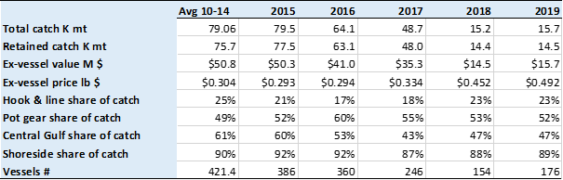

Table 2.1.3b. Gulf of Alaska Pacific cod first-wholesale market data. First-wholesale production (thousand metric tons), value (million US$), price (US$ per pound), fillet and head and gut volume (thousand metric tons), value share, and price (US$ per pound), inshore share of value; 2010-2014 average and 2015-2019.

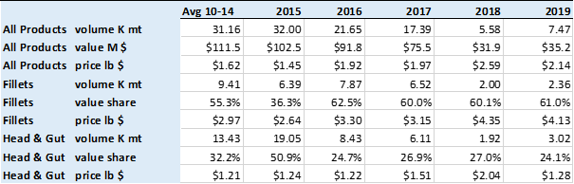

Table 2.1.3c. GOA Pacific cod global catch (thousand metric tons), U.S. and AK shares of global catch; WA & AK export volume (thousand metric tons), value (million US$), price (US$ per pound) and the share of export value from trade with Japan and China, 2009-2013 average and 2014-2019.

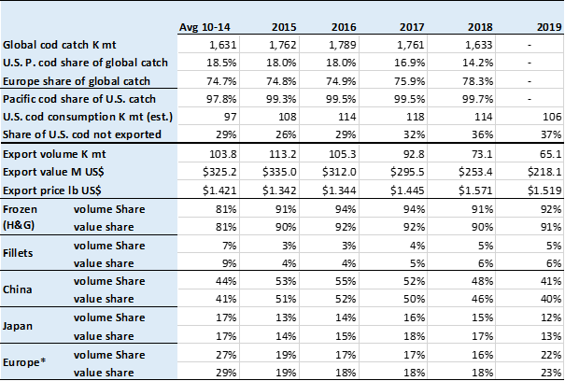

Note: Pacific cod in this table is for all U.S. Unless noted, `cod’ in this table refers to Atlantic and Pacific cod. Russia, Norway, and Iceland account for the majority of Europe’s cod catch which is largely focused in the Barents sea.

*Europe export statistics refers to: Austria, Belgium, Denmark, France, Germany, Greece, Ireland, Italy, Netherlands, Norway, Portugal, Spain, Sweden, Switzerland, and United Kingdom.

Source: NMFS Alaska Region Blend and Catch-accounting System estimates; NMFS Alaska Region At-sea and Shoreside Production Reports; and ADF&G Commercial Operators Annual Reports (COAR). Data compiled and provided by the Alaska Fisheries Information Network (AKFIN). FAO Fisheries & Aquaculture Dept. Statistics <http://www.fao.org/fishery/statistics/en>. NMFS Alaska Region Blend and Catch-accounting System estimates. NOAA Fisheries, Fisheries Statistics Division, Foreign Trade Division of the U.S. Census Bureau, <http://www.st.nmfs.noaa.gov/commercial-fisheries/foreign-trade/index>. U.S. Department of Agriculture <http://www.ers.usda.gov/data-products/agricultural-exchange-rate-data-set.aspx>.

Table 2.1.4a. Beginning stage ecosystem indicator score analysis for GOA Pacific cod by four main categories (physical, lower trophic, upper trophic, and overall ecosystem). Each indicator is scored based on the traffic light evaluation for that indicator (1 if a positive value increase creates good conditions for GOA Pacific cod, -1 if positive increase creates poor conditions for GOA Pacific cod, 0 otherwise), multiplied by the value relative to the long-term mean of the time series (greater than, less than, or within 1 standard deviation). Those scores are summed by category and then divided by the total number of indicators for that category. Number of indicators for each category are also provided. NA = no indicators available. Color coding based on column, blue = 1 shading through white = 0 shading through red = -1.

|  |  |  |  |  |  |  |  |  |  |  |  |
| --- | --- | --- | --- | --- | --- | --- | --- | --- | --- | --- | --- |
|  | Physical | | Lower Trophic | | | Upper Trophic | | | Total Ecosystem | | |
| Year | Score | # Indicators | | Score | # Indicators | | Score | # Indicators | | Score | # Indicators |
| 2000 | 0.00 | 4 | | 0.00 | 2 | | 0.50 | 2 | | 0.13 | 8 |
| 2001 | -0.25 | 4 | | 0.50 | 2 | | 0.17 | 6 | | 0.08 | 12 |
| 2002 | 0.25 | 4 | | 0.00 | 2 | | -0.50 | 2 | | 0.00 | 8 |
| 2003 | -0.60 | 5 | | 0.00 | 3 | | -0.50 | 6 | | -0.43 | 14 |
| 2004 | 0.20 | 5 | | 0.00 | 2 | | -0.50 | 2 | | 0.00 | 9 |
| 2005 | 0.00 | 5 | | -0.25 | 4 | | -0.50 | 6 | | -0.27 | 15 |
| 2006 | 0.00 | 5 | | 0.00 | 3 | | -0.50 | 2 | | -0.10 | 10 |
| 2007 | 0.60 | 5 | | 0.25 | 4 | | -0.17 | 6 | | 0.20 | 15 |
| 2008 | 0.20 | 5 | | 0.00 | 2 | | -0.50 | 2 | | 0.00 | 9 |
| 2009 | 0.00 | 5 | | -0.25 | 4 | | -0.33 | 6 | | -0.20 | 15 |
| 2010 | 0.20 | 5 | | 0.00 | 3 | | 0.00 | 2 | | 0.10 | 10 |
| 2011 | 0.00 | 5 | | 0.00 | 4 | | -0.17 | 6 | | -0.07 | 15 |
| 2012 | 0.80 | 5 | | 0.50 | 2 | | 0.00 | 2 | | 0.56 | 9 |
| 2013 | 0.00 | 5 | | 0.25 | 4 | | 0.00 | 6 | | 0.07 | 15 |
| 2014 | -0.20 | 5 | | 0.00 | 2 | | 0.00 | 2 | | -0.11 | 9 |
| 2015 | -0.20 | 5 | | -0.60 | 5 | | -0.17 | 6 | | -0.31 | 16 |
| 2016 | -0.20 | 5 | | -0.50 | 2 | | 0.00 | 2 | | -0.22 | 9 |
| 2017 | -0.20 | 5 | | -0.40 | 5 | | 0.33 | 6 | | -0.06 | 16 |
| 2018 | -0.40 | 5 | | 0.00 | 2 | | 0.00 | 2 | | -0.22 | 9 |
| 2019 | -0.40 | 5 | | -0.20 | 5 | | 0.00 | 6 | | -0.19 | 16 |
| 2020 | -0.25 | 4 | | 1.00 | 1 | | 0.00 | 1 | | 0.00 | 6 |

Table 2.1.4b. Beginning stage socioeconomic indicator score analysis for GOA Pacific cod by four main categories (performance, economic, community, and overall socioeconomic). Each indicator is scored based on the traffic light evaluation for that indicator (1 if a positive value increase creates good socioeconomic environment for GOA Pacific cod, -1 if positive increase creates poor conditions for GOA Pacific cod, 0 otherwise), multiplied by the value relative to the long-term mean of the time series (greater than, less than, or within 1 standard deviation). Those scores are summed by category and then divided by the total number of indicators for that category. Number of indicators for each category are also provided. NA = no indicators available. Color coding based on column, blue = 1 shading through white = 0 shading through red = -1.

|  |  |  |  |  |  |  |  |  |  |  |  |
| --- | --- | --- | --- | --- | --- | --- | --- | --- | --- | --- | --- |
|  | Fishery Performance | | Economic | | | Community | | | Total Socioeconomic | | |
| Year | Score | # Indicators | | Score | # Indicators | | Score | # Indicators | | Score | # Indicators |
| 2000 | NA | NA | | 0.00 | 0 | | 1.00 | 2 | | 1.00 | 2 |
| 2001 | NA | NA | | 0.00 | 0 | | 0.00 | 2 | | 0.00 | 2 |
| 2002 | NA | NA | | 0.00 | 0 | | 0.00 | 2 | | 0.00 | 2 |
| 2003 | NA | NA | | 0.00 | 3 | | 0.00 | 2 | | 0.00 | 5 |
| 2004 | NA | NA | | -0.33 | 3 | | 0.00 | 2 | | -0.20 | 5 |
| 2005 | NA | NA | | -0.33 | 3 | | 0.00 | 2 | | -0.20 | 5 |
| 2006 | NA | NA | | 0.00 | 3 | | 0.00 | 2 | | 0.00 | 5 |
| 2007 | NA | NA | | 1.00 | 3 | | 0.00 | 2 | | 0.60 | 5 |
| 2008 | NA | NA | | 1.00 | 3 | | 0.50 | 4 | | 0.71 | 7 |
| 2009 | NA | NA | | -0.33 | 3 | | 0.00 | 4 | | -0.14 | 7 |
| 2010 | NA | NA | | 0.00 | 3 | | 0.25 | 4 | | 0.14 | 7 |
| 2011 | NA | NA | | 0.67 | 3 | | 0.00 | 4 | | 0.29 | 7 |
| 2012 | NA | NA | | 0.33 | 3 | | 0.00 | 4 | | 0.14 | 7 |
| 2013 | NA | NA | | -0.33 | 3 | | -0.25 | 4 | | -0.29 | 7 |
| 2014 | NA | NA | | 0.00 | 3 | | 0.50 | 4 | | 0.29 | 7 |
| 2015 | NA | NA | | 0.00 | 3 | | 0.25 | 4 | | 0.14 | 7 |
| 2016 | NA | NA | | -0.33 | 3 | | 0.00 | 4 | | -0.14 | 7 |
| 2017 | NA | NA | | 0.00 | 3 | | -0.50 | 4 | | -0.29 | 7 |
| 2018 | NA | NA | | -0.33 | 3 | | -1.00 | 4 | | -0.71 | 7 |
| 2019 | NA | NA | | 0.33 | 3 | | -1.00 | 4 | | -0.43 | 7 |
| 2020 | NA | NA | | -0.50 | 2 | | 0.00 | 0 | | -0.50 | 2 |

# Figures

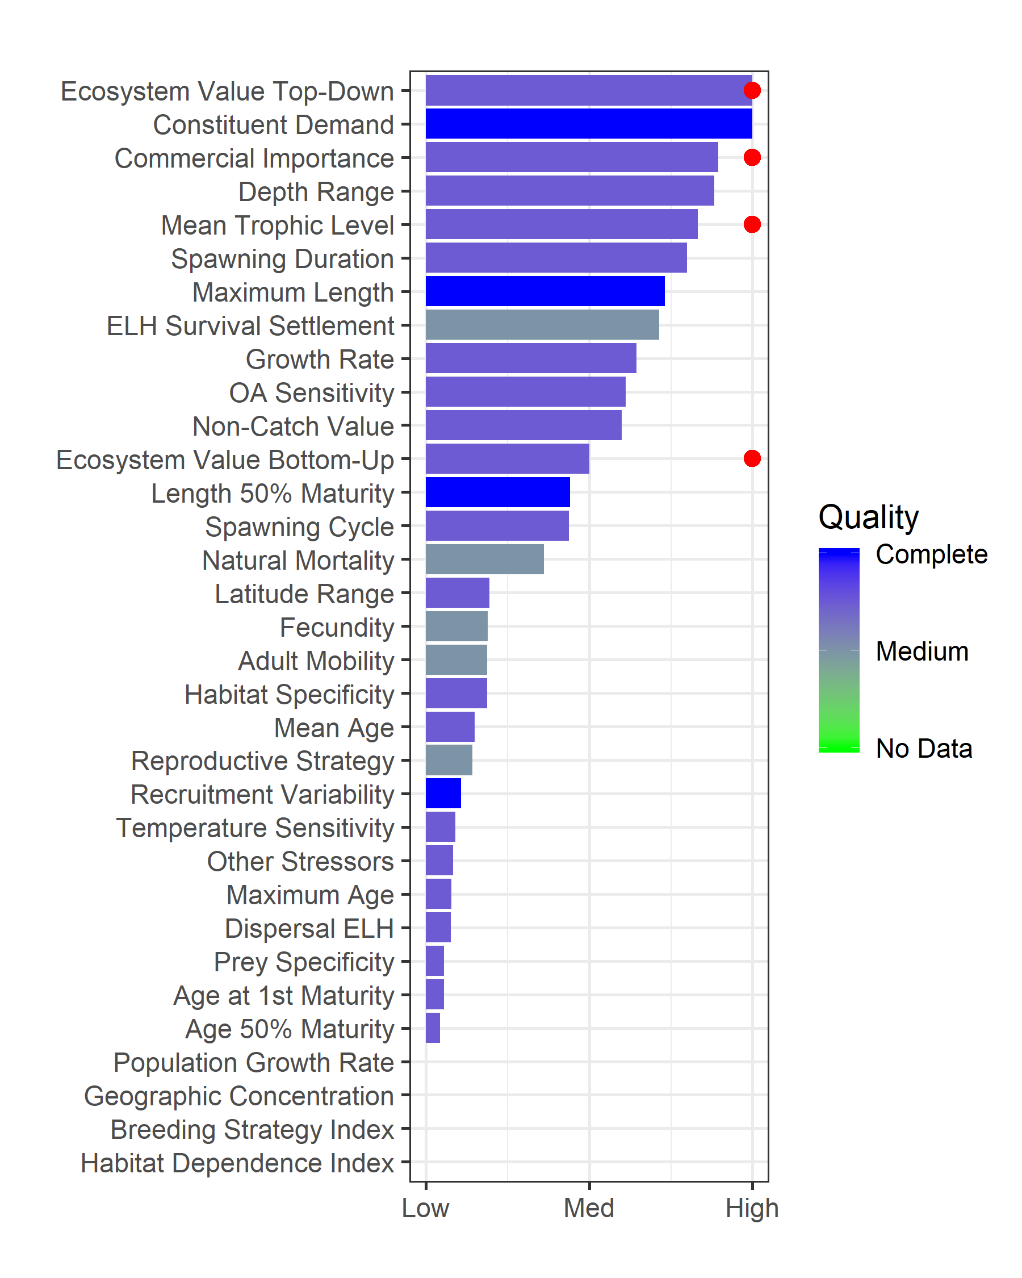

Figure 2.1.1. Baseline metrics for GOA Pacific cod graded as percentile rank over all groundfish in the FMP. Red dots indicate value passes a national threshold for vulnerability. Higher rank values indicate a vulnerability and color of the horizontal bar describes data quality of the metric (see Shotwell *et al.,* *In Review*, for more details on the metric definitions and thresholds).

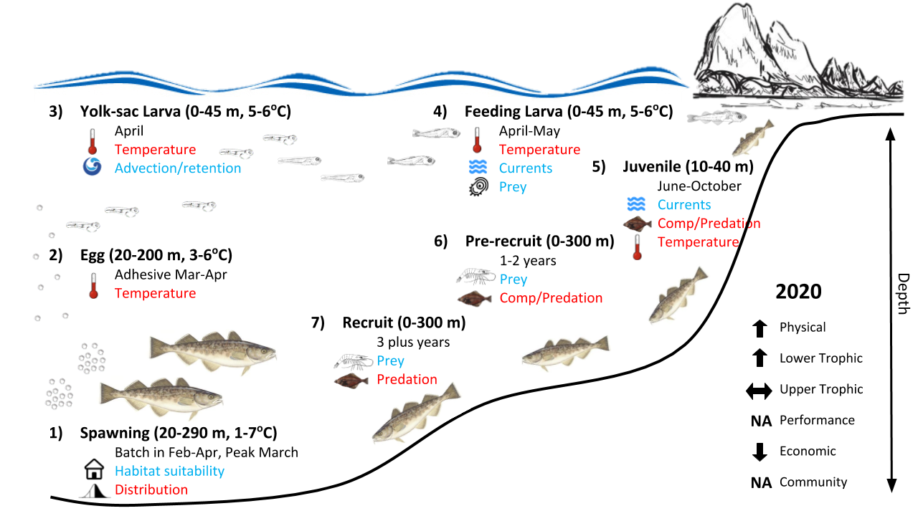

Figure 2.1.2: Life history conceptual model for GOA Pacific cod summarizing ecological information and key ecosystem processes affecting survival by life history stage. Red text means increases in process negatively affect survival, while blue text means increases in process positively affect survival. Trend of current year value compared to last year’s value depicted with arrows on the right. NA means no indicators for that category.

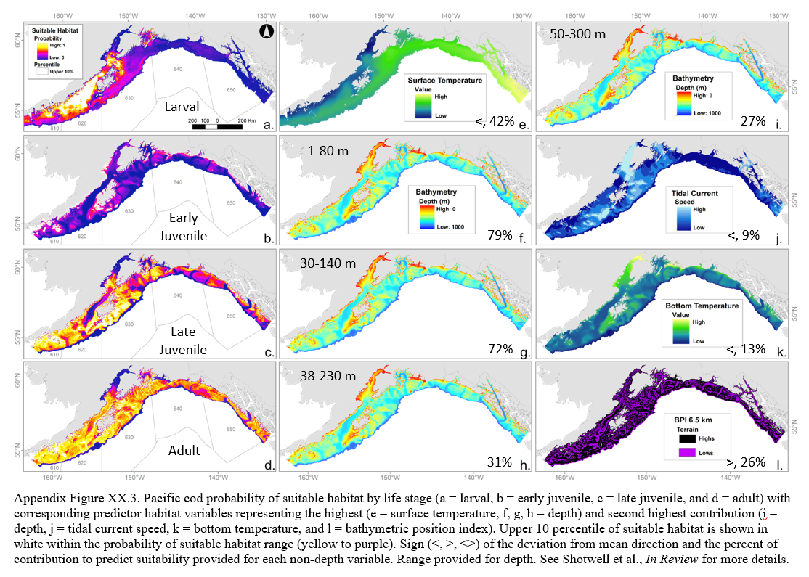

Figure 2.1.3. GOA Pacific cod probability of suitable habitat by life stage (a=larval, b=early juvenile, c=late juvenile, and d=adult) with predictor habitat variables representing the highest (e=depth, f=tidal current speed, g=depth, h=depth) and second highest contribution (i=surface temperature, j=bottom temperature, k=bottom temperature, and l=tidal current speed). Upper 10 %-ile of suitable habitat is shown in white within the probability of suitable habitat range (yellow to purple). Sign (<, >, <>) of the deviation from mean direction and the percent of contribution to predict suitability provided for each non-depth variable. Range provided for depth. See Shotwell *et al.,* *In Review* for more details.

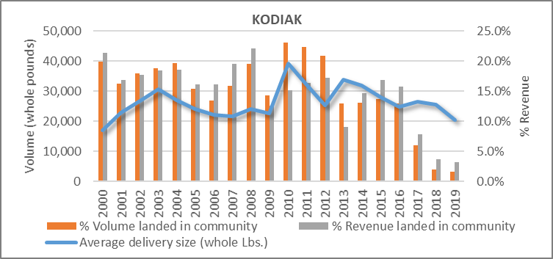

Figure 2.1.4a: Processing engagement for Kodiak: Average pounds delivered and percentage of value landed attributed to GOA Pacific cod for the highly engaged community of Kodiak (2000-2019).

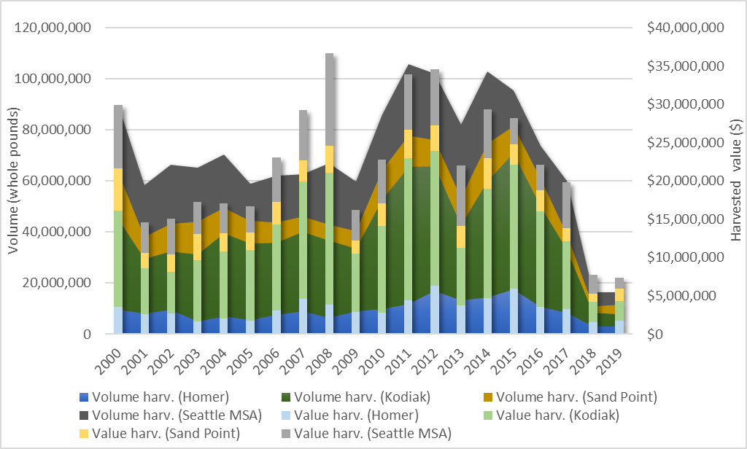

Figure 2.1.4b: Harvesting engagement: Average volume and value of GOA Pacific cod harvested by vessels owned by community residents (2000-2019).

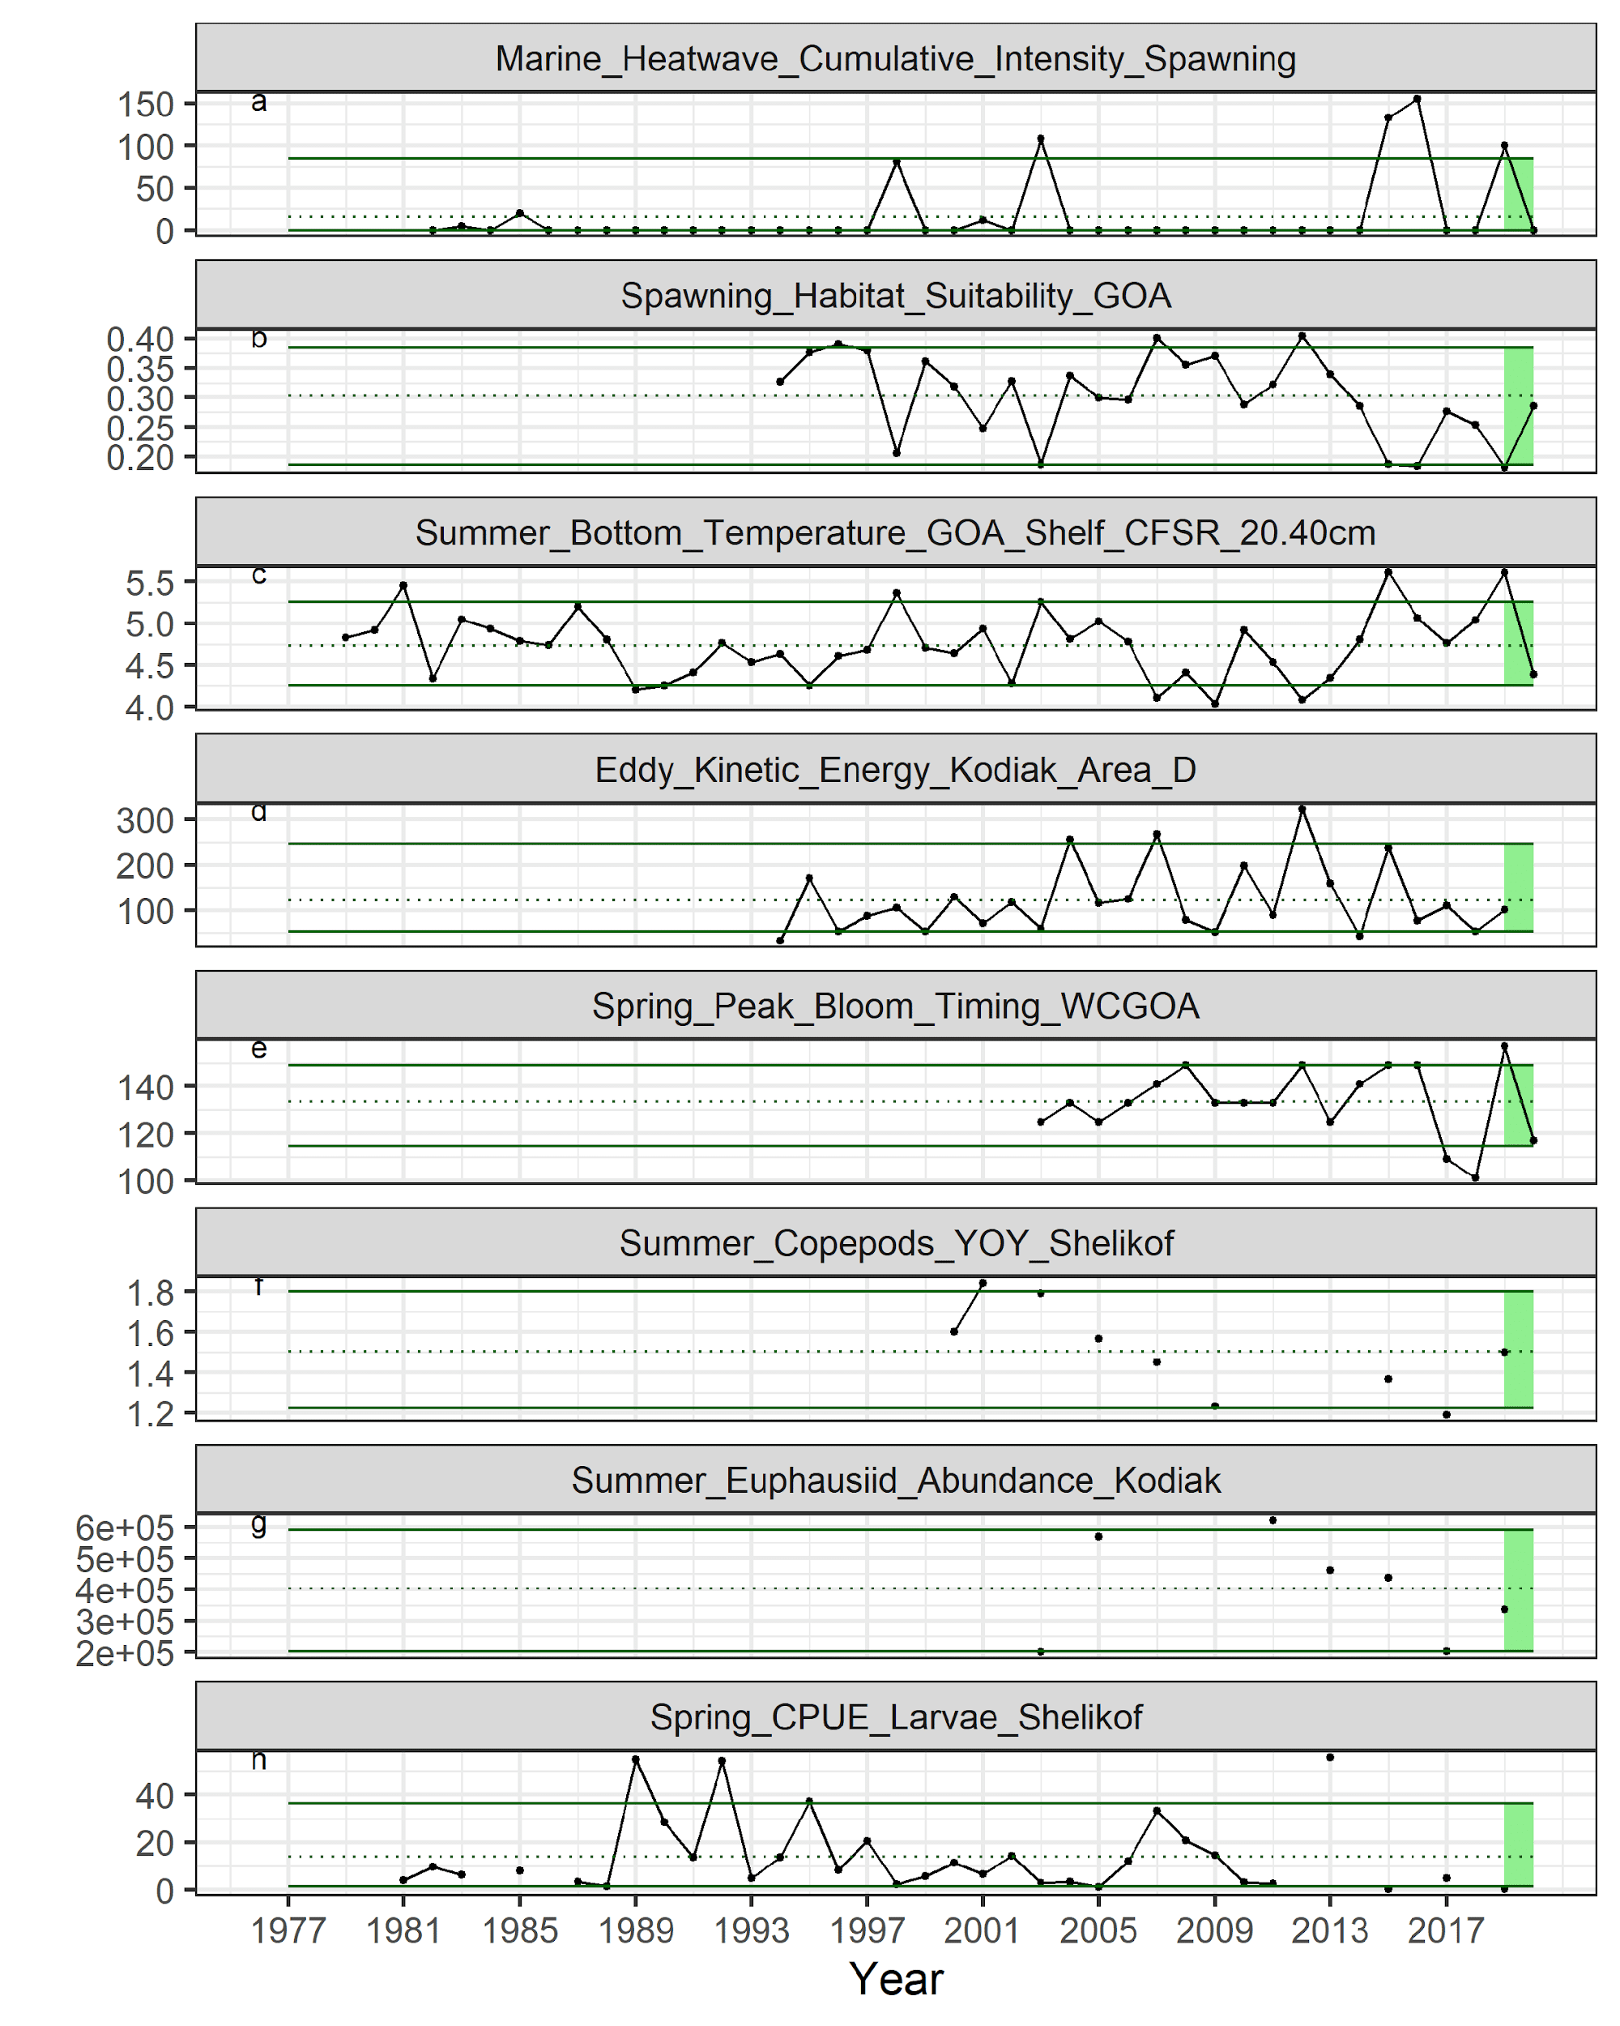

Figure 2.1.5a. Selected ecosystem indicators for GOA Pacific cod with time series ranging from 1977 – present. Upper and lower solid green horizontal lines are 90th and 10th percentiles of time series. Dotted green horizontal line is mean of time series. Light green shaded area represents most recent year for traffic light analysis.

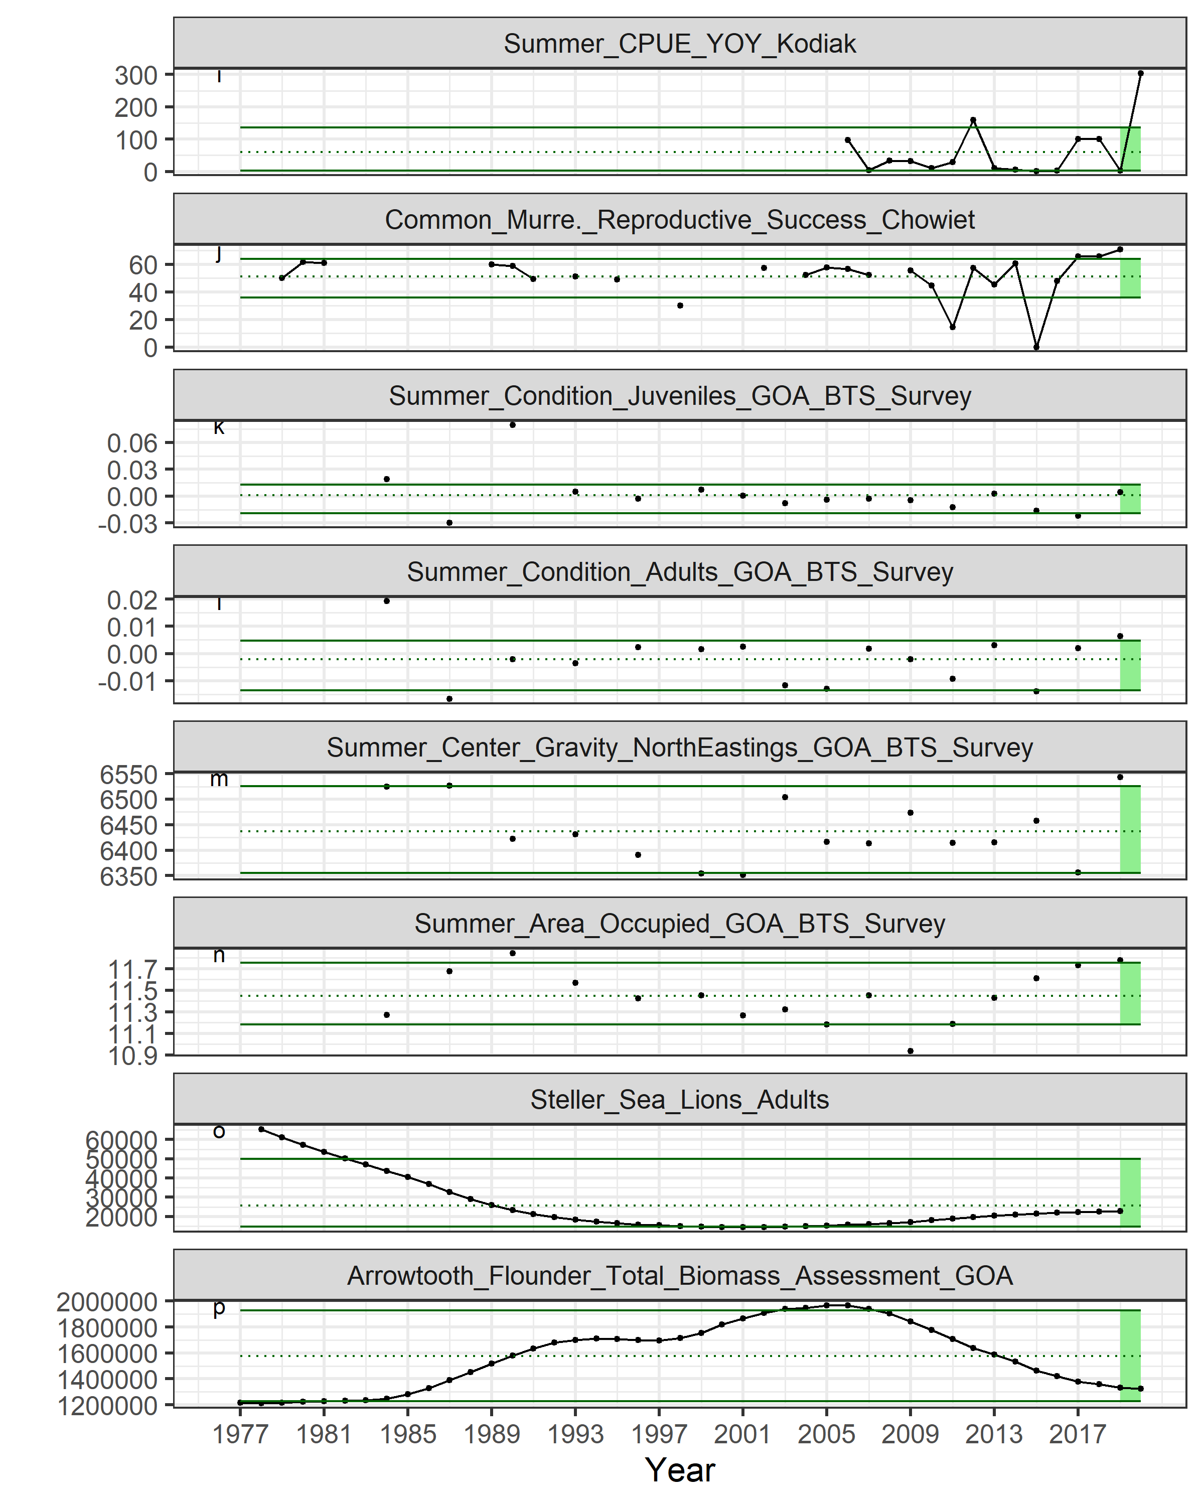

Figure 2.1.5a (cont.). Selected ecosystem indicators for GOA Pacific cod with time series ranging from 1977 – present. Upper and lower solid green horizontal lines are 90th and 10th percentiles of time series. Dotted green horizontal line is mean of time series. Light green shaded area represents most recent year for traffic light analysis.

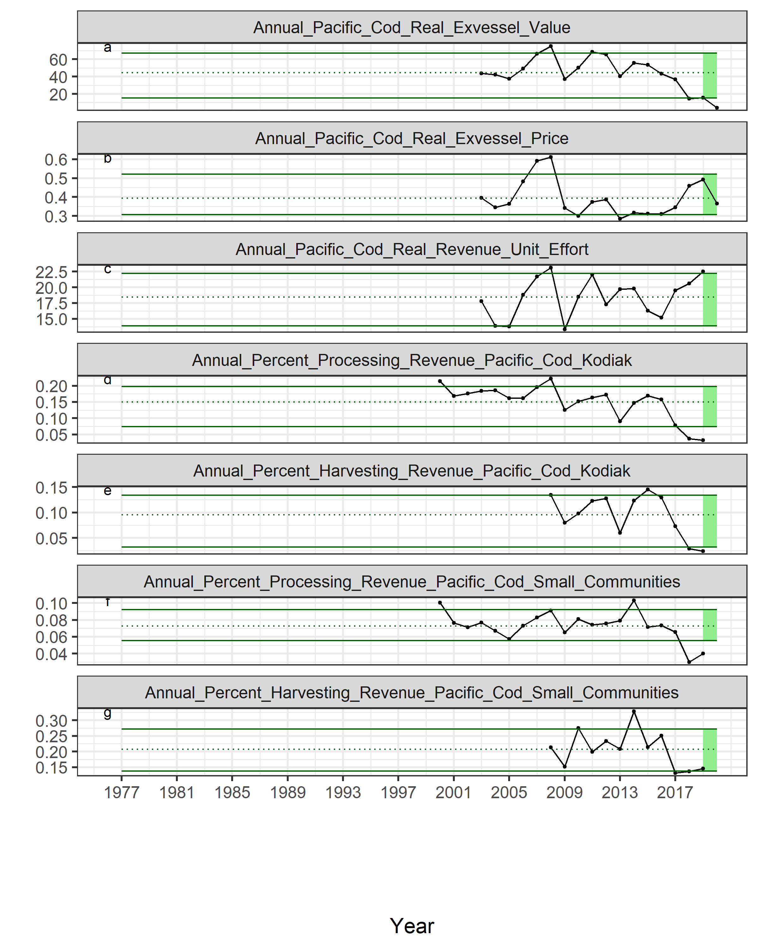

Figure 2.1.5b. Selected socioeconomic indicators for GOA Pacific cod with time series ranging from 1977 – present. Upper and lower solid green horizontal lines are 90th and 10th percentiles of time series. Dotted green horizontal line is mean of time series. Light green shaded area represents most recent year for traffic light analysis.

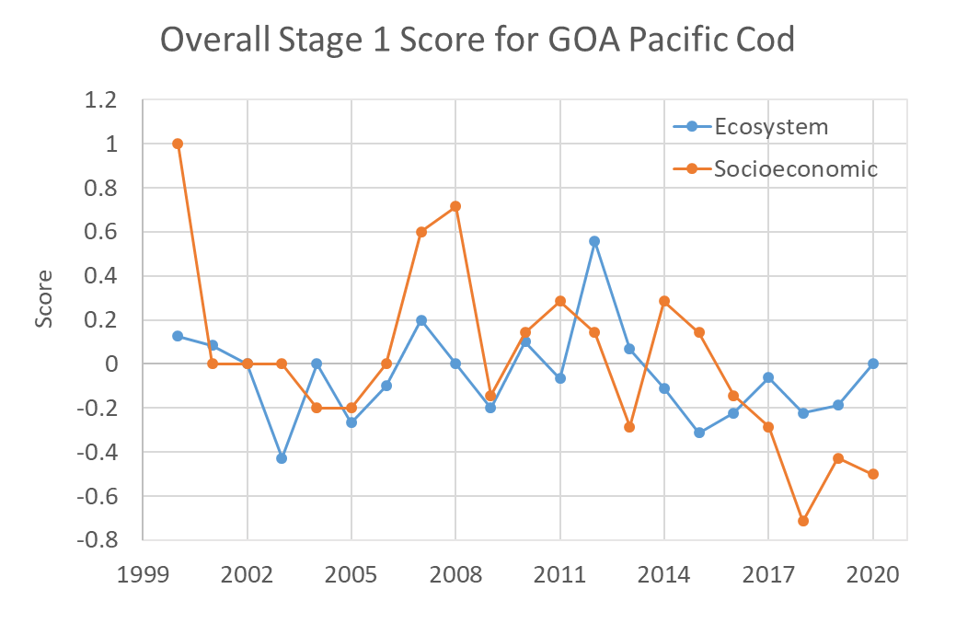

Figure 2.1.6: Beginning stage traffic light score for overall ecosystem and socioeconomic categories from 2000 to present.

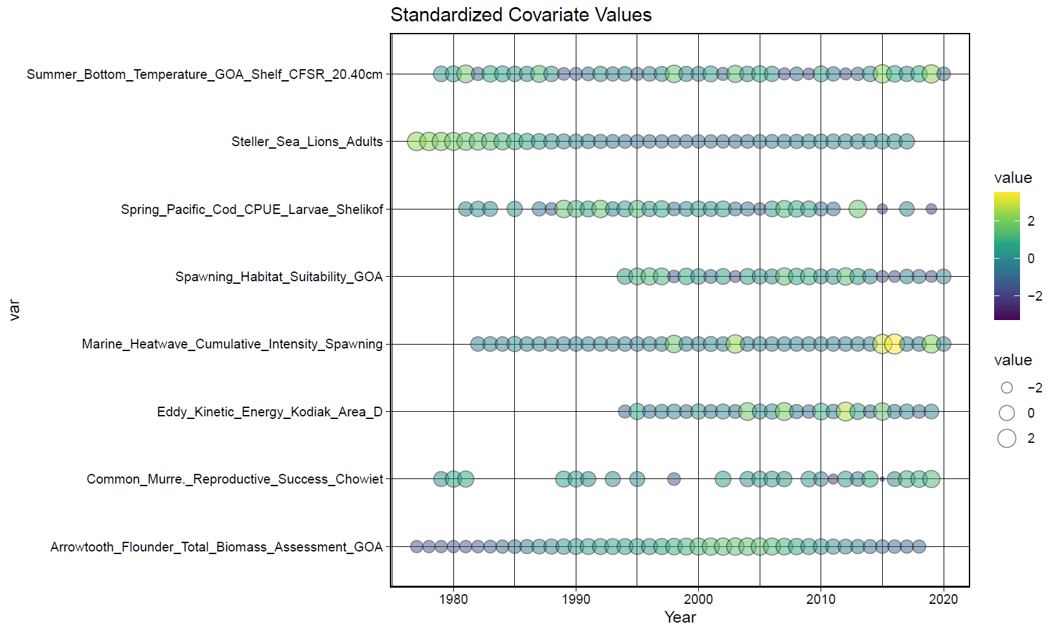

**a**

**b**

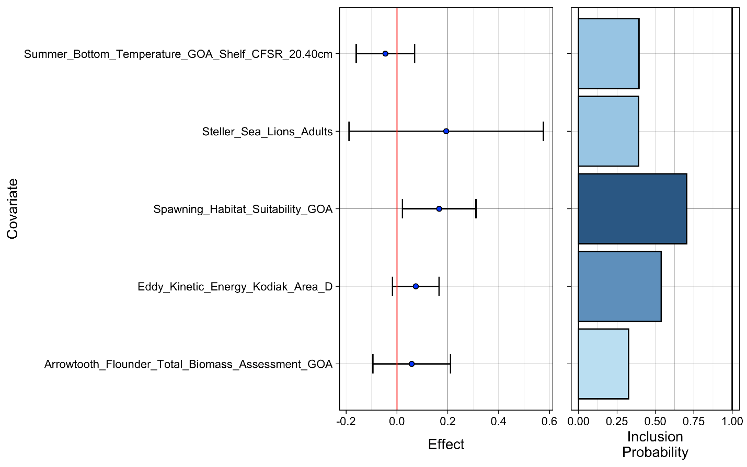

Figure 2.1.7: Bayesian adaptive sampling output showing (a) standardized covariates prior to subsetting and (b) the mean relationship and uncertainty (95% confidence intervals) with log GOA Pacific cod recruitment, in each estimated effect (left bottom graph), and marginal inclusion probabilities (right bottom graph) for each predictor variable of the subsetted covariate set.

# Attachment 2.1.1 Ecosystem and Socioeconomic Profile of the Pacific cod stock in the Gulf of Alaska - Report Card

S. Kalei Shotwell, Steven Barbeaux, Bridget Ferriss, Ben Fissel, Ben Laurel, Lauren Rogers, and Abigail Tyrell

November 2021

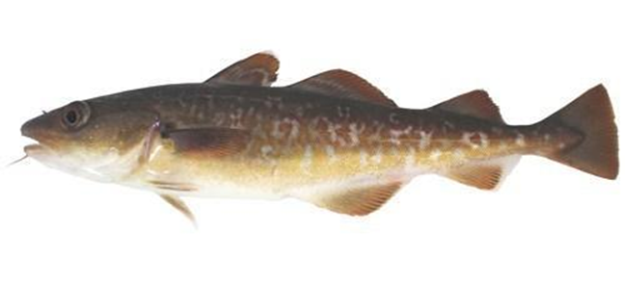

*With Contributions from:*

Kerim Aydin, Wei Cheng, Curry Cunningham, Kirstin Holsman, Beth Matta, Sandi Neidetcher, Patrick Ressler, Heather Renner, Sean Rohan, Elizabeth Siddon, Ingrid Spies, Katie Sweeney, Grant Thompson, Muyin Wang, Jordan Watson, Sarah Wise, Stephani Zador

# Current Year Update

The ecosystem and socioeconomic profile or ESP is a standardized framework for compiling and evaluating relevant stock-specific ecosystem and socioeconomic indicators and communicating linkages and potential drivers of the stock within the stock assessment process (Shotwell et al., *In Review*). The ESP process creates a traceable pathway from the initial development of indicators to management advice and serves as an on-ramp for developing ecosystem-linked stock assessments.

When a full ESP is completed in the current year, we provide a shortened version of the report card as an attachment to the full ESP appendix. This allows for providing updated current year information for use in the main SAFE report. Please refer to the main text of this appendix for further information regarding the ecosystem and socioeconomic linkages for this stock.

## Management Considerations

The following are the summary considerations from current year updates to the ecosystem and socioeconomic indicators evaluated for GOA Pacific cod:

* Cooling temperatures both at surface and depth in 2021 lower the susceptibility of starvation for larval Pacific cod and impact of mismatch to prey
* Annual eddy kinetic energy has shifted from a lower energy system in 2016 to 2019 to above average energy in 2020 and 2021 due to a strong, persistent eddy around Kodiak
* Survey cancellations and delays limited lower trophic indicators but spring larval Pacific cod were unusually low while reproductive success of seabirds was high in 2021
* Condition of juveniles and adults decreased in 2021, while the spatial distribution of the stock has spread out substantially from 2015 to 2021 with a center shift to the southwest in 2021
* Ex-vessel value and revenue-per-unit-effort are at the lowest in the time series in 2020, cost pressure from COVID-19 mitigation efforts likely had upstream impacts on ex-vessel prices
* The impact of COVID-19 had only marginal effects on first-wholesale and export prices, as retail and food service are both significant components of the market for cod products
* Overall, ecosystem indicators were average to above average in 2021 with socioeconomic indicators low in 2020

## Modeling Considerations

The following are the summary results from the intermediate and advanced stage monitoring analyses for GOA Pacific cod:

* Highest ranked predictors for the recruitment importance model were spawning habitat suitability and the eddy kinetic energy (inclusion probability > 0.5)
* New research models are being evaluated as alternatives for the operational assessment using indicators of temperature and nearshore beach seine survey of age-0 Pacific cod

# 

# Assessment

## Ecosystem and Socioeconomic Processes

Please refer to the full detail of the ecosystem and socioeconomic processes section in the main text of this appendix. The conceptual model (Figure 2.1.1.1) is provided here for reference.

## Indicator Suite

The following list of indicators for GOA Pacific cod are organized by categories, three for ecosystem indicators (physical, lower trophic, and upper trophic) and three for socioeconomic indicators (fishery performance, economic, and community). A short description and contact name for the indicator contributor are provided. Please refer to the full ESP document for detailed information regarding the ecosystem and socioeconomic indicator descriptions for this stock (Appendix 2.1). Time series of the ecosystem and socioeconomic indicators are provided in Figure 2.1.1.2a and Figure 2.1.1.2b, respectively.

### Ecosystem Indicators:

Physical Indicators (Figure 2.1.1.2a.a-d)

* 1. Spawning marine heatwave cumulative index over the central GOA (contact: S. Barbeaux).
  2. Winter spring spawning habitat suitability index from January to April in the central GOA shelf at GAK1 station (contact: L. Rogers).
  3. Summer bottom temperatures where small Pacific cod (0-20 cm) have been sampled by the AFSC GOA bottom trawl survey from the CFSR dataset (contact: S. Barbeaux).
  4. Annual eddy kinetic energy (EKE) calculated from sea surface height in the Kodiak area (contact: W. Cheng).

Lower Trophic Indicators (Figure 2.1.1.2a.e-i)

* 1. Peak timing of the spring bloom averaged across individual ADF&G statistical areas in the western and central GOA region from the MODIS satellite (contact: J. Watson).
  2. Summer large copepods for young-of-the-year (YOY) from the EcoFOCI summer survey (contact: L. Rogers).
  3. Summer euphausiid abundance for the Gulf of Alaska from the AFSC acoustic survey (contact: P. Ressler).
  4. Spring Pacific cod larvae catch-per-unit-of-effort (CPUE) from the EcoFOCI spring survey (contact: L. Rogers).
  5. Common murre (piscivores) reproductive success at Chowiet Island (contact: S. Zador).

Upper Trophic Indicators (Figure 2.1.1.2a.j-o)

* 1. Summer condition for juvenile (<420 mm) Pacific cod from the AFSC GOA shelf bottom trawl survey (contact: S. Rohan).
  2. Summer condition for adult (>=420 mm) Pacific cod from the AFSC GOA shelf bottom trawl survey (contact: S. Rohan).
  3. Summer Pacific cod center of gravity northeastings estimated by a spatio-temporal model using the package VAST on AFSC GOA bottom trawl survey data (contact: Z. Oyafuso)
  4. Summer Pacific cod area occupied estimated by a spatio-temporal model using the package VAST on AFSC GOA bottom trawl survey data (contact: Z. Oyafuso)
  5. Arrowtooth flounder total biomass from the most recent stock assessment model in the GOA (contact: K. Shotwell).
  6. Steller sea lion non-pup estimates for the GOA portion of the western Distinct Population Segment (contact: K. Sweeney).

### Socioeconomic Indicators:

Economic Indicators (Figure 2.1.1.2b.a-c)

* 1. Annual estimated real ex-vessel value of GOA Pacific cod (contact: B. Fissel)
  2. Annual real ex-vessel price per pound of GOA Pacific cod from fish ticket information (contact: B. Fissel).
  3. Annual estimated real revenue per unit effort measured in weeks fished of GOA Pacific cod (contact: B. Fissel)

Community Indicators (Figure 2.1.1.2b.d-g)

* 1. Regional quotient of Pacific cod for harvesting revenue of the highly engaged community of Kodiak (contact: S. Wise)
  2. Regional quotient of Pacific cod for processing revenue of the highly engaged community of Kodiak (contact: S. Wise)
  3. Regional quotient of Pacific cod for harvesting revenue of three smaller highly engaged communities (Sand Point, King Cove, and Akutan) combined (contact: S. Wise)
  4. Regional quotient of Pacific cod for processing revenue of three smaller highly engaged communities (Sand Point, King Cove, and Akutan) combined (contact: S. Wise)

## Indicator Monitoring Analysis

There are up to three stages (beginning, intermediate, and advanced) of statistical analyses for monitoring the indicator suite listed in the previous section. The beginning stage is a relatively simple evaluation by traffic light scoring. This evaluates the current year trends relative to the mean of the whole time series, and provides a historical perspective on the utility of the whole indicator suite. The intermediate stage uses importance methods related to a stock assessment variable of interest (e.g., recruitment, biomass, catchability). These regression techniques provide a simple predictive performance for the variable of interest and are run separate from the stock assessment model. They provide the direction, magnitude, uncertainty of the effect, and an estimate of inclusion probability. The advanced stage is used for testing a research ecosystem linked model and output can be compared with the current operational model to understand information on retrospective patterns, prediction performance, and comparisons of other model output such as terminal spawning stock biomass or mean recruitment. This stage provides an on-ramp for introducing an alternative ecosystem linked stock assessment model to the current operational stock assessment model and can be used to understand the potential reduction in uncertainty by including the ecosystem information. Please refer to the indicator monitoring analysis section in the main text of this appendix for more details on the analysis stages.

### Beginning Stage: Traffic Light Test

We use a simple scoring calculation for this beginning stage traffic light evaluation. Indicator status is evaluated based on being greater than (“high”), less than (“low”), or within (“neutral”) one standard deviation of the long-term mean. A sign based on the anticipated relationship between the indicator and the stock (Figure 2.1.1.1) is also assigned to the indicator where possible. If a high value of an indicator generates good conditions for the stock and is also greater than one standard deviation above the mean, then that value receives a +1 score. If a high value generates poor conditions for the stock and is greater than one standard deviation above the mean, then that value receives a -1 score. All values less than or equal to one standard deviation from the long-term mean are average and receive a 0 score. The scores are summed by the three organizational categories within the ecosystem (physical, lower trophic, and upper trophic) or socioeconomic (fishery performance, economic, and community) indicators and divided by the total number of indicators available in that category for a given year. The scores over time allow for comparison of the indicator performance and the history of stock productivity (Figure 2.1.1.3). We also provide five year indicator status tables with a color or text code for the relationship with the stock (Tables 2.1.1.2a,b) and evaluate the current year status in the historical indicator time series graphic (Figures 2.1.1.2a,b) for each ecosystem and socioeconomic indicator.

We evaluate the status and trends of the ecosystem and socioeconomic indicators to understand the pressures on the GOA Pacific cod stock regarding recruitment, stock productivity, and stock health. We start with the physical indicators and proceed through the increasing trophic levels, economic, and community indicators as listed above. Here we concentrate on updates relative to the results presented in the main text of this appendix. Overall both the physical and lower trophic level indicators scored average for 2021, while the upper trophic indicators were above average (Figure 2.1.1.3). Compared to the results presented in the main text of this appendix, this is a drop from above average for the physical indicators, an improvement from below average for the lower trophic indicators, and an improvement from average for the upper trophic indicators. We also note caution when comparing scores between odd to even years as there are many lower and upper trophic indicators missing in even years due to the off-cycle year surveys in the GOA. Also, there have been other cancellations due to COVID-19 or other survey delays in 2020 and 2021 that have limited production of several indicators. Economic and community indicators are all lagged by at least one year due to timing of the availability of the current year information and the production of this report. Economic indicators scored below average for 2020 which is a drop from above average in 2019. There were no updates for community indicators.

For physical indicators, there has been increased sea surface warming and reduced Pacific cod spawning habitat suitability in the GOA ecosystem and the presence of a series of major marine heatwaves for the past several years (Figure 2.1.1.2a.a-c). However, in 2020 and 2021 there were reduced temperatures both at the surface and bottom, near average habitat suitability, and zero to low marine heatwave events during spawning season for Pacific cod. We also see a shift in the annual eddy kinetic energy (EKE) near Kodiak from a period of lower energy in 2016 to 2019 to above average in 2020 and 2021 (Figure 2.1.1.2a.d). This EKE region near Kodiak has an opposite seasonal cycle phase than other regions in the GOA implying separate forcing mechanisms in the western GOA (Cheng, 2021). Sustained EKE may help with retention on the shelf and enhance cross-shelf transport of young-of-the-year Pacific cod to suitable nearshore nursery environments.

For the lower trophic level indicators (Figure 2.1.1.2a.e-i), the peak timing of the spring bloom appears highly variable since the onset of the marine heatwaves in 2014 and continues to oscillate in 2020 and 2021 from early to late, respectively. This may have implications for mismatch between larval Pacific cod and the available plankton abundance. During warm years this may be particularly important for Pacific cod due to their increased metabolic requirements and the implications of a later bloom may be somewhat tempered in a cooler thermal environment such as in 2020 and 2021 (B. Laurel, pers. commun.). CPUE of larvae in the spring EcoFOCI survey continues to be low, although reproductive success of common Murre seabirds on Chowiet continues to be high suggesting sufficient forage fish prey resources. Years of high abundance for the late winter to early spring shelf spawners (i.e., Pacific cod, walleye pollock, and northern rock sole) were associated with cooler winters and enhanced alongshore winds during spring (Deary et al., 2021). Since physical indicators appear average this year the expectation was average abundances of Pacific cod in the larval survey. However, abundances were especially low in 2021 and the highest catches were outside of the core area, which is unusual.

For the upper trophic indicators, the condition of juvenile and adult Pacific cod from the summer bottom trawl survey decreased in 2021, with juveniles now slightly below average and adults still above average (Figure 2.1.1.2a.j-k). Many factors may contribute to the variation in morphometric condition such as temperature-dependent metabolic rates, survey timing, stomach fullness of individual fish, migration patterns, and distribution of samples within survey strata (O’Leary et al., 2021). The thermal environment is cooler in the GOA this year but benthic prey resources were highly variable (Whitehouse and Aydin, 2021). The center of gravity in the northeast direction for the GOA Pacific cod population has decreased from the 2019 survey, while the area occupied estimate remains consistent and high, implying a change in distribution toward the southwest and a fairly large population spread (Figure 2.1.1.2a.l-m). These trends may reflect a shift in the spatial clustering of the stock concurrent with the change in biomass and potentially suggest the stock may be expanding out of preferred habitat. There were no updates for arrowtooth flounder biomass as the stock assessment is currently in review; however, recent survey estimates are slightly larger than in 2019 (bottom trawl survey) and 2020 (longline survey), but still well below average (Shotwell et al., 2021). In general, apex fish predators in the GOA are at relatively low abundances (Whitehouse and Aydin, 2021) suggesting low predation pressure on GOA Pacific cod.

From 2009-2016 Pacific cod typically accounted for just under 30% of the GOA’s FMP groundfish harvest and over 20% of the total Pacific cod catch in Alaska. By 2020 these shares fell to 3% and 4%, respectively, with the closure of directed fishing in Federal waters. Catch of Pacific cod in the GOA was down 57% from 2019 with a total catch of 6.7 thousand t and retained catch 4.8 thousand t (Fissel et al., 2021). Ex-vessel prices decreased 20% to $0.39 per pound in 2020. Ex-vessel revenues in 2020 were down 72% to $4.4 million with the decrease in catch and prices (Figure 2.1.1.2b.a-b). The number of vessels has dropped from 360 in 2016 to 102 in 2020. Poor fishing conditions may have contributed to the significant reduction in jig fleet participation since 2017. Prior to 2016, approximately 60% of the retained catch volume and value was in the Central Gulf fisheries, 40% in the Western Gulf, and 1-2% occurring in other regions of the GOA. In 2020 with the closure of directed fishing in Federal waters distribution has shifted to about 72% of cod being caught in the Central Gulf (Fissel et al., 2021). The price differential between fixed gear and trawl vessels was $0.07 per pound in 2020. The products made from GOA Pacific cod had a first-wholesale value of $15 million in 2020, which was down 57% from 2019 and below the 2011-2015 average of $112 million (Fissel et al., 2021). The two primary product forms produced from cod in the GOA are fillets and head and gut (H&G), which comprised 68% and 23% of the value in 2020, though the relative share can fluctuate year over year depending on relative prices and processing decisions. The average price of GOA Pacific cod products in 2020 increased 7% to $2.14 per pound (Figure 2.1.1.2b.b) as fillet prices were stable at $4.11 per pound and H&G prices increased 9% to $1.39 per pound (Fissel et al., 2021). Since 2016 reductions in global supply have put upward pressure on prices resulting in significant year over year price increases in 2017 and 2018. In 2019 prices leveled off, decreasing slightly, as markets have adjusted. In 2020 COVID-19 closures resulted in increased demand for retail products and frozen products, and decreased food service and fresh products. Retail and food service are both significant components of the market for cod products. As such, the impact of COVID-19 on prices appears muted with only marginal changes in first-wholesale and export prices. Cost pressure from COVID-19 mitigation efforts likely had upstream impacts on ex-vessel prices, which decreased significantly.

The community indicators evaluated in the ESP are similar to those presented in the ACEPO report but on the stock level rather than the community level. The indicators are separated into two categories of fisheries involvement: commercial processing and commercial harvesting (Wise et al., 2021). By separating commercial processing from commercial harvesting, the engagement indices highlight the importance of fisheries in communities that may not have a large amount of landings or processing in their community, but have a large number of fishers and/or vessel owners that participate in commercial fisheries who are based in the community. At this time there are no updates to the community indicators. In the future we plan to evaluate how to reference the products available in the ACEPO report for use in the ESPs to inform on stock health.

### Intermediate Stage: Importance Test

Bayesian adaptive sampling (BAS) was used for the intermediate stage statistical test to quantify the association between hypothesized predictors and GOA Pacific cod recruitment and to assess the strength of support for each hypothesis. In this stage, the full set of indicators is first winnowed to the predictors that could directly relate to recruitment and highly correlated covariates are removed. We further restrict potential covariates to those that can provide the longest model run and through the most recent estimate of recruitment that is well estimated in the current operational stock assessment model (Figure 2.1.1.4a). This results in a model run from 1994 through the 2017 year-class. We then provide the mean relationship between each predictor variable and log GOA Pacific cod recruitment over time (Figure 2.1.1.4b, left side), with error bars describing the uncertainty (95% confidence intervals) in each estimated effect and the marginal inclusion probabilities for each predictor variable (Figure 2.1.1.4b, right side). A higher probability indicates that the variable is a better candidate predictor of GOA Pacific cod recruitment. The highest ranked predictor variables (inclusion probability > 0.5) based on this process continue to be the spawning habitat suitability index in the GOA and the eddy kinetic energy in Kodiak area D (Figure 2.1.1.4).

### Advanced Stage: Research Model Test

Please refer to the full detail of the advanced stage research model test section in the main text of this appendix.

# Data Gaps and Future Research Priorities

While the metric and indicator assessments provide a relevant set of proxy indicators for evaluation at this time, there are certainly areas for improvement. The majority of indicators collected for GOA Pacific cod have a fair number of gaps due to the biennial nature of survey sampling in the GOA. This causes issues with updating the ESP and the ecosystem considerations during off-cycle years and can lead to difficulty in identifying impending shifts in the ecosystem that may impact the GOA Pacific cod population. Development of high-resolution remote sensing (e.g., regional surface temperature, transport estimates, primary production estimates) or climate model indicators (e.g., bottom temperature, NPZ variables) would assist with the current multi-year data gap for several indicators if they sufficiently capture the main trends of the survey data and are consistently and reliably available.

Refinements or updates to current indicators may also be helpful. More specific phytoplankton indicators tuned to the spatial and temporal distribution of GOA Pacific cod larvae as well as phytoplankton community structure information (e.g., hyperspectral information for size fractionation) could be more useful for understanding Pacific cod larval fluctuations. Current estimates of zooplankton biomass are only available at smaller spatial scales and regional to gulf-wide estimates of zooplankton biomass would help elucidate prey trends at the spatial scales relevant to fisheries management. Demographic differences in the YOY population need to be evaluated within and among larval and juvenile surveys conducted in the Central and Western GOA (currently sampling ~1000km of coastline). Size shifts in the YOY population have already been observed in marine heatwave years, but it is unclear if one or more of the following processes are involved: 1) spawning (earlier); 2) larval/juvenile growth (higher); and/or 3) larval/juvenile mortality (higher/size-selective). Ongoing research seeks to understand how climate-driven changes in size and age may also impact survival trajectories of YOY cohorts and their potential to recruit to the fishery, which will guide further indicator development.

We currently lack an indicator of predation on YOY Pacific cod during their first autumn and winter, during a period when predation mortality is thought to be significant. Sampling of predator diets in fall and winter would help to fill this gap. An index of age-1 Pacific cod from the Kodiak beach seine survey is available and could be useful for understanding overwinter survival in reference to the age-0 index used in the operational model. The GOA CEATTLE model is now more developed and has potential to provide a gap-free index of predation mortality for age-1 GOA Pacific cod (Adams et al., 2021). The Pacific cod individual based model (IBM) is also currently being updated (Shotwell et al., In prep.) as part of the Essential Fish Habitat (EFH) update. Information on connectivity from spawning to nursery areas and dynamic spatial distribution of egg and larval EFH could be used to create indicators for understanding early life history dynamics. Additionally, evaluating condition and energy density of juvenile and adult Pacific cod samples at the outer edge of the population may be useful for understanding the impacts of shifting spatial statistics such as center of gravity and area occupied. Information is available from the GulfWatch Alaska program that could be helpful for evaluating the eastern edge of the GOA Pacific cod population. Also, a new project has recently been funded involving a multi-model approach including the development of the GOA Ecopath models and an Atlantis ecosystem model. This project is part of the GOA Regional Action Plan and will start in 2021 with the goal of evaluating the biological reference points used for status determination of individual stocks (e.g., Pacific cod) under projected climate scenarios (M. Dorn, pers., commun.). The project has a three-year timeline and we hope to incorporate the results of this effort as they become available.

We plan to evaluate the information provided in the Economic SAFE and ACEPO report to determine what socioeconomic indicators could be provided in the ESP that are not redundant with those reports and related directly to stock health. This may result in a transition of indicators currently reported in this ESP to a different series of socioeconomic indicators in future ESPs and may include a shift in focus from engagement to dependency. Additional considerations should be given for the timing of the economic and community reports that are delayed by 1-2 years depending on the data source from the annual stock assessment cycle. The Scientific and Statistical Committee (SSC) recently recommended that local knowledge, traditional knowledge and subsistence information may be helpful for understanding recent fluctuations in stock health, shifts in stock distributions, or changes in size or condition of species in the fishery. We could include this information as supportive evidence and perspective on many indicators monitored within the ESP.

As indicators are improved or updated, they may replace those in the current set of indicators to allow for refinement of the BAS model and potential evaluation of performance and risk within the operational stock assessment model. The annual request for indicators (RFI) for the GOA Pacific cod ESP will include these data gaps and research priorities along with a list of potential new indicators that could be developed for the next full ESP assessment.

# Literature Cited

Adams, G., K. Holsman, K. Aydin, S. Barbeaux, M. Dorn, A. Hollowed, J. Ianelli, A. Punt, I. Spies. 2021. Multispecies model estimates of time-varying natural mortality of groundfish in the Gulf of Alaska. *In* Ferriss, B., and Zador, S., 2021. Ecosystem Status Report 2021: Gulf of Alaska, Stock Assessment and Fishery Evaluation Report, North Pacific Fishery Management Council, 1007 West Third, Suite 400, Anchorage, Alaska 99501.

Cheng, W. 2021. Eddies in the Gulf of Alaska. *In* Ferriss, B., and Zador, S., 2021. Ecosystem Status Report 2021: Gulf of Alaska, Stock Assessment and Fishery Evaluation Report, North Pacific Fishery Management Council, 1007 West Third, Suite 400, Anchorage, Alaska 99501.

Deary, A., L. Rogers, and K. Axler. 2021. Larval fish abundance in the Gulf of Alaska 1981-2021. *In* Ferriss, B., and Zador, S., 2021. Ecosystem Status Report 2021: Gulf of Alaska, Stock Assessment and Fishery Evaluation Report, North Pacific Fishery Management Council, 1007 West Third, Suite 400, Anchorage, Alaska 99501.

Fissel, B., M. Dalton, B. Garber-Yonts, A. Haynie, S. Kasperski, J. Lee, D. Lew, C. Seung, K. Sparks, M. Szymkowiak, and S. Wise. 2021. Economic status of the groundfish fisheries off Alaska, 2019. *In* Stock assessment and fishery evaluation report for the groundfish resources of the GOA and BS/AI. North Pacific Fishery Management Council, 605 W 4th Ave, Suite 306 Anchorage, AK 99501.

O'Leary, C., Laman, N., Rohan, S. 2021. Gulf of Alaska groundfish condition. *In* Ferriss, B., and Zador, S., 2021. Ecosystem Status Report 2021: Gulf of Alaska, Stock Assessment and Fishery Evaluation Report, North Pacific Fishery Management Council, 605 W 4th Ave, Suite 306, Anchorage, AK 99501.

Shotwell, S.K., K., Blackhart, C. Cunningham, E. Fedewa, D., Hanselman, K., Aydin, M., Doyle, B., Fissel, P., Lynch, O. Ormseth, P., Spencer, S., Zador. *In Review*. Introducing the Ecosystem and Socioeconomic Profile, a proving ground for next generation stock assessments.

Shotwell, K., I. Spies, J.N. Ianelli, K. Aydin, D.H Hanselman, W. Palsson, K. Siwicke, and E. Yasumiishi. 2021. Assessment of the arrowtooth flounder stock in the Gulf of Alaska. *In* Stock assessment and fishery evaluation report for the groundfish resources of the Gulf of Alaska. North Pacific Fishery Mngt. Council, 605 W 4th Ave, Suite 306 Anchorage, AK 99501.

Shotwell, S.K., W. Stockhausen, G.A. Gibson, J. Pirtle, A. Deary, and C. Rooper. In Prep. Developing a novel approach to estimate habitat-related survival rates for early life history stages using individual-based models.

Whitehouse, A. and K. Aydin. 2021. Foraging guild biomass-Gulf of Alaska. *In* Ferriss, B. and Zador, S., 2021. Ecosystem Status Report 2021: Gulf of Alaska, Stock Assessment and Fishery Evaluation Report, North Pacific Fishery Management Council, 1007 West Third, Suite 400, Anchorage, Alaska 99501.

Wise, S., K. Sparks, and J. Lee. 2021. Annual Community Engagement and Participation Overview. Report from the Economic and Social Sciences Program of the Alaska Fisheries Science Center. 57 pp.

# 

# Tables

Table 2.1.1.1a. First stage ecosystem indicator analysis for GOA Pacific cod, including indicator title and the indicator status of the last five years. The indicator status is designated with text, (greater than = “high”, less than = “low”, or within 1 standard deviation = “neutral” of long-term mean). Fill color of the cell is based on the sign of the anticipated relationship between the indicator and GOA Pacific cod (blue or italicized text = good conditions for GOA Pacific cod, red or bold text = poor conditions, white = average conditions). A gray fill and text = “NA” will appear if there were no data for that year.

| **Indicator category** | **Indicator** | **2017 Status** | **2018 Status** | **2019 Status** | **2020 Status** | **2021 Status** |
| --- | --- | --- | --- | --- | --- | --- |
| Physical | Spawning Heatwave GOA Model | neutral | neutral | **high** | neutral | neutral |
| Winter Spring Pacific Cod Spawning Habitat Suitability GAK1 Model | neutral | neutral | **low** | neutral | neutral |
| Summer Temperature Bottom GOA Model | neutral | neutral | **high** | neutral | neutral |
| Annual Eddy Kinetic Energy Kodiak Satellite | neutral | neutral | neutral | *high* | neutral |
| Lower Trophic | Spring Chlorophyll a Peak WCGOA Satellite | **low** | **low** | *high* | **low** | neutral |
| Summer Large Copepod Abundance Shelikof Survey | **low** | NA | neutral | NA | NA |
| Summer Euphausiid Abundance Kodiak Survey | **low** | NA | neutral | NA | NA |
| Spring Pacific Cod CPUE Larvae Shelikof Survey | neutral | NA | neutral | NA | neutral |
| Annual Common Murre Reproductive Success Chowiet Survey | neutral | neutral | *high* | NA | neutral |
| Upper Trophic | Summer Pacific Cod Condition Juvenile GOA Survey | neutral | NA | neutral | NA | neutral |
| Summer Pacific Cod Condition Adult GOA Survey | neutral | NA | neutral | NA | neutral |
| Summer Pacific Cod Center Gravity Northeast WCGOA Model | *low* | NA | **high** | NA | neutral |
| Summer Pacific Cod Area Occupied WCGOA Model | neutral | NA | *high* | NA | *high* |
| Annual Arrowtooth Biomass GOA Model | neutral | neutral | neutral | neutral | NA |
| Annual Steller Sea Lion Adult GOA Survey | neutral | neutral | neutral | NA | NA |

Table 2.1.1.1b. First stage socioeconomic indicator analysis for GOA Pacific cod, including indicator title and the indicator status of the last five years. The indicator status is designated with text, (greater than = “high”, less than = “low”, or within 1 standard deviation = “neutral” of long-term mean). Fill color of the cell is based on the sign of the anticipated relationship between the indicator and GOA Pacific cod (blue or italicized text = good conditions for GOA Pacific cod, red or bold text = poor conditions, white = average conditions). A gray fill and text = “NA” will appear if there were no data for that year.

|  |  |  |  |  |  |  |
| --- | --- | --- | --- | --- | --- | --- |
| **Indicator category** | **Indicator** | **2017 Status** | **2018 Status** | **2019 Status** | **2020 Status** | **2021 Status** |
| Economic | Annual Pacific Cod Real Exvessel Value GOA Fishery | neutral | **low** | **low** | **low** | NA |
| Annual Pacific Cod Real Exvessel Price GOA Fishery | neutral | neutral | *high* | neutral | NA |
| Annual Pacific Cod Real Revenue Per Unit Effort GOA Fishery | neutral | neutral | *high* | **low** | NA |
| Community | Annual Pacific Cod RQ Harvesting Revenue Kodiak Fishery | neutral | **low** | **low** | NA | NA |
| Annual Pacific Cod RQ Processing Revenue Kodiak Fishery | **low** | **low** | **low** | NA | NA |
| Annual Pacific Cod RQ Harvesting Revenue Small Communities GOA Fishery | **low** | **low** | **low** | NA | NA |
| Annual Pacific Cod RQ Processing Revenue Small Communities GOA Fishery | neutral | **low** | **low** | NA | NA |

# 

# Figures

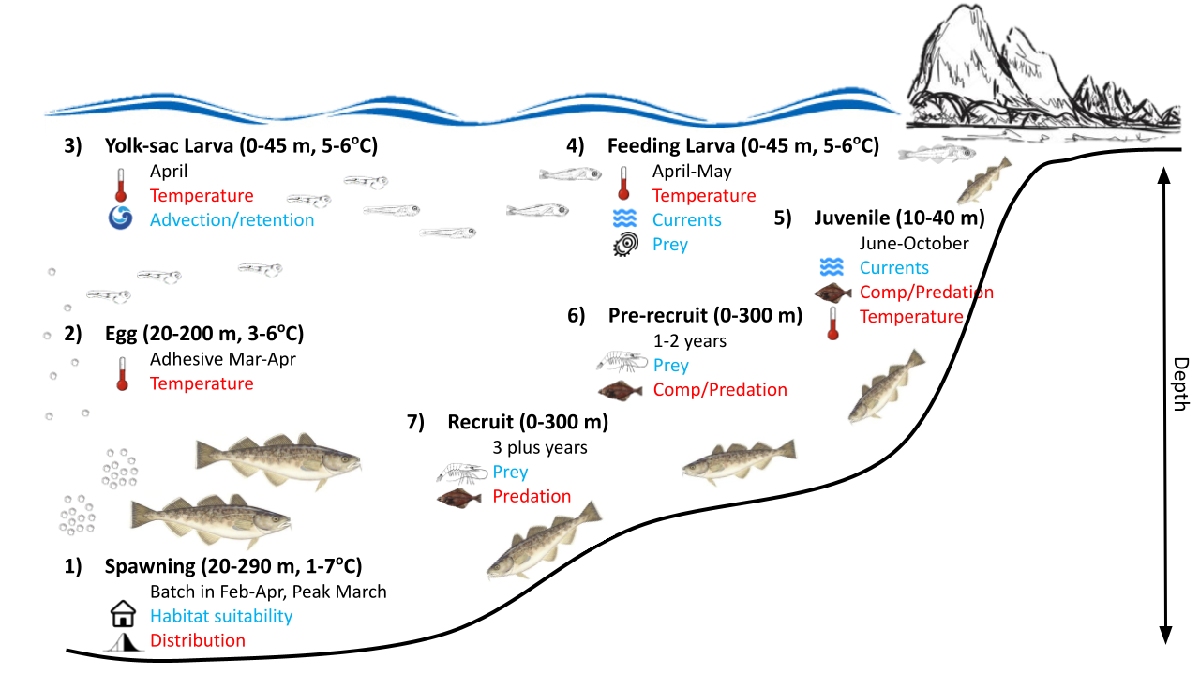

Figure 2.1.1.1: Life history conceptual model for GOA Pacific cod summarizing ecological information and key ecosystem processes affecting survival by life history stage. Red text means increases in process negatively affect survival, while blue text means increases in process positively affect survival.

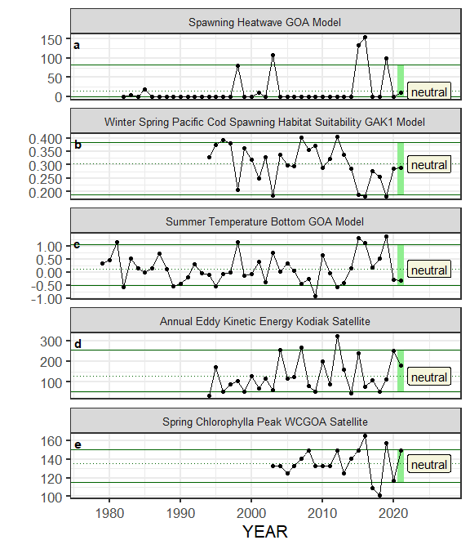

Figure 2.1.1.2a. Selected ecosystem indicators for GOA Pacific cod with time series ranging from 1977 – present. Upper and lower solid green horizontal lines are 90th and 10th percentiles of time series. Dotted green horizontal line is the mean of the time series. Light green shaded areas represent the most recent year of the traffic light analysis results. Text box follows the traffic light status table for the current year.

#### 

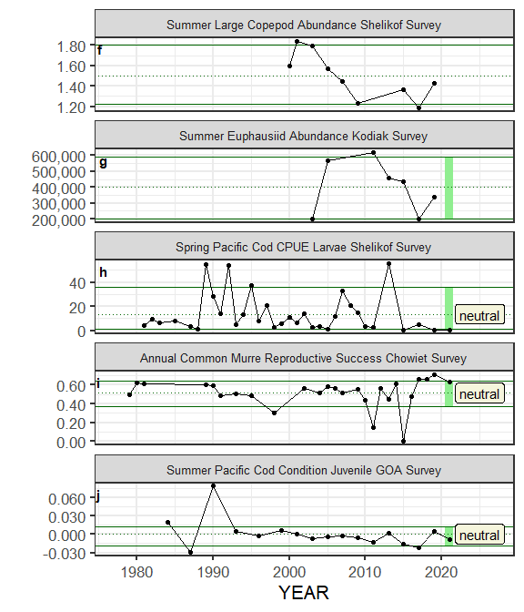

Figure 2.1.1.2a (cont.). Selected ecosystem indicators for GOA Pacific cod with time series ranging from 1977 – present. Upper and lower solid green horizontal lines are 90th and 10th percentiles of time series. Dotted green horizontal line is the mean of the time series. Light green shaded areas represent the most recent year of the traffic light analysis results. Text box follows the traffic light status table for the current year.

#### 

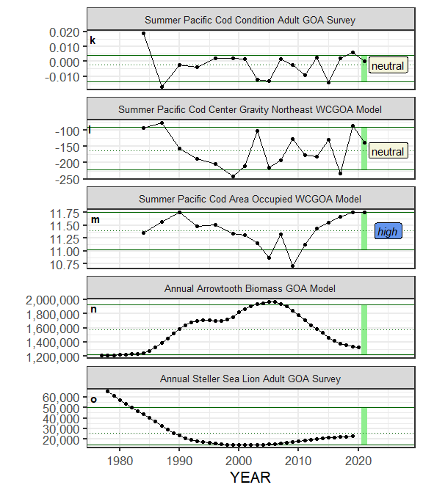

Figure 2.1.1.2a (cont.). Selected ecosystem indicators for GOA Pacific cod with time series ranging from 1977 – present. Upper and lower solid green horizontal lines are 90th and 10th percentiles of time series. Dotted green horizontal line is the mean of the time series. Light green shaded areas represent the most recent year of the traffic light analysis results. Text box follows the traffic light status table for the current year.

#### 

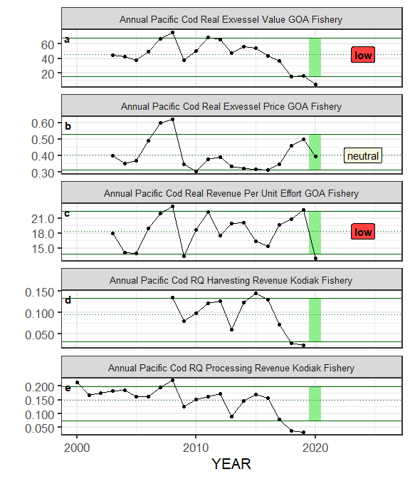

Figure 2.1.1.2b. Selected socioeconomic indicators for GOA Pacific cod with time series ranging from 1977 – present. Upper and lower solid green horizontal lines are 90th and 10th percentiles of time series. Dotted green horizontal line is the mean of the time series. Light green shaded areas represent the most recent year of the traffic light analysis results. Text box follows the traffic light status table for the current year.

#### 

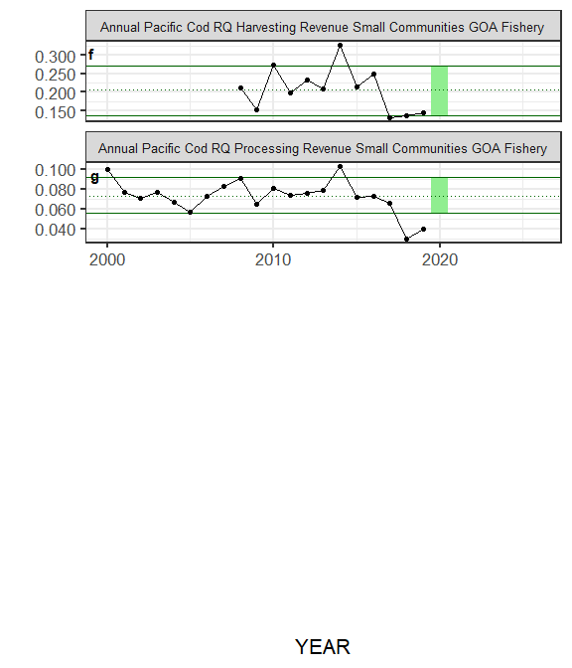

Figure 2.1.1.2b (cont.). Selected socioeconomic indicators for GOA Pacific cod with time series ranging from 1977 – present. Upper and lower solid green horizontal lines are 90th and 10th percentiles of time series. Dotted green horizontal line is the mean of the time series. Light green shaded areas represent the most recent year of the traffic light analysis results. Text box follows the traffic light status table for the current year.

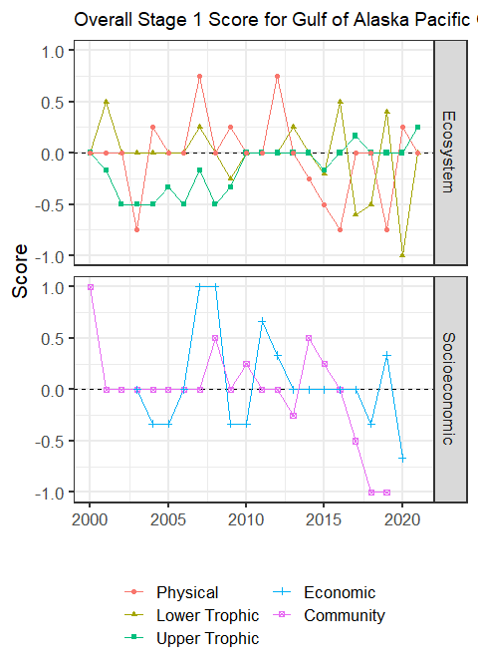

Figure 2.1.1.3: Simple summary traffic light score by category for ecosystem and socioeconomic indicators from 2000 to present.

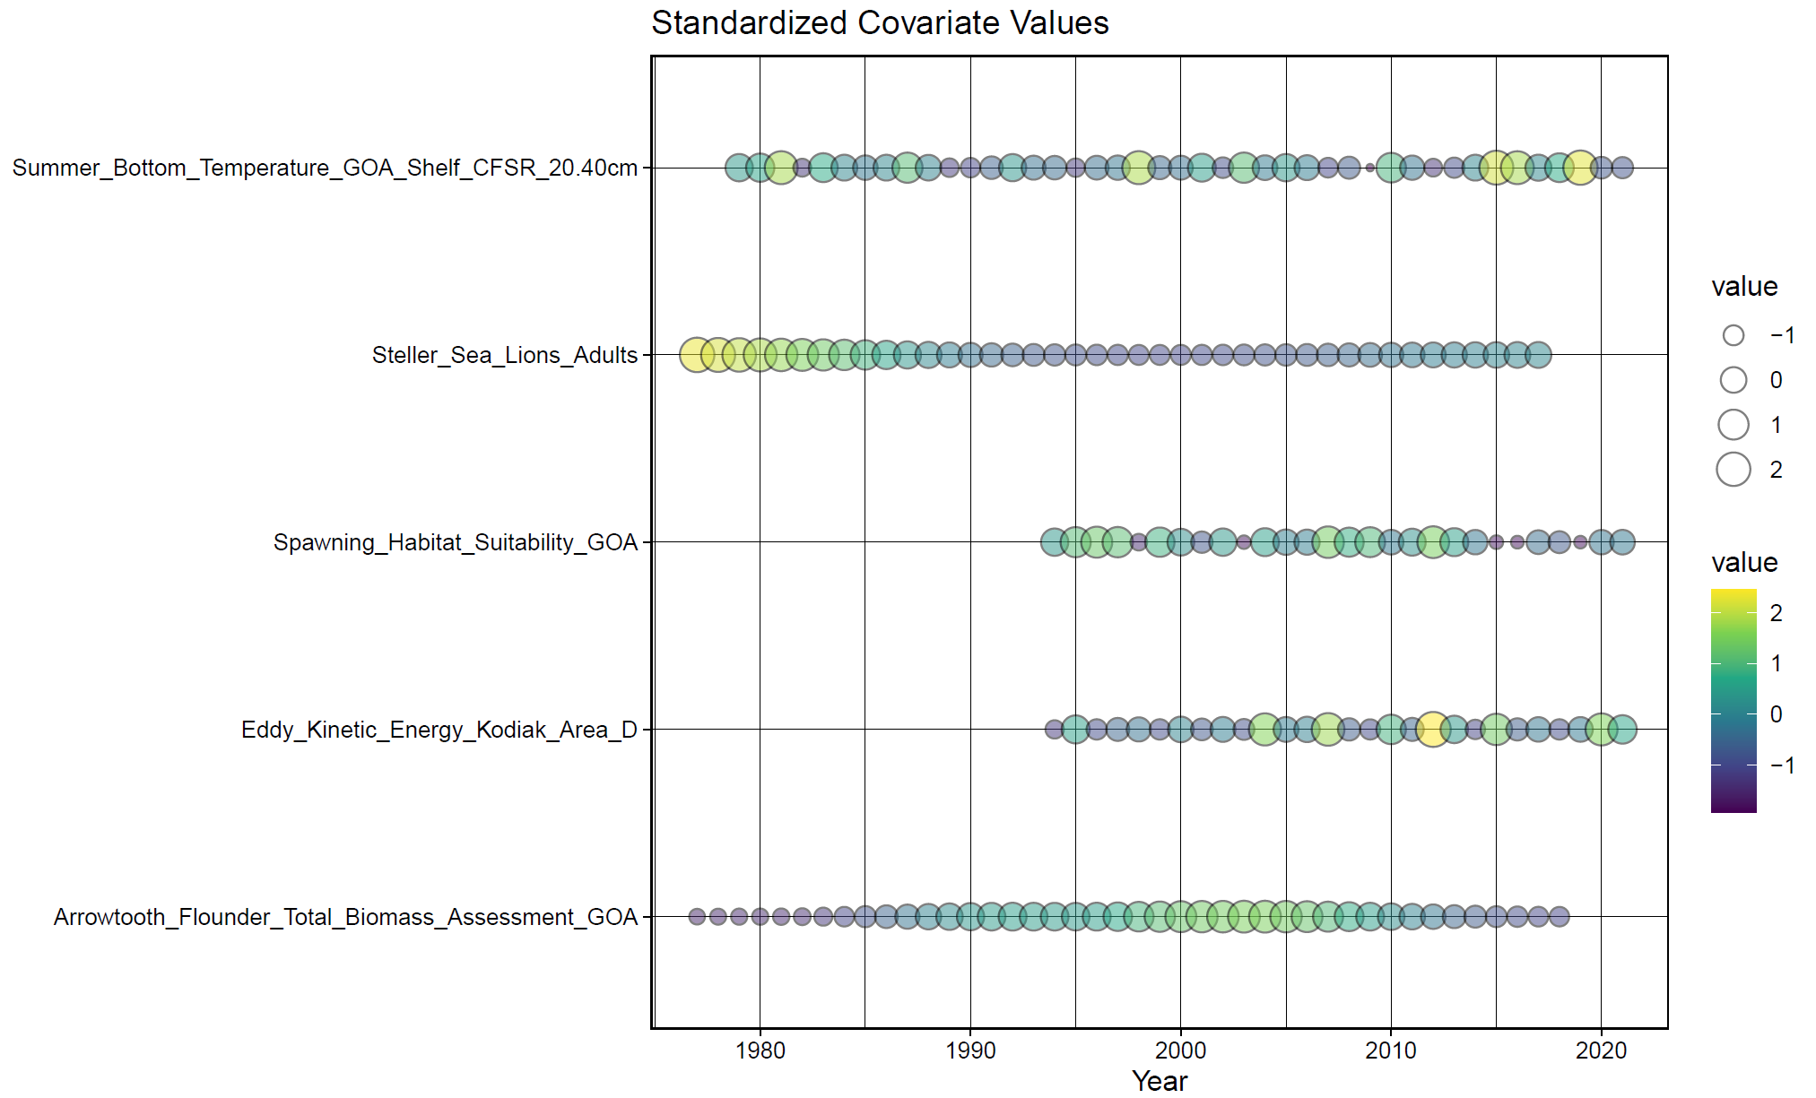

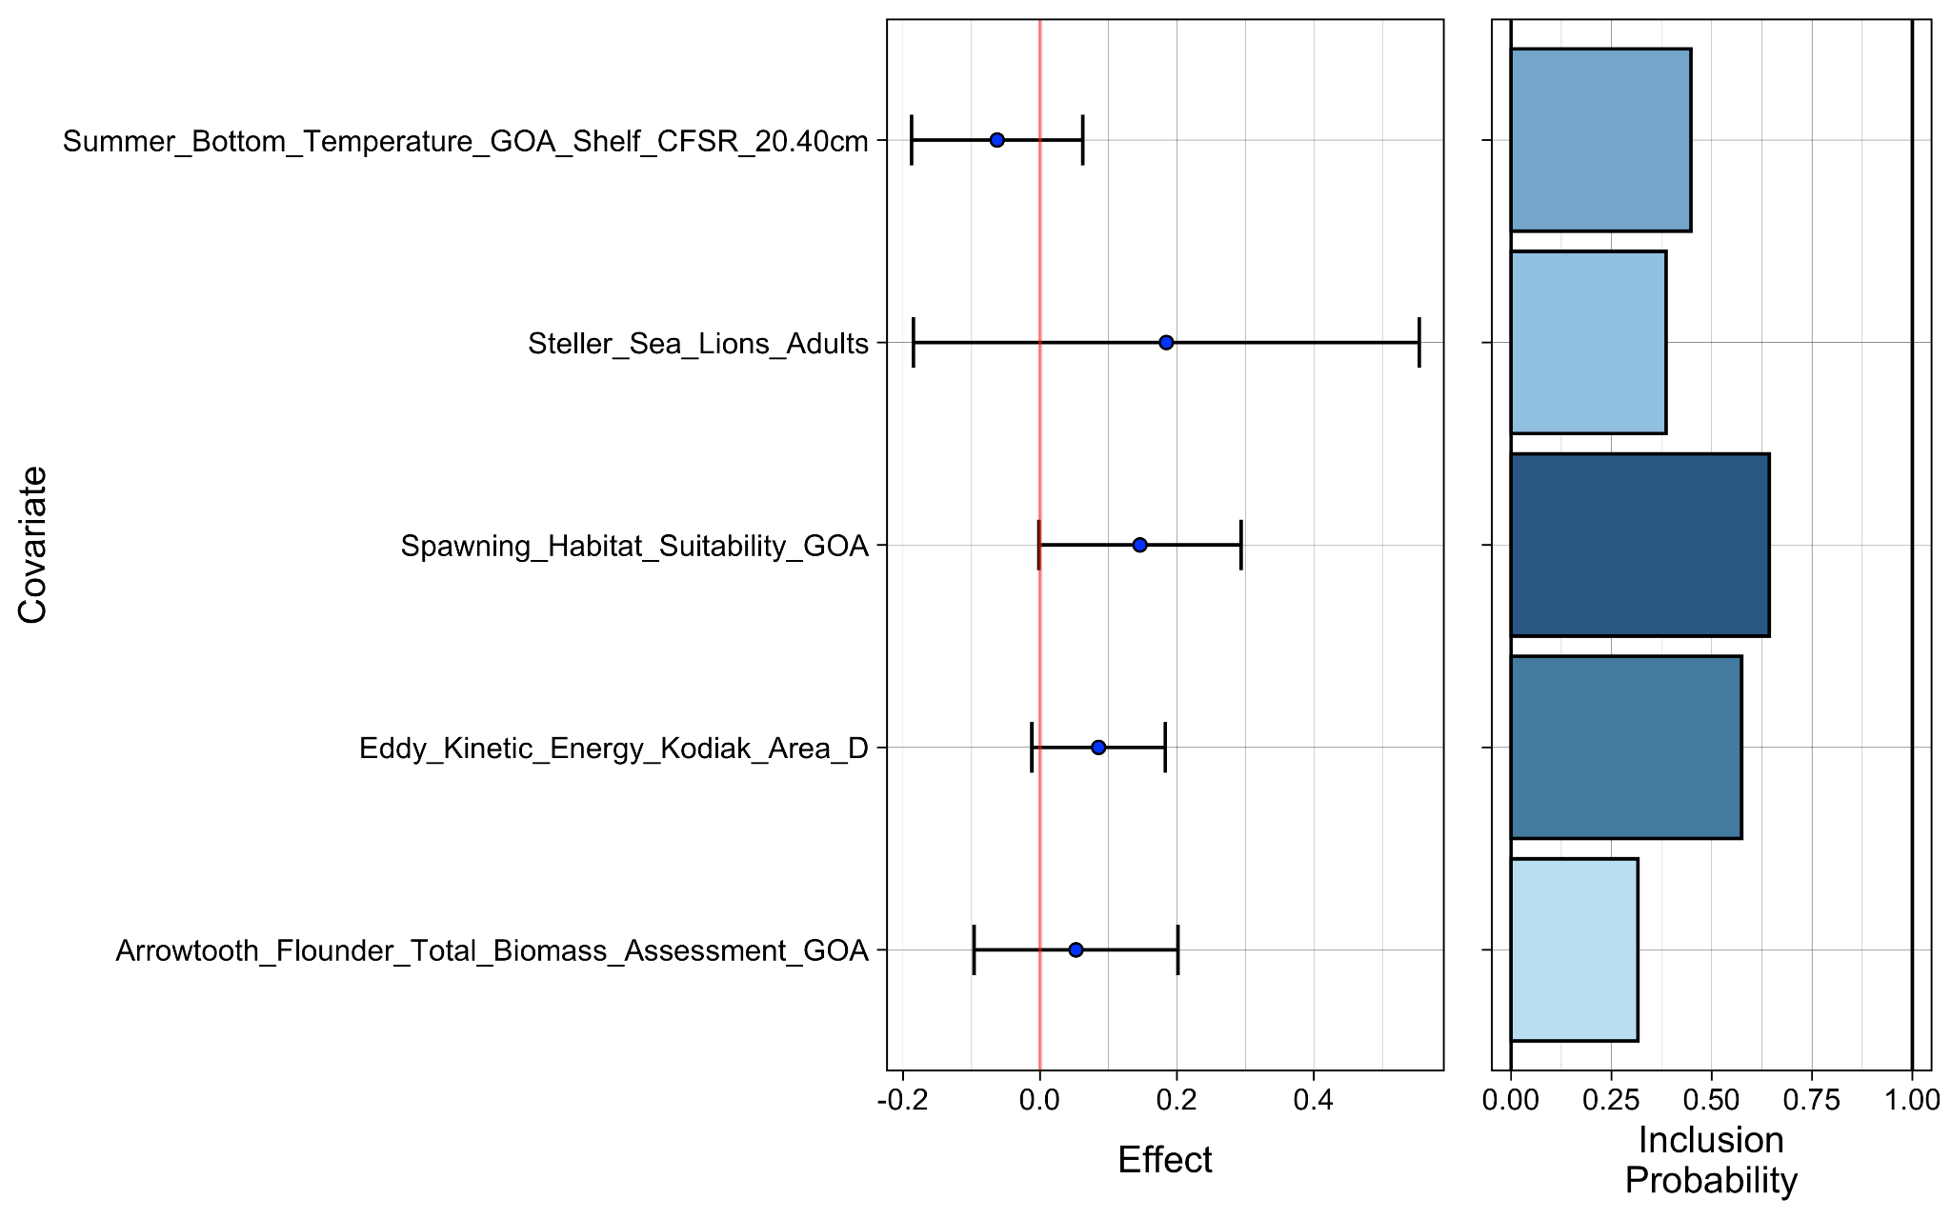

Figure 2.1.1.4: Bayesian adaptive sampling output showing (top graph) standardized covariates and (bottom graph) the mean relationship and uncertainty (95% confidence intervals) with log GOA Pacific cod recruitment, in each estimated effect (left bottom graph), and marginal inclusion probabilities (right bottom graph) for each predictor variable of the covariate set.

## Appendix 2.2 GOA Pacific cod 2021 Stock Synthesis model files

<https://apps-afsc.fisheries.noaa.gov/Plan_Team/2021/GOAPCOD2021Appendix2.2.zip>

## Appendix 2.3 GOA Pacific cod 2021 Model 19.1 selected data and model results

[https://apps-afsc.fisheries.noaa.gov/Plan_Team/2021/GOAPCOD2021Appendix2.3.xlsx](https://apps-afsc.fisheries.noaa.gov/Plan_Team/2021/GOAPCOD2021Appendix2.3.xlsx )

## Appendix 2.4 GOA Pacific cod 2021 Model 21.1 selected data and model results

<https://apps-afsc.fisheries.noaa.gov/Plan_Team/2021/GOAPCOD2021Appendix2.4.xlsx>

## Appendix 2.5 GOA Pacific cod 2021 Model 21.1 selected data and model results for Projection A

<https://apps-afsc.fisheries.noaa.gov/Plan_Team/2021/GOAPCOD2021Appendix2.5.xlsx>

## Appendix 2.6 GOA Pacific cod 2021 Model 21.1 selected data and model results for Projection B

<https://apps-afsc.fisheries.noaa.gov/Plan_Team/2021/GOAPCOD2021Appendix2.6.xlsx>

## Appendix 2.7 GOA Pacific cod 2021 Model 21.2 MCMC results

## <https://apps-afsc.fisheries.noaa.gov/Plan_Team/2021/GOAPCOD2021Appendix2.7.xlsx>

## Appendix 2.8 Gulf of Alaska Pacific cod assessment models for Plan Team consideration, September 2021

Steven Barbeaux, Ben Laurel, Mike Litzow, and Ingrid Spies

Alaska Fisheries Science Center

National Marine Fisheries Service

National Oceanic and Atmospheric Administration

7600 Sand Point Way NE., Seattle, WA 98115-6349

## Introduction

In this document the authors present a series of bridged models and seek advice on which models the Plan Team would like presented in November. The authors would also like advice on what objective model selection criteria the Plan Team would suggest be presented to aid in model evaluation and selection for November.

For this year we explored five changes to the model from the 2020 reference model (Model 19.1, Barbeaux *et al.* 2020) that resulted in nine bridged models (Table 1). First we looked at the inclusion of a beach seine age-0 index of abundance to the model; second, we examined environmental links on growth, natural mortality, and recruitment; third we examined changing the natural mortality block to 2015-2020; and finally we examined tuning the indices input standard error to the RMSE and tuning composition data using the Francis method. The addition of the age-0 beach seine data as a recruitment index was provided as an improvement to help inform recruitment estimates. Previous models used to manage this stock have had few data to inform abundance at ages younger than 3. The set of environmentally linked models demonstrated issues with fitting these links in single species stock assessment models and the difficulty in model selection where improvements are minimal. The tuned models were presented to demonstrate the sensitivity of the models to differences in data weighting.

Adding environmental links to the base model adds complexity to the models and makes assumptions about the processes that impact the annual variability of the stock that may not yet be well established in the literature. The improvements to the tactical model in all cases were at best minor while changes to the management advice resulting from the models were in some cases substantial. The authors wish to continue to work on these models and present a set of these for November, but are reluctant to recommend any of them for management of the stock at this time.

## Environmental Data

### Laurel and Litzow age-0 index

Beach seine sampling of age-0 cod was conducted at two Kodiak Island bays during 2006-2021 and an expanded survey was conducted during 2018-21 at 13 additional bays on Kodiak Island, the Alaska Peninsula, and the Shumagin Islands (n = 3 - 9 fixed stations per bay, 95 total stations). Sampling occured during July and August (days of year 184-240), within two hours of a minus tide at the long-term Kodiak sites, and within three hours of a low tide at the expanded survey sites. At all sites, a 36 m long, negatively buoyant beach seine was deployed from a boat and pulled to shore by two people standing a fixed distance apart on shore. Wings on the seine (13 mm mesh) were 1 m deep at the ends and 2.25 m in the middle with a 5 mm delta mesh cod end bag. The seine wings were attached to 25 m ropes for deployment and retrieval from shore. The seine was set parallel to and ~ 25 m, making the effective sampling area ~ 900 m 2 of bottom habitat.

A model-based index of annual catch per unit effort (CPUE) for age-0 cod was used to resolve inter-annual differences in sampling across different bays and different days of the year. Specifically, a Bayesian zero-inflated negative binomial (ZINB) model was used invoking year as a categorical variable, day of year as a continuous variable, and site nested within bay as a group-level (random) effect. The day of year effect was modeled with thin plate regression splines to account for non-linear changes in abundance through the season and the number of basis functions was limited to 3 to avoid over-fitting data. This model was fit using Stan 2.21.0, R 4.0.2 and the *brms* package (Carpenter et al. 2017, Buerkner 2017, R Core Team 2021). The beach seine age-0 CPUE index showed the large 2012 year class and subsequent drop in CPUE for 2013-2016, larger recruitment in 2017 and 2018, a drop again in 2019, and then large 2020 year class (Table 2). The most recent bottom trawl survey included in Model 19.1 was 2019, however Pacific cod don’t fully recruit into this survey until approximately age-3. Therefore Model 19.1 would not have much information informing year classes after 2016. The 2006 through 2016 recruitment deviations from Model 19.1 correlate positively with the log CPUE of the beach seine index with an R2 of 0.67.

### CFSR bottom temperature indices

The Climate Forecast System Reanalysis (CFSR) was the latest version of the National Centers for Environmental Prediction (NCEP) climate reanalysis. The oceanic component of CFSR included the Geophysical Fluid Dynamics Laboratory Modular Ocean Model version 4 (MOM4) with an iterative sea-ice (Saha et al., 2010). It used 40 levels in the vertical with a 10-meter resolution from surface down to about 262 meters. The zonal resolution was 0.5° and a meridional resolution of 0.25° between 10°S and 10°N, gradually increasing through the tropics until becoming fixed at 0.5° poleward of 30°S and 30°N.

To make the index the CFSR reanalysis grid points were co-located with the AFSC bottom trawl survey stations. The co-located CFSR oceanic temperature profiles were then linearly interpolated to obtain the temperatures at the depths centers of gravity for 10 cm and 40 cm Pacific cod as determined from the AFSC bottom trawl survey. All co-located grid points were then averaged to get the time series of CFSR temperatures over the period of 1979-2020 (Table 3).

### Sum of annual marine heatwave cumulative intensity index (MHCI)

The daily sea surface temperatures for 1 January 1981 through 31 December 2020 were retrieved from the NOAA High-resolution Blended Analysis Data database (National Oceanic and Atmospheric Administration, 2017) and filtered to only include data from the central Gulf of Alaska between 145°W and 160°W longitude for waters less than 300 m in depth. The overall daily mean sea surface temperatures were then calculated for the entire region. These daily mean sea surface temperatures data were processed through the R package *heatwaveR* (Schlegel and Smit, 2018) to obtain the marine heatwave cumulative intensity (MHCI; Hobday et al., 2016) value where we defined a heatwave as 5 days or more with daily mean sea surface temperatures greater than the 90th percentile of the 1 January 1982 through 31 December 2012 time series. The MHCI were then summed for each year to create an annual index of MHCI, summed for each year for the months of January through March, November, and December to create an annual winter index of MHCI, and summed for February and March to create an annual spawning index of MHCI (Table 3).

## Model Configurations

Except where noted below, the models presented were configured the same as Model 19.1 from Barbeaux et al. (2020), the reference model used to set management advice. All ecosystem-link parameters presented were fit with uninformative uniform priors.

### AFSC longline survey catchability

For the base model an ecosystem-linked covariate on AFSC longline survey catchability has been in use since 2017 (Barbeaux et al., 2016) and will continue to be used in all of the models used in this study. Annual catchability, Qy, was modeled using a multiplicative link as:

$$log\left(Q_{y}\right)=log\left(\overline{Q}\right)e^{αf_{Jy}}$$,

where $\overline{Q}$ was the mean catchability for the AFSC longline survey for 1977 through 2020, α was the ecosystem link parameter fit with an uninformative prior, and $f_{Jy}$ was the June CFSR bottom temperature anomaly in the Central GOA in year y.

### Growth

For the base model (19.1), 21.1a, 21.1b, and 21.1c length at age, $L_{a}$, were modeled as three parameter von Bertalanffy growth models with length in June, $L_{1}$, maximum asymptotic length, L2, and growth rate, k, as:

$L_{a}={L_{2}-\left(L_{2}-L_{1}\right)e}^{-ak}$,

where a was age.

For the ecosystem-linked models 21.1d, 21.1e, 21.1f, 21.5a and 21.5b length at age for each year, $L_{ay}$, were modeled as six parameter von Bertalanffy growth modeled with annual water temperature covariates on $L_{1}$, $L_{2}$, and k as:

$$L_{ay}={L_{2y}-\left(L_{2y}-L_{1y}\right)e}^{-ak\left(e^{{φf}_{Jy}}\right)}$$

$$L_{1y}={\overline{L}}_{1}e^{\left(γ\frac{e^{\left(0.2494+0.3216\left(\overline{t}+f_{Jy}\right)-0.0069{\left(\overline{t}+f_{Jy}\right)}^{2}-0.0004{\left(\overline{t}+f_{Jy}\right)}^{3}\right)}}{e^{\left(0.2494+0.3216\left(\overline{t}\right)-0.0069{\left(\overline{t}\right)}^{2}-0.0004{\left(\overline{t}\right)}^{3}\right)}}\right)}$$

$$L_{2y}={\overline{L}}_{2}e^{υf_{Jy}}$$

where was the June bottom temperature anomaly in the Central GOA (described above) in year y, γ was the temperature anomaly link parameters for and an index of the ratio of the annual June temperature, , dependent juvenile growth (Laurel *et al.* 2015) for a given year over the growth in June for the mean temperature for 1982-2012, , υ was the temperature anomaly link parameter for L2, and φ the temperature anomaly link parameter for *k*.

### Natural mortality

Natural mortality in the base Model 19.1, and Models 21.1a, 21.1b, and 21.1d were fit for two time blocks, 2014-2016 and all other years, as a single non-varying parameter for all ages for each block. Natural mortality in Model 21.1c, 21.1e, and 21.1g was annually varying with a linear ecosystem-link parameter, $η$, which scaled the non-heatwave year natural mortality, , using the annual central GOA marine heatwave cumulative index (*IAy*) as:

A logistic curve was used to convert the index forcing M to asymptote at higher index values (Table 3). Here the shape of the logistic curve including the asymptote, λ, slope, ς, and inflection point in °C days, ψ, was determined within the model iteratively and the parameters resulting in the lowest negative log-likelihood were selected for projections. The best fit model had λ at 0.65, ς = 0.005 and ψ = 400 resulting in increased natural mortality estimates for years with positive *IAy* values. Note the maximum annual marine heatwave index value in the time series was 631°C-days in 2016, well below future projected values.

For Models 21.5a and 21.5c natural mortality were fit for two time blocks, 2015-2021 and all other years, as a single non-varying parameter for all ages for each block with uninformative priors.

### Recruitment

In the base Model 19.1, Model 21.1a, and Model 21.1b recruitment by year, Ry, were modeled as:

$R_{y}=\left(R_{0}e^{ϑ}\right)e^{-0.5b_{y}σ_{R}^{2}+{\tilde{R}}_{y}}$, if y ≥ 1977 → $ϑ$ = 0, where ${\tilde{R}}_{y}=N\left(0; σ_{R}^{2}\right)$,

$R_{0}$ was the unfished equilibrium recruitment, ${\tilde{R}}_{y}$ was the lognormal recruitment deviation for year y, was the standard deviation among recruitment deviations in log space and was fixed at 0.44, and by was a bias adjustment fraction applied during year, y (Methot Jr and Taylor, 2011). To account for an environmental regime change in 1977 (Anderson and Piatt, 1999) the parameter was fit for recruitment allowing for a change in R0 prior to the regime change in 1977. Projections in the base model post-2017 assumed average recruitment for 1977-2017 for Ry.

The ecosystem-linked recruitment (Ry) in models 21.1d, 21.1e, 21.1g, 21.5a, and 21.5c were modeled as Beverton-Holt relationships with parameter ($ω$) which scaled the unfished equilibrium recruitment, $R_{0}$, using the annual spawning Central GOA marine heatwave cumulative index (Iy; described below) as:

, if y ≥ 1977 → = 0, where ,

h was the steepness parameter, SB0 was the unﬁshed equilibrium spawning biomass (corresponding to R0), and SBy was the spawning biomass at the start of the spawning season during year y.

Where h=1, the formula reduces to $R_{y}=e^{ϑ+ln\left(R_{0}e^{ωI_{Sy}^{\frac{1}{3}}}\right)}e^{-0.5b_{y}σ_{R}^{2}+{\tilde{R}}_{y}}$.

### Model tuning

For all models except Model 21.1g and 21.5c the models remained at the base configuration with no additional tuning. For these two models the index input variances were tuned to the RMSE and the length and age composition sample size tuned using the Francis TA1.8 method (Francis 2011).

## Results

### Beach seine index

The inclusion of the age-0 beach seine index in Model 21.1a resulted in a poorer fit for the majority of data components compared to Model 19.1 (Table 4); however, there was a reduction in the objective function for recruitment (Table 5). Comparisons of overall likelihood and marginal likelihoods were not possible given the inclusion of a new dataset/likelihood component. As one would expect the variance estimates for recruitment deviations for the years in which index data were available were lower than in the model without the beach seine index (Table 6). For 2006-2020 the mean CV for Model 19.1 was 0.25 and for Model 21.1a, with the beach seine age-0 index, was 0.19. The index root-mean-squared-standardized-residual (RMSSR) for the bottom trawl and longline survey showed a reduction in fit and the Effective N for age and length compositions for all components showed a slight degradation in fit from Model 19.1 to Model 21.1a.

Retrospective analysis showed both models had slight positive retrospective bias in the estimates of spawning stock biomass with the Mohn’s ρ of 0.081 for Model 19.1 and 0.087 for Model 21.1a. The Woodshole ρ and RMSE for spawning stock biomass were also similar (Table 7) with only slight differences between the two configurations. The retrospective bias for both models was considered to be within acceptable bounds.

The largest change in model results between Model 19.1 and Model 21.1a was the increase in estimates for the 2017, 2018, and 2020 year classes and slight decrease in the 2019 year class estimate (Table 6 and Fig. 2) resulting in an overall increase in 2019-2020 estimates of spawning stock biomass (Table 8 and Fig. 2) and increase in projected 2021 and 2022 spawning biomass. This increasing abundance starting in 2017 due to fit to the age-0 index and inability of the model to compensate with changing M post-2016 resulted in the disagreement in Model 21.1a with the recent reduction in the longline survey abundance. Model 21.1a would recommend a ~200% increase in ABC for 2022. This large increase was mostly due to a drop in the estimated unfished spawning biomass with increases in recruitment (Table 5) and an increase in the projected spawning biomass for 2022 resulting in the spawning biomass ratio being above B40% and no longer on the sloping portion of the control rule.

As Model 21.1a was configured there was disagreement between the age-0 beach seine index and all other data components. There were at least two possible reasons for this disparity 1) the beach seine survey doesn’t capture the GOA-wide trend in age-0 abundance, and/or 2) Model 21.1a with natural mortality modeled across all ages with only a block for 2014-2016 does not adequately capture survival variability between age-0 and age-3. Attempts this year at fitting annually varying age-specific M failed as there was a lack of information for the younger age classes as these younger fish were not consistently caught in the fisheries or surveys. For the remainder of the models presented we assumed that the beach seine survey index captures the trend in GOA age-0 Pacific cod abundance.

### Environmentally-linked models

The three new environmental links on growth, natural mortality, and recruitment made improvements to the overall model fits over Model 21.1a as measured by full likelihood and full AIC. However the marginal likelihood (Thorson *et al.* 2019) in some cases suggested some of the changes were not true model improvements. Most of the changes made by the inclusion of the environmental links were minor in terms of fit, but some would result in substantial changes in management advice from the base model. Although the residual plots were not provided due to the volume of possible plots, they were assessed by the authors and can be made available on request for any model. For all the age and length composition data there were no severe trends in the residuals and it was very difficult to ascertain differences in model fits visually as differences were subtle. For all models presented there were no parameters near bounds and the likelihoods appeared well defined with the gradient of the objective function at less than 10e-4. All models were examined by “jittering” starting parameters by 10% over 50 runs to evaluate if models had converged to local minima. All models evaluated were deemed adequate.

#### Model21.1b: SST-linked growth

The parameterization and fit of the SST-linked growth in Model 21.1b resulted in the model estimating faster growth in warm years and slower growth in cold years (Fig 3). The parameters appeared to be well fit with small gradients and CVs between 0.23 and 0.28. SST-linked growth was most impactful in the age-0 fish creating a cohort effect on length in the model (Fig. 3). The addition of sea surface temperature links to growth in Model 21.1b resulted in an improvement in both length and age composition fits for likelihood and effective N, and a slight improvement to the bottom trawl survey (Table 4), but a larger degradation in the fit to the longline and beach seine survey indices with increases in likelihood and RMSSR. There was an overall improvement in AIC from Model 21.1a, however the marginal AIC suggests that the SST-linked growth was not a model improvement. Although the retrospective bias remained within acceptable bounds the analysis suggests a slight increase in positive retrospective bias from Model 21.1a in the spawning biomass estimates across all three measures (Table 7). Overall model results in terms of reference points and current biomass levels (Table 5 and Table 8) remained similar to Model 21.1a.

#### Model 21.1c: Annual heatwave linked natural mortality

Adding heatwave-linked natural mortality to the model made the greatest improvement to the objective function, AIC, and Marginal AIC over all of the single eco-linked changes from Model 21.1a. The environmental link parameter was well fit with low gradient and a CV of 0.10. Model 21.1c showed improvement over Model 21.1a in fits to the most recent drop in abundance in the longline survey (Fig. 4), in the trawl and longline fishery length composition data, and in the beach seine index. There was a slight degradation in fit to the other data components (Table 4 and Table 5), however the improvement of fit to the most recent longline survey estimates were greater than the combined negative impacts to fit to the other components. Including annual heatwave index-linked natural mortality in Model 21.1c (Fig. 5) results in natural mortality peaking during heatwave years with the highest in 2016 at 0.92 and second highest in 2019 at 0.81. The retrospective analysis showed the model within acceptable bounds with a slight increase in the Mohn’s ρ, but a decrease in both the Woodshole ρ and retrospective RMSE compared to Model 21.1a.

Although the overall trend in abundance and recruitment were similar for most of the time series as were reference points between Models 21.1a and 21.1c, the management implications of the estimated drop in abundance for 2018-2020 and projections in Model 21.1c (Fig. 7) changed recommended harvest advice on ABC considerably from Model 21.1a and 21.1b with a -40% lower ABC in 2022. This difference resulted in an ABC nearer the Model 19.1 value (+23%). The difference from Model 21.1a was partly due to the 2022 Model 21.1c spawning biomass being estimated below B40% (Table 5) and on the slope of the control rule.

#### Model 21.1d: Spawning heatwave index linked recruitment

The spawning heatwave index linked recruitment (Fig. 6) in Model 21.1d resulted in a slight improvement of fit compared to model 21.1a based on a lower overall objective function and AIC estimate, however there was an increase in the marginal AIC (Table 7). Minor improvements in the objective function can be attributed to fit to the bottom trawl and longline surveys and reduction in recruitment residuals. There were minor reductions in fit to all of the age and length composition data (Table 4). Retrospective bias remained positive for all measures with a slight improvement over Model 21.1a (Table 7). Estimates for unfished biomass were within 1% of the Model 21.1a values as were the recommended ABC for 2022.

#### Model 21.1e: All three environmental links

Inclusion of all three environmental links in Model 21.1e (Table 5) resulted in a better fit model in regards to the objective function and AIC, however the marginal AIC was higher than Model 21.1c with just heatwave-linked natural mortality. In addition, although still within generally acceptable bounds the retrospective analysis resulted in an increase in the positive bias in the model over all the other models examined for the Mohn’s ρ and retrospective RMSE (Table 7). Gradients for the environmental link parameters were all relatively low (Table 9). The ω link parameter on R0 was the least well defined with a CV of 0.38 and gradient of 0.0001. Compared to Model 21.1a, Model 21.1e improved fits to the longline and beach seine survey indices, the length and age composition data for all three fisheries, the bottom trawl survey age composition data, and the longline survey length composition data (Table 4). Recruitment residuals were improved over all of the other models assessed before tuning (Table 5).

For Model 21.1e the overall trend in abundance and recruitment were similar to the other Model 21.1 series (Fig. 1). Like model 21.1c, Model 21.1e had a drop in abundance for recent years (Fig. 7) and the projections with similar estimates of annually varying natural mortality. Model 21.1e unfished spawning biomass at 345,360 t was the lowest of the un-tuned Model 21.1 series, but was only -5% different from Model 21.1a and -6% from Model 21.1d, the highest of the series, and -16% from Model 19.1. The management implications of the estimated drop in abundance for 2018-2020 and projections in Model 21.1e (Fig. 7) changed recommended harvest advice on ABC considerably from Model 21.1a and 21.1b with a -45% lower ABC in 2022. The Model 21.1e ABC, like Model 21.1c ABC, was nearer the Model 19.1 value (+13%).

### Expanding the natural mortality block to 2015-2020

Like Model 21.1e, Model 21.5a had environmental links on recruitment and growth, but unlike Model 21.1e the mortality block first used in Model 19.1 was changed from 2014-2016 to 2015-2020 after iteratively testing combinations of M blocks (Fig. 5). Compared to Model 21.1e, Model 21.5a improved fits to all age composition data and all length composition data except the longline survey length composition and length composition data as well as the longline and beach seine surveys over Model 21.1e while degrading the fit to the bottom trawl survey index. The AIC and marginal AIC were the lowest of all un-tuned models examined for this analysis. Environmentally linked parameter estimates (Table 9) were well estimated with low gradients and relatively low CVs. The estimate for natural mortality for 1978-2014 was the lowest of all the models evaluated at 0.40 and an estimate of M for 2015-2020 at 0.72. Both the bottom trawl and base longline catchability were high for Model 21.5a at 1.359 and 1.413, respectively. The α parameter linking the longline survey catchability to the CFSR surface temperatures was substantially lower than the other non-tuned models from between 0.8 and 1.0 down to 0.5 suggesting less influence of temperature on the longline survey index estimates (Table 9). The retrospective analysis on SSB suggested an increase in the Woodshole ρ and retrospective RMSE over all other models examined (Table 7), but a slight decrease in the Mohn’s ρ compared to Model 21.1e, but still higher than other un-tuned models examined. The increased natural mortality in 2015-2020 improved the fit to the large drop in abundance estimated in the longline survey over the last 5 years while degrading the fit to the increasing biomass estimate from the 2019 bottom trawl survey (Fig. 9) making it the worst fit model to this dataset of all examined. While improving the fit to the beach seine survey Model 21.5a increased residuals to estimated recruitment over Model 21.1e.

The trends in spawning biomass and recruitment mirrored the other models examined, however with the lower estimates for natural mortality and higher estimates for catchability the recruitment estimates were lower than other models as were the biomass estimates. Like the other models examined in this document Model 21.5a estimated that the lowest spawning biomass occurred in 2020 (Table 8), however spawning biomass in Model 21.5a was estimated to be below B12% in 2020 and 2021 and to remain below B20% through 2022, which would substantially change management advice for this stock compared to the other un-tuned models.

### Tuning the models

With the addition of the age-0 index we once again looked into model tuning and the use of the Dirichlet multinomial to handle data weighting for the length and age composition as recommended in Thorson et al. (2019). As in previous attempts with the GOA Pacific cod model, the model fits resulted in the ln(θ) parameters with values >15. In addition when implemented in Stock Synthesis the Dirichlet multinomial option led the models to be highly unstable and sensitivity, jitter, and retrospective runs often failed to converge making it difficult to evaluate the models even with the theta parameters fixed. In this document we chose to run two model configurations (Model 21.1g and 21.5c) with the indices tuned to the Index RMSE and the age and length composition sample sizes tuned using the Francis A1.8 method as implemented in R4SS. These models corresponded with the un-tuned models 21.1e and 21.5a.

Due to differences in the multinomial sample sizes the overall likelihoods between Model 21.1g and 21.5c cannot be compared nor can they be compared with the other models presented. For both tuned models there was a reduced weight on all three survey indices with an increase in variance for all three indices and a reduction in all age and length composition sample sizes (Table 10). However once tuned these models ended up placing more weight on the indices as can be seen in the reduction of the RMSSR for all three (Table 5) to near or below 1.0. The effective sample size in both tuned models were substantially lower than the un-tuned models as would be expected with the lower input sample size. The increase in variance and drop in input sample size placed less weight on the data components and allowed the model to adhere more closely to structural assumptions such as those provided for recruitment. The model then expended less in reducing recruitment residuals where the assumptions conflicted with data. Due to the higher variance for the longline survey index in both tuned models, the environmental link parameter on catchability (α) was substantially lower (0.382 and 0.295 for Model 21.1g and Model 21.5c) than the un-tuned models (between 0.8 and 1.0 for the Model 21.1 series and 0.5 for Model 21.5a), resulting in models with less variability in the longline survey index with sea surface temperature. Similarly, the temperature growth link parameters (φ, γ, and υ) were lower in the tuned models resulting in lower annual variability in growth overall (Table 9).

One issue in the tuned models was a large increase in the catchability for both the bottom trawl and longline surveys (Table 5). Inflating catchability allowed for an overall lower abundance making it easier to fit to the large recent drop in the longline abundance. The larger catchabilities also allowed for lower recruitment with smaller deviations from the spawner-recruit relationship.

Tuning increased the positive retrospective bias for Model 21.1g over the other 21.1 series models. For Model 21.5c, however, the retrospective bias was substantially reduced with a slightly negative bias for Mohn’s ρ and Woodshole ρ and lower retrospective RMSE for the spawning biomass estimates making Model 21.5c the best model in terms of least retrospective bias (Table 7 and Fig. 11). Having RMSSR lower than 1.0 for most of the indices may indicate overfitting of the indices in these models and an additional iteration on tuning the input variance warranted.

## Discussion

The inclusion of the age-0 beach seine index provided an anchor point for the models and resulted in an improvement in estimates of recruitment with lower recruitment residuals and a reduction in recruitment variability and variability in reference points. However this improvement came at a cost to the fits to the other data components. For the 21.1 and 21.5 series of models we needed to assume the beach seine index captured the overall trend in GOA age-0 Pacific cod abundance. We know that the other survey and fishery data included in this assessment provide poor estimates of young fish between ages 0 and 3. Therefore the degradation in model fit to the other survey indices and composition data we believe identifies model misspecification. This is likely due to the current set of models not having age-varying natural mortality and the likeliness of age-varying natural mortality being time varying. Models should be further explored that do include time and age-varying natural mortality. Attempts this year to develop such models found that fitting both of these in a single model was problematic and led to unlikely results with large differences in natural mortality between adjacent ages.

The exploration of ecosystem-linked models in this document highlight the difficulty in developing environmental links for tactical management advice. Here we saw marginal changes in measured model fit to the data that then produced a wide range of management advice depending on which environmental relationships were included. In the case of the models presented we can examine the partial impacts of increasing temperature and probability of a severe heatwave events, both of which were trending with climate change. Because we have opposing impacts on spawning biomass (faster growth, lower recruitment, and higher natural mortality with increasing temperature), including only one relationship may be problematic where data become scarce and in projections where they may drive estimates in a particular direction. Laboratory studies provide one means of examining the relationships and parameterizing the models; however, interactions within the ecosystem make these relationships less certain. In single species models the uncertainty in the relationships among ecosystem components when environmental conditions exceed the range of those observed in the past is not quantifiable.

It should be noted that when tuning a model, one is shifting weights of the data components in a model and changing the balance between the data components and model structure, including prior assumptions. In the series of models presented in this document, tuning of the model resulted in down-weighting all of the data components by adding variance to the indices and reducing sample size in the composition data. In broad terms the data down-weighting resulted in the model placing more emphasis on model assumptions and structure instead of data, particularly for recruitment. In addition the inflation of catchability in the tuned models was problematic and would lead me to disregard these model configurations.

Overall the variability in model results due to inclusion of different environmental links without a clear objective means of determining which configuration provides the best management advice was problematic. Retrospective analysis with time varying parameters was difficult to interpret particularly where there were time blocks and environmental linked relationships within the retrospective time period assessed. Likelihood and AIC measures were not useful for comparing models with different data components or different data weightings.

### References

Barbeaux. S. J., A’mar, T., and Palsson, W. 2016. Assessment of the Pacific cod stock in the Gulf of Alaska. In Plan Team for Groundfish Fisheries of the Gulf of Alaska (compiler), Stock assessment and fishery evaluation report for the groundfish resources of the Gulf of Alaska, p. 175-324. North Pacific Fishery Management Council, 605 W. 4th Avenue Suite 306, Anchorage, AK 99501

Barbeaux. S. J., B. Ferris, W. Palsson, I. Spies, M. Wang, and S. Zador. 2020. Assessment of the Pacific cod stock in the Gulf of Alaska. In Plan Team for Groundfish Fisheries of the Gulf of Alaska (compiler), Stock assessment and fishery evaluation report for the groundfish resources of the Gulf of Alaska. North Pacific Fishery Management Council, 605 W. 4th Avenue Suite 306, Anchorage, AK 99501

Francis, R.I.C.C. (2011). Data weighting in statistical fisheries stock assessment models. Can. J. Fish. Aquat. Sci. 68: 1124-1138. <https://doi.org/10.1139/f2011-025>

Laurel, B., M. Spencer, P. Iseri, and L. Copeman. 2016a. Temperature-dependent growth and behavior of juvenile Arctic cod (*Boreogadus saida*) and co-occurring North Pacific gadids. Polar Biology 39:1127-1135.

Laurel, B. J., B. A. Knoth, and C. H. Ryer. 2016b. Growth, mortality, and recruitment signals in age-0 gadids settling in coastal Gulf of Alaska. ICES Journal of Marine Science 73:2227-2237.

Thorson, J.T., Johnson, K.F., Methot, R.D. and Taylor, I.G., 2017. Model-based estimates of effective sample size in stock assessment models using the Dirichlet-multinomial distribution. Fisheries Research, 192, pp.84-93.

## Tables

Table 2.8.1 - Models developed for September 2021

|  |  |  |  |
| --- | --- | --- | --- |
| Model name | Data changes from 2020 | Model changes from 2020 | Description |
| Model 19.1 | None | None | Reference model from 2020 |
| Model 21.1a | Laurel/Litzow larval index | Model 19.1 | Addition of the age-0 index from the Kodiak Beach seine surveys conducted by Laurel and Litzow. |
| Model 21.1b | Laurel/Litzow larval index | Model 21.1a with Temp.-linked growth | SST-linked growth in model |
| Model 21.1c | Laurel/Litzow larval index | Model 21.1a with heatwave-linked natural mortality | Heatwave-linked natural mortality |
| Model 21.1d | Laurel/Litzow larval index | Model 21.1a with heatwave-linked recruitment | Heatwave-linked recruitment in model |
| Model 21.1e | Laurel/Litzow larval index | Model 21.1a with Temp.-linked growth, and heatwave-linked recruitment and mortality. | All environmental links turned on |
| Model 21.1g | Laurel/Litzow larval index | Model 21.1e with index tuned to RMSE and length composition tuned using the Francis method | Model 21.1e tuned |
|  |  |  |  |
| Model 21.5a | Laurel/Litzow larval index | Model 21.1e with extended M block 2015- 2020 | Extended heatwave M to include 2015-2020 instead of environmental link |
| Model 21.5c | Laurel/Litzow larval index | Model 21.35a with index tuned to RMSE and length composition tuned using the Francis method | Model 21.5a tuned |

Table 2.8.2 - Age-0 beach seine index CPUE (fish per set) and standard error and Model 19.1 age-0 recruitment in billions (109).

|  |  |  |  |
| --- | --- | --- | --- |
| Year | CPUE  (#/set) | SE | age-0  (1×109) |
| 2006 | 86.34 | 0.41 | 0.687 |
| 2007 | 6.22 | 0.46 | 0.443 |
| 2008 | 20.45 | 0.44 | 0.652 |
| 2009 | 21.98 | 0.59 | 0.392 |
| 2010 | 6.53 | 0.54 | 0.507 |
| 2011 | 22.14 | 0.46 | 0.655 |
| 2012 | 117.77 | 0.44 | 1.215 |
| 2013 | 6.73 | 0.48 | 0.638 |
| 2014 | 5.95 | 0.58 | 0.211 |
| 2015 | 0.77 | 0.95 | 0.260 |
| 2016 | 1.30 | 0.55 | 0.168 |
| 2017 | 52.18 | 0.41 | 0.246 |
| 2018 | 84.85 | 0.31 | 0.390 |
| 2019 | 1.52 | 0.62 | 0.399 |
| 2020 | 117.81 | 0.35 | 0.464 |

Table 2.8.3 - Environmental indices used in reviewed 2021 models.

|  |  |  |  |  |  |
| --- | --- | --- | --- | --- | --- |
| Year | CFSR SST Anomaly (°C) | Annual heatwave index (°C-days) | Spawning heatwave index (°C-days) | Larval growth index | Asymptotic heatwave index |
| 1977 | 0.00 | 0.00 | 0.00 | 1.00 | 0.077 |
| 1978 | 0.00 | 0.00 | 0.00 | 1.00 | 0.077 |
| 1979 | 0.33 | 0.00 | 0.00 | 1.08 | 0.077 |
| 1980 | 0.45 | 0.00 | 0.00 | 1.11 | 0.077 |
| 1981 | 1.14 | 0.00 | 0.00 | 1.28 | 0.077 |
| 1982 | -0.58 | 0.00 | 0.00 | 0.87 | 0.077 |
| 1983 | 0.53 | 31.88 | 1.68 | 1.13 | 0.089 |
| 1984 | 0.15 | 88.21 | 0.00 | 1.04 | 0.113 |
| 1985 | 0.00 | 24.61 | 2.70 | 1.00 | 0.086 |
| 1986 | 0.15 | 16.35 | 0.00 | 1.04 | 0.083 |
| 1987 | 0.72 | 5.58 | 0.00 | 1.18 | 0.079 |
| 1988 | 0.12 | 0.00 | 0.00 | 1.03 | 0.077 |
| 1989 | -0.53 | 0.00 | 0.00 | 0.88 | 0.077 |
| 1990 | -0.46 | 8.72 | 0.00 | 0.90 | 0.081 |
| 1991 | -0.19 | 0.00 | 0.00 | 0.96 | 0.077 |
| 1992 | 0.32 | 0.00 | 0.00 | 1.08 | 0.077 |
| 1993 | -0.05 | 19.10 | 0.00 | 0.99 | 0.084 |
| 1994 | -0.10 | 0.00 | 0.00 | 0.98 | 0.077 |
| 1995 | -0.54 | 0.00 | 0.00 | 0.88 | 0.077 |
| 1996 | -0.08 | 0.00 | 0.00 | 0.98 | 0.077 |
| 1997 | -0.01 | 142.05 | 0.00 | 1.00 | 0.140 |
| 1998 | 1.15 | 150.85 | 4.32 | 1.29 | 0.145 |
| 1999 | -0.14 | 0.00 | 0.00 | 0.97 | 0.077 |
| 2000 | -0.06 | 0.00 | 0.00 | 0.99 | 0.077 |
| 2001 | 0.40 | 46.91 | 2.25 | 1.10 | 0.095 |
| 2002 | -0.37 | 51.27 | 0.00 | 0.92 | 0.097 |
| 2003 | 0.73 | 207.85 | 4.76 | 1.18 | 0.180 |
| 2004 | 0.03 | 117.65 | 0.00 | 1.01 | 0.127 |
| 2005 | 0.33 | 284.60 | 0.00 | 1.08 | 0.234 |
| 2006 | 0.05 | 35.14 | 0.00 | 1.01 | 0.090 |
| 2007 | -0.44 | 0.00 | 0.00 | 0.90 | 0.077 |
| 2008 | -0.25 | 0.00 | 0.00 | 0.94 | 0.077 |
| 2009 | -0.92 | 0.00 | 0.00 | 0.80 | 0.077 |
| 2010 | 0.63 | 6.52 | 0.00 | 1.15 | 0.080 |
| 2011 | -0.03 | 0.00 | 0.00 | 0.99 | 0.077 |
| 2012 | -0.58 | 0.00 | 0.00 | 0.87 | 0.077 |
| 2013 | -0.40 | 0.00 | 0.00 | 0.91 | 0.077 |
| 2014 | 0.16 | 283.02 | 0.00 | 1.04 | 0.233 |
| 2015 | 1.30 | 402.32 | 5.11 | 1.33 | 0.327 |
| 2016 | 1.13 | 630.87 | 5.38 | 1.28 | 0.494 |
| 2017 | 0.18 | 53.03 | 0.00 | 1.04 | 0.097 |
| 2018 | 0.53 | 128.50 | 0.00 | 1.13 | 0.133 |
| 2019 | 1.37 | 496.74 | 4.65 | 1.34 | 0.402 |
| 2020 | -0.28 | 102.92 | 0.00 | 0.94 | 0.143 |

Table 2.8.4 - Likelihood components by fleet for models reviewed in 2021. Note that likelihoods for some models are not comparable due to differences in data (Model 19.1 survey ALL) or weighting (Models 21.1g and 21.5c).

|  |  |  |  |  |  |  |  |  |
| --- | --- | --- | --- | --- | --- | --- | --- | --- |
| Label | ALL | FshTrawl | FshLL | FshPot | Srv | LLSrv | Seine | Model |
| Age_like | 1633.74 | 302.58 | 362.41 | 288.45 | 680.30 |  |  | 19.1 |
| Age_like | 1634.15 | 303.56 | 361.95 | 288.31 | 680.32 |  |  | 21.1a |
| Age_like | 1625.46 | 302.40 | 358.74 | 285.91 | 678.40 |  |  | 21.1b |
| Age_like | 1635.35 | 304.22 | 362.38 | 288.28 | 680.48 |  |  | 21.1c |
| Age_like | 1634.62 | 303.61 | 361.98 | 288.32 | 680.71 |  |  | 21.1d |
| Age_like | 1625.20 | 302.96 | 358.77 | 285.56 | 677.91 |  |  | 21.1e |
| Age_like | 1562.15 | 295.63 | 342.96 | 276.29 | 647.27 |  |  | 21.1g |
| Age_like | 1622.36 | 302.82 | 358.11 | 285.50 | 675.93 |  |  | 21.5a |
| Age_like | 1562.75 | 295.88 | 343.21 | 276.65 | 647.01 |  |  | 21.5c |
| Length_like | 1568.22 | 467.69 | 316.81 | 362.55 | 170.06 | 251.10 |  | 19.1 |
| Length_like | 1576.75 | 460.93 | 319.98 | 367.51 | 174.35 | 253.99 |  | 21.1a |
| Length_like | 1573.39 | 462.68 | 321.19 | 363.61 | 176.50 | 249.41 |  | 21.1b |
| Length_like | 1569.87 | 455.02 | 316.72 | 370.02 | 173.81 | 254.29 |  | 21.1c |
| Length_like | 1577.55 | 460.64 | 319.48 | 368.42 | 175.40 | 253.61 |  | 21.1d |
| Length_like | 1568.46 | 456.89 | 318.00 | 366.89 | 176.93 | 249.76 |  | 21.1e |
| Length_like | 525.05 | 128.03 | 147.81 | 61.22 | 80.41 | 107.58 |  | 21.1g |
| Length_like | 1561.77 | 455.25 | 316.78 | 362.68 | 176.14 | 250.92 |  | 21.5a |
| Length_like | 521.18 | 126.74 | 144.14 | 62.55 | 82.25 | 105.50 |  | 21.5c |
| Surv_like | -16.12 |  |  |  | -10.64 | -5.48 |  | 19.1 |
| Surv_like | -2.36 |  |  |  | -7.00 | 0.49 | 4.15 | 21.1a |
| Surv_like | -0.81 |  |  |  | -7.94 | 2.54 | 4.59 | 21.1b |
| Surv_like | -6.22 |  |  |  | -3.20 | -6.04 | 3.02 | 21.1c |
| Surv_like | -4.09 |  |  |  | -7.37 | -0.92 | 4.20 | 21.1d |
| Surv_like | -5.64 |  |  |  | -4.02 | -4.96 | 3.34 | 21.1e |
| Surv_like | -32.74 |  |  |  | -9.23 | -21.99 | -1.52 | 21.1g |
| Surv_like | -11.09 |  |  |  | 2.89 | -14.37 | 0.40 | 21.5a |
| Surv_like | -34.89 |  |  |  | -8.13 | -25.07 | -1.68 | 21.5c |
| Length mean effN |  | 788.6 | 1312.3 | 638.9 | 470.6 | 429.9 |  | 19.1 |
| Length mean effN |  | 789.0 | 1314.4 | 630.2 | 468.0 | 420.0 |  | 21.1a |
| Length mean effN |  | 799.9 | 1393.7 | 641.8 | 450.1 | 431.6 |  | 21.1b |
| Length mean effN |  | 786.5 | 1313.6 | 633.9 | 467.5 | 416.3 |  | 21.1c |
| Length mean effN |  | 790.4 | 1318.1 | 627.3 | 468.2 | 422.4 |  | 21.1d |
| Length mean effN |  | 798.6 | 1402.7 | 642.6 | 449.3 | 429.4 |  | 21.1e |
| Length mean effN |  | 727.4 | 1136.7 | 622.0 | 445.5 | 439.7 |  | 21.1g |
| Length mean effN |  | 797.7 | 1440.5 | 646.6 | 449.1 | 431.9 |  | 21.5a |
| Length mean effN |  | 728.7 | 1165.2 | 626.3 | 446.7 | 441.0 |  | 21.5c |
| Age mean effN |  | 4.7 | 8.7 | 7.3 | 13.7 |  |  | 19.1 |
| Age mean effN |  | 4.8 | 8.6 | 7.4 | 13.2 |  |  | 21.1a |
| Age mean effN |  | 4.8 | 8.9 | 7.8 | 12.2 |  |  | 21.1b |
| Age mean effN |  | 4.7 | 8.6 | 7.5 | 13.6 |  |  | 21.1c |
| Age mean effN |  | 4.7 | 8.6 | 7.4 | 13.6 |  |  | 21.1d |
| Age mean effN |  | 4.8 | 8.8 | 7.8 | 12.3 |  |  | 21.1e |
| Age mean effN |  | 5.2 | 9.4 | 8.9 | 12.8 |  |  | 21.1g |
| Age mean effN |  | 4.8 | 8.7 | 7.7 | 12.5 |  |  | 21.5a |
| Age mean effN |  | 5.2 | 9.3 | 8.9 | 12.7 |  |  | 21.5c |

Table 2.8.5 - Likelihood components and derived quantities for models reviewed in 2021. For models with environmental links on M and models 21.5a and 21.5c the mortality estimates in brackets and greyed are the maximum and minimum estimates.

|  |  |  |  |  |  |  |  |  |  |
| --- | --- | --- | --- | --- | --- | --- | --- | --- | --- |
|  | Model 19.1 | Model 21.1a | Model 21.1b | Model 21.1c | Model 21.1d | Model 21.1e | Model 21.1g | Model 21.5a | Model 21.5c |
| TOTAL_like | 3190.02 | 3210.54 | 3202.85 | 3194.11 | 3205.07 | 3182.09 | 2039.62 | 3168.69 | 2036.43 |
| Survey_like | -16.12 | -2.36 | -0.81 | -6.22 | -4.09 | -5.64 | -32.74 | -11.09 | -34.89 |
| Length_comp_like | 1568.22 | 1576.75 | 1573.39 | 1569.87 | 1577.55 | 1568.46 | 525.05 | 1561.77 | 521.18 |
| Age_comp_like | 1633.74 | 1634.15 | 1625.46 | 1635.35 | 1634.62 | 1625.20 | 1562.15 | 1622.36 | 1562.75 |
| Recruitment | -5.50 | -8.37 | -5.60 | -15.48 | -12.34 | -15.70 | -20.48 | -13.67 | -18.47 |
| InitEQ_Regime | 1.48 | 1.45 | 1.90 | 2.03 | 1.59 | 2.67 | 1.17 | 2.13 | 1.30 |
| Forecast_Recruitment | 0.06 | 1.91 | 2.10 | 1.60 | 0.74 | 0.71 | 0.54 | 0.69 | 0.61 |
| Parm_priors_like | 1.59 | 0.47 | 0.01 | 0.47 | 0.47 | 0.01 | 0.00 | 0.01 | 0.00 |
| Recr_Virgin_millions | 463.71 | 472.99 | 406.78 | 495.07 | 544.07 | 485.41 | 444.55 | 324.79 | 310.91 |
| SR_LN(R0) | 13.05 | 13.07 | 12.92 | 13.11 | 13.21 | 13.09 | 13.00 | 12.69 | 12.65 |
| SR_LN(R0)_ENV_mult |  |  |  |  | -0.0114 | -0.0092 | -0.0096 | -0.0092 | -0.0098 |
| NatM (min M) | 0.47 | 0.47 | 0.44 | min(0.45) | 0.47 | min(0.44) | min(0.44) | min(0.40) | min(0.41) |
| NatM for 2014-2016 (max M) | 0.82 | 0.75 | 0.75 | max(0.92) | 0.75 | max(0.93) | max(0.85) | max(0.72) | max(0.68) |
| NatM central parameter |  |  |  | 0.37 |  | 0.35 | 0.37 |  |  |
| NatM additive |  |  |  | 1.12 |  | 1.17 | 0.98 |  |  |
| NatM mult. 2015-2020 |  |  |  |  |  |  |  | 0.57 | 0.51 |
| L_at_Amin | 12.09 | 12.09 | 7.00 | 12.08 | 12.08 | 6.67 | 5.67 | 6.66 | 5.59 |
| L at Amin ENV mult. |  |  | 0.56 |  |  | 0.61 | 0.71 | 0.61 | 0.73 |
| L_at_Amax | 99.46 | 99.46 | 99.46 | 99.46 | 99.46 | 99.46 | 99.46 | 99.46 | 99.46 |
| L at Amax ENV mult. |  |  | 0.11 |  |  | 0.11 | 0.10 | 0.11 | 0.10 |
| VonBert K | 0.17 | 0.17 | 0.17 | 0.17 | 0.17 | 0.17 | 0.17 | 0.17 | 0.17 |
| VonBert K ENV mult |  |  | -0.16 |  |  | -0.15 | -0.13 | -0.15 | -0.12 |
| Q bottom trawl index | 1.16 | 1.16 | 1.23 | 1.10 | 1.15 | 1.16 | 1.43 | 1.36 | 1.61 |
| SSB unfished 1000’s t | 413.55 | 365.05 | 361.74 | 347.33 | 368.36 | 345.36 | 318.94 | 310.79 | 300.36 |
| SSB unfished CV | 0.081 | 0.074 | 0.074 | 0.075 | 0.075 | 0.076 | 0.080 | 0.072 | 0.080 |
| FMSY (sum apical F) | 0.668 | 0.753 | 0.678 | 0.795 | 0.761 | 0.729 | 0.753 | 0.639 | 0.636 |
| 2022 FABC (sum apical F) | 0.448 | 0.753 | 0.678 | 0.620 | 0.761 | 0.549 | 0.648 | 0.292 | 0.344 |
| SSBratio 2021 | 0.22 | 0.33 | 0.33 | 0.23 | 0.32 | 0.22 | 0.25 | 0.12 | 0.14 |
| SSBratio 2022 | 0.28 | 0.43 | 0.43 | 0.32 | 0.41 | 0.31 | 0.35 | 0.19 | 0.23 |
| Index root of mean squared standardized residuals (RMSSR) | | | | |  |  |  |  |  |
| Bottom trawl survey | 1.416 | 1.589 | 1.546 | 1.752 | 1.572 | 1.718 | 0.926 | 1.984 | 1.007 |
| Longline survey | 1.878 | 1.978 | 2.011 | 1.868 | 1.955 | 1.887 | 0.938 | 1.718 | 0.825 |
| Beach seine survey | NA | 1.408 | 1.429 | 1.353 | 1.410 | 1.369 | 0.920 | 1.217 | 0.908 |
| Std.Dev(Ln(age-0)) 1978-2019 | 0.443 | 0.424 | 0.445 | 0.342 | 0.439 | 0.375 | 0.342 | 0.393 | 0.373 |

Table 2.8.6 - Age-0 recruitment in thousands of fish and coefficient of variation (CV) for assessed models.

|  |  |  |  |  |  |  |  |  |  |  |
| --- | --- | --- | --- | --- | --- | --- | --- | --- | --- | --- |
|  | Model 19.1 | | Model 21.1a | | Model21.1b | | Model21.1c | | Model21.1d | |
| Year | Age-0 | CV | Age-0 | CV | Age-0 | CV | Age-0 | CV | Age-0 | CV |
| 1978 | 377,556 | 0.349 | 379,158 | 0.345 | 377,992 | 0.347 | 361,736 | 0.338 | 417,244 | 0.342 |
| 1979 | 369,733 | 0.319 | 376,339 | 0.314 | 373,381 | 0.317 | 359,789 | 0.308 | 410,868 | 0.311 |
| 1980 | 624,014 | 0.288 | 638,465 | 0.281 | 504,666 | 0.302 | 607,456 | 0.277 | 693,037 | 0.279 |
| 1981 | 689,951 | 0.268 | 698,292 | 0.262 | 659,821 | 0.253 | 667,217 | 0.258 | 752,084 | 0.259 |
| 1982 | 756,252 | 0.271 | 769,099 | 0.265 | 729,879 | 0.268 | 734,718 | 0.26 | 834,698 | 0.261 |
| 1983 | 538,912 | 0.31 | 540,797 | 0.307 | 407,980 | 0.325 | 520,729 | 0.299 | 536,447 | 0.312 |
| 1984 | 709,138 | 0.276 | 722,969 | 0.27 | 657,489 | 0.265 | 689,984 | 0.264 | 809,158 | 0.264 |
| 1985 | 886,695 | 0.238 | 892,515 | 0.234 | 799,968 | 0.231 | 833,058 | 0.23 | 889,248 | 0.237 |
| 1986 | 499,375 | 0.271 | 503,011 | 0.267 | 375,480 | 0.294 | 478,455 | 0.26 | 551,995 | 0.261 |
| 1987 | 588,083 | 0.227 | 595,309 | 0.222 | 491,730 | 0.223 | 562,530 | 0.219 | 618,762 | 0.219 |
| 1988 | 597,962 | 0.221 | 603,810 | 0.216 | 538,538 | 0.21 | 579,513 | 0.213 | 635,484 | 0.213 |
| 1989 | 632,229 | 0.217 | 639,776 | 0.212 | 596,082 | 0.207 | 621,659 | 0.209 | 671,344 | 0.208 |
| 1990 | 749,185 | 0.203 | 754,939 | 0.198 | 643,233 | 0.199 | 740,039 | 0.196 | 791,292 | 0.195 |
| 1991 | 444,758 | 0.224 | 446,710 | 0.22 | 346,336 | 0.23 | 449,242 | 0.218 | 469,281 | 0.217 |
| 1992 | 385,255 | 0.216 | 387,645 | 0.212 | 311,307 | 0.212 | 402,972 | 0.211 | 405,677 | 0.209 |
| 1993 | 309,854 | 0.219 | 313,010 | 0.215 | 256,693 | 0.214 | 337,543 | 0.215 | 327,972 | 0.212 |
| 1994 | 347,856 | 0.206 | 352,879 | 0.201 | 312,422 | 0.194 | 391,114 | 0.202 | 368,422 | 0.199 |
| 1995 | 438,067 | 0.187 | 440,732 | 0.182 | 380,762 | 0.18 | 503,708 | 0.184 | 461,184 | 0.179 |
| 1996 | 309,470 | 0.198 | 312,439 | 0.194 | 268,489 | 0.192 | 369,782 | 0.196 | 323,913 | 0.192 |
| 1997 | 293,505 | 0.196 | 294,918 | 0.191 | 231,693 | 0.2 | 363,125 | 0.195 | 314,388 | 0.189 |
| 1998 | 272,155 | 0.192 | 274,925 | 0.187 | 212,963 | 0.185 | 329,572 | 0.19 | 276,357 | 0.187 |
| 1999 | 366,527 | 0.181 | 370,574 | 0.177 | 351,062 | 0.169 | 436,357 | 0.178 | 391,163 | 0.174 |
| 2000 | 439,377 | 0.173 | 442,541 | 0.169 | 359,828 | 0.169 | 552,223 | 0.17 | 462,909 | 0.166 |
| 2001 | 250,745 | 0.192 | 250,536 | 0.189 | 236,532 | 0.179 | 335,654 | 0.19 | 254,341 | 0.188 |
| 2002 | 193,147 | 0.192 | 194,844 | 0.189 | 167,993 | 0.192 | 259,680 | 0.191 | 209,745 | 0.185 |
| 2003 | 244,348 | 0.176 | 245,085 | 0.172 | 212,052 | 0.169 | 321,670 | 0.174 | 245,080 | 0.172 |
| 2004 | 307,845 | 0.171 | 311,232 | 0.165 | 289,611 | 0.161 | 366,652 | 0.165 | 327,856 | 0.163 |
| 2005 | 420,358 | 0.167 | 410,764 | 0.161 | 346,196 | 0.16 | 454,397 | 0.159 | 424,567 | 0.158 |
| 2006 | 686,755 | 0.163 | 706,285 | 0.152 | 631,775 | 0.148 | 658,602 | 0.148 | 733,076 | 0.15 |
| 2007 | 443,195 | 0.178 | 404,280 | 0.165 | 356,507 | 0.164 | 379,898 | 0.159 | 417,934 | 0.164 |
| 2008 | 651,882 | 0.173 | 601,931 | 0.158 | 543,933 | 0.154 | 548,979 | 0.153 | 624,993 | 0.156 |
| 2009 | 391,813 | 0.195 | 397,704 | 0.172 | 334,628 | 0.176 | 373,756 | 0.164 | 409,121 | 0.17 |
| 2010 | 506,839 | 0.192 | 434,530 | 0.171 | 339,557 | 0.17 | 401,095 | 0.163 | 448,951 | 0.17 |
| 2011 | 655,108 | 0.202 | 567,604 | 0.175 | 513,133 | 0.172 | 536,803 | 0.165 | 583,773 | 0.174 |
| 2012 | 1,215,110 | 0.215 | 1,039,390 | 0.184 | 949,610 | 0.184 | 1,024,320 | 0.173 | 1,069,210 | 0.183 |
| 2013 | 638,080 | 0.248 | 468,547 | 0.208 | 433,984 | 0.209 | 495,858 | 0.196 | 479,472 | 0.207 |
| 2014 | 211,074 | 0.286 | 241,005 | 0.227 | 209,402 | 0.227 | 272,007 | 0.211 | 244,487 | 0.227 |
| 2015 | 260,163 | 0.247 | 240,750 | 0.22 | 165,092 | 0.234 | 306,902 | 0.219 | 237,647 | 0.22 |
| 2016 | 168,038 | 0.248 | 190,432 | 0.214 | 180,225 | 0.202 | 231,348 | 0.205 | 183,224 | 0.217 |
| 2017 | 246,044 | 0.235 | 438,126 | 0.194 | 377,592 | 0.196 | 475,888 | 0.182 | 439,743 | 0.194 |
| 2018 | 389,895 | 0.278 | 698,218 | 0.189 | 616,627 | 0.188 | 696,969 | 0.18 | 713,420 | 0.189 |
| 2019 | 399,011 | 0.401 | 253,131 | 0.259 | 213,060 | 0.26 | 268,197 | 0.239 | 226,550 | 0.273 |
| 2020 | 463,705 | 0.482 | 852,381 | 0.207 | 762,533 | 0.208 | 812,021 | 0.196 | 894,707 | 0.21 |
| 2006-2020 mean | 488,447 | 0.249 | 502,288 | 0.193 | 441,844 | 0.193 | 498,843 | 0.183 | 513,754 | 0.193 |
| 1978-2020 mean | 473,699 | 0.235 | 481,340 | 0.212 | 420,182 | 0.213 | 491,005 | 0.207 | 501,880 | 0.211 |

Table 2.8.6 Cont. - Age-0 recruitment in thousands of fish and coefficient of variation (CV) for assessed models.

|  |  |  |  |  |  |  |  |  |
| --- | --- | --- | --- | --- | --- | --- | --- | --- |
|  | *Model 21.1e* | | *Model 21.1g* | | *Model 21.5a* | | *Model21.5c* | |
| Year | *Age-0* | *CV* | *Age-0* | *CV* | *Age-0* | *CV* | *Age-0* | *CV* |
| 1978 | 395,269 | 0.343 | 405,973 | 0.397 | 250,342 | 0.351 | 273,273 | 0.404 |
| 1979 | 385,344 | 0.316 | 366,576 | 0.373 | 237,661 | 0.331 | 244,589 | 0.384 |
| 1980 | 515,580 | 0.302 | 401,744 | 0.376 | 320,765 | 0.318 | 270,439 | 0.383 |
| 1981 | 683,986 | 0.255 | 518,978 | 0.338 | 433,580 | 0.275 | 353,499 | 0.347 |
| 1982 | 759,232 | 0.267 | 628,058 | 0.364 | 481,087 | 0.286 | 425,742 | 0.369 |
| 1983 | 394,972 | 0.328 | 350,884 | 0.416 | 259,739 | 0.338 | 242,584 | 0.413 |
| 1984 | 696,500 | 0.263 | 618,507 | 0.354 | 460,863 | 0.279 | 434,964 | 0.356 |
| 1985 | 759,515 | 0.235 | 571,253 | 0.342 | 534,252 | 0.249 | 417,468 | 0.342 |
| 1986 | 392,411 | 0.286 | 384,481 | 0.355 | 273,842 | 0.3 | 280,494 | 0.355 |
| 1987 | 487,543 | 0.223 | 463,544 | 0.302 | 347,065 | 0.236 | 343,380 | 0.302 |
| 1988 | 550,431 | 0.211 | 441,318 | 0.306 | 385,336 | 0.225 | 322,706 | 0.306 |
| 1989 | 615,420 | 0.208 | 575,463 | 0.293 | 423,790 | 0.224 | 415,443 | 0.292 |
| 1990 | 663,983 | 0.202 | 538,987 | 0.297 | 452,010 | 0.218 | 384,469 | 0.295 |
| 1991 | 368,196 | 0.231 | 338,298 | 0.317 | 247,678 | 0.243 | 239,031 | 0.313 |
| 1992 | 341,316 | 0.215 | 322,690 | 0.295 | 225,506 | 0.225 | 225,246 | 0.291 |
| 1993 | 293,828 | 0.217 | 305,766 | 0.289 | 187,902 | 0.226 | 208,267 | 0.285 |
| 1994 | 366,345 | 0.198 | 341,370 | 0.279 | 230,233 | 0.207 | 228,376 | 0.273 |
| 1995 | 461,980 | 0.186 | 399,468 | 0.271 | 277,983 | 0.194 | 259,289 | 0.262 |
| 1996 | 332,732 | 0.199 | 316,787 | 0.28 | 194,141 | 0.205 | 199,809 | 0.269 |
| 1997 | 308,514 | 0.206 | 271,199 | 0.296 | 173,363 | 0.211 | 165,041 | 0.281 |
| 1998 | 259,454 | 0.194 | 256,860 | 0.274 | 154,449 | 0.197 | 162,637 | 0.259 |
| 1999 | 444,120 | 0.175 | 378,239 | 0.266 | 263,873 | 0.182 | 238,206 | 0.251 |
| 2000 | 475,600 | 0.176 | 422,947 | 0.259 | 266,965 | 0.182 | 252,129 | 0.244 |
| 2001 | 332,943 | 0.186 | 265,022 | 0.271 | 175,222 | 0.192 | 152,467 | 0.256 |
| 2002 | 244,538 | 0.198 | 233,581 | 0.268 | 129,464 | 0.202 | 134,300 | 0.254 |
| 2003 | 286,522 | 0.177 | 244,064 | 0.252 | 155,503 | 0.181 | 144,368 | 0.237 |
| 2004 | 364,921 | 0.165 | 341,839 | 0.238 | 222,424 | 0.17 | 220,369 | 0.226 |
| 2005 | 401,823 | 0.162 | 358,779 | 0.235 | 262,307 | 0.169 | 246,100 | 0.226 |
| 2006 | 614,612 | 0.147 | 586,454 | 0.215 | 464,906 | 0.156 | 457,584 | 0.206 |
| 2007 | 347,100 | 0.161 | 349,904 | 0.228 | 266,598 | 0.167 | 272,617 | 0.218 |
| 2008 | 514,246 | 0.152 | 470,056 | 0.221 | 378,419 | 0.159 | 359,218 | 0.21 |
| 2009 | 320,417 | 0.171 | 290,948 | 0.239 | 230,732 | 0.175 | 217,718 | 0.226 |
| 2010 | 321,967 | 0.166 | 305,709 | 0.23 | 227,382 | 0.166 | 224,491 | 0.215 |
| 2011 | 494,854 | 0.167 | 478,024 | 0.232 | 336,251 | 0.164 | 343,155 | 0.213 |
| 2012 | 958,239 | 0.177 | 806,918 | 0.244 | 626,495 | 0.168 | 573,267 | 0.219 |
| 2013 | 468,120 | 0.202 | 373,191 | 0.266 | 319,211 | 0.187 | 273,128 | 0.241 |
| 2014 | 241,961 | 0.217 | 228,882 | 0.285 | 178,291 | 0.206 | 171,794 | 0.263 |
| 2015 | 205,189 | 0.24 | 178,631 | 0.308 | 165,812 | 0.232 | 144,272 | 0.29 |
| 2016 | 225,846 | 0.204 | 220,776 | 0.273 | 182,407 | 0.2 | 175,980 | 0.257 |
| 2017 | 418,118 | 0.188 | 461,615 | 0.255 | 347,844 | 0.188 | 366,859 | 0.243 |
| 2018 | 639,029 | 0.184 | 589,737 | 0.251 | 457,327 | 0.181 | 435,326 | 0.236 |
| 2019 | 212,764 | 0.251 | 208,246 | 0.312 | 160,661 | 0.241 | 157,075 | 0.297 |
| 2020 | 760,536 | 0.203 | 674,723 | 0.263 | 529,127 | 0.195 | 498,365 | 0.248 |
| 2006-2020 mean | 449,533 | 0.189 | 414,921 | 0.255 | 324,764 | 0.186 | 311,390 | 0.239 |
| 1978-2020 mean | 449,442 | 0.213 | 402,011 | 0.289 | 299,972 | 0.219 | 282,687 | 0.28 |

Table 2.8.7 - Negative log likelihood, Akaike information criterion (AIC), negative log marginal likelihood, marginal AIC, and retrospective values for 10-year peal for spawning stock biomass for models reviewed in 2021 showing Mohn’s ρ, Woodshole ρ, and retrospective RMSE. Color coding is unique for each column with higher values in red, lower in green. Attributes are G = SST linked growth, Mh = annual heatwave-linked M, R = spawning heatwave-linked recruitment, M20 = 2015-2020 block M, and T = Index variance and composition sample sizes tuned.

|  |  |  |  |  |  |  |  |  |  |
| --- | --- | --- | --- | --- | --- | --- | --- | --- | --- |
|  |  |  |  |  |  |  | Retrospective analysis (SSB) | | |
|  | Attributes | # Parameters | -Log likelihood | AIC | -Marginal log likelihood | Marginal AIC | ρ | Woodshole ρ | RMSE |
| Model 19.1 |  | 201 | 3,190.0 | 6,782.0 | 3,356.6 | 7,115.3 | 0.078 | 0.077 | 0.148 |
| Model 21.1 |  | 202 | 3,210.5 | 6,825.1 | 3,368.7 | 7,139.3 | 0.087 | 0.071 | 0.162 |
| Model 21.1b | G | 204 | 3,202.8 | 6,813.7 | 3,372.1 | 7,152.3 | 0.129 | 0.080 | 0.178 |
| Model 21.1c | Mh | 201 | 3,194.1 | 6,790.2 | 3,352.2 | 7,106.4 | 0.101 | 0.063 | 0.159 |
| Model 21.1d | R | 203 | 3,205.1 | 6,816.1 | 3,368.7 | 7,141.5 | 0.086 | 0.067 | 0.145 |
| Model 21.1e | G, R, Mh | 205 | 3,182.1 | 6,774.2 | 3,356.3 | 7,122.6 | 0.164 | 0.072 | 0.183 |
| Model 21.1g | G, R, Mh, T | 205 | 2,039.6 | 4,489.2 | 2,149.1 | 4,708.2 | 0.164 | 0.120 | 0.198 |
| Model 21.5a | G, R, M20 | 205 | 3,168.7 | 6,747.4 | 3,343.6 | 7,097.2 | 0.132 | 0.121 | 0.223 |
| Model 21.5c | G, R, M20,T | 205 | 2,036.4 | 4,482.9 | 2,149.8 | 4,709.5 | -0.047 | -0.015 | 0.078 |

Table 2.8.8 - Spawning biomass (SSB) in tons for models presented with coefficient of variation (CV).

|  |  |  |  |  |  |  |  |  |  |  |
| --- | --- | --- | --- | --- | --- | --- | --- | --- | --- | --- |
|  | *Model 19.1* | | *Model 21.1a* | | *Model 21.1b* | | *Model 21.1c* | | *Model 21.1d* | |
| *Year* | *SSB (t)* | *CV* | *SSB (t)* | *CV* | *SSB (t)* | *CV* | *SSB (t)* | *CV* | *SSB (t)* | *CV* |
| *1978* | 239,697 | 0.209 | 247,661 | 0.203 | 234,602 | 0.202 | 240,390 | 0.206 | 265,263 | 0.206 |
| *1979* | 235,975 | 0.2 | 243,100 | 0.194 | 231,204 | 0.195 | 237,479 | 0.198 | 260,113 | 0.197 |
| *1980* | 240,527 | 0.191 | 246,978 | 0.185 | 239,307 | 0.185 | 242,276 | 0.188 | 264,244 | 0.187 |
| *1981* | 287,555 | 0.188 | 294,080 | 0.183 | 293,990 | 0.182 | 289,829 | 0.185 | 315,213 | 0.183 |
| *1982* | 333,569 | 0.184 | 340,448 | 0.179 | 364,284 | 0.178 | 339,561 | 0.181 | 364,838 | 0.18 |
| *1983* | 344,749 | 0.178 | 351,411 | 0.173 | 364,603 | 0.172 | 355,580 | 0.175 | 376,146 | 0.173 |
| *1984* | 347,180 | 0.173 | 353,440 | 0.168 | 383,529 | 0.166 | 357,296 | 0.168 | 377,812 | 0.167 |
| *1985* | 377,083 | 0.159 | 382,980 | 0.155 | 419,197 | 0.154 | 375,007 | 0.155 | 407,388 | 0.153 |
| *1986* | 422,196 | 0.142 | 427,757 | 0.138 | 457,103 | 0.137 | 417,136 | 0.137 | 451,838 | 0.136 |
| *1987* | 454,985 | 0.127 | 460,277 | 0.124 | 480,673 | 0.123 | 448,565 | 0.123 | 481,751 | 0.122 |
| *1988* | 466,017 | 0.114 | 470,623 | 0.111 | 505,793 | 0.112 | 459,994 | 0.11 | 489,655 | 0.109 |
| *1989* | 486,343 | 0.102 | 490,345 | 0.099 | 519,829 | 0.099 | 482,471 | 0.098 | 506,062 | 0.097 |
| *1990* | 486,461 | 0.092 | 489,978 | 0.089 | 492,421 | 0.089 | 487,076 | 0.089 | 502,450 | 0.088 |
| *1991* | 446,601 | 0.088 | 449,667 | 0.086 | 437,560 | 0.085 | 450,899 | 0.087 | 460,138 | 0.084 |
| *1992* | 410,158 | 0.086 | 412,946 | 0.084 | 397,392 | 0.084 | 419,881 | 0.085 | 422,082 | 0.082 |
| *1993* | 382,899 | 0.086 | 385,405 | 0.083 | 379,372 | 0.082 | 398,215 | 0.085 | 393,484 | 0.081 |
| *1994* | 388,969 | 0.081 | 391,230 | 0.078 | 382,088 | 0.077 | 407,402 | 0.08 | 399,183 | 0.077 |
| *1995* | 388,821 | 0.073 | 390,752 | 0.071 | 376,714 | 0.07 | 413,835 | 0.074 | 397,579 | 0.07 |
| *1996* | 345,532 | 0.07 | 347,113 | 0.068 | 323,908 | 0.069 | 376,731 | 0.071 | 353,005 | 0.067 |
| *1997* | 293,694 | 0.068 | 295,099 | 0.067 | 273,635 | 0.068 | 330,841 | 0.07 | 299,826 | 0.065 |
| *1998* | 247,246 | 0.069 | 248,599 | 0.067 | 229,602 | 0.069 | 269,814 | 0.07 | 252,560 | 0.066 |
| *1999* | 220,957 | 0.07 | 222,196 | 0.068 | 215,899 | 0.068 | 230,759 | 0.07 | 225,763 | 0.067 |
| *2000* | 194,687 | 0.073 | 195,821 | 0.071 | 185,549 | 0.071 | 209,989 | 0.073 | 199,068 | 0.069 |
| *2001* | 175,784 | 0.073 | 176,768 | 0.071 | 166,102 | 0.072 | 197,078 | 0.074 | 179,842 | 0.069 |
| *2002* | 167,020 | 0.07 | 167,881 | 0.068 | 161,370 | 0.068 | 191,560 | 0.071 | 170,359 | 0.067 |
| *2003* | 165,756 | 0.067 | 166,546 | 0.065 | 155,023 | 0.066 | 195,955 | 0.069 | 168,727 | 0.064 |
| *2004* | 166,849 | 0.067 | 167,552 | 0.065 | 162,136 | 0.065 | 186,357 | 0.066 | 169,945 | 0.064 |
| *2005* | 158,075 | 0.067 | 158,653 | 0.066 | 153,967 | 0.066 | 175,612 | 0.065 | 160,748 | 0.064 |
| *2006* | 141,916 | 0.066 | 142,365 | 0.065 | 141,699 | 0.065 | 136,755 | 0.061 | 144,081 | 0.064 |
| *2007* | 124,747 | 0.067 | 125,029 | 0.066 | 126,129 | 0.066 | 119,532 | 0.063 | 126,230 | 0.065 |
| *2008* | 116,691 | 0.071 | 116,683 | 0.069 | 114,917 | 0.067 | 112,403 | 0.066 | 117,659 | 0.068 |
| *2009* | 126,048 | 0.074 | 125,263 | 0.071 | 122,135 | 0.069 | 121,278 | 0.069 | 126,597 | 0.07 |
| *2010* | 164,317 | 0.072 | 162,984 | 0.068 | 149,085 | 0.068 | 158,925 | 0.066 | 164,762 | 0.066 |
| *2011* | 186,628 | 0.075 | 182,178 | 0.069 | 176,185 | 0.067 | 178,513 | 0.068 | 184,086 | 0.068 |
| *2012* | 198,720 | 0.082 | 188,101 | 0.074 | 182,205 | 0.072 | 185,023 | 0.073 | 190,017 | 0.073 |
| *2013* | 205,243 | 0.089 | 190,468 | 0.079 | 176,541 | 0.078 | 188,345 | 0.078 | 192,062 | 0.078 |
| *2014* | 213,549 | 0.098 | 192,761 | 0.084 | 176,462 | 0.086 | 191,957 | 0.082 | 193,864 | 0.084 |
| *2015* | 156,531 | 0.086 | 145,963 | 0.078 | 131,856 | 0.08 | 165,593 | 0.085 | 147,059 | 0.077 |
| *2016* | 125,791 | 0.079 | 123,232 | 0.075 | 115,357 | 0.073 | 147,985 | 0.083 | 124,512 | 0.074 |
| *2017* | 89,922 | 0.08 | 94,194 | 0.08 | 90,029 | 0.077 | 98,459 | 0.08 | 95,373 | 0.079 |
| *2018* | 71,880 | 0.1 | 77,567 | 0.096 | 72,754 | 0.095 | 81,840 | 0.094 | 78,264 | 0.095 |
| *2019* | 69,588 | 0.101 | 77,671 | 0.094 | 74,533 | 0.094 | 78,777 | 0.091 | 77,438 | 0.094 |
| *2020* | 69,263 | 0.109 | 82,742 | 0.097 | 83,838 | 0.097 | 57,944 | 0.1 | 81,096 | 0.097 |
| *1978-2020 mean* | 254,331 | 0.103 | 255,872 | 0.099 | 253,967 | 0.098 | 260,719 | 0.1 | 264,144 | 0.098 |

Table 2.8.8 Cont. - Spawning biomass (SSB) in tons for models presented with coefficient of variation (CV).

|  |  |  |  |  |  |  |  |  |  |  |
| --- | --- | --- | --- | --- | --- | --- | --- | --- | --- | --- |
|  | *Model 21.1cd* | | *Model 21.1e* | | *Model 21.1g* | | *Model 21.5a* | | *Model 21.5c* | |
| *Year* | SSB (t) | CV | SSB (t) | CV | SSB (t) | CV | SSB (t) | CV | SSB (t) | CV |
| *1978* | 252,650 | 0.207 | 240,259 | 0.212 | 272,696 | 0.24 | 159,924 | 0.218 | 193,131 | 0.258 |
| *1979* | 249,397 | 0.198 | 238,047 | 0.205 | 265,215 | 0.234 | 159,149 | 0.212 | 189,158 | 0.254 |
| *1980* | 254,442 | 0.189 | 247,656 | 0.195 | 265,775 | 0.225 | 165,611 | 0.204 | 190,434 | 0.246 |
| *1981* | 304,840 | 0.184 | 307,043 | 0.19 | 301,502 | 0.217 | 204,890 | 0.202 | 216,954 | 0.238 |
| *1982* | 357,053 | 0.18 | 386,189 | 0.185 | 359,273 | 0.213 | 262,614 | 0.196 | 264,576 | 0.229 |
| *1983* | 373,479 | 0.174 | 390,960 | 0.178 | 354,935 | 0.206 | 269,157 | 0.19 | 266,805 | 0.221 |
| *1984* | 374,939 | 0.167 | 410,566 | 0.171 | 357,632 | 0.201 | 289,105 | 0.185 | 276,261 | 0.214 |
| *1985* | 392,432 | 0.153 | 432,416 | 0.157 | 360,737 | 0.186 | 324,366 | 0.171 | 295,569 | 0.197 |
| *1986* | 434,368 | 0.135 | 466,769 | 0.14 | 377,566 | 0.167 | 363,663 | 0.151 | 320,384 | 0.173 |
| *1987* | 464,061 | 0.121 | 486,995 | 0.126 | 388,733 | 0.15 | 390,650 | 0.135 | 338,603 | 0.153 |
| *1988* | 473,796 | 0.108 | 512,399 | 0.114 | 406,694 | 0.137 | 420,275 | 0.12 | 361,031 | 0.137 |
| *1989* | 494,007 | 0.096 | 527,121 | 0.102 | 414,118 | 0.122 | 439,583 | 0.106 | 372,635 | 0.12 |
| *1990* | 496,327 | 0.087 | 501,425 | 0.092 | 391,652 | 0.109 | 422,272 | 0.094 | 355,337 | 0.106 |
| *1991* | 458,706 | 0.084 | 448,277 | 0.089 | 347,064 | 0.107 | 377,254 | 0.091 | 314,875 | 0.103 |
| *1992* | 426,699 | 0.083 | 412,331 | 0.088 | 314,412 | 0.106 | 343,293 | 0.089 | 282,767 | 0.103 |
| *1993* | 404,222 | 0.082 | 400,338 | 0.087 | 300,893 | 0.107 | 328,001 | 0.088 | 266,318 | 0.104 |
| *1994* | 413,273 | 0.078 | 405,879 | 0.082 | 307,616 | 0.1 | 332,861 | 0.082 | 271,672 | 0.097 |
| *1995* | 418,785 | 0.071 | 406,302 | 0.076 | 310,736 | 0.091 | 332,552 | 0.075 | 273,589 | 0.087 |
| *1996* | 380,882 | 0.069 | 357,566 | 0.075 | 273,090 | 0.089 | 287,602 | 0.073 | 236,837 | 0.084 |
| *1997* | 334,002 | 0.068 | 312,180 | 0.074 | 239,497 | 0.089 | 244,169 | 0.071 | 202,634 | 0.083 |
| *1998* | 272,559 | 0.068 | 253,115 | 0.074 | 197,549 | 0.089 | 204,837 | 0.072 | 171,849 | 0.084 |
| *1999* | 233,359 | 0.067 | 227,788 | 0.072 | 180,998 | 0.086 | 193,687 | 0.069 | 164,116 | 0.082 |
| *2000* | 212,287 | 0.071 | 202,479 | 0.076 | 160,126 | 0.091 | 165,313 | 0.073 | 140,580 | 0.085 |
| *2001* | 199,167 | 0.072 | 188,992 | 0.078 | 150,122 | 0.092 | 147,858 | 0.074 | 127,055 | 0.086 |
| *2002* | 193,090 | 0.069 | 187,821 | 0.074 | 151,911 | 0.087 | 144,519 | 0.069 | 126,380 | 0.08 |
| *2003* | 197,137 | 0.067 | 185,962 | 0.073 | 149,904 | 0.084 | 138,718 | 0.068 | 120,905 | 0.076 |
| *2004* | 187,849 | 0.064 | 184,057 | 0.068 | 148,854 | 0.081 | 145,577 | 0.066 | 124,789 | 0.075 |
| *2005* | 176,854 | 0.063 | 173,813 | 0.067 | 138,144 | 0.08 | 138,088 | 0.066 | 115,608 | 0.076 |
| *2006* | 138,040 | 0.06 | 137,703 | 0.063 | 110,165 | 0.074 | 128,002 | 0.064 | 105,080 | 0.074 |
| *2007* | 120,464 | 0.061 | 121,760 | 0.064 | 96,026 | 0.075 | 114,076 | 0.064 | 92,709 | 0.074 |
| *2008* | 113,153 | 0.065 | 111,625 | 0.066 | 87,339 | 0.079 | 102,979 | 0.066 | 83,623 | 0.077 |
| *2009* | 122,263 | 0.067 | 119,405 | 0.068 | 93,947 | 0.083 | 107,779 | 0.068 | 88,541 | 0.08 |
| *2010* | 160,139 | 0.064 | 146,178 | 0.068 | 118,836 | 0.08 | 129,526 | 0.066 | 110,571 | 0.076 |
| *2011* | 179,657 | 0.066 | 173,528 | 0.067 | 143,042 | 0.076 | 151,603 | 0.062 | 131,697 | 0.07 |
| *2012* | 185,945 | 0.071 | 179,629 | 0.072 | 146,154 | 0.08 | 152,382 | 0.064 | 131,625 | 0.071 |
| *2013* | 188,812 | 0.076 | 173,979 | 0.079 | 138,857 | 0.086 | 142,737 | 0.068 | 121,909 | 0.074 |
| *2014* | 191,787 | 0.08 | 174,067 | 0.086 | 137,290 | 0.095 | 137,492 | 0.072 | 116,825 | 0.079 |
| *2015* | 165,518 | 0.083 | 149,549 | 0.09 | 119,158 | 0.102 | 135,963 | 0.082 | 114,577 | 0.096 |
| *2016* | 148,435 | 0.081 | 140,636 | 0.084 | 117,154 | 0.1 | 125,248 | 0.077 | 110,939 | 0.097 |
| *2017* | 99,600 | 0.078 | 96,023 | 0.08 | 85,734 | 0.11 | 104,598 | 0.076 | 96,421 | 0.105 |
| *2018* | 82,694 | 0.092 | 78,415 | 0.096 | 69,005 | 0.139 | 65,695 | 0.089 | 62,398 | 0.134 |
| *2019* | 79,042 | 0.089 | 76,258 | 0.093 | 69,397 | 0.139 | 49,064 | 0.094 | 49,205 | 0.155 |
| *2020* | 57,957 | 0.1 | 57,495 | 0.102 | 57,892 | 0.163 | 37,099 | 0.116 | 39,822 | 0.197 |
| *1978-2020 mean* | 266,609 | 0.098 | 265,837 | 0.102 | 220,406 | 0.123 | 211,159 | 0.103 | 186,902 | 0.123 |

Table 2.8.9 – Environmental link parameters, coefficient of variation, gradient by model for all models evaluated.

|  |  |  |  |  |  |
| --- | --- | --- | --- | --- | --- |
| Environmental link | | Value | cv | Gradient | Model |
| Catchability | Q - α | 0.941 | 0.324 | 1.83E-07 | 19.1 |
| Catchability | Q - α | 0.926 | 0.340 | -6.64E-07 | 21.1a |
| Catchability | Q - α | 0.802 | 0.301 | 1.73E-06 | 21.1b |
| Catchability | Q - α | 1.064 | 0.404 | 1.07E-05 | 21.1c |
| Catchability | Q - α | 0.992 | 0.339 | -4.74E-08 | 21.1d |
| Catchability | Q - α | 0.953 | 0.370 | 1.61E-05 | 21.1e |
| Catchability | Q - α | 0.382 | 0.730 | -2.79E-05 | 21.1g |
| Catchability | Q - α | 0.529 | 0.285 | 1.27E-07 | 21.5a |
| Catchability | Q - α | 0.295 | 0.714 | -2.93E-05 | 21.5c |
| Growth | K - φ | -0.159 | 0.276 | -9.84E-06 | 21.1b |
| Growth | K - φ | -0.155 | 0.281 | 1.45E-05 | 21.1e |
| Growth | K - φ | -0.127 | 0.419 | -8.71E-05 | 21.1g |
| Growth | K - φ | -0.146 | 0.292 | 1.26E-06 | 21.5a |
| Growth | K - φ | -0.124 | 0.428 | -2.12E-04 | 21.5c |
| Growth | L1 - γ | 0.559 | 0.231 | 2.68E-05 | 21.1b |
| Growth | L1 - γ | 0.606 | 0.217 | 3.11E-05 | 21.1e |
| Growth | L1 - γ | 0.714 | 0.217 | -1.09E-04 | 21.1g |
| Growth | L1 - γ | 0.613 | 0.211 | 2.41E-06 | 21.5a |
| Growth | L1 - γ | 0.728 | 0.213 | -9.99E-05 | 21.5c |
| Growth | L2 - υ | 0.111 | 0.248 | -1.98E-05 | 21.1b |
| Growth | L2 - υ | 0.110 | 0.247 | 2.43E-05 | 21.1e |
| Growth | L2 - υ | 0.097 | 0.352 | -1.23E-04 | 21.1g |
| Growth | L2 - υ | 0.109 | 0.245 | 1.98E-06 | 21.5a |
| Growth | L2 - υ | 0.097 | 0.351 | -4.01E-04 | 21.5c |
| Mortality | M - η | 1.116 | 0.099 | -4.50E-05 | 21.1c |
| Mortality | M - η | 1.174 | 0.099 | -6.01E-05 | 21.1e |
| Mortality | M - η | 0.984 | 0.160 | 2.29E-04 | 21.1g |
| Mortality | M - η | 0.572 | 0.078 | -1.87E-06 | 21.5a |
| Mortality | M - η | 0.508 | 0.134 | -7.39E-06 | 21.5c |
| Recruitment | R0 - ω | -0.011 | 0.308 | 1.80E-05 | 21.1d |
| Recruitment | R0 - ω | -0.009 | 0.381 | -1.14E-04 | 21.1e |
| Recruitment | R0 - ω | -0.010 | 0.384 | -5.69E-03 | 21.1g |
| Recruitment | R0 - ω | -0.009 | 0.393 | 5.08E-05 | 21.5a |
| Recruitment | R0 - ω | -0.010 | 0.388 | 7.69E-03 | 21.5c |

Table 2.8.10 – Tuning values for Model 21.1g and Model 21.5c

|  |  |  |  |  |
| --- | --- | --- | --- | --- |
| Component | | Tuning | Model 21.1g | Model 21.5c |
| Index | Beach siene survey | add_to_survey_CV | 0.100 | 0.100 |
|  | Bottom trawl survey | add_to_survey_CV | 0.162 | 0.162 |
|  | Longline survey | add_to_survey_CV | 0.171 | 0.171 |
| Length | Trawl fishery | mult_by_lencomp_N | 0.256 | 0.257 |
|  | Longline fishery | mult_by_lencomp_N | 0.417 | 0.423 |
|  | Pot fishery | mult_by_lencomp_N | 0.156 | 0.152 |
|  | Bottom trawl survey | mult_by_lencomp_N | 0.432 | 0.420 |
|  | Longline survey | mult_by_lencomp_N | 0.403 | 0.412 |
| Age | Trawl fishery | mult_by_agecomp_N | 0.511 | 0.532 |
|  | Longline fishery | mult_by_agecomp_N | 0.572 | 0.577 |
|  | Pot Fishery | mult_by_agecomp_N | 0.346 | 0.358 |
|  | Bottom trawl survey | mult_by_agecomp_N | 0.196 | 0.192 |

## Figures

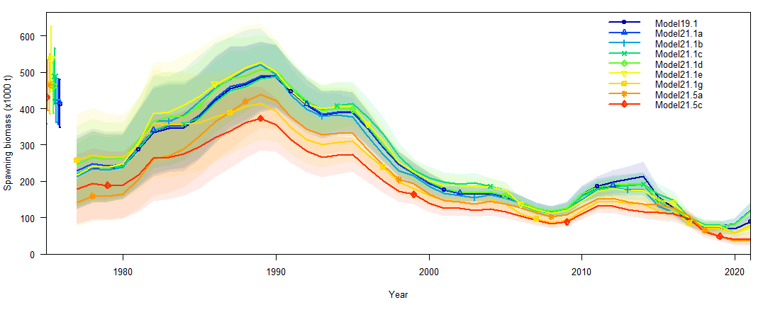

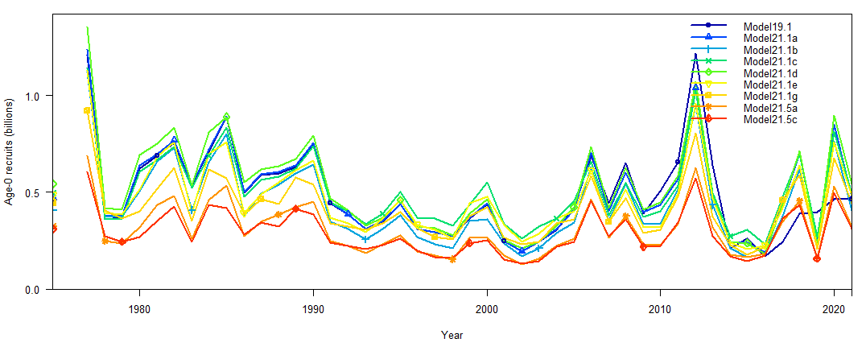

Figure 2.8.1 – (Top) spawning biomass (1000 t), and (Bottom) number of age-0 recruits (billions) for assessed models.

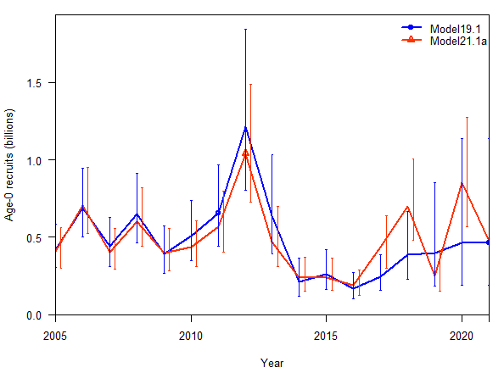 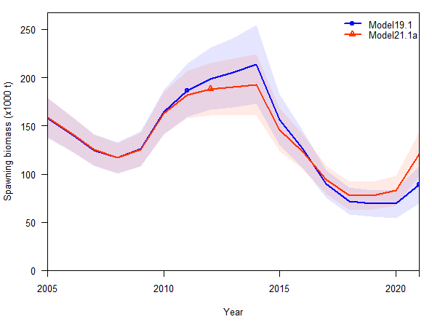

Figure 2.8.2 - (Left) estimate of the number of age-0 recruits for 2006-2021 and (Right) estimate of the 2006-2020 spawning biomass for the base model 19.1 and Model 21.1a with the inclusion of the age-0 beach seine index.

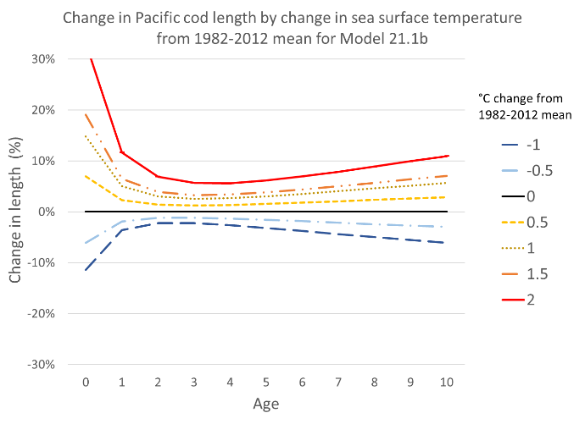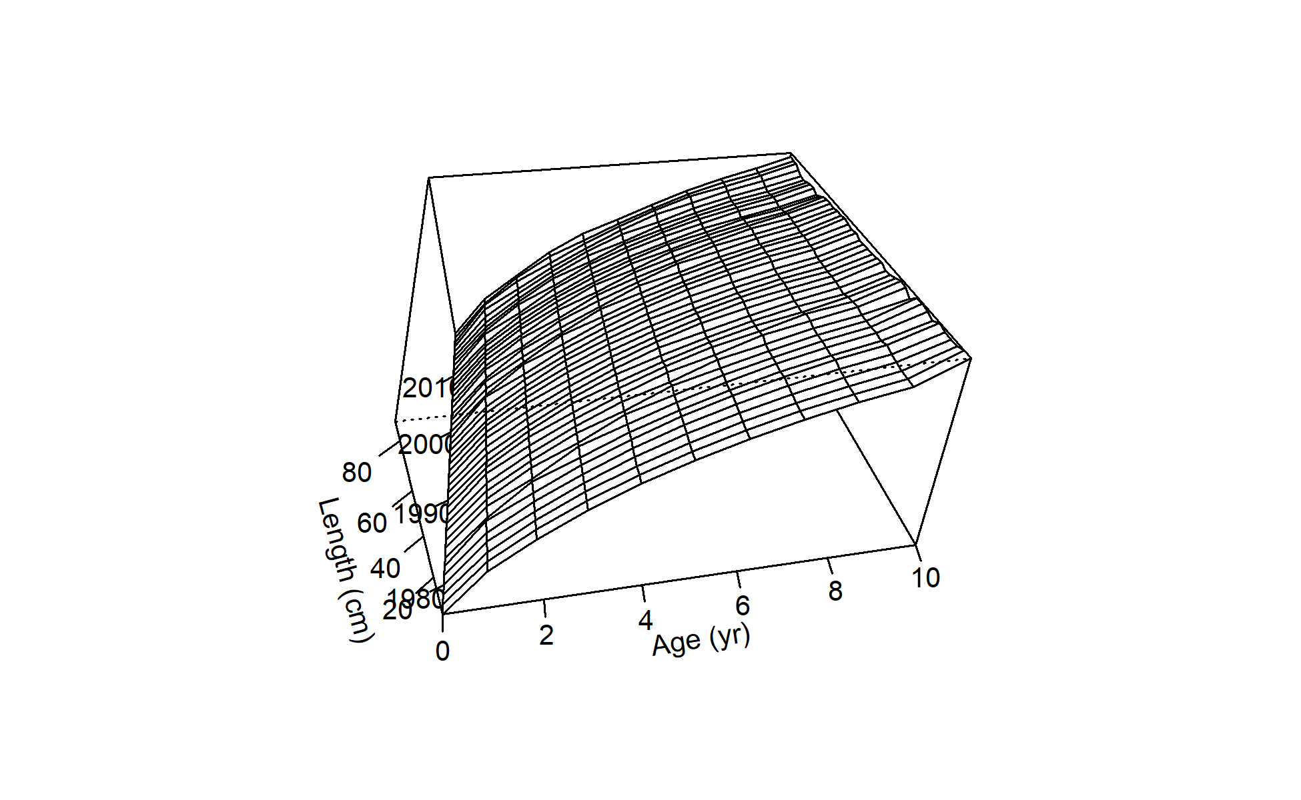

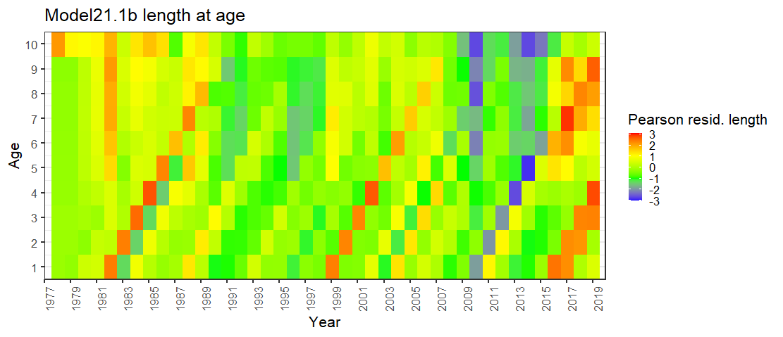

Figure 2.8.3 – For Model 21.1b (Top left) percent change in length from mean temperature by age, (Top right) Length at age over time for 1978-2020, and (bottom) Pearson residuals for length (cm) at age showing temperature effect on growth with larger Pacific cod originating in the warm years.

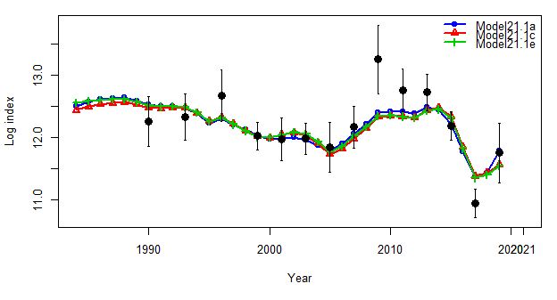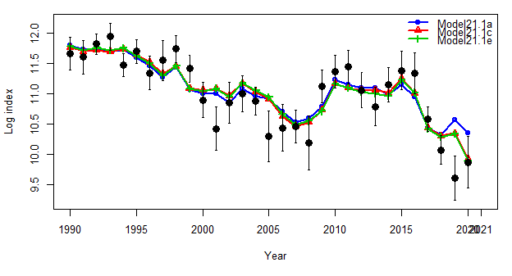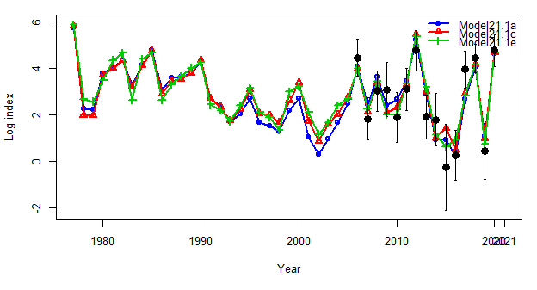

Bottom trawl survey

Longline survey

Beach seine survey

Figure 2.8.4 – Model fits to survey data for (Top left) Bottom trawl survey in tons, (Top left) Longline survey in relative population numbers, and Beach seine age-0 survey in fish per set for Model 21.1a (blue), Model 21.1c (red), and Model 21.1e (green).

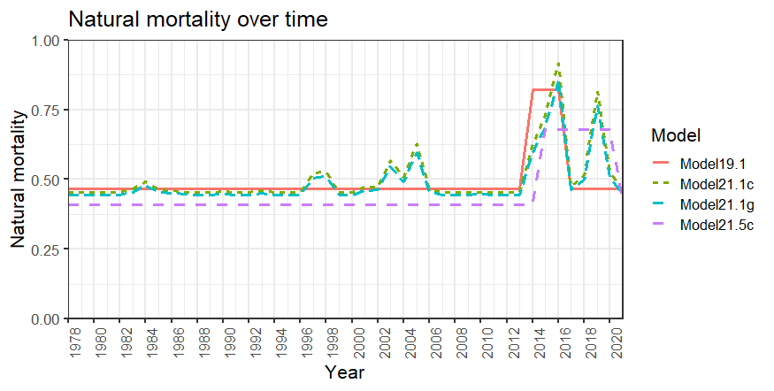

Figure 2.8.5 – Natural mortality over time for Models 19.1, 21.1c, 21.1g, and 21.5c.

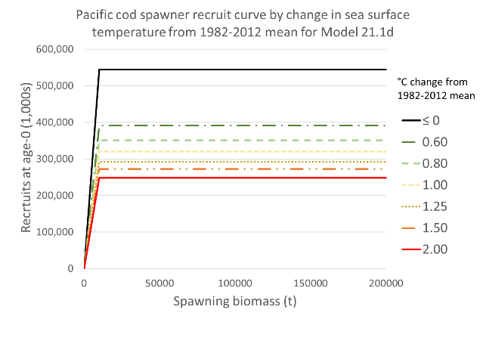

Figure 2.8.6 - Model 21.1d spawner-recruit relationship showing change over mean temperature driven by linking R0 to the spawning heatwave index. We should note here that as GOA Pacific cod remain a tier 3 stock assessment, steepness was fixed at 1.0.

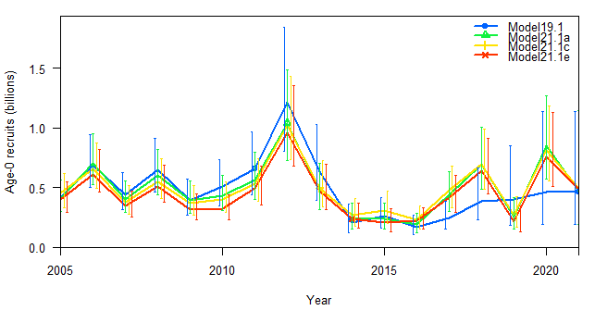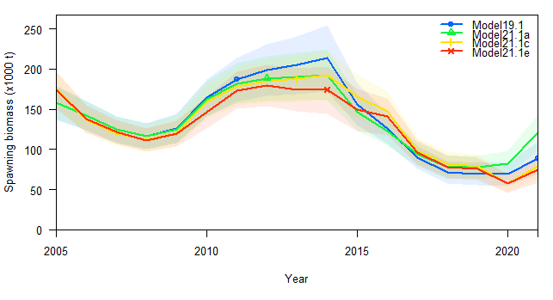

Figure 2.8.7 – (Left) Age-0 recruits and (Right) spawning biomass for 2005-2006 for Model 19.1, Model 21.1a, Model 21.1c, and Model 21.1e.

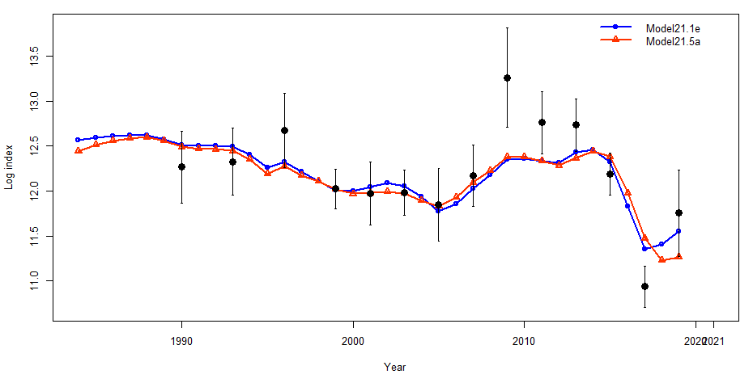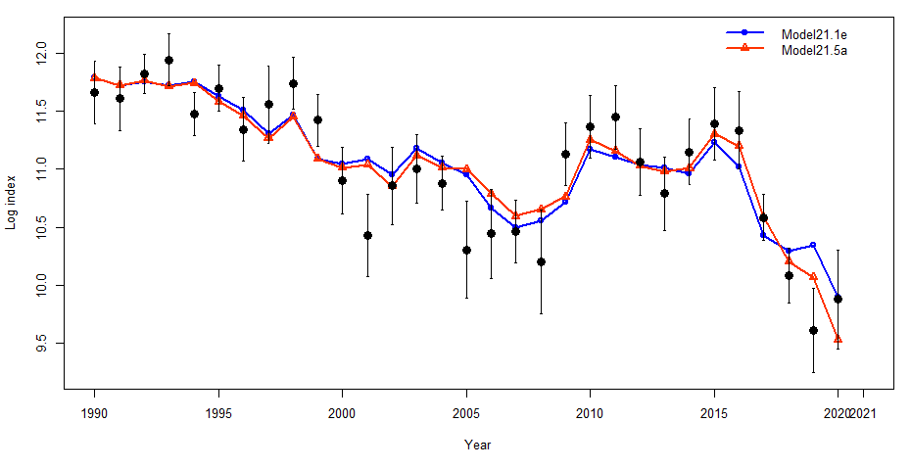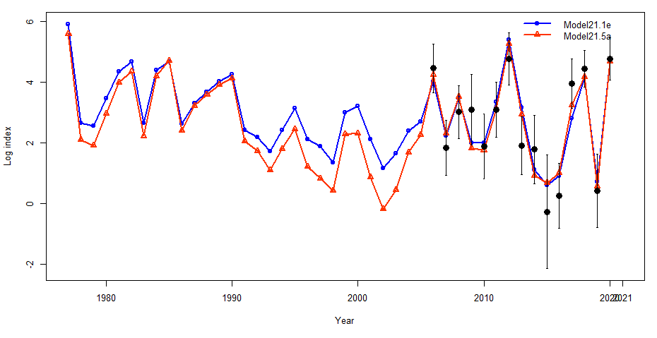

Beach seine survey

Longline survey

Bottom trawl survey

Figure 2.8.8 – Model fits to survey data for (Top left) Bottom trawl survey in tons, (Top left) Longline survey in relative population numbers, and Beach seine age-0 survey in fish per set for Model 21.1e (blue) and Model 21.5a (red).

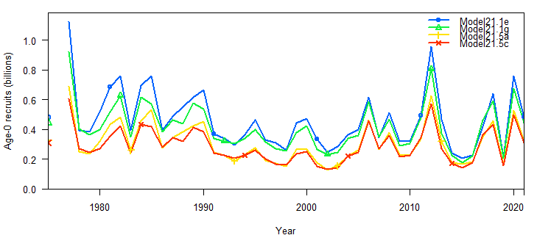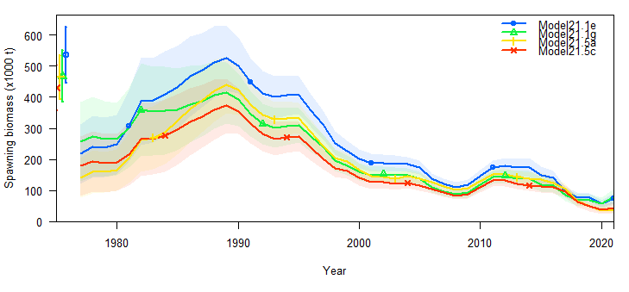

Figure 2.8.9 – (Left) Estimate of the number of age-0 recruits and (Right) estimate of the spawning biomass for 1978-2021for Model 21.1e, 21.1g. 21.5a, and 21.5c.

Model 21.1a

Model 19.1

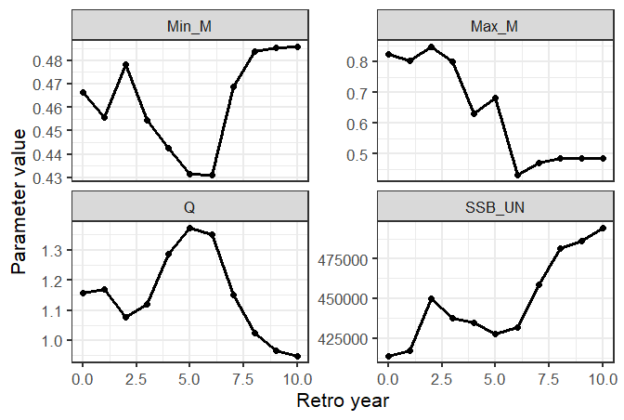 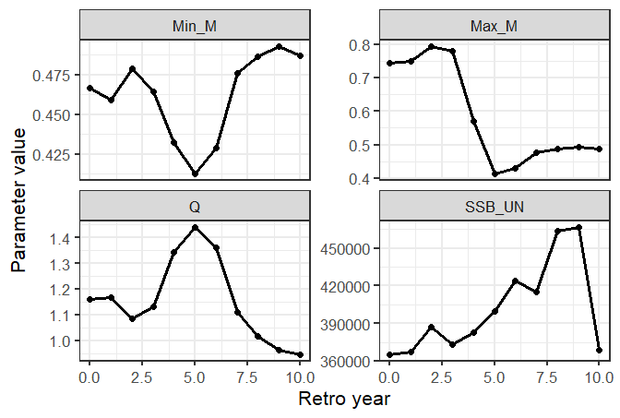

Model 21.5c

Model 21.1g

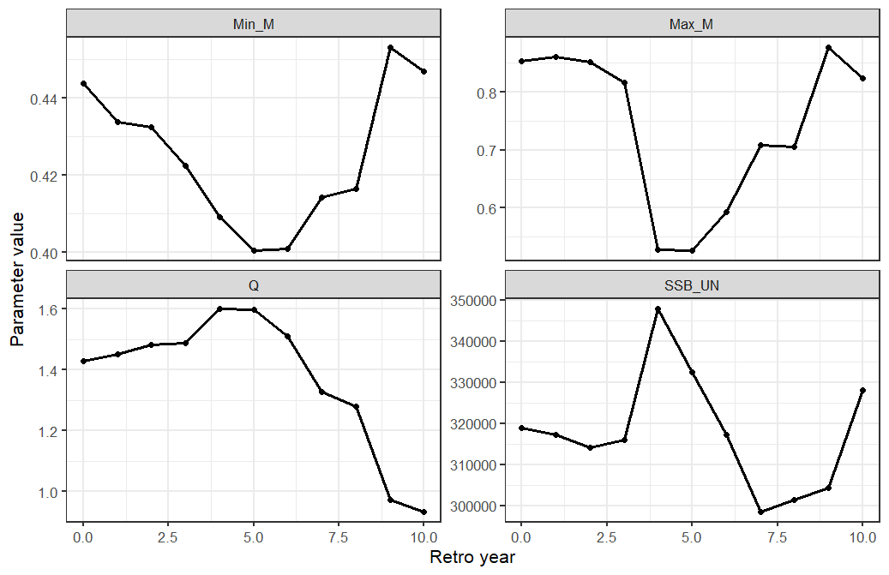 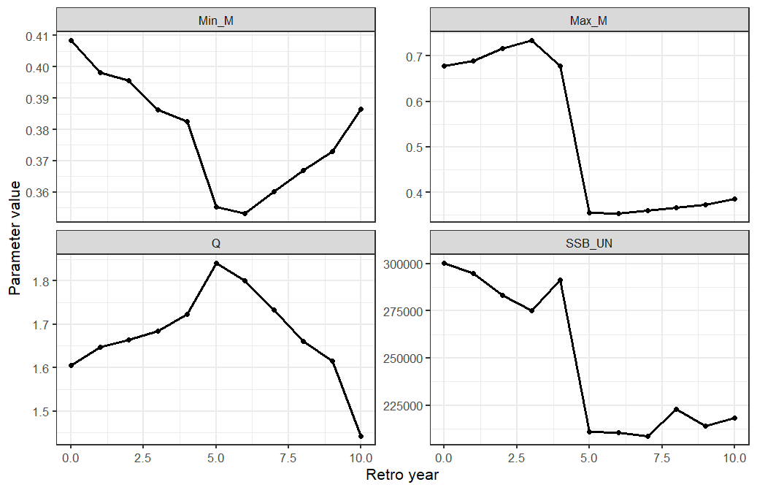

Figure 2.8.10 – Parameter values from retrospective analyses (Min_M=minumum natural mortality, Max_M=maximum natural mortality, Q = catchability, and SSB = unfished spawning biomass) for 10-year peals.

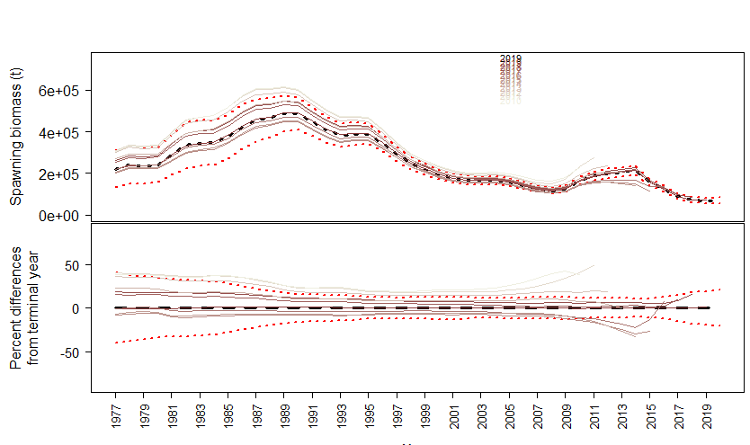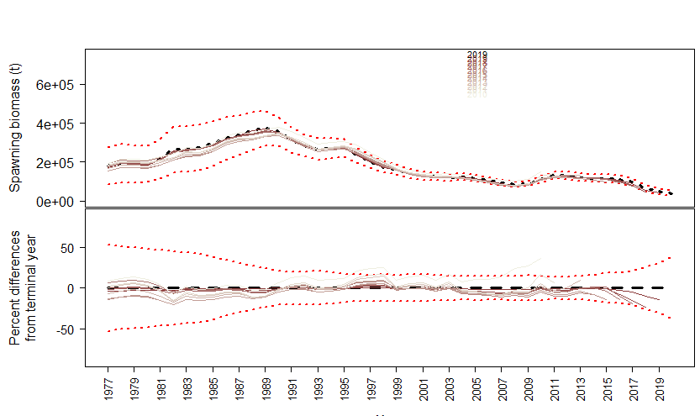

Figure 2.8.11 – Spawning stock biomass estimates from retrospective analyses for 10-year peals showing (top) spawning biomass and (bottom) percent different from terminal year for (left) Model 19.1 and (right) Model 21.5c.